* **Write a program for generating derivation sequence / language for the given sequence of productions – Grouping, Validating phone Number & Email_id.**
* **INPUT :(Valid email & phone no): -**

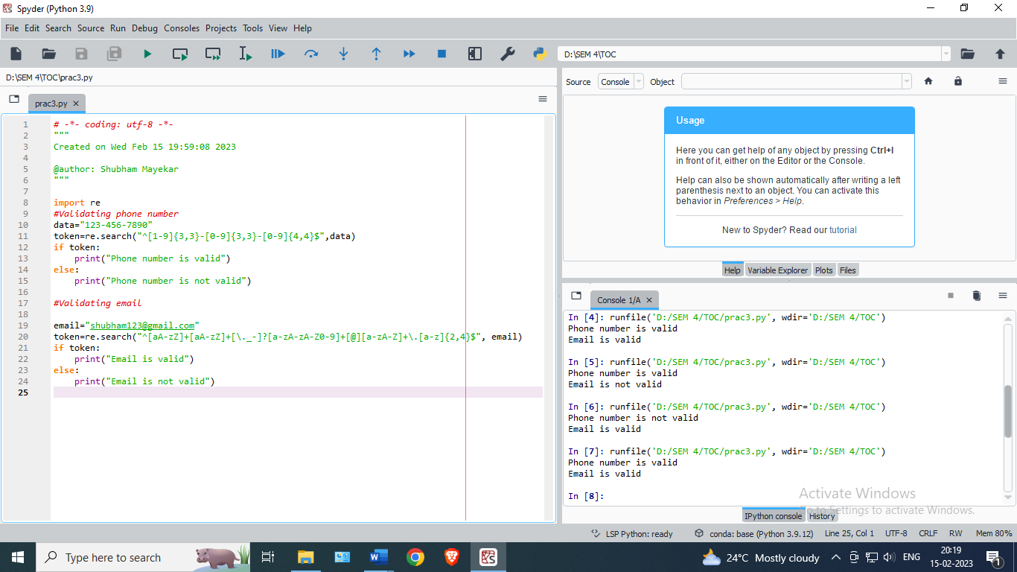

* **Output:**



* **INPUT: (Wrong email and phone no) : -**

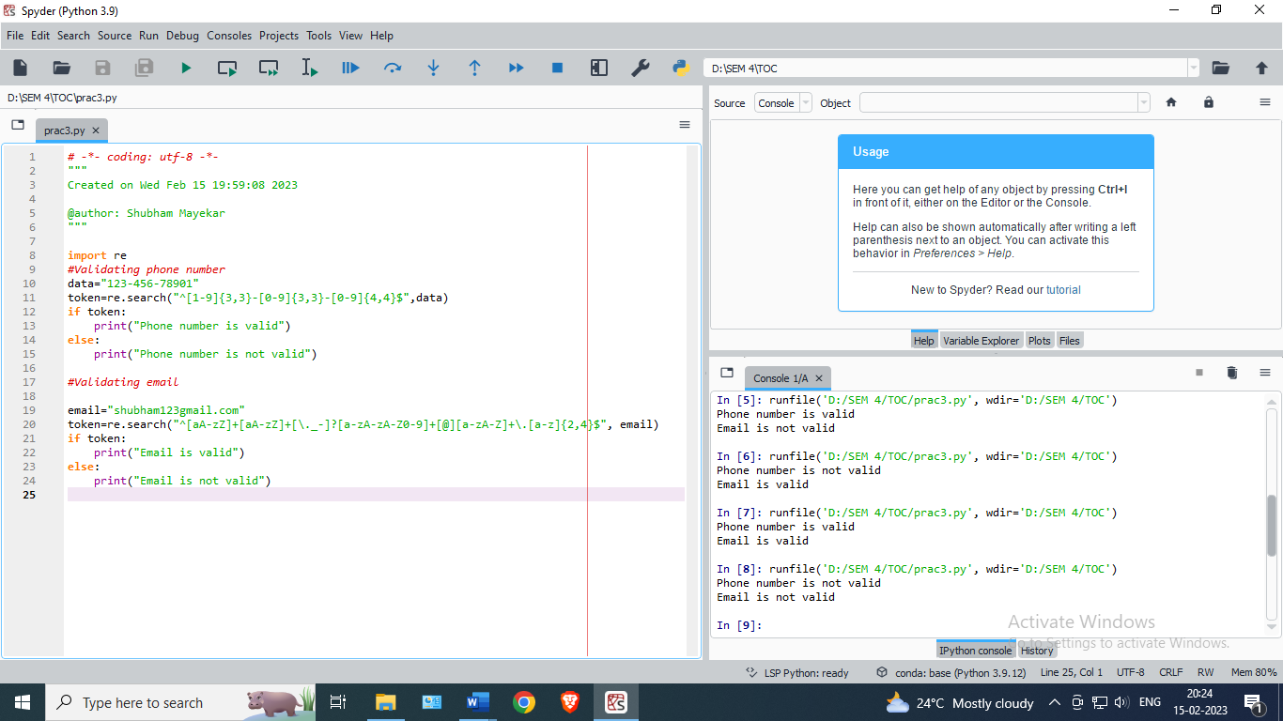

* **Output:**

