* AutoCompleteTextView and Spinner.

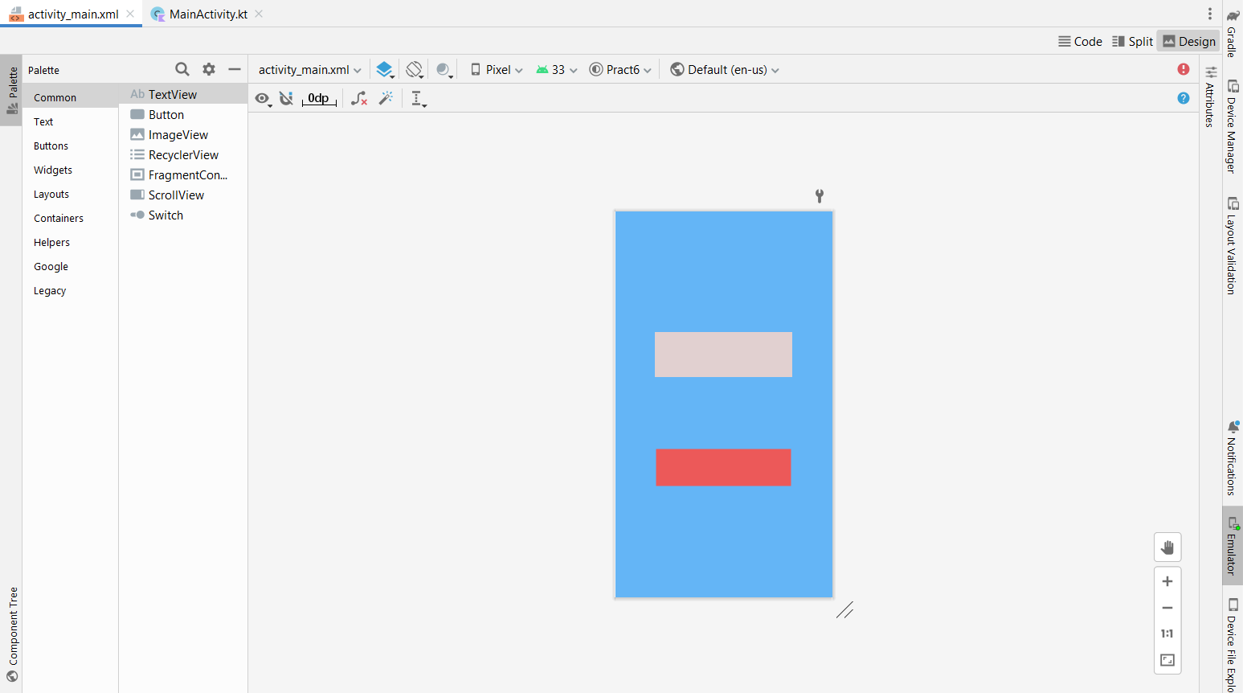

MainActivity.kt

Code:-

package com.example.pract6  
  
import androidx.appcompat.app.AppCompatActivity  
import android.os.Bundle  
import android.widget.ArrayAdapter  
import android.widget.AutoCompleteTextView  
import android.widget.Spinner  
  
class MainActivity : AppCompatActivity() {  
 override fun onCreate(savedInstanceState: Bundle?) {  
 super.onCreate(savedInstanceState)  
 setContentView(R.layout.*activity_main*)  
 *//AutoCompleteTextView* var players= *arrayOf*("Rohit Sharma","Shubhman Gill","Hardik Pandya","Krunal Pandya")  
 var adapter:ArrayAdapter<String>  
 adapter=ArrayAdapter(*applicationContext*,android.R.layout.*simple_dropdown_item_1line*,players)  
 var autotext:AutoCompleteTextView=findViewById(R.id.*ACtxt1*)  
 autotext.*threshold*=2;  
 autotext.setAdapter(adapter)  
  
 *//Spinner* var spin:Spinner=findViewById(R.id.*spinner1*)  
 spin.*adapter*=adapter;  
 }  
}

AutoCompleteTextView Output:-

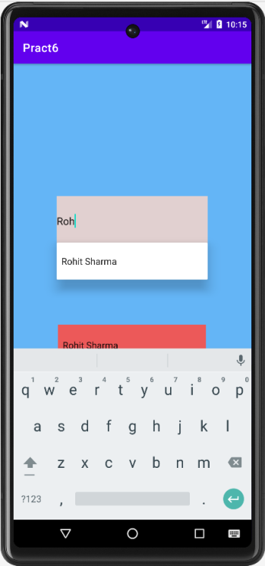

Spinner Output:-

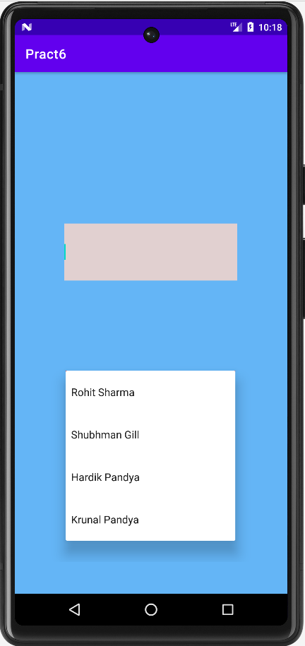

* ListView.

MainActivity.kt:-

Code:-

package com.example.pract6listview  
  
import androidx.appcompat.app.AppCompatActivity  
import android.os.Bundle  
import android.view.View  
import android.widget.AdapterView  
import android.widget.ArrayAdapter  
import android.widget.ListView  
import android.widget.Toast  
  
class MainActivity : AppCompatActivity(), AdapterView.OnItemClickListener {  
 override fun onCreate(savedInstanceState: Bundle?) {  
 super.onCreate(savedInstanceState)  
 setContentView(R.layout.*activity_main*)  
  
 var list1:ListView?=null  
 var adapter:ArrayAdapter<String>?= null  
 var itemlist:Array<String>  
 itemlist=*resources*.getStringArray((R.array.*Programming_lang*))  
  
 list1=findViewById(R.id.*l1*)  
 adapter= ArrayAdapter(this,android.R.layout.*simple_list_item_1*,itemlist)  
  
 list1.*adapter*=adapter  
 list1.*onItemClickListener*=this  
 }  
 override fun onItemClick(p0:AdapterView<*>?, p1: View?, p2:Int, p3:Long) {  
  
 var item=p0?.getItemIdAtPosition(p2).*toString*()  
 Toast.makeText(this,"Selected Language: "+item,Toast.*LENGTH_LONG*).show()  
 }  
}

strings.xml:-

Code:-

<resources>  
 <string name="app_name">Pract6 ListView</string>  
 <string-array name="Programming_lang">  
 <item>Python</item>  
 <item>C++</item>  
 <item>Java</item>  
 <item>Kotlin</item>  
 <item>C#</item>  
 </string-array>  
</resources>

Output:-

