**Create an Android application to demonstrate the different types of menus.**

1)Context Menu

Code:-

package com.example.contextmenu  
  
import androidx.appcompat.app.AppCompatActivity  
import android.os.Bundle  
import android.view.ContextMenu  
import android.view.MenuItem  
import android.view.View  
import android.widget.TextView  
import android.widget.Toast  
  
class MainActivity : AppCompatActivity() {  
 override fun onCreate(savedInstanceState: Bundle?) {  
 super.onCreate(savedInstanceState)  
 setContentView(R.layout.*activity_main*)  
  
 var text1: TextView = findViewById(R.id.*textView1*)  
 text1.setOnCreateContextMenuListener(this)  
 }  
  
 override fun onCreateContextMenu(menu: ContextMenu?, v: View?, menuInfo: ContextMenu.ContextMenuInfo?  
 ) {  
 super.onCreateContextMenu(menu, v, menuInfo)  
 createMyContextMenu(menu)  
 }  
  
 fun createMyContextMenu(menu: ContextMenu?){  
 var menu1: MenuItem?=menu?.add(0,0,0,"First Item")  
 var menu2: MenuItem?=menu?.add(0,1,1,"Second Item")  
 var menu3: MenuItem?=menu?.add(0,2,2,"Third Item")  
 var menu4: MenuItem?=menu?.add(0,3,3,"Fourth Item")  
 }  
  
 override fun onContextItemSelected(item:MenuItem):Boolean {  
 return handlemyContextMenu(item)  
 }  
 fun handlemyContextMenu(item:MenuItem):Boolean{  
 var id:Int=item.*itemId* when(id){  
 0->Toast.makeText(*applicationContext*,"You Clicked Item 1",Toast.*LENGTH_LONG*).show()  
 1->Toast.makeText(*applicationContext*,"You Clicked Item 2",Toast.*LENGTH_LONG*).show()  
 2->Toast.makeText(*applicationContext*,"You Clicked Item 3",Toast.*LENGTH_LONG*).show()  
 3->Toast.makeText(*applicationContext*,"You Clicked Item 4",Toast.*LENGTH_LONG*).show()  
  
 }  
 return false  
 }  
}

Output:-

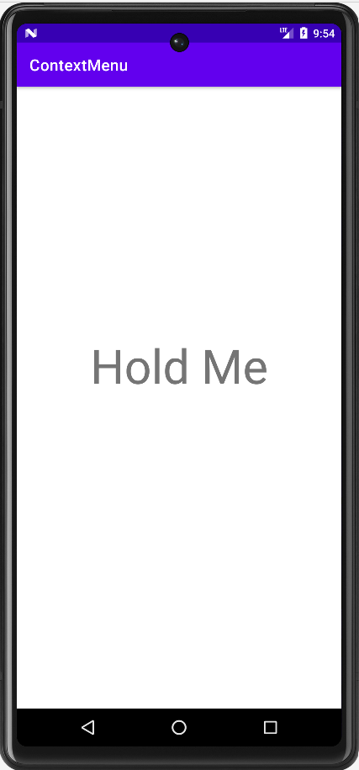 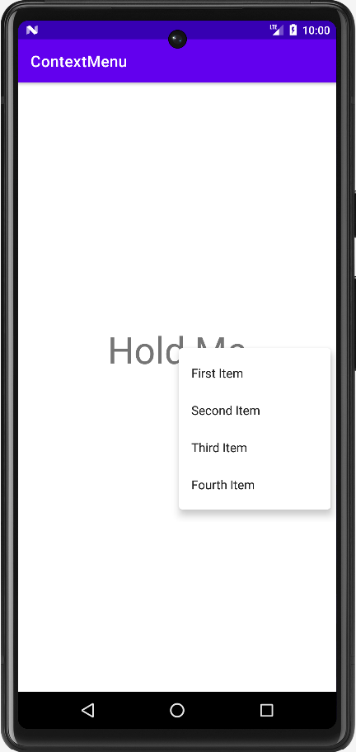 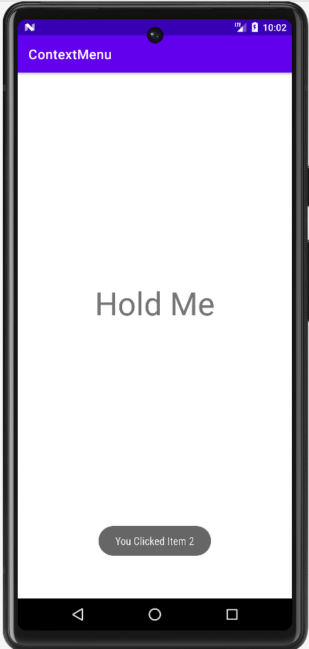

2)Menu List:-

Code:-

package com.example.contextmenu  
  
import androidx.appcompat.app.AppCompatActivity  
import android.os.Bundle  
import android.view.Menu  
import android.view.MenuItem  
import android.widget.Toast  
  
class MainActivity : AppCompatActivity() {  
 override fun onCreate(savedInstanceState: Bundle?) {  
 super.onCreate(savedInstanceState)  
 setContentView(R.layout.*activity_main*)  
  
 }  
  
 override fun onCreateOptionsMenu(menu: Menu?): Boolean {  
 super.onCreateOptionsMenu(menu)  
 createmyMenu(menu)  
 return true  
 }  
 fun createmyMenu(menu: Menu?){  
 var menu1: MenuItem?=menu?.add(0,0,0,"First Item")  
 var menu2: MenuItem?=menu?.add(0,1,1,"Second Item")  
 var menu3: MenuItem?=menu?.add(0,2,2,"Third Item")  
 var menu4: MenuItem?=menu?.add(0,3,3,"Fourth Item")  
 }  
  
 override fun onOptionsItemSelected(item:MenuItem):Boolean {  
 return handlemyMenuItemEvent(item)  
 }  
 fun handlemyMenuItemEvent(item:MenuItem):Boolean{  
 var id:Int=item.*itemId* when(id){  
 0->Toast.makeText(*applicationContext*,"You Clicked Item 1",Toast.*LENGTH_LONG*).show()  
 1->Toast.makeText(*applicationContext*,"You Clicked Item 2",Toast.*LENGTH_LONG*).show()  
 2->Toast.makeText(*applicationContext*,"You Clicked Item 3",Toast.*LENGTH_LONG*).show()  
 3->Toast.makeText(*applicationContext*,"You Clicked Item 4",Toast.*LENGTH_LONG*).show()  
  
 }  
 return false  
 }  
}

Output:-

