Kunaal Raghav
What Do I look Like | 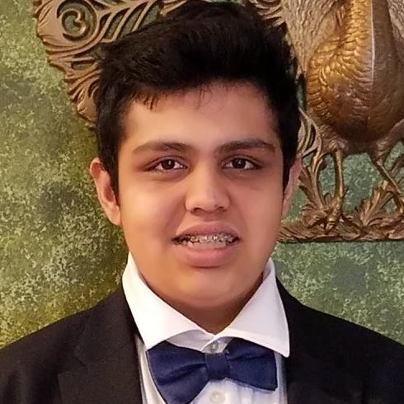
About | I am a 23-year-old current Grad Student in the MPP program at American University  I am an Eagle Scout  I was born to two immigrant parents, both of whom were from Northern India ( UP and Rajasthan)  I have 1 younger brother  Currently reading Devils/ Demons by Dostoyevsky
Where I am from | Monroe Township, NJ
LinkedIn Link | Link

