Homework 7
Kunaal Raghav

Package Download
The following r chunk includes the packages we will use for homework assignment
library(ISLR2)
library(car)
Loading required package: carData
library(boot)
Attaching package: 'boot'
The following object is masked from 'package:car':
logit
library(glmnet)
Loading required package: Matrix
Loaded glmnet 4.1-10

College Applications
Prior to addressing any of the homework assignments, I will be including the training/testing split that the homework requires
data("College")
my.college <- College[-484, ]
my.college <- College[College$Apps <=16000, ]
train.pct <- 0.78
set.seed(2025)
Z <- sample(nrow(my.college), floor(train.pct*nrow(my.college)))
college.data <- my.college[Z, ]
holdout.data <- my.college[-Z, ]
Part A
# Fit full model
fit_full <- lm(Outstate ~ ., data = college.data)
# Compute VIF
vif_values <- vif(fit_full)
vif_values
Private Apps Accept Enroll Top10perc Top25perc
2.441275 12.255015 17.059213 23.293431 7.734286 5.576040
F.Undergrad P.Undergrad Room.Board Books Personal PhD
20.042519 1.920015 1.894824 1.126544 1.309841 4.150999
Terminal S.F.Ratio perc.alumni Expend Grad.Rate
4.008997 1.899343 1.885216 3.914240 1.975435
Several of the coefficients, such as Apps, Accept, Enroll, and PHD seem to have high colliniarity
Part B
#Respective models
model1 <- glm(Apps ~ Private + Accept + Top10perc + Top25perc +
F.Undergrad + Outstate + Room.Board + PhD +
perc.alumni + Expend + Grad.Rate,
data = college.data, family = gaussian)
model2 <- glm(Apps ~ Private + Accept + Top10perc + Top25perc +
Outstate + Room.Board + PhD + Expend,
data = college.data, family = gaussian)
AIC(model1, model2)
df AIC
model1 13 9857.878
model2 10 9867.595
BIC(model1, model2)
df BIC
model1 13 9915.016
model2 10 9911.548
#Respectiv CV
cv1 <- cv.glm(college.data, model1, K = 10)
cv2 <- cv.glm(college.data, model2, K = 10)
cv1$delta[1]
[1] 867133.8
cv2$delta[1]
[1] 891130.5
As we expected (Though it was explained in the homework sheet) Model 1 is the lowest for AIC, while model 2 is lowest for the BIC. With the 10 fold cross validation attempt, model 2 has the lowest predicted MSE
Part C
x <- model.matrix(Apps ~ ., data = college.data)[, -1]
y <- college.data$Apps
cv.ridge <- cv.glmnet(x, y, alpha = 0)
best.lambda <- cv.ridge$lambda.min
best.lambda
[1] 290.4228
plot(cv.ridge)
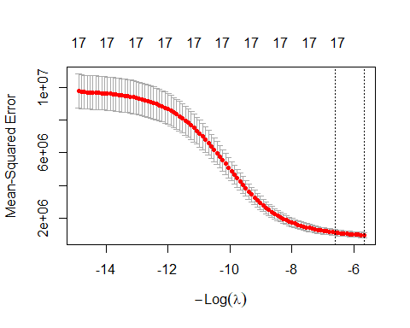
mse.ridge <- min(cv.ridge$cvm)
mse.ridge
[1] 992768.3
Part D
x <- model.matrix(Apps ~ ., college.data)[, -1]
y <- college.data$Apps
cv.lasso <- cv.glmnet(x, y, alpha = 1)
plot(cv.lasso)
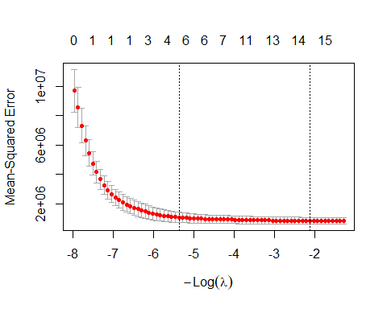
best.lambda <- cv.lasso$lambda.min
best.lambda
[1] 8.271346
min_mse <- min(cv.lasso$cvm)
min_mse
[1] 862024.6

