Name :- Solanki Kunal A.

Description:-
Data Preprocessing is the first step of train the model. This technique use for all types of model training. Data preprocessing is the process of cleaning, transforming, and organizing raw data before it is used to train a machine learning model. Real-world data is often incomplete, inconsistent, noisy, or stored in formats that machine learning algorithms cannot directly use.Preprocessing is the technique to use to improve the accuracy of model.

Main Steps in Data Preprocessing
- Data Cleaning
- Handling missing values.
- Removing duplicate records.
- Find and compute outliers.
- Data Integration
- Combining data from multiple sources into a single dataset.
- Resolving conflicts between different data formats or structures.
- Data Transformation
- Scaling features using techniques such as normalization and standardization.
- Encoding categorical variables into numerical values.
- Data Reduction
- Removing unnecessary features.
- Reducing dimensionality using techniques like PCA.
- Data Splitting
- Dividing the dataset into training, validation, and testing sets.
- Ensuring the model is evaluated on unseen data.

Code:-

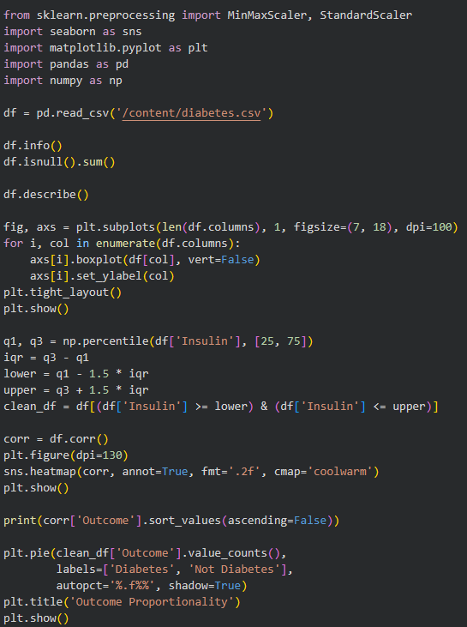

Output:-

