Numerical Computing II
Assignment VII — Trapezoidal Rule
Date: 08/10/2026
Name: Kunal Kamod
Roll No: MS2513

For this assignment, I wrote a Python program to perform numerical integration using the Trapezoidal Rule, compute errors across different step sizes, and plot the graphs. The results, tables, and plots below are generated from that program.

Method & Formula:
• Logic: We split the area under the curve into n strips of equal width h = (b − a) / n. Connecting consecutive points with a straight line turns each strip into a trapezoid. Summing all trapezoids estimates the integral.
• Formula: I ≈ h · [ f(a)/2 + f(x₁) + f(x₂) + ... + f(x_{n-1}) + f(b)/2 ]
• Why: Inside points are shared by two adjacent trapezoids so their weights add to 1, while outer endpoints a and b belong to only one trapezoid so they get weight 1/2.

Question 1
Given integral: I = ∫₀² x² dx for n = 1, 2, 4, 8, 16.
Exact value = [x³ / 3]₀² = 8 / 3 ≈ 2.6666666667
n | h | Approximation | Absolute Error | Order
1 | 2.000000 | 4.0000000000 | 1.3333333333 | —
2 | 1.000000 | 3.0000000000 | 0.3333333333 | 2.000000
4 | 0.500000 | 2.7500000000 | 0.0833333333 | 2.000000
8 | 0.250000 | 2.6875000000 | 0.0208333333 | 2.000000
16 | 0.125000 | 2.6718750000 | 0.0052083333 | 2.000000
Comparison with exact value: As n increases from 1 to 16, the approximation converges from 4.0000 down to 2.6719, approaching 2.6667. Halving the step size h cuts the absolute error by 4 times (order = 2.000000), confirming second-order accuracy O(h²). The approximations stay higher than the exact value because f(x) = x² is concave up, so the straight chords stay above the curve.
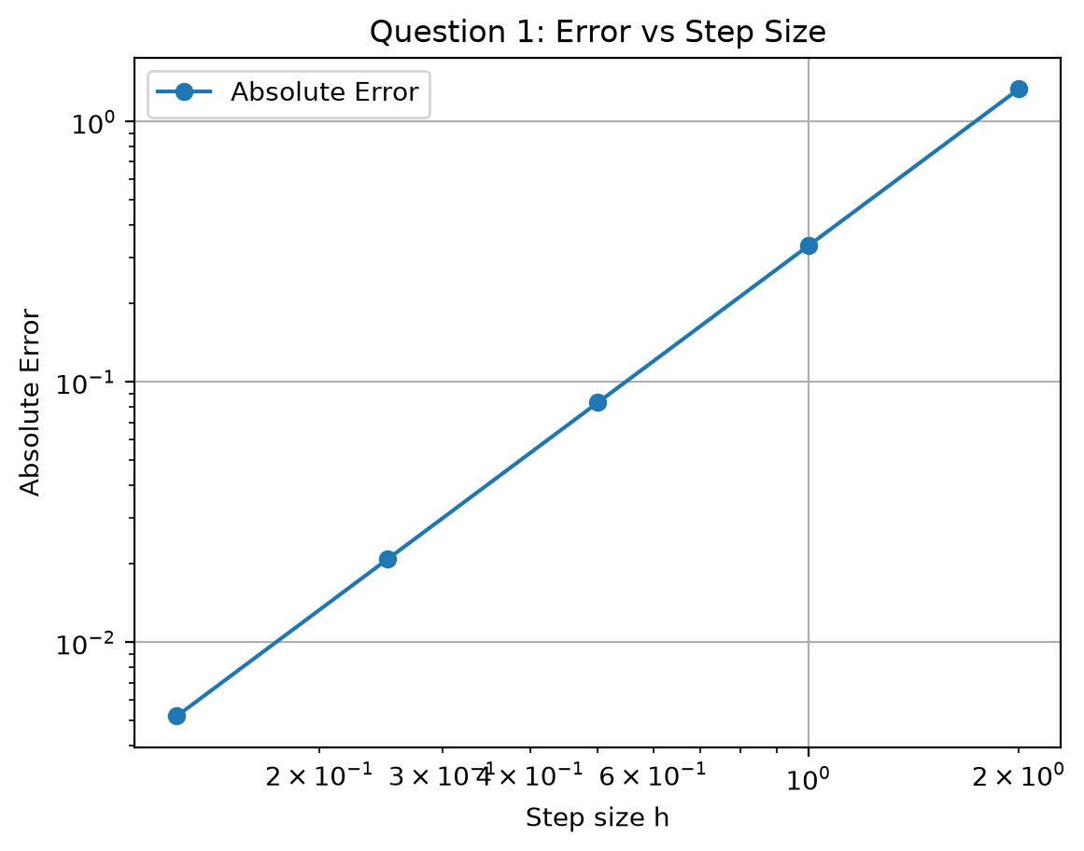
What the graph tells us: The log-log plot of Error vs Step Size h is a straight line with a slope of 2. This visually verifies the O(h²) convergence rate: smaller step sizes rapidly reduce the error in a clean, predictable line.

Question 2: Function Without Elementary Antiderivative
Integral: I = ∫₀¹ e^(-x²) dx for n = 4, 8, 16, 32.
Reference value = 0.7468241328
n | h | Approximation | Absolute Error
4 | 0.250000 | 0.7429840978 | 0.0038400350
8 | 0.125000 | 0.7458656148 | 0.0009585180
16 | 0.062500 | 0.7465845968 | 0.0002395360
32 | 0.031250 | 0.7467642547 | 0.0000598782
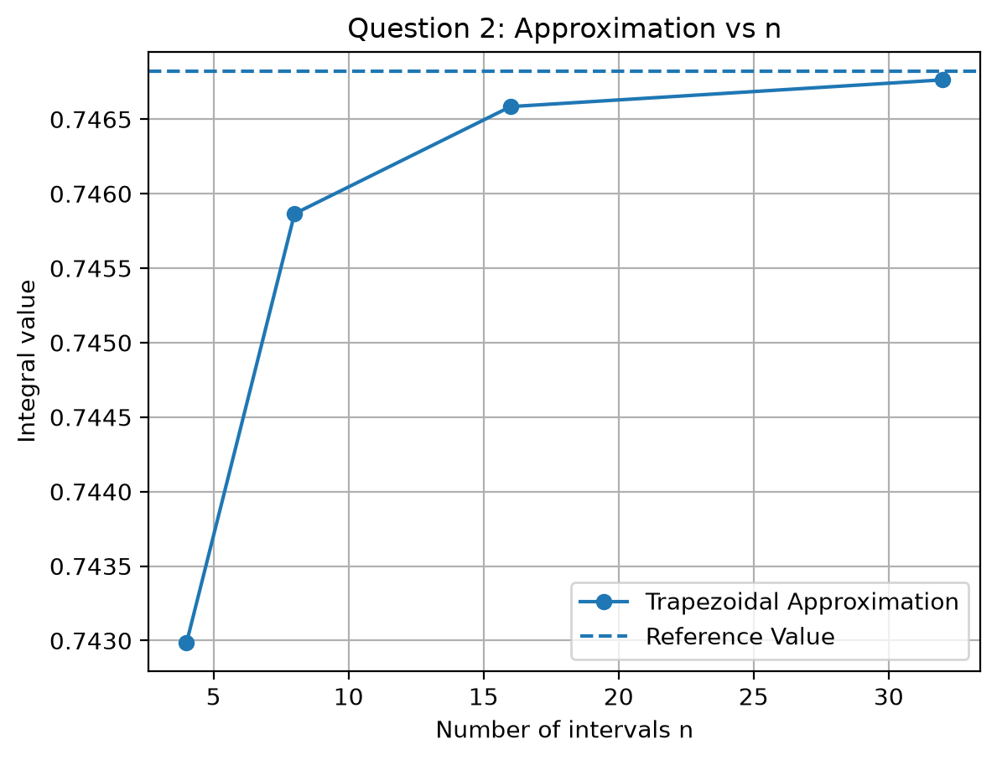
What the graph tells us: The approximation curve rises smoothly toward the dashed horizontal reference line. By n = 16 and n = 32, the gap has almost completely vanished, showing fast convergence.
1. Does increasing n always improve the approximation? Yes. Every time n is increased (from 4 up to 32), the error drops steadily because e^(-x²) is a smooth function, so narrower intervals fit the curve better.
2. What do you observe? The approximations converge from below (underestimating slightly due to concavity), and the error shrinks by roughly 4× every time n doubles, confirming the same O(h²) behavior even without an elementary antiderivative.

Question 3: Data Instead of a Function
Given experimental data:
x | 0.0 | 0.5 | 1.0 | 1.5 | 2.0
f(x) | 1.00 | 1.65 | 2.70 | 4.48 | 7.39
Trapezoidal Calculation:
• Step size h = 0.5
• I ≈ 0.5 · [ (1.00 + 7.39)/2 + 1.65 + 2.70 + 4.48 ] = 0.5 · [ 4.195 + 8.83 ] = 0.5 · 13.025 = 6.5125
• Estimated Integral = 6.5125
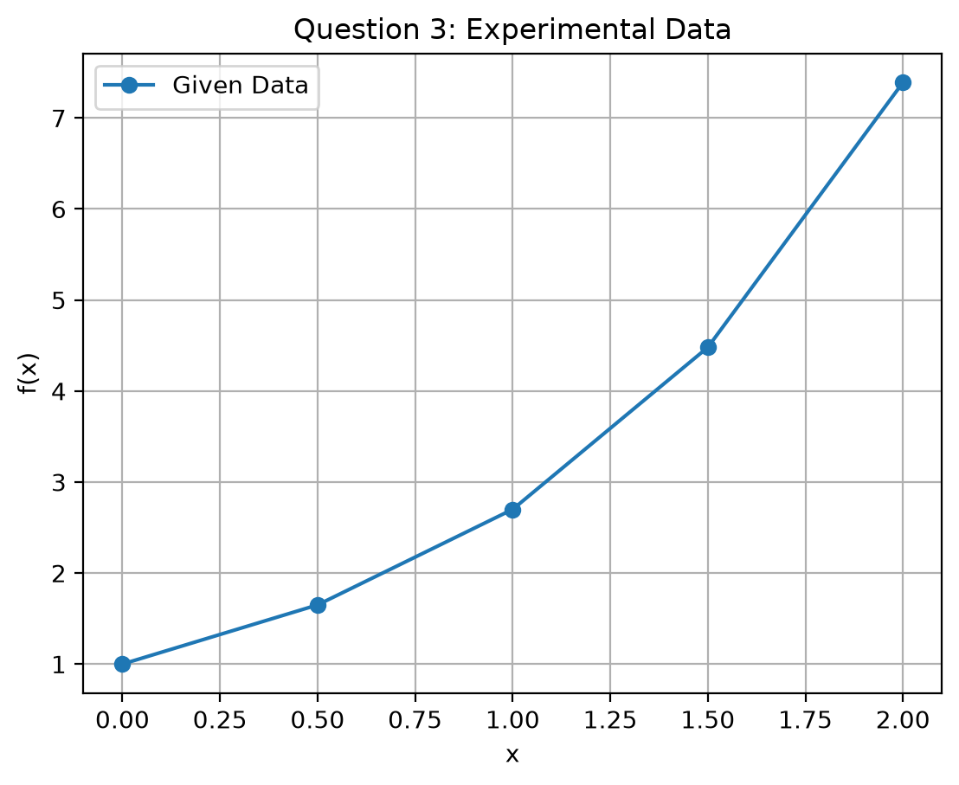
What the graph tells us: The plot shows the data points connected by straight line segments. These segments form the top edges of the trapezoids, and the total area under these trapezoids equals 6.5125.

Why is numerical integration particularly useful in this situation?
In experimental labs, we only get discrete measurements (like sensor readings), not a formula. Standard calculus requires an equation to find an antiderivative, which does not exist here. Numerical integration is essential because it computes the total area (such as total energy or distance) directly from the data points alone.

