Numerical Computing II
Assignment VIII — Simpson's 1/3 and 3/8 Rules with Three-Method Comparison
Date: Oct 11, 2026
Name: Kunal Kamod
Roll No: MS2513
For this assignment, I implemented Simpson's 1/3 Rule and Simpson's 3/8 Rule in Python to evaluate definite integrals, verify their fourth-order accuracy O(h⁴), and compare both methods with the Trapezoidal Rule.

PART 1: SIMPSON'S 1/3 RULE
Method & Formula:
• Logic: Fits a parabola (quadratic curve) through sets of 3 points (each spanning 2 strips). Therefore, total intervals n must be even.
• Formula:
I ≈ (h / 3) · [ f(x₀) + 4 ∑_{i odd} f(x_i) + 2 ∑_{i even} f(x_i) + f(x_n) ]
• Why the weights (1, 4, 2, 4, ..., 1): Midpoints inside each parabolic curve get weight 4; boundaries shared between parabolas add to 2 (1 + 1).
Question 1: I = ∫₀² x² dx (Exact = 8/3 ≈ 2.6666666667)
n | h | Approximation | Absolute Error | Order
2 | 1.000000 | 2.6666666667 | 0.0000000000 | —
4 | 0.500000 | 2.6666666667 | 0.0000000000 | Exact
8 | 0.250000 | 2.6666666667 | 0.0000000000 | Exact
16 | 0.125000 | 2.6666666667 | 0.0000000000 | Exact
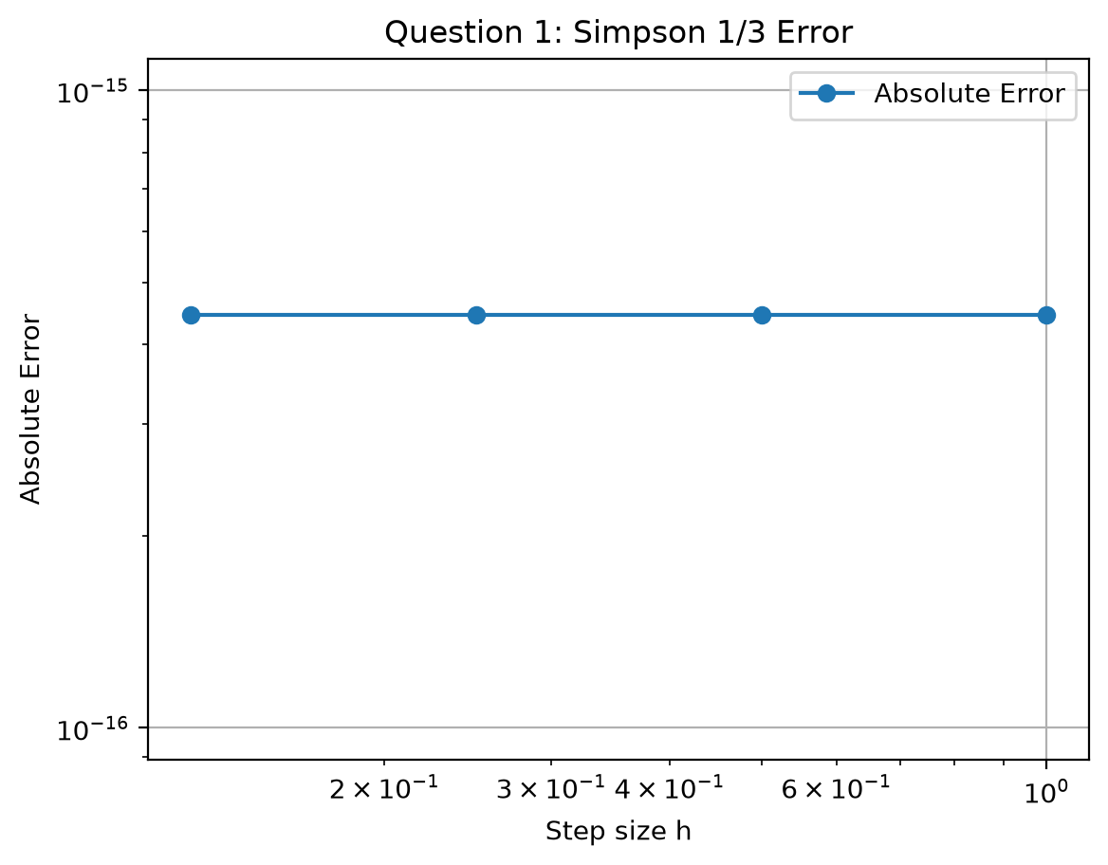
What this graph tells us: The error is identically 0.0000000000 across all step sizes. Because Simpson's 1/3 rule fits parabolas and the integrand f(x) = x² is already a parabola, it captures the true area exactly with zero truncation error.
Question 2: I = ∫₀¹ e^(-x²) dx (Reference = 0.7468241328)
n | h | Approximation | Absolute Error | Order
4 | 0.250000 | 0.7468553798 | 0.0000312470 | —
8 | 0.125000 | 0.7468261205 | 0.0000019877 | 3.974534
16 | 0.062500 | 0.7468242574 | 0.0000001246 | 3.995465
32 | 0.031250 | 0.7468241406 | 0.0000000078 | 3.998963
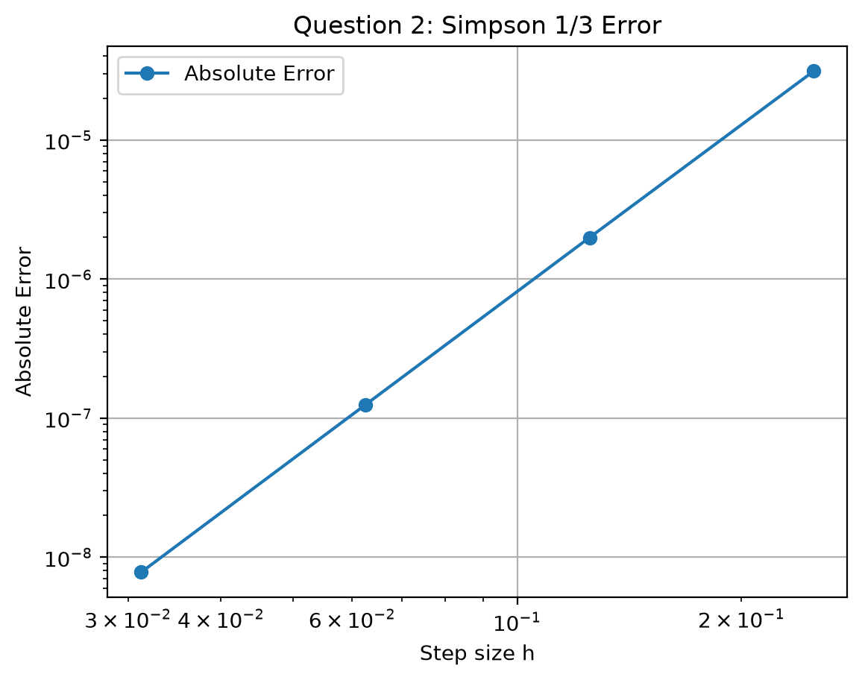
What this graph tells us: The error vs step size h drops in a steep straight line on a log-log scale with slope ≈ 4.0 (O(h⁴)). Halving h slashes the error by roughly 16 times, reaching an error of only 7.8 × 10⁻⁹ at n = 32.
Question 3: Experimental Data (n = 4 intervals, h = 0.5)
• Formula: I ≈ (h/3) · [ f(0) + 4·f(0.5) + 2·f(1.0) + 4·f(1.5) + f(2.0) ]
• Calculation: I ≈ (0.5/3) · [ 1.00 + 4(1.65) + 2(2.70) + 4(4.48) + 7.39 ] = (0.5/3) · 38.31 = 6.3850
• Estimated Integral = 6.3850000000 (Applicable because n = 4 is an even number of intervals).
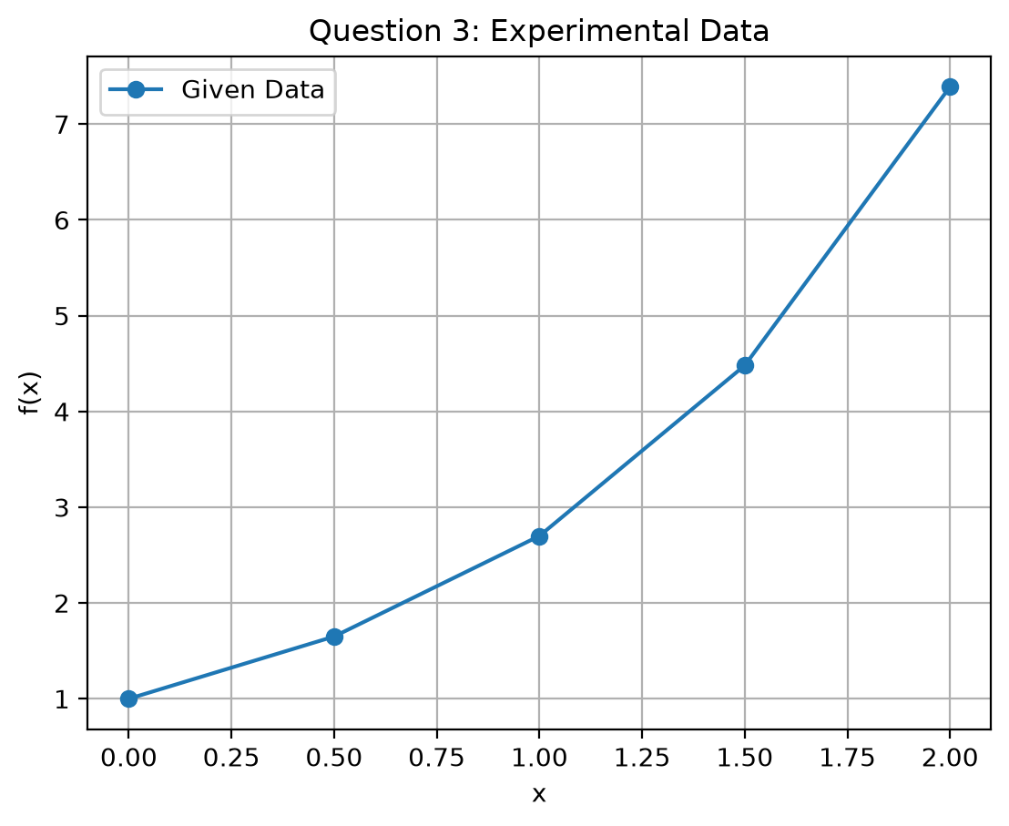
What this graph tells us: The plot shows the experimental points. Simpson's 1/3 rule fits smooth parabolas across (0, 0.5, 1.0) and (1.0, 1.5, 2.0), providing a smoother and more accurate area estimate (6.3850) than straight-line interpolation.

PART 2: SIMPSON'S 3/8 RULE
Method & Formula:
• Logic: Fits a cubic (degree-3) polynomial across sets of 4 points (spanning 3 strips). Therefore, total intervals n must be a multiple of 3.
• Formula:
I ≈ (3h / 8) · [ f(x₀) + 3·f(x₁) + 3·f(x₂) + 2·f(x₃) + 3·f(x₄) + 3·f(x₅) + ... + f(x_n) ]
• Why the weights: Intermediate interior points get weight 3; boundaries shared between adjacent cubic segments add up to 2 (1 + 1).
Question 1: I = ∫₀² x² dx (Exact = 8/3 ≈ 2.6666666667)
n | h | Approximation | Absolute Error | Order
3 | 0.666667 | 2.6666666667 | 0.0000000000 | —
6 | 0.333333 | 2.6666666667 | 0.0000000000 | Exact
12 | 0.166667 | 2.6666666667 | 0.0000000000 | Exact
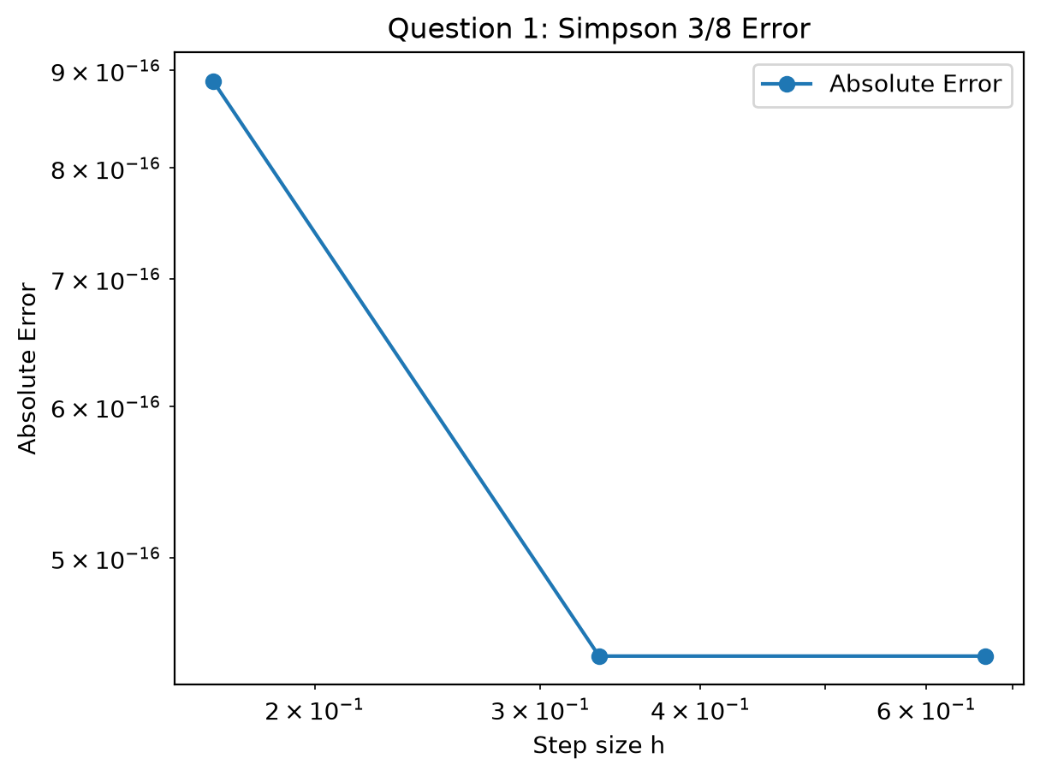
What this graph tells us: The absolute error is zero (within floating-point precision). Because Simpson's 3/8 rule uses cubic interpolation, it exactly integrates all polynomials of degree ≤ 3, including f(x) = x².
Question 2: I = ∫₀¹ e^(-x²) dx (Reference = 0.7468241328)
n | h | Approximation | Absolute Error | Order
3 | 0.333333 | 0.7469923196 | 0.0001681868 | —
6 | 0.166667 | 0.7468380575 | 0.0000139247 | 3.594346
12 | 0.083333 | 0.7468250167 | 0.0000008838 | 3.977713
24 | 0.041667 | 0.7468241882 | 0.0000000554 | 3.995987
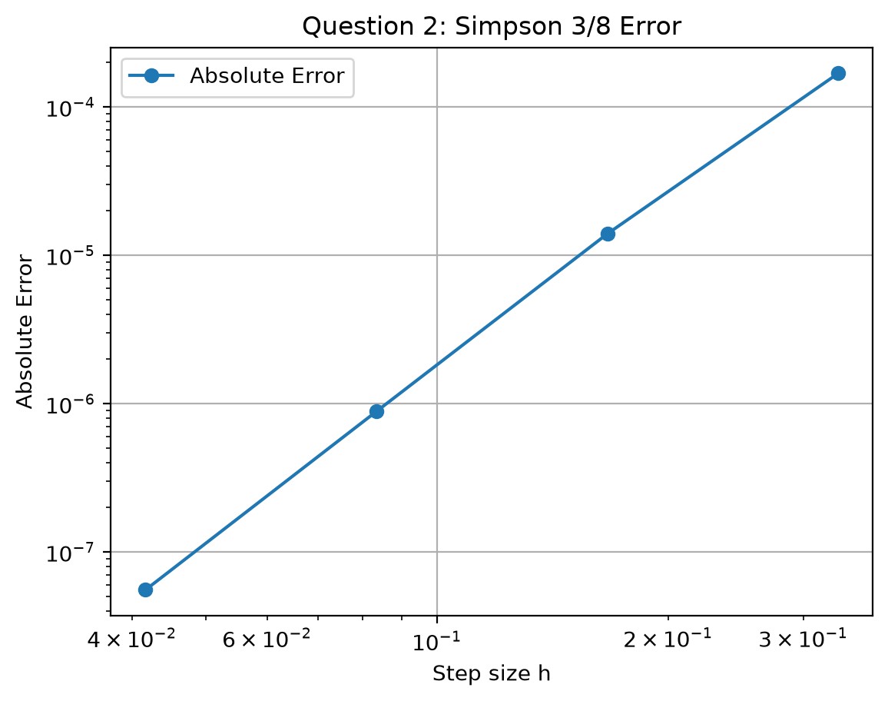
What this graph tells us: The log-log error curve slopes steeply at rate 4 (O(h⁴)), demonstrating that increasing n from 3 to 24 drops the error dramatically from 1.68 × 10⁻⁴ down to 5.54 × 10⁻⁸.
Question 3 Restriction for Simpson 3/8:
• The given dataset contains 5 points, giving n = 4 intervals.
• Simpson 3/8 requires n to be a multiple of 3 (n = 3, 6, 9, ...).
• Because 4 is not divisible by 3, pure Simpson 3/8 cannot be applied alone across the full interval [0, 2].
What this graph tells us: This plot illustrates the 4 discrete intervals in the dataset. Because 4 cannot be partitioned into triplets of 3, pure Simpson 3/8 cannot cover all four segments without leaving an unintegrated remainder.

PART 3: COMPARISON OF THE THREE METHODS (TRAPEZOIDAL vs 1/3 vs 3/8)
Below is the complete side-by-side comparison of the Trapezoidal Rule, Simpson's 1/3 Rule, and Simpson's 3/8 Rule across all three assignment problems:
Feature / Metric | Trapezoidal Rule | Simpson's 1/3 Rule | Simpson's 3/8 Rule
Approximating Curve | Linear (Degree 1 chords) | Parabolic (Degree 2) | Cubic (Degree 3)
Theoretical Order | O(h²) [Second-order] | O(h⁴) [Fourth-order] | O(h⁴) [Fourth-order]
Interval Constraint | Any n ≥ 1 | n must be even (2, 4, 6...) | n multiple of 3 (3, 6, 9...)
Q1 Error (f(x) = x²) | 0.0833 (at n=4) | 0.0000 (Exact for all n) | 0.0000 (Exact for all n)
Q2 Error (at h ≈ 0.125) | 9.58 × 10⁻⁴ (at n=8) | 1.99 × 10⁻⁶ (at n=8) | 1.39 × 10⁻⁵ (at n=6, h=0.16)
Q3 Result (n = 4) | 6.5125 (Applicable) | 6.3850 (Applicable, n even) | Not directly applicable (n≠3k)
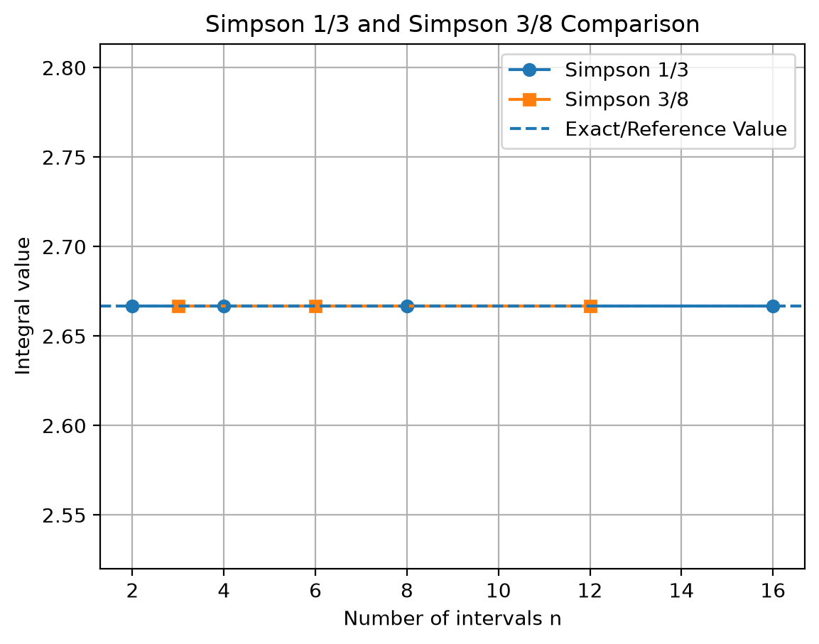
What Graph 1 (Q1 Approximations) tells us: This plot compares the calculated integral values against the exact 2.6667 value. Both Simpson 1/3 and 3/8 immediately match the exact line across all n, whereas Trapezoidal starts with overestimation and slowly converges.
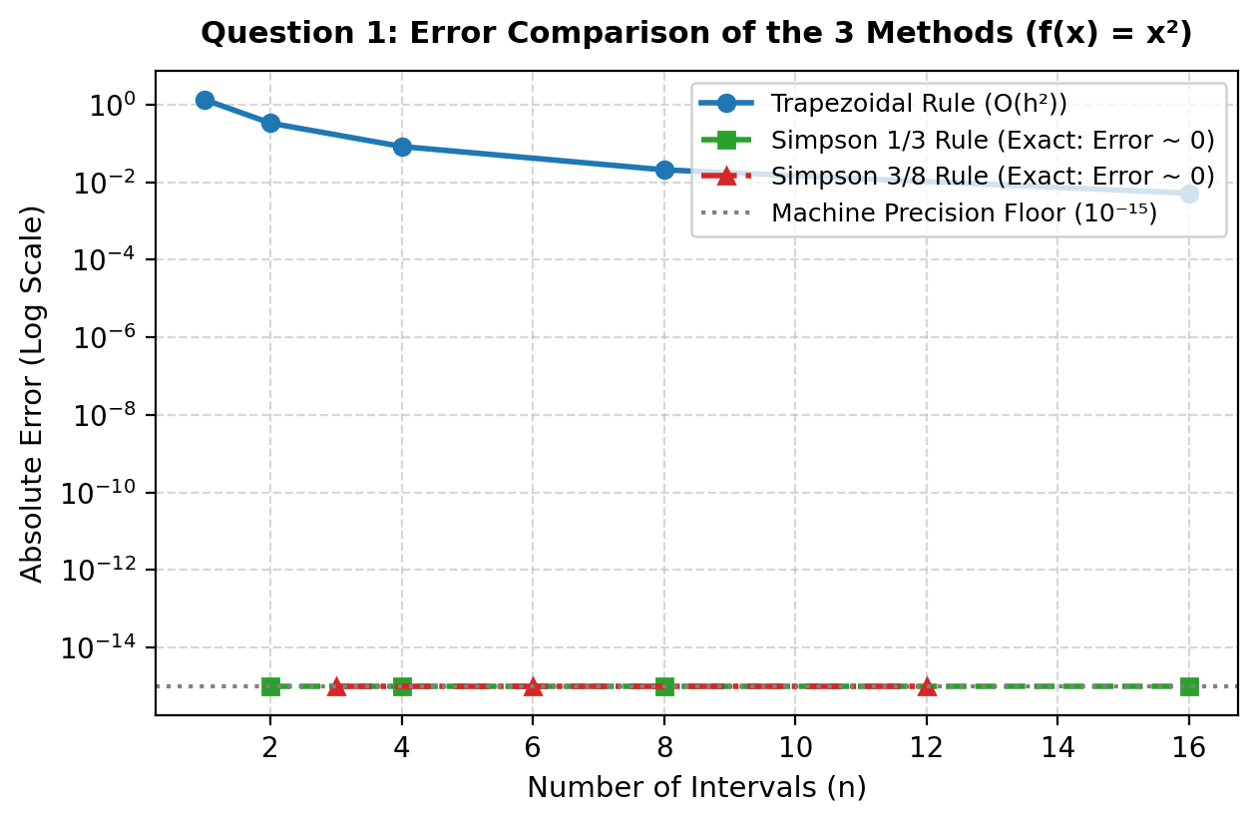
What Graph 2 (Q1 Three-Method Error) tells us: On a logarithmic error scale, the Trapezoidal Rule displays positive non-zero errors descending with slope 2, while both Simpson rules sit flat at machine precision 10⁻¹⁵ (0.0000000000 error).
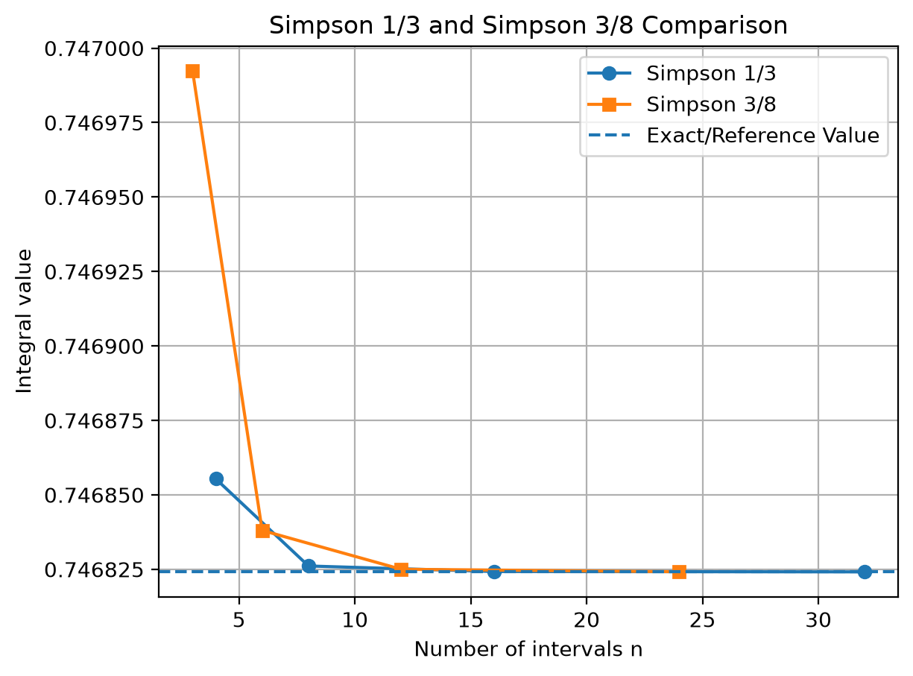
What Graph 3 (Q2 Approximations) tells us: This plot shows numerical convergence toward the reference value 0.746824. Both Simpson curves latch onto the reference horizontal line much faster than the Trapezoidal curve.
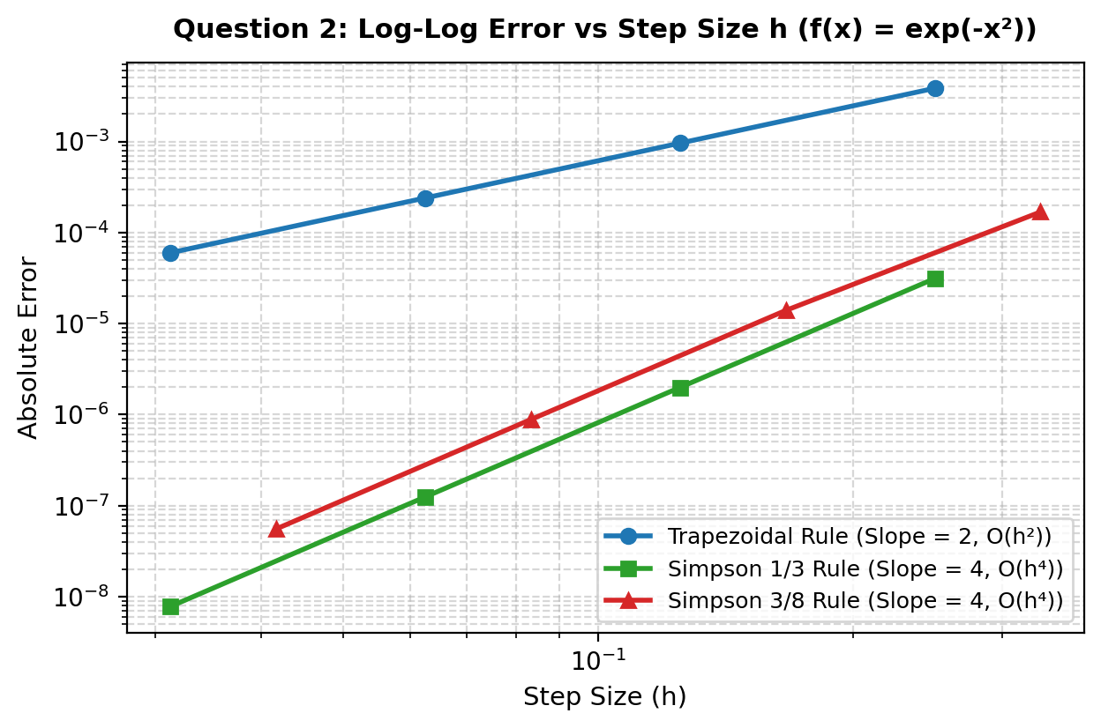
What Graph 4 (Q2 Three-Method Log-Log Error) tells us: The slopes reveal the order of convergence: Trapezoidal has slope 2 (O(h²)), while Simpson 1/3 and 3/8 have slope 4 (O(h⁴)). At h = 0.03125, Simpson 1/3 attains an error of 7.8 × 10⁻⁹, whereas Trapezoidal error is still 6.0 × 10⁻⁵—roughly 7,700 times higher.
Logical Conclusions & When to Use Which Method:
1. Trapezoidal Rule is the most flexible: It works for any number of intervals n without restriction, but needs a very fine step size h due to O(h²) accuracy.
2. Simpson's 1/3 Rule is the most efficient choice: It achieves fourth-order O(h⁴) accuracy with simple alternating weights (1, 4, 2, ...), provided n is even.
3. Simpson's 3/8 Rule is equally accurate (O(h⁴)): It serves as an essential companion when n is a multiple of 3, or when combined with 1/3 to integrate odd numbers of intervals.

