Numerical Computing II
Assignment V — Lagrange Interpolation on Large Datasets
Date: Aug 22, 2026
For this assignment, I updated the Python program to handle large datasets using a Barycentric Lagrange Interpolation approach. Specifically, I processed a dataset of 150 points (student_academic_stress_interpolation_150.csv).
Interpolating large datasets at once with a single high-degree polynomial traditionally results in massive numerical overflow. By using the Barycentric algorithm, we achieve numerical stability and can compute the polynomial safely.

1. Full Dataset (Scatter Plot)
First, here is a scatter plot showing all 150 data points before any interpolation is applied:
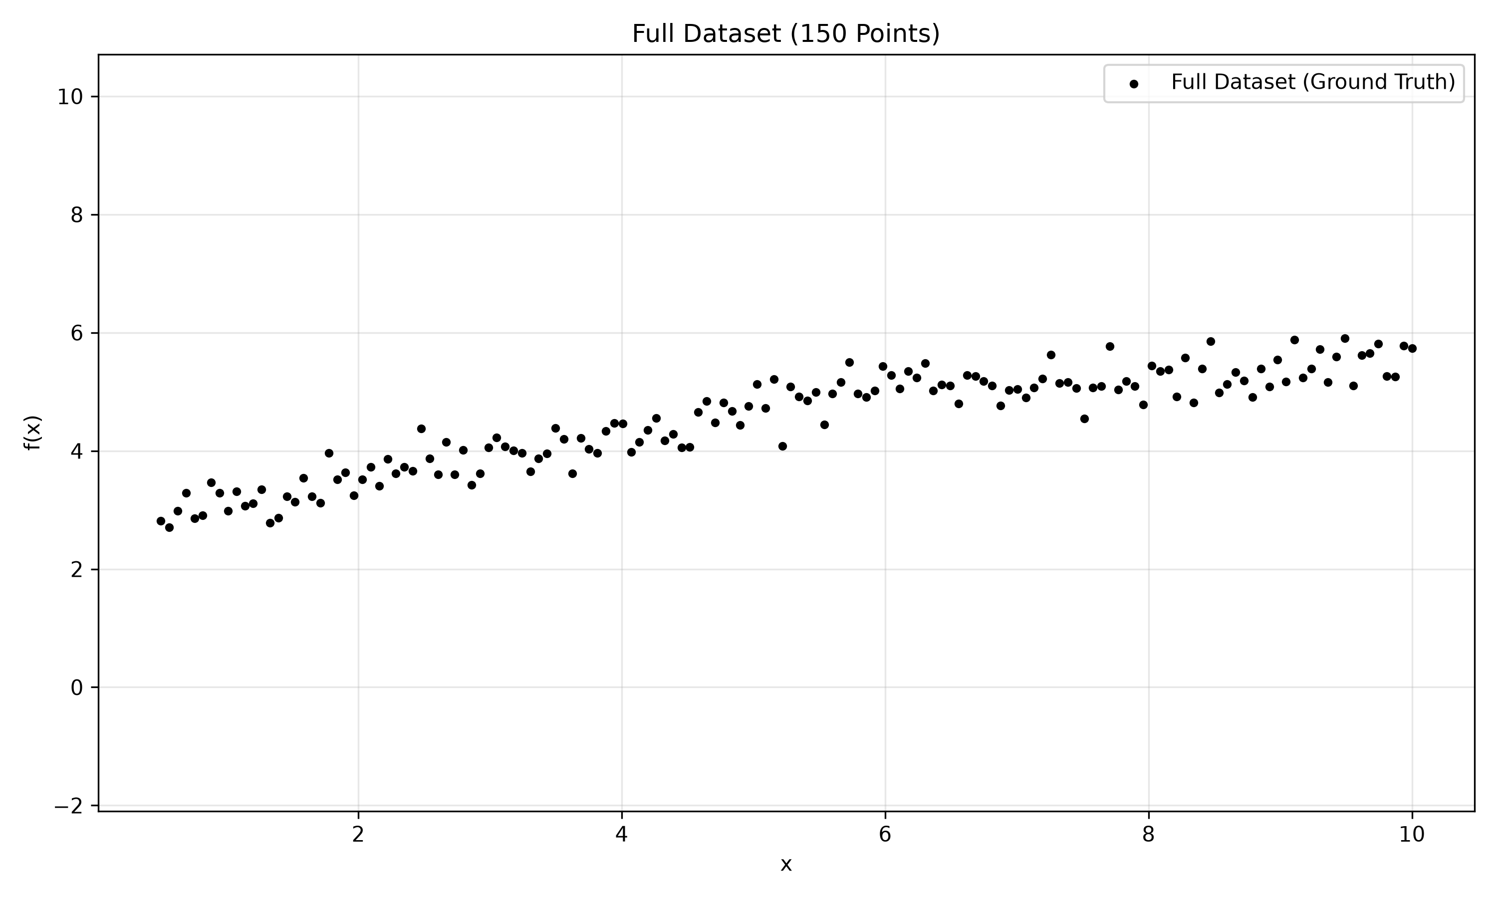

2. Runge's Phenomenon Progression
Below, we progressively fit a single polynomial across increasing subsets of the evenly spaced points. This illustrates how the geometric nature of fitting a high-degree polynomial causes wild boundary oscillations known as Runge's Phenomenon, even though the Barycentric method prevents numerical overflow.

Interpolation with N = 5 Points
This graph shows the interpolating polynomial generated by fitting a degree-4 curve across an evenly spaced subset of 5 points, drawn over the original dataset.
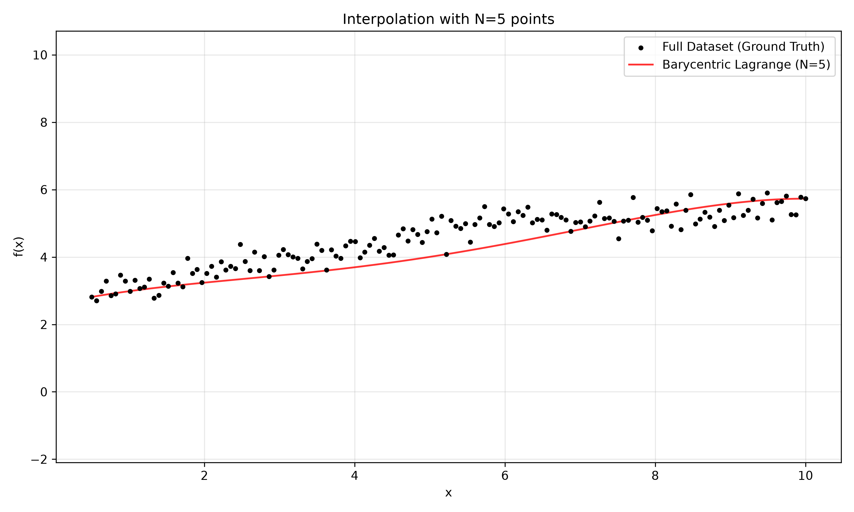

Interpolation with N = 20 Points
This graph shows the interpolating polynomial generated by fitting a degree-19 curve across an evenly spaced subset of 20 points, drawn over the original dataset.
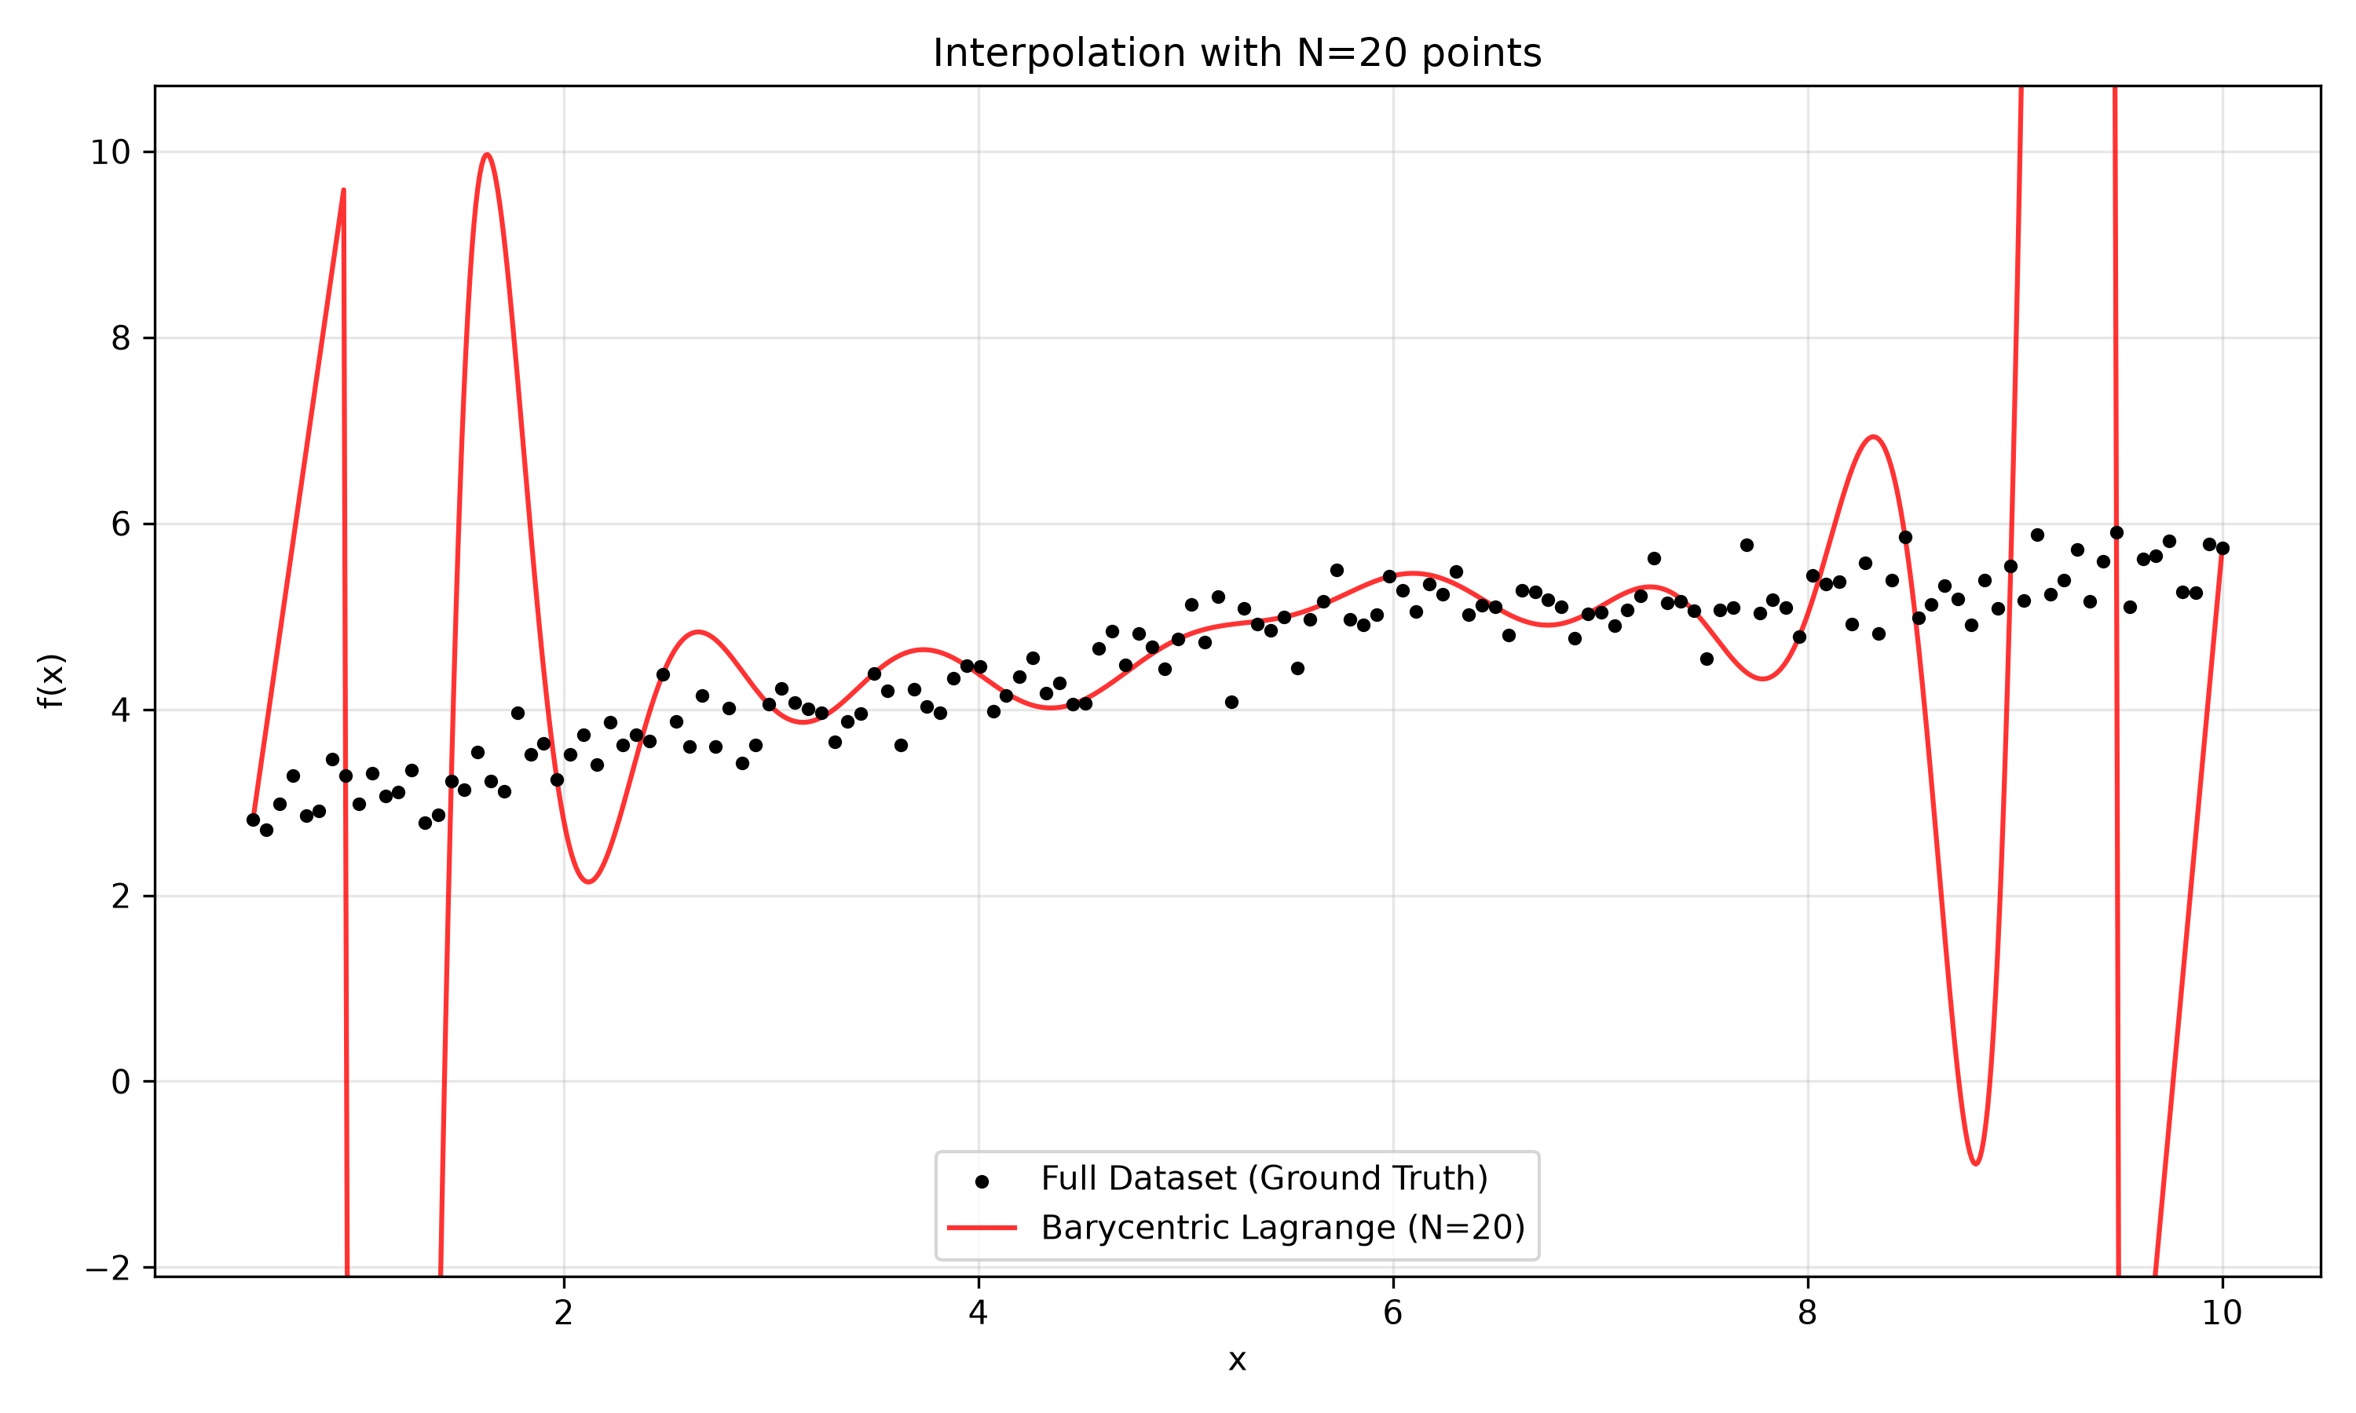

Interpolation with N = 50 Points
This graph shows the interpolating polynomial generated by fitting a degree-49 curve across an evenly spaced subset of 50 points, drawn over the original dataset.
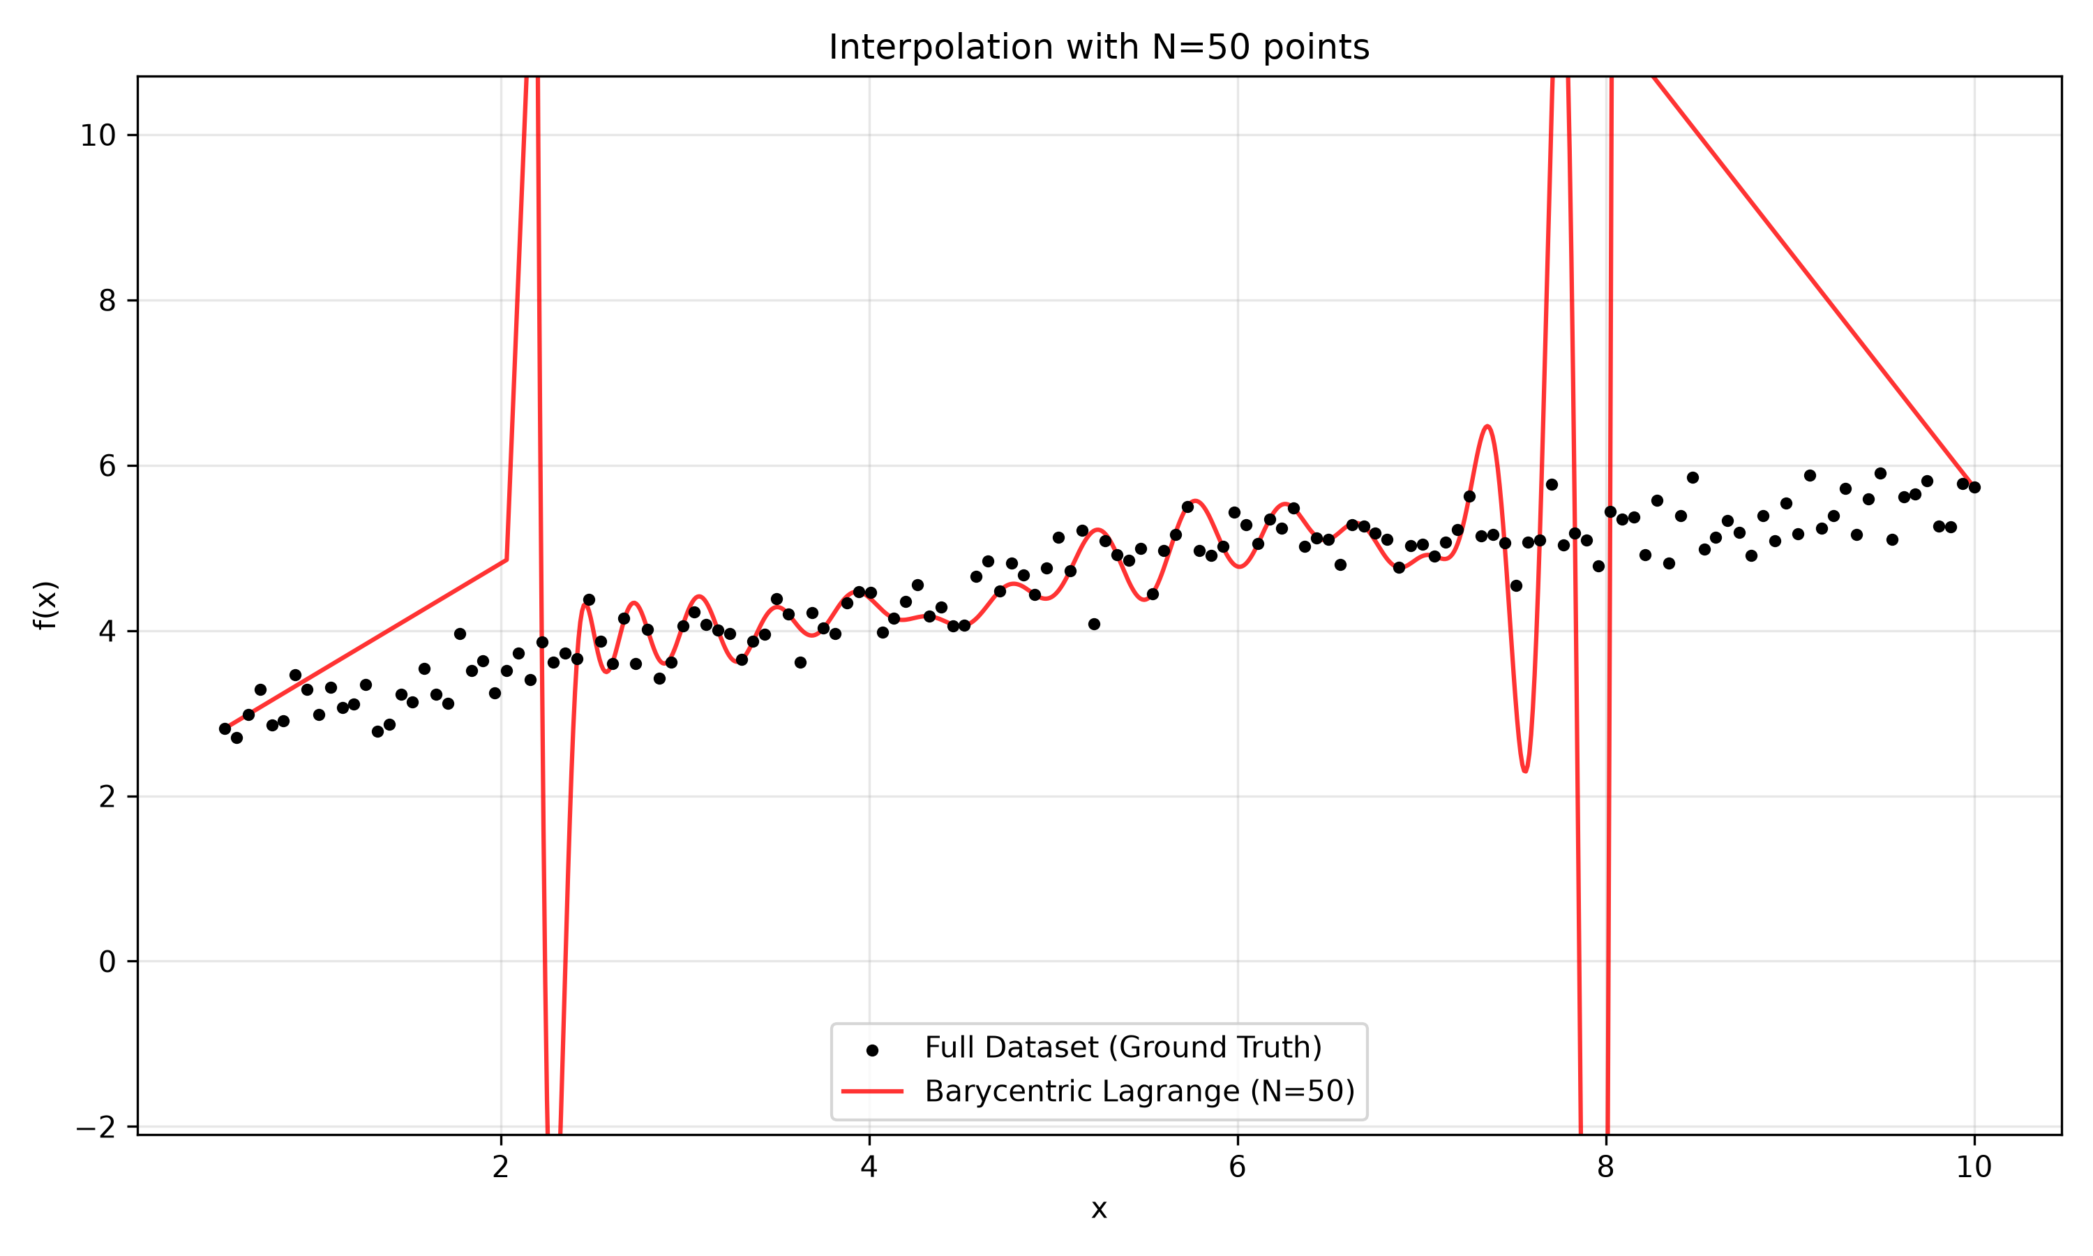

Interpolation with N = 100 Points
This graph shows the interpolating polynomial generated by fitting a degree-99 curve across an evenly spaced subset of 100 points, drawn over the original dataset.
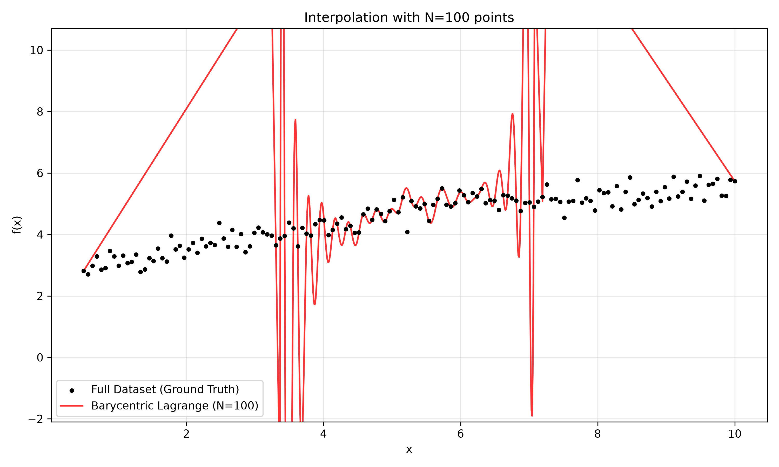

Interpolation with N = 150 Points
This graph shows the interpolating polynomial generated by fitting a degree-149 curve across an evenly spaced subset of 150 points, drawn over the original dataset.
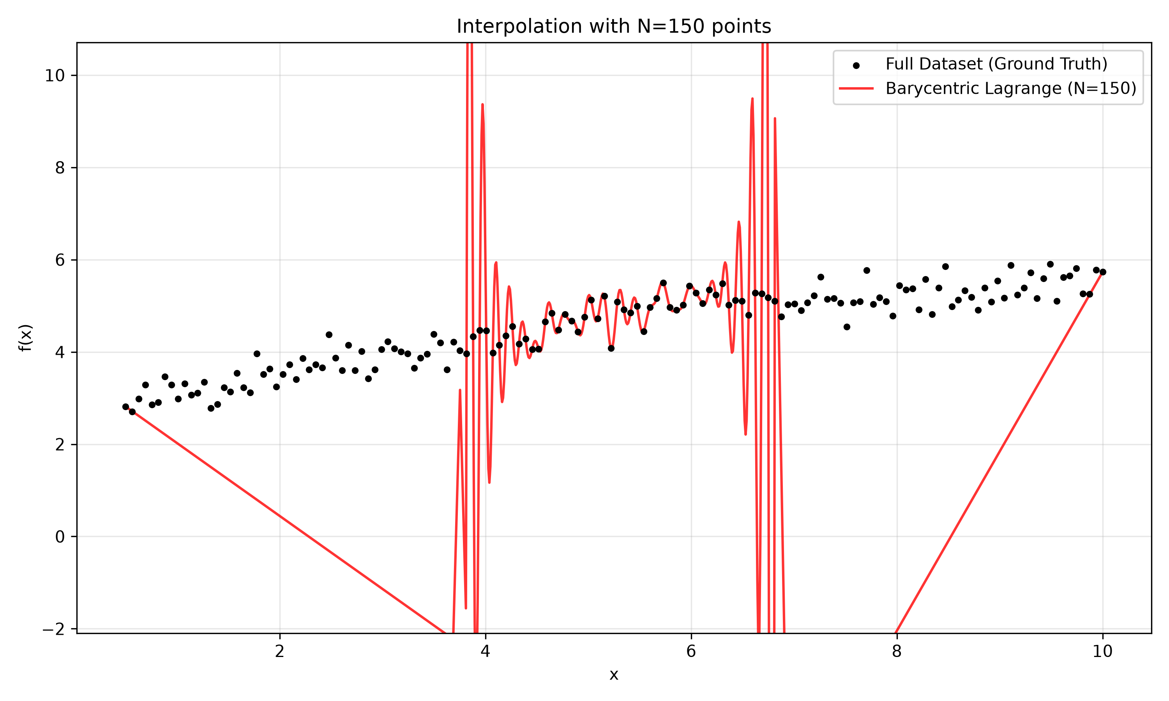
As seen in the final graph (N=150), the boundary fluctuations have become massively chaotic. This visually confirms Runge's Phenomenon.

