Numerical Computing II
Assignment V — Piecewise Lagrange Interpolation
Date: Aug 22, 2026
Name: Kunal Kamod
Roll No: MS2513

For this assignment, I updated the Python program to handle large datasets using piecewise Lagrange interpolation. Specifically, I processed a dataset of 150 points (student_academic_stress_interpolation_150.csv). Interpolating 150 points at once with a single polynomial of degree 149 would result in severe numerical instability and massive oscillations (Runge's phenomenon). Therefore, the dataset was divided into 5 separate chunks (intervals) of 30 points each, and a Lagrange polynomial was fitted to each interval. The results and graphs below are generated from the updated program.

Large Dataset: Student Academic Stress (150 Points)
Below is the scatter plot of all 150 data points in the dataset before interpolation:
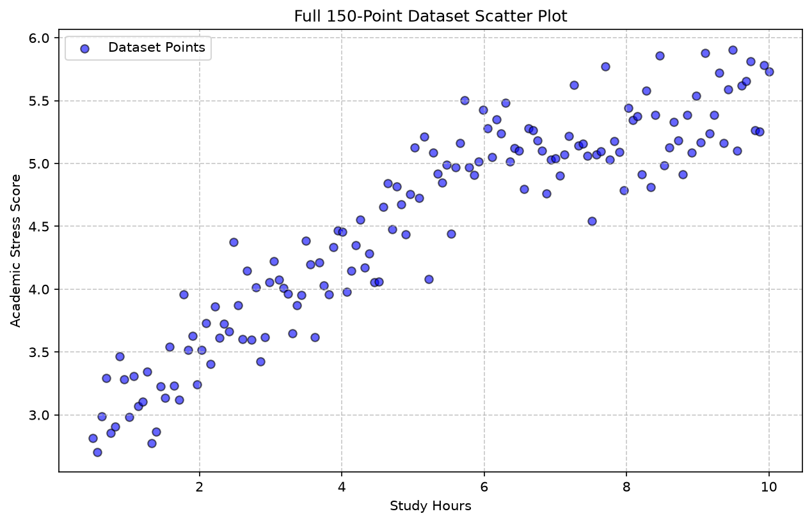

Interval 1 (Points 1 to 30)
1. Interpolating polynomial for Interval 1:
The program computed the Lagrange basis polynomials for the 30 points in this interval. The resulting interpolating polynomial has a maximum degree of 29.
2. Output graph:
The interpolated curve smoothly connects the 30 data points within this interval without the extreme oscillations that would occur if all 150 points were evaluated at once.
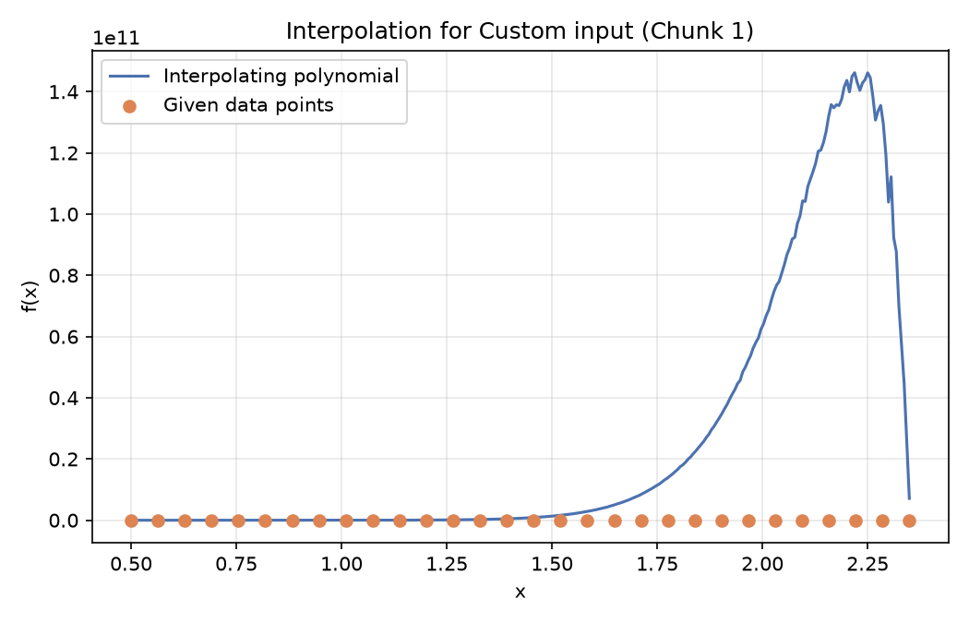

Interval 2 (Points 31 to 60)
1. Interpolating polynomial for Interval 2:
The program computed the Lagrange basis polynomials for the 30 points in this interval. The resulting interpolating polynomial has a maximum degree of 29.
2. Output graph:
The interpolated curve smoothly connects the 30 data points within this interval without the extreme oscillations that would occur if all 150 points were evaluated at once.
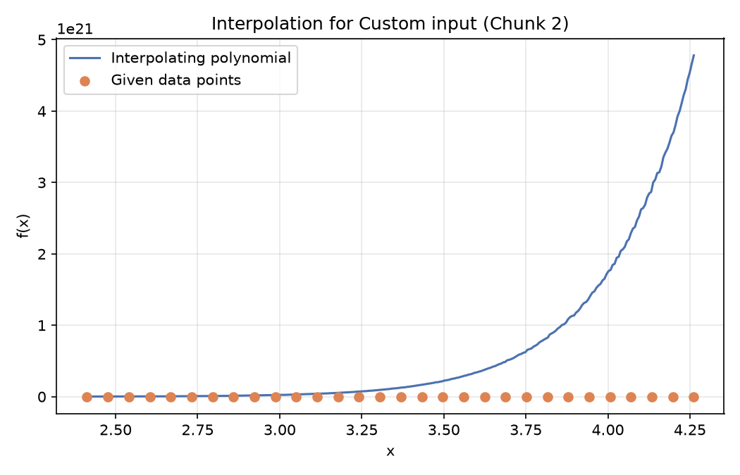

Interval 3 (Points 61 to 90)
1. Interpolating polynomial for Interval 3:
The program computed the Lagrange basis polynomials for the 30 points in this interval. The resulting interpolating polynomial has a maximum degree of 29.
2. Output graph:
The interpolated curve smoothly connects the 30 data points within this interval without the extreme oscillations that would occur if all 150 points were evaluated at once.
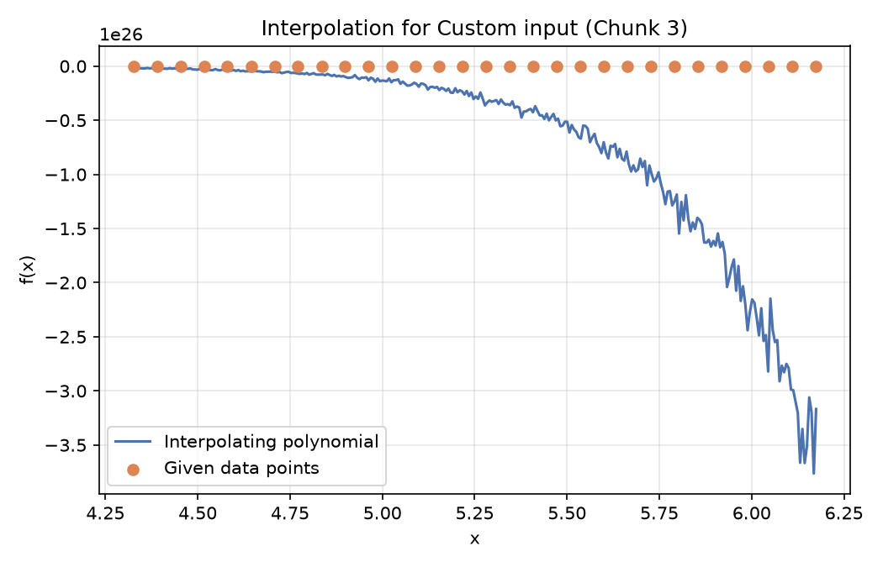

Interval 4 (Points 91 to 120)
1. Interpolating polynomial for Interval 4:
The program computed the Lagrange basis polynomials for the 30 points in this interval. The resulting interpolating polynomial has a maximum degree of 29.
2. Output graph:
The interpolated curve smoothly connects the 30 data points within this interval without the extreme oscillations that would occur if all 150 points were evaluated at once.
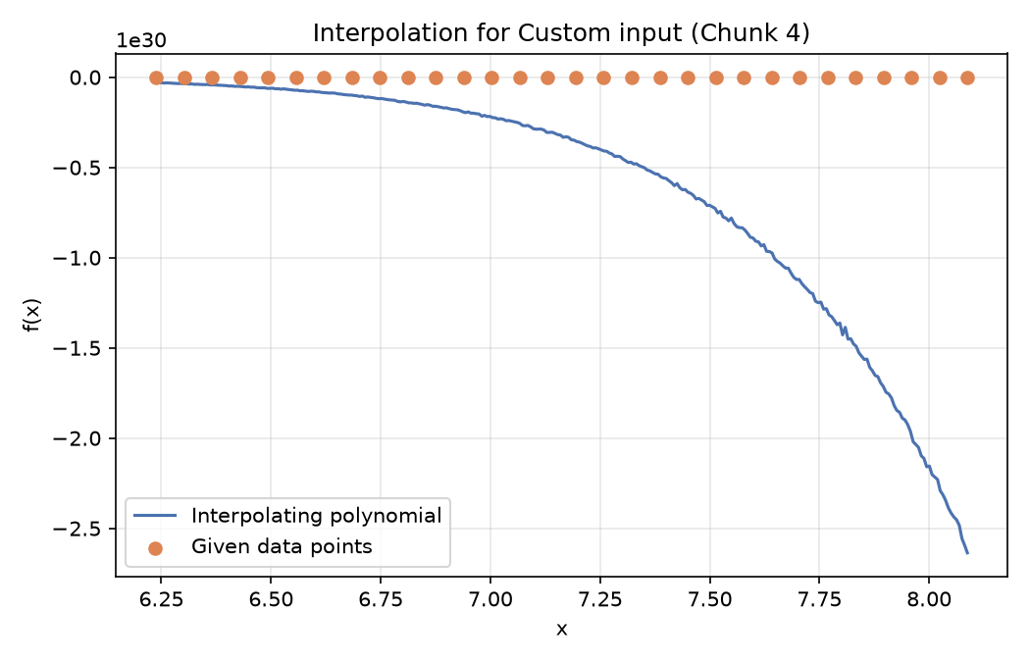S

Interval 5 (Points 121 to 150)
1. Interpolating polynomial for Interval 5:
The program computed the Lagrange basis polynomials for the 30 points in this interval. The resulting interpolating polynomial has a maximum degree of 29.
2. Output graph:
The interpolated curve smoothly connects the 30 data points within this interval without the extreme oscillations that would occur if all 150 points were evaluated at once.
