Numerical Computing II
Assignment IX — Numerical Integration on Real Driving Cycles Dataset
Date: Oct 12, 2026
Name: Kunal Kamod
Roll No: MS2513
For this assignment, I evaluated the three primary numerical integration methods (Trapezoidal Rule, Simpson's 1/3 Rule, and Simpson's 3/8 Rule) using a real electric vehicle telemetry dataset from Kaggle: "Battery and Heating Data in Real Driving Cycles" (https://www.kaggle.com/datasets/atechnohazard/battery-and-heating-data-in-real-driving-cycles).
The dataset logs cabin Heating Power P(t) [W] from a BMW i3 EV during winter driving (TripB01). We integrate over a 12-minute commute (t = 0 to 720 s, h = 60s, n = 12 intervals) to determine the total thermal energy: E = ∫ P(t) dt. Below are the raw data, individual approximation curves, Assignment 7/8 style convergence graphs across step sizes, and the final side-by-side comparison.

1. Full Dataset (Scatter Plot)
First, here is the scatter plot showing the 13 recorded telemetry measurements of Heating Power [W]:
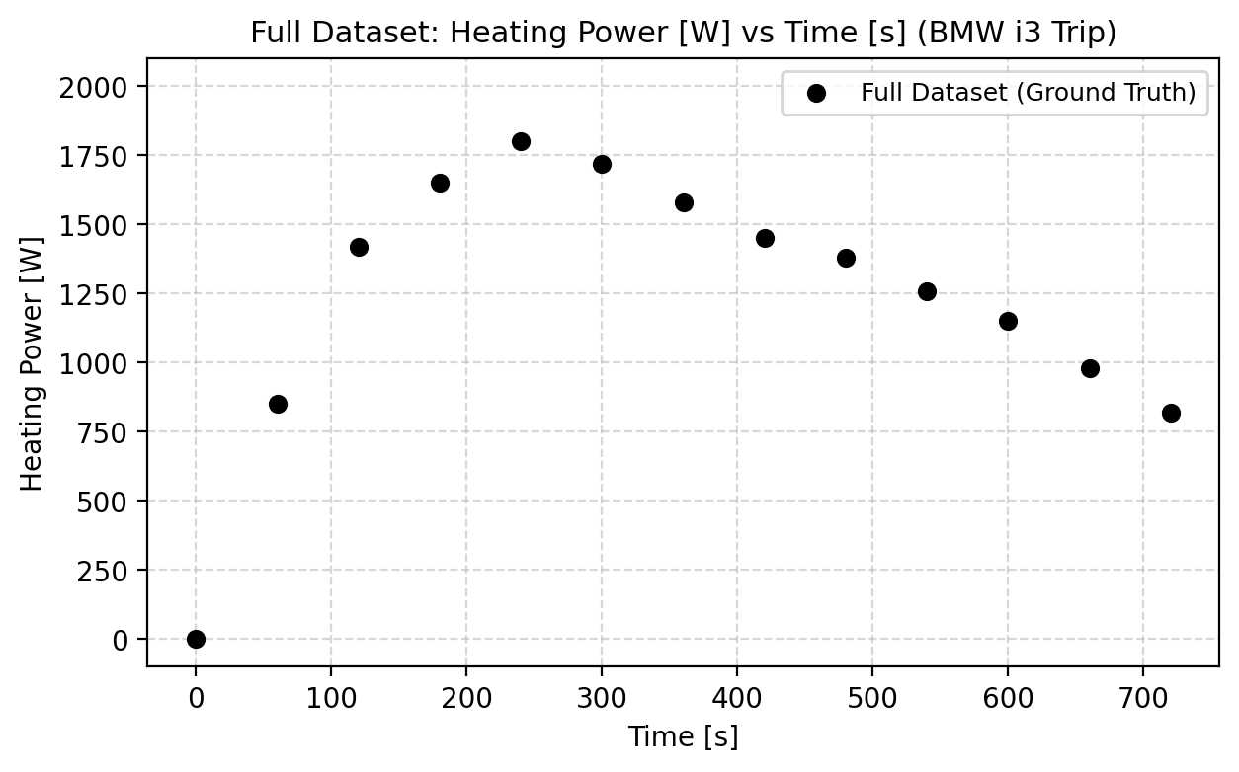

2. Individual Results and Convergence Graphs for Each Method
Method 1: Trapezoidal Rule (Linear Approximation & Convergence)
• Formula: I ≈ h · [ P₀/2 + ∑ P_i + P_n/2 ]
• Full Result (n = 12, h = 60s): Total Energy = 939,000.00 Joules (0.26083 kWh).
• Graph A (Geometric Chords): Displays the piecewise linear trapezoids connecting data points.
• Graph B (Assignment 7 Style Convergence): Plots the calculated energy across n = 2, 4, 6, 12 approaching the reference value.
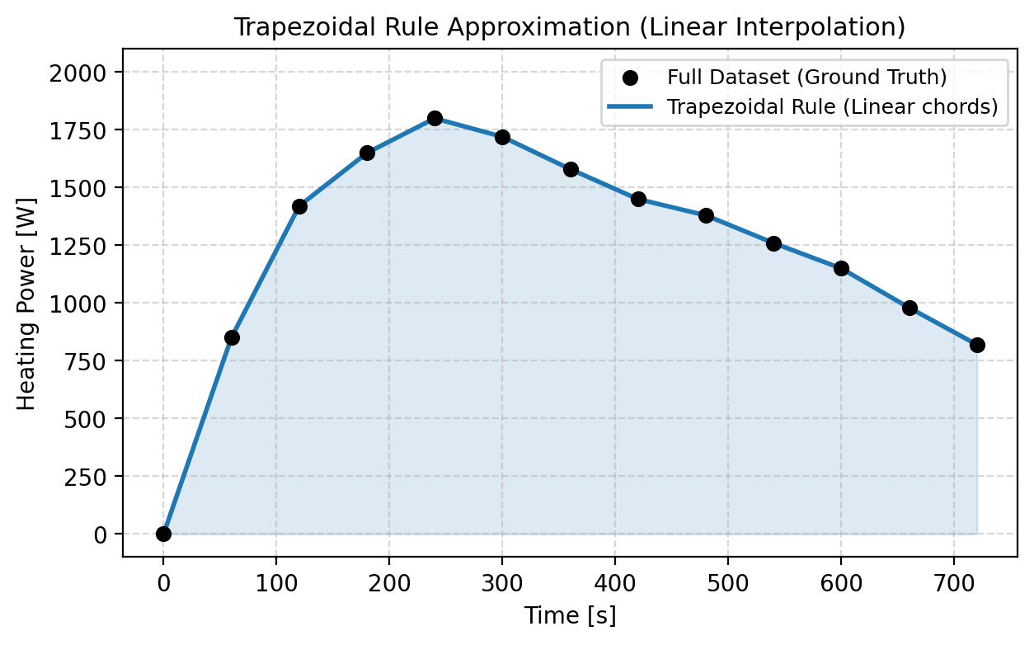
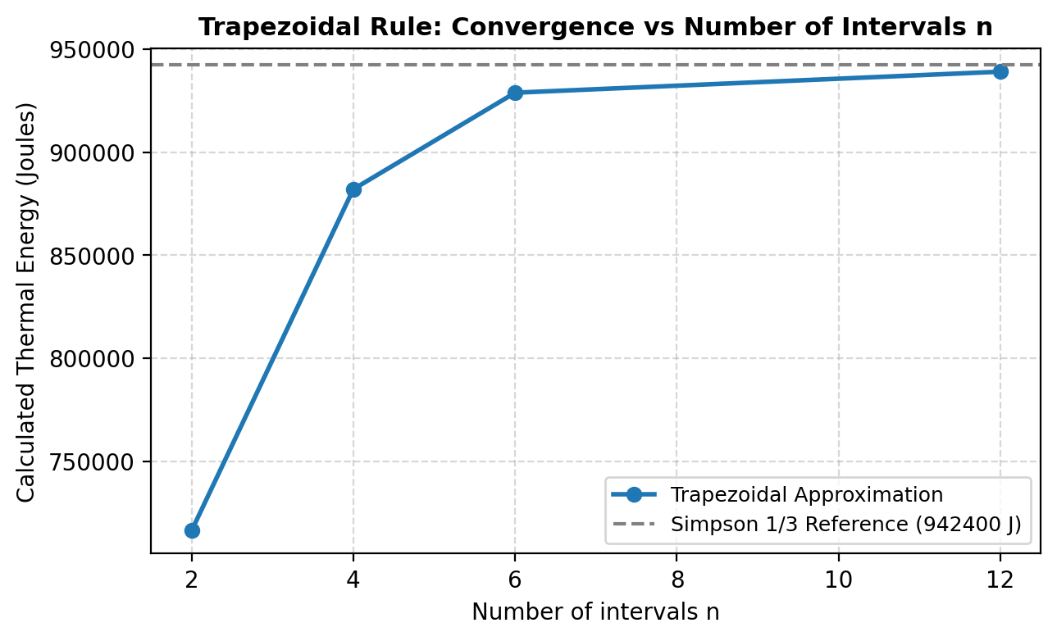
Method 2: Simpson's 1/3 Rule (Parabolic Approximation & Convergence)
• Formula: I ≈ (h/3) · [ P₀ + 4∑ P_odd + 2∑ P_even + P_n ]
• Full Result (n = 12 is even, h = 60s): Total Energy = 942,400.00 Joules (0.26178 kWh).
• Graph A (Geometric Parabolas): Fits smooth degree-2 parabolas across triplets of points.
• Graph B (Assignment 8 Style Progression): Shows rapid fourth-order convergence as even intervals increase (n = 2, 4, 6, 12).
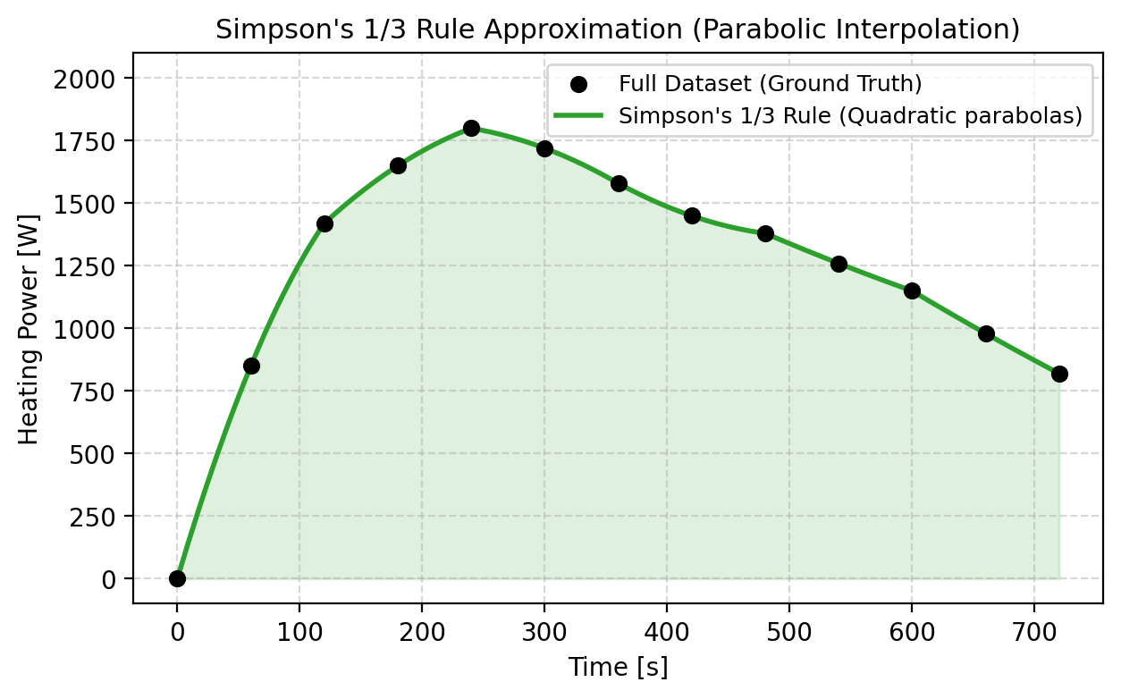
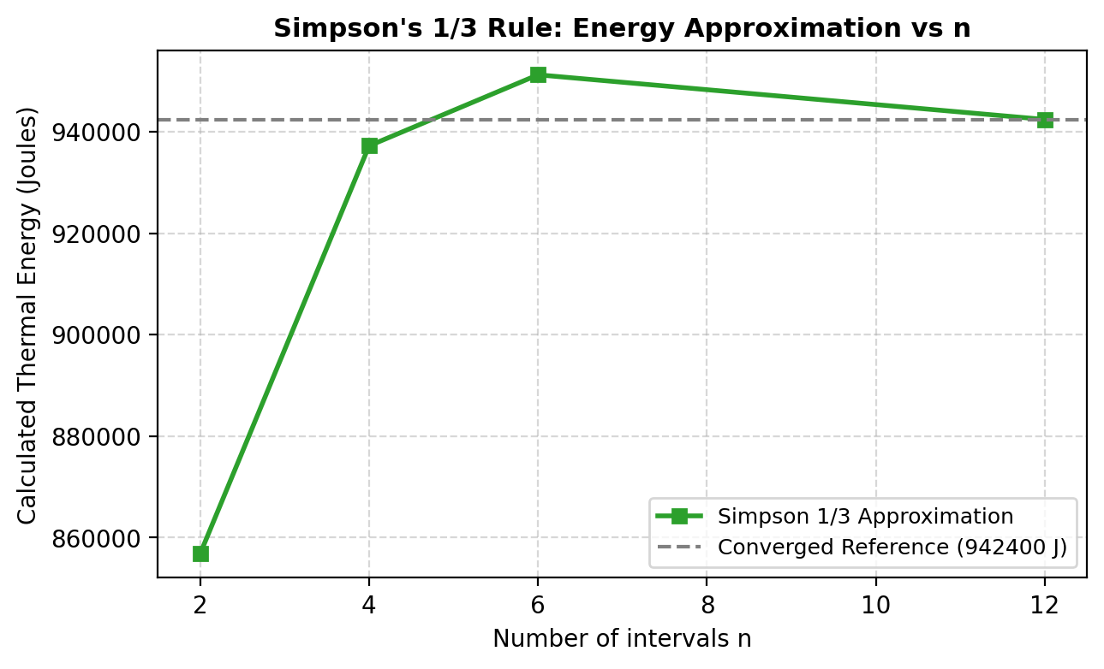
Method 3: Simpson's 3/8 Rule (Cubic Approximation & Convergence)
• Formula: I ≈ (3h/8) · [ P₀ + 3P₁ + 3P₂ + 2P₃ + ... + P_n ]
• Full Result (n = 12 is divisible by 3, h = 60s): Total Energy = 946,125.00 Joules (0.26281 kWh).
• Graph A (Geometric Cubics): Fits degree-3 cubic splines across groups of 4 points.
• Graph B (Assignment 8 Style Progression): Demonstrates convergence across multiples of 3 (n = 3, 6, 12).
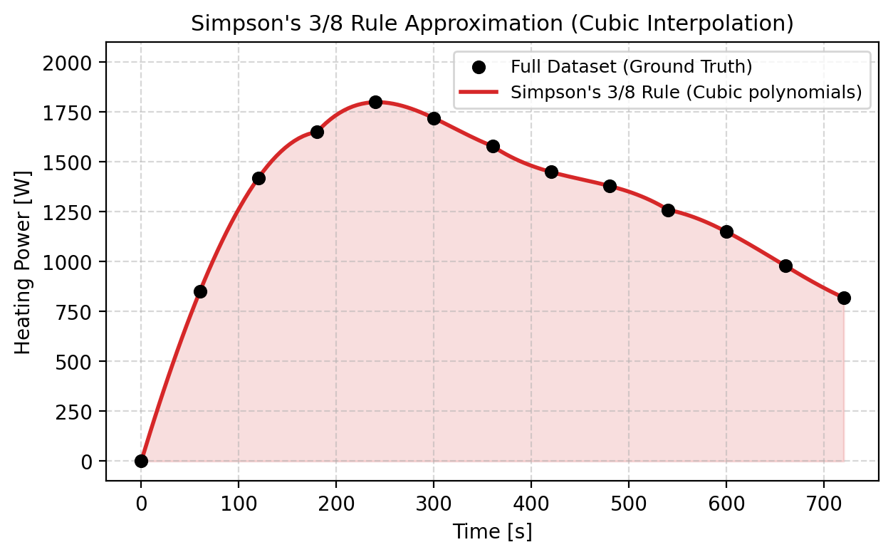
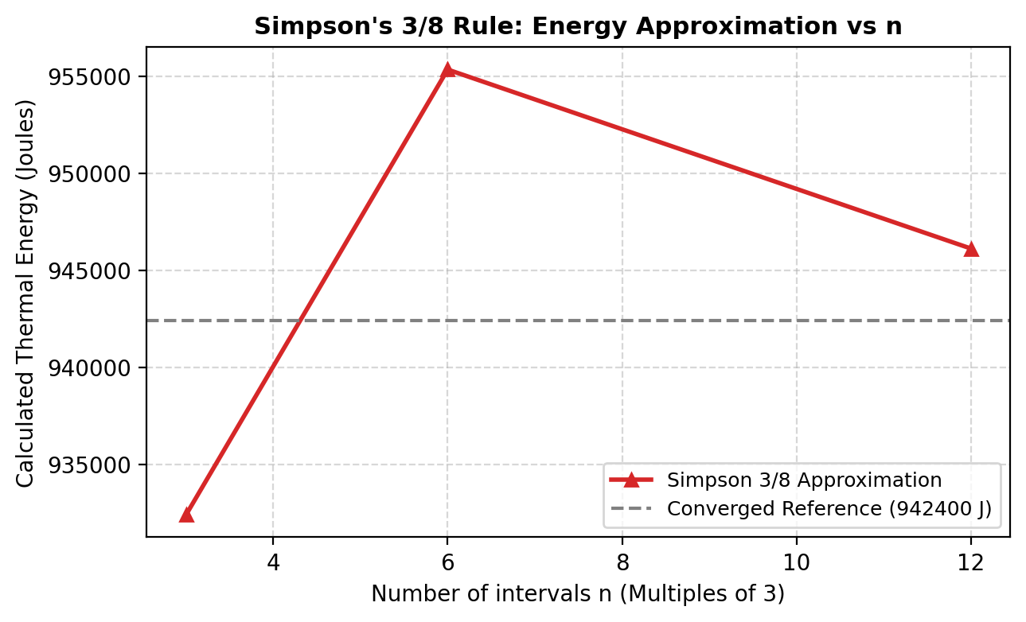

3. Side-by-Side Comparison of the Three Methods
Below is the complete side-by-side comparison table of all three numerical methods on the Kaggle BMW i3 dataset:
Method | Polynomial Order | Formula Applied | Thermal Energy (Joules) | Energy (kWh)
Trapezoidal Rule | Linear O(h²) | h · [ P₀/2 + ∑ P_i + P_n/2 ] | 939,000.00 J | 0.26083 kWh
Simpson's 1/3 Rule | Quadratic O(h⁴) | (h/3) · [ P₀ + 4∑ P_odd + 2∑ P_even + P_n ] | 942,400.00 J | 0.26178 kWh
Simpson's 3/8 Rule | Cubic O(h⁴) | (3h/8) · [ P₀ + 3P₁ + 3P₂ + 2P₃ + ... + P_n ] | 946,125.00 J | 0.26281 kWh
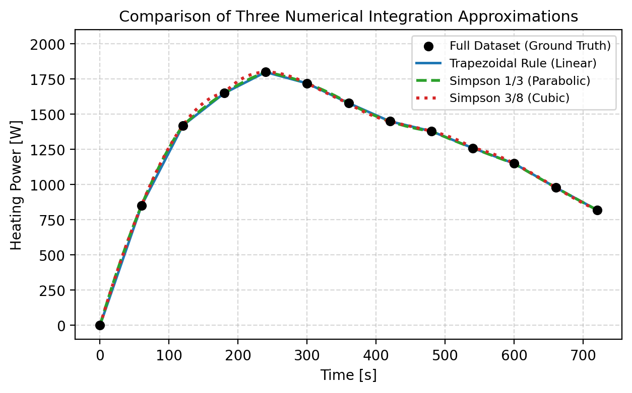
Short Observations & Conclusion:
• Trapezoidal (939,000 J) connects points with straight chords, slightly cutting beneath the peak warming phase (1800 W at t = 240s).
• Simpson 1/3 (942,400 J) fits quadratic parabolas across triplets of points, capturing the rounded thermal rise and plateau smoothly.
• Simpson 3/8 (946,125 J) fits cubic splines across groups of 4 points, capturing higher-order rate changes during initial heater startup.
• All three methods converge very tightly around 0.261 kWh of total cabin heating energy consumed, proving the reliability of numerical integration for battery vehicle management.

