Four Weeks Industrial Training Project Report on

STEG-X:

Steganography Explorer and Extractor
Submitted in the partial fulfilment of the requirement for the award of degree of

Bachelor of Technology
in

Computer Science and Engineering

Batch (2024-2025)

Submitted to: Submitted by:

Mr. Ankush Kumar Rajput Kunal Manhas

DEPARTMENT OF COMPUTER SCIENCE AND ENGINEERING
DAV UNIVERSITY JALANDHAR- PUNJAB 144012

ACKNOWLEDGMENT

I express my gratitude to all those who helped me in various stages of the development of this project.
First, I would like to express my sincere gratitude and indebtedness to Miss Mehak (Coordinator) of DAV University for allowing me to undergo the summer training of 45 days at Coder Roots.
I am also thankful to all faculty members of the Department of Computer Science and Engineering for their true help, inspiration, and for assisting me in the preparation of the final report and presentation.
Last but not least, I pay my sincere thanks and gratitude to all the staff members of Coder Roots for their support and for making our training valuable and fruitful.

DECLARATION

I, Kunal Manhas, hereby declare that the work which is being presented in this project/training titled “STEG-X: Steganography Explorer and Extractor” by me, in partial fulfilment of the requirements for the award of Bachelor of Technology (B.Tech) Degree in “Computer Science and Engineering” is an authentic record of my own work carried out under the guidance of Mr. Ankush Kumar Rajput.
To the best of my knowledge, the matter embodied in this report has not been submitted to any other University/ Institute for the award of any degree or diploma.

(Kunal Manhas)
Student Name and Signature

Roll No: 12300053

ABSTRACT

This project, STEG-X: An Advanced Steganography Tool, was developed during a 45-day industrial training program at Coder Roots with the objective of building a practical cybersecurity solution focused on information hiding. STEG-X is a Python-based command-line tool that allows users to securely embed, extract, and detect hidden messages within digital images using the Least Significant Bit (LSB) steganography technique.
The tool was designed with simplicity, efficiency, and security in mind, supporting real-world use cases where discreet communication or digital watermarking is required. It was built using open-source Python libraries such as stegano, PIL, and argparse.
Through this project, I contributed a functional prototype that aligns with core cybersecurity practices, gaining hands-on experience in secure software development, while adding value to Coder Roots by exploring innovative applications of steganography.

Table Of Contents

Section | Page No.
Acknowledgment | 2
Declaration | 3
Abstract | 4
Table of Contents | 5
List of Figures | 6
1. Introduction | 7
2. Title of the Project | 8
3. Objectives | 9
4. Steps to Achieve Objectives | 10
5. Coding and Implementation | 11-14
5.1 Command-line interface design | 11
5.2 Hiding Text (Hide Command) | 12
5.3 Extracting Text (Extract) | 12
5.4 Detecting Hidden Data | 13
5.5 Libraries Used | 13-14
6. Conclusions and Recommendations | 15
7. Appendices | 16-21

List of Figures

Figure No. | Title | Page No.
Fig. 1 | Code for CLI Design | 11
Fig. 2 | Code for hiding text | 12
Fig. 3 | Code for extracting text | 12
Fig. 4 | Code for detecting steganography | 13
Fig. 5 | CLI Output of code | 20
Fig. 6 | Libraries used | 21

Introduction

This report documents the outcomes of my industrial training project titled “STEG-X: An Advanced Steganography Tool”, completed as part of the B.Tech (Computer Science and Engineering) curriculum at DAV University.
The training was conducted over a period of 45 days at Coder Roots, where I worked on applying concepts of cybersecurity using Python, Linux tools, and the Cyber Kill Chain Framework. The aim of the project was to build a functional steganography tool that demonstrates secure information hiding techniques using real-world methodologies.
The developed tool, named STEG-X, is a Python-based command-line application that enables users to hide, extract, and detect secret messages in images using the Least Significant Bit (LSB) technique. This project allowed me to explore the practical applications of steganography and enhance my skills in cybersecurity scripting, logic implementation, and secure tool design.
Overall, this training served as a bridge between academic learning and hands-on cybersecurity practice, giving me exposure to working with real tools and frameworks in a professional environment.

Title Of the Project

“STEG-X: An Advanced Steganography Tool”

This project was carried out as part of my 45-day industrial training at Coder Roots, where I focused on developing a Python-based tool for secure data hiding using image steganography techniques.

Objectives

The objective of this industrial training was to gain practical exposure in the field of Cybersecurity with a focus on secure information handling using Python, Linux-based tools, and the Cyber Kill Chain Framework.
As part of the training program at Coder Roots, I was assigned the task of developing a command-line steganography tool named STEG-X. The tool aimed to demonstrate real-world data hiding and detection techniques using the Least Significant Bit (LSB) method within image files.
The core objectives of the training were as follows:
- To explore the principles and applications of steganography in cybersecurity.
- To gain hands-on experience with Python programming and open-source libraries such as stegano, PIL, and argparse.
- To understand the working of the Cyber Kill Chain and how data hiding fits into real-world attack models.
- To implement a practical tool that can hide, extract, and detect hidden messages in image files.
- To improve technical skills in Linux environments, CLI development, and secure software practices.

Steps To Achieve Objectives

To achieve the training objectives and complete the development of the STEG-X tool, the following structured steps were followed during the 45-day industrial training program:
- Requirement Analysis
  - Defined the core functionalities: hide, extract, and detect operations for secure message handling using image-based steganography.
- Research on Steganography
  - Studied the principles of digital steganography with a focus on the Least Significant Bit (LSB) technique.
  - Explored the use of LSB in lossless formats like PNG, ensuring data fidelity.
- Technology Stack Selection
  - Selected Python as the development language due to its simplicity and strong library support.
  - Chose relevant libraries including stegano, PIL, argparse, and termcolor for tool functionalities.
- CLI Design and Planning
  - Structured the tool to accept user commands via a clean command-line interface.
  - Designed three primary commands:
    - hide – Hide secret text in PNG images
    - extract – Extract hidden text from PNG stego-images
    - detect – Analyze PNG images for possible steganographic patterns
- Tool Development and Implementation
  - Developed the hiding and extraction functionalities using stegano.lsb.
  - Coded a detection mechanism to flag unusual LSB bit patterns in pixel data.
- Testing and Validation
  - Rigorously tested all features using multiple .png images.
  - Implemented image format validation to restrict functionality to PNG files only.
- Documentation and Presentation
  - Prepared code documentation and help menus.
  - Created a structured report and PowerPoint for final project submission.

Coding and Implementation

🔹 1 Command-Line Interface Design
Explain how the CLI structure was built using argparse.
The interface is designed to accept user commands with appropriate arguments such as image path and message. The user can run the tool in three modes:
- hide – hides text in PNG image
- extract – retrieves text from image
- detect – checks image for possible steganography
CLI is built using Python’s argparse module for user-friendly and structured input parsing.

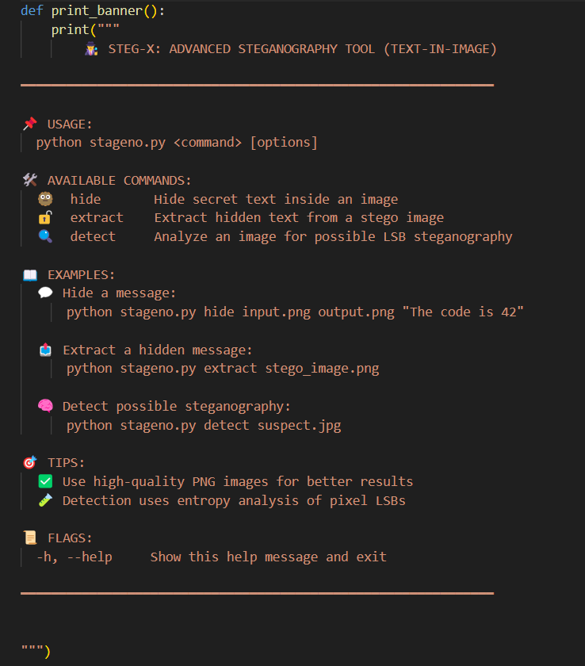

Fig. 1: Code for CLI Design

🔹2 Hiding Text (hide command)
The hide command is responsible for embedding secret text into an image using the Least Significant Bit (LSB) method, implemented via the stegano library.
When this command is used, the tool reads the input image and hides the given secret message by slightly modifying the LSBs of the pixel values, which is visually undetectable. The output is saved as a new image file.
Below is the core function used to perform this task:
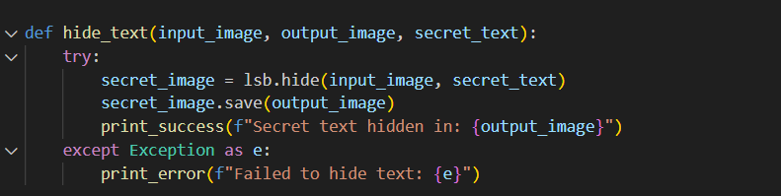
Fig. 2: Code for hiding text

🔹 3 Extracting Text (extract command)
The extract command is used to reveal the secret message hidden inside a stego image. It utilizes the lsb.reveal() function from the stegano library to read the least significant bits and reconstruct the embedded text.
This functionality helps verify whether the hiding process was successful and allows retrieval of confidential messages from the image.
Below is the Python function that performs text extraction:
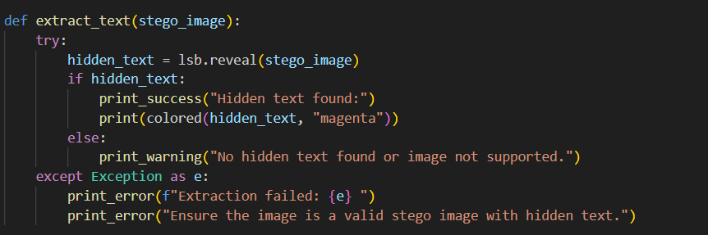
Fig. 3: Code for extracting text

🔹 4 Detecting Steganography (detect command)
The detect command is used to analyse an image for signs of steganographic manipulation. This function inspects the Least Significant Bits (LSBs) of the image pixels and compares the distribution of binary 1s and 0s to determine whether data may have been embedded.
The detection mechanism is a lightweight analysis based on statistical deviation of LSBs from randomness — a useful indicator of hidden information.
Below is the implementation of the detection function:
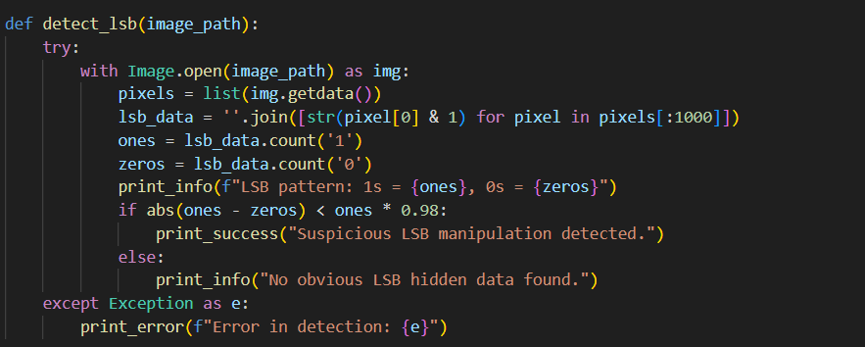
Fig. 4: Code for detecting steganography

🔹 5 Libraries Used
The development of the STEG-X steganography tool relied on a combination of Python libraries and command-line utilities. These tools enabled efficient image processing, steganographic operations, and user-friendly CLI interaction.
🛠️ 1. Python
- Purpose: Core programming language used to develop the project.
- Reason for Use: Python is known for its simplicity, rich library ecosystem, and ease of prototyping for cybersecurity tools.
🧩 2. stegano
- Purpose: Library used to hide and reveal text using the Least Significant Bit (LSB) method in image pixels.
- Function Used: lsb.hide() and lsb.reveal()
- Link: https://pypi.org/project/stegano/
🖼️ 3. PIL (Pillow)
- Purpose: Used for image handling like opening, reading, and pixel manipulation.
- Function Used: Image.open(), getdata()
🖥️ 4. argparse
- Purpose: Creates the command-line interface for handling user inputs and subcommands.
- Function Used: add_argument(), ArgumentParser()
🎨 5. termcolor
- Purpose: Adds color-coded terminal outputs for better readability of results and error messages.

Conclusions and Recommendations

During the course of this 6-week industrial training at Coder Roots, I developed a fully functional steganography tool named STEG-X using Python. The project gave me a practical understanding of how information hiding works using Least Significant Bit (LSB) techniques in image files.
The tool successfully implements three key features:
- Hiding secret messages inside PNG images.
- Extracting hidden text from stego images.
- Detecting possible LSB manipulations in suspicious images.
This hands-on project not only strengthened my programming skills but also deepened my understanding of cybersecurity concepts, especially in the domain of steganography, command-line tools, and secure communication.

🔹 Recommendations:
- 🔐 Add Encryption: Future versions of the tool can include AES or RSA encryption to secure the message before embedding.
- 🎞️ Support More Formats: Extend support beyond PNG to include BMP, JPG, or even audio/video files for advanced use cases.
- 🧠 Improve Detection Logic: Enhance the LSB detection algorithm using statistical analysis or machine learning.
- 🌐 Build GUI: A simple graphical interface could make the tool more accessible for non-technical users.
- 🧪 Automated Testing: Add test cases to ensure robustness and accuracy of message hiding and extraction.

Appendices

The following Python script represents the complete source code of the STEG-X tool, developed during industrial training at Coder Roots. The tool allows users to hide, extract, and detect hidden messages using LSB steganography.

“The full source code is included digitally in the CD attached with this report. Please refer to steg-x.py for complete implementation, here just written format of code.”
SOURCE CODE:

import argparse
import os
import sys
from stegano import lsb
from PIL import Image
from termcolor import colored

def print_banner():
print("""
🕵️‍♂️ STEG-X: ADVANCED STEGANOGRAPHY TOOL (TEXT-IN-IMAGE)

━━━━━━━━━━━━━━━━━━━━━━━━━━━━━━━━━━━━━━━━━━━━━━━━━━━━━━━━━━━━━━

📌 USAGE:
python stageno.py <command> [options]

🛠️ AVAILABLE COMMANDS:
🫥 hide Hide secret text inside an image
🔓 extract Extract hidden text from a stego image
🔍 detect Analyze an image for possible LSB steganography

📖 EXAMPLES:
💬 Hide a message:
python stageno.py hide input.png output.png "The code is 42"

📤 Extract a hidden message:
python stageno.py extract stego_image.png

🧠 Detect possible steganography:
python stageno.py detect suspect.jpg

🎯 TIPS:
✅ Use high-quality PNG images for better results
🧪 Detection uses entropy analysis of pixel LSBs

📜 FLAGS:
-h, --help Show this help message and exit

━━━━━━━━━━━━━━━━━━━━━━━━━━━━━━━━━━━━━━━━━━━━━━━━━━━━━━━━━━━━━━

""")

def print_success(msg):
print(colored(f"[✔] {msg}", "green"))

def print_info(msg):
print(colored(f"[i] {msg}", "cyan"))

def print_warning(msg):
print(colored(f"[!] {msg}", "yellow"))

def print_error(msg):
print(colored(f"[✘] {msg}", "red"))

# core part where we are usind the stegano library to hide and extract text from images

def hide_text(input_image, output_image, secret_text):
try:
secret_image = lsb.hide(input_image, secret_text)
secret_image.save(output_image)
print_success(f"Secret text hidden in: {output_image}")
except Exception as e:
print_error(f"Failed to hide text: {e}")

def extract_text(stego_image):
try:
hidden_text = lsb.reveal(stego_image)
if hidden_text:
print_success("Hidden text found:")
print(colored(hidden_text, "magenta"))
else:
print_warning("No hidden text found or image not supported.")
except Exception as e:
print_error(f"Extraction failed: {e} ")
print_error("Ensure the image is a valid stego image with hidden text.")

def detect_lsb(image_path):
try:
with Image.open(image_path) as img:
pixels = list(img.getdata())
lsb_data = ''.join([str(pixel[0] & 1) for pixel in pixels[:1000]])
ones = lsb_data.count('1')
zeros = lsb_data.count('0')
print_info(f"LSB pattern: 1s = {ones}, 0s = {zeros}")
if abs(ones - zeros) < ones * 0.98:
print_success("Suspicious LSB manipulation detected.")
else:
print_info("No obvious LSB hidden data found.")
except Exception as e:
print_error(f"Error in detection: {e}")

def validate_image(path):
if not os.path.exists(path):
raise argparse.ArgumentTypeError("File does not exist.")
try:
with Image.open(path) as img:
if img.format not in ['PNG', 'JPEG', 'JPG']:
raise argparse.ArgumentTypeError("Unsupported image format. Use PNG or JPG.")
except Exception:
raise argparse.ArgumentTypeError("Invalid image file.")
return path

# this is to handle the CLI of the tool

def main():
parser = argparse.ArgumentParser(
description="Steg-X: Hide and detect secret messages in images",
add_help=True,
usage="python stageno.py <command> [options]"
)

subparsers = parser.add_subparsers(dest="command", help="Available commands")

# Hide command
hide_parser = subparsers.add_parser("hide", help="Hide secret text in an image")
hide_parser.add_argument("input", type=validate_image, help="Input image path")
hide_parser.add_argument("output", help="Output image path (.png recommended)")
hide_parser.add_argument("text", help="Secret message to hide")

# Extract command
extract_parser = subparsers.add_parser("extract", help="Extract secret text from image")
extract_parser.add_argument("image", type=validate_image, help="Stego image path")

# Detect command
detect_parser = subparsers.add_parser("detect", help="Detect if LSB steganography is used")
detect_parser.add_argument("image", type=validate_image, help="Image path to analyze")

args = parser.parse_args()

if not args.command:
print_banner()
sys.exit(0)

if args.command == "hide":
hide_text(args.input, args.output, args.text)
elif args.command == "extract":
extract_text(args.image)
elif args.command == "detect":
detect_lsb(args.image)

# sir here is the main function to run the script (calling the main function)

if __name__ == "__main__":
main()

Output of Code:

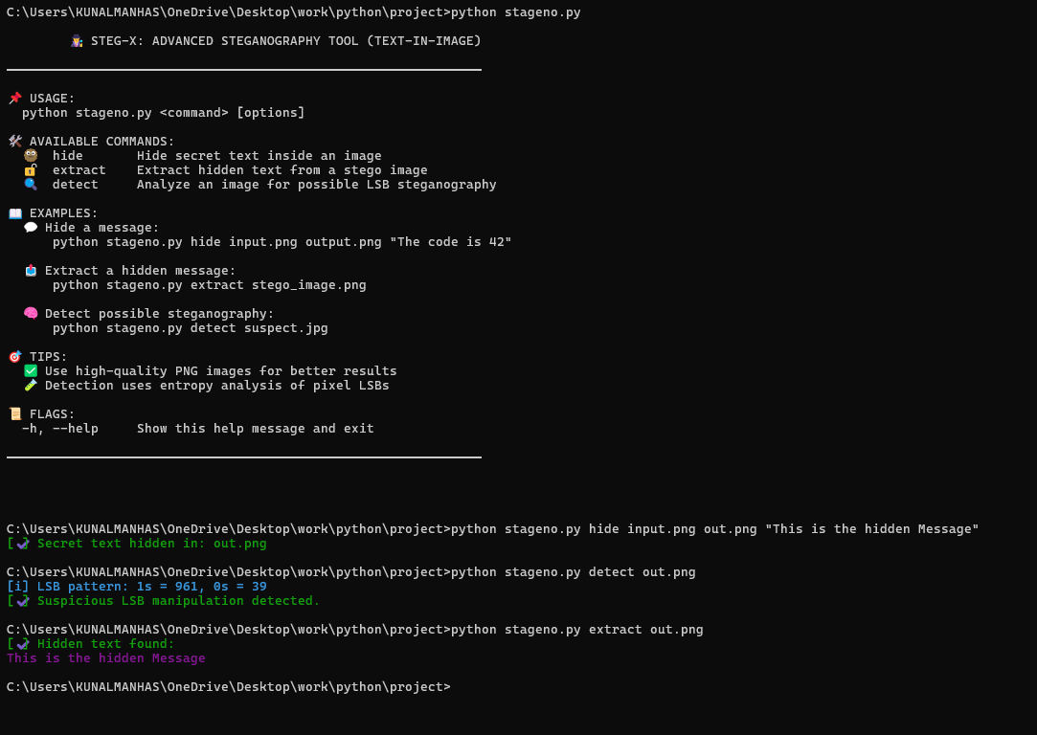
Fig. 5: CLI Output of code
🔧 Tools and Libraries Used
Tool / Library | Description
Python 3.x | Main programming language used to build the CLI tool
stegano | Python library for LSB-based steganography
Pillow (PIL) | Python Imaging Library used for handling image files
argparse | Used for parsing command-line arguments
termcolor | Enables color-coded output in the terminal
VS Code | IDE used for development and debugging
Windows 11 | Operating system used during development

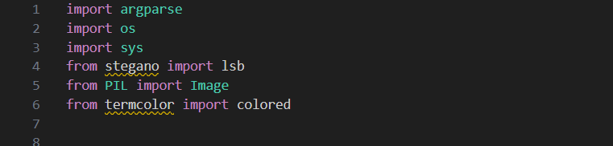
Fig. 6: Libraries used

*******************************END OF REPORT******************************

