Four Weeks Industrial Training Project Report on

STEG-X:

Steganography Explorer and Extractor
Submitted in the partial fulfilment of the requirement for the award of degree of

Bachelor of Technology
in

Computer Science and Engineering

Batch (2023-2027)

Submitted to: Submitted by:

Ms. Ananya Sharma Kunal Manhas

DEPARTMENT OF COMPUTER SCIENCE AND ENGINEERING
DAV UNIVERSITY JALANDHAR- PUNJAB 144012

ACKNOWLEDGMENT

I express my gratitude to all those who helped me in various stages of the development of this project.
First, I would like to express my sincere gratitude and indebtedness to Dr. Ridhi (Coordinator) of DAV University for allowing me to undergo the summer training of 45 days at Coder Roots.
I am also thankful to all faculty members of the Department of Computer Science and Engineering for their true help, inspiration, and for assisting me in the preparation of the final report and presentation.
Last but not least, I pay my sincere thanks and gratitude to all the staff members of Coder Roots for their support and for making our training valuable and fruitful.

DECLARATION

I, Kunal Manhas, hereby declare that the work which is being presented in this project/training titled “STEG-X: Steganography Explorer and Extractor” by me, in partial fulfilment of the requirements for the award of Bachelor of Technology (B.Tech) Degree in “Computer Science and Engineering” is an authentic record of my own work carried out under the command-line dance of Mr. Ankush Kumar Rajput.
To the best of my knowledge, the matter embodied in this report has not been submitted to any other University/ Institute for the award of any degree or diploma.

(Kunal Manhas)
Student Name and Signature

Roll No: 12300053

TRAINING CERTIFICATE

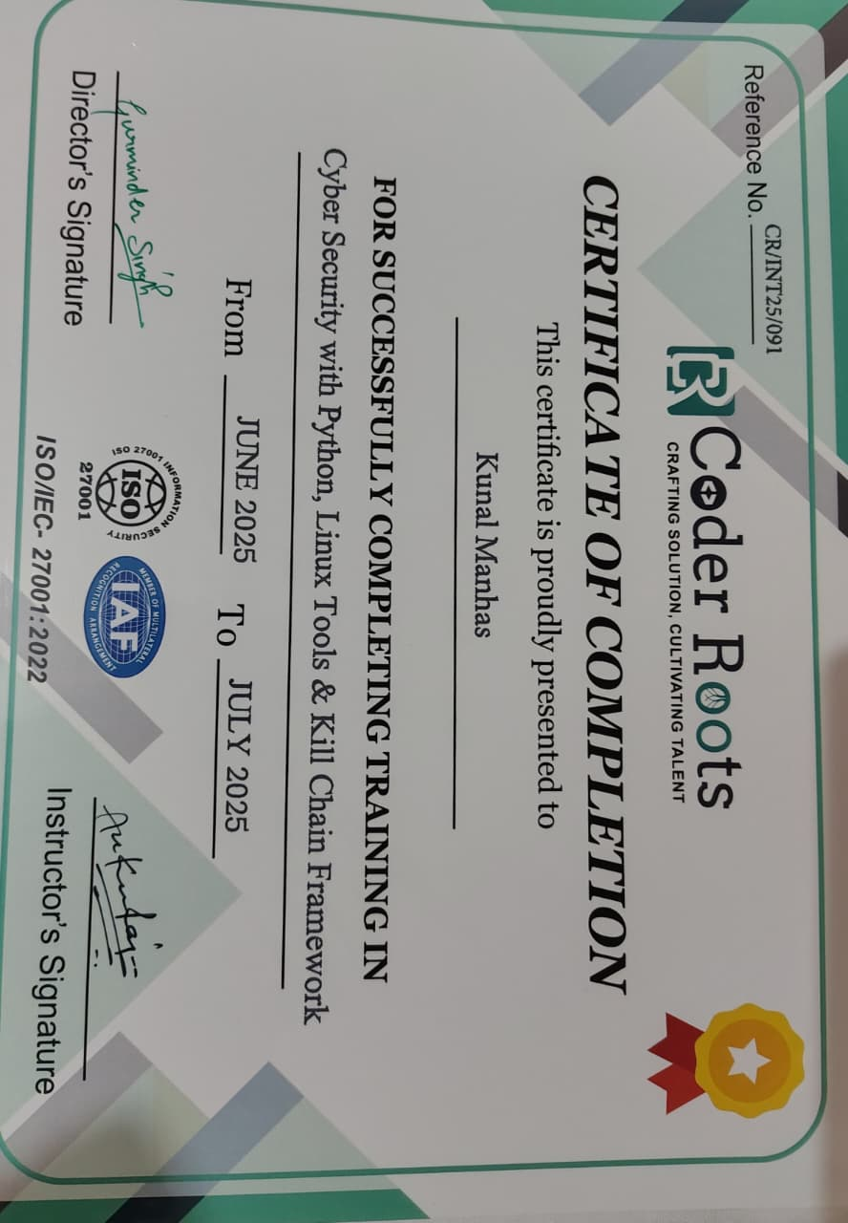

COMPANY PROFILE



Coder Roots is a professional IT services and digital solutions company based in Mohali, Punjab, with over 15 years of experience in the industry. The company specializes in delivering high-quality services such as Web Development, Mobile App Development, Custom Software Development, UI/UX Designing, Digital Marketing, Hosting Services, and Website Maintenance.
Coder Roots follows a complete project development cycle that includes requirement analysis, design, development, testing, deployment, and 24×7 support. With a strong focus on innovation, transparency, and timely delivery, the company has built long-term partnerships with clients across various sectors including e-commerce, education, healthcare, and corporate businesses.
The company also provides professional training programs in various IT domains. As part of their cybersecurity training, students learn about essential security concepts such as vulnerability scanning, penetration testing basics, network security, web application security, secure coding practices, OWASP command-line delines, and real-world security tools used in the industry.
Coder Roots is committed to delivering reliable, scalable, and secure solutions while maintaining high standards of quality and customer satisfaction.
Website: www.coderroots.com
Contact: +91 8264123555
Email: contact@coderroots.com

ABSTRACT

This project, STEG-X: An Advanced Steganography Tool, was developed during a 45-day industrial training program at Coder Roots with the objective of building a practical cybersecurity solution for secure information hiding. STEG-X is a Python-based tool that provides both a Command-Line Interface (CLI) and a Graphical User Interface (GUI) to embed, extract, and detect hidden messages in images using the Least Significant Bit (LSB) steganography technique.
The tool focuses on simplicity, efficiency, and usability, making it suitable for real-world applications such as discreet communication, digital watermarking, educational demonstrations, and cybersecurity research. It is built using open-source libraries including stegano, PIL, argparse, and Tkinter.
Through this project, I developed a fully functional prototype aligned with modern cybersecurity practices, gaining hands-on experience in secure coding, image processing, and tool development. STEG-X adds value by demonstrating practical implementation of steganography techniques in both technical and user-friendly environments.

.

Table Of Contents

Section | Page No.
Acknowledgment | 2
Declaration | 3
Training Certificate | 4
Company Profile | 5
Abstract | 6
Table of Contents | 7
List of Figures | 8
1. Introduction | 9
2. Title of the Project | 10
3. Objectives | 11
4. Steps to Achieve Objectives | 12-14
5. Coding and Implementation | 15-18
5.1 CLI AND GUI design | 15
5.2 Hiding Text (Hide Command) | 16
5.3 Extracting Text (Extract) | 16-17
5.4 Detecting Hidden Data | 17
5.5 Libraries Used | 17-18
6. Conclusions and Recommendations | 19-20
7. Appendices | 21-24

List of Figures

Figure No. | Title | Page No.
Fig. 1 | Code for CLI Design | 15
Fig. 2 | Code for GUI Design | 16
Fig. 3 | Code for hiding text | 16
Fig. 4 | Code for extracting text | 17
Fig. 5 | Code for detecting steganography | 17
Fig. 6 | Code of cli and gui | 21
Fig. 7 | CLI Output of code | 22
Fig. 8 | GUI Output of code | 22
Fig. 9 | Hiding message | 23
Fig. 10 | Detecting Lsb | 23
Fig. 11 | Extracting hidden message | 24

Introduction

This report documents the outcomes of my industrial training project titled “STEG-X: An Advanced Steganography Tool”, completed as part of the B.Tech (Computer Science and Engineering) curriculum at DAV University.
The training was conducted over a period of 45 days at Coder Roots, where I worked on applying concepts of cybersecurity using Python, Linux tools, and the Cyber Kill Chain Framework. The aim of the project was to build a functional steganography tool that demonstrates secure information hiding techniques using real-world methodologies.
The developed tool, named STEG-X, is a Python-based COMMAND-LINE AND GUI application that enables users to hide, extract, and detect secret messages in images using the Least Significant Bit (LSB) technique. This project allowed me to explore the practical applications of steganography and enhance my skills in cybersecurity scripting, logic implementation, and secure tool design.
Overall, this training served as a bridge between academic learning and hands-on cybersecurity practice, giving me exposure to working with real tools and frameworks in a professional environment.

Title Of the Project

“STEG-X: An Advanced Steganography Tool”

The project titled “STEG-X: An Advanced Steganography Tool” was undertaken during my 45-day industrial training at Coder Roots, where I specialized in cybersecurity and Python-based security automation. The objective of this project was to design and develop a secure, efficient, and user-friendly tool that implements image-based steganography for concealing sensitive data within digital media.
Steganography, a vital branch of information security, focuses on hiding secret information inside ordinary files such that its presence remains undetectable to unauthorized users. Unlike cryptography, which only encrypts data, steganography conceals the very existence of communication, making it an essential technique for secure information exchange, digital watermarking, and privacy protection in today's cyber-threat landscape.
During my training, I gained hands-on exposure to cybersecurity fundamentals, encryption methods, vulnerability analysis, and secure coding practices. Leveraging this knowledge, I developed STEG-X, a Python-powered command-line and GUI tool capable of embedding and extracting hidden text data within image files using LSB (Least Significant Bit) techniques. The tool is designed to support common image formats, provide a clean interface, and ensure data integrity throughout the hiding and extraction processes.
This project not only strengthened my understanding of cybersecurity concepts but also enhanced my practical skills in Python programming, algorithm implementation, and secure data handling. Through STEG-X, I aimed to demonstrate how steganography can be integrated into real-world applications to improve confidentiality, protect communications, and counter emerging cyber risks.

Objectives

The objective of this industrial training was to gain practical exposure in the field of Cybersecurity with a focus on secure information handling using Python, Linux-based tools, and the Cyber Kill Chain Framework.
As part of the training program at Coder Roots, I was assigned the task of developing a COMMAND-LINE AND GUI steganography tool named STEG-X. The tool aimed to demonstrate real-world data hiding and detection techniques using the Least Significant Bit (LSB) method within image files.
The core objectives of the training were as follows:
- To explore the principles and applications of steganography in cybersecurity.
- To gain hands-on experience with Python programming and open-source libraries such as stegano, PIL, and argparse.
- To understand the working of the Cyber Kill Chain and how data hiding fits into real-world attack models.
- To implement a practical tool that can hide, extract, and detect hidden messages in image files.
- To improve technical skills in Linux environments, CLI development, and secure software practices.

Steps To Achieve Objectives

To successfully complete the development of the STEG-X tool and meet the training objectives during the 45-day industrial training program, the following structured steps were followed:

1. Requirement Analysis
  - Identified the essential functionalities required for a complete steganography tool: hide, extract, and detect operations.
  - Defined the need for supporting both Command-Line Interface (CLI) and Graphical User Interface (GUI) to make the tool accessible to both technical and non-technical users.

2. Research on Steganography
  - Studied the core principles of digital steganography, focusing primarily on the Least Significant Bit (LSB) technique for securely embedding data inside images.
  - Analysed the behaviour of LSB in lossless image formats such as PNG to ensure high data accuracy and minimal distortion.
  - Explored real-world applications of steganography in cybersecurity and data protection.

3. Technology Stack Selection
  - Selected Python as the primary development language due to its simplicity, readability, and vast ecosystem of libraries.
  - Utilized major libraries including:
  - stegano – for LSB-based embedding and extraction
  - PIL (Pillow) – for image processing
  - argparse – for building the CLI command structure
  - termcolor – for enhancing CLI output readability
  - tkinter – for developing the Graphical User interface
  - Ensured that the stack supported cross-platform compatibility and ease of deployment.

4. CLI Design and Planning
  - Structured a clean and user-friendly command-line workflow.
  - Designed three core commands:
  - hide – Embed secret text inside PNG images
  - extract – Retrieve hidden text from stego-images
  - detect – Analyse images for abnormal LSB patterns indicating hidden data
  - Implemented argument-based input handling for smooth execution and error-free operation.

5. GUI Design and Development
  - Planned a simple and intuitive Tkinter-based GUI to provide ease of use for beginners.
  - Added user-friendly elements such as:
  - File selection dialogs
  - Buttons for Hide, Extract, and Detect operations
  - Status and output display area
  - Ensured that GUI and CLI both use the same backend logic for consistency and maintainability.

6. Tool Development and Implementation
  - Implemented core steganographic functions using stegano.lsb for data embedding and extraction.
  - Developed a custom detection algorithm to analyse pixel-level LSB patterns and flag potential steganographic traces.
  - Integrated both interfaces (CLI + GUI) with robust error handling and image validation.

7. Testing and Validation
  - Conducted extensive testing using multiple PNG images of varying sizes and pixel densities.
  - Validated:
  - Data accuracy after extraction
  - Image quality preservation
  - Proper detection of stego-images
  - COMMAND-LINE responsiveness and error handling
  - CLI command correctness with various argument combinations
  - Ensured the tool strictly supports PNG format, preventing misuse with lossy formats like JPEG.

8. Documentation and Presentation
  - Prepared clear and structured documentation for both CLI commands and GUI usage.
  - Created a detailed project report explaining methodology, implementation, and results.
  - Designed a PowerPoint presentation for final evaluation and project demonstration.
.

Coding and Implementation

1 CL Interface Design
The CLI for STEG-X was built using Python’s argparse module, allowing users to execute operations through terminal commands. It supports three key subcommands:
- hide – Embed secret text into a PNG image
- extract – Retrieve hidden text from a stego-image
- detect – Scan an image for possible LSB modifications
The CLI provides structured argument parsing, automatic help menus, and easy error handling, making it suitable for technical and cybersecurity users.
GU Interface Design
A simple and user-friendly GUI was developed using Tkinter to make the tool accessible for non-technical users. The interface includes:
- Buttons for Hide, Extract, and Detect
- File selection dialogs
- Text input/output fields
- Pop-up status messages
The GUI provides a clean and intuitive workflow while using the same backend logic as the CLI for consistent performance.

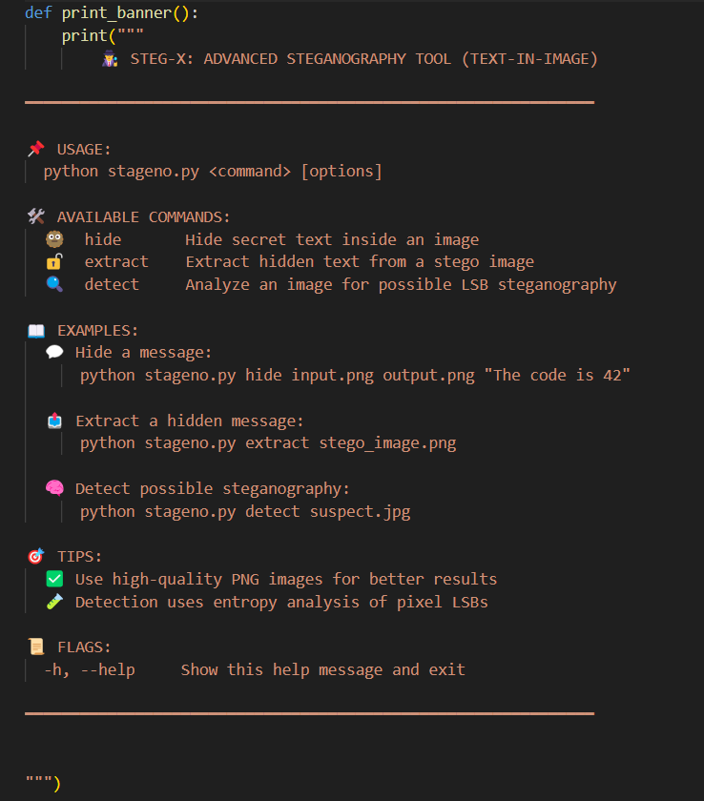
Fig. 1: Code for CLI Design

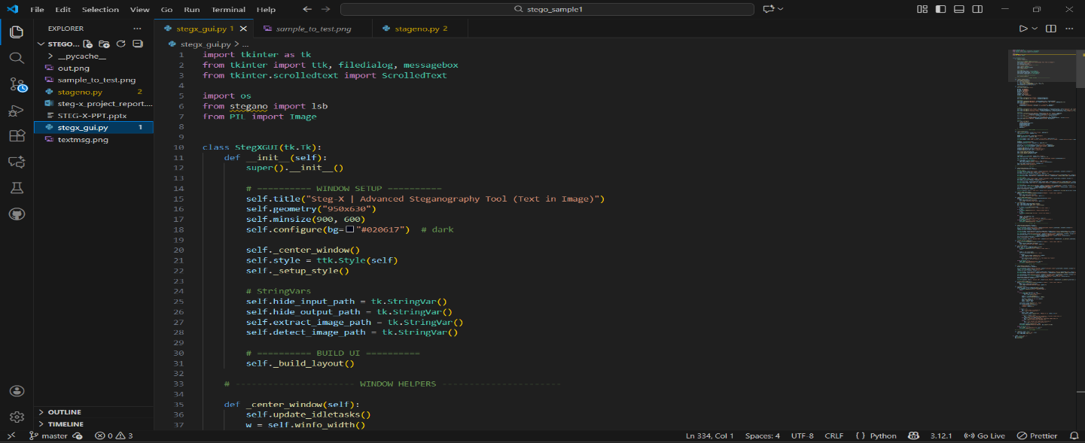
Fig. 2: Code for GUI Design

2 Hiding Text (hide command)
The hide command is responsible for embedding secret text into an image using the Least Significant Bit (LSB) method, implemented via the stegano library.
When this command is used, the tool reads the input image and hides the given secret message by slightly modifying the LSBs of the pixel values, which is visually undetectable. The output is saved as a new image file.
Below is the core function used to perform this task:
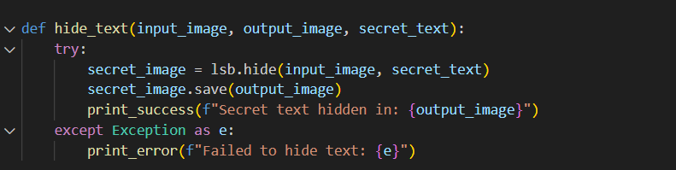
Fig. 3: Code for hiding text

3 Extracting Text (extract command)
The extract command is used to reveal the secret message hidden inside a stego image. It utilizes the lsb.reveal() function from the stegano library to read the least significant bits and reconstruct the embedded text.
This functionality helps verify whether the hiding process was successful and allows retrieval of confidential messages from the image.
Below is the Python function that performs text extraction:
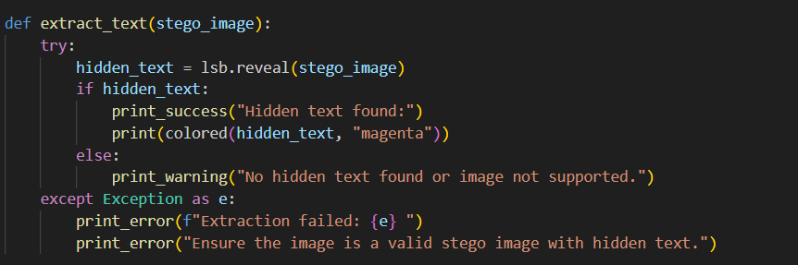
Fig. 4: Code for extracting text

4 Detecting Steganography (detect command)
The detect command is used to analyse an image for signs of steganographic manipulation. This function inspects the Least Significant Bits (LSBs) of the image pixels and compares the distribution of binary 1s and 0s to determine whether data may have been embedded.
The detection mechanism is a lightweight analysis based on statistical deviation of LSBs from randomness — a useful indicator of hidden information.
Below is the implementation of the detection function:
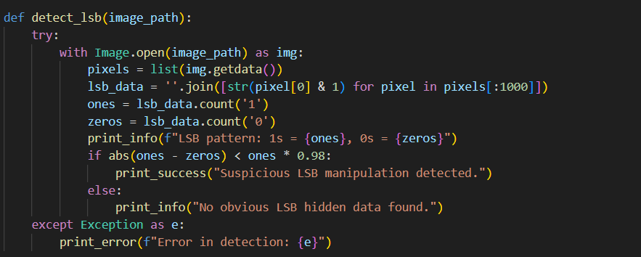
Fig. 5: Code for detecting steganography

5 Libraries Used
The development of the STEG-X steganography tool relied on a combination of Python libraries and COMMAND-LINE utilities. These tools enabled efficient image processing, steganographic operations, and user-friendly CLI interaction.
🛠️ 1. Python
- Purpose: Core programming language used to develop the project.
- Reason for Use: Python is known for its simplicity, rich library ecosystem, and ease of prototyping for cybersecurity tools.
🧩 2. stegano
- Purpose: Library used to hide and reveal text using the Least Significant Bit (LSB) method in image pixels.
- Function Used: lsb.hide() and lsb.reveal()
🖼️ 3. PIL (Pillow)
- Purpose: Used for image handling like opening, reading, and pixel manipulation.
- Function Used: Image.open(), getdata()
🖥️ 4. argparse
- Purpose: Creates the COMMAND-LINE interface for handling user inputs and subcommands.
- Function Used: add_argument(), ArgumentParser()
🎨 5. termcolor
- Purpose: Adds color-coded terminal outputs for better readability of results and error messages.
🖱️ 6. tkinter (Added for GUI functionality)
- Purpose: Used to develop the Graphical User Interface (GUI) version of STEG-X.
- Components Used:
  - Buttons, labels, input fields, message pop-ups
  - File dialogs for selecting images easily
- Role in Project: Allows non-technical users to hide, extract, and detect data through an easy-to-use graphical interface without needing commands

Conclusions and Recommendations

During my 6-week industrial training at Coder Roots, I successfully developed a complete steganography tool named STEG-X, using Python. The project helped me gain practical experience in the field of cybersecurity, especially in the area of information hiding and secure data communication. By working on both the Command-Line Interface (CLI) and the newly added Graphical User Interface (GUI), I was able to understand how security tools can be made accessible for both technical and non-technical users.
The tool now includes the following fully functional features:
- Hiding secret messages inside PNG images using LSB steganography.
- Extracting hidden text accurately from stego-images.
- Detecting suspicious LSB manipulation patterns in images.
- User-friendly GUI, allowing easy image selection and operations without using terminal commands.
This hands-on project strengthened my programming skills, enhanced my understanding of image processing, and deepened my knowledge of cybersecurity concepts such as steganography, secure communication, and tool development for both CLI and GUI environments.

⭐ Recommendations
To improve and extend the functionality of STEG-X in future versions, the following enhancements are recommended:
🔐 1. Add Encryption
Implement AES or RSA encryption to secure the message before embedding, ensuring double-layer protection (encryption + hiding).
🎞️ 2. Support More File Formats
Extend support beyond PNG to include BMP, JPG, JPEG2000, and even audio/video steganography, making the tool more versatile.
🧠 3. Enhance Detection Logic
Improve the LSB detection mechanism using:
- Statistical analysis
- Chi-square tests
- Machine learning methods
This will enable more accurate identification of stego-images.
🖥️ 4. Improve GUI Design
Upgrade the GUI to a more advanced interface using:
- PyQt5
- CustomTkinter
- Kivy
This can include drag-and-drop features, progress bars, and dark mode.
🧪 5. Add Automated Testing
Incorporate automated test cases using pytest to ensure reliability, minimize errors, and improve long-term maintainability.
🌐 6. Add Export/Import Options
Allow users to save logs, export results, and maintain usage records for forensic or academic purposes.

Appendices

The following Python script represents the complete source code of the STEG-X tool, developed during my industrial training at Coder Roots. The tool provides functionality to hide, extract, and detect hidden messages using LSB (Least Significant Bit) steganography. It includes both a Command-Line Interface (CLI) and a Graphical User Interface (GUI).
Note:
The full and updated source code of STEG-X is available in the GitHub repository submitted along with this report. For detailed implementation, please refer to the file stegx.py (or the respective modules) in the GitHub project folder(https://github.com/Kunal-Manhas/STEG-X-).
Only the formatted code excerpts are included in this report for documentation purposes.
SOURCE CODE:
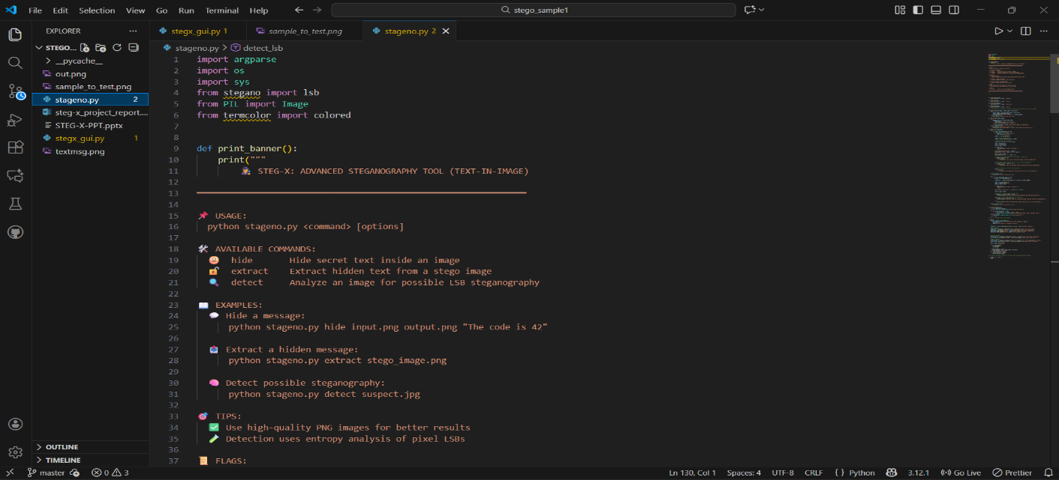
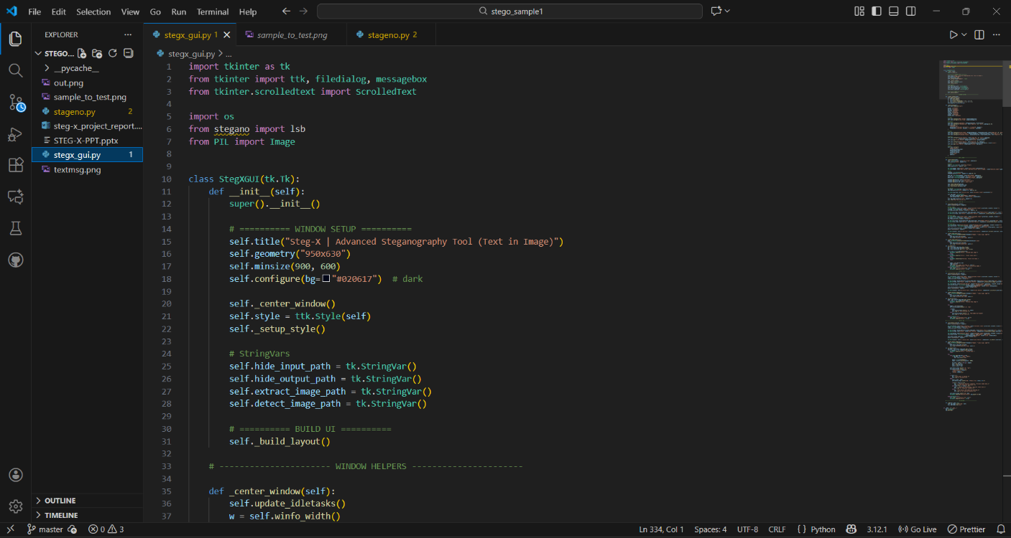
Fig. 6: Code of cli and gui

Output of Code:

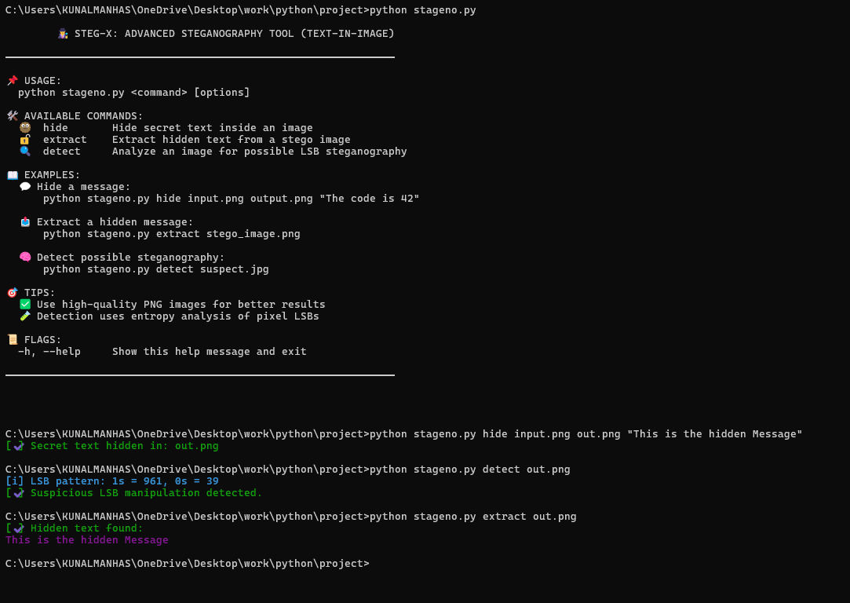
Fig. 7: CLI Output of code
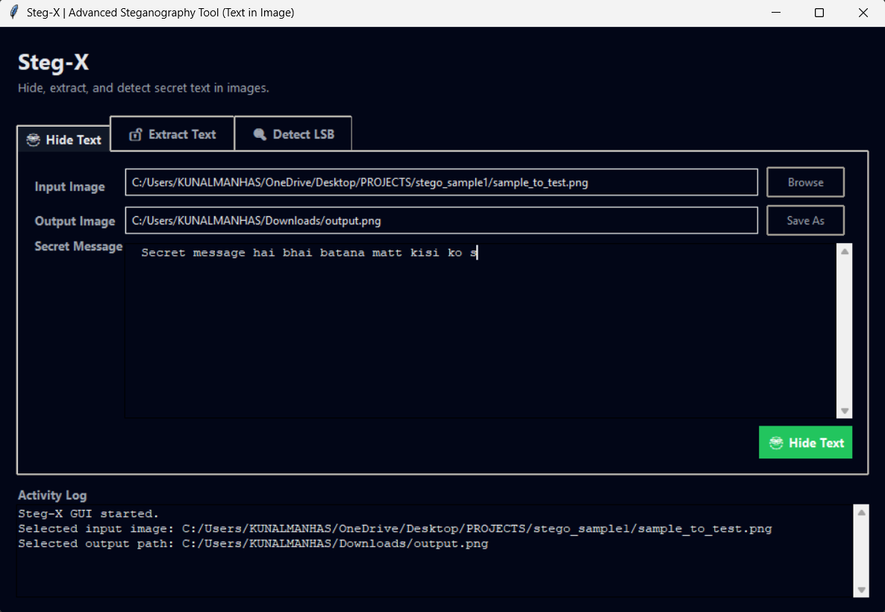
Fig. 8: GUI Output of code
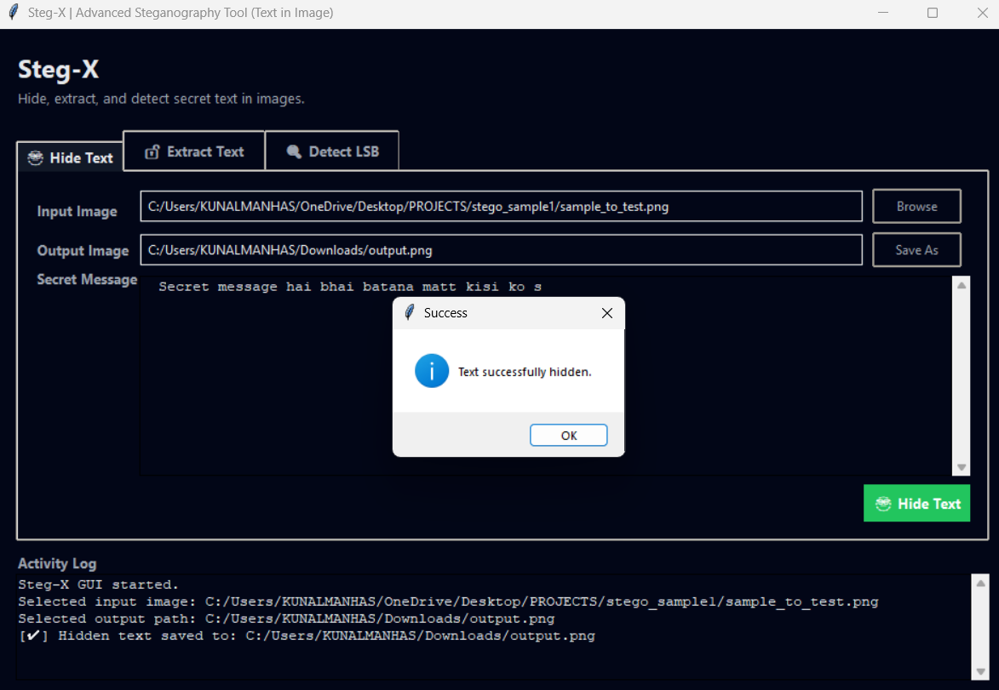
Fig. 9: Hiding message

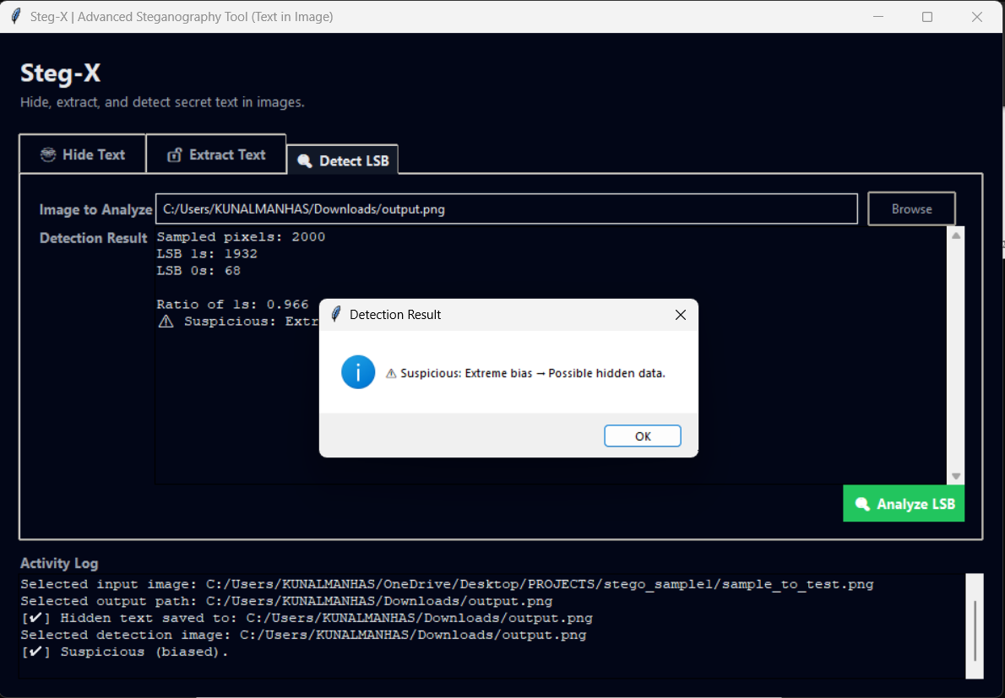
Fig. 10: Detecting Lsb

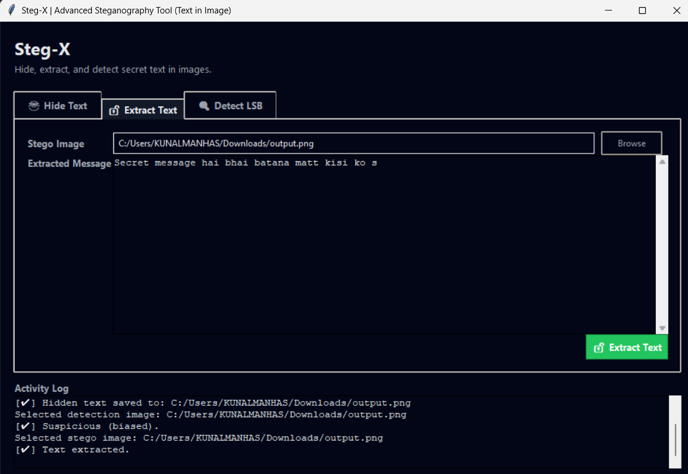

Fig. 11: Extracting hidden message

*******************************END OF REPORT******************************

