Practical No 04:- **Use git push to send your change to the primary repository. Look online to see if your change has been pushed.** Name: Kunal Satish Patil

Roll No.:- 136 Date:- 18-04-2023

**Bash :-**

comp@comp238 MINGW32 ~ (main)

$ git clone https://github.com/Kunal-Patil-14/MCA_136.git

Cloning into 'MCA_136'...

remote: Counting objects: 100% (3/3), done.

remote: Total 3 (delta 0), reused 0 (delta 0), pack-reused 0

Receiving objects: 100% (3/3), done.

comp@comp238 MINGW32 ~ (main)

$ cd MCA_136

comp@comp238 MINGW32 ~/MCA_136 (main)

$ git init MCA_136

Initialized empty Git repository in C:/Users/comp/MCA_136/MCA_136/.git/

comp@comp238 MINGW32 ~/MCA_136 (main)

$ touch MCA_136.txt

comp@comp238 MINGW32 ~/MCA_136 (main)

$ git status

On branch main

Your branch is up to date with 'origin/main'.

Untracked files:

(use "git add <file>..." to include in what will be committed)

MCA_136.txt

MCA_136/

nothing added to commit but untracked files present (use "git add" to track)

comp@comp238 MINGW32 ~/MCA_136 (main)

$ git add MCA_136.txt

comp@comp238 MINGW32 ~/MCA_136 (main)

$ git status

On branch main

Your branch is up to date with 'origin/main'.

Changes to be committed:

(use "git restore --staged <file>..." to unstage)

new file: MCA_136.txt

Untracked files:

(use "git add <file>..." to include in what will be committed)

MCA_136/

comp@comp238 MINGW32 ~/MCA_136 (main)

$ git commit -m "Roll No. is MCA_136"

[main 9da6506] Roll No. is MCA_136

1 file changed, 0 insertions(+), 0 deletions(-)

create mode 100644 MCA_136.txt

comp@comp238 MINGW32 ~/MCA_136 (main)

$ git push -u origin main

comp@comp238 MINGW32 ~/MCA_136 (main)

$ git push -u origin main

Enumerating objects: 4, done.

Counting objects: 100% (4/4), done.

Delta compression using up to 4 threads

Compressing objects: 100% (2/2), done.

Writing objects: 100% (3/3), 293 bytes | 293.00 KiB/s, done.

Total 3 (delta 0), reused 0 (delta 0), pack-reused 0

To https://github.com/Kunal-Patil-14/MCA_136.git

3113e72..9da6506 main -> main

branch 'main' set up to track 'origin/main'.

**Output:-**

Create a new repository:

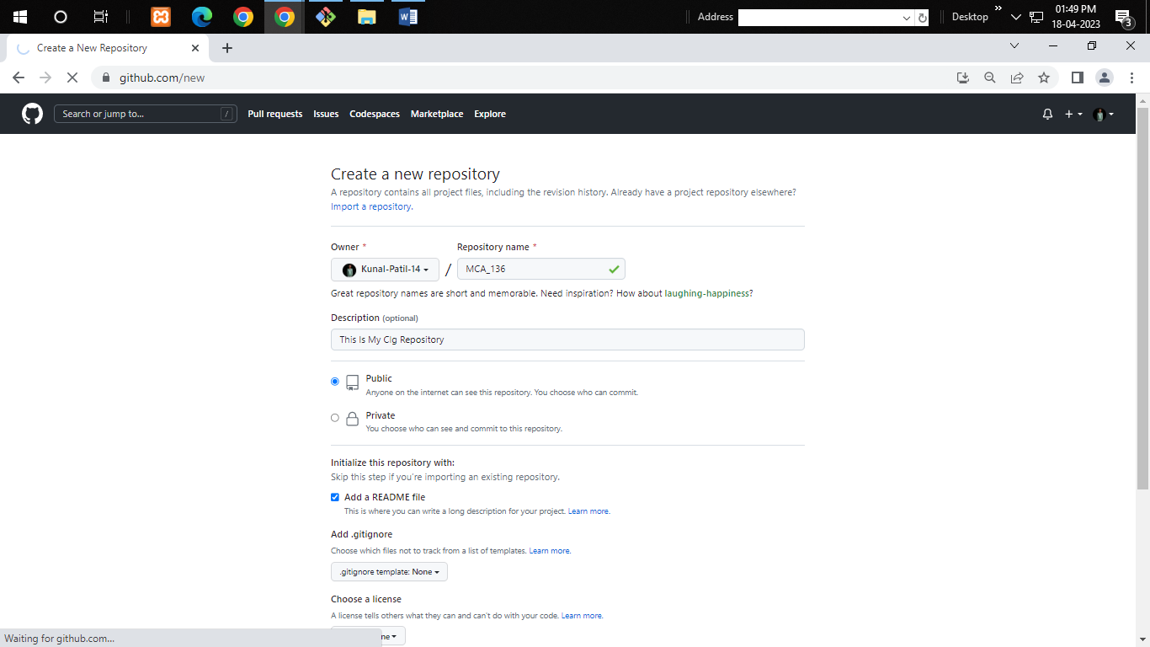

Push On Github:

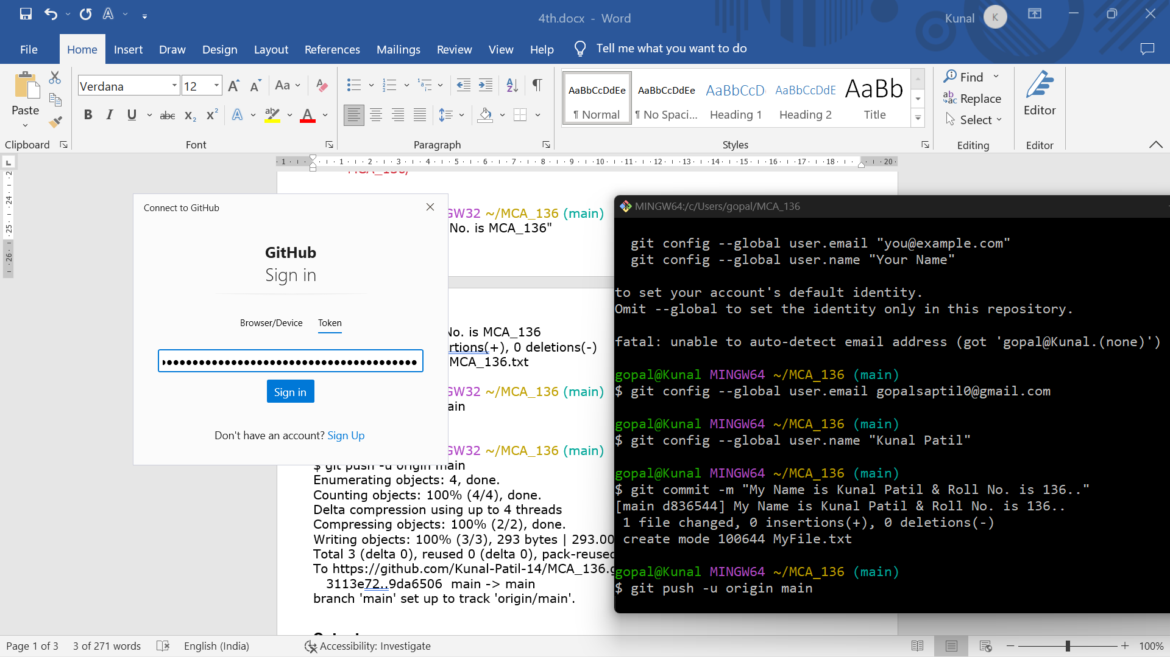

After Push on GitHub & commit the statement:

