Practical No 05:- **Use git pull to get your partners change into your repository. Verify that you have the new.**

Name: Kunal Satish Patil

Roll No.:- 136 Date:- 02-05-2023

**Bash:-**

gopal@Kunal MINGW64 ~

$ cd MCA_136/

gopal@Kunal MINGW64 ~/MCA_136 (main)

$ git init MCA_136/

Reinitialized existing Git repository in C:/Users/gopal/MCA_136/MCA_136/.git/

gopal@Kunal MINGW64 ~/MCA_136 (main)

$ git pull https://github.com/Kunal-Patil-14/MCA_136.git

remote: Enumerating objects: 4, done.

remote: Counting objects: 100% (4/4), done.

remote: Compressing objects: 100% (3/3), done.

remote: Total 3 (delta 0), reused 0 (delta 0), pack-reused 0

Unpacking objects: 100% (3/3), 2.29 MiB | 1.21 MiB/s, done.

From https://github.com/Kunal-Patil-14/MCA_136

* branch HEAD -> FETCH_HEAD

Updating d836544..f7de161

Fast-forward

1654955454282.jpg | Bin 0 -> 2400684 bytes

1 file changed, 0 insertions(+), 0 deletions(-)

create mode 100644 1654955454282.jpg

**Before Pull:-**

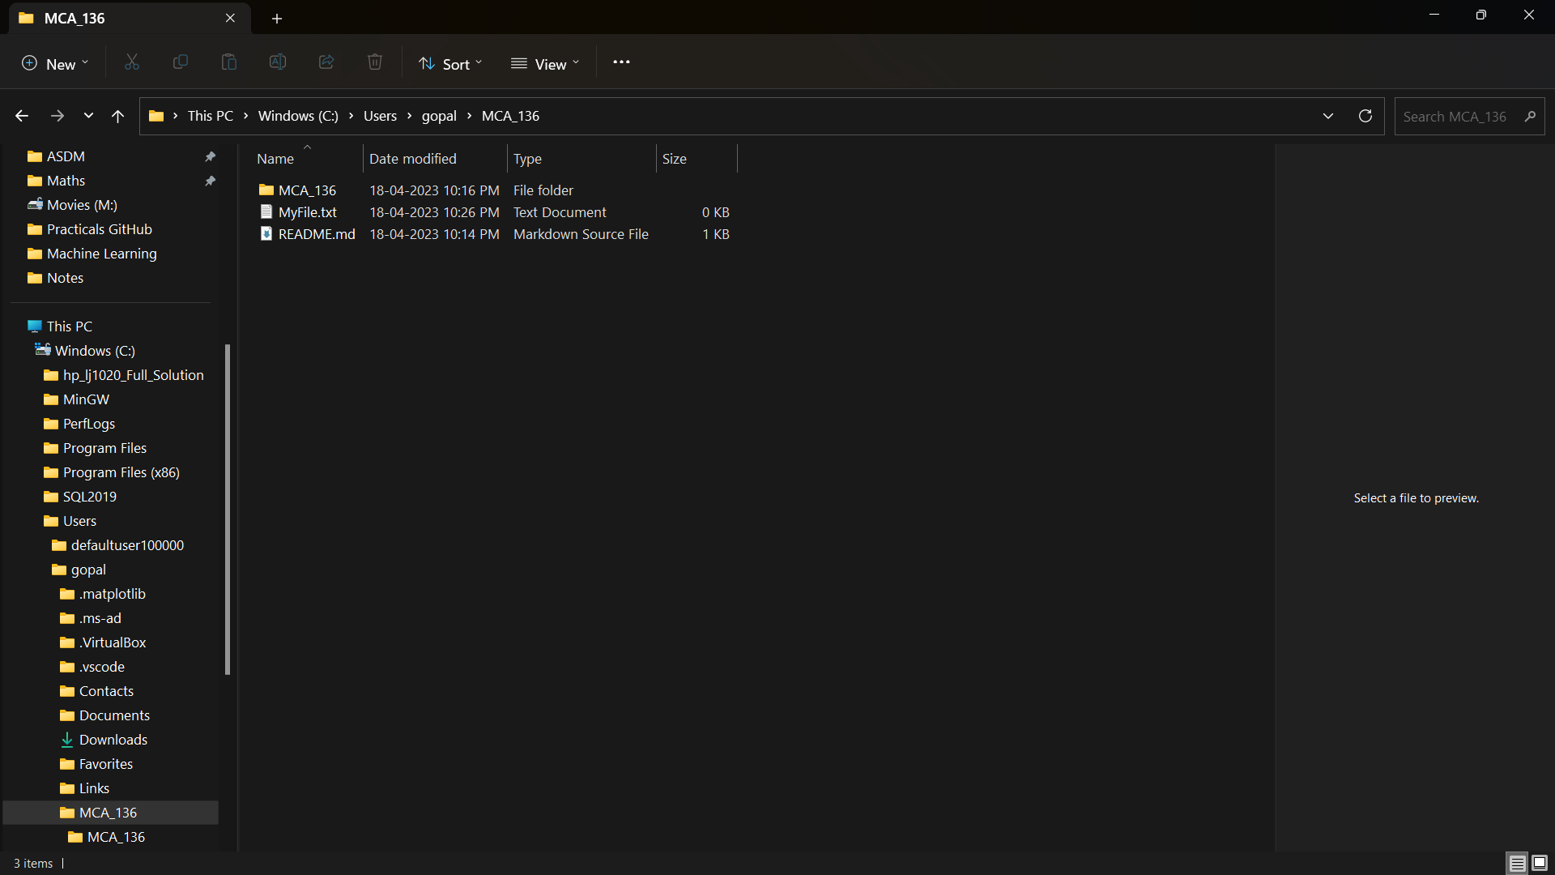

**After Pull:-**

