Practical No 07:- **Use git branch to create a new branch and git checkout to switch to the branch.**

Name: Kunal Satish Patil

Roll No.:- 136 Date:- 22-05-2023

**Bash:-**

gopal@Kunal MINGW64 ~

$ cd MCA_136/

gopal@Kunal MINGW64 ~/MCA_136 (main)

$ git init MCA_136/

Reinitialized existing Git repository in C:/Users/gopal/MCA_136/MCA_136/.git/

gopal@Kunal MINGW64 ~/MCA_136 (main)

$ git checkout BRANCH

Switched to branch 'BRANCH'

gopal@Kunal MINGW64 ~/MCA_136 (BRANCH)

$ touch File.txt

gopal@Kunal MINGW64 ~/MCA_136 (BRANCH)

$ git add File.txt

gopal@Kunal MINGW64 ~/MCA_136 (BRANCH)

$ git commit -m "File is Committed.."

[BRANCH 1155769] File is Committed..

1 file changed, 0 insertions(+), 0 deletions(-)

create mode 100644 File.txt

gopal@Kunal MINGW64 ~/MCA_136 (BRANCH)

$ git push -u origin main

Everything up-to-date

branch 'main' set up to track 'origin/main'.

gopal@Kunal MINGW64 ~/MCA_136 (BRANCH)

$ git push -u origin BRANCH

Enumerating objects: 3, done.

Counting objects: 100% (3/3), done.

Delta compression using up to 8 threads

Compressing objects: 100% (2/2), done.

Writing objects: 100% (2/2), 235 bytes | 235.00 KiB/s, done.

Total 2 (delta 1), reused 0 (delta 0), pack-reused 0

remote: Resolving deltas: 100% (1/1), completed with 1 local object.

remote:

remote: Create a pull request for 'BRANCH' on GitHub by visiting:

remote: https://github.com/Kunal-Patil-14/MCA_136/pull/new/BRANCH

remote:

To https://github.com/Kunal-Patil-14/MCA_136.git

* [new branch] BRANCH -> BRANCH

branch 'BRANCH' set up to track 'origin/BRANCH'.

**Before Pull & Merge on remote repository :-**

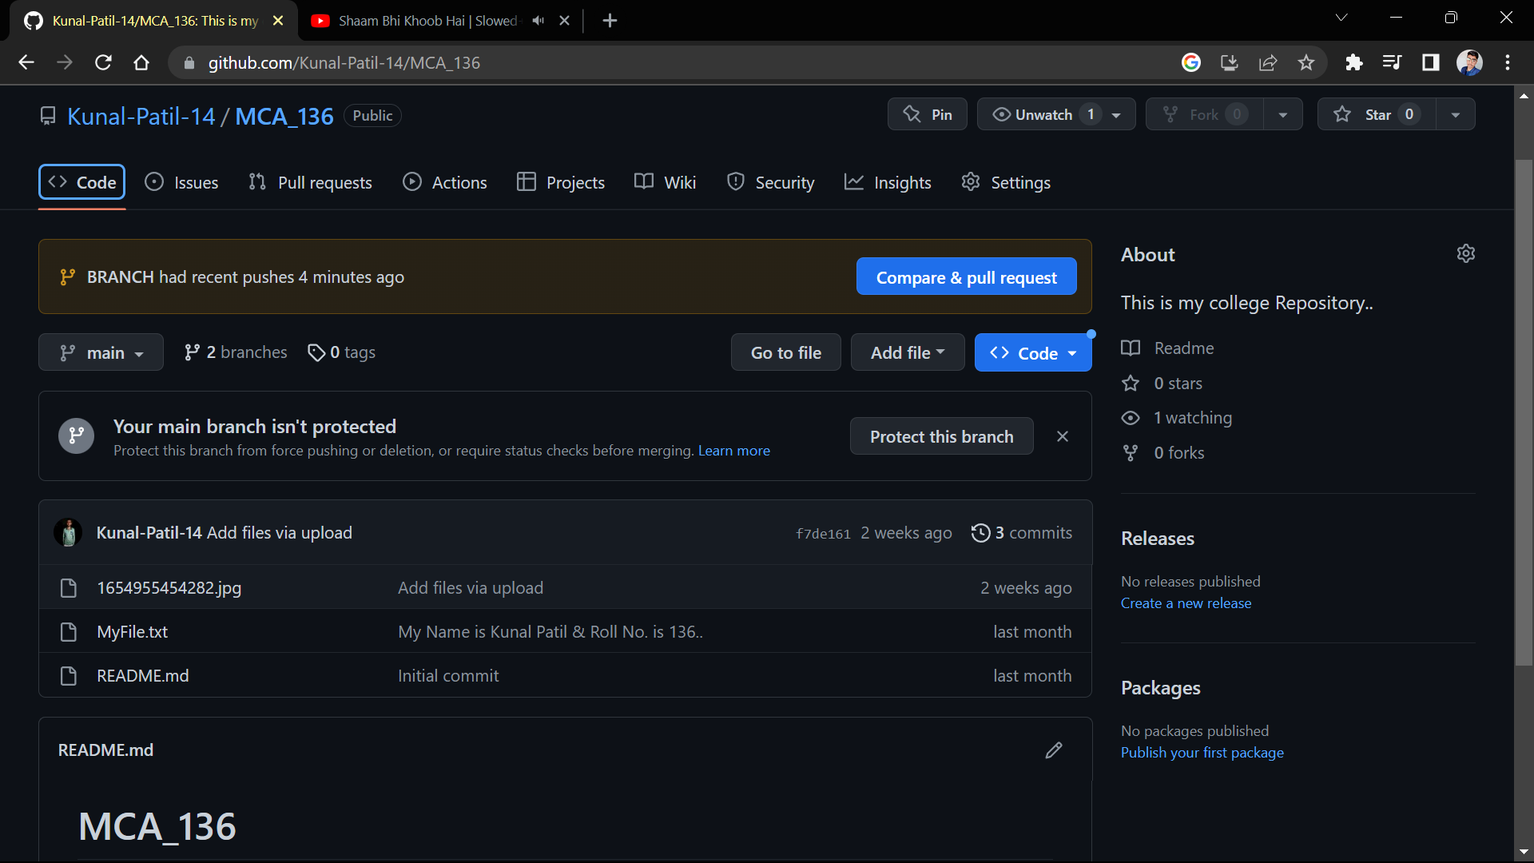

**Performing Pull request :-**

**`** 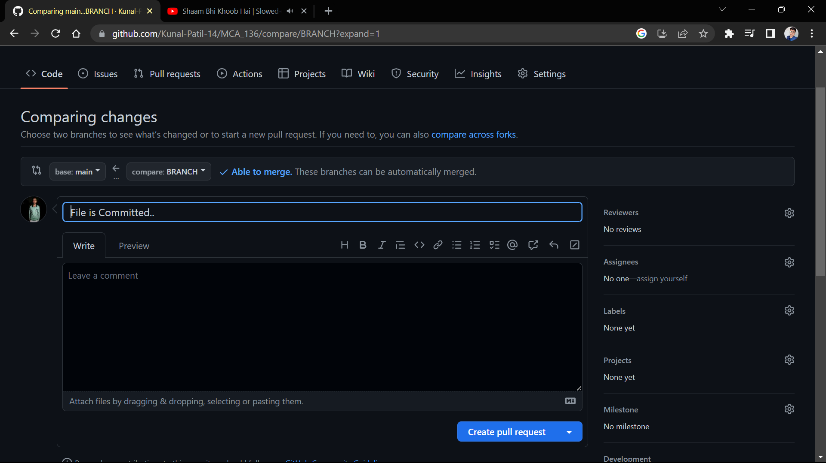

**After Pull Performing Merge on remote repository at primary branch (main):-**

**`**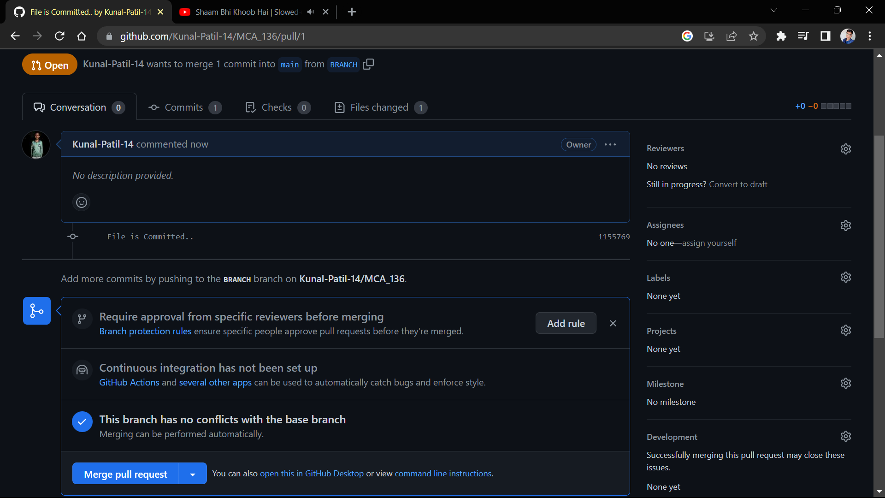

**After Merge from branch 2 to primary branch (main) on remote repository: -**

