Practical No 08:- **Use git merge to merge you changes to the primary branch..**

Name: Kunal Satish Patil

Roll No.:- 136 Date:- 22-05-2023

**Bash:-**

gopal@Kunal MINGW64 ~

$ git clone https://github.com/Kunal-Patil-14/MCA_136.git

Cloning into 'MCA_136'...

remote: Enumerating objects: 12, done.

remote: Counting objects: 100% (12/12), done.

remote: Compressing objects: 100% (8/8), done.

remote: Total 12 (delta 1), reused 6 (delta 1), pack-reused 0

Receiving objects: 100% (12/12), 2.29 MiB | 60.00 KiB/s, done.

Resolving deltas: 100% (1/1), done.

gopal@Kunal MINGW64 ~

$ cd MCA_136

gopal@Kunal MINGW64 ~/MCA_136 (main)

$ touch Webpage.html

gopal@Kunal MINGW64 ~/MCA_136 (main)

$ git add Webpage.html

gopal@Kunal MINGW64 ~/MCA_136 (main)

$ git commit -m"Add the new Branch On git Local Repository.."

[main fa597ae] Add the new Branch On git Local Repository..

1 file changed, 0 insertions(+), 0 deletions(-)

create mode 100644 Webpage.html

gopal@Kunal MINGW64 ~/MCA_136 (main)

$ git checkout main

Already on 'main'

Your branch is ahead of 'origin/main' by 1 commit.

(use "git push" to publish your local commits)

gopal@Kunal MINGW64 ~/MCA_136 (main)

$ git checkout Branch1

Switched to branch 'Branch1'

gopal@Kunal MINGW64 ~/MCA_136 (Branch1)

$ git branch --list

* Branch1

main

**OUTPUT:-**

**Before Merge to local repository :-**

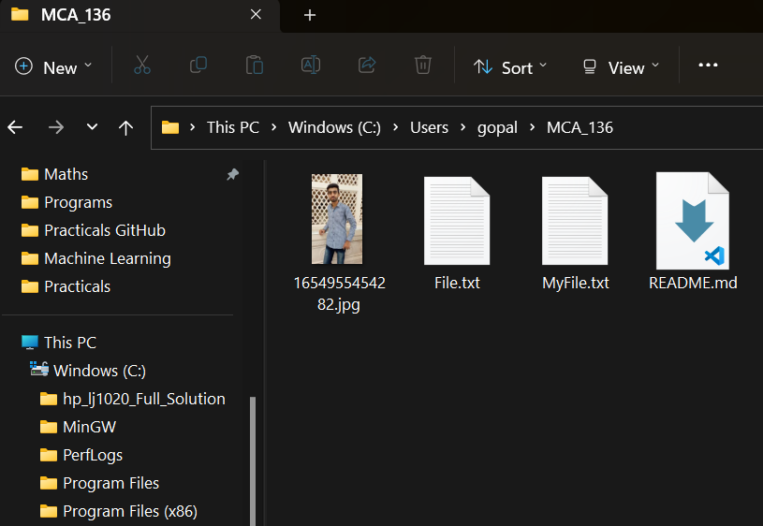

**Before Merge to local repository :-**

