Practical No 01 :- **Set up GitHub account and send email message to friend telling to your friend about the account.**

Name:- Kunal Satish Patil.

Roll No:- 136 Date :- 27-03-2023

**Step 1:-** Fill information to create account & verify user is human or machine.

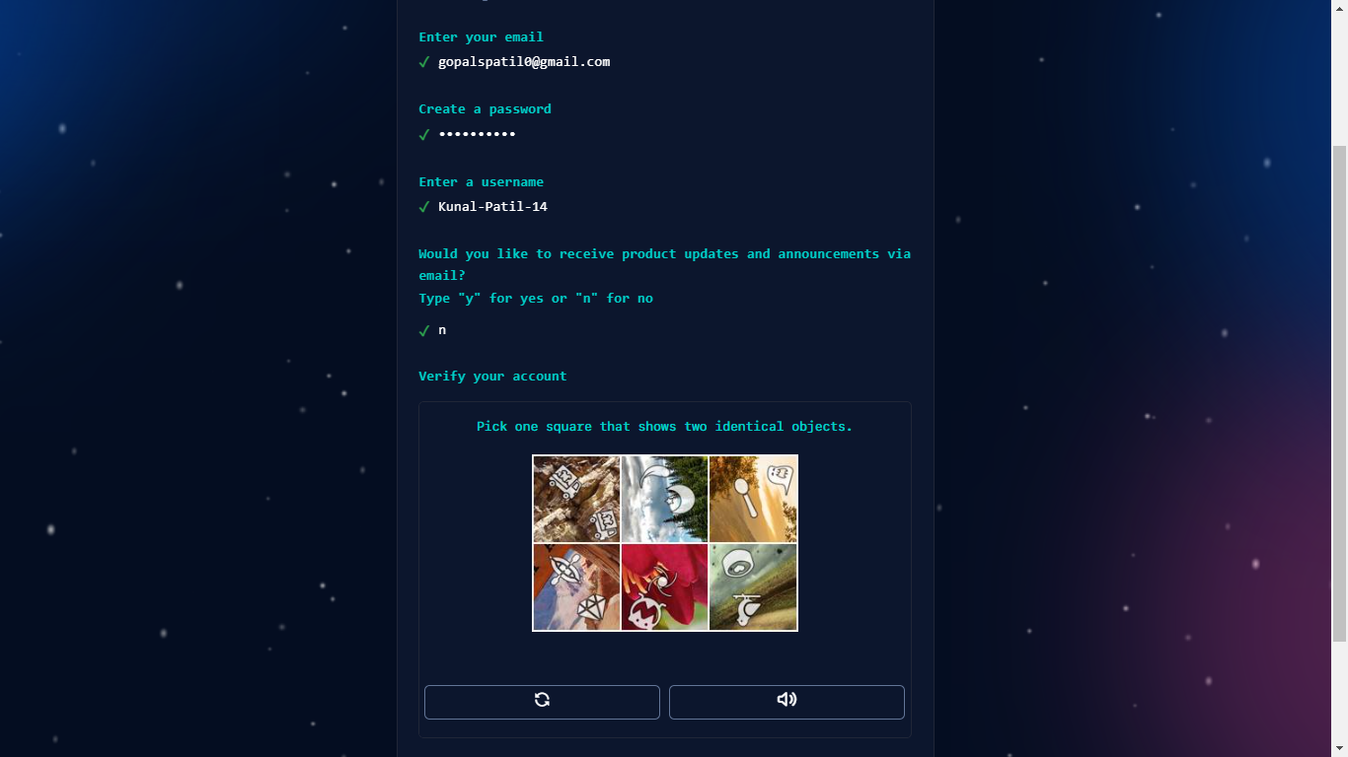

Step 2:- For Which purpose you create this account.

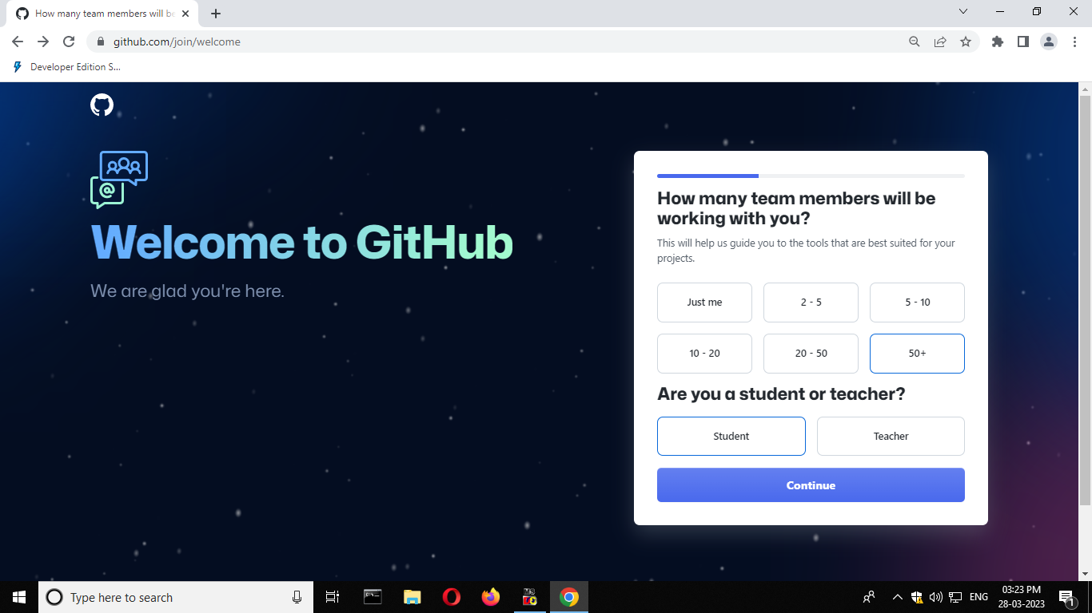

Step 3:- The tools you need to build what you want.



Step 4:- Here account is created successfully.

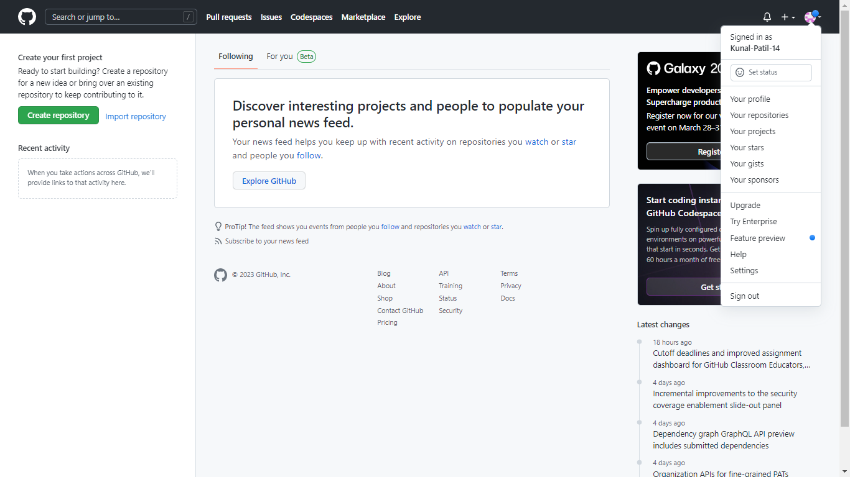

Step 5:- I am telling GitHub account to my friend.

