**Scope:**

This web app is useful for everyone who wants to go from one palace to another by cab or auto. Everyone goes to their offices, homes, or workplaces every day and they need to book cabs on daily basis, even many times a day. And our web app makes this task very easy and simple and better than booking a cab by themself.

This web app can be used by all the drivers for finding passengers and can select optimal trips according to their choice. Good drivers can earn a reputation and can get more passengers by this web app.

**Stakeholders:**

People who want to travel somewhere by taxi, people who want to book their travel arrangements in advance, people who want a safer journey with trusted drivers, people who want an option on what type of taxi they want to travel in, etc are our one of the stakeholders.

Taxi drivers who want to find more passengers and don’t want to negotiate with prices and who want to use the latest technology to help in their day-to-day taxi driving work are our other stakeholders.

**Entities and Relationships:**

Passengers, Drivers, Trips, Transections, Vehicles

Pass_trip, Drives, Payment

E-R Diagram:

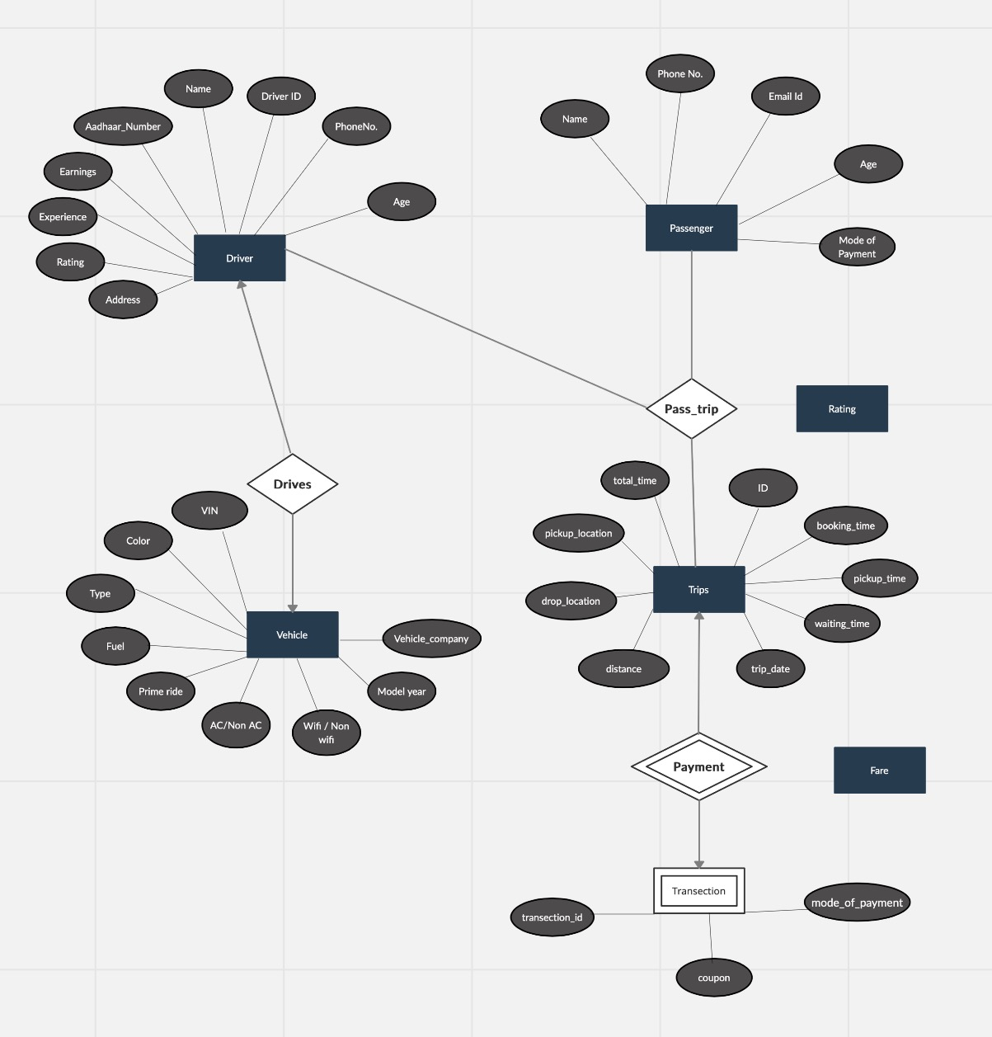

**Entities:**

Driver (**Driver ID**, Name, Aadhaar_Number, Earnings, Experience, Rating, Address, Phone_number, Age)

Trip(**ID**, booking_time, pickup_time, waiting_time, trip_date, total_time, pickup_location, drop_location, distance)

Route( **Trip.ID**, Pick up Location, Destination location, distance)

Passenger(Name,**phone number**,email_id, age, mode_of_payment)

Transactions( **Transaction_id**, coupon, mode_of_payment)

Vehicle(**Vin,** Color, Type, Fuel, Prime_ride ,Ac/Non-Ac, Wifi/Non-wifi, Model_year, Vehicle_company)

**Relationship sets:**

Drivers(**Driver_ID, Registraion_number**)

Pass_trip(**phone_number, Trip.ID, Driver.Driver_ID,** Rating)

Payment(**Trip.ID, Transections.Transection_id,** Fare)

**Weak Entity**:

Transections( **Transection_id**, **Trip.Trip_ID**,fare, coupon, mode)

Here Transections is a weak entity. Because their existence is dependent on the entity Trip. In this database, if there’s a transaction then there must be a trip. Without trip, the transection doesn’t exist.

**Ternary Relationship**:

Pass_trip(**phone_number, Trip.ID, Driver.Driver_ID,** Rating)

Here the relationship Pass_trip is a ternary relationship. Here only phone_number of passenger and driver_id of the driver is not sufficient to accurately describe the semantics of the association i. e. We can’t know anything about the trip, so we also don’t anything about pick up or drop location, the fare of the trip, distance, etc.

**Participation types:**

In pass_trips: trips= total; passengers, drivers = partial;

In the pass_trips relationship, trips have total participation in the relationship. But diver and passengers do not. Because there may be some case when some passengers have only signed up for our cab booking service but haven’t had any trip. And same for some drivers. But in this relationship, there always will be a trip.

In payment (Trip and Transection): one to one;

In Drives (Driver and Vehicle): one to one.