**Classes From the Table Structure**

1. 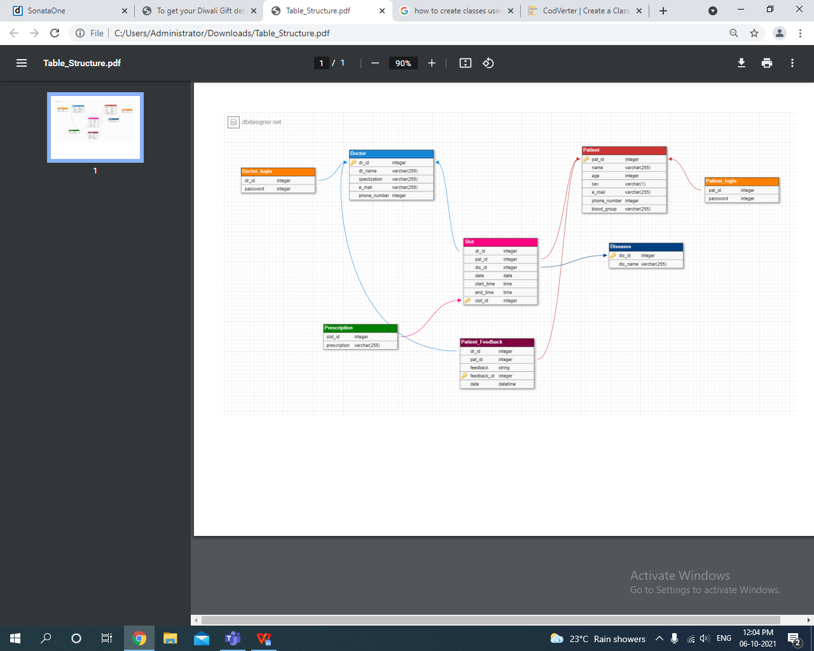**Class Doctor**

**dr_ID int**

**dr_name varchar**

**specialization varchar**

**email varchar**

**phone_number int**

**Doctor_Login()**

**dr_ID int**

**password int**

1. **Class Patient**

**pat_id int**

**name varchar**

**age int**

**sex varchar**

**email varchar**

**phone_number int**

**blood_group varchar**

**Patient_Login()**

**pat_ID int**

**password int**

1. **Class Diseases**

**dis_ID int**

**dis_name varchar**

1. **Class Patient_Feedback**

**dr_ID int**

**pat_ID Int**

**feedback varchar**

**feedback_ID int**

**date Varchar**

**Feedback()**

1. **Class Slot**

**dr_ID int**

**pat_ID int**

**dis_ID int**

**date varchar**

**start_time varchar**

**end_time varchar**

**slot_id int**

**Slot_booking()**

1. **Class Prescription**

**slot_ID int**

**prescription varchar**