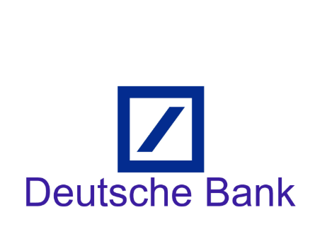

Round 1 Result:

|  |  |  |
| --- | --- | --- |
| Name | Status | Role |
| Tanmay Bhatt | Pass | UI/UX Designer |
| Kunal Kamra | Pass | SDE |
| Sheeja Chaturvedi | Pass | SDE |
| Devesh Shah | Fail | Business Analyst |