# Backend Api Requests documentation

:8000/api

/csrf_cookie:(Universal)

Request :

Type: GET

header:

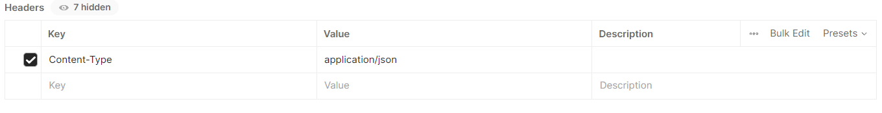

Body:

<Empty>

Response:

Body:

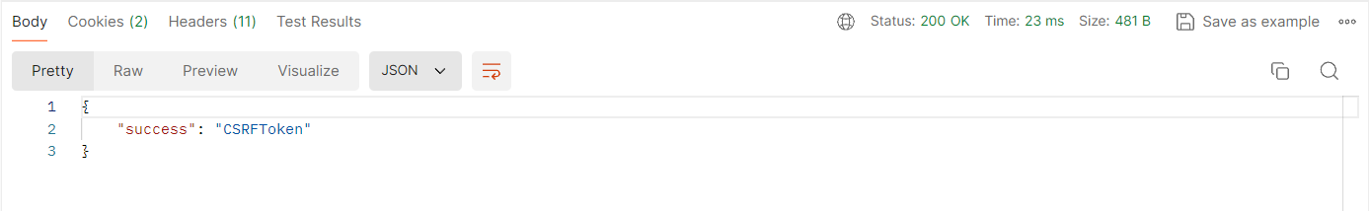

Cookie:

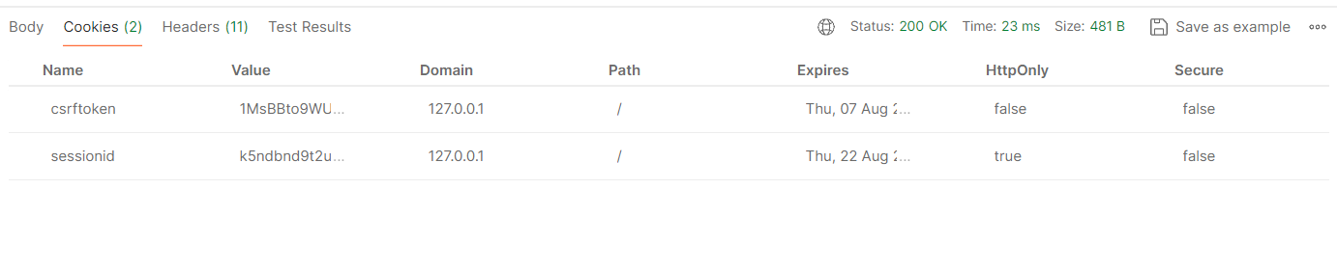

/register:(step 1)

Type: POST

Request:

Header:

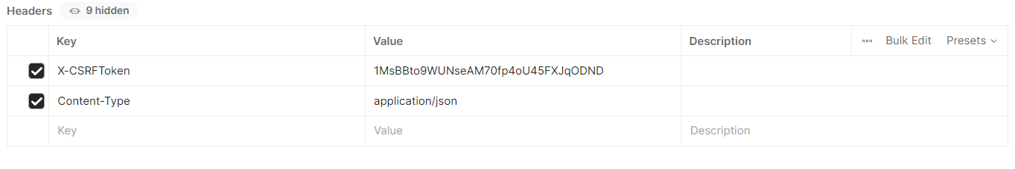

Body:

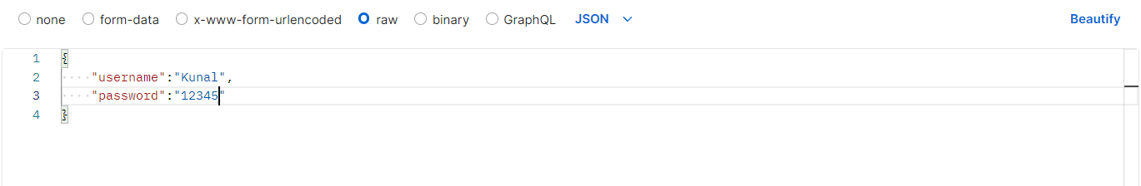

Response:

Body:

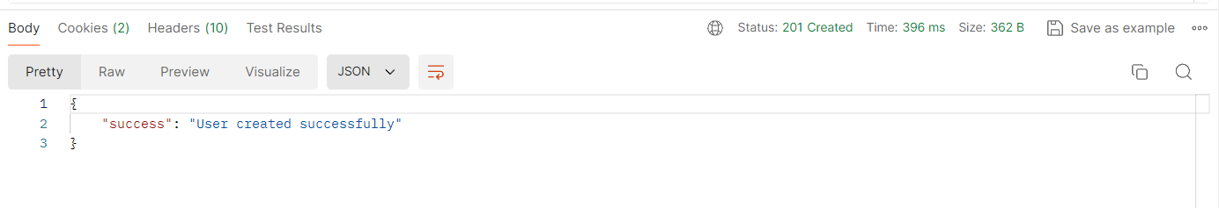

Cookie:

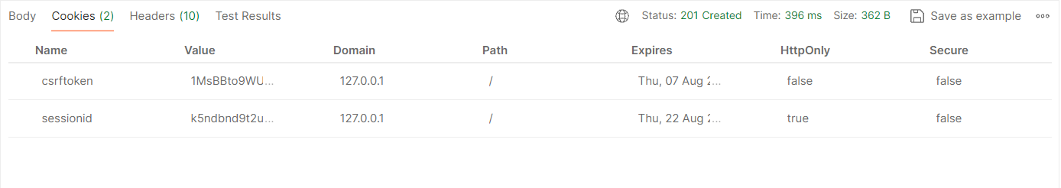

<the session id is from a previous session and needs to be ignored here>

/login:(step 2)

Type: POST <You get your session id authenticated as a user

Request:

Header:

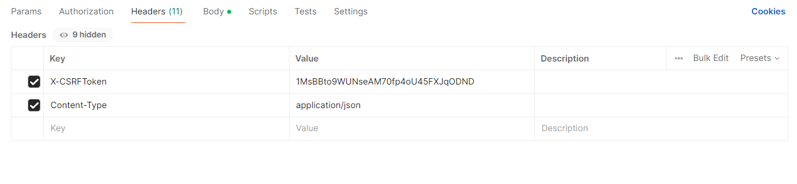

Body:



Response:

Body:

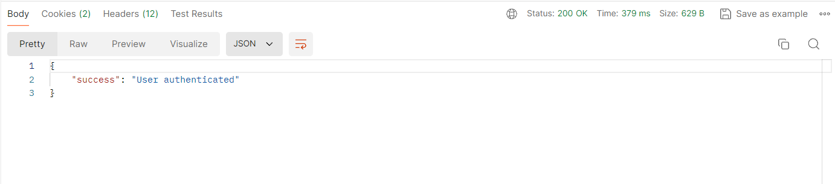 Cookie:

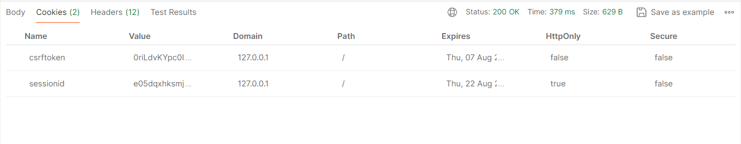

<session id and csrf cookie changes as authenticated user status is achieved>

/café_info:(step 3) Type: POST

<only to get the user data in the data base, no update and deletes>

Request:

Header:

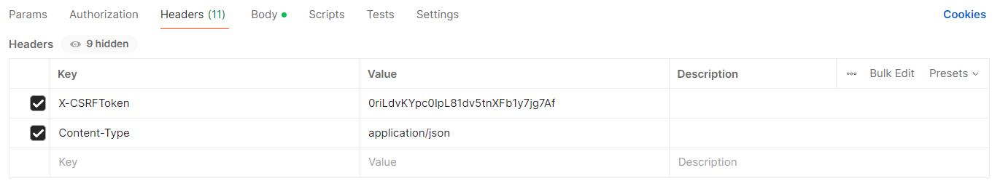

<use the newly acquired csrf token from cookie>

Body:

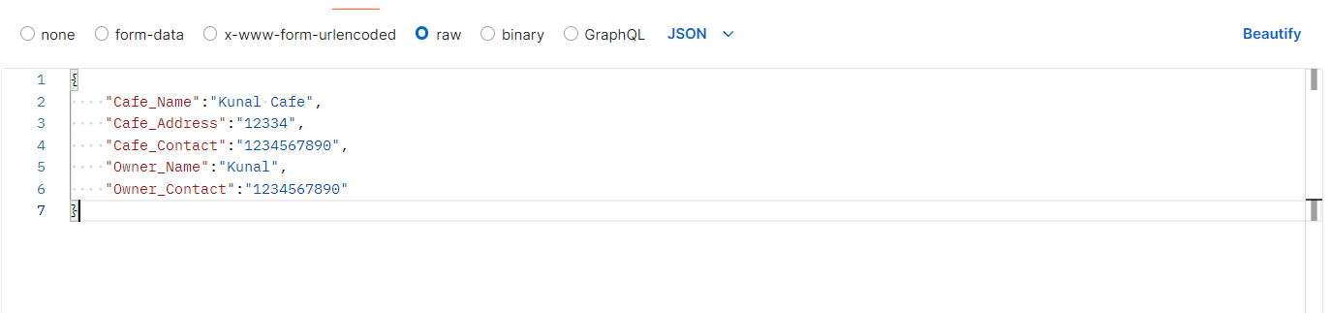

Response:

Body:

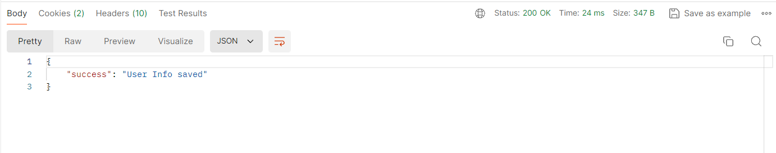

Cookie:

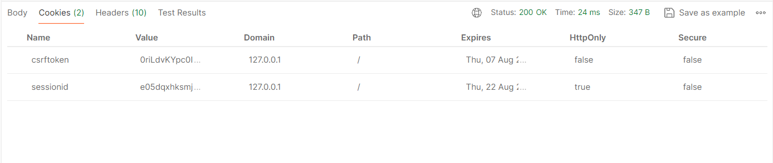

<csrf token remains the same a the user is authenticated >

/logout:(End) Type: POST

Request:

Header:

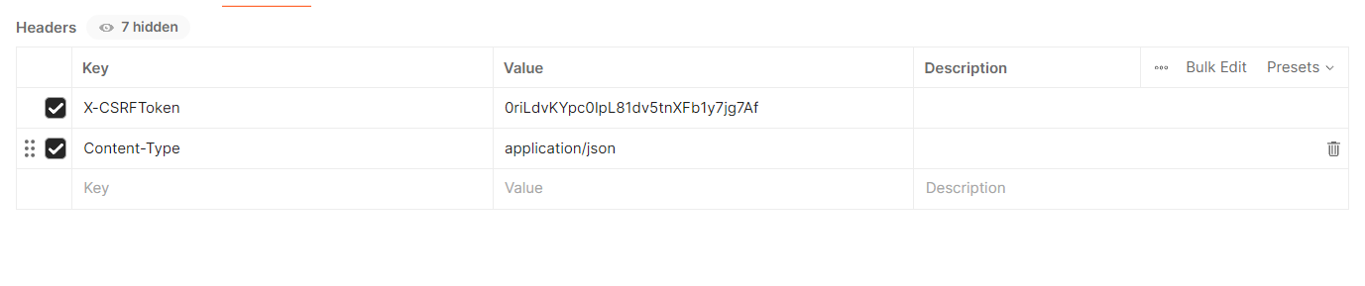

Body:

<Empty>

Response:

Body:

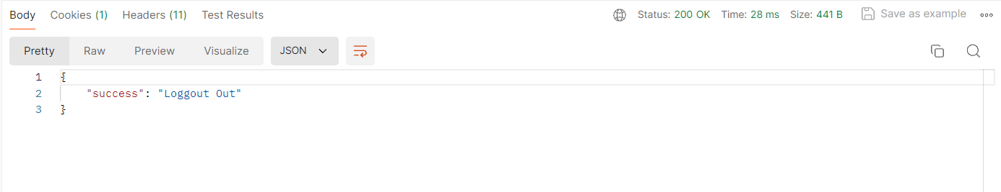

Cookie:

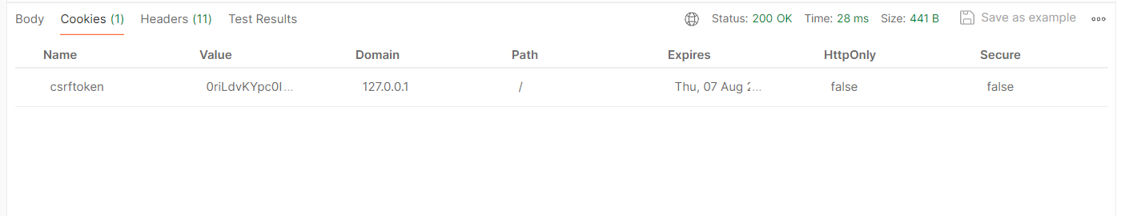

<session id is gone as the user is logged out and the session ie terminated>