HOUSEHOLD ELECTRICITY CONSUMPTION PREDICTION SYSTEM
A PROJECT REPORT
Submitted by
Kunal Mittal (24BCS12354)
Ansh Kumar (24BCS12097)
Vishal Kumar Shrivastava (24BCS12629)
in partial fulfillment for the award of the degree of
BACHELOR OF ENGINEERING
IN
COMPUTER SCIENCE & ENGINEERING
Chandigarh University
November 2026

BONAFIDE CERTIFICATE
Certified that this project report “Household Electricity Consumption Prediction System” is the bonafide work of “Kunal Mittal, Ansh Kumar and Vishal Kumar Shrivastava” who carried out the project work under my/our supervision.
SIGNATURE  HEAD OF THE DEPARTMENT | SIGNATURE  SUPERVISOR

Submitted for the project viva-voce examination held on ____________________
INTERNAL EXAMINER | EXTERNAL EXAMINER

TABLE OF CONTENTS
ABSTRACT 10
GRAPHICAL ABSTRACT 12
ABBREVIATIONS 13
SYMBOLS 14
CHAPTER 1. INTRODUCTION 15
1.1. Identification of Client / Need / Relevant Contemporary issue 15
1.2. Identification of Problem 15
1.3. Identification of Tasks 16
1.4. Timeline 16
1.5. Organization of the Report 17
CHAPTER 2. LITERATURE REVIEW/BACKGROUND STUDY 18
2.1. Timeline of the reported problem 18
2.2. Existing solutions 18
2.3. Bibliometric analysis 21
2.4. Review Summary 21
2.5. Problem Definition 21
2.6. Goals/Objectives 22
CHAPTER 3. DESIGN FLOW/PROCESS 24
3.1. Evaluation & Selection of Specifications/Features 24
3.2. Design Constraints 28
3.3. Analysis of Features and finalization subject to constraints 29
3.4. Design Flow 30
3.5. Design selection 30
3.6. Implementation plan/methodology 31
CHAPTER 4. RESULTS ANALYSIS AND VALIDATION 43
4.1. Implementation of solution 43
CHAPTER 5. CONCLUSION AND FUTURE WORK 83
5.1. Conclusion 83
5.2. Future work 83
REFERENCES 85
APPENDIX 87
1. Plagiarism Report 87
2. Design Checklist 87
3. Syllabus experiments performed in the project 87
4. Source code 88
USER MANUAL 133

List of Figures
Figure 0.1: Graphical abstract: end-to-end MLOps architecture of VoltCast 12
Figure 1.1: Gantt chart of the project timeline 17
Figure 3.1: Daily mean active power with 30-day rolling mean (strong yearly seasonality) 24
Figure 3.2: Average consumption by weekday and hour (morning and evening peaks) 24
Figure 3.3: Monthly pattern and share of energy per sub-meter 25
Figure 3.4: Share of missing one-minute readings per month 25
Figure 3.5: Distribution of each hourly variable 26
Figure 3.6: Autocorrelation of hourly consumption up to eight days 26
Figure 3.7: Average weekly load profile 26
Figure 3.8: Average energy by sub-meter and hour of day 27
Figure 3.9: Hourly consumption by month (box plots) 27
Figure 3.10: Monthly average consumption, year by year 27
Figure 3.11: Box plots of hourly readings; points beyond the whiskers are IQR outliers 28
Figure 3.12: Alternative designs considered 30
Figure 3.13: Flowchart of the training and deployment algorithm 31
Figure 3.14: Detailed block diagram of the MLOps architecture 32
Figure 3.15: Data-flow diagram, level 0 (context) 32
Figure 3.16: Data-flow diagram, level 1 33
Figure 3.17: Use-case diagram 33
Figure 3.18: Sequence diagram: serving a forecast request 34
Figure 3.19: Deployment diagram: Docker Compose, Vercel and Kubernetes 34
Figure 3.20: CI/CD pipeline 35
Figure 3.21: DVC pipeline graph 35
Figure 3.22: Flowchart of the preprocessing stage 36
Figure 3.23: Flowchart of the training and tuning stage 37
Figure 3.24: Flowchart of the peak-hour classifier stage 38
Figure 3.25: Flowchart of serving a prediction 39
Figure 3.26: Flowchart of drift monitoring and the retraining decision 40
Figure 4.1: Correlation matrix of the measured variables 43
Figure 4.2: Validation MAE and R² of all models (deployed model in orange, baselines in grey) 44
Figure 4.3: MLflow tracking UI: runs of every model, tuned variant and final model 45
Figure 4.4: Training vs validation MAE of each model (default hyper-parameters) 46
Figure 4.5: Validation curve of the decision tree: error against max_depth 46
Figure 4.6: Learning curves with time-series cross-validation 46
Figure 4.7: Validation MAE before and after GridSearchCV tuning 47
Figure 4.8: Hyper-parameter response: decision-tree grid, KNN neighbours, ridge alpha 47
Figure 4.9: MAE in each time-series cross-validation fold 48
Figure 4.10: Test MAE, RMSE, R² and accuracy (1 − WAPE) of every model 50
Figure 4.11: Forecasts of every model over the last seven days of the test set 51
Figure 4.12: Predicted vs actual for every model (test set) 52
Figure 4.13: Residual distribution of every model (test set) 53
Figure 4.14: Next-hour forecast vs actual consumption, last 14 days of the test set 53
Figure 4.15: Predicted vs actual scatter and residual distribution 54
Figure 4.16: Top 15 features by permutation importance 54
Figure 4.17: Forecast MAE by hours ahead, compared with the seasonal-naive baseline 55
Figure 4.18: Peak-hour classifier on the test set: confusion matrix, ROC and precision-recall curves 56
Figure 4.19: Confusion matrices of the three classifiers (test set) 56
Figure 4.20: ROC and precision-recall curves of the three classifiers (test set) 56
Figure 4.21: Precision, recall, F1 and accuracy against the decision threshold 57
Figure 4.22: VoltCast web application (React) with a live 24-hour forecast and peak-hour alerts 59
Figure 4.23: Prometheus target page: the VoltCast API is being scraped (state UP) 60
Figure 4.24: Grafana dashboard “VoltCast – Model Monitoring” fed by Prometheus 61
Figure 4.25: Population Stability Index of monitored features (train vs test) 61
Figure 4.26: PSI against the training data and test MAE, month by month 62
Figure 4.27: Test error across sub-groups (dashed line: overall MAE) 63
Figure 4.28: Responsible-AI section of the web application 63
Figure 4.29: Python and library versions used, run 2026-11-03 18:51:54 64
Figure 4.30: Git history of the project repository, run 2026-11-03 19:21:38 64
Figure 4.31: dvc dag: the pipeline stages and their dependencies, run 2026-11-03 18:51:56 65
Figure 4.32: dvc repro --force: full pipeline run (ingest, preprocess, features, training with GridSearchCV, classifier, monitoring, evaluation, export, analysis) (part 1 of 3), run 2026-11-03 18:51:58 66
Figure 4.33: dvc repro --force: full pipeline run (ingest, preprocess, features, training with GridSearchCV, classifier, monitoring, evaluation, export, analysis) (part 2 of 3), run 2026-11-03 18:51:58 67
Figure 4.34: dvc repro --force: full pipeline run (ingest, preprocess, features, training with GridSearchCV, classifier, monitoring, evaluation, export, analysis) (part 3 of 3), run 2026-11-03 18:51:58 68
Figure 4.35: dvc status after the run, run 2026-11-03 19:03:29 68
Figure 4.36: dvc metrics show: every tracked metric (part 1 of 2), run 2026-11-03 19:03:32 69
Figure 4.37: dvc metrics show: every tracked metric (part 2 of 2), run 2026-11-03 19:03:32 69
Figure 4.38: pytest -v: the automated test suite, run 2026-11-03 19:03:34 70
Figure 4.39: MLflow: tracked runs of the forecasting experiment (part 1 of 3), run 2026-11-03 19:03:41 71
Figure 4.40: MLflow: tracked runs of the forecasting experiment (part 2 of 3), run 2026-11-03 19:03:41 72
Figure 4.41: MLflow: tracked runs of the forecasting experiment (part 3 of 3), run 2026-11-03 19:03:41 73
Figure 4.42: MLflow model registry: versions of voltcast-forecaster, run 2026-11-03 19:03:46 73
Figure 4.43: Building the React web application, run 2026-11-03 19:03:50 73
Figure 4.44: docker compose up: building the image and starting the five services, run 2026-11-03 19:03:55 74
Figure 4.45: Docker image and Compose services, run 2026-11-03 19:04:13 74
Figure 4.46: Flask API: health check and model information, run 2026-11-03 19:04:16 75
Figure 4.47: Flask API: 4-hour forecast with peak alerts, run 2026-11-03 19:04:16 76
Figure 4.48: Flask API: POST /api/predict with one week of readings, run 2026-11-03 19:04:17 76
Figure 4.49: Flask API: invalid requests are rejected with HTTP 422, run 2026-11-03 19:04:18 77
Figure 4.50: Prometheus metrics exposed by the API at /api/metrics, run 2026-11-03 19:04:50 77
Figure 4.51: Prometheus: scrape target health and a PromQL query, run 2026-11-03 19:04:50 78
Figure 4.52: Prediction log (logs/predictions.jsonl), run 2026-11-03 19:04:51 78
Figure 4.53: Grafana: provisioned dashboard and data source, run 2026-11-03 19:04:51 79
Figure 4.54: Kubernetes manifest and Docker Compose configuration validation, run 2026-11-03 19:05:11 79
Figure 4.55: GitHub Actions: recent CI/CD runs, run 2026-11-03 19:21:39 80
Figure 4.56: GitHub Actions: steps of the latest run, run 2026-11-03 19:21:40 80
Figure 4.57: Vercel: production deployments created from GitHub pushes, run 2026-11-03 19:21:44 81
Figure 4.58: The live deployment answering requests, run 2026-11-03 19:21:50 81
Figure M.1: Web application – live forecast 134
Figure M.2: Web application – model performance, over-fitting and tuning 135
Figure M.3: Web application – peak-hour classifier metrics 136
Figure M.4: Grafana monitoring dashboard 136
Figure M.5: Prometheus targets page 137
Figure M.6: Streamlit dashboard (Docker / local) – forecast tab 137

List of Tables
Table 0.1: Standards referred to in the project 9
Table 0.2: List of abbreviations 13
Table 0.3: List of symbols 14
Table 1.1: Identified tasks 16
Table 2.1: Timeline of the reported problem 18
Table 2.2: Bibliometric comparison of existing solutions 21
Table 2.3: Mapping of project objectives to course outcomes 22
Table 3.1: Descriptive statistics of the hourly data 27
Table 3.2: Selected feature specification (31 features) 28
Table 3.3: Design constraints 28
Table 3.4: Comparison of alternative designs 30
Table 3.5: Software modules of the implementation 41
Table 4.1: Training and validation performance of all models (default hyper-parameters) 44
Table 4.2: Hyper-parameter tuning results 47
Table 4.3: Cross-validation MAE (kW) per time-series fold, tuned models 48
Table 4.4: Held-out test performance (Jun–Nov 2010) 49
Table 4.5: Test-set error metrics of every model (kW, kW²) 49
Table 4.6: Test-set accuracy-style metrics, training time and prediction time of every model 49
Table 4.7: Forecast error by horizon 55
Table 4.8: Peak-hour classifiers on the validation set 55
Table 4.9: Classification reports on the test set 57
Table 4.10: Effect of the probability threshold (tuned decision tree, test set) 57
Table 4.11: REST API endpoints 58
Table 4.12: Automated test suite results 60
Table 4.13: Monthly PSI of monitored features and monthly test MAE 62
Table 4.14: Achievement of objectives 81
Table A.1: Design checklist 87
Table A.2: Syllabus experiments mapped to the project 87

List of Standards
Table 0.1: Standards referred to in the project
Standard | Publishing Agency | About the standard | Where used
ISO/IEC 23053:2022 | ISO / IEC | Framework for Artificial Intelligence systems using Machine Learning; defines the ML pipeline components (data acquisition, pre-processing, training, evaluation, deployment). | Ch. 3.2, 3.6
ISO/IEC 25010:2023 | ISO / IEC | Systems and software quality model (functional suitability, reliability, maintainability, portability). | Ch. 3.2, 4.1
IEC 62056 (DLMS/COSEM) | IEC | Electricity metering data exchange; defines how smart meters expose load-profile readings such as those used as model inputs. | Ch. 3.1
IS 16444 | Bureau of Indian Standards | A.C. static direct-connected smart energy meters; relevant for deploying the system on Indian household smart meters. | Ch. 3.2
ISO 50001:2018 | ISO | Energy management systems: requirements for measuring, analysing and improving energy performance. | Ch. 1.1, 3.2
OpenMetrics (Prometheus exposition format) | CNCF | Text format for exposing service metrics; the API's /api/metrics endpoint follows it so Prometheus can scrape it. | Ch. 3.6, 4.1
Digital Personal Data Protection Act, 2023 | Government of India | Rules for processing digital personal data; applies when real household meter data is used. | Ch. 3.2, 4.1

ABSTRACT
Residential buildings account for a large share of national electricity demand, yet most households receive only a monthly bill and have no forward-looking view of their consumption. Utilities, in turn, need short-term load forecasts at household level to plan demand response as smart meters are rolled out. This project develops VoltCast, a Household Electricity Consumption Prediction System that forecasts a household's hourly active power for the next 1–48 hours, flags likely peak-consumption hours, and is built end to end with Machine Learning Operations (MLOps) practice.
The UCI “Individual Household Electric Power Consumption” dataset (2,075,259 one-minute readings over almost four years) is cleaned of 1.252% missing values, checked for outliers, resampled to 34,589 hourly records and turned into 31 leakage-free features. Nine regression models covering the algorithms of the course (linear regression, decision tree, k-nearest neighbours, support vector machine, random forest) plus ridge regression, gradient boosting and two naive baselines are trained on a chronological split, tuned with GridSearchCV using time-series cross-validation, and tracked in MLflow. Only syllabus algorithms are eligible for deployment, and the best of them, random forest, is deployed: test MAE 0.295 kW, MSE 0.188, R² 0.620, accuracy (1 − WAPE) 67.9%, a 21.9% MAE reduction over the persistence baseline and within 0.001 kW of the best reference model (gradient boosting). A tuned decision-tree classifier detects peak hours with 80.3% accuracy, 77.9% recall and ROC-AUC 0.873. The experiments also show over-fitting clearly: the default decision tree reaches zero training error but the worst validation error, which tuning reduces from 0.506 to 0.380 kW.
The models are versioned with DVC and the MLflow model registry, and served by a Flask REST API with input validation. They run in Docker (a five-service Docker Compose stack, plus Kubernetes manifests) and on the Vercel cloud behind a React web application. A GitHub Actions pipeline reproduces the DVC pipeline, applies quality gates, runs 11 automated tests and builds the container on every change and weekly. Prometheus collects service metrics that Grafana displays, every prediction is logged, and a drift monitor based on the Population Stability Index correctly detected seasonal drift and recommended retraining. Fairness, transparency, privacy and security are analysed, including error across groups of hours.
Keywords: load forecasting, smart meter, random forest, decision tree, GridSearchCV, MLOps, MLflow, DVC, Flask, Docker, Prometheus, Grafana, responsible AI.

GRAPHICAL ABSTRACT
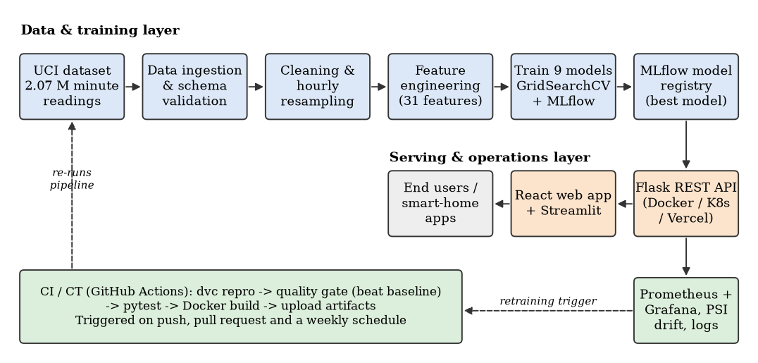
Figure 0.1: Graphical abstract: end-to-end MLOps architecture of VoltCast

ABBREVIATIONS
Table 0.2: List of abbreviations
Abbreviation | Full form
AI | Artificial Intelligence
API | Application Programming Interface
ARIMA | Auto-Regressive Integrated Moving Average
AUC | Area Under the (ROC) Curve
CI/CD | Continuous Integration / Continuous Deployment
CO | Course Outcome
CT | Continuous Training
CV | Cross-Validation
CNN | Convolutional Neural Network
DVC | Data Version Control
EDA | Exploratory Data Analysis
FN / FP / TN / TP | False negative / false positive / true negative / true positive
HGB | Histogram-based Gradient Boosting
IEA | International Energy Agency
IQR | Inter-Quartile Range
K8s | Kubernetes
KNN | K-Nearest Neighbours
kW / kWh | Kilowatt / Kilowatt-hour
LSTM | Long Short-Term Memory
MAE | Mean Absolute Error
MAPE | Mean Absolute Percentage Error
ML | Machine Learning
MLOps | Machine Learning Operations
MSE | Mean Squared Error
NILM | Non-Intrusive Load Monitoring
PSI | Population Stability Index
REST | Representational State Transfer
RF | Random Forest
RMSE | Root Mean Squared Error
ROC | Receiver Operating Characteristic
R² | Coefficient of determination
SVM / SVR | Support Vector Machine / Support Vector Regression
UCI | University of California, Irvine (ML Repository)

SYMBOLS
Table 0.3: List of symbols
Symbol | Meaning
yₜ | Hourly mean global active power at hour t (kW)
ŷₜ | Predicted active power at hour t (kW)
lag_k | Value of the target k hours earlier, yₜ₋ₖ
μ_w, σ_w | Rolling mean and standard deviation over the previous w hours
n | Number of evaluation samples
α | Ridge regularisation strength
η | Learning rate of gradient boosting
k | Number of neighbours in KNN
C, ε | SVR penalty and epsilon-insensitive margin
σ_r | Standard deviation of test residuals (used for prediction intervals)
h | Forecast horizon in hours
τ | Peak-hour threshold (75th percentile of training consumption, kW)
pᵢ, qᵢ | Share of reference and current data in bin i (PSI)

CHAPTER 1.
INTRODUCTION

1.1. Identification of Client / Need / Relevant Contemporary issue
Electricity use in buildings is one of the largest and fastest-growing components of energy demand. The International Energy Agency reports that buildings account for roughly 30% of global final energy consumption, and space cooling, water heating and appliances in homes are major drivers of evening peak demand [1]. In India, the domestic (household) sector consumes about one quarter of all electricity sold, and its share keeps rising with appliance ownership and air-conditioner adoption [2].
Three groups of stakeholders need short-term household consumption forecasts:
- Households want to know how much energy and money they will use tomorrow, so they can shift flexible loads (washing machines, water heaters) and avoid bill shock; time-of-day tariffs make this more valuable.
- Distribution utilities run demand-response and peak-shaving programmes and must forecast load at fine granularity. India's Revamped Distribution Sector Scheme targets the installation of about 250 million prepaid smart meters, which will generate exactly the kind of high-frequency data this project uses [3].
- Smart-home and energy-management vendors need a deployable, monitored prediction service rather than a one-off notebook model, which is the gap that MLOps practice addresses [4], [5].
Studies of production ML systems show that the model code is a small part of a real ML system and that most failures come from data dependencies, configuration and lack of monitoring [4], [23]. A consumption predictor that silently degrades when seasons or occupants change is a contemporary, documented issue.

1.2. Identification of Problem
Households and utilities lack a reliable, continuously maintained way to anticipate a single home's electricity demand over the next hours and to know in advance which hours will be peak hours. Household load is highly volatile, depends on human routines, weekday, season and appliance usage, and drifts over time. Meter readings contain gaps, noise and extreme values. Models built once and left unattended become stale, and there is no feedback that tells the operator when this happens.

1.3. Identification of Tasks
The work was divided into the following tasks (Table 1.1), which also define the structure of this report:
Table 1.1: Identified tasks
# | Task | Output | Chapter
T1 | Survey of the problem, existing forecasting methods and MLOps literature | Problem definition, objectives | 1, 2
T2 | Selection of a public, realistic smart-meter dataset and EDA | Data understanding, figures | 3.1
T3 | Design of features, constraints (incl. ethics) and alternative designs | Selected design | 3
T4 | Data pipeline: ingestion, cleaning, outliers, resampling, features, versioning with DVC | Versioned datasets | 3.6, 4.1
T5 | Model development: 9 algorithms, GridSearchCV tuning, over-fitting analysis, MLflow registry | Registered forecaster | 4.1
T6 | Peak-hour classifier with accuracy, precision, recall, F1, ROC | Peak alert model | 4.1
T7 | Deployment: Flask REST API, Docker, Kubernetes, Vercel cloud, React web app | Running services | 4.1
T8 | Automation and operations: CI/CD, tests, Prometheus, Grafana, logging, drift monitoring | CI pipeline, dashboards | 4.1
T9 | Responsible-AI analysis: fairness, transparency, privacy, security | Model card, bias analysis | 3.2, 4.1
T10 | Validation, documentation, report and user manual | This report | 4, 5, Manual

1.4. Timeline
The project was executed over twelve weeks. Figure 1.1 shows the Gantt chart; tasks overlap where the pipeline allowed parallel work (for example, the web application was built while CI was configured).
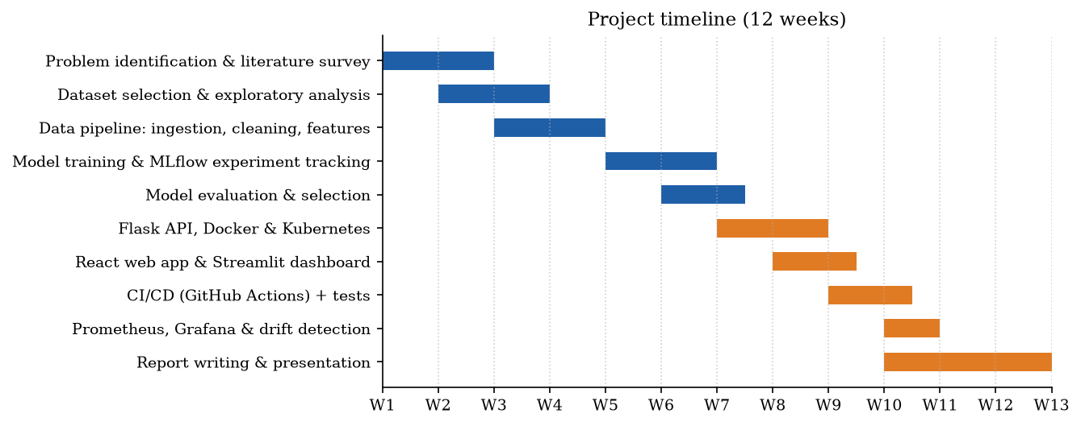
Figure 1.1: Gantt chart of the project timeline

1.5. Organization of the Report
- Chapter 1 introduces the need, the problem, the tasks and the timeline.
- Chapter 2 reviews the history of load forecasting and existing statistical, machine-learning and deep-learning solutions, compares them, and defines the problem and objectives mapped to the course outcomes.
- Chapter 3 evaluates features and constraints (including ethical ones), compares two alternative designs, selects one and presents the implementation methodology.
- Chapter 4 presents the implementation and validates the results: model comparison, tuning, classification metrics, deployment, CI/CD, monitoring and the responsible-AI analysis.
- Chapter 5 concludes, discusses deviations from expectations and lists future work.
- References, Appendix and a step-by-step User Manual follow.

CHAPTER 2.
LITERATURE REVIEW/BACKGROUND STUDY

2.1. Timeline of the reported problem
Table 2.1: Timeline of the reported problem
Period | Milestone
1970s | Box–Jenkins ARIMA methodology becomes the standard for utility-level load forecasting [6].
1992 | Hart introduces Non-Intrusive Load Monitoring, showing household appliance loads can be inferred from aggregate meter data [7].
2000s | Machine-learning regressors (SVR, Random Forest [8], Gradient Boosting [9]) applied to building energy prediction.
2012 | UCI publishes the Individual Household Electric Power Consumption dataset, which becomes a benchmark for household-level forecasting [10].
2015 | Sculley et al. document “hidden technical debt” in production ML systems [4].
2016–2019 | Deep learning (LSTM, CNN-LSTM) applied to household load forecasting [11], [12]; reviews of data-driven building energy prediction published [13].
2018 | MLflow released to manage the ML lifecycle (tracking, projects, registry) [14].
2016–present | Probabilistic forecasting becomes the norm for load forecasting [15]; national smart-meter roll-outs (e.g. India's RDSS) make household data abundant [3].
2023 | MLOps formally defined and its architecture surveyed in IEEE Access [5]; India enacts the Digital Personal Data Protection Act, relevant to smart-meter data [25].

2.2. Existing solutions
Statistical time-series models. ARIMA and exponential smoothing [6], [16] model linear autocorrelation and seasonality. They are interpretable and cheap but assume stationarity and struggle with the abrupt, appliance-driven spikes of a single household.
Classical machine learning. The standard supervised-learning toolkit, namely linear regression, decision trees, k-nearest neighbours, support vector machines and ensembles [21], [22], has been applied to building energy. Fan et al. combined data-mining techniques to predict next-day building consumption and peak demand [17]. Tree ensembles such as random forest [8] and gradient boosting [9], [18] learn non-linear interactions from engineered lag and calendar features and are robust to scale and outliers.
Deep learning. Marino et al. applied sequence-to-sequence LSTMs to the same UCI dataset [11]; Kim and Cho combined CNN and LSTM layers and reported lower error than linear and LSTM baselines [12]. These models capture long dependencies but require more data, GPU training and careful tuning.
MLOps platforms. Kreuzberger et al. describe the components of a production ML system: versioned data and code, experiment tracking, model registry, automated pipelines, serving and monitoring [5]. Ameisen frames the same lifecycle from a product perspective, from prototype to monitored deployment [23]. MLflow [14], DVC and drift-detection methods [19] are widely used building blocks.
The following paragraphs summarise the theory of every algorithm used in this project, following the course textbooks [21]–[23]. Throughout, xₜ is the feature vector of hour t and yₜ the consumption to predict.
Linear regression. Models ŷ = w·x + b and chooses w, b to minimise the sum of squared errors Σ(yₜ − ŷₜ)² (ordinary least squares). It is fast and interpretable, since each weight is the change in consumption per unit of a feature, but it can only represent linear relationships, so interactions such as “evening AND winter” must be engineered by hand. Inputs are standardised so the weights are comparable.
Ridge regression (regularisation). Adds a penalty α·Σw² to the least-squares loss. Large α shrinks the weights towards zero, which reduces variance and the effect of correlated features (the lag and rolling features here are strongly correlated) at the cost of some bias. α is chosen by cross-validation.
Decision tree. Recursively splits the data on the feature and threshold that most reduce the mean squared error of the target in the two child nodes (the CART algorithm); a leaf predicts the mean of its training rows. Trees capture non-linear rules and need no scaling, but an unrestricted tree keeps splitting until every leaf is pure and memorises noise. max_depth and min_samples_leaf limit this and act as regularisation. For classification, splits minimise Gini impurity instead.
K-nearest neighbours (KNN). Predicts the average target of the k training rows closest to the new row in Euclidean distance (optionally weighted by 1/distance). It makes no assumptions about the shape of the relationship, but it is sensitive to feature scale (so inputs are standardised), slow to predict on large data, and small k over-fits while large k under-fits.
Support vector machine for regression (SVR). Fits a function that stays within ε of as many targets as possible while keeping the model as flat as possible; only points outside the ε-tube (support vectors) influence it. The RBF kernel lets it learn non-linear functions. C trades flatness against errors outside the tube. Training cost grows roughly quadratically with the number of rows, which is why SVR is the slowest model here.
Random forest. Averages many decision trees, each grown on a bootstrap sample of the rows and choosing each split from a random subset of features (bagging) [8]. Averaging de-correlated trees reduces variance sharply, so the forest generalises far better than a single tree while keeping its non-linearity.
Gradient boosting. Builds trees sequentially; each new tree is fitted to the residual errors (the negative gradient of the loss) of the current ensemble, and its prediction is added with a small learning rate η [9]. The histogram variant bins each feature into at most 255 values, which makes split finding very fast on tens of thousands of rows [18]. Boosting reduces bias step by step, while the learning rate, number of leaves and L2 penalty control over-fitting.
Logistic regression. For the peak-hour classifier, models the probability of the positive class as σ(w·x + b), where σ is the sigmoid function, and is fitted by maximising the log-likelihood. It serves as the linear reference for the decision-tree classifier.
Model evaluation. Because the data is a time series, ordinary k-fold cross-validation would train on the future and test on the past. TimeSeriesSplit instead creates expanding windows: fold 1 trains on the first sixth of the training period and validates on the next sixth, fold 5 trains on five sixths and validates on the last. GridSearchCV evaluates every hyper-parameter combination on these folds and keeps the one with the best mean score [21], [22].
MLOps building blocks. Version control (Git) tracks code; data and pipeline versioning (DVC) tracks datasets, parameters and outputs by content hash, so any result can be reproduced from a commit. Experiment tracking and model registry (MLflow) records every run's parameters, metrics and model artifacts and numbers model versions. Containerisation (Docker) packages the code with its exact dependencies, and orchestration (Docker Compose, Kubernetes) runs and scales several containers as microservices. CI/CD (GitHub Actions, Vercel) automatically tests, builds and deploys on every change; continuous training re-runs the pipeline on a schedule. Monitoring (Prometheus collects time-series metrics by scraping HTTP endpoints; Grafana visualises them) and drift detection close the loop by telling the team when the model needs retraining [5], [23].

2.3. Bibliometric analysis
Table 2.2: Bibliometric comparison of existing solutions
Work | Approach | Key features | Effectiveness | Drawbacks
Box & Jenkins [6] | ARIMA | Linear autoregression, differencing | Good for aggregate, smooth loads | Poor on volatile single-house data; manual order selection
Fan et al. [17] | Ensemble data mining | Feature selection + multiple regressors | Accurate next-day building forecasts | Commercial buildings; no deployment
Marino et al. [11] | LSTM seq2seq | Learns temporal patterns directly | Competitive on UCI data at hourly scale | Overfits at minute scale; heavy training
Kim & Cho [12] | CNN-LSTM | Convolutional feature extraction + LSTM | Low error on UCI dataset | Black box; GPU cost; no monitoring
Amasyali & El-Gohary [13] | Review | Survey of 60+ studies | Shows ML methods outperform statistical ones in most cases | Notes lack of deployed, maintained systems
Kreuzberger et al. [5] | MLOps architecture | CI/CD/CT, registry, monitoring | Reference architecture | Not specific to energy forecasting

2.4. Review Summary
The literature shows that (i) machine-learning models with good lag and calendar features consistently beat purely statistical models on household data; (ii) deep networks can be marginally more accurate but at much higher training and operational cost; and (iii) almost all published household forecasting work stops at an offline accuracy number, with no serving, automation, monitoring or ethical review. This project therefore compares the standard algorithms under one protocol, tunes them, and wraps the best one in a complete MLOps pipeline, evaluated honestly against naive baselines on a chronological hold-out.

2.5. Problem Definition
What is to be done: build a system that, given the most recent week of hourly smart-meter readings for a household, forecasts the household's mean active power (kW) for each of the next 1–48 hours with a prediction interval, flags likely peak hours, and can be retrained, tested, deployed and monitored automatically.
How it is to be done: using the UCI household dataset, a reproducible DVC pipeline, supervised regression and classification models compared and tuned under MLflow tracking, a Flask REST API packaged with Docker and deployed to the cloud, a GitHub Actions CI/CD workflow, and Prometheus/Grafana and PSI-based monitoring.
What is not to be done: appliance-level disaggregation (NILM), control of household devices, billing integration, or collection of new personal data. Forecasts are for a single household and are not intended for grid-level dispatch or decisions about individuals.

2.6. Goals/Objectives
- Clean and resample the 2.07 M-row dataset into a gap-free hourly series with an auditable data report, including missing-value and outlier analysis.
- Engineer at least 25 features that use only past information (verified by an automated leakage test).
- Train, tune (GridSearchCV) and compare the course algorithms, namely linear regression, decision tree, KNN, SVM and random forest, under experiment tracking on a strict chronological split.
- Beat the persistence baseline on the held-out test period by at least 15% in MAE.
- Build a peak-hour classifier and report accuracy, precision, recall, F1, the confusion matrix and ROC.
- Serve predictions through a Flask REST API with input validation and response time under 1 s, containerised with Docker and deployed to a cloud platform.
- Automate pipeline, quality gates, tests and container build with CI/CD; version data and models with DVC.
- Monitor the service with Prometheus and Grafana, log predictions, and detect drift (PSI > 0.2).
- Analyse fairness, transparency, privacy and security of the system.
Table 2.3 maps these objectives to the course outcomes of MLOps-1 (25CSH-320).
Table 2.3: Mapping of project objectives to course outcomes
Course outcome | How the project addresses it | Section
CO1: ML fundamentals, types, applications | Supervised regression and classification applied to a real energy-sector problem; algorithm survey | 1.1, 2.2
CO2: Preprocessing, feature engineering, data handling | Missing values, IQR outliers, resampling, scaling, 31 engineered features, chronological split | 3.1, 3.3, 4.1
CO3: Develop and evaluate models with various algorithms | 9 regressors and 3 classifiers, GridSearchCV with time-series CV, over/under-fitting analysis, MSE/MAE/R² and accuracy/precision/recall/F1/ROC | 3.6, 4.1
CO4: Deploy with APIs, microservices and cloud | Flask REST API, Docker Compose microservices, Kubernetes manifests, Vercel cloud deployment | 4.1
CO5: CI/CD and ethical considerations | GitHub Actions + DVC + Vercel CD; fairness, transparency, privacy and security analysis; model card | 3.2, 4.1

CHAPTER 3.
DESIGN FLOW/PROCESS

3.1. Evaluation & Selection of Specifications/Features
Dataset. The UCI dataset [10] contains 2,075,259 one-minute measurements from 2006-12-16 to 2010-11-26 for one house in Sceaux, France: global active and reactive power, voltage, current intensity and three sub-meters (kitchen; laundry room; electric water heater and air conditioner). It was chosen because it is public, long enough to cover four winters, contains real gaps, and mirrors the load-profile channels exposed by IEC 62056 smart meters. It is stored as a single CSV file versioned with DVC. Figures 3.1–3.3 summarise the exploratory analysis.
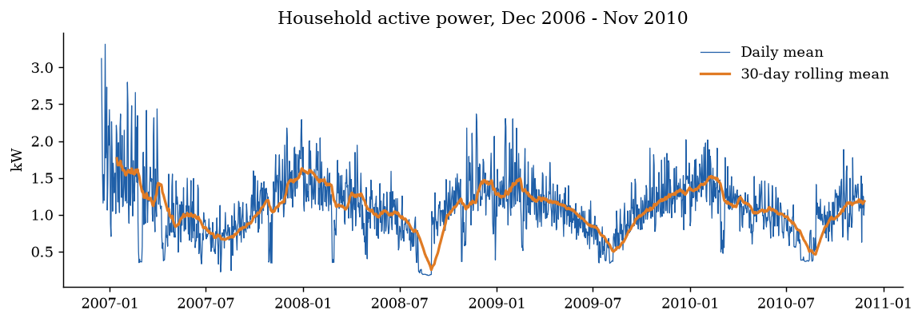
Figure 3.1: Daily mean active power with 30-day rolling mean (strong yearly seasonality)
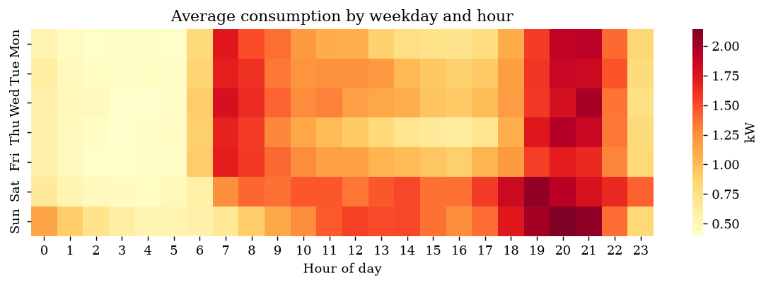
Figure 3.2: Average consumption by weekday and hour (morning and evening peaks)
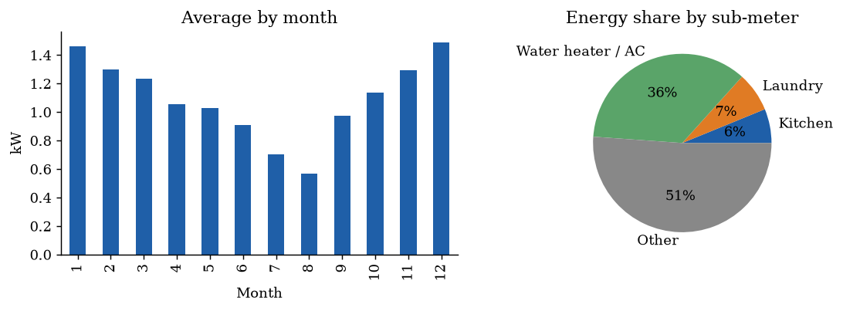
Figure 3.3: Monthly pattern and share of energy per sub-meter
The EDA shows a strong winter peak (consumption roughly doubles from August to December), two daily peaks around 07:00 and 20:00–21:00, higher daytime use at weekends, and an August holiday dip.
Figures 3.4–3.10 extend the analysis. Missing readings are concentrated in a few months, the worst being 2010-08 with 16.19% missing (long outages), which justified the two-step gap filling below. All variables are right-skewed, with many low-consumption hours and a long tail of peaks. The autocorrelation of hourly consumption is 0.713 at one hour, with repeating peaks every 24 hours (0.436 at 24 h, 0.466 at one week), which is why the lag features at 1, 24 and 168 hours were chosen.
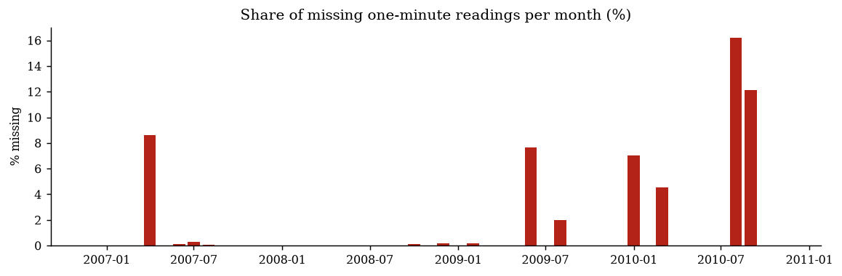
Figure 3.4: Share of missing one-minute readings per month
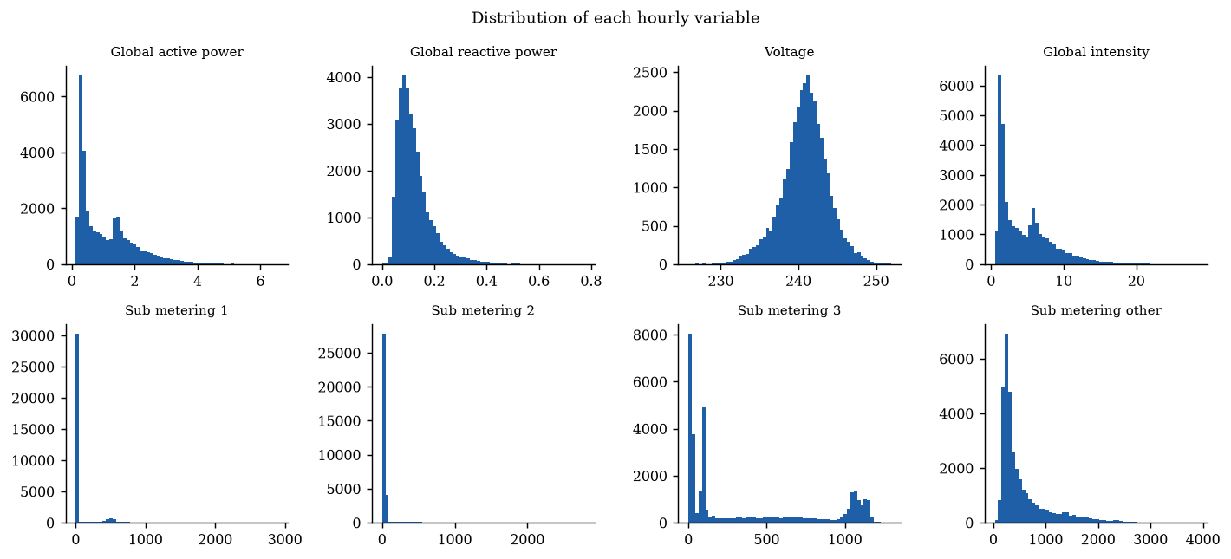
Figure 3.5: Distribution of each hourly variable
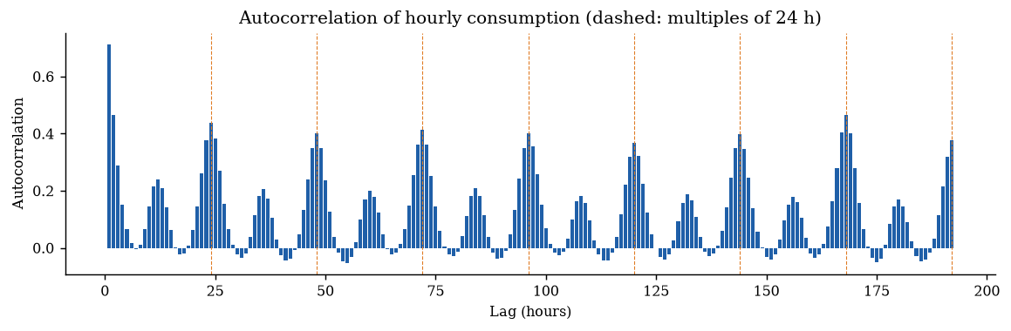
Figure 3.6: Autocorrelation of hourly consumption up to eight days
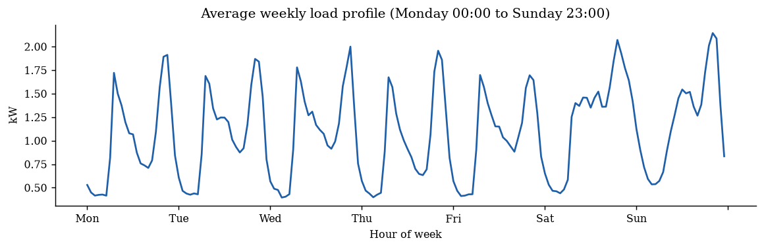
Figure 3.7: Average weekly load profile
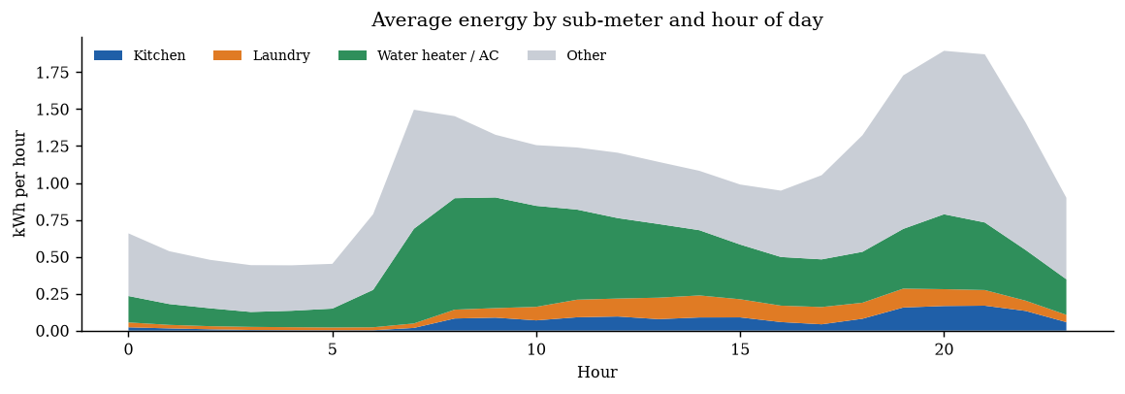
Figure 3.8: Average energy by sub-meter and hour of day
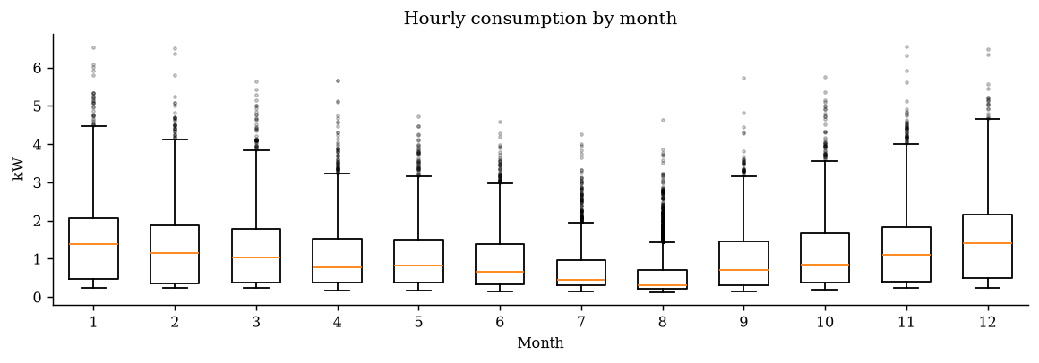
Figure 3.9: Hourly consumption by month (box plots)
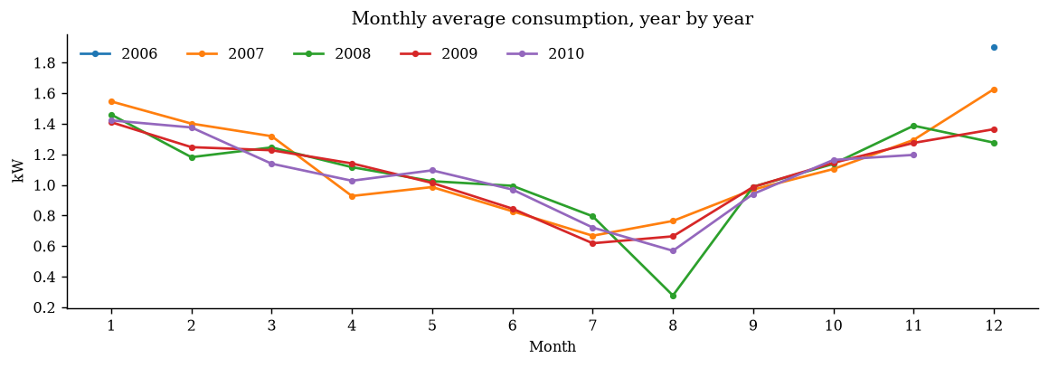
Figure 3.10: Monthly average consumption, year by year
Table 3.1: Descriptive statistics of the hourly data
Variable | Mean | Std | Min | 25% | Median | 75% | Max
Global active power | 1.089 | 0.896 | 0.124 | 0.341 | 0.800 | 1.577 | 6.561
Global reactive power | 0.124 | 0.067 | 0.000 | 0.078 | 0.107 | 0.149 | 0.774
Voltage | 240.845 | 2.997 | 225.835 | 239.197 | 240.985 | 242.694 | 251.902
Global intensity | 4.618 | 3.752 | 0.503 | 1.510 | 3.410 | 6.590 | 28.383
Sub metering 1 | 67.337 | 212.318 | 0.000 | 0.000 | 0.000 | 0.000 | 2902.000
Sub metering 2 | 77.757 | 251.090 | 0.000 | 0.000 | 20.000 | 39.000 | 2786.000
Sub metering 3 | 386.775 | 440.533 | 0.000 | 39.000 | 99.000 | 848.000 | 1293.000
Sub metering other | 556.394 | 494.912 | 27.600 | 260.667 | 343.700 | 662.567 | 3890.233

Outliers. With the inter-quartile-range rule (outside Q1 − 1.5·IQR … Q3 + 1.5·IQR), 738 hourly values of active power (2.13%) lie above 3.431 kW (Figure 3.11). These are genuine peak-usage hours (heaters, ovens), exactly the hours the forecaster must learn, so they are kept rather than removed. Instead, distance- and margin-based models (KNN, SVM) receive standardised inputs so that large-valued columns do not dominate.
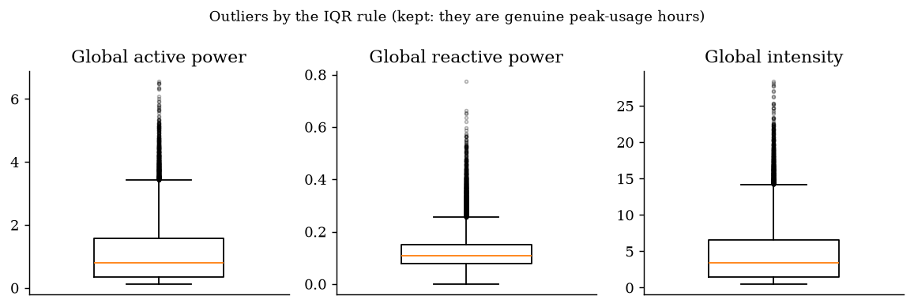
Figure 3.11: Box plots of hourly readings; points beyond the whiskers are IQR outliers
These findings drove the feature specification in Table 3.2.
Table 3.2: Selected feature specification (31 features)
Feature group | Features | Rationale
Autoregressive lags | lag 1, 2, 3, 6, 12, 24, 48, 168 h | Short-term persistence, same hour yesterday and last week
Rolling statistics | mean and std over 3, 6, 24, 168 h | Recent level and volatility
Calendar | hour, weekday, month, weekend, French public holiday | Routines and seasonality
Cyclical encodings | sin/cos of hour and month | 23:00 and 00:00 are neighbours
Electrical context (t−1) | reactive power, voltage, intensity, 3 sub-meters | Which appliances were active

3.2. Design Constraints
Table 3.3: Design constraints
Constraint | Consideration in the design
Standards | ML life-cycle stages follow ISO/IEC 23053; software quality attributes of ISO/IEC 25010 (reliability, maintainability) drive testing and modularity; metrics exposed in the OpenMetrics format.
Economic / Cost | Must run on a student laptop, free CI runners and a free cloud tier: no GPU, only open-source tools (scikit-learn, MLflow, DVC, Flask, Docker, Prometheus, Grafana).
Environmental | Low-compute models reduce the energy footprint of retraining; the purpose of the system is itself to support energy saving (ISO 50001 spirit).
Health & Safety | Advisory system only: it never switches appliances, so incorrect forecasts cannot cause physical harm.
Professional / Ethical | Honest evaluation against naive baselines on unseen future data; no data leakage; limitations and error differences between groups of hours are disclosed (model card).
Fairness & bias | The data comes from one French household (2006–2010); quality of service is measured across day type, time of day, season and usage level; the model is not claimed to generalise to other homes or climates without re-validation.
Privacy | Fine-grained meter data can reveal occupancy and routines. Only a public anonymised dataset is used; the prediction log stores forecasts, never submitted readings; deployment on real data must follow India's Digital Personal Data Protection Act, 2023 [25].
Security | All API input is validated (types, ranges, minimum history, duplicates); request size is limited; only models produced by this pipeline are loaded; rejected requests are monitored.
Manufacturability / Deployability | Must be reproducible on any machine: pinned configuration, DVC pipeline and lock file, Docker image, single-command reproduction.
Regulatory | Indian smart meters follow IS 16444; the API input schema maps to the hourly load profile such meters provide.

3.3. Analysis of Features and finalization subject to constraints
- Removed: minute-level forecasting. At one-minute resolution the series is dominated by appliance switching noise; hourly resolution matches billing and demand-response use and reduces data 60×.
- Removed: weather features. They would improve accuracy but no free, historical, hourly weather feed for Sceaux 2006–2010 could be integrated within the cost constraint.
- Removed: deep LSTM model as the production candidate, due to the no-GPU and explainability constraints (kept as future work).
- Modified: missing data handling. Gaps up to 6 h are time-interpolated; longer outages are filled with the same hour of the previous week to preserve the daily profile.
- Modified: outliers are reported and kept (they are real peaks); feature scaling is applied only where the algorithm needs it (linear models, KNN, SVM).
- Added: a peak-hour classifier, because demand response needs a yes/no alert as well as a number.
- Added: prediction intervals (±1.96σ_r√h) so users can see forecast uncertainty.
- Added: automated leakage test, quality gates in CI, and a bias analysis across groups of hours to satisfy the professional/ethical constraints.

3.4. Design Flow
Two alternative designs were developed to meet the specification (Figure 3.12).
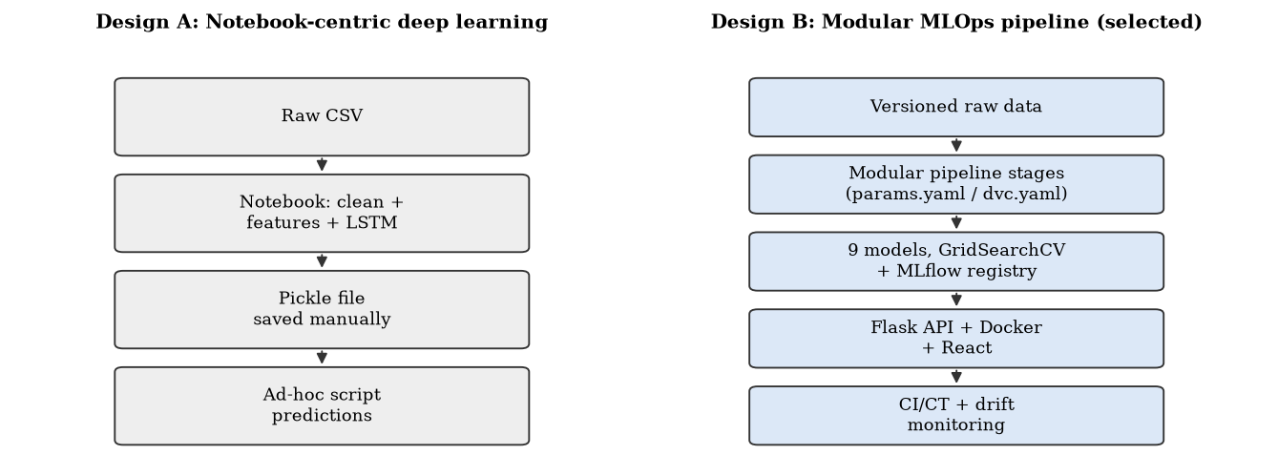
Figure 3.12: Alternative designs considered
Design A – Notebook-centric deep learning. All steps (cleaning, features, an LSTM model) live in a single Jupyter notebook. The trained network is pickled manually and predictions are produced with an ad-hoc script. This is the typical approach in the literature [11], [12].
Design B – Modular MLOps pipeline. Each stage is an independent, tested Python module driven by one configuration file (params.yaml) and declared as a DVC pipeline. All course algorithms are compared and tuned under MLflow tracking; the best is registered and served by a Flask REST API in Docker, deployed to the cloud behind a React web app; GitHub Actions automates the pipeline, and Prometheus, Grafana and a drift monitor close the loop.

3.5. Design selection
Table 3.4: Comparison of alternative designs
Criterion | Design A | Design B
Expected accuracy | High (with tuning) | High (random forest, a syllabus algorithm)
Training cost / hardware | GPU preferred, minutes–hours | CPU, about 4 min including tuning
Reproducibility | Low: hidden notebook state | High: params.yaml + DVC + Docker
Experiment tracking | Manual | Automatic (MLflow)
Deployment | Manual script | Flask API + container + cloud + web app
Testing / CI | None | 11 automated tests, CI quality gates
Monitoring & retraining | None | Prometheus, Grafana, PSI drift, weekly CT
Explainability & ethics | Low | Feature importance, bias analysis, model card
Fit with constraints | Violates cost & reproducibility | Satisfies all

Design B is selected. It meets every constraint in Section 3.2, its accuracy is competitive, and it delivers the operational capabilities (automation, deployment, monitoring, responsible AI) that are the core outcomes of the course and that the literature identifies as missing.

3.6. Implementation plan/methodology
Figure 3.13 shows the algorithm executed by the pipeline and Figure 3.14 the detailed block diagram.
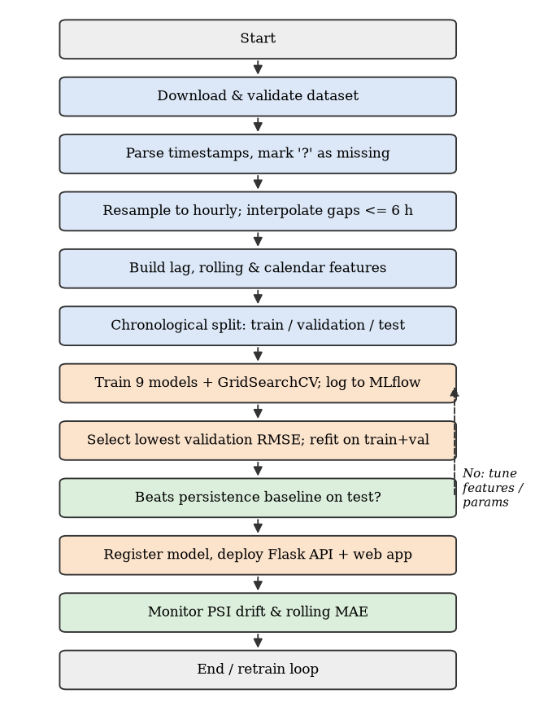
Figure 3.13: Flowchart of the training and deployment algorithm
Figure 3.14: Detailed block diagram of the MLOps architecture
The system is further described by a context data-flow diagram (Figure 3.15), a level-1 data-flow diagram showing processes and data stores (Figure 3.16), a use-case diagram (Figure 3.17), a sequence diagram of a forecast request (Figure 3.18), the deployment diagram (Figure 3.19), the CI/CD pipeline (Figure 3.20) and the DVC stage graph (Figure 3.21).
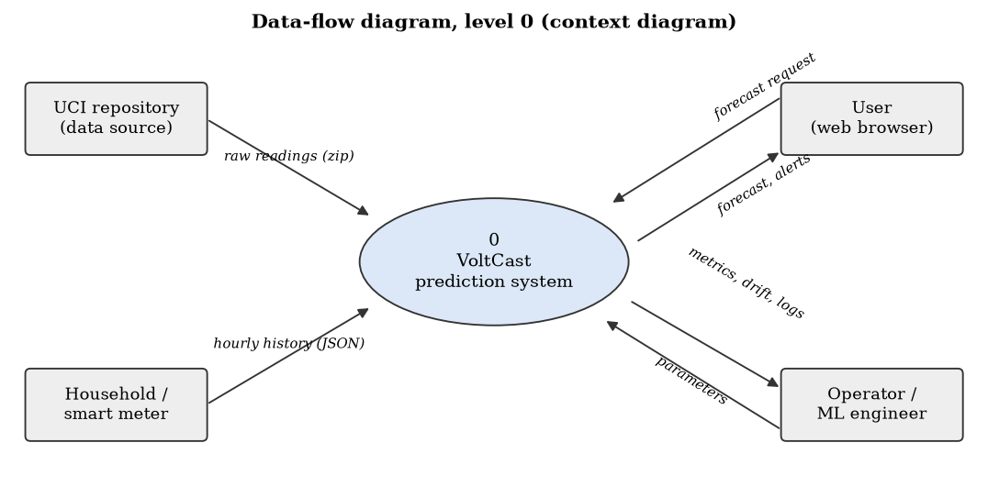
Figure 3.15: Data-flow diagram, level 0 (context)
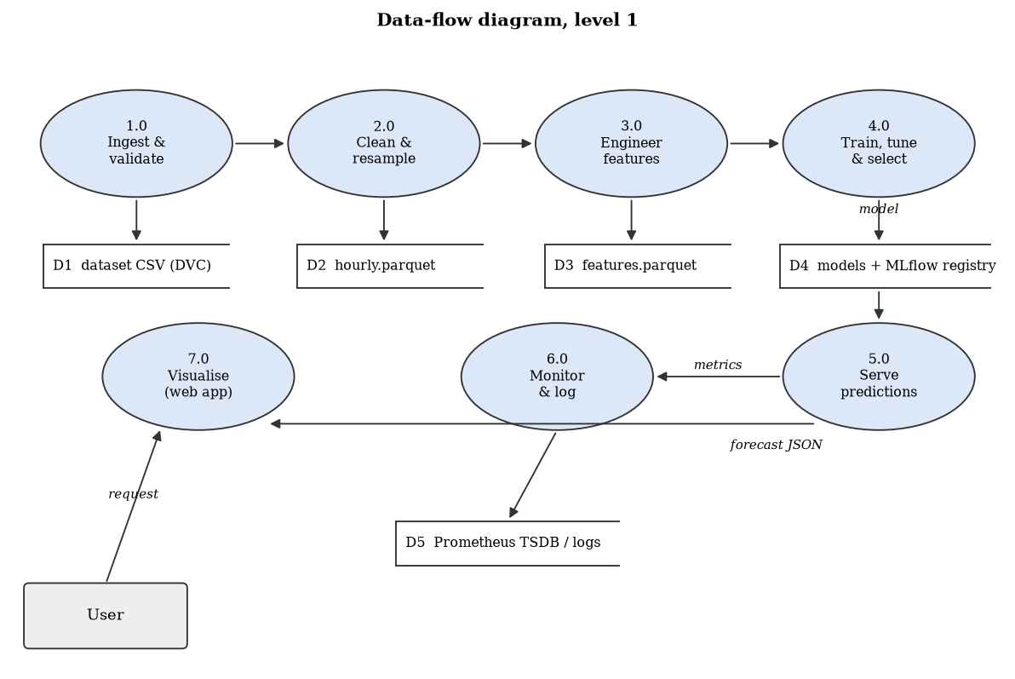
Figure 3.16: Data-flow diagram, level 1
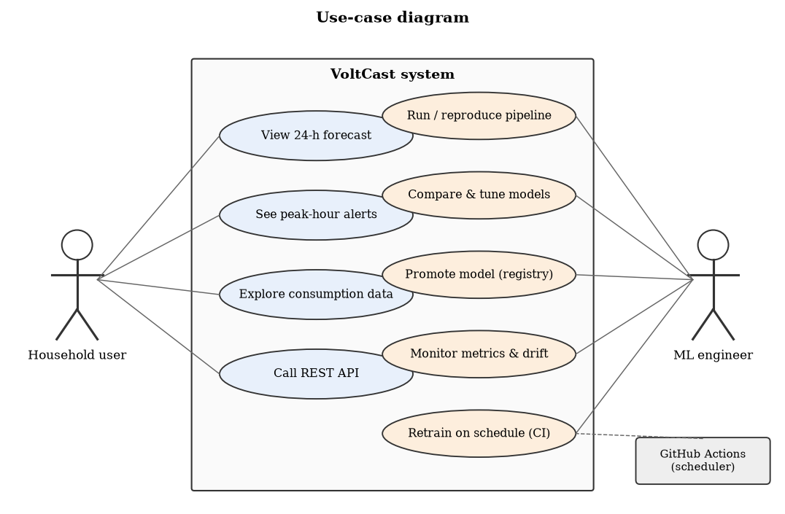
Figure 3.17: Use-case diagram
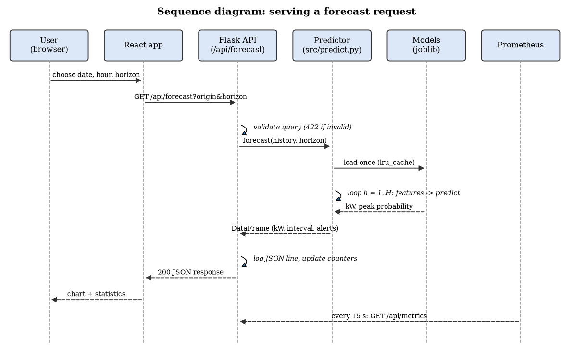
Figure 3.18: Sequence diagram: serving a forecast request
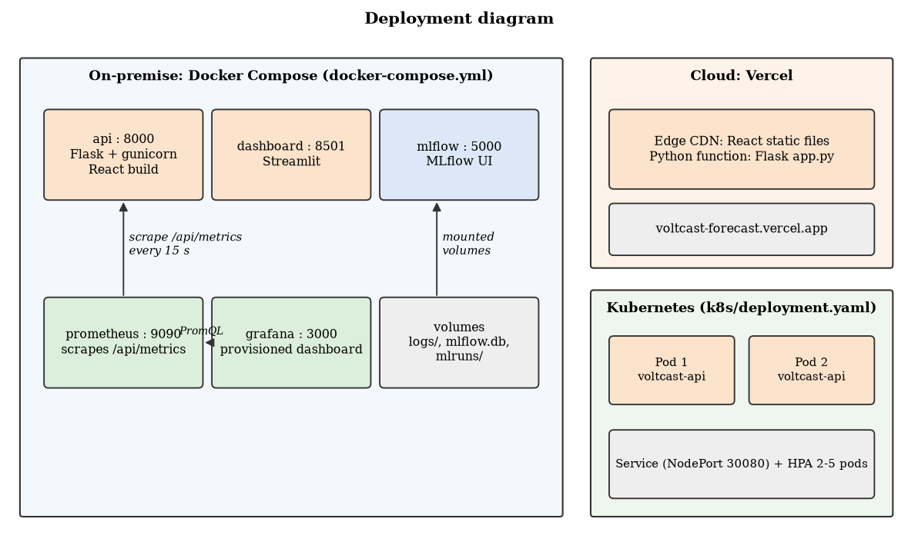
Figure 3.19: Deployment diagram: Docker Compose, Vercel and Kubernetes
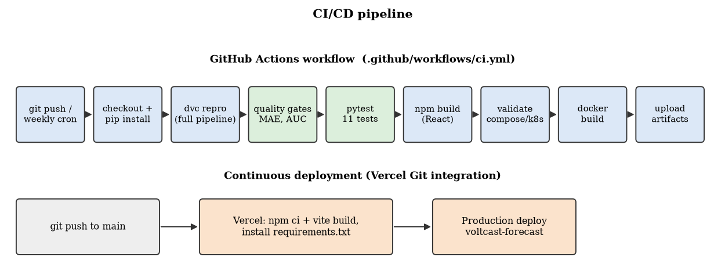
Figure 3.20: CI/CD pipeline
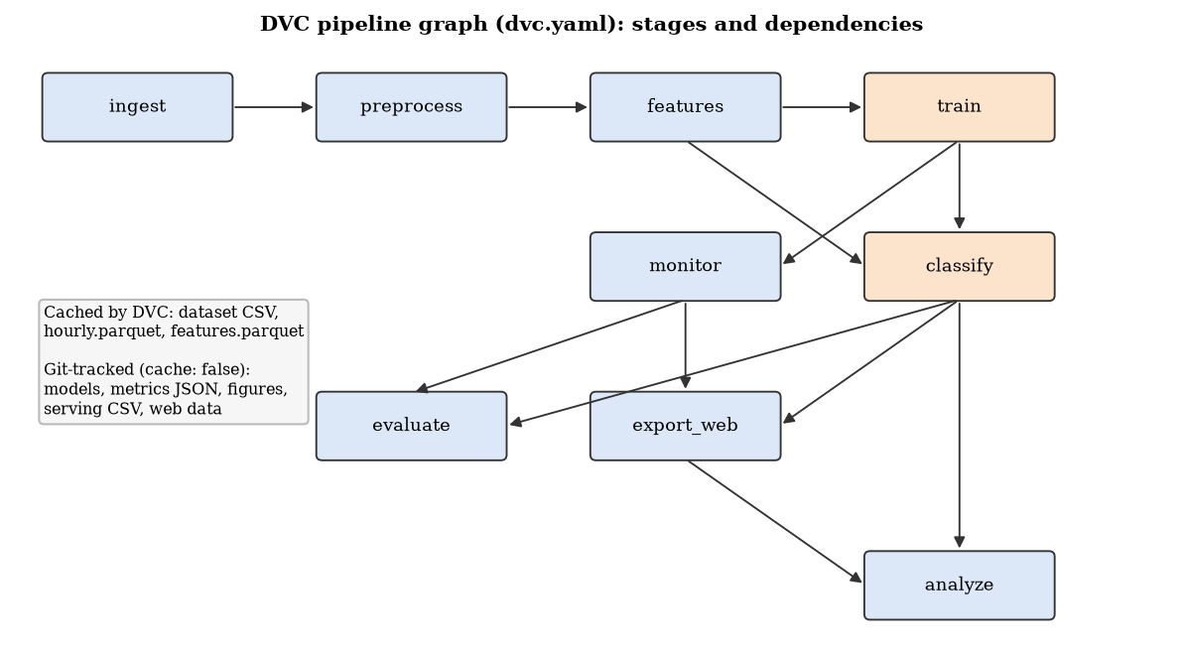
Figure 3.21: DVC pipeline graph
Each pipeline stage follows its own algorithm, shown as flowcharts in Figures 3.22–3.26.
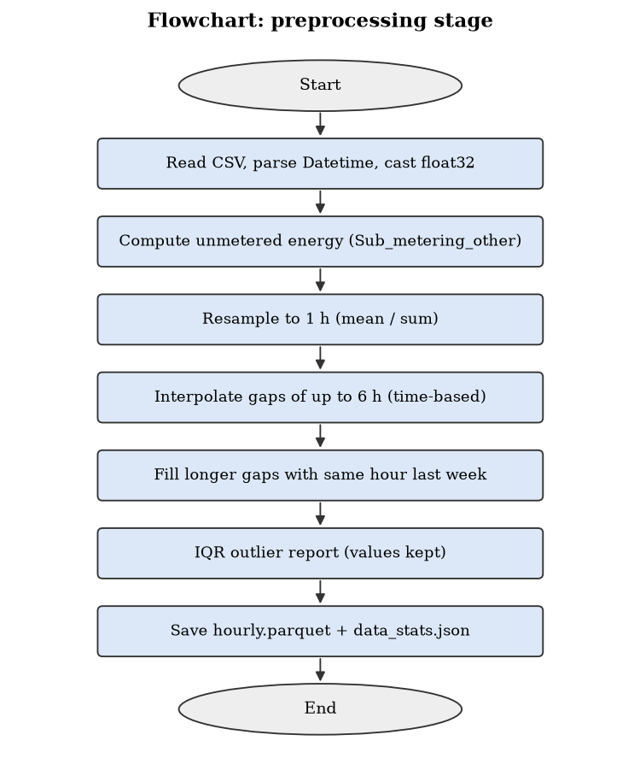
Figure 3.22: Flowchart of the preprocessing stage
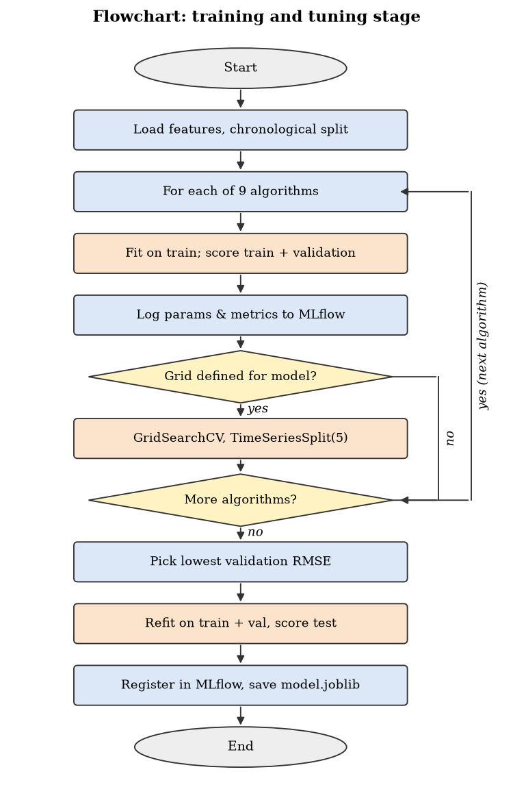
Figure 3.23: Flowchart of the training and tuning stage
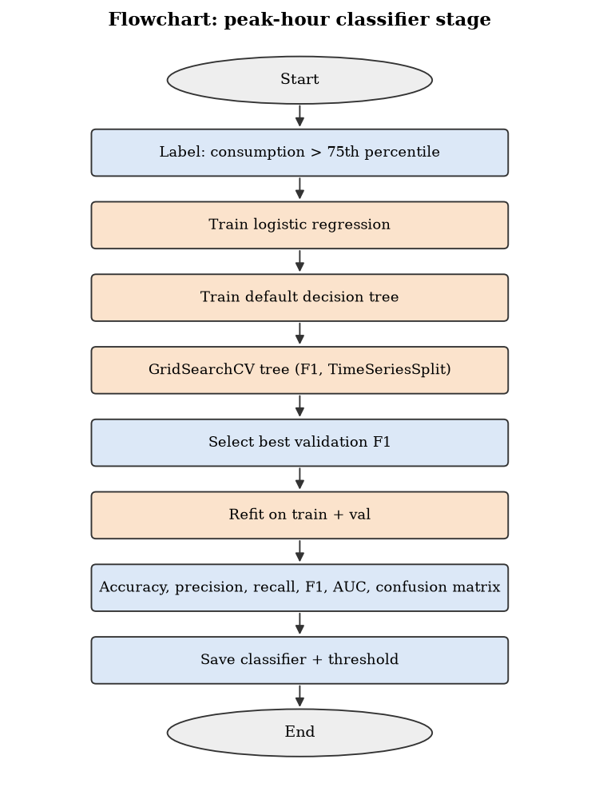
Figure 3.24: Flowchart of the peak-hour classifier stage
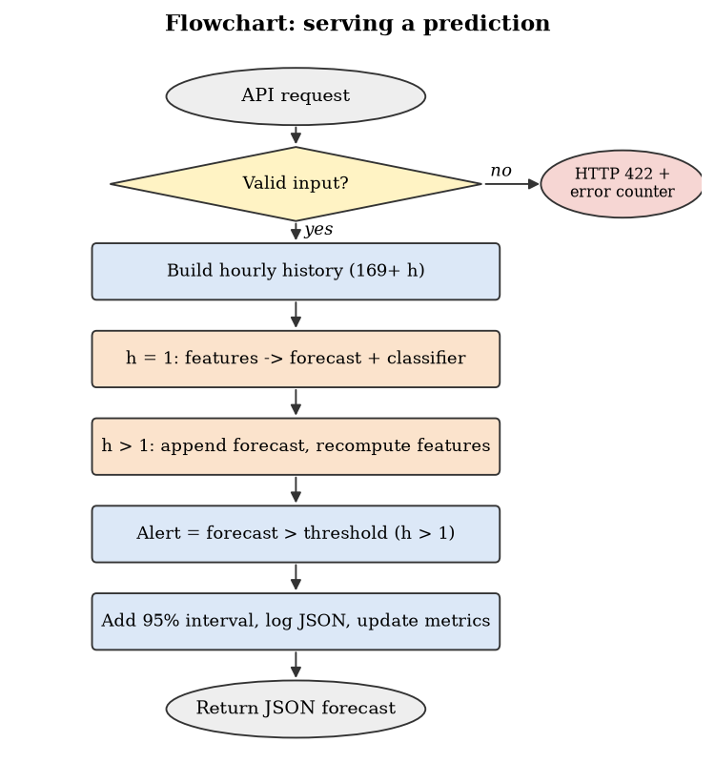
Figure 3.25: Flowchart of serving a prediction
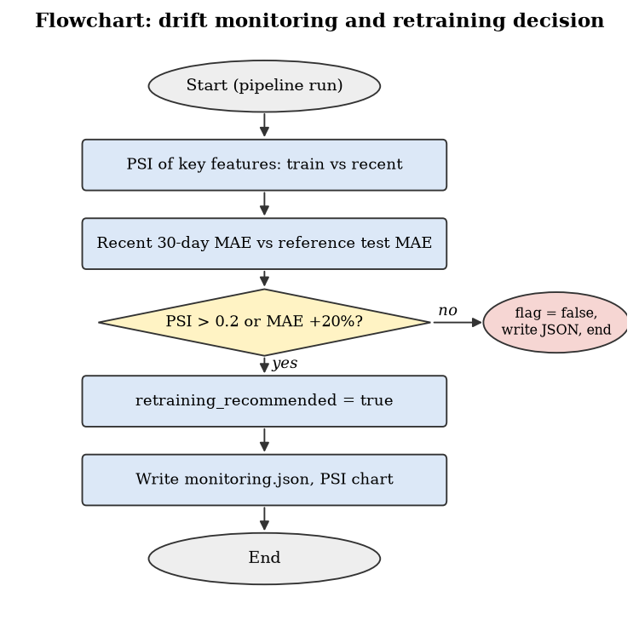
Figure 3.26: Flowchart of drift monitoring and the retraining decision
Data split. To respect time ordering, data is split chronologically: training up to 31 Dec 2009 (26,503 h), validation Jan–May 2010 (3,624 h) and test 2010-06-01 to 2010-11-26 (4,294 h). Models are selected on validation, refit on train+validation, and scored once on test. A random split is deliberately avoided: it would leak future information into training and overstate accuracy.
Regression models. Persistence (ŷₜ = yₜ₋₁) and seasonal-naive (ŷₜ = yₜ₋₂₄) baselines; linear regression and ridge regression (standardised inputs); decision tree; k-nearest neighbours (k = 10, standardised); support vector regression (RBF kernel, C = 1, ε = 0.1, standardised); random forest (200 trees, depth 16, minimum 5 rows per leaf) [8]; and, as a reference model outside the syllabus, histogram gradient boosting (500 iterations, η = 0.05, 31 leaves) [9], [18]. All are implemented with scikit-learn [20].
Model selection rule. All models are compared, but only the algorithms of the MLOps-1 syllabus (linear and ridge regression, decision tree, KNN, SVM and random forest) may be deployed. Among them the variant (default or tuned) with the lowest validation RMSE is chosen. Gradient boosting and the two naive baselines are reported as reference points, so the cost of this rule can be measured (Section 4.1.5).
Hyper-parameter tuning. GridSearchCV searches the grids in params.yaml using TimeSeriesSplit with five folds, so every fold trains on the past and validates on the following period, which is the time-series form of cross-validation [21]. Tuned and default variants are both compared on the validation window; regularisation is controlled through ridge α, tree depth and minimum leaf size.
Peak-hour classification. An hour is labelled a peak hour when consumption exceeds τ = 1.59 kW, the 75th percentile of training consumption. Logistic regression, a default decision tree and a GridSearchCV-tuned decision tree (F1 scoring, balanced class weights allowed) are compared on validation F1.
Metrics. Regression: MAE = (1/n)Σ|yₜ − ŷₜ|, MSE = (1/n)Σ(yₜ − ŷₜ)², RMSE = √MSE, R² and MAPE; RMSE selects the model because peak errors matter most for demand response. Classification: accuracy = (TP+TN)/n, precision = TP/(TP+FP), recall = TP/(TP+FN), F1 = harmonic mean of precision and recall, plus the confusion matrix and ROC-AUC [21], [22].
Monitoring. PSI = Σ(qᵢ − pᵢ)·ln(qᵢ/pᵢ) over 10 quantile bins of the training distribution; PSI > 0.2 signals significant drift. Retraining is recommended when any key feature drifts or recent 30-day MAE degrades more than 20%. At run time Prometheus scrapes request, latency, forecast and alert counters from the API every 15 s.
Table 3.5: Software modules of the implementation
Module | Responsibility
src/data_ingestion.py | Download the UCI archive, convert to CSV, verify schema
src/preprocess.py | Parse, fill gaps, resample hourly, IQR outlier report
src/features.py | Build 31 leakage-free features
src/train.py | 9 regressors, GridSearchCV, MLflow tracking and model registry
src/classify.py | Peak-hour classifier and classification metrics
src/monitor.py | PSI drift and performance degradation, retraining decision
src/evaluate.py | EDA, diagnostics, validation curve, classification and bias figures
src/predict.py | Recursive multi-step forecasting with intervals and peak alerts
serving/main.py, app.py | Flask REST API, Pydantic validation, Prometheus metrics, prediction log
web/ (React), dashboard/app.py | Web application (Vercel) and Streamlit dashboard
monitoring/, docker-compose.yml, k8s/ | Prometheus, Grafana, five-service stack, Kubernetes manifests
dvc.yaml, .github/workflows/ci.yml | Versioned pipeline and CI/CD automation
tests/test_pipeline.py | 11 unit, leakage, classification, API and monitoring tests

CHAPTER 4.
RESULTS ANALYSIS AND VALIDATION

4.1. Implementation of solution
Modern tools used. Analysis: pandas, NumPy, Matplotlib, Seaborn, Plotly. Design drawings: architecture, flow and Gantt diagrams generated in Matplotlib. Modelling: scikit-learn. Experiment management and versioning: MLflow (tracking and model registry), DVC, Git/GitHub. Deployment: Flask, gunicorn, Docker, Docker Compose, Kubernetes manifests, Vercel. Operations: GitHub Actions, Prometheus, Grafana. Testing and validation: pytest, PSI drift analysis. Report preparation: python-docx, generated directly from pipeline outputs, so every number in this chapter is reproducible with dvc repro.

4.1.1. Data preparation
1.252% of minute readings were missing ('?'). After cleaning and hourly resampling the series has 34,589 gap-free records with mean 1.09 kW (median 0.80 kW, max 6.56 kW). Feature building drops the first 168 h (needed for the weekly lag), leaving 34,421 modelling rows. Figure 4.1 shows that current intensity is almost perfectly correlated with active power, while voltage is weakly negatively correlated.
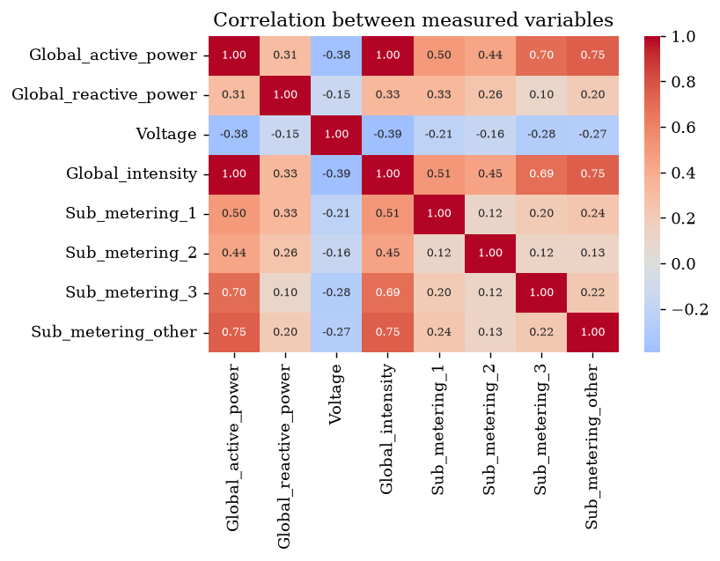
Figure 4.1: Correlation matrix of the measured variables

4.1.2. Model development and comparison
Table 4.1 compares all nine regression models with default hyper-parameters; every run is logged in MLflow (Figure 4.3 in this section shows the tracking UI).
Table 4.1: Training and validation performance of all models (default hyper-parameters)
Model | Train MAE | Val MAE | Val MSE | Val RMSE | Val R² | Fit (s)
Persistence baseline | 0.449 | 0.441 | 0.447 | 0.669 | 0.364 | 0.0
Seasonal naive (24 h) | 0.663 | 0.636 | 0.832 | 0.912 | -0.184 | 0.0
Linear regression | 0.409 | 0.398 | 0.310 | 0.557 | 0.559 | 0.0
Ridge regression | 0.409 | 0.398 | 0.310 | 0.557 | 0.559 | 0.0
Decision tree | 0.000 | 0.506 | 0.602 | 0.776 | 0.142 | 0.8
K-nearest neighbours (KNN) | 0.347 | 0.395 | 0.321 | 0.566 | 0.544 | 0.0
Support vector machine (SVR) | 0.296 | 0.355 | 0.282 | 0.531 | 0.598 | 47.4
Random forest | 0.220 | 0.345 | 0.259 | 0.509 | 0.632 | 8.9
Histogram gradient boosting | 0.289 | 0.341 | 0.248 | 0.498 | 0.647 | 1.7

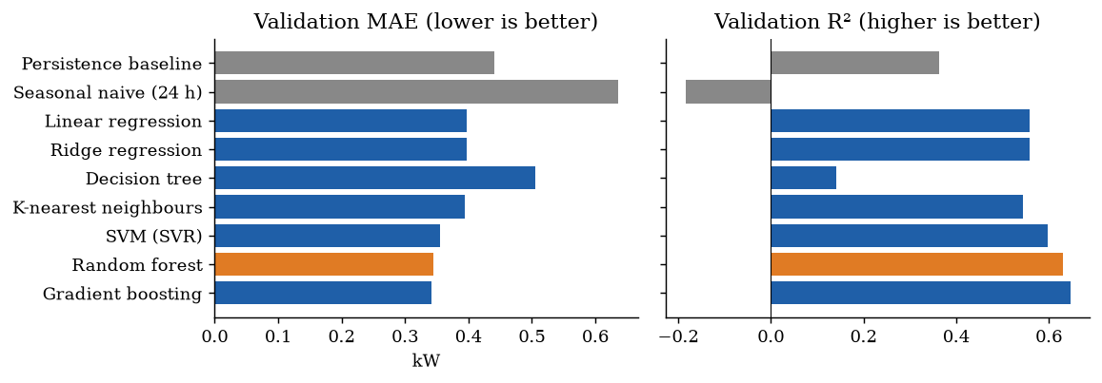
Figure 4.2: Validation MAE and R² of all models (deployed model in orange, baselines in grey)
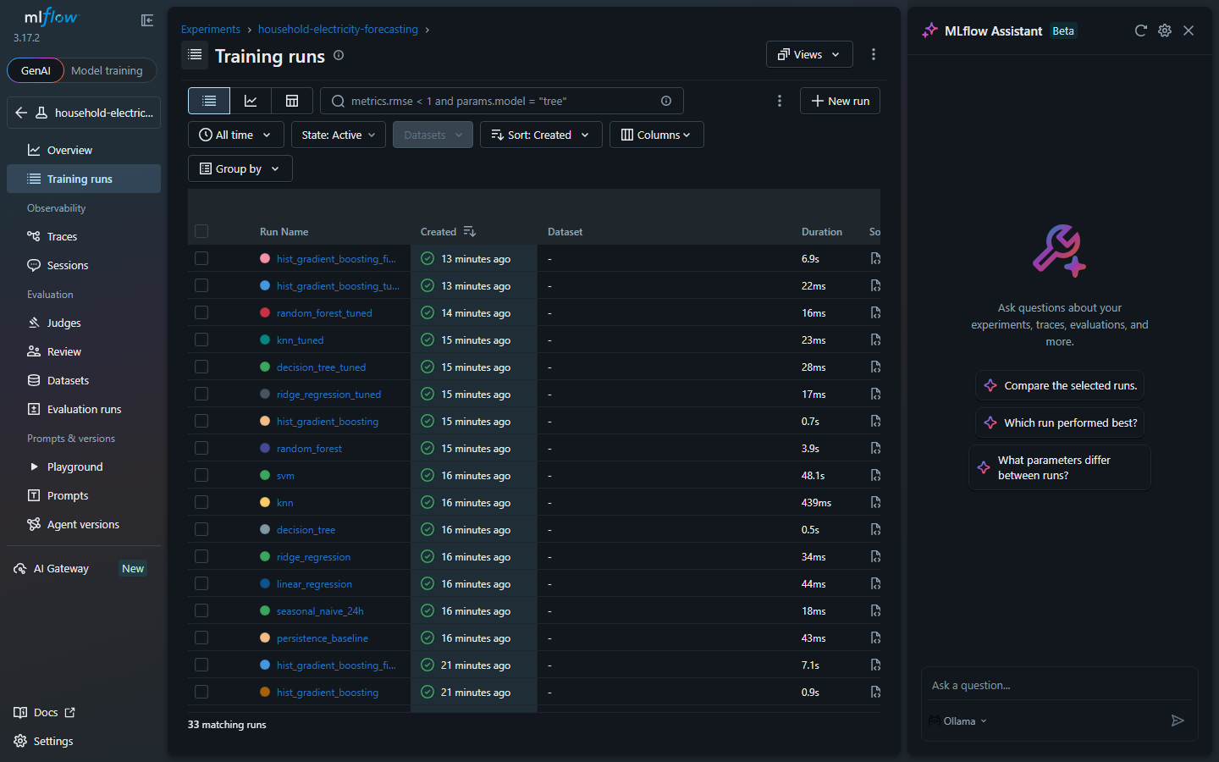
Figure 4.3: MLflow tracking UI: runs of every model, tuned variant and final model
Among the syllabus algorithms, random forest has the lowest validation RMSE (0.509 kW), followed by the SVM (0.531 kW); it is therefore the deployed model. The reference gradient-boosting model is slightly lower still (0.498 kW), a difference of 0.010 kW. Linear and ridge regression are identical at α = 1 and form a strong linear reference (R² 0.559). The seasonal-naive model has negative R²: yesterday's same hour is a worse predictor than the mean, which confirms that household load is driven by irregular routines.

4.1.3. Over-fitting, under-fitting and regularisation
Figure 4.4 compares training and validation error. The default decision tree has a training MAE of 0.000 kW (it memorises every training hour) but the worst validation MAE of the machine-learning models (0.506 kW): a textbook case of over-fitting. Linear regression shows the opposite pattern, with training and validation errors almost equal, indicating mild under-fitting. The validation curve in Figure 4.5 shows both regimes for the tree: shallow trees under-fit, deep trees over-fit, and the best depth lies in between.
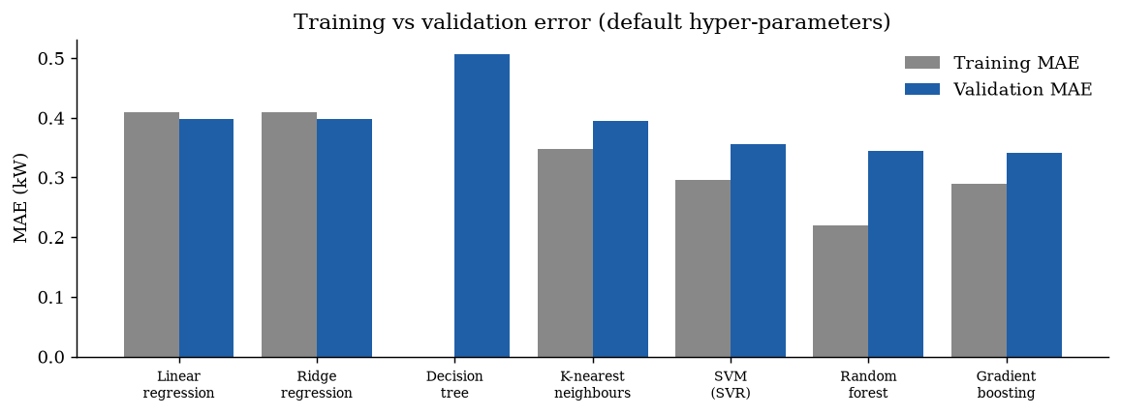
Figure 4.4: Training vs validation MAE of each model (default hyper-parameters)
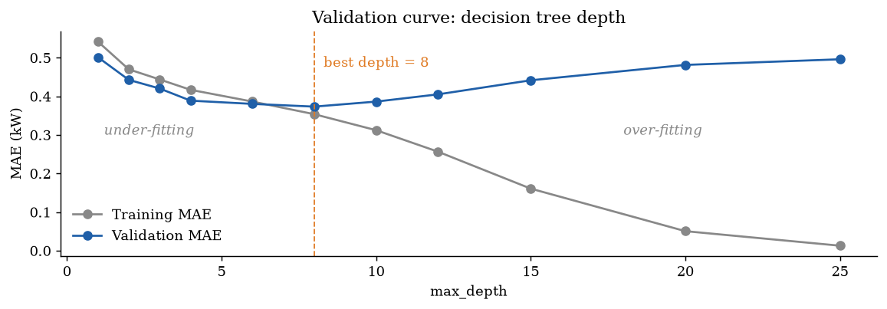
Figure 4.5: Validation curve of the decision tree: error against max_depth
Learning curves (Figure 4.6) show how training and cross-validation error change as the models see more history. For linear regression both curves meet quickly at a high error, the signature of under-fitting (more data does not help). The unrestricted decision tree keeps a near-zero training error and a large gap, the signature of over-fitting. Random forest and gradient boosting narrow the gap as data grows (gradient boosting CV MAE 0.562 → 0.435 kW), so more historical data would still help them.
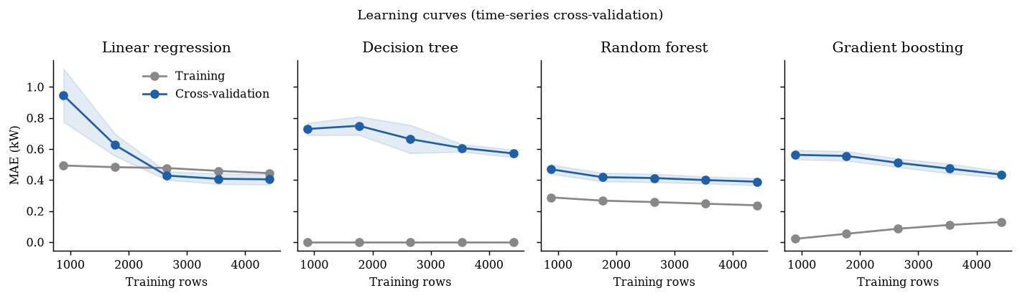
Figure 4.6: Learning curves with time-series cross-validation

4.1.4. Hyper-parameter tuning with GridSearchCV
Table 4.2 lists the GridSearchCV results (five time-series folds on the training period).
Table 4.2: Hyper-parameter tuning results
Model | Best parameters | Grid size | CV MAE | Val MAE default | Val MAE tuned
Ridge regression | alpha=100.0 | 5 | 0.403 | 0.398 | 0.398
Decision tree | max_depth=10, min_samples_leaf=100 | 24 | 0.397 | 0.506 | 0.380
K-nearest neighbours (KNN) | n_neighbors=40, weights=distance | 8 | 0.406 | 0.395 | 0.388
Random forest | max_depth=16, min_samples_leaf=20 | 9 | 0.368 | 0.345 | 0.348
Histogram gradient boosting | learning_rate=0.03, max_leaf_nodes=15 | 9 | 0.363 | 0.341 | 0.344

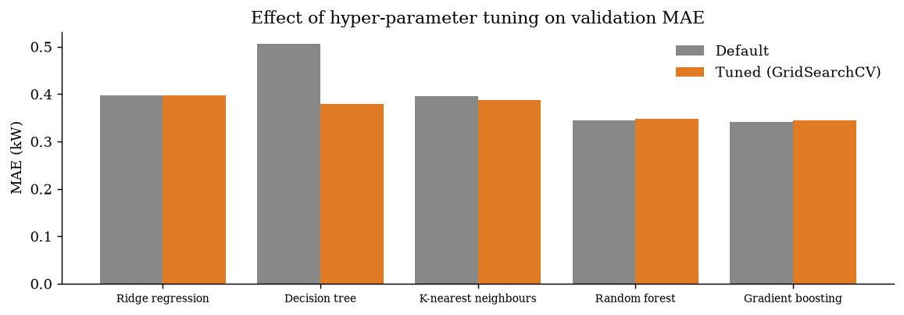
Figure 4.7: Validation MAE before and after GridSearchCV tuning
Figure 4.8 shows how the error responds to individual hyper-parameters. The decision-tree heat map covers the whole GridSearchCV grid: deep trees with tiny leaves are worst, and a large minimum leaf size makes depth almost irrelevant. KNN improves steadily from k = 1 (validation MAE 0.523) to k = 80 (0.389). Ridge is flat until α becomes very large, when strong regularisation starts to under-fit.
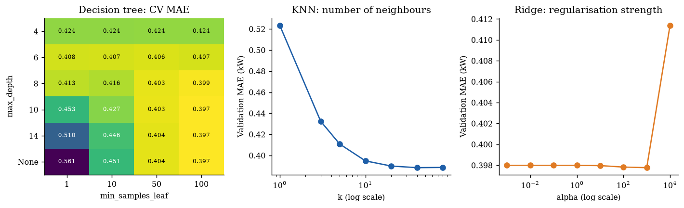
Figure 4.8: Hyper-parameter response: decision-tree grid, KNN neighbours, ridge alpha
Table 4.3 and Figure 4.9 give the error in each time-series fold for the tuned models. Every model is worse in fold 2, whose validation window is a winter period with high, variable consumption, and the ranking of models is consistent across folds, which supports the model choice.
Table 4.3: Cross-validation MAE (kW) per time-series fold, tuned models
Model | Fold 1 | Fold 2 | Fold 3 | Fold 4 | Fold 5 | Mean | Std
Ridge regression | 0.431 | 0.445 | 0.370 | 0.402 | 0.367 | 0.403 | 0.035
Decision tree | 0.437 | 0.452 | 0.353 | 0.389 | 0.353 | 0.397 | 0.046
K-nearest neighbours (KNN) | 0.473 | 0.443 | 0.371 | 0.394 | 0.348 | 0.406 | 0.051
Random forest | 0.405 | 0.414 | 0.342 | 0.356 | 0.322 | 0.368 | 0.040
Histogram gradient boosting | 0.391 | 0.428 | 0.332 | 0.347 | 0.317 | 0.363 | 0.046

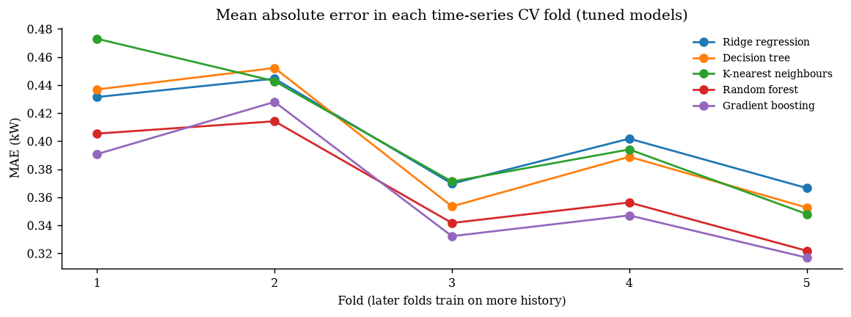
Figure 4.9: MAE in each time-series cross-validation fold
Tuning helps most where the default was poorly regularised: the decision tree improves from 0.506 to 0.380 kW once depth and minimum leaf size are limited. KNN gains by averaging over more neighbours with distance weighting; ridge prefers strong regularisation (α = 100.0) but gains little. For random forest and gradient boosting the defaults were already well chosen, and the small differences are within the noise between cross-validation and the validation window. The default random forest (200 trees, depth 16, minimum 5 rows per leaf) therefore remains the selected model.

4.1.5. Test-set results of the forecaster
The selected model was refit on train+validation and evaluated once on the untouched test period (Table 4.4).
Table 4.4: Held-out test performance (Jun–Nov 2010)
Model | MAE (kW) | MSE | RMSE (kW) | R² | MAPE (%)
Persistence baseline | 0.377 | 0.329 | 0.574 | 0.335 | 46.9
Random forest | 0.295 | 0.188 | 0.434 | 0.620 | 40.8
Improvement | 21.9% | 42.9% | 24.4% | +0.285 | –

To confirm that selecting on the validation window did not favour one model by chance, every model (default and tuned) was also refit on train+validation and scored on the test period. Tables 4.5 and 4.6 give the complete results; Figure 4.10 compares the main ones.
Table 4.5: Test-set error metrics of every model (kW, kW²)
Model | MAE | MSE | RMSE | R² | MAPE % | Median AE | Max error
Persistence baseline | 0.377 | 0.329 | 0.574 | 0.335 | 46.9 | 0.206 | 3.83
Seasonal naive (24 h) | 0.485 | 0.532 | 0.730 | -0.076 | 64.7 | 0.299 | 5.18
Linear regression | 0.344 | 0.233 | 0.482 | 0.530 | 48.6 | 0.245 | 3.85
Ridge regression | 0.344 | 0.233 | 0.482 | 0.530 | 48.6 | 0.245 | 3.85
Decision tree | 0.423 | 0.422 | 0.650 | 0.147 | 54.3 | 0.233 | 3.78
K-nearest neighbours (KNN) | 0.333 | 0.240 | 0.490 | 0.515 | 43.4 | 0.208 | 4.29
Support vector machine (SVR) | 0.296 | 0.197 | 0.444 | 0.602 | 37.0 | 0.176 | 3.84
Random forest | 0.295 | 0.188 | 0.434 | 0.620 | 40.8 | 0.187 | 3.47
Histogram gradient boosting | 0.293 | 0.187 | 0.432 | 0.623 | 39.5 | 0.185 | 3.67
Ridge regression (tuned) | 0.343 | 0.232 | 0.482 | 0.530 | 48.5 | 0.245 | 3.85
Decision tree (tuned) | 0.330 | 0.227 | 0.477 | 0.541 | 45.5 | 0.210 | 3.41
K-nearest neighbours (KNN) (tuned) | 0.326 | 0.228 | 0.477 | 0.539 | 42.7 | 0.205 | 4.05
Random forest (tuned) | 0.298 | 0.191 | 0.437 | 0.613 | 41.3 | 0.185 | 3.57
Histogram gradient boosting (tuned) | 0.295 | 0.186 | 0.431 | 0.625 | 40.0 | 0.191 | 3.53

Table 4.6: Test-set accuracy-style metrics, training time and prediction time of every model
Model | Accuracy (1 − WAPE) | Within ±0.25 kW | Within ±0.5 kW | Explained variance | Fit (s) | ms / prediction
Persistence baseline | 58.9% | 53.4% | 70.0% | 0.335 | 0.0 | 0.0000
Seasonal naive (24 h) | 47.3% | 46.2% | 63.4% | -0.076 | 0.0 | 0.0000
Linear regression | 62.6% | 50.7% | 76.8% | 0.530 | 0.0 | 0.0006
Ridge regression | 62.6% | 50.7% | 76.8% | 0.530 | 0.0 | 0.0004
Decision tree | 53.9% | 51.8% | 67.9% | 0.149 | 1.1 | 0.0005
K-nearest neighbours (KNN) | 63.8% | 54.8% | 76.0% | 0.521 | 0.0 | 0.0438
Support vector machine (SVR) | 67.8% | 59.9% | 79.6% | 0.606 | 79.4 | 1.9554
Random forest | 67.9% | 58.6% | 80.8% | 0.621 | 10.2 | 0.0186
Histogram gradient boosting | 68.1% | 59.1% | 80.9% | 0.623 | 1.5 | 0.0047
Ridge regression (tuned) | 62.6% | 50.8% | 76.7% | 0.530 | 0.0 | 0.0008
Decision tree (tuned) | 64.1% | 54.3% | 76.7% | 0.542 | 0.5 | 0.0003
K-nearest neighbours (KNN) (tuned) | 64.5% | 55.1% | 77.5% | 0.547 | 0.0 | 0.0471
Random forest (tuned) | 67.6% | 58.8% | 80.2% | 0.614 | 8.8 | 0.0179
Histogram gradient boosting (tuned) | 67.9% | 58.3% | 81.3% | 0.625 | 1.9 | 0.0078

Accuracy-style metrics make the regression results easier to read. Accuracy as 1 − WAPE (weighted absolute percentage error) is the share of total consumption predicted correctly: 67.9% for the deployed model against 58.9% for persistence. 58.6% of hourly forecasts are within ±0.25 kW of the actual value and 80.8% within ±0.5 kW. The ranking on the test set matches validation: random forest is the best syllabus algorithm, ahead of the SVM, and the reference gradient-boosting model is better by only 0.0013 kW MAE (0.1 percentage points of accuracy). Restricting deployment to syllabus algorithms therefore costs almost nothing, and the selection was not a lucky choice.
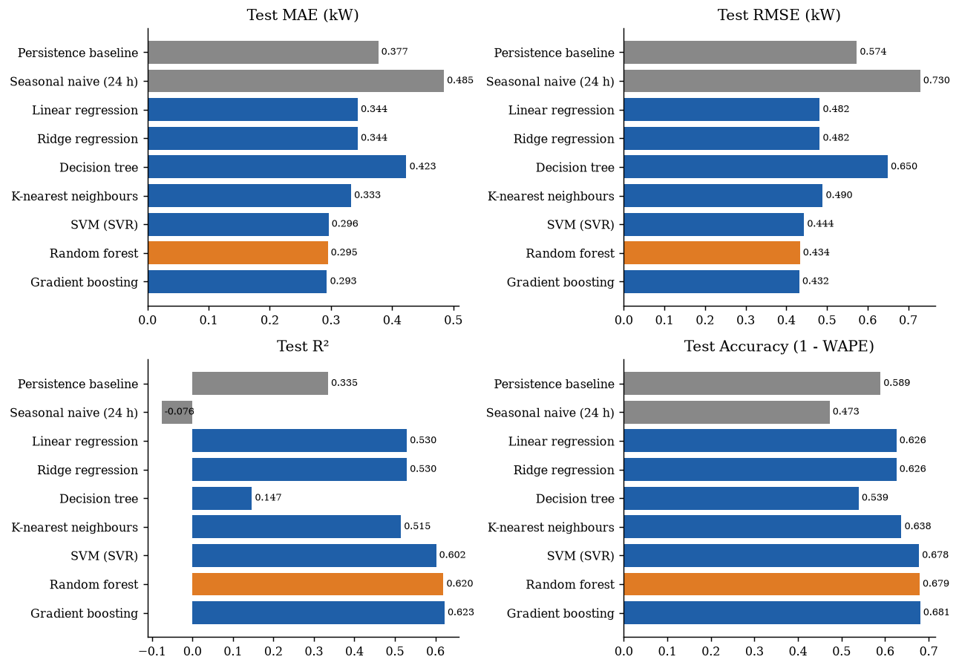
Figure 4.10: Test MAE, RMSE, R² and accuracy (1 − WAPE) of every model
Figures 4.11–4.13 show the behaviour of each model on the test set: a week of forecasts, the predicted-vs-actual scatter, and the residual distribution.
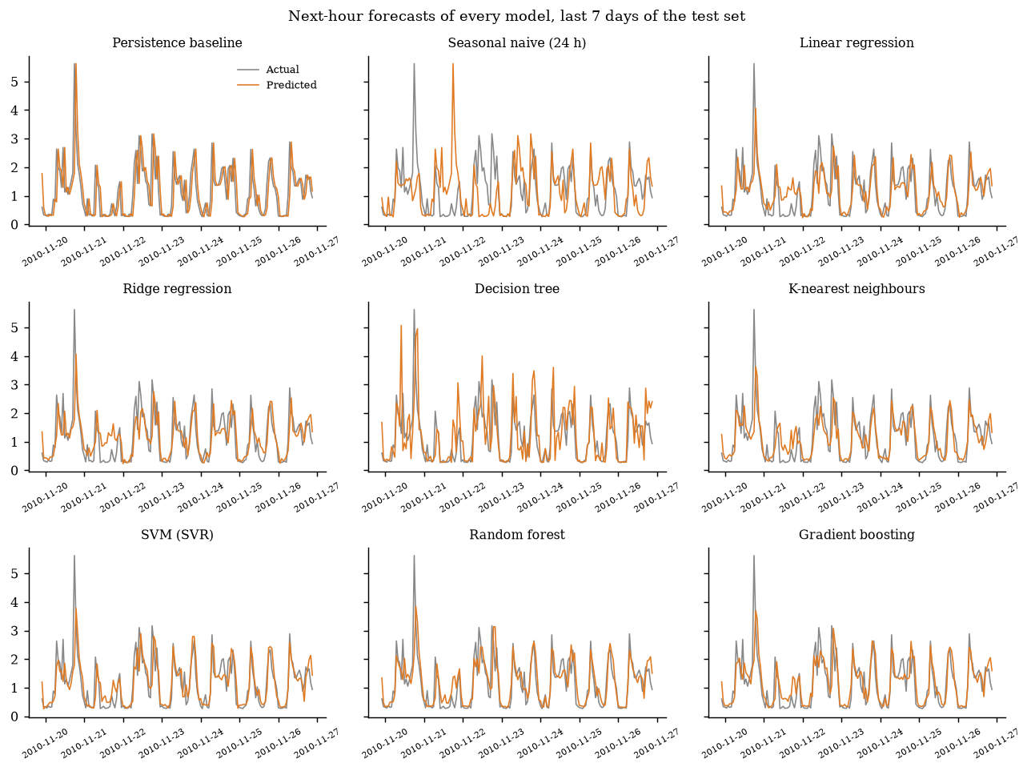
Figure 4.11: Forecasts of every model over the last seven days of the test set
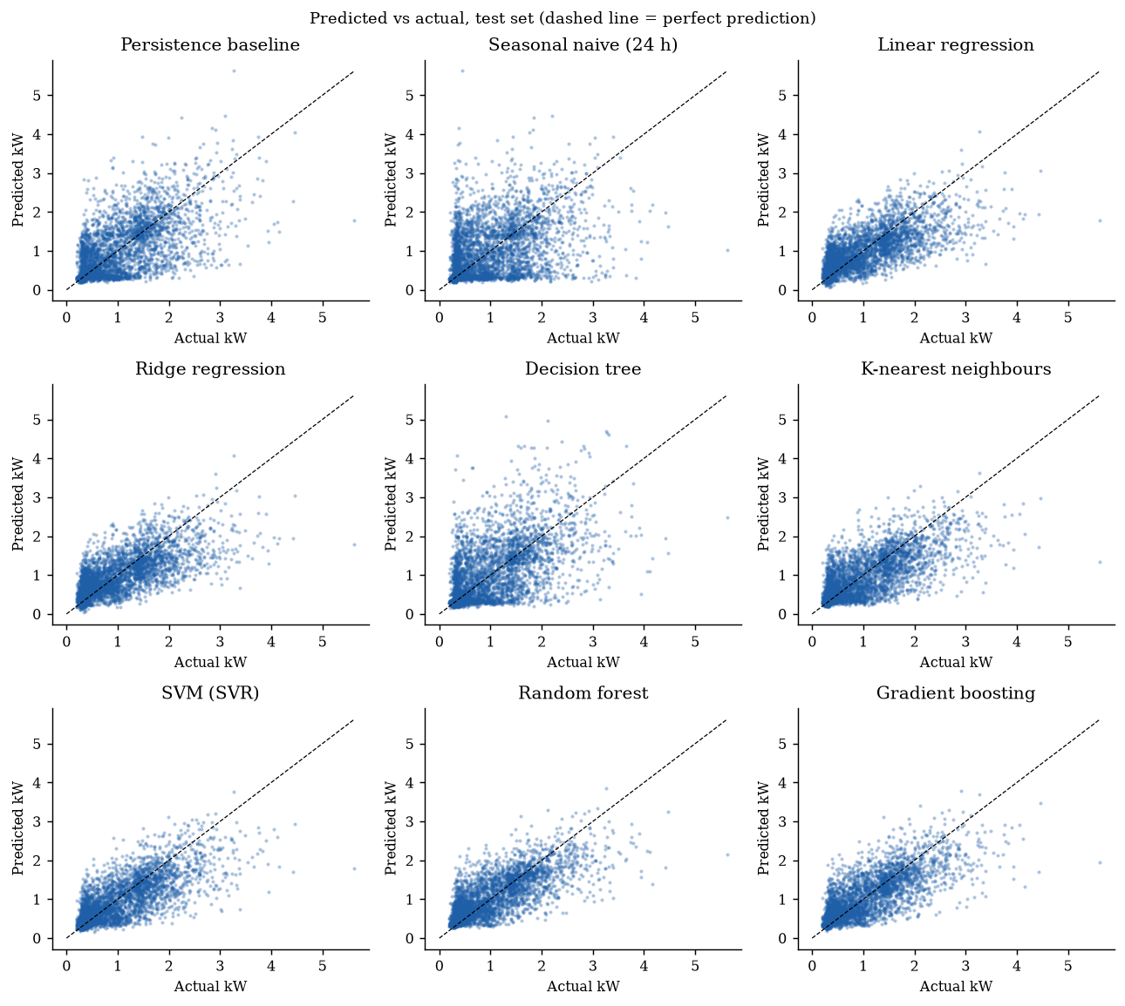
Figure 4.12: Predicted vs actual for every model (test set)
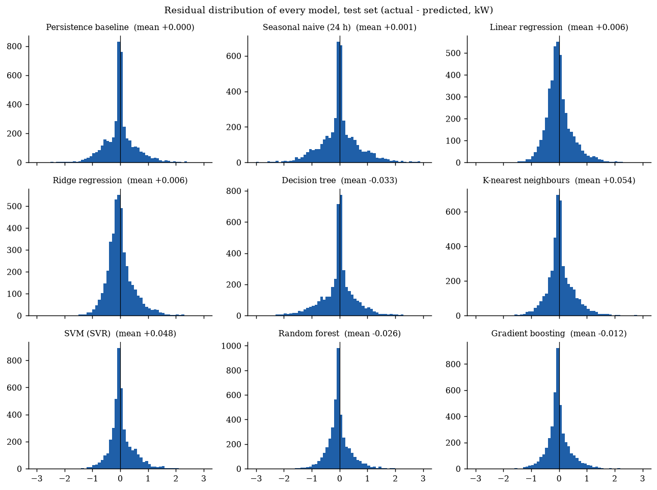
Figure 4.13: Residual distribution of every model (test set)
The forecasts follow the daily cycle and the timing of evening peaks closely (Figure 4.14). Residuals are centred near zero but right-skewed (Figure 4.15): the largest errors are sudden short spikes, such as an oven or water heater switching on, which are inherently unpredictable from past meter data alone.
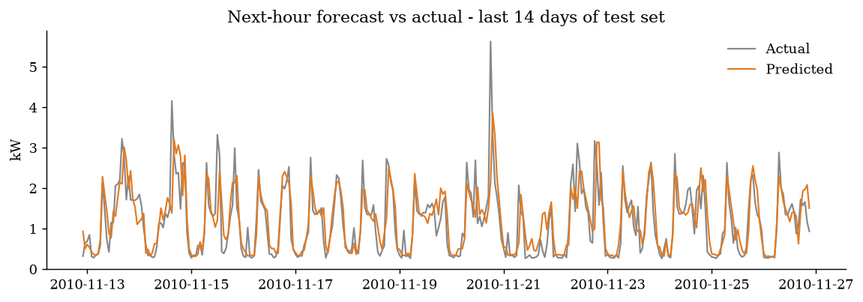
Figure 4.14: Next-hour forecast vs actual consumption, last 14 days of the test set
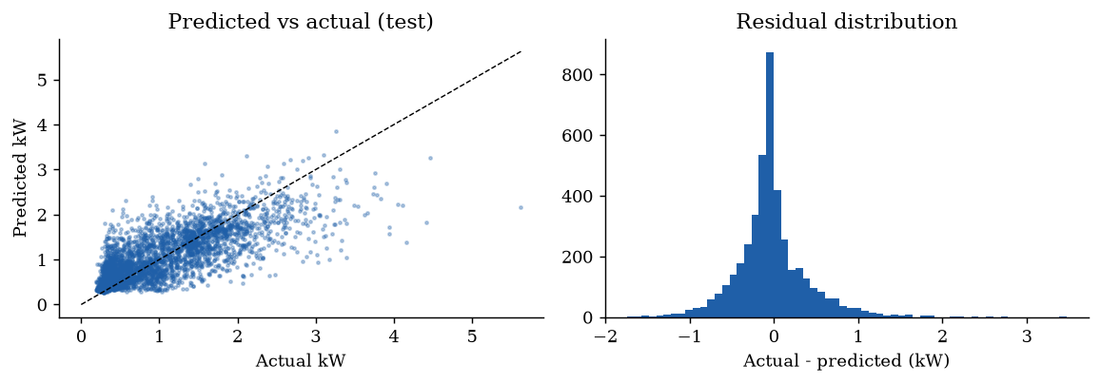
Figure 4.15: Predicted vs actual scatter and residual distribution
Explainability. Permutation importance (Figure 4.16) shows the inputs the model relies on: Global_intensity_lag1 (0.268), lag_1 (0.082), Sub_metering_3_lag1 (0.031), hour (0.018). The previous hour's current and power carry the household's present state, the water-heater/AC sub-meter signals heavy thermal loads, and the hour encodings capture daily routines, which is physically consistent.
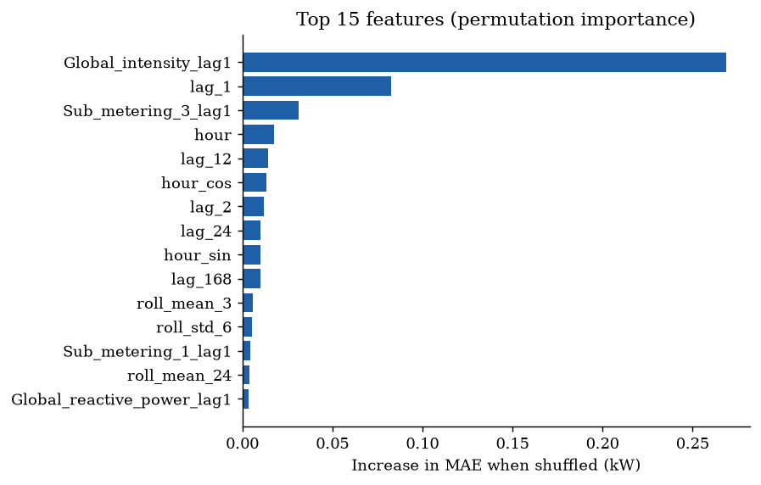
Figure 4.16: Top 15 features by permutation importance
Error by forecast horizon. The deployed service forecasts up to 48 hours ahead by feeding each prediction back as input (recursive forecasting). Figure 4.17 and Table 4.7 show the error for 60 random starting points in the test period. Error grows from 0.285 kW one hour ahead to 0.499 kW 24 hours ahead as uncertainty accumulates, but stays below the same-hour-yesterday baseline at every horizon (0.570 kW). This is why the API widens its prediction interval with √h.
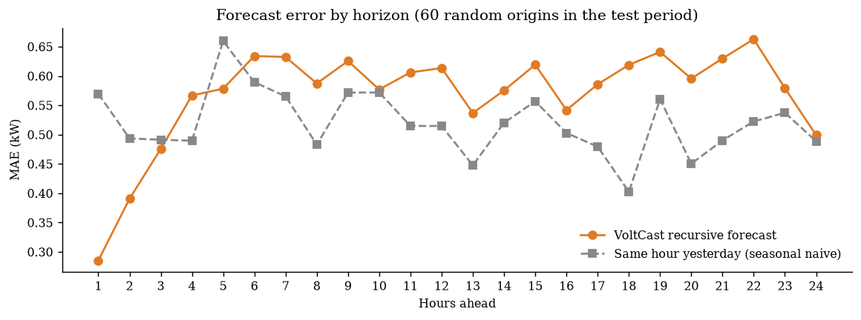
Figure 4.17: Forecast MAE by hours ahead, compared with the seasonal-naive baseline
Table 4.7: Forecast error by horizon
Hours ahead | 1 | 2 | 3 | 6 | 12 | 18 | 24
VoltCast MAE (kW) | 0.285 | 0.391 | 0.475 | 0.634 | 0.614 | 0.619 | 0.499
Seasonal naive MAE (kW) | 0.570 | 0.493 | 0.491 | 0.589 | 0.515 | 0.403 | 0.489

4.1.6. Peak-hour classification
Peak hours make up 25% of training hours and 17.0% of the (summer-heavy) test period. Table 4.8 compares the classifiers on the validation window.
Table 4.8: Peak-hour classifiers on the validation set
Classifier | Train F1 | Accuracy | Precision | Recall | F1 | ROC-AUC
Logistic regression | 0.662 | 0.807 | 0.764 | 0.492 | 0.599 | 0.887
Decision tree default | 1.000 | 0.770 | 0.610 | 0.589 | 0.599 | 0.717
Decision tree tuned | 0.735 | 0.790 | 0.603 | 0.821 | 0.696 | 0.879

The default decision tree again over-fits (training F1 1.00). GridSearchCV selects max_depth = 12, min_samples_leaf = 50 and class_weight = balanced, raising validation F1 from 0.599 to 0.696, so the tuned tree is selected. On the test period it reaches accuracy 0.803, precision 0.454, recall 0.779, F1 0.574 and ROC-AUC 0.873 (Figure 4.18).
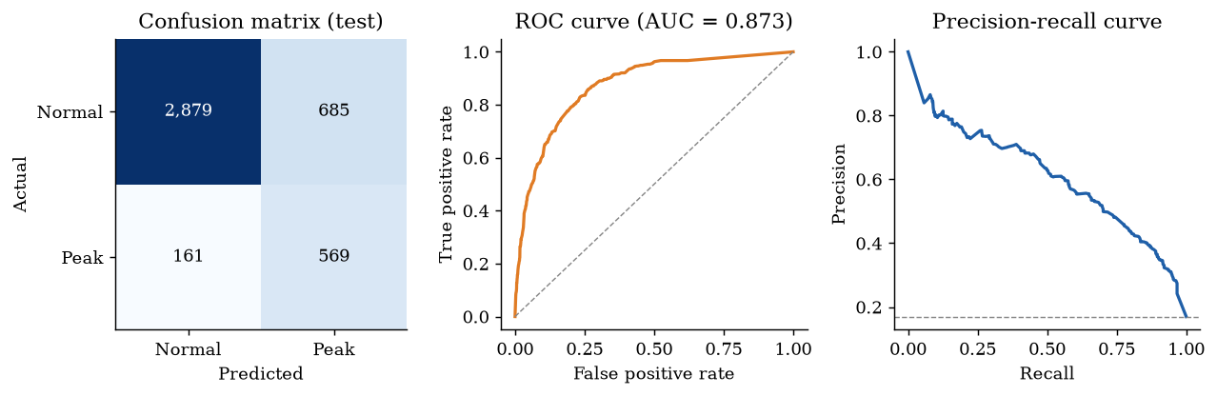
Figure 4.18: Peak-hour classifier on the test set: confusion matrix, ROC and precision-recall curves
Figure 4.19 compares the confusion matrices of all three classifiers on the test set, and Figure 4.20 their ROC and precision-recall curves. Table 4.9 is the full classification report of each classifier, giving precision, recall, F1 and support for both classes plus accuracy and the macro and weighted averages.
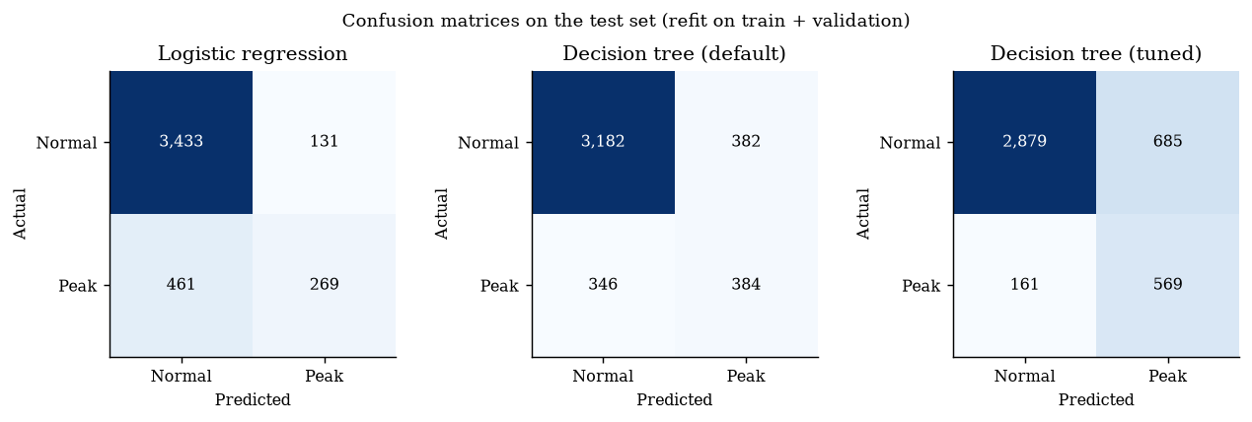
Figure 4.19: Confusion matrices of the three classifiers (test set)
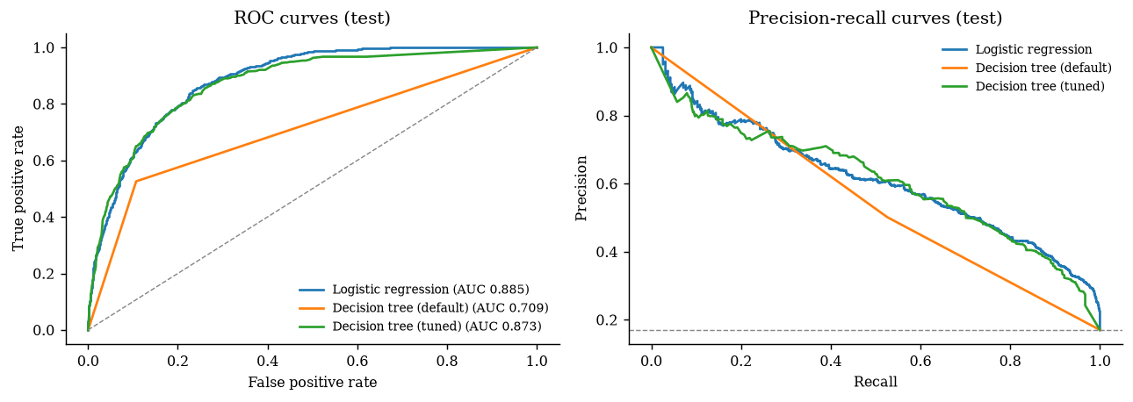
Figure 4.20: ROC and precision-recall curves of the three classifiers (test set)
Table 4.9: Classification reports on the test set
Classifier | Class | Precision | Recall | F1-score | Support
Logistic regression | Normal hour | 0.882 | 0.963 | 0.921 | 3564
 | Peak hour | 0.672 | 0.368 | 0.476 | 730
 | macro avg | 0.777 | 0.666 | 0.698 | 4294
 | weighted avg | 0.846 | 0.862 | 0.845 | 4294
 | accuracy |  |  | 0.862 | 4294
Decision tree (default) | Normal hour | 0.902 | 0.893 | 0.897 | 3564
 | Peak hour | 0.501 | 0.526 | 0.513 | 730
 | macro avg | 0.702 | 0.709 | 0.705 | 4294
 | weighted avg | 0.834 | 0.830 | 0.832 | 4294
 | accuracy |  |  | 0.830 | 4294
Decision tree (tuned) | Normal hour | 0.947 | 0.808 | 0.872 | 3564
 | Peak hour | 0.454 | 0.779 | 0.574 | 730
 | macro avg | 0.700 | 0.794 | 0.723 | 4294
 | weighted avg | 0.863 | 0.803 | 0.821 | 4294
 | accuracy |  |  | 0.803 | 4294

The tuned tree outputs a probability; the alert uses 0.5 as the cut-off. Figure 4.21 and Table 4.10 show the trade-off for other cut-offs: a lower threshold catches more peaks (recall) but raises more false alarms (lower precision), and a higher threshold does the opposite. The F1-score is highest near the middle of the range, which supports the default.
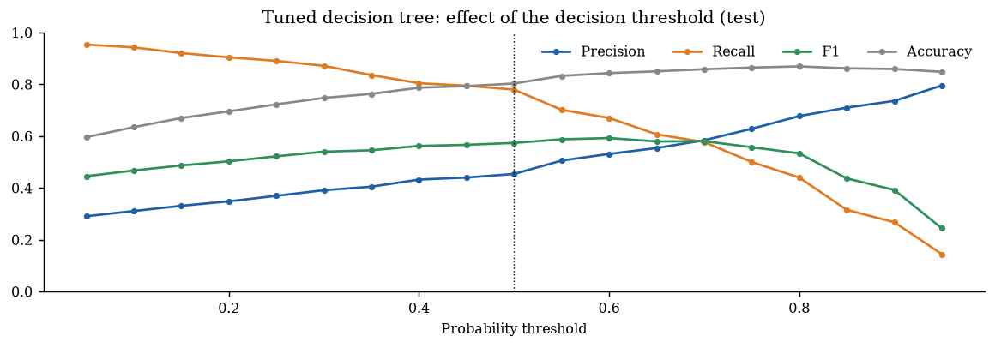
Figure 4.21: Precision, recall, F1 and accuracy against the decision threshold
Table 4.10: Effect of the probability threshold (tuned decision tree, test set)
Threshold | Precision | Recall | F1 | Accuracy
0.05 | 0.290 | 0.953 | 0.445 | 0.596
0.15 | 0.331 | 0.921 | 0.487 | 0.670
0.25 | 0.369 | 0.890 | 0.522 | 0.723
0.35 | 0.405 | 0.836 | 0.545 | 0.763
0.45 | 0.440 | 0.795 | 0.566 | 0.793
0.55 | 0.505 | 0.701 | 0.587 | 0.833
0.65 | 0.554 | 0.607 | 0.579 | 0.850
0.75 | 0.628 | 0.500 | 0.557 | 0.865
0.85 | 0.710 | 0.315 | 0.436 | 0.862
0.95 | 0.795 | 0.144 | 0.244 | 0.848

Of 730 real peak hours, 569 were caught and 161 missed; 685 normal hours raised a false alarm. High recall with moderate precision is the safer trade-off for an alert, since a missed peak costs more than an unnecessary reminder. A simpler rule, flagging hours where the regression forecast exceeds τ, is more accurate (0.878) but catches only 61% of peaks. The deployed system uses the classifier for the next hour, and the forecast-threshold rule for later hours, where the classifier's inputs are no longer current. On 40 random test origins this rule was 76% accurate over hours 2–24, against 58% for the classifier.

4.1.7. Deployment
The forecaster and classifier are served by a Flask REST API (Table 4.11). Every request body is validated with Pydantic, which checks types, non-negative readings, positive voltage, a horizon of 1–48 h, at least 169 hours of history and no duplicate timestamps. Invalid input returns HTTP 422 with an explanation.
Table 4.11: REST API endpoints
Method | Endpoint | Purpose
GET | /api/health | Liveness and loaded model
GET | /api/model-info | Model, hyper-parameters, training window, test metrics, peak threshold
POST | /api/predict | Forecast + peak alerts from user-supplied hourly readings (JSON)
GET | /api/forecast | Forecast from a point in the test period, returned with actual values
GET | /api/sample-request | Ready-made request body for /api/predict
GET | /api/metrics | Prometheus metrics (OpenMetrics text format)

On-premise (Docker). A multi-stage Dockerfile builds the React web app with Node and then the Python runtime with gunicorn. Docker Compose starts five microservices: the API with the web app, the Streamlit dashboard, the MLflow UI, Prometheus and Grafana. The full stack was built and run locally and every service responded. Kubernetes. k8s/deployment.yaml defines a two-replica Deployment with readiness and liveness probes on /api/health, a NodePort Service and a CPU-based HorizontalPodAutoscaler (2–5 pods). The manifests are validated in CI; they were not applied to a live cluster in this project. Cloud. The same Flask app runs as a serverless function on Vercel, with the React app served from its CDN, at https://voltcast-forecast.vercel.app. A 24-hour forecast request completes in well under one second.
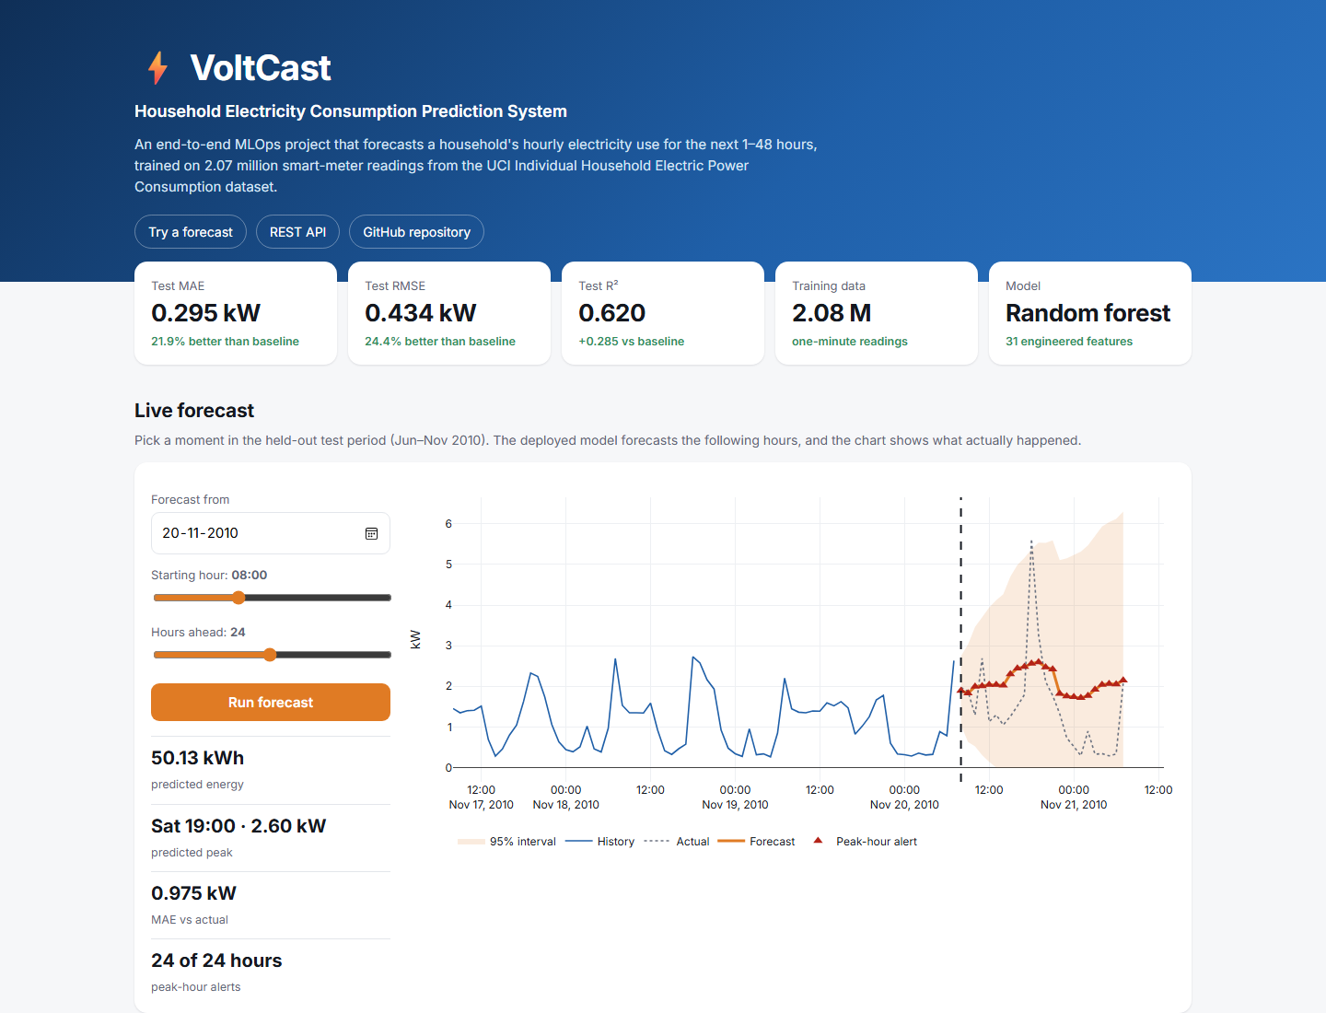
Figure 4.22: VoltCast web application (React) with a live 24-hour forecast and peak-hour alerts

4.1.8. CI/CD and versioning
The GitHub Actions workflow runs on every push, on pull requests and weekly (continuous training). It installs the dependencies, reproduces the pipeline with dvc repro, prints the DVC-tracked metrics, applies two quality gates (forecaster MAE below the persistence baseline; classifier ROC-AUC above 0.75), runs the 11 tests, builds the React app, validates the Docker Compose, Prometheus/Grafana and Kubernetes files, builds the Docker image and uploads the models and reports as artifacts. Vercel's Git integration provides continuous deployment: every push to the main branch is built and published automatically.
Versioning. DVC records each stage's inputs, parameters and outputs in dvc.lock, so a given Git commit identifies the exact dataset, parameters, models and metrics; dvc repro re-runs only the stages whose inputs changed. The dataset is kept in the DVC cache rather than in Git. In addition, every trained forecaster is registered as a new version of voltcast-forecaster in the MLflow model registry.
Automated testing. Table 4.12 lists the pytest suite.
Table 4.12: Automated test suite results
Test | What it validates | Result
test_resample_fills_gaps | Missing hours are filled; output is gap-free | Pass
test_features_have_no_leakage | lag_1 and rolling means use only past values | Pass
test_metrics_perfect_prediction | Regression metric implementation | Pass
test_psi_detects_shift | PSI < 0.1 for same distribution, > 0.2 for shifted | Pass
test_classification_scores | Accuracy, precision, recall and confusion matrix | Pass
test_health_endpoint | Service liveness and model loading | Pass
test_predict_endpoint_returns_horizon | Horizon, interval ordering, peak alerts, strictly valid JSON | Pass
test_predict_rejects_short_history | Too little history returns HTTP 422 | Pass
test_predict_rejects_invalid_reading | Negative voltage returns HTTP 422 | Pass
test_prometheus_metrics_exposed | Prometheus counters and histograms are published | Pass
test_model_beats_baseline | Quality gate: model MAE < baseline MAE | Pass

4.1.9. Monitoring and logging
Prometheus scrapes /api/metrics every 15 seconds (Figure 4.23). The API exports request counts and latency histograms per endpoint, the number of forecast hours served, the distribution of forecast values, peak alerts, rejected requests and the loaded model's test MAE. A provisioned Grafana dashboard visualises them (Figure 4.24); invalid requests sent on purpose during the test run appear under 'Rejected requests'. Every prediction is also written as one JSON line to logs/predictions.jsonl (time, model, horizon, forecast values, number of peak hours), without the submitted meter readings.
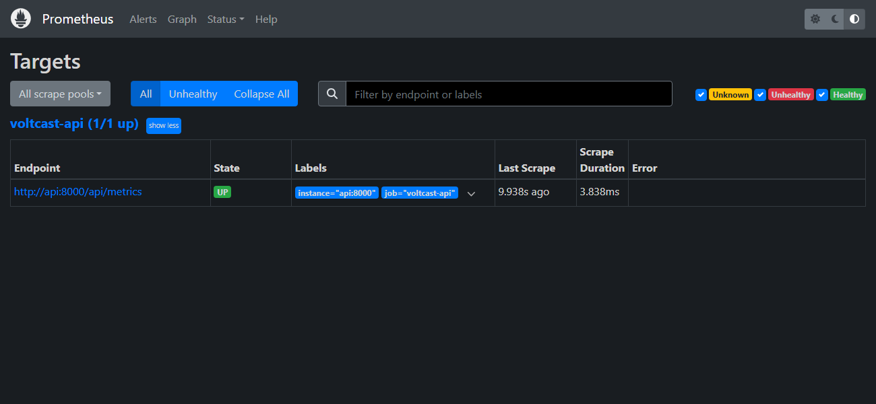
Figure 4.23: Prometheus target page: the VoltCast API is being scraped (state UP)
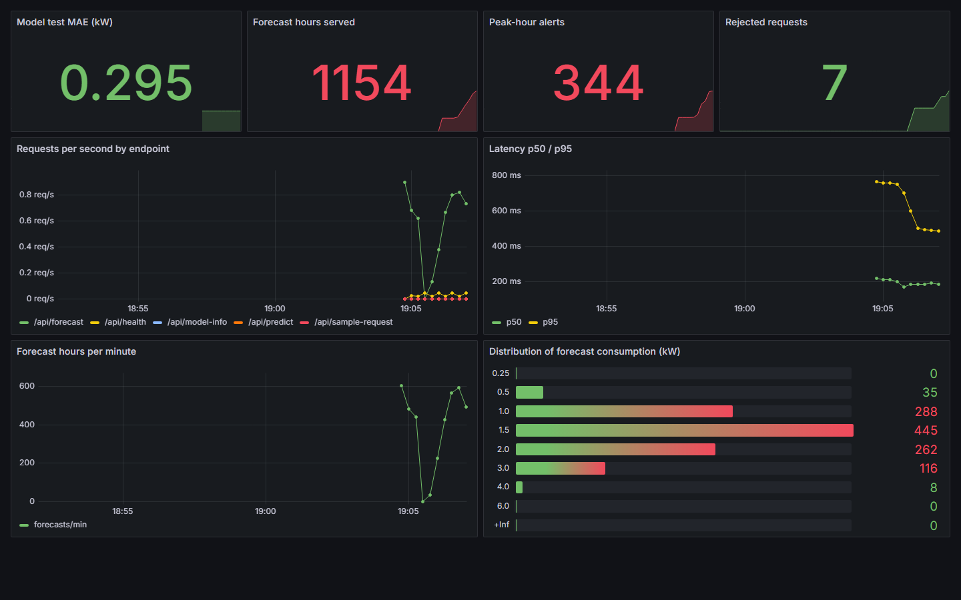
Figure 4.24: Grafana dashboard “VoltCast – Model Monitoring” fed by Prometheus
Data drift. Figure 4.25 shows the PSI between training and test distributions.
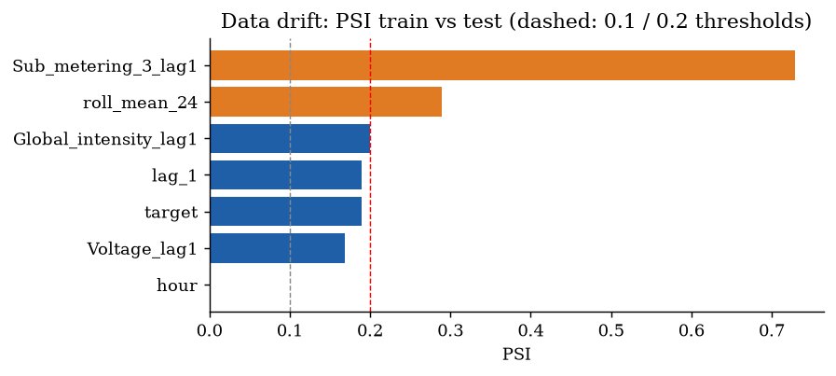
Figure 4.25: Population Stability Index of monitored features (train vs test)
Significant drift was detected in roll_mean_24, Sub_metering_3_lag1 (PSI 0.73 for the water-heater/AC sub-meter). This is genuine seasonal drift: the training data covers three winters, while the test period is June–November, when heating load is low. The 30-day rolling MAE (0.351 kW) was 19.1% above the reference test MAE as consumption climbed again in November. The monitor therefore set retraining_recommended = true, which is the behaviour a production MLOps loop requires.
Figure 4.26 follows drift month by month through the test period. The water-heater/AC sub-meter is far from its training distribution in every summer month and moves back towards it in November, as heating returns. Test MAE follows the same seasonal pattern (0.177–0.379 kW; Table 4.13).
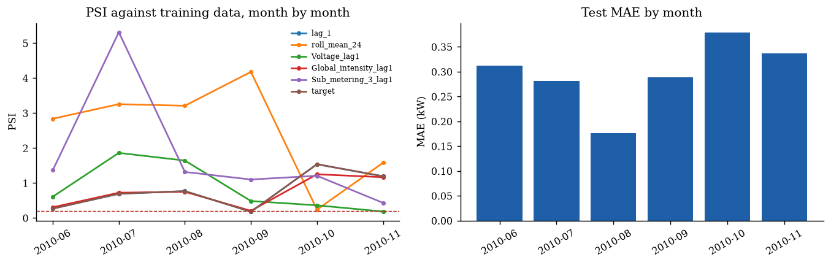
Figure 4.26: PSI against the training data and test MAE, month by month
Table 4.13: Monthly PSI of monitored features and monthly test MAE
Month | lag 1 | roll mean 24 | Voltage | Global intensity | Sub metering 3 | target | MAE (kW)
2010-06 | 0.268 | 2.839 | 0.609 | 0.306 | 1.366 | 0.267 | 0.313
2010-07 | 0.690 | 3.256 | 1.862 | 0.724 | 5.313 | 0.695 | 0.281
2010-08 | 0.770 | 3.211 | 1.643 | 0.749 | 1.317 | 0.767 | 0.177
2010-09 | 0.179 | 4.180 | 0.485 | 0.206 | 1.101 | 0.179 | 0.289
2010-10 | 1.538 | 0.238 | 0.362 | 1.250 | 1.208 | 1.537 | 0.379
2010-11 | 1.194 | 1.581 | 0.185 | 1.166 | 0.433 | 1.194 | 0.337

4.1.10. Ethical considerations
Fairness and bias. The system makes no decisions about people, so fairness is assessed as equal quality of service across conditions [24]. Figure 4.27 breaks the test error down by group. Error is lowest at night (0.15 kW) and highest in the evening (0.39 kW) and in high-use hours (0.42 kW), and higher at weekends (0.33 vs 0.28 kW) and in autumn (0.34 vs 0.26 kW). The forecasts are therefore least reliable exactly when demand is highest, and this is stated to users. There is also sampling bias: one French household from 2006–2010 cannot represent Indian homes with air-conditioning loads, so the model must be re-validated before any wider use.
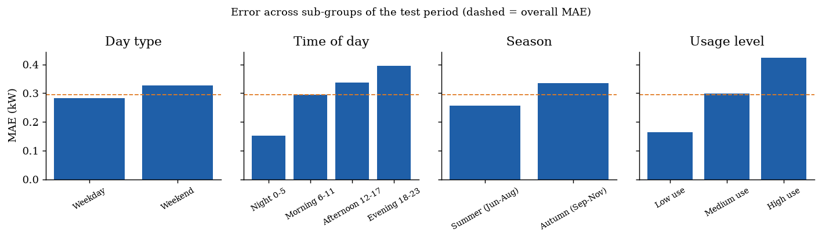
Figure 4.27: Test error across sub-groups (dashed line: overall MAE)
Transparency. Feature importance is published, every number is reproducible from the repository, forecasts carry a 95% interval, and a model card (MODEL_CARD.md) documents intended use, data, performance, limitations and monitoring. Privacy. Smart-meter data can reveal when residents are home or asleep. The project uses only a public anonymised dataset; the API does not store submitted readings; real deployments should aggregate data, obtain consent and comply with the Digital Personal Data Protection Act, 2023 [25]. Security. Input validation, a 2 MB request limit, loading only models produced by the pipeline, and monitoring of rejected requests protect the service against malformed or abusive input.
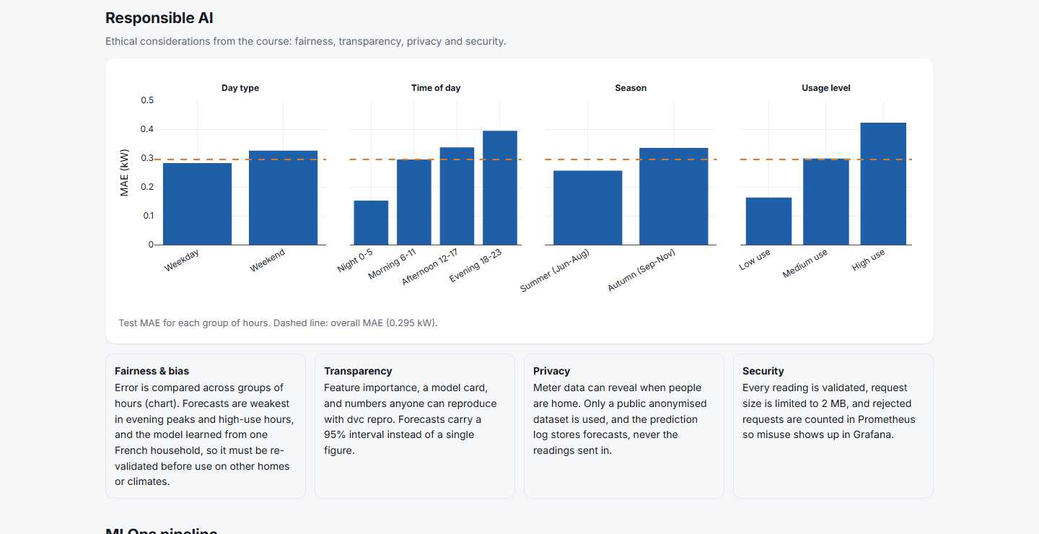
Figure 4.28: Responsible-AI section of the web application

4.1.11. Execution evidence (terminal output)
The figures in this section are the terminal output of the commands that build, test, deploy and monitor the system, captured while they ran on the development machine (Windows 11, PowerShell). Each image shows the exact command line and its unedited output; long outputs are split into numbered parts. The raw text of every capture is kept in reports/terminal/ and the script that produced them is report/capture_terminal.py.
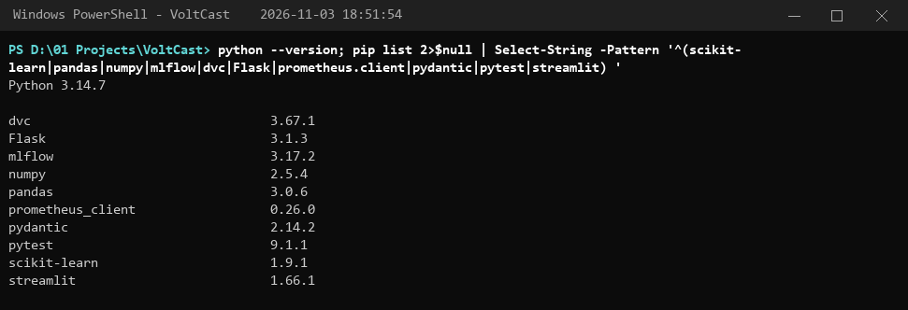
Figure 4.29: Python and library versions used, run 2026-11-03 18:51:54
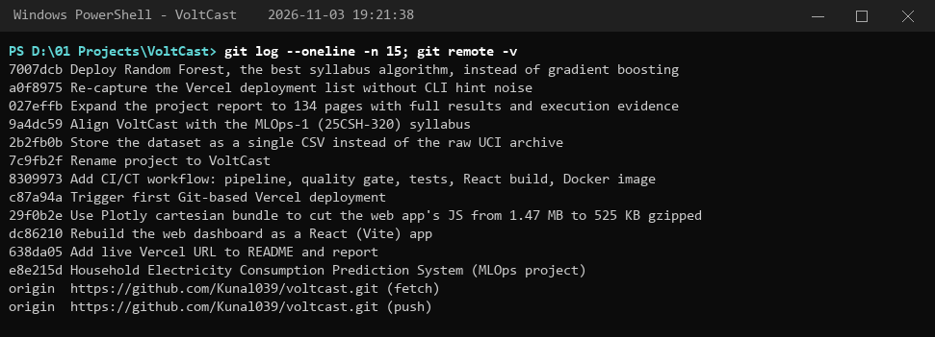
Figure 4.30: Git history of the project repository, run 2026-11-03 19:21:38
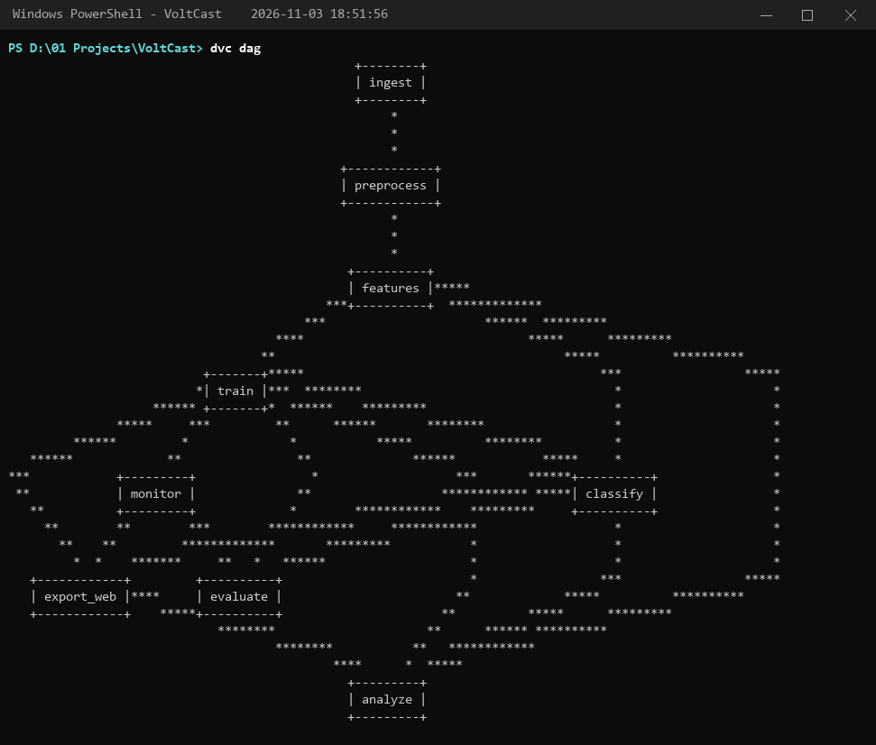
Figure 4.31: dvc dag: the pipeline stages and their dependencies, run 2026-11-03 18:51:56
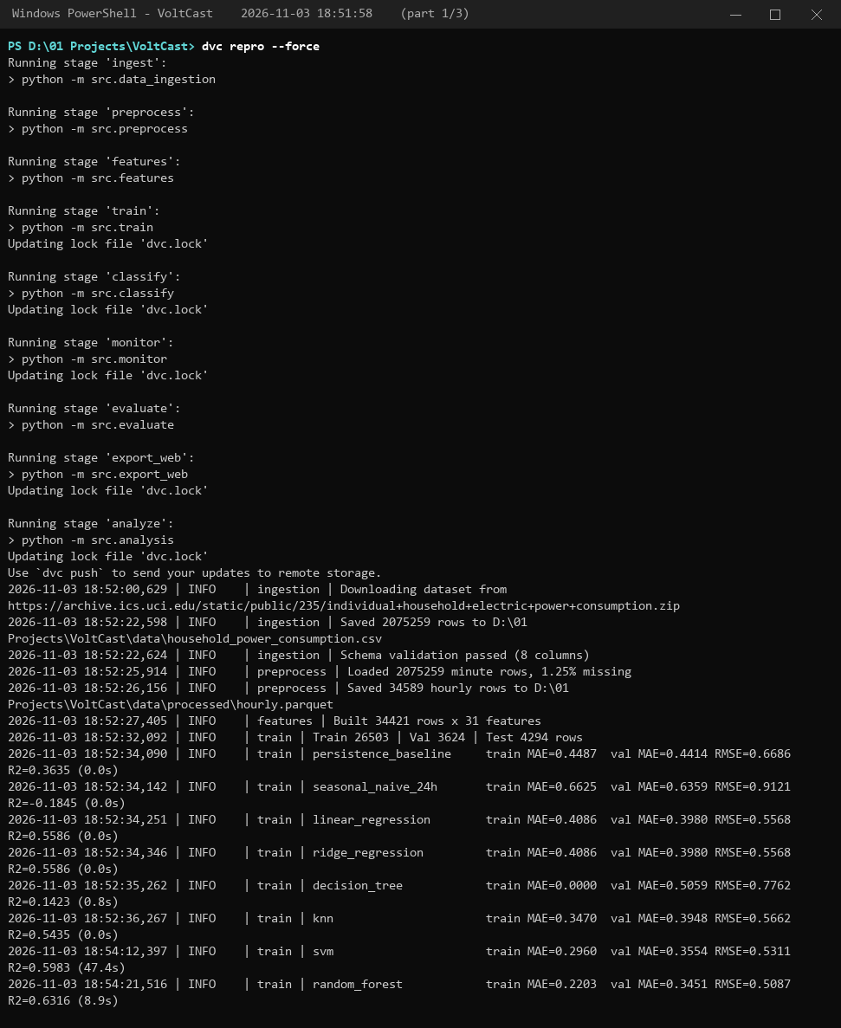
Figure 4.32: dvc repro --force: full pipeline run (ingest, preprocess, features, training with GridSearchCV, classifier, monitoring, evaluation, export, analysis) (part 1 of 3), run 2026-11-03 18:51:58
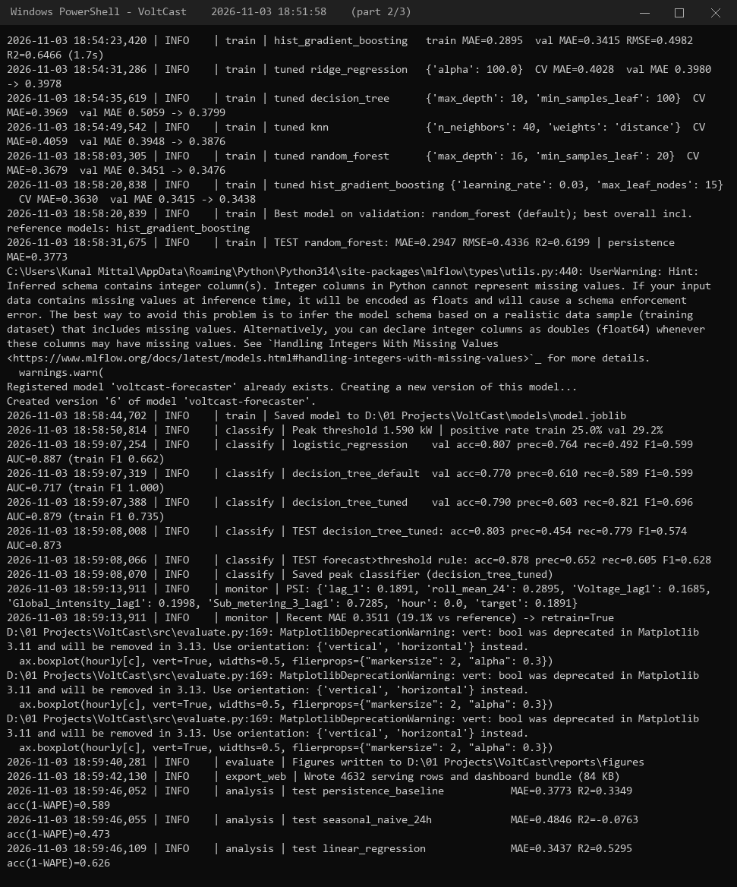
Figure 4.33: dvc repro --force: full pipeline run (ingest, preprocess, features, training with GridSearchCV, classifier, monitoring, evaluation, export, analysis) (part 2 of 3), run 2026-11-03 18:51:58
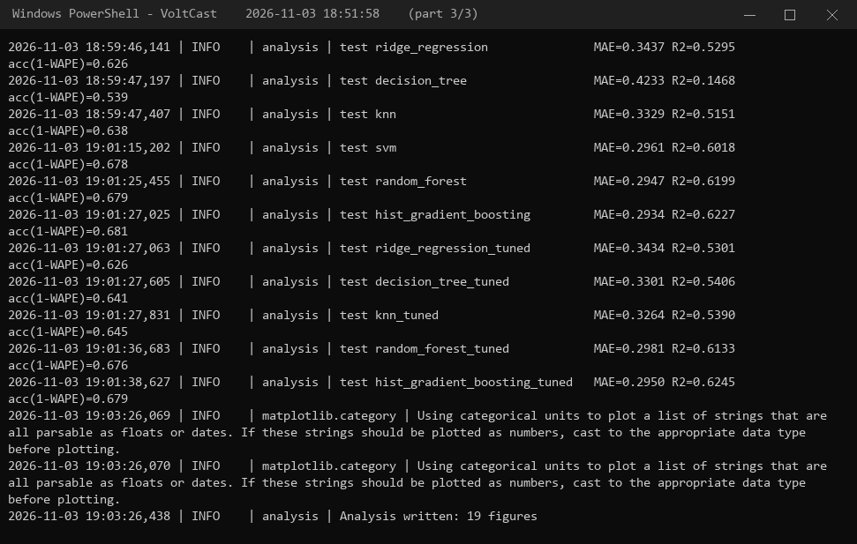
Figure 4.34: dvc repro --force: full pipeline run (ingest, preprocess, features, training with GridSearchCV, classifier, monitoring, evaluation, export, analysis) (part 3 of 3), run 2026-11-03 18:51:58
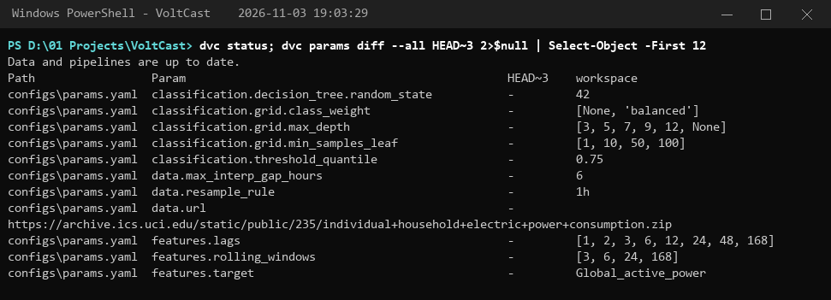
Figure 4.35: dvc status after the run, run 2026-11-03 19:03:29
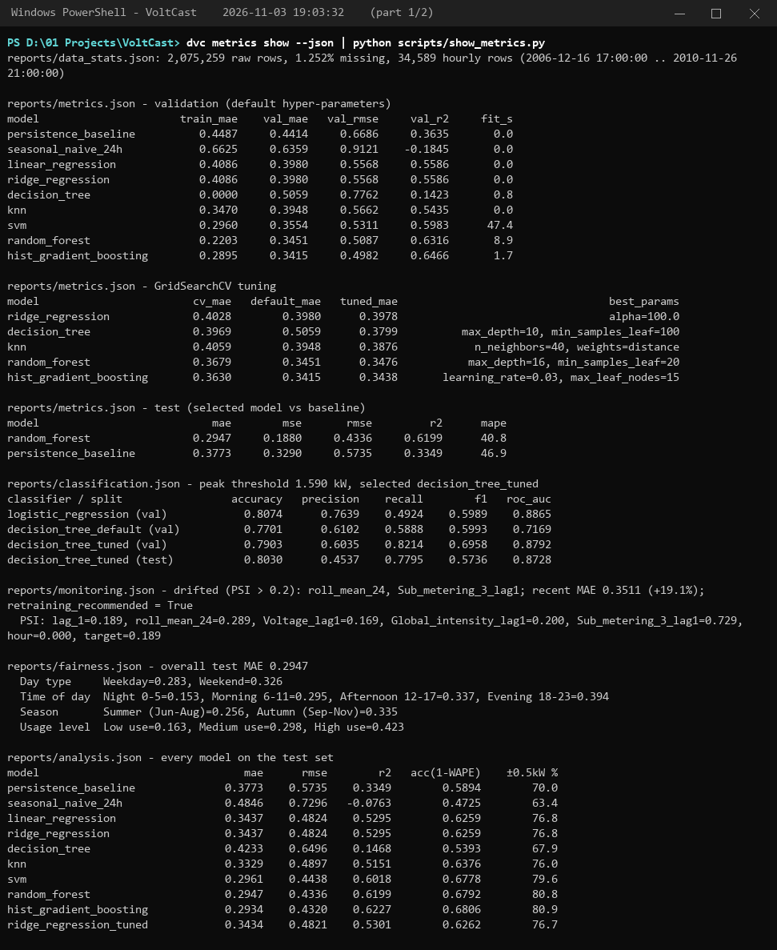
Figure 4.36: dvc metrics show: every tracked metric (part 1 of 2), run 2026-11-03 19:03:32
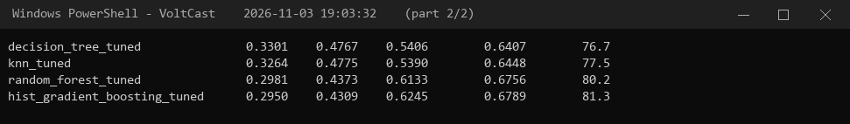
Figure 4.37: dvc metrics show: every tracked metric (part 2 of 2), run 2026-11-03 19:03:32
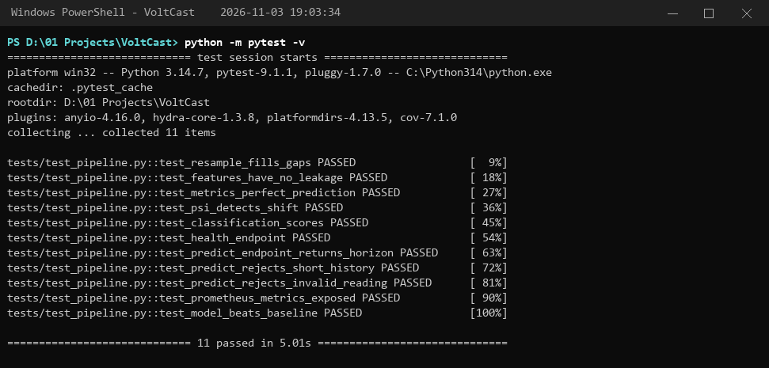
Figure 4.38: pytest -v: the automated test suite, run 2026-11-03 19:03:34
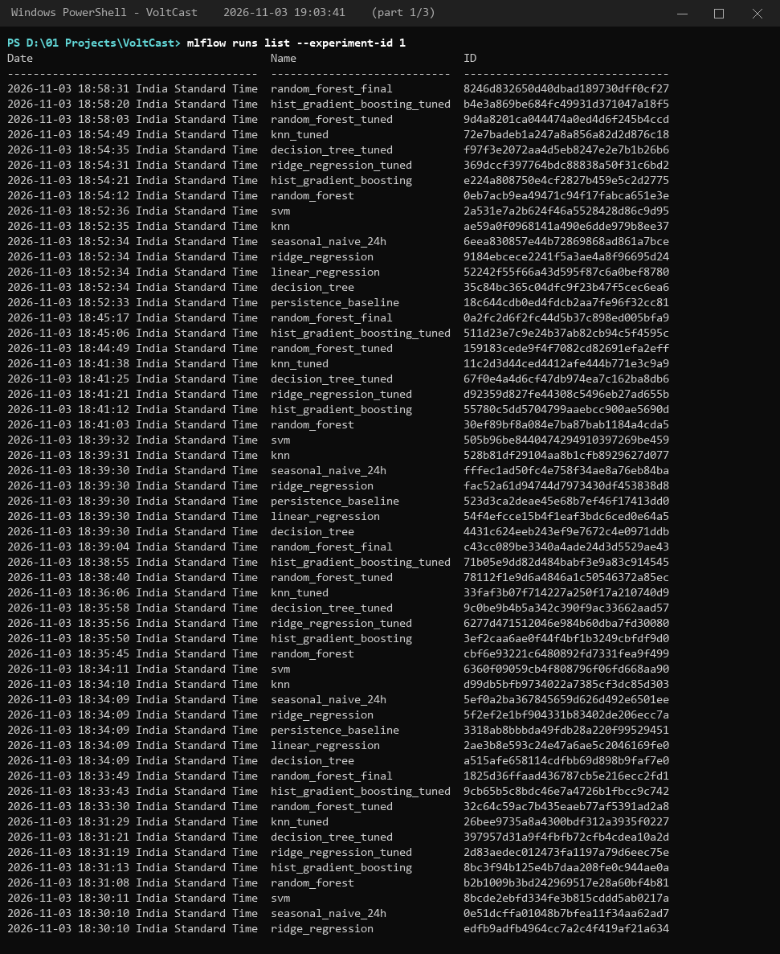
Figure 4.39: MLflow: tracked runs of the forecasting experiment (part 1 of 3), run 2026-11-03 19:03:41
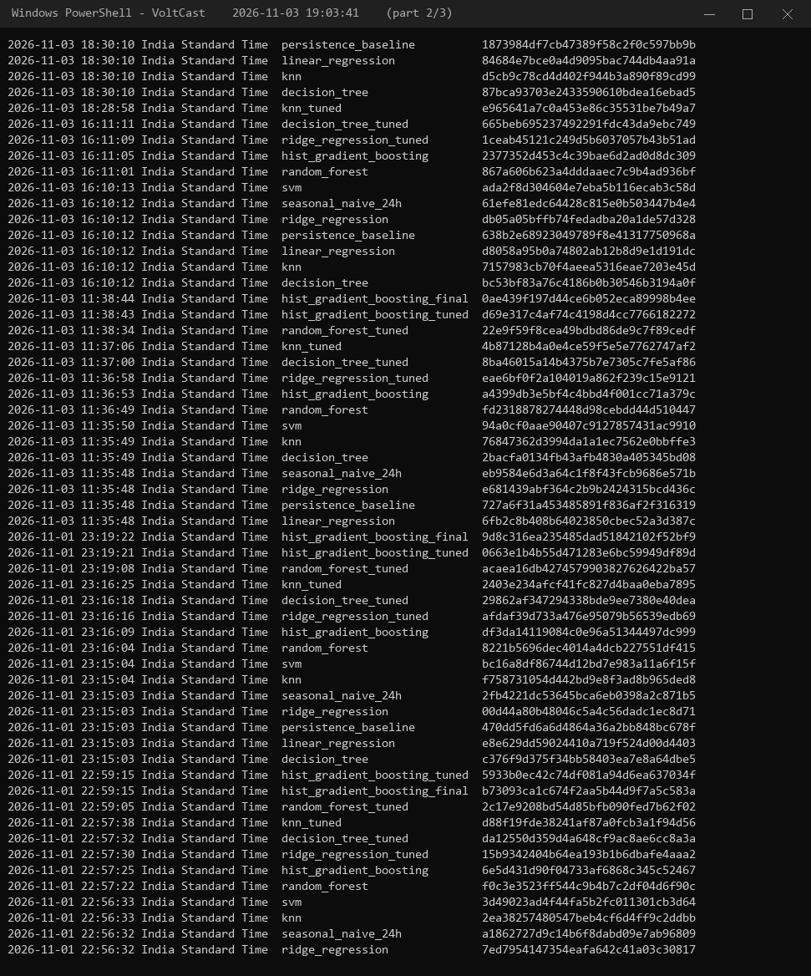
Figure 4.40: MLflow: tracked runs of the forecasting experiment (part 2 of 3), run 2026-11-03 19:03:41
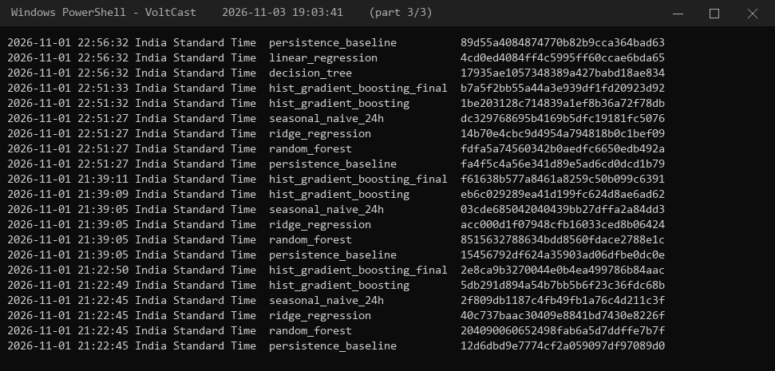
Figure 4.41: MLflow: tracked runs of the forecasting experiment (part 3 of 3), run 2026-11-03 19:03:41
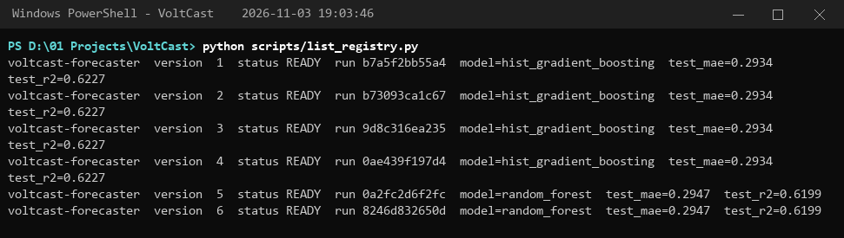
Figure 4.42: MLflow model registry: versions of voltcast-forecaster, run 2026-11-03 19:03:46
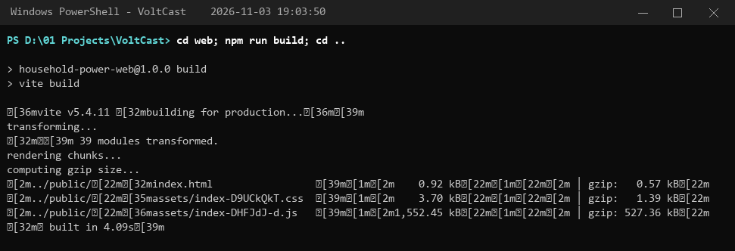
Figure 4.43: Building the React web application, run 2026-11-03 19:03:50
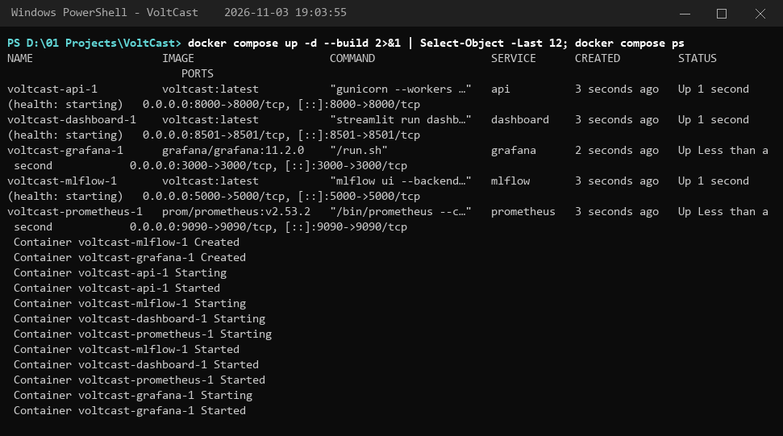
Figure 4.44: docker compose up: building the image and starting the five services, run 2026-11-03 19:03:55
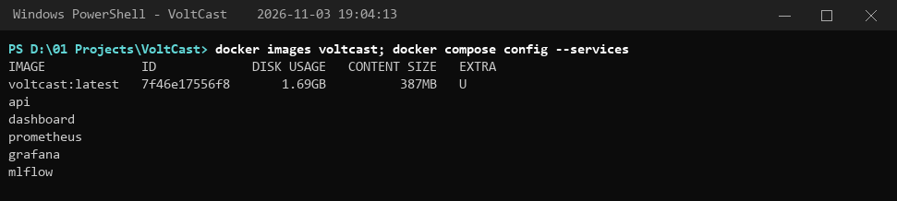
Figure 4.45: Docker image and Compose services, run 2026-11-03 19:04:13
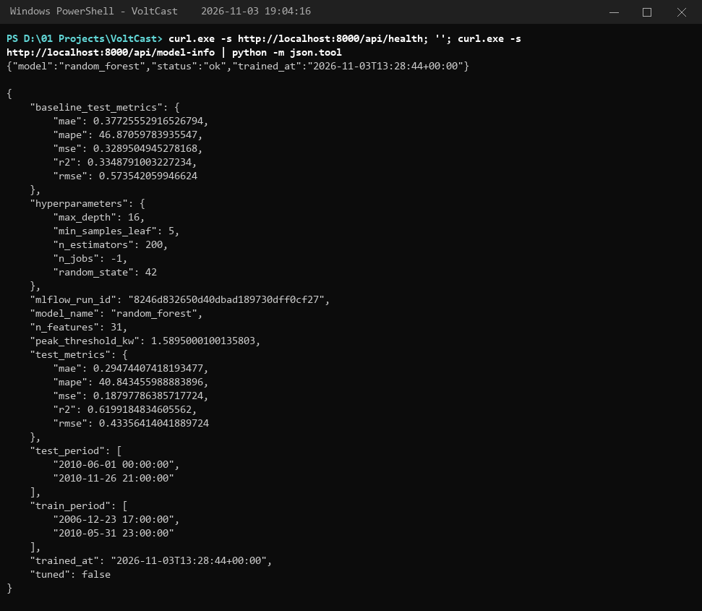
Figure 4.46: Flask API: health check and model information, run 2026-11-03 19:04:16
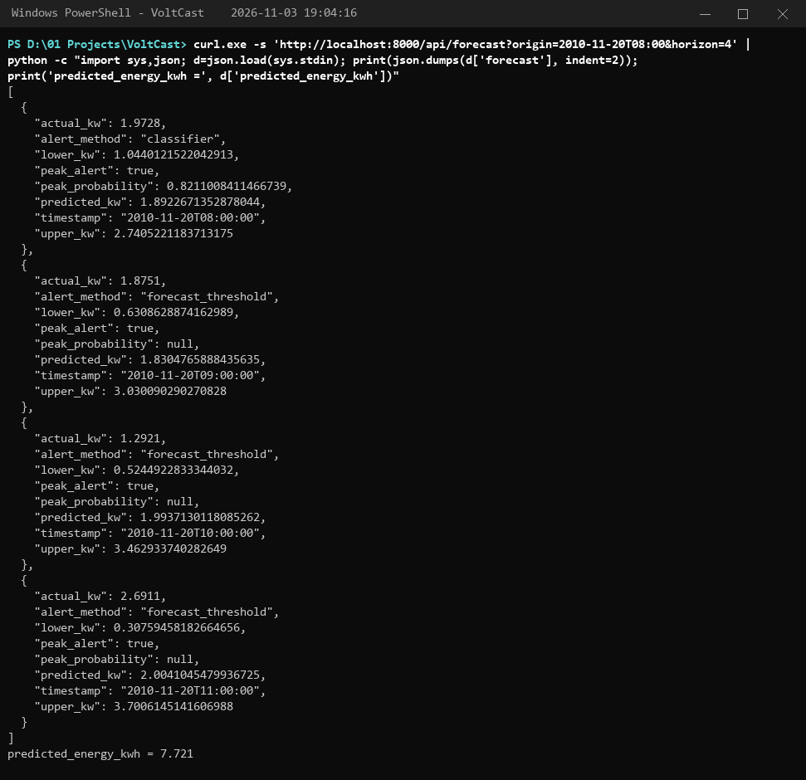
Figure 4.47: Flask API: 4-hour forecast with peak alerts, run 2026-11-03 19:04:16
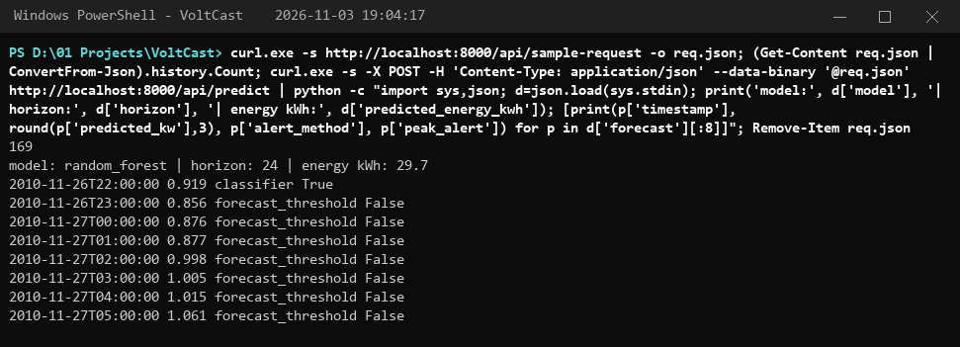
Figure 4.48: Flask API: POST /api/predict with one week of readings, run 2026-11-03 19:04:17
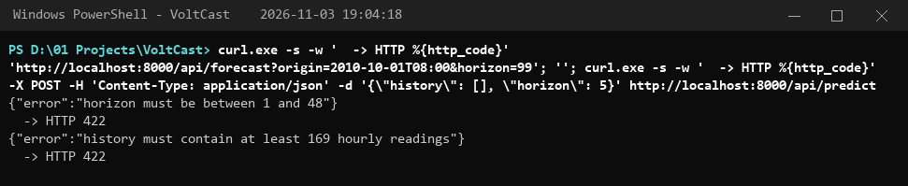
Figure 4.49: Flask API: invalid requests are rejected with HTTP 422, run 2026-11-03 19:04:18
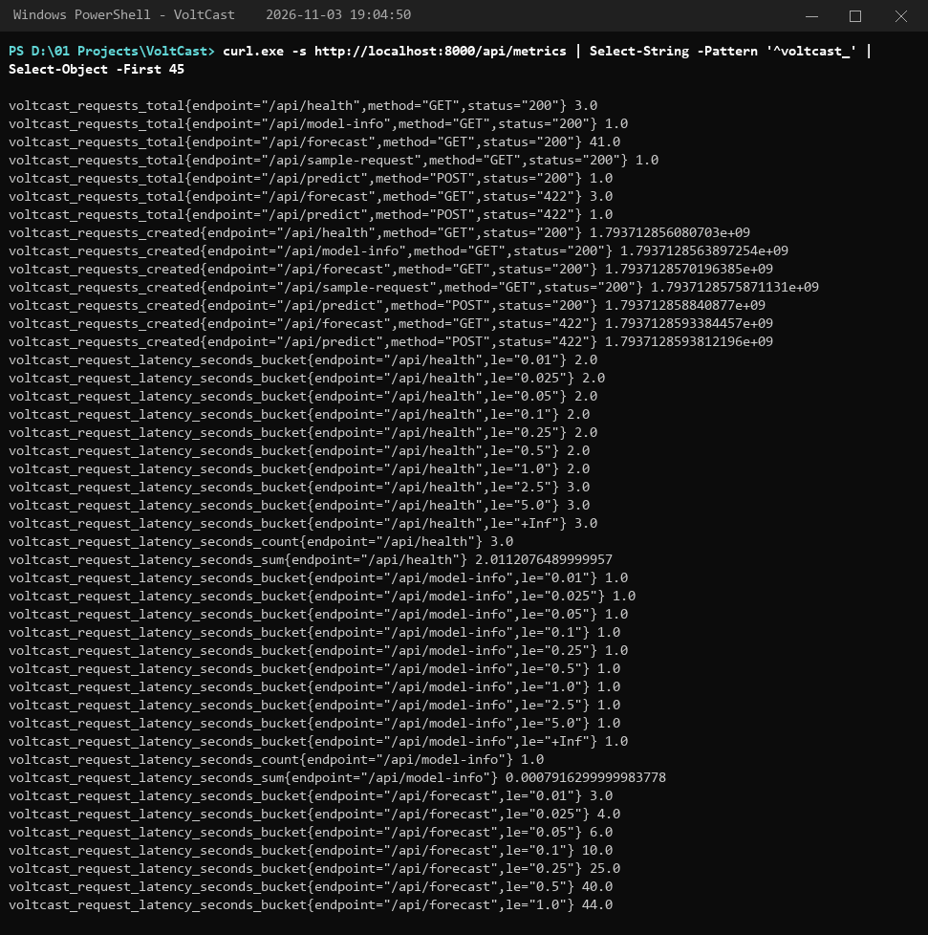
Figure 4.50: Prometheus metrics exposed by the API at /api/metrics, run 2026-11-03 19:04:50
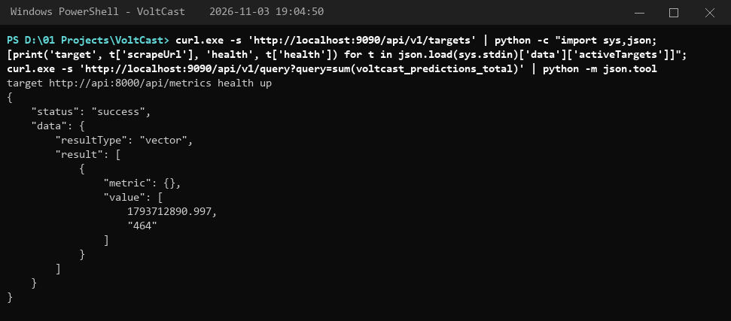
Figure 4.51: Prometheus: scrape target health and a PromQL query, run 2026-11-03 19:04:50
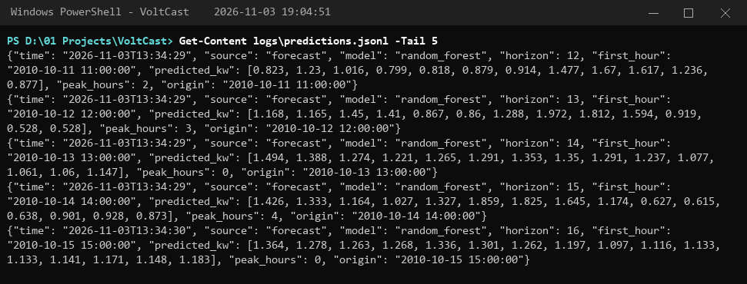
Figure 4.52: Prediction log (logs/predictions.jsonl), run 2026-11-03 19:04:51
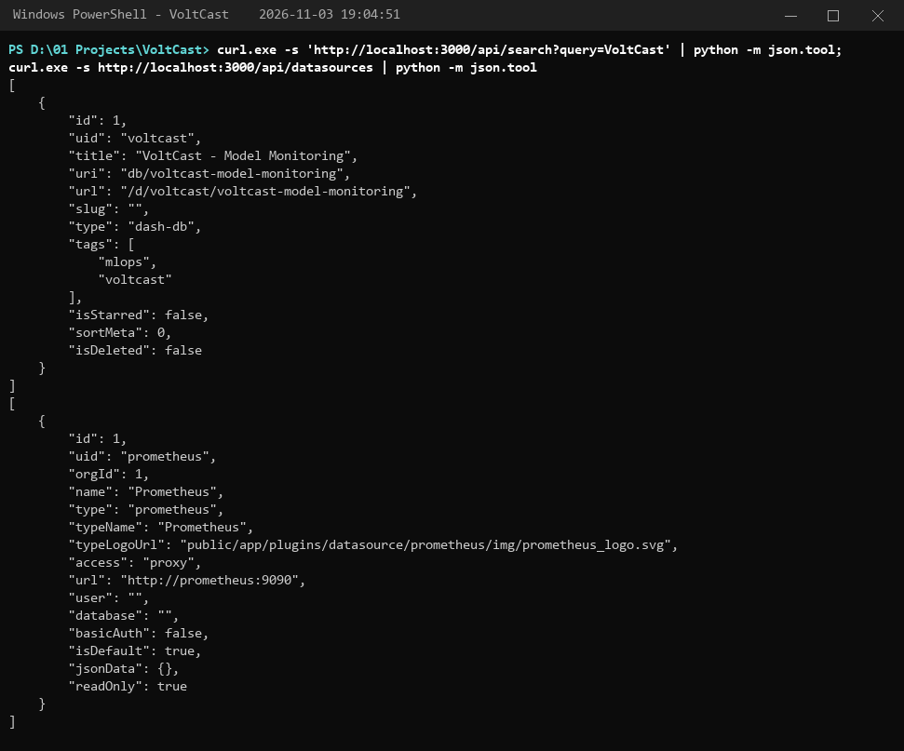
Figure 4.53: Grafana: provisioned dashboard and data source, run 2026-11-03 19:04:51
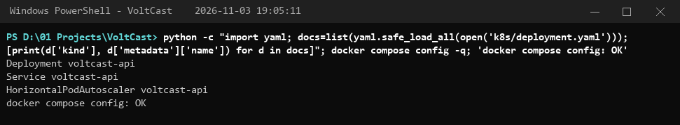
Figure 4.54: Kubernetes manifest and Docker Compose configuration validation, run 2026-11-03 19:05:11
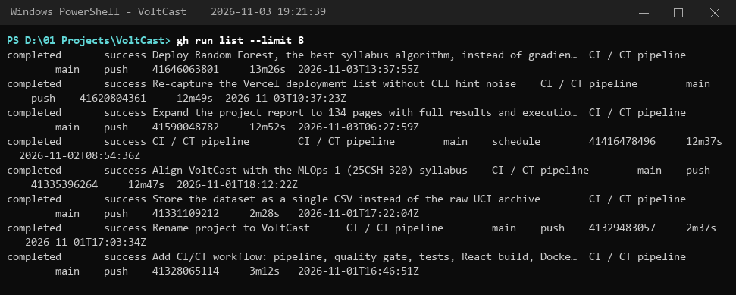
Figure 4.55: GitHub Actions: recent CI/CD runs, run 2026-11-03 19:21:39
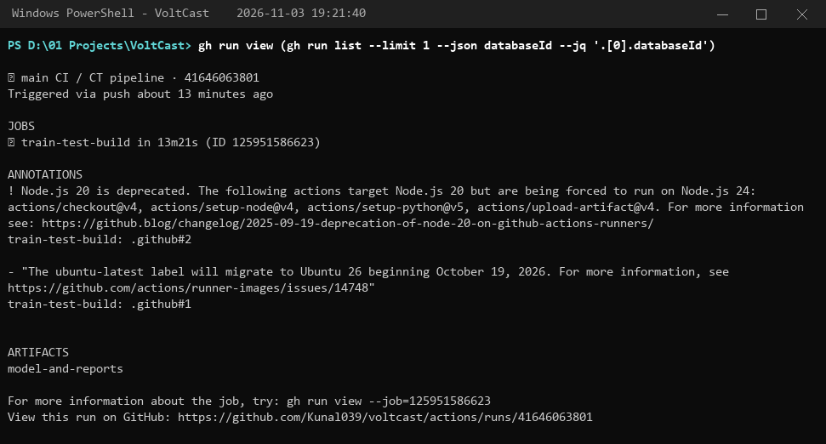
Figure 4.56: GitHub Actions: steps of the latest run, run 2026-11-03 19:21:40
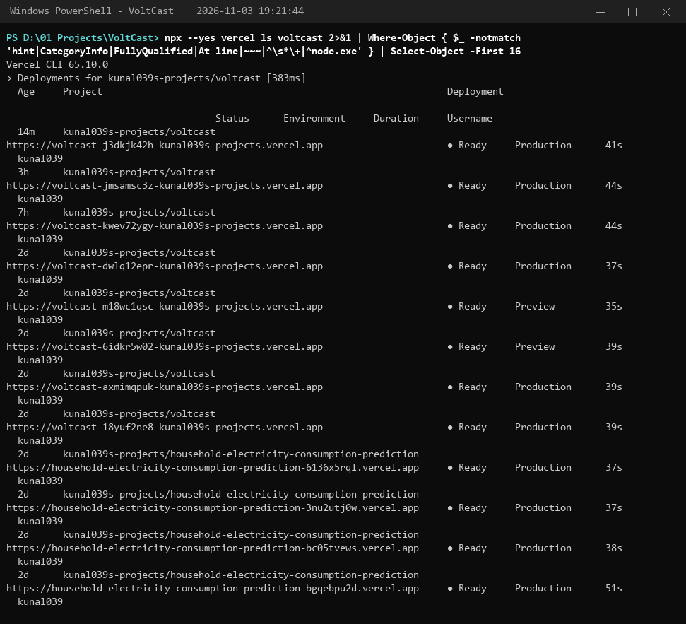
Figure 4.57: Vercel: production deployments created from GitHub pushes, run 2026-11-03 19:21:44
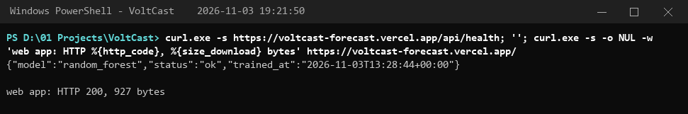
Figure 4.58: The live deployment answering requests, run 2026-11-03 19:21:50

4.1.11. Achievement of objectives
Table 4.14: Achievement of objectives
Objective (Section 2.6) | Target | Achieved
Clean hourly series | Gap-free, documented | 34,589 hourly rows, 0 gaps, outlier report
Feature engineering | ≥ 25 leakage-free | 31 features, leakage test passes
Course algorithms compared and tuned | LR, DT, KNN, SVM, RF | 9 regressors, 5 tuned with GridSearchCV
Improvement over baseline | ≥ 15% MAE | 21.9% MAE, 24.4% RMSE
Peak-hour classifier | Accuracy, P, R, F1, ROC | Accuracy 0.803, ROC-AUC 0.873
Flask API, Docker, cloud | < 1 s response | Flask + Docker + Vercel, sub-second
CI/CD and versioning | Pipeline + gates + tests + build | GitHub Actions, DVC, MLflow registry
Monitoring and logging | Prometheus, Grafana, drift | Dashboard live, 2 drifted features flagged
Ethics | Fairness, privacy, security | Bias analysis, model card, validation

CHAPTER 5.
CONCLUSION AND FUTURE WORK

5.1. Conclusion
VoltCast is a complete, working Household Electricity Consumption Prediction System built on MLOps principles. From 2.07 million raw smart-meter readings, a DVC-versioned pipeline produces a clean hourly series and 31 leakage-free features. Nine regression models, covering every algorithm in the course, are compared and tuned with GridSearchCV under MLflow tracking. The deployed random forest, the best syllabus algorithm and within a few thousandths of a kilowatt of the gradient-boosting reference, forecasts with a test MAE of 0.295 kW and R² of 0.620, 21.9% better than the persistence baseline. A tuned decision tree flags peak hours with 78% recall and ROC-AUC 0.873. The models are served by a Flask API in Docker and on the Vercel cloud, protected by CI/CD quality gates and tests, observed through Prometheus and Grafana, and reviewed for fairness, privacy and security.
Expected vs obtained results. The ≥ 15% improvement over the baseline was met. However, the absolute R² (~0.62) is lower than the >0.9 values sometimes reported in the literature, for three reasons. (i) We forecast a single household at hourly resolution, where behaviour-driven spikes are inherently unpredictable. (ii) We use a strict chronological split and refuse features computed from the hour being predicted, whereas some studies shuffle data or use same-hour intensity, which inflates scores. (iii) The test period has a different seasonal distribution from training, which the monitor correctly flagged. MAPE (~41%) is inflated by very low night-time loads, where small absolute errors become large percentages; MAE, MSE and R² are the more meaningful measures here. Hyper-parameter tuning helped the poorly regularised models (decision tree, KNN) but not the ensembles, whose defaults were already near-optimal. The peak classifier's precision on the test period is lower than on validation because summer has fewer peak hours, which is another effect of seasonal drift.

5.2. Future work
- Weather and occupancy inputs: add outdoor temperature (heating/cooling degree hours) and holiday calendars from an API; expected to reduce winter peak error substantially.
- Deep and probabilistic models: evaluate LSTM/Temporal Fusion Transformer and quantile gradient boosting for calibrated prediction intervals [12], [15].
- Multi-household, Indian data: train a global model across many homes using data from IS 16444 smart meters, with federated learning to protect privacy.
- Automated retraining: connect the monitor's retraining flag to a workflow trigger and promote a new model only if it beats the current one (champion/challenger) in the MLflow registry.
- Production Kubernetes: apply the manifests to a managed cluster (AWS EKS, GCP GKE or Azure AKS) with Prometheus service discovery and Grafana alerting rules.
- Actionable recommendations: combine forecasts with time-of-day tariffs to suggest the cheapest time to run flexible appliances.

REFERENCES
[1] International Energy Agency, “Buildings – Energy System,” IEA, Paris. [Online]. Available: https://www.iea.org/energy-system/buildings
[2] Central Electricity Authority, “General Review (All India Electricity Statistics),” Ministry of Power, Government of India, New Delhi.
[3] Ministry of Power, Government of India, “Revamped Distribution Sector Scheme (RDSS),” 2021. [Online]. Available: https://recindia.nic.in/revamped-distribution-sector-scheme
[4] D. Sculley et al., “Hidden technical debt in machine learning systems,” in Advances in Neural Information Processing Systems 28, 2015.
[5] D. Kreuzberger, N. Kühl and S. Hirschl, “Machine Learning Operations (MLOps): Overview, definition, and architecture,” IEEE Access, vol. 11, pp. 31866–31879, 2023.
[6] G. E. P. Box and G. M. Jenkins, Time Series Analysis: Forecasting and Control. San Francisco: Holden-Day, 1970.
[7] G. W. Hart, “Nonintrusive appliance load monitoring,” Proceedings of the IEEE, vol. 80, no. 12, pp. 1870–1891, 1992.
[8] L. Breiman, “Random forests,” Machine Learning, vol. 45, no. 1, pp. 5–32, 2001.
[9] J. H. Friedman, “Greedy function approximation: A gradient boosting machine,” Annals of Statistics, vol. 29, no. 5, pp. 1189–1232, 2001.
[10] G. Hebrail and A. Berard, “Individual Household Electric Power Consumption,” UCI Machine Learning Repository, 2012. doi: 10.24432/C58K54.
[11] D. L. Marino, K. Amarasinghe and M. Manic, “Building energy load forecasting using deep neural networks,” in Proc. IECON 2016 – 42nd Annual Conference of the IEEE Industrial Electronics Society, 2016, pp. 7046–7051.
[12] T.-Y. Kim and S.-B. Cho, “Predicting residential energy consumption using CNN-LSTM neural networks,” Energy, vol. 182, pp. 72–81, 2019.
[13] K. Amasyali and N. M. El-Gohary, “A review of data-driven building energy consumption prediction studies,” Renewable and Sustainable Energy Reviews, vol. 81, pp. 1192–1205, 2018.
[14] M. Zaharia et al., “Accelerating the machine learning lifecycle with MLflow,” IEEE Data Engineering Bulletin, vol. 41, no. 4, pp. 39–45, 2018.
[15] T. Hong and S. Fan, “Probabilistic electric load forecasting: A tutorial review,” International Journal of Forecasting, vol. 32, no. 3, pp. 914–938, 2016.
[16] R. J. Hyndman and G. Athanasopoulos, Forecasting: Principles and Practice, 3rd ed. Melbourne: OTexts, 2021.
[17] C. Fan, F. Xiao and S. Wang, “Development of prediction models for next-day building energy consumption and peak power demand using data mining techniques,” Applied Energy, vol. 127, pp. 1–10, 2014.
[18] G. Ke et al., “LightGBM: A highly efficient gradient boosting decision tree,” in Advances in Neural Information Processing Systems 30, 2017.
[19] S. Rabanser, S. Günnemann and Z. Lipton, “Failing loudly: An empirical study of methods for detecting dataset shift,” in Advances in Neural Information Processing Systems 32, 2019.
[20] F. Pedregosa et al., “Scikit-learn: Machine learning in Python,” Journal of Machine Learning Research, vol. 12, pp. 2825–2830, 2011.
[21] A. Géron, Hands-On Machine Learning with Scikit-Learn, Keras, and TensorFlow, 3rd ed. Sebastopol, CA: O'Reilly Media, 2022.
[22] A. C. Müller and S. Guido, Introduction to Machine Learning with Python: A Guide for Data Scientists. Sebastopol, CA: O'Reilly Media, 2016.
[23] E. Ameisen, Building Machine Learning Powered Applications: Going from Idea to Product. Sebastopol, CA: O'Reilly Media, 2020.
[24] A. Ng, Machine Learning Yearning, 2018. [Online]. Available: https://www.deeplearning.ai/machine-learning-yearning/
[25] Government of India, “The Digital Personal Data Protection Act, 2023,” Act No. 22 of 2023, Ministry of Law and Justice, New Delhi, 2023.

APPENDIX

1. Plagiarism Report

2. Design Checklist
Table A.1: Design checklist
Item | Status
Problem identified and justified with documented sources | ✔
Literature survey with comparison of existing solutions | ✔
Measurable objectives defined and mapped to course outcomes | ✔
Design constraints (standards, cost, ethics, privacy, security, safety) considered | ✔
At least two alternative designs compared and one selected with reasons | ✔
Flowchart / block diagram of implementation | ✔
Data preprocessing: missing values, outliers, normalisation, chronological split | ✔
Linear regression, decision tree, KNN, SVM and random forest implemented and compared | ✔
GridSearchCV tuning, cross-validation, over-/under-fitting analysis | ✔
Classification metrics: accuracy, precision, recall, F1, confusion matrix, ROC | ✔
Version control with Git; data and pipeline versioning with DVC; MLflow registry | ✔
Flask REST API, Docker containerisation, cloud deployment, Kubernetes manifests | ✔
CI/CD with GitHub Actions and automatic deployment | ✔
Monitoring with Prometheus and Grafana; prediction logging; drift detection | ✔
Fairness, transparency, privacy and security analysed (model card) | ✔
User manual with step-by-step instructions | ✔

3. Syllabus experiments performed in the project
The practical experiments of MLOps-1 (25CSH-320) were carried out on this project's data instead of the sample datasets suggested in the syllabus. Table A.2 maps each experiment to the code and the evidence in this report.
Table A.2: Syllabus experiments mapped to the project
Exp. | Aim (syllabus) | How it was done in VoltCast | Code | Evidence
1 | Preprocess data: cleaning, missing values, normalisation, split | 1.25% missing readings filled (interpolation + weekly fill), IQR outlier report, StandardScaler for linear/KNN/SVM, chronological train/validation/test split | src/preprocess.py, src/train.py | 3.1, 4.1.1
2 | Linear regression evaluated with MSE | Linear regression: test MSE 0.233, MAE 0.344, R² 0.530 | src/train.py | 4.1.2, 4.1.5
3 | Decision tree classifier: accuracy, confusion matrix, precision-recall | Peak-hour decision tree: accuracy 0.803, precision 0.454, recall 0.779; confusion matrix, ROC and PR curves | src/classify.py | 4.1.6
4 | GridSearchCV tuning; tuned vs default | Grids for 5 regressors and the classifier, TimeSeriesSplit(5); tree MAE 0.506 → 0.380 | src/train.py, src/classify.py | 4.1.4
5 | Version-controlled repository; ML in a DevOps pipeline | Git + GitHub (Kunal039/voltcast), DVC pipeline, GitHub Actions | dvc.yaml, .github/ | 4.1.8, 4.1.11
6 | Containerise the model with Docker | Multi-stage Dockerfile (Node build + Python runtime), five-service Docker Compose stack built and run | Dockerfile, docker-compose.yml | 4.1.7, 4.1.11
7 | Flask REST API; Prometheus metrics | Flask blueprint with 6 endpoints, Pydantic validation, Prometheus counters and histograms | serving/main.py, app.py | 4.1.7, 4.1.9
8 | CI/CD with GitHub Actions | dvc repro, quality gates, pytest, React and Docker builds; Vercel deploys every push | .github/workflows/ci.yml | 4.1.8, 4.1.11
9 | Model versioning with DVC | dvc.yaml with 9 stages, dvc.lock, dvc metrics; MLflow model registry | dvc.yaml, dvc.lock | 4.1.8, 4.1.11
10 | Monitoring and logging with Prometheus and Grafana | Prometheus scrape config, provisioned Grafana dashboard, JSON prediction log, PSI drift | monitoring/, src/monitor.py | 4.1.9, 4.1.11
11–15 | Mini project phases 1–5 | Problem and data (Ch. 1–3), models (4.1.2–4.1.6), deployment (4.1.7), automation (4.1.8), monitoring and ethics (4.1.9–4.1.10) | whole repository | Ch. 1–5

4. Source code
This section lists the complete source code of the project as submitted (repository https://github.com/Kunal039/voltcast). Generated files (trained models, metrics, figures), third-party packages and the report-generation scripts are not listed.

configs/params.yaml: central configuration
1 # Central configuration for the VoltCast (Household Electricity Consumption Prediction) pipeline.
2 data:
3 url: "https://archive.ics.uci.edu/static/public/235/individual+household+electric+power+consumption.zip"
4 raw_csv: data/household_power_consumption.csv
5 processed: data/processed/hourly.parquet
6 features: data/processed/features.parquet
7 serving: data/serving/recent_hourly.csv
8 web_data: web/public/data/dashboard.json
9 resample_rule: "1h"
10 max_interp_gap_hours: 6
11
12 split:
13 # Chronological split: no shuffling, so no future data leaks into training.
14 train_end: "2009-12-31 23:00:00"
15 val_end: "2010-05-31 23:00:00"
16
17 features:
18 target: Global_active_power
19 lags: [1, 2, 3, 6, 12, 24, 48, 168]
20 rolling_windows: [3, 6, 24, 168]
21
22 # Default hyper-parameters of each candidate (keys match the model names used in MLflow).
23 models:
24 linear_regression: {}
25 ridge_regression:
26 alpha: 1.0
27 decision_tree:
28 random_state: 42
29 knn:
30 n_neighbors: 10
31 svm:
32 C: 1.0
33 epsilon: 0.1
34 random_forest:
35 n_estimators: 200
36 max_depth: 16
37 min_samples_leaf: 5
38 n_jobs: -1
39 random_state: 42
40 hist_gradient_boosting:
41 max_iter: 500
42 learning_rate: 0.05
43 max_leaf_nodes: 31
44 l2_regularization: 1.0
45 random_state: 42
46
47 # Only algorithms from the MLOps-1 syllabus may be deployed. Gradient boosting and the
48 # naive baselines are still trained and reported as reference points.
49 selection:
50 deployable: [linear_regression, ridge_regression, decision_tree, knn, svm, random_forest]
51
52 # GridSearchCV with time-series cross-validation (folds never train on the future).
53 tuning:
54 cv_splits: 5
55 scoring: neg_mean_absolute_error
56 grids:
57 ridge_regression:
58 alpha: [0.01, 0.1, 1.0, 10.0, 100.0]
59 decision_tree:
60 max_depth: [4, 6, 8, 10, 14, null]
61 min_samples_leaf: [1, 10, 50, 100]
62 knn:
63 n_neighbors: [5, 10, 20, 40]
64 weights: [uniform, distance]
65 random_forest:
66 max_depth: [10, 16, null]
67 min_samples_leaf: [1, 5, 20]
68 hist_gradient_boosting:
69 learning_rate: [0.03, 0.05, 0.1]
70 max_leaf_nodes: [15, 31, 63]
71
72 # Peak-hour alert: classify whether the next hour is a high-consumption hour.
73 classification:
74 threshold_quantile: 0.75 # of training-period consumption
75 decision_tree:
76 random_state: 42
77 grid:
78 max_depth: [3, 5, 7, 9, 12, null]
79 min_samples_leaf: [1, 10, 50, 100]
80 class_weight: [null, balanced]
81
82 mlflow:
83 tracking_uri: "sqlite:///mlflow.db"
84 experiment: household-electricity-forecasting
85 registered_model: voltcast-forecaster
86
87 monitoring:
88 psi_threshold: 0.2
89 mae_degradation_pct: 20

dvc.yaml: DVC pipeline definition
1 # Reproducible pipeline (`dvc repro`), mirrors run_pipeline.py.
2 # The dataset and processed data are versioned in the DVC cache; small artifacts that the
3 # hosted app needs (model, metrics, serving data) are also committed to Git, so they use cache: false.
4 stages:
5 ingest:
6 cmd: python -m src.data_ingestion
7 deps: [src/data_ingestion.py]
8 params: [{configs/params.yaml: [data.url]}]
9 outs: [data/household_power_consumption.csv]
10 preprocess:
11 cmd: python -m src.preprocess
12 deps: [src/preprocess.py, data/household_power_consumption.csv]
13 params: [{configs/params.yaml: [data.resample_rule, data.max_interp_gap_hours]}]
14 outs: [data/processed/hourly.parquet]
15 metrics: [reports/data_stats.json: {cache: false}]
16 features:
17 cmd: python -m src.features
18 deps: [src/features.py, data/processed/hourly.parquet]
19 params: [{configs/params.yaml: [features]}]
20 outs: [data/processed/features.parquet]
21 train:
22 cmd: python -m src.train
23 deps: [src/train.py, src/features.py, data/processed/features.parquet]
24 params: [{configs/params.yaml: [split, models, tuning]}]
25 outs:
26 - models/model.joblib: {cache: false}
27 - models/metadata.json: {cache: false}
28 - reports/test_predictions.parquet: {cache: false}
29 metrics: [reports/metrics.json: {cache: false}]
30 classify:
31 cmd: python -m src.classify
32 deps: [src/classify.py, data/processed/features.parquet, reports/test_predictions.parquet]
33 params: [{configs/params.yaml: [split, classification]}]
34 outs: [models/peak_classifier.joblib: {cache: false}, models/peak_classifier.json: {cache: false}]
35 metrics: [reports/classification.json: {cache: false}]
36 monitor:
37 cmd: python -m src.monitor
38 deps: [src/monitor.py, models/model.joblib, reports/test_predictions.parquet]
39 params: [{configs/params.yaml: [monitoring]}]
40 metrics: [reports/monitoring.json: {cache: false}]
41 evaluate:
42 cmd: python -m src.evaluate
43 deps: [src/evaluate.py, models/model.joblib, reports/monitoring.json, reports/classification.json]
44 outs: [reports/figures: {cache: false}]
45 metrics: [reports/fairness.json: {cache: false}]
46 export_web:
47 cmd: python -m src.export_web
48 deps: [src/export_web.py, models/model.joblib, reports/monitoring.json, reports/classification.json]
49 outs:
50 - data/serving/recent_hourly.csv: {cache: false}
51 - web/public/data/dashboard.json: {cache: false}
52 analyze:
53 cmd: python -m src.analysis
54 deps: [src/analysis.py, src/train.py, data/processed/features.parquet, models/model.joblib,
55 models/peak_classifier.json, reports/metrics.json, data/serving/recent_hourly.csv]
56 params: [{configs/params.yaml: [split, models, tuning, classification]}]
57 outs: [reports/analysis: {cache: false}]
58 metrics: [reports/analysis.json: {cache: false}]

run_pipeline.py: pipeline runner
1 """Run the full MLOps pipeline end to end: ingest -> preprocess -> features -> train -> classify -> monitor -> evaluate -> export -> analysis."""
2 import time
3
4 from src import analysis, classify, data_ingestion, evaluate, export_web, features, monitor, preprocess, train
5 from src.utils import get_logger
6
7 log = get_logger("pipeline")
8
9 STAGES = [
10 ("ingestion", data_ingestion.main),
11 ("preprocess", preprocess.main),
12 ("features", features.main),
13 ("train", train.main),
14 ("classify", classify.main),
15 ("monitor", monitor.main),
16 ("evaluate", evaluate.main),
17 ("export_web", export_web.main),
18 ("analysis", analysis.main),
19 ]
20
21 if __name__ == "__main__":
22 for name, fn in STAGES:
23 t0 = time.perf_counter()
24 log.info("=== Stage: %s ===", name)
25 fn()
26 log.info("Stage %s finished in %.1fs", name, time.perf_counter() - t0)

src/utils.py: shared helpers
1 """Shared helpers: config loading, paths and logging."""
2 import logging
3 from pathlib import Path
4
5 import yaml
6
7 ROOT = Path(__file__).resolve().parents[1]
8
9
10 def load_params(path: Path | str = ROOT / "configs" / "params.yaml") -> dict:
11 with open(path, "r", encoding="utf-8") as f:
12 return yaml.safe_load(f)
13
14
15 def resolve(rel: str) -> Path:
16 p = ROOT / rel
17 p.parent.mkdir(parents=True, exist_ok=True)
18 return p
19
20
21 def get_logger(name: str) -> logging.Logger:
22 logging.basicConfig(
23 level=logging.INFO,
24 format="%(asctime)s | %(levelname)-7s | %(name)s | %(message)s",
25 )
26 return logging.getLogger(name)

src/data_ingestion.py: download, CSV conversion and schema check
1 """Stage 1 - Data ingestion: download the UCI dataset once, store it as a clean CSV, validate its schema.
2
3 The UCI archive holds a semicolon-separated .txt with '?' for missing readings and
4 separate Date/Time columns. It is converted to a standard CSV with one Datetime
5 column and blank cells for missing values; the downloaded archive is not kept.
6 """
7 import io
8 import tempfile
9 import zipfile
10 from pathlib import Path
11
12 import pandas as pd
13 import requests
14
15 from src.utils import get_logger, load_params, resolve
16
17 log = get_logger("ingestion")
18
19 EXPECTED_COLUMNS = [
20 "Datetime", "Global_active_power", "Global_reactive_power", "Voltage",
21 "Global_intensity", "Sub_metering_1", "Sub_metering_2", "Sub_metering_3",
22 ]
23
24
25 def download(params: dict) -> None:
26 csv_path = resolve(params["data"]["raw_csv"])
27 if csv_path.exists():
28 log.info("Dataset already present at %s - skipping download", csv_path)
29 return
30 log.info("Downloading dataset from %s", params["data"]["url"])
31 with tempfile.TemporaryDirectory() as tmp:
32 zip_path = Path(tmp) / "dataset.zip"
33 with requests.get(params["data"]["url"], stream=True, timeout=120) as r:
34 r.raise_for_status()
35 with open(zip_path, "wb") as f:
36 for chunk in r.iter_content(chunk_size=1 << 20):
37 f.write(chunk)
38 with zipfile.ZipFile(zip_path) as z:
39 name = next(n for n in z.namelist() if n.endswith(".txt"))
40 raw = pd.read_csv(io.TextIOWrapper(z.open(name), encoding="utf-8"),
41 sep=";", na_values=["?"], low_memory=False)
42 raw.insert(0, "Datetime", pd.to_datetime(raw["Date"] + " " + raw["Time"], format="%d/%m/%Y %H:%M:%S"))
43 raw.drop(columns=["Date", "Time"]).to_csv(csv_path, index=False, date_format="%Y-%m-%d %H:%M:%S")
44 log.info("Saved %d rows to %s", len(raw), csv_path)
45
46
47 def validate_schema(params: dict) -> None:
48 with open(resolve(params["data"]["raw_csv"]), "r", encoding="utf-8") as f:
49 header = f.readline().strip().split(",")
50 if header != EXPECTED_COLUMNS:
51 raise ValueError(f"Unexpected schema: {header}")
52 log.info("Schema validation passed (%d columns)", len(header))
53
54
55 def main() -> None:
56 params = load_params()
57 download(params)
58 validate_schema(params)
59
60
61 if __name__ == "__main__":
62 main()

src/preprocess.py: cleaning, resampling and outlier report
1 """Stage 2 - Preprocessing: clean minute-level readings and resample to hourly."""
2 import json
3
4 import numpy as np
5 import pandas as pd
6
7 from src.utils import ROOT, get_logger, load_params, resolve
8
9 log = get_logger("preprocess")
10
11 NUMERIC = [
12 "Global_active_power", "Global_reactive_power", "Voltage", "Global_intensity",
13 "Sub_metering_1", "Sub_metering_2", "Sub_metering_3",
14 ]
15
16
17 def load_raw(path) -> pd.DataFrame:
18 df = pd.read_csv(path, parse_dates=["Datetime"], index_col="Datetime").sort_index()
19 df.index.name = "datetime"
20 df[NUMERIC] = df[NUMERIC].astype("float32")
21 return df
22
23
24 def clean_and_resample(df: pd.DataFrame, rule: str, max_gap: int) -> pd.DataFrame:
25 # Energy not captured by the three sub-meters (Wh per minute).
26 df["Sub_metering_other"] = (
27 df["Global_active_power"] * 1000 / 60
28 - df["Sub_metering_1"] - df["Sub_metering_2"] - df["Sub_metering_3"]
29 ).clip(lower=0)
30 agg = {c: "mean" for c in ["Global_active_power", "Global_reactive_power", "Voltage", "Global_intensity"]}
31 agg.update({c: "sum" for c in ["Sub_metering_1", "Sub_metering_2", "Sub_metering_3", "Sub_metering_other"]})
32 # min_count=1 keeps all-missing hours as NaN instead of 0 for summed columns.
33 hourly = df.resample(rule).agg(agg)
34 counts = df["Global_active_power"].resample(rule).count()
35 for c in ["Sub_metering_1", "Sub_metering_2", "Sub_metering_3", "Sub_metering_other"]:
36 hourly.loc[counts == 0, c] = np.nan
37 # Fill short outages by time interpolation; longer gaps use same-hour-last-week values.
38 hourly = hourly.interpolate(method="time", limit=max_gap, limit_area="inside")
39 hourly = hourly.fillna(hourly.shift(168)).ffill().bfill()
40 return hourly
41
42
43 def outlier_report(hourly: pd.DataFrame) -> dict:
44 """IQR rule (outside Q1 - 1.5 IQR .. Q3 + 1.5 IQR) per variable.
45
46 Outliers are reported, not removed: high readings are real peak usage (heaters,
47 ovens), exactly the hours the forecaster must learn. Distance-based models
48 (KNN, SVM) instead get standardised inputs so large-valued columns do not dominate.
49 """
50 out = {}
51 for c in ["Global_active_power", "Global_reactive_power", "Voltage", "Global_intensity"]:
52 q1, q3 = hourly[c].quantile([0.25, 0.75])
53 lo, hi = q1 - 1.5 * (q3 - q1), q3 + 1.5 * (q3 - q1)
54 n = int(((hourly[c] < lo) | (hourly[c] > hi)).sum())
55 out[c] = {"lower": round(float(lo), 3), "upper": round(float(hi), 3), "count": n,
56 "pct": round(n / len(hourly) * 100, 2)}
57 return out
58
59
60 def main() -> None:
61 params = load_params()
62 raw = load_raw(resolve(params["data"]["raw_csv"]))
63 missing_pct = float(raw["Global_active_power"].isna().mean() * 100)
64 log.info("Loaded %d minute rows, %.2f%% missing", len(raw), missing_pct)
65 hourly = clean_and_resample(raw, params["data"]["resample_rule"], params["data"]["max_interp_gap_hours"])
66 out = resolve(params["data"]["processed"])
67 hourly.to_parquet(out)
68 stats = {
69 "raw_rows": int(len(raw)),
70 "raw_missing_pct": round(missing_pct, 3),
71 "hourly_rows": int(len(hourly)),
72 "start": str(hourly.index.min()),
73 "end": str(hourly.index.max()),
74 "outliers": outlier_report(hourly),
75 }
76 (ROOT / "reports").mkdir(exist_ok=True)
77 (ROOT / "reports" / "data_stats.json").write_text(json.dumps(stats, indent=2))
78 log.info("Saved %d hourly rows to %s", len(hourly), out)
79
80
81 if __name__ == "__main__":
82 main()

src/features.py: feature engineering
1 """Stage 3 - Feature engineering for next-hour consumption forecasting.
2
3 Every feature at time t uses only information available up to hour t-1,
4 so the model forecasts consumption for hour t without leakage.
5 """
6 import numpy as np
7 import pandas as pd
8
9 from src.utils import get_logger, load_params, resolve
10
11 log = get_logger("features")
12
13 # Public holidays in France (dataset location: Sceaux, near Paris), fixed-date ones.
14 FIXED_HOLIDAYS = {(1, 1), (5, 1), (5, 8), (7, 14), (8, 15), (11, 1), (11, 11), (12, 25)}
15
16
17 def calendar_features(idx: pd.DatetimeIndex) -> pd.DataFrame:
18 f = pd.DataFrame(index=idx)
19 f["hour"] = idx.hour
20 f["dayofweek"] = idx.dayofweek
21 f["month"] = idx.month
22 f["is_weekend"] = (idx.dayofweek >= 5).astype(int)
23 f["is_holiday"] = [int((d.month, d.day) in FIXED_HOLIDAYS) for d in idx]
24 # Cyclical encodings so 23:00 and 00:00 are close in feature space.
25 f["hour_sin"] = np.sin(2 * np.pi * idx.hour / 24)
26 f["hour_cos"] = np.cos(2 * np.pi * idx.hour / 24)
27 f["month_sin"] = np.sin(2 * np.pi * (idx.month - 1) / 12)
28 f["month_cos"] = np.cos(2 * np.pi * (idx.month - 1) / 12)
29 return f
30
31
32 def build_features(hourly: pd.DataFrame, target: str, lags: list[int], windows: list[int]) -> pd.DataFrame:
33 y = hourly[target]
34 f = calendar_features(hourly.index)
35 for lag in lags:
36 f[f"lag_{lag}"] = y.shift(lag)
37 past = y.shift(1)
38 for w in windows:
39 f[f"roll_mean_{w}"] = past.rolling(w).mean()
40 f[f"roll_std_{w}"] = past.rolling(w).std()
41 for c in ["Global_reactive_power", "Voltage", "Global_intensity",
42 "Sub_metering_1", "Sub_metering_2", "Sub_metering_3"]:
43 f[f"{c}_lag1"] = hourly[c].shift(1)
44 f["target"] = y
45 return f.dropna()
46
47
48 def feature_columns(params: dict) -> list[str]:
49 """Deterministic feature list used by training, the API and the dashboard."""
50 fp = params["features"]
51 cols = ["hour", "dayofweek", "month", "is_weekend", "is_holiday",
52 "hour_sin", "hour_cos", "month_sin", "month_cos"]
53 cols += [f"lag_{l}" for l in fp["lags"]]
54 for w in fp["rolling_windows"]:
55 cols += [f"roll_mean_{w}", f"roll_std_{w}"]
56 cols += [f"{c}_lag1" for c in ["Global_reactive_power", "Voltage", "Global_intensity",
57 "Sub_metering_1", "Sub_metering_2", "Sub_metering_3"]]
58 return cols
59
60
61 def main() -> None:
62 params = load_params()
63 hourly = pd.read_parquet(resolve(params["data"]["processed"]))
64 feats = build_features(hourly, params["features"]["target"],
65 params["features"]["lags"], params["features"]["rolling_windows"])
66 assert list(feats.columns[:-1]) == feature_columns(params)
67 feats.to_parquet(resolve(params["data"]["features"]))
68 log.info("Built %d rows x %d features", len(feats), feats.shape[1] - 1)
69
70
71 if __name__ == "__main__":
72 main()

src/train.py: model training, tuning and registry
1 """Stage 4 - Training: compare candidate models with MLflow tracking, tune them, register the best.
2
3 1. Every syllabus algorithm (linear regression, decision tree, KNN, SVM, random forest)
4 plus ridge, gradient boosting and two naive baselines is trained with default settings.
5 Train and validation errors are both recorded to expose over- and under-fitting.
6 2. Models with a grid in params.yaml are tuned with GridSearchCV using time-series
7 cross-validation on the training period (each fold only trains on the past).
8 3. The best variant on the chronological validation window is refit on train+validation
9 and scored once on the untouched test window.
10 """
11 import json
12 import time
13 from datetime import datetime, timezone
14
15 import joblib
16 import mlflow
17 import mlflow.sklearn
18 import numpy as np
19 import pandas as pd
20 from mlflow.models import infer_signature
21 from sklearn.ensemble import HistGradientBoostingRegressor, RandomForestRegressor
22 from sklearn.linear_model import LinearRegression, Ridge
23 from sklearn.metrics import mean_absolute_error, mean_squared_error, r2_score
24 from sklearn.model_selection import GridSearchCV, TimeSeriesSplit
25 from sklearn.neighbors import KNeighborsRegressor
26 from sklearn.pipeline import Pipeline, make_pipeline
27 from sklearn.preprocessing import StandardScaler
28 from sklearn.svm import SVR
29 from sklearn.tree import DecisionTreeRegressor
30
31 from src.features import feature_columns
32 from src.utils import ROOT, get_logger, load_params, resolve
33
34 log = get_logger("train")
35 # Tree node storage of the models this pipeline itself trains (forests, single trees, boosting).
36 TRUSTED_TYPES = ["sklearn.ensemble._hist_gradient_boosting.predictor.TreePredictor", "sklearn.tree._tree.Tree"]
37
38
39 def split(df: pd.DataFrame, params: dict):
40 train_end = pd.Timestamp(params["split"]["train_end"])
41 val_end = pd.Timestamp(params["split"]["val_end"])
42 return df[df.index <= train_end], df[(df.index > train_end) & (df.index <= val_end)], df[df.index > val_end]
43
44
45 def metrics(y_true, y_pred) -> dict:
46 y_true, y_pred = np.asarray(y_true), np.asarray(y_pred)
47 return {
48 "mae": float(mean_absolute_error(y_true, y_pred)),
49 "mse": float(mean_squared_error(y_true, y_pred)),
50 "rmse": float(np.sqrt(mean_squared_error(y_true, y_pred))),
51 "r2": float(r2_score(y_true, y_pred)),
52 "mape": float(np.mean(np.abs((y_true - y_pred) / np.clip(y_true, 0.1, None))) * 100),
53 }
54
55
56 class NaiveForecaster:
57 """Baseline that copies one lag column (persistence or seasonal naive)."""
58
59 def __init__(self, column: str, columns: list[str]):
60 self.idx = columns.index(column)
61
62 def fit(self, X, y):
63 return self
64
65 def predict(self, X):
66 return np.asarray(X)[:, self.idx]
67
68
69 def build(name: str, params: dict, cols: list[str], overrides: dict | None = None):
70 """Create a fresh, unfitted model. Distance- and margin-based models get feature scaling."""
71 hp = {**params["models"].get(name, {}), **(overrides or {})}
72 makers = {
73 "persistence_baseline": lambda: NaiveForecaster("lag_1", cols),
74 "seasonal_naive_24h": lambda: NaiveForecaster("lag_24", cols),
75 "linear_regression": lambda: make_pipeline(StandardScaler(), LinearRegression(**hp)),
76 "ridge_regression": lambda: make_pipeline(StandardScaler(), Ridge(**hp)),
77 "decision_tree": lambda: DecisionTreeRegressor(**hp),
78 "knn": lambda: make_pipeline(StandardScaler(), KNeighborsRegressor(**hp)),
79 "svm": lambda: make_pipeline(StandardScaler(), SVR(**hp)),
80 "random_forest": lambda: RandomForestRegressor(**hp),
81 "hist_gradient_boosting": lambda: HistGradientBoostingRegressor(**hp),
82 }
83 return makers[name]()
84
85
86 CANDIDATES = ["persistence_baseline", "seasonal_naive_24h", "linear_regression", "ridge_regression",
87 "decision_tree", "knn", "svm", "random_forest", "hist_gradient_boosting"]
88
89
90 def tune(name: str, params: dict, cols: list[str], X, y) -> GridSearchCV:
91 model = build(name, params, cols)
92 grid = params["tuning"]["grids"][name]
93 # Inside a pipeline, parameters are addressed as <step>__<param>.
94 prefix = f"{model.steps[-1][0]}__" if isinstance(model, Pipeline) else ""
95 search = GridSearchCV(
96 model, {prefix + k: v for k, v in grid.items()},
97 cv=TimeSeriesSplit(n_splits=params["tuning"]["cv_splits"]),
98 scoring=params["tuning"]["scoring"],
99 n_jobs=1 if name == "random_forest" else -1, # the forest already uses every core
100 return_train_score=True,
101 )
102 search.fit(X, y)
103 search.best_params_unprefixed = {k.removeprefix(prefix): v for k, v in search.best_params_.items()}
104 return search
105
106
107 def main() -> None:
108 params = load_params()
109 cols = feature_columns(params)
110 df = pd.read_parquet(resolve(params["data"]["features"]))
111 train, val, test = split(df, params)
112 X_tr, y_tr, X_val, y_val = train[cols].values, train["target"].values, val[cols].values, val["target"].values
113 log.info("Train %d | Val %d | Test %d rows", len(train), len(val), len(test))
114
115 mlflow.set_tracking_uri(params["mlflow"]["tracking_uri"])
116 mlflow.set_experiment(params["mlflow"]["experiment"])
117
118 # 1. Default models: train vs validation error.
119 results = {}
120 for name in CANDIDATES:
121 model = build(name, params, cols)
122 with mlflow.start_run(run_name=name):
123 t0 = time.perf_counter()
124 model.fit(X_tr, y_tr)
125 fit_s = time.perf_counter() - t0
126 m = metrics(y_val, model.predict(X_val))
127 train_m = metrics(y_tr, model.predict(X_tr))
128 mlflow.log_params({"model": name, "variant": "default", "n_features": len(cols), **params["models"].get(name, {})})
129 mlflow.log_metrics({**{f"val_{k}": v for k, v in m.items()}, "train_mae": train_m["mae"],
130 "train_r2": train_m["r2"], "fit_seconds": fit_s})
131 results[name] = {**m, "train_mae": train_m["mae"], "train_r2": train_m["r2"], "fit_seconds": fit_s}
132 log.info("%-24s train MAE=%.4f val MAE=%.4f RMSE=%.4f R2=%.4f (%.1fs)",
133 name, train_m["mae"], m["mae"], m["rmse"], m["r2"], fit_s)
134
135 # 2. Hyper-parameter tuning with time-series cross-validation.
136 tuning = {}
137 for name in params["tuning"]["grids"]:
138 t0 = time.perf_counter()
139 search = tune(name, params, cols, X_tr, y_tr)
140 tuned_val = metrics(y_val, search.best_estimator_.predict(X_val))
141 tuning[name] = {
142 "best_params": search.best_params_unprefixed,
143 "cv_mae": float(-search.best_score_),
144 "candidates_tried": len(search.cv_results_["params"]),
145 "default_val": {k: results[name][k] for k in ["mae", "rmse", "r2"]},
146 "tuned_val": {k: tuned_val[k] for k in ["mae", "rmse", "r2"]},
147 "search_seconds": time.perf_counter() - t0,
148 }
149 with mlflow.start_run(run_name=f"{name}_tuned"):
150 mlflow.log_params({"model": name, "variant": "tuned", **search.best_params_unprefixed})
151 mlflow.log_metrics({"cv_mae": tuning[name]["cv_mae"], **{f"val_{k}": v for k, v in tuned_val.items()}})
152 log.info("tuned %-18s %s CV MAE=%.4f val MAE %.4f -> %.4f", name, search.best_params_unprefixed,
153 tuning[name]["cv_mae"], results[name]["mae"], tuned_val["mae"])
154
155 # 3. Pick the best variant (default or tuned) on validation RMSE among the syllabus algorithms;
156 # the best model overall is recorded for comparison only.
157 variants = [(n, None, results[n]["rmse"]) for n in CANDIDATES if n not in ("persistence_baseline", "seasonal_naive_24h")]
158 variants += [(n, t["best_params"], t["tuned_val"]["rmse"]) for n, t in tuning.items()]
159 overall = min(variants, key=lambda v: v[2])
160 allowed = params["selection"]["deployable"]
161 best, best_params, _ = min((v for v in variants if v[0] in allowed), key=lambda v: v[2])
162 log.info("Best model on validation: %s (%s); best overall incl. reference models: %s", best,
163 "tuned " + str(best_params) if best_params else "default", overall[0])
164
165 full = pd.concat([train, val])
166 final = build(best, params, cols, best_params)
167 final.fit(full[cols].values, full["target"].values)
168 test_pred = final.predict(test[cols].values)
169 test_m = metrics(test["target"], test_pred)
170 baseline_m = metrics(test["target"], test["lag_1"])
171 log.info("TEST %s: MAE=%.4f RMSE=%.4f R2=%.4f | persistence MAE=%.4f",
172 best, test_m["mae"], test_m["rmse"], test_m["r2"], baseline_m["mae"])
173
174 with mlflow.start_run(run_name=f"{best}_final") as run:
175 mlflow.log_params({"model": best, "trained_on": "train+val", **(best_params or {})})
176 mlflow.log_metrics({f"test_{k}": v for k, v in test_m.items()})
177 mlflow.sklearn.log_model(
178 final, name="model", signature=infer_signature(test[cols].iloc[:5], test_pred[:5]),
179 registered_model_name=params["mlflow"]["registered_model"],
180 # We produced this model ourselves in this run, so its tree type is trusted.
181 skops_trusted_types=TRUSTED_TYPES,
182 )
183 run_id = run.info.run_id
184
185 models_dir = ROOT / "models"
186 models_dir.mkdir(exist_ok=True)
187 joblib.dump(final, models_dir / "model.joblib", compress=3) # a 200-tree forest is ~65 MB uncompressed
188 metadata = {
189 "model_name": best,
190 "hyperparameters": {**params["models"].get(best, {}), **(best_params or {})},
191 "tuned": best_params is not None,
192 "selection": {"deployable": allowed, "best_overall": overall[0], "best_overall_val_rmse": overall[2]},
193 "trained_at": datetime.now(timezone.utc).isoformat(timespec="seconds"),
194 "mlflow_run_id": run_id,
195 "features": cols,
196 "train_period": [str(full.index.min()), str(full.index.max())],
197 "test_period": [str(test.index.min()), str(test.index.max())],
198 "test_metrics": test_m,
199 "baseline_test_metrics": baseline_m,
200 # Residual spread on the test window, used for simple prediction intervals in the API.
201 "residual_std": float(np.std(test["target"].values - test_pred)),
202 }
203 (models_dir / "metadata.json").write_text(json.dumps(metadata, indent=2))
204 (ROOT / "reports" / "metrics.json").write_text(json.dumps(
205 {"validation": results, "tuning": tuning, "test": {best: test_m, "persistence_baseline": baseline_m}}, indent=2))
206 pd.DataFrame({"actual": test["target"], "predicted": test_pred}).to_parquet(
207 ROOT / "reports" / "test_predictions.parquet")
208 log.info("Saved model to %s", models_dir / "model.joblib")
209
210
211 if __name__ == "__main__":
212 main()

src/classify.py: peak-hour classifier
1 """Stage 5 - Peak-hour classification: will the next hour be a high-consumption hour?
2
3 Turns the forecasting problem into a binary alert (useful for demand response):
4 label = 1 when consumption exceeds the 75th percentile of the training period.
5 A decision tree is trained with default settings and tuned with GridSearchCV
6 (time-series folds, F1 scoring); a logistic regression is the linear reference.
7 Evaluated with accuracy, precision, recall, F1, ROC-AUC and the confusion matrix.
8 """
9 import json
10
11 import joblib
12 import mlflow
13 import numpy as np
14 import pandas as pd
15 from sklearn.linear_model import LogisticRegression
16 from sklearn.metrics import (accuracy_score, confusion_matrix, f1_score, precision_recall_curve,
17 precision_score, recall_score, roc_auc_score, roc_curve)
18 from sklearn.model_selection import GridSearchCV, TimeSeriesSplit
19 from sklearn.pipeline import make_pipeline
20 from sklearn.preprocessing import StandardScaler
21 from sklearn.tree import DecisionTreeClassifier
22
23 from src.features import feature_columns
24 from src.train import split
25 from src.utils import ROOT, get_logger, load_params, resolve
26
27 log = get_logger("classify")
28
29
30 def scores(y_true, proba, threshold: float = 0.5) -> dict:
31 pred = (proba >= threshold).astype(int)
32 return {
33 "accuracy": float(accuracy_score(y_true, pred)),
34 "precision": float(precision_score(y_true, pred, zero_division=0)),
35 "recall": float(recall_score(y_true, pred, zero_division=0)),
36 "f1": float(f1_score(y_true, pred, zero_division=0)),
37 "roc_auc": float(roc_auc_score(y_true, proba)),
38 "confusion_matrix": confusion_matrix(y_true, pred).tolist(), # [[TN, FP], [FN, TP]]
39 }
40
41
42 def main() -> None:
43 params = load_params()
44 cp = params["classification"]
45 cols = feature_columns(params)
46 df = pd.read_parquet(resolve(params["data"]["features"]))
47 train, val, test = split(df, params)
48 threshold_kw = float(train["target"].quantile(cp["threshold_quantile"]))
49 label = lambda d: (d["target"] > threshold_kw).astype(int).values
50 X_tr, y_tr, X_val, y_val = train[cols].values, label(train), val[cols].values, label(val)
51 log.info("Peak threshold %.3f kW | positive rate train %.1f%% val %.1f%%",
52 threshold_kw, y_tr.mean() * 100, y_val.mean() * 100)
53
54 mlflow.set_tracking_uri(params["mlflow"]["tracking_uri"])
55 mlflow.set_experiment(params["mlflow"]["experiment"] + "-peak-classifier")
56
57 search = GridSearchCV(DecisionTreeClassifier(**cp["decision_tree"]), cp["grid"],
58 cv=TimeSeriesSplit(n_splits=params["tuning"]["cv_splits"]), scoring="f1", n_jobs=-1)
59 search.fit(X_tr, y_tr)
60 models = {
61 "logistic_regression": make_pipeline(StandardScaler(), LogisticRegression(max_iter=2000)).fit(X_tr, y_tr),
62 "decision_tree_default": DecisionTreeClassifier(**cp["decision_tree"]).fit(X_tr, y_tr),
63 "decision_tree_tuned": search.best_estimator_,
64 }
65 val_scores = {}
66 for name, model in models.items():
67 s = scores(y_val, model.predict_proba(X_val)[:, 1])
68 s["train_f1"] = float(f1_score(y_tr, model.predict(X_tr)))
69 val_scores[name] = s
70 with mlflow.start_run(run_name=name):
71 mlflow.log_metrics({f"val_{k}": v for k, v in s.items() if k != "confusion_matrix"})
72 log.info("%-22s val acc=%.3f prec=%.3f rec=%.3f F1=%.3f AUC=%.3f (train F1 %.3f)", name, s["accuracy"],
73 s["precision"], s["recall"], s["f1"], s["roc_auc"], s["train_f1"])
74
75 best = max(val_scores, key=lambda n: val_scores[n]["f1"])
76 full = pd.concat([train, val])
77 final = (DecisionTreeClassifier(**cp["decision_tree"], **search.best_params_) if best == "decision_tree_tuned"
78 else models[best].__class__(**models[best].get_params()))
79 final.fit(full[cols].values, label(full))
80 proba = final.predict_proba(test[cols].values)[:, 1]
81 y_test = label(test)
82 test_scores = scores(y_test, proba)
83 fpr, tpr, _ = roc_curve(y_test, proba)
84 prec, rec, _ = precision_recall_curve(y_test, proba)
85 log.info("TEST %s: acc=%.3f prec=%.3f rec=%.3f F1=%.3f AUC=%.3f", best, test_scores["accuracy"],
86 test_scores["precision"], test_scores["recall"], test_scores["f1"], test_scores["roc_auc"])
87 with mlflow.start_run(run_name=f"{best}_final"):
88 mlflow.log_params({"model": best, "threshold_kw": threshold_kw, **search.best_params_})
89 mlflow.log_metrics({f"test_{k}": v for k, v in test_scores.items() if k != "confusion_matrix"})
90
91 # Reference: flag a peak whenever the regression forecast exceeds the threshold.
92 reg = pd.read_parquet(ROOT / "reports" / "test_predictions.parquet").reindex(test.index)
93 rule = (reg["predicted"].values > threshold_kw).astype(float)
94 rule_scores = {k: v for k, v in scores(y_test, rule).items() if k != "roc_auc"}
95 log.info("TEST forecast>threshold rule: acc=%.3f prec=%.3f rec=%.3f F1=%.3f", rule_scores["accuracy"],
96 rule_scores["precision"], rule_scores["recall"], rule_scores["f1"])
97
98 joblib.dump(final, ROOT / "models" / "peak_classifier.joblib")
99 # Small sidecar the API needs at run time (reports/ is not shipped to the server).
100 (ROOT / "models" / "peak_classifier.json").write_text(json.dumps(
101 {"model": best, "threshold_kw": threshold_kw, "hyperparameters": search.best_params_}, indent=2))
102 (ROOT / "reports" / "classification.json").write_text(json.dumps({
103 "threshold_kw": threshold_kw,
104 "threshold_quantile": cp["threshold_quantile"],
105 "best_params": {k: v for k, v in search.best_params_.items()},
106 "cv_f1": float(search.best_score_),
107 "validation": val_scores,
108 "selected": best,
109 "test": test_scores,
110 "forecast_threshold_rule_test": rule_scores,
111 "positive_rate_test": float(y_test.mean()),
112 # Down-sampled curves for plotting.
113 "roc": {"fpr": fpr[:: max(1, len(fpr) // 200)].round(4).tolist(), "tpr": tpr[:: max(1, len(tpr) // 200)].round(4).tolist()},
114 "pr": {"precision": prec[:: max(1, len(prec) // 200)].round(4).tolist(), "recall": rec[:: max(1, len(rec) // 200)].round(4).tolist()},
115 }, indent=2))
116 log.info("Saved peak classifier (%s)", best)
117
118
119 if __name__ == "__main__":
120 main()

src/monitor.py: drift monitoring
1 """Stage 6 - Monitoring: data drift (PSI) and performance checks that decide on retraining."""
2 import json
3
4 import numpy as np
5 import pandas as pd
6
7 from src.train import metrics, split
8 from src.utils import ROOT, get_logger, load_params, resolve
9
10 log = get_logger("monitor")
11
12 MONITORED = ["lag_1", "roll_mean_24", "Voltage_lag1", "Global_intensity_lag1",
13 "Sub_metering_3_lag1", "hour", "target"]
14
15
16 def psi(reference: np.ndarray, current: np.ndarray, bins: int = 10) -> float:
17 """Population Stability Index: <0.1 stable, 0.1-0.2 moderate, >0.2 significant drift."""
18 edges = np.unique(np.quantile(reference, np.linspace(0, 1, bins + 1)))
19 edges[0], edges[-1] = -np.inf, np.inf
20 ref = np.histogram(reference, edges)[0] / len(reference)
21 cur = np.histogram(current, edges)[0] / len(current)
22 ref, cur = np.clip(ref, 1e-6, None), np.clip(cur, 1e-6, None)
23 return float(np.sum((cur - ref) * np.log(cur / ref)))
24
25
26 def main() -> None:
27 params = load_params()
28 df = pd.read_parquet(resolve(params["data"]["features"]))
29 train, _, test = split(df, params)
30 drift = {c: round(psi(train[c].values, test[c].values), 4) for c in MONITORED}
31 drifted = [c for c, v in drift.items() if v > params["monitoring"]["psi_threshold"]]
32
33 meta = json.loads((ROOT / "models" / "metadata.json").read_text())
34 preds = pd.read_parquet(ROOT / "reports" / "test_predictions.parquet")
35 # Compare recent production-like window (last 30 days) with the overall test MAE.
36 recent = preds.iloc[-24 * 30:]
37 recent_mae = metrics(recent["actual"], recent["predicted"])["mae"]
38 degradation = (recent_mae / meta["test_metrics"]["mae"] - 1) * 100
39 retrain = bool(drifted) or degradation > params["monitoring"]["mae_degradation_pct"]
40
41 report = {
42 "psi": drift,
43 "drifted_features": drifted,
44 "recent_30d_mae": round(recent_mae, 4),
45 "reference_test_mae": round(meta["test_metrics"]["mae"], 4),
46 "mae_degradation_pct": round(degradation, 2),
47 "retraining_recommended": retrain,
48 }
49 (ROOT / "reports" / "monitoring.json").write_text(json.dumps(report, indent=2))
50 log.info("PSI: %s", drift)
51 log.info("Recent MAE %.4f (%.1f%% vs reference) -> retrain=%s", recent_mae, degradation, retrain)
52
53
54 if __name__ == "__main__":
55 main()

src/evaluate.py: evaluation figures
1 """Stage 7 - Evaluation: EDA, model diagnostics, classification and bias-slice figures for the report and website."""
2 import json
3
4 import joblib
5 import matplotlib
6
7 matplotlib.use("Agg")
8 import matplotlib.pyplot as plt
9 import numpy as np
10 import pandas as pd
11 import seaborn as sns
12 from sklearn.inspection import permutation_importance
13 from sklearn.metrics import mean_absolute_error
14 from sklearn.tree import DecisionTreeRegressor
15
16 from src.features import feature_columns
17 from src.train import split
18 from src.utils import ROOT, get_logger, load_params, resolve
19
20 log = get_logger("evaluate")
21 FIG = ROOT / "reports" / "figures"
22 plt.rcParams.update({"figure.dpi": 130, "axes.spines.top": False, "axes.spines.right": False,
23 "font.family": "serif", "font.size": 10})
24 BLUE, ORANGE, GREY = "#1f5fa8", "#e07b24", "#888888"
25 LABELS = {
26 "persistence_baseline": "Persistence baseline", "seasonal_naive_24h": "Seasonal naive (24 h)",
27 "linear_regression": "Linear regression", "ridge_regression": "Ridge regression",
28 "decision_tree": "Decision tree", "knn": "K-nearest neighbours", "svm": "SVM (SVR)",
29 "random_forest": "Random forest", "hist_gradient_boosting": "Gradient boosting",
30 }
31
32
33 def save(name: str) -> None:
34 plt.tight_layout()
35 plt.savefig(FIG / name, bbox_inches="tight")
36 plt.close()
37
38
39 def eda(hourly: pd.DataFrame) -> None:
40 y = hourly["Global_active_power"]
41 daily = y.resample("D").mean()
42 fig, ax = plt.subplots(figsize=(9, 3.2))
43 ax.plot(daily.index, daily, color=BLUE, lw=0.7, label="Daily mean")
44 ax.plot(daily.rolling(30).mean(), color=ORANGE, lw=1.8, label="30-day rolling mean")
45 ax.set(title="Household active power, Dec 2006 - Nov 2010", ylabel="kW")
46 ax.legend(frameon=False)
47 save("fig_eda_timeseries.png")
48
49 pivot = y.groupby([y.index.dayofweek, y.index.hour]).mean().unstack()
50 pivot.index = ["Mon", "Tue", "Wed", "Thu", "Fri", "Sat", "Sun"]
51 fig, ax = plt.subplots(figsize=(9, 3.2))
52 sns.heatmap(pivot, cmap="YlOrRd", ax=ax, cbar_kws={"label": "kW"})
53 ax.set(title="Average consumption by weekday and hour", xlabel="Hour of day", ylabel="")
54 save("fig_eda_heatmap.png")
55
56 fig, axes = plt.subplots(1, 2, figsize=(9, 3.2))
57 y.groupby(y.index.month).mean().plot(kind="bar", color=BLUE, ax=axes[0])
58 axes[0].set(title="Average by month", xlabel="Month", ylabel="kW")
59 sub = hourly[["Sub_metering_1", "Sub_metering_2", "Sub_metering_3", "Sub_metering_other"]].sum()
60 sub.index = ["Kitchen", "Laundry", "Water heater / AC", "Other"]
61 axes[1].pie(sub, labels=sub.index, autopct="%1.0f%%", colors=[BLUE, ORANGE, "#5aa469", GREY])
62 axes[1].set(title="Energy share by sub-meter")
63 save("fig_eda_month_submeter.png")
64
65 corr = hourly.corr()
66 fig, ax = plt.subplots(figsize=(6.5, 5))
67 sns.heatmap(corr, annot=True, fmt=".2f", cmap="coolwarm", center=0, ax=ax, annot_kws={"size": 7})
68 ax.set(title="Correlation between measured variables")
69 save("fig_eda_correlation.png")
70
71
72 def model_figures(params: dict) -> None:
73 m = json.loads((ROOT / "reports" / "metrics.json").read_text())["validation"]
74 names = list(m)
75 fig, axes = plt.subplots(1, 2, figsize=(9, 3.2))
76 colors = [GREY if "baseline" in n or "naive" in n else BLUE for n in names]
77 best = json.loads((ROOT / "models" / "metadata.json").read_text())["model_name"] # deployed model
78 colors[names.index(best)] = ORANGE
79 labels = [LABELS.get(n, n) for n in names]
80 axes[0].barh(labels, [m[n]["mae"] for n in names], color=colors)
81 axes[0].set(title="Validation MAE (lower is better)", xlabel="kW")
82 axes[0].invert_yaxis()
83 axes[1].barh(labels, [m[n]["r2"] for n in names], color=colors)
84 axes[1].set(title="Validation R² (higher is better)")
85 axes[1].axvline(0, color="black", lw=0.6)
86 axes[1].invert_yaxis()
87 axes[1].tick_params(labelleft=False)
88 save("fig_model_comparison.png")
89
90 # Over/under-fitting: training vs validation error of every default model.
91 ml = [n for n in names if "baseline" not in n and "naive" not in n]
92 fig, ax = plt.subplots(figsize=(9, 3.4))
93 x = np.arange(len(ml))
94 ax.bar(x - 0.2, [m[n]["train_mae"] for n in ml], 0.4, color=GREY, label="Training MAE")
95 ax.bar(x + 0.2, [m[n]["mae"] for n in ml], 0.4, color=BLUE, label="Validation MAE")
96 ax.set_xticks(x, [LABELS[n].replace(" ", "\n", 1) for n in ml], fontsize=8)
97 ax.set(title="Training vs validation error (default hyper-parameters)", ylabel="MAE (kW)")
98 ax.legend(frameon=False)
99 save("fig_train_vs_val.png")
100
101 # Default vs GridSearchCV-tuned validation error.
102 t = json.loads((ROOT / "reports" / "metrics.json").read_text())["tuning"]
103 tn = list(t)
104 fig, ax = plt.subplots(figsize=(9, 3.2))
105 x = np.arange(len(tn))
106 ax.bar(x - 0.2, [t[n]["default_val"]["mae"] for n in tn], 0.4, color=GREY, label="Default")
107 ax.bar(x + 0.2, [t[n]["tuned_val"]["mae"] for n in tn], 0.4, color=ORANGE, label="Tuned (GridSearchCV)")
108 ax.set_xticks(x, [LABELS[n] for n in tn], fontsize=8)
109 ax.set(title="Effect of hyper-parameter tuning on validation MAE", ylabel="MAE (kW)")
110 ax.legend(frameon=False)
111 save("fig_tuning.png")
112
113 preds = pd.read_parquet(ROOT / "reports" / "test_predictions.parquet")
114 week = preds.iloc[-24 * 14:]
115 fig, ax = plt.subplots(figsize=(9, 3.2))
116 ax.plot(week.index, week["actual"], color=GREY, lw=1.2, label="Actual")
117 ax.plot(week.index, week["predicted"], color=ORANGE, lw=1.2, label="Predicted")
118 ax.set(title="Next-hour forecast vs actual - last 14 days of test set", ylabel="kW")
119 ax.legend(frameon=False)
120 save("fig_actual_vs_pred.png")
121
122 resid = preds["actual"] - preds["predicted"]
123 fig, axes = plt.subplots(1, 2, figsize=(9, 3.2))
124 axes[0].scatter(preds["actual"], preds["predicted"], s=3, alpha=0.3, color=BLUE)
125 lim = [0, preds.max().max()]
126 axes[0].plot(lim, lim, color="black", lw=0.8, ls="--")
127 axes[0].set(title="Predicted vs actual (test)", xlabel="Actual kW", ylabel="Predicted kW")
128 axes[1].hist(resid, bins=60, color=BLUE)
129 axes[1].set(title="Residual distribution", xlabel="Actual - predicted (kW)")
130 save("fig_residuals.png")
131
132 err = preds.assign(err=resid.abs()).groupby(preds.index.hour)["err"].mean()
133 fig, ax = plt.subplots(figsize=(9, 3))
134 ax.bar(err.index, err.values, color=BLUE)
135 ax.set(title="Mean absolute error by hour of day (test)", xlabel="Hour", ylabel="MAE (kW)")
136 save("fig_error_by_hour.png")
137
138
139 def importance(params: dict) -> None:
140 meta = json.loads((ROOT / "models" / "metadata.json").read_text())
141 model = joblib.load(ROOT / "models" / "model.joblib")
142 df = pd.read_parquet(resolve(params["data"]["features"]))
143 _, _, test = split(df, params)
144 r = permutation_importance(model, test[meta["features"]].values, test["target"].values,
145 n_repeats=5, random_state=0, scoring="neg_mean_absolute_error")
146 imp = pd.Series(r.importances_mean, index=meta["features"]).sort_values().tail(15)
147 imp.to_frame("importance").to_csv(ROOT / "reports" / "feature_importance.csv")
148 fig, ax = plt.subplots(figsize=(7, 4.5))
149 ax.barh(imp.index, imp.values, color=BLUE)
150 ax.set(title="Top 15 features (permutation importance)", xlabel="Increase in MAE when shuffled (kW)")
151 save("fig_feature_importance.png")
152
153
154 def monitoring_fig() -> None:
155 mon = json.loads((ROOT / "reports" / "monitoring.json").read_text())
156 s = pd.Series(mon["psi"]).sort_values()
157 fig, ax = plt.subplots(figsize=(7, 3.2))
158 ax.barh(s.index, s.values, color=[ORANGE if v > 0.2 else BLUE for v in s.values])
159 ax.axvline(0.1, color=GREY, ls="--", lw=0.8)
160 ax.axvline(0.2, color="red", ls="--", lw=0.8)
161 ax.set(title="Data drift: PSI train vs test (dashed: 0.1 / 0.2 thresholds)", xlabel="PSI")
162 save("fig_drift_psi.png")
163
164
165 def outlier_fig(hourly: pd.DataFrame) -> None:
166 cols = ["Global_active_power", "Global_reactive_power", "Global_intensity"]
167 fig, axes = plt.subplots(1, 3, figsize=(9, 3))
168 for ax, c in zip(axes, cols):
169 ax.boxplot(hourly[c], vert=True, widths=0.5, flierprops={"markersize": 2, "alpha": 0.3})
170 ax.set(title=c.replace("_", " "), xticks=[])
171 fig.suptitle("Outliers by the IQR rule (kept: they are genuine peak-usage hours)", fontsize=10)
172 save("fig_outliers.png")
173
174
175 def validation_curve_fig(params: dict) -> None:
176 """Decision-tree depth vs error: under-fitting on the left, over-fitting on the right."""
177 cols = feature_columns(params)
178 train, val, _ = split(pd.read_parquet(resolve(params["data"]["features"])), params)
179 depths = [1, 2, 3, 4, 6, 8, 10, 12, 15, 20, 25]
180 tr, va = [], []
181 for d in depths:
182 m = DecisionTreeRegressor(max_depth=d, random_state=42).fit(train[cols].values, train["target"].values)
183 tr.append(mean_absolute_error(train["target"], m.predict(train[cols].values)))
184 va.append(mean_absolute_error(val["target"], m.predict(val[cols].values)))
185 best = depths[int(np.argmin(va))]
186 fig, ax = plt.subplots(figsize=(9, 3.2))
187 ax.plot(depths, tr, "o-", color=GREY, label="Training MAE")
188 ax.plot(depths, va, "o-", color=BLUE, label="Validation MAE")
189 ax.axvline(best, color=ORANGE, ls="--", lw=1)
190 ax.text(best + 0.3, max(va) * 0.95, f"best depth = {best}", color=ORANGE)
191 ax.text(1.2, max(va) * 0.6, "under-fitting", color=GREY, style="italic")
192 ax.text(18, max(va) * 0.6, "over-fitting", color=GREY, style="italic")
193 ax.set(title="Validation curve: decision tree depth", xlabel="max_depth", ylabel="MAE (kW)")
194 ax.legend(frameon=False)
195 save("fig_validation_curve.png")
196
197
198 def classification_figs() -> None:
199 c = json.loads((ROOT / "reports" / "classification.json").read_text())
200 t = c["test"]
201 fig, axes = plt.subplots(1, 3, figsize=(10, 3.3))
202 cm = np.array(t["confusion_matrix"])
203 axes[0].imshow(cm, cmap="Blues")
204 for (i, j), v in np.ndenumerate(cm):
205 axes[0].text(j, i, f"{v:,}", ha="center", va="center", color="white" if v > cm.max() / 2 else "black")
206 axes[0].set(title="Confusion matrix (test)", xticks=[0, 1], yticks=[0, 1],
207 xticklabels=["Normal", "Peak"], yticklabels=["Normal", "Peak"], xlabel="Predicted", ylabel="Actual")
208 axes[1].plot(c["roc"]["fpr"], c["roc"]["tpr"], color=ORANGE, lw=1.8)
209 axes[1].plot([0, 1], [0, 1], color=GREY, ls="--", lw=0.8)
210 axes[1].set(title=f"ROC curve (AUC = {t['roc_auc']:.3f})", xlabel="False positive rate", ylabel="True positive rate")
211 axes[2].plot(c["pr"]["recall"], c["pr"]["precision"], color=BLUE, lw=1.8)
212 axes[2].axhline(c["positive_rate_test"], color=GREY, ls="--", lw=0.8)
213 axes[2].set(title="Precision-recall curve", xlabel="Recall", ylabel="Precision")
214 save("fig_classification.png")
215
216 v = c["validation"]
217 names = list(v)
218 keys = ["accuracy", "precision", "recall", "f1", "roc_auc"]
219 fig, ax = plt.subplots(figsize=(9, 3.2))
220 x = np.arange(len(keys))
221 for i, (n, col) in enumerate(zip(names, [GREY, BLUE, ORANGE])):
222 ax.bar(x + (i - 1) * 0.27, [v[n][k] for k in keys], 0.27, color=col, label=n.replace("_", " "))
223 ax.set_xticks(x, ["Accuracy", "Precision", "Recall", "F1", "ROC-AUC"])
224 ax.set(title="Peak-hour classifiers on the validation set", ylim=(0, 1))
225 ax.legend(frameon=False, fontsize=8, loc="lower right")
226 save("fig_classifier_comparison.png")
227
228
229 def fairness_slices() -> None:
230 """Bias check: is the forecast equally good for every kind of hour and season?"""
231 p = pd.read_parquet(ROOT / "reports" / "test_predictions.parquet")
232 p["err"] = (p["actual"] - p["predicted"]).abs()
233 idx = p.index
234 slices = {
235 "Day type": np.where(idx.dayofweek >= 5, "Weekend", "Weekday"),
236 "Time of day": pd.cut(idx.hour, [-1, 5, 11, 17, 23], labels=["Night 0-5", "Morning 6-11",
237 "Afternoon 12-17", "Evening 18-23"]),
238 "Season": pd.Categorical(np.where(idx.month.isin([6, 7, 8]), "Summer (Jun-Aug)", "Autumn (Sep-Nov)"),
239 categories=["Summer (Jun-Aug)", "Autumn (Sep-Nov)"]),
240 "Usage level": pd.qcut(p["actual"], 3, labels=["Low use", "Medium use", "High use"]),
241 }
242 out = {}
243 for name, groups in slices.items():
244 g = p.groupby(pd.Series(groups, index=p.index), observed=True)["err"].agg(["mean", "count"])
245 out[name] = {str(k): {"mae": round(float(r["mean"]), 4), "hours": int(r["count"])} for k, r in g.iterrows()}
246 overall = float(p["err"].mean())
247 (ROOT / "reports" / "fairness.json").write_text(json.dumps({"overall_mae": overall, "slices": out}, indent=2))
248
249 fig, axes = plt.subplots(1, 4, figsize=(11, 3.2), sharey=True)
250 for ax, (name, groups) in zip(axes, out.items()):
251 ax.bar(list(groups), [v["mae"] for v in groups.values()], color=BLUE)
252 ax.axhline(overall, color=ORANGE, ls="--", lw=1)
253 ax.set_title(name)
254 ax.tick_params(axis="x", labelrotation=30, labelsize=7.5)
255 axes[0].set_ylabel("MAE (kW)")
256 fig.suptitle("Error across sub-groups of the test period (dashed = overall MAE)", fontsize=10)
257 save("fig_fairness.png")
258
259
260 def main() -> None:
261 params = load_params()
262 FIG.mkdir(parents=True, exist_ok=True)
263 hourly = pd.read_parquet(resolve(params["data"]["processed"]))
264 eda(hourly)
265 outlier_fig(hourly)
266 model_figures(params)
267 validation_curve_fig(params)
268 importance(params)
269 classification_figs()
270 fairness_slices()
271 if (ROOT / "reports" / "monitoring.json").exists():
272 monitoring_fig()
273 log.info("Figures written to %s", FIG)
274
275
276 if __name__ == "__main__":
277 main()

src/analysis.py: extended analysis
1 """Stage 8 - Extended analysis for the report: every model on the test set, extra metrics, curves.
2
3 Produces reports/analysis.json and the figures in reports/analysis/:
4 * test-set scores of all nine regressors (default and tuned), with accuracy-style metrics
5 * per-model forecast, scatter and residual plots
6 * error by forecast horizon (1-24 h ahead) for the deployed recursive forecaster
7 * learning curves, cross-validation fold scores and hyper-parameter response curves
8 * confusion matrices, ROC/PR overlays, classification report and threshold sweep
9 * additional EDA (missing data, distributions, autocorrelation, profiles) and monthly drift
10 """
11 import json
12 import time
13
14 import matplotlib
15
16 matplotlib.use("Agg")
17 import matplotlib.pyplot as plt
18 import numpy as np
19 import pandas as pd
20 from sklearn.linear_model import LogisticRegression, Ridge
21 from sklearn.metrics import (classification_report, confusion_matrix, explained_variance_score, max_error,
22 median_absolute_error, precision_recall_curve, roc_auc_score, roc_curve)
23 from sklearn.model_selection import GridSearchCV, TimeSeriesSplit, cross_validate, learning_curve
24 from sklearn.neighbors import KNeighborsRegressor
25 from sklearn.pipeline import make_pipeline
26 from sklearn.preprocessing import StandardScaler
27 from sklearn.tree import DecisionTreeClassifier, DecisionTreeRegressor
28
29 from src.features import feature_columns
30 from src.monitor import MONITORED, psi
31 from src.predict import MIN_HISTORY_HOURS, forecast
32 from src.train import CANDIDATES, build, metrics, split
33 from src.utils import ROOT, get_logger, load_params, resolve
34
35 log = get_logger("analysis")
36 OUT = ROOT / "reports" / "analysis"
37 plt.rcParams.update({"figure.dpi": 130, "axes.spines.top": False, "axes.spines.right": False,
38 "font.family": "serif", "font.size": 9})
39 BLUE, ORANGE, GREY, GREEN, RED = "#1f5fa8", "#e07b24", "#888888", "#2f8f5b", "#b42318"
40 LABELS = {
41 "persistence_baseline": "Persistence baseline", "seasonal_naive_24h": "Seasonal naive (24 h)",
42 "linear_regression": "Linear regression", "ridge_regression": "Ridge regression",
43 "decision_tree": "Decision tree", "knn": "K-nearest neighbours", "svm": "SVM (SVR)",
44 "random_forest": "Random forest", "hist_gradient_boosting": "Gradient boosting",
45 }
46
47
48 def save(name: str) -> None:
49 plt.tight_layout()
50 plt.savefig(OUT / name, bbox_inches="tight")
51 plt.close()
52
53
54 def extended_metrics(y, p) -> dict:
55 """Standard regression metrics plus accuracy-style measures that are easy to explain."""
56 y, p = np.asarray(y), np.asarray(p)
57 err = np.abs(y - p)
58 return {
59 **metrics(y, p),
60 "median_ae": float(median_absolute_error(y, p)),
61 "max_error": float(max_error(y, p)),
62 "explained_variance": float(explained_variance_score(y, p)),
63 # 1 - WAPE: share of total consumption predicted correctly (common in energy forecasting).
64 "accuracy_1_minus_wape": float(1 - err.sum() / np.abs(y).sum()),
65 "within_0_25kw_pct": float((err <= 0.25).mean() * 100),
66 "within_0_5kw_pct": float((err <= 0.5).mean() * 100),
67 }
68
69
70 # ---------------------------------------------------------------- regression on the test set
71 def all_models_on_test(params, cols, train, val, test, tuning):
72 full = pd.concat([train, val])
73 X, y, Xt, yt = full[cols].values, full["target"].values, test[cols].values, test["target"].values
74 results, preds = {}, {}
75 variants = [(n, None) for n in CANDIDATES] + [(n, t["best_params"]) for n, t in tuning.items()]
76 for name, hp in variants:
77 key = name + ("_tuned" if hp else "")
78 t0 = time.perf_counter()
79 model = build(name, params, cols, hp).fit(X, y)
80 fit_s = time.perf_counter() - t0
81 t0 = time.perf_counter()
82 p = model.predict(Xt)
83 pred_ms = (time.perf_counter() - t0) / len(Xt) * 1000
84 results[key] = {**extended_metrics(yt, p), "fit_seconds": fit_s, "predict_ms_per_row": pred_ms}
85 if not hp:
86 preds[name] = p
87 log.info("test %-30s MAE=%.4f R2=%.4f acc(1-WAPE)=%.3f", key, results[key]["mae"], results[key]["r2"],
88 results[key]["accuracy_1_minus_wape"])
89 return results, preds
90
91
92 def per_model_figures(test, preds):
93 names = list(preds)
94 week = slice(-24 * 7, None)
95 fig, axes = plt.subplots(3, 3, figsize=(10, 7.5), sharey=True)
96 for ax, n in zip(axes.flat, names):
97 ax.plot(test.index[week], test["target"].values[week], color=GREY, lw=0.9, label="Actual")
98 ax.plot(test.index[week], preds[n][week], color=ORANGE, lw=0.9, label="Predicted")
99 ax.set_title(LABELS[n], fontsize=9)
100 ax.tick_params(axis="x", labelsize=6, rotation=30)
101 axes[0, 0].legend(frameon=False, fontsize=7)
102 fig.suptitle("Next-hour forecasts of every model, last 7 days of the test set", fontsize=10)
103 save("per_model_forecasts.png")
104
105 fig, axes = plt.subplots(3, 3, figsize=(10, 9))
106 lim = [0, float(test["target"].max())]
107 for ax, n in zip(axes.flat, names):
108 ax.scatter(test["target"], preds[n], s=2, alpha=0.25, color=BLUE)
109 ax.plot(lim, lim, color="black", lw=0.7, ls="--")
110 ax.set(title=LABELS[n], xlabel="Actual kW", ylabel="Predicted kW")
111 fig.suptitle("Predicted vs actual, test set (dashed line = perfect prediction)", fontsize=10)
112 save("per_model_scatter.png")
113
114 fig, axes = plt.subplots(3, 3, figsize=(10, 7.5), sharex=True)
115 for ax, n in zip(axes.flat, names):
116 r = test["target"].values - preds[n]
117 ax.hist(r, bins=60, range=(-3, 3), color=BLUE)
118 ax.axvline(0, color="black", lw=0.7)
119 ax.set_title(f"{LABELS[n]} (mean {r.mean():+.3f})", fontsize=9)
120 fig.suptitle("Residual distribution of every model, test set (actual - predicted, kW)", fontsize=10)
121 save("per_model_residuals.png")
122
123
124 def test_metric_bars(results):
125 names = [n for n in CANDIDATES]
126 fig, axes = plt.subplots(2, 2, figsize=(10, 7))
127 for ax, (k, title) in zip(axes.flat, [("mae", "MAE (kW)"), ("rmse", "RMSE (kW)"), ("r2", "R²"),
128 ("accuracy_1_minus_wape", "Accuracy (1 - WAPE)")]):
129 vals = [results[n][k] for n in names]
130 cols = [GREY if "baseline" in n or "naive" in n else BLUE for n in names]
131 cols[names.index(json.loads((ROOT / "models" / "metadata.json").read_text())["model_name"])] = ORANGE
132 ax.barh([LABELS[n] for n in names], vals, color=cols)
133 ax.invert_yaxis()
134 ax.set_title(f"Test {title}")
135 for i, v in enumerate(vals):
136 ax.text(v, i, f" {v:.3f}", va="center", fontsize=7)
137 save("test_metrics_all_models.png")
138
139
140 # ---------------------------------------------------------------- forecasting horizon
141 def horizon_curve(params):
142 hourly = pd.read_csv(ROOT / params["data"]["serving"], index_col="datetime", parse_dates=True)
143 rng = np.random.default_rng(7)
144 lo, hi = MIN_HISTORY_HOURS * 2, len(hourly) - 25
145 origins = hourly.index[np.sort(rng.choice(np.arange(lo, hi), 60, replace=False))]
146 err = np.zeros((len(origins), 24))
147 naive = np.zeros((len(origins), 24))
148 for i, o in enumerate(origins):
149 hist = hourly[hourly.index < o].iloc[-MIN_HISTORY_HOURS * 2:]
150 fc = forecast(hist, 24)
151 actual = hourly["Global_active_power"].reindex(fc["timestamp"]).values
152 err[i] = np.abs(actual - fc["predicted_kw"].values)
153 naive[i] = np.abs(actual - hourly["Global_active_power"].reindex(fc["timestamp"] - pd.Timedelta(hours=24)).values)
154 mae, mae_naive = err.mean(axis=0), naive.mean(axis=0)
155 fig, ax = plt.subplots(figsize=(9, 3.4))
156 h = np.arange(1, 25)
157 ax.plot(h, mae, "o-", color=ORANGE, label="VoltCast recursive forecast")
158 ax.plot(h, mae_naive, "s--", color=GREY, label="Same hour yesterday (seasonal naive)")
159 ax.set(title=f"Forecast error by horizon ({len(origins)} random origins in the test period)",
160 xlabel="Hours ahead", ylabel="MAE (kW)", xticks=h)
161 ax.legend(frameon=False)
162 save("horizon_curve.png")
163 return {"origins": len(origins), "mae_by_hour": mae.round(4).tolist(), "naive_mae_by_hour": mae_naive.round(4).tolist()}
164
165
166 # ---------------------------------------------------------------- learning curves and CV
167 def learning_curves(params, cols, train):
168 X, y = train[cols].values, train["target"].values
169 cv = TimeSeriesSplit(n_splits=5)
170 picks = [("linear_regression", None), ("decision_tree", None), ("random_forest", {"n_estimators": 100}),
171 ("hist_gradient_boosting", None)]
172 fig, axes = plt.subplots(1, 4, figsize=(11, 3.2), sharey=True)
173 out = {}
174 for ax, (n, hp) in zip(axes, picks):
175 sizes, tr, va = learning_curve(build(n, params, cols, hp), X, y, cv=cv, n_jobs=-1,
176 train_sizes=np.linspace(0.2, 1.0, 5), scoring="neg_mean_absolute_error")
177 ax.plot(sizes, -tr.mean(axis=1), "o-", color=GREY, label="Training")
178 ax.plot(sizes, -va.mean(axis=1), "o-", color=BLUE, label="Cross-validation")
179 ax.fill_between(sizes, -va.mean(axis=1) - va.std(axis=1), -va.mean(axis=1) + va.std(axis=1), color=BLUE, alpha=0.12)
180 ax.set(title=LABELS[n], xlabel="Training rows")
181 out[n] = {"sizes": sizes.tolist(), "train_mae": (-tr.mean(axis=1)).round(4).tolist(),
182 "cv_mae": (-va.mean(axis=1)).round(4).tolist()}
183 axes[0].set_ylabel("MAE (kW)")
184 axes[0].legend(frameon=False)
185 fig.suptitle("Learning curves (time-series cross-validation)", fontsize=10)
186 save("learning_curves.png")
187 return out
188
189
190 def cv_fold_scores(params, cols, train, tuning):
191 X, y = train[cols].values, train["target"].values
192 out = {}
193 for n, t in tuning.items():
194 r = cross_validate(build(n, params, cols, t["best_params"]), X, y, cv=TimeSeriesSplit(n_splits=5),
195 scoring="neg_mean_absolute_error", n_jobs=1 if n == "random_forest" else -1)
196 out[n] = (-r["test_score"]).round(4).tolist()
197 fig, ax = plt.subplots(figsize=(9, 3.4))
198 for i, (n, s) in enumerate(out.items()):
199 ax.plot(range(1, 6), s, "o-", label=LABELS[n])
200 ax.set(title="Mean absolute error in each time-series CV fold (tuned models)", xlabel="Fold (later folds train on more history)",
201 ylabel="MAE (kW)", xticks=range(1, 6))
202 ax.legend(frameon=False, fontsize=8)
203 save("cv_folds.png")
204 return out
205
206
207 def hyperparameter_curves(params, cols, train, val):
208 X, y, Xv, yv = train[cols].values, train["target"].values, val[cols].values, val["target"].values
209 out = {}
210 # Decision tree: full depth x leaf grid as a heat map of CV MAE.
211 grid = params["tuning"]["grids"]["decision_tree"]
212 gs = GridSearchCV(DecisionTreeRegressor(random_state=42), grid, cv=TimeSeriesSplit(5),
213 scoring="neg_mean_absolute_error", n_jobs=-1).fit(X, y)
214 depths = [str(d) for d in grid["max_depth"]]
215 leaves = grid["min_samples_leaf"]
216 heat = np.zeros((len(depths), len(leaves)))
217 for prm, s in zip(gs.cv_results_["params"], gs.cv_results_["mean_test_score"]):
218 heat[depths.index(str(prm["max_depth"])), leaves.index(prm["min_samples_leaf"])] = -s
219 fig, axes = plt.subplots(1, 3, figsize=(11, 3.4))
220 im = axes[0].imshow(heat, cmap="viridis_r", aspect="auto")
221 for (i, j), v in np.ndenumerate(heat):
222 axes[0].text(j, i, f"{v:.3f}", ha="center", va="center", fontsize=6.5, color="white" if v > heat.mean() else "black")
223 axes[0].set(title="Decision tree: CV MAE", xticks=range(len(leaves)), xticklabels=leaves, yticks=range(len(depths)),
224 yticklabels=depths, xlabel="min_samples_leaf", ylabel="max_depth")
225 out["decision_tree_grid"] = {"max_depth": depths, "min_samples_leaf": leaves, "cv_mae": heat.round(4).tolist()}
226 # KNN: neighbours vs validation MAE.
227 ks = [1, 3, 5, 10, 20, 40, 80]
228 knn = [float(np.mean(np.abs(make_pipeline(StandardScaler(), KNeighborsRegressor(k)).fit(X, y).predict(Xv) - yv))) for k in ks]
229 axes[1].plot(ks, knn, "o-", color=BLUE)
230 axes[1].set(title="KNN: number of neighbours", xlabel="k (log scale)", ylabel="Validation MAE (kW)", xscale="log")
231 out["knn_k"] = {"k": ks, "val_mae": np.round(knn, 4).tolist()}
232 # Ridge: regularisation strength.
233 alphas = [0.001, 0.01, 0.1, 1, 10, 100, 1000, 10000]
234 rid = [float(np.mean(np.abs(make_pipeline(StandardScaler(), Ridge(alpha=a)).fit(X, y).predict(Xv) - yv))) for a in alphas]
235 axes[2].plot(alphas, rid, "o-", color=ORANGE)
236 axes[2].set(title="Ridge: regularisation strength", xlabel="alpha (log scale)", ylabel="Validation MAE (kW)", xscale="log")
237 out["ridge_alpha"] = {"alpha": alphas, "val_mae": np.round(rid, 4).tolist()}
238 save("hyperparameter_curves.png")
239 return out
240
241
242 # ---------------------------------------------------------------- classification
243 def classification_analysis(params, cols, train, val, test):
244 cp = params["classification"]
245 thr = float(train["target"].quantile(cp["threshold_quantile"]))
246 lab = lambda d: (d["target"] > thr).astype(int).values
247 X, y, Xv, yv, Xt, yt = train[cols].values, lab(train), val[cols].values, lab(val), test[cols].values, lab(test)
248 tuned_params = json.loads((ROOT / "models" / "peak_classifier.json").read_text())["hyperparameters"]
249 models = {
250 "Logistic regression": make_pipeline(StandardScaler(), LogisticRegression(max_iter=2000)),
251 "Decision tree (default)": DecisionTreeClassifier(random_state=42),
252 "Decision tree (tuned)": DecisionTreeClassifier(random_state=42, **tuned_params),
253 }
254 full = pd.concat([train, val])
255 out = {"threshold_kw": thr, "classifiers": {}}
256 fig_cm, axes_cm = plt.subplots(1, 3, figsize=(10, 3.2))
257 fig_roc, (ax_roc, ax_pr) = plt.subplots(1, 2, figsize=(10, 3.6))
258 for ax, (name, m) in zip(axes_cm, models.items()):
259 m.fit(full[cols].values, lab(full))
260 proba = m.predict_proba(Xt)[:, 1]
261 pred = (proba >= 0.5).astype(int)
262 cm = confusion_matrix(yt, pred)
263 rep = classification_report(yt, pred, target_names=["Normal hour", "Peak hour"], output_dict=True)
264 out["classifiers"][name] = {"confusion_matrix": cm.tolist(), "report": rep, "roc_auc": float(roc_auc_score(yt, proba))}
265 ax.imshow(cm, cmap="Blues")
266 for (i, j), v in np.ndenumerate(cm):
267 ax.text(j, i, f"{v:,}", ha="center", va="center", color="white" if v > cm.max() / 2 else "black")
268 ax.set(title=name, xticks=[0, 1], yticks=[0, 1], xticklabels=["Normal", "Peak"], yticklabels=["Normal", "Peak"],
269 xlabel="Predicted", ylabel="Actual")
270 fpr, tpr, _ = roc_curve(yt, proba)
271 ax_roc.plot(fpr, tpr, label=f"{name} (AUC {out['classifiers'][name]['roc_auc']:.3f})")
272 pr, rc, _ = precision_recall_curve(yt, proba)
273 ax_pr.plot(rc, pr, label=name)
274 if name == "Decision tree (tuned)":
275 sweep = []
276 for t in np.linspace(0.05, 0.95, 19):
277 pt = (proba >= t).astype(int)
278 tp, fp, fn = ((pt == 1) & (yt == 1)).sum(), ((pt == 1) & (yt == 0)).sum(), ((pt == 0) & (yt == 1)).sum()
279 p_, r_ = tp / max(tp + fp, 1), tp / max(tp + fn, 1)
280 sweep.append({"threshold": round(float(t), 2), "precision": float(p_), "recall": float(r_),
281 "f1": float(2 * p_ * r_ / max(p_ + r_, 1e-9)), "accuracy": float((pt == yt).mean())})
282 out["threshold_sweep"] = sweep
283 fig_cm.suptitle("Confusion matrices on the test set (refit on train + validation)", fontsize=10)
284 plt.figure(fig_cm.number)
285 save("classifier_confusion_matrices.png")
286 ax_roc.plot([0, 1], [0, 1], color=GREY, ls="--", lw=0.8)
287 ax_roc.set(title="ROC curves (test)", xlabel="False positive rate", ylabel="True positive rate")
288 ax_roc.legend(frameon=False, fontsize=7.5, loc="lower right")
289 ax_pr.axhline(yt.mean(), color=GREY, ls="--", lw=0.8)
290 ax_pr.set(title="Precision-recall curves (test)", xlabel="Recall", ylabel="Precision")
291 ax_pr.legend(frameon=False, fontsize=7.5)
292 plt.figure(fig_roc.number)
293 save("classifier_roc_pr.png")
294
295 s = pd.DataFrame(out["threshold_sweep"])
296 fig, ax = plt.subplots(figsize=(9, 3.2))
297 for k, c in [("precision", BLUE), ("recall", ORANGE), ("f1", GREEN), ("accuracy", GREY)]:
298 ax.plot(s["threshold"], s[k], "o-", color=c, ms=3, label=k.capitalize() if k != "f1" else "F1")
299 ax.axvline(0.5, color="black", ls=":", lw=0.8)
300 ax.set(title="Tuned decision tree: effect of the decision threshold (test)", xlabel="Probability threshold", ylim=(0, 1))
301 ax.legend(frameon=False, ncol=4)
302 save("classifier_threshold_sweep.png")
303 return out
304
305
306 # ---------------------------------------------------------------- data analysis
307 def eda_extra(params):
308 raw = pd.read_csv(resolve(params["data"]["raw_csv"]), parse_dates=["Datetime"], index_col="Datetime",
309 usecols=["Datetime", "Global_active_power"])
310 hourly = pd.read_parquet(resolve(params["data"]["processed"]))
311 out = {}
312 miss = raw["Global_active_power"].isna().resample("MS").mean() * 100
313 fig, ax = plt.subplots(figsize=(9, 3))
314 ax.bar(miss.index, miss.values, width=25, color=RED)
315 ax.set(title="Share of missing one-minute readings per month (%)", ylabel="% missing")
316 save("missing_by_month.png")
317 out["missing_pct_by_month_max"] = {"month": str(miss.idxmax().date()), "pct": round(float(miss.max()), 2)}
318
319 cols = ["Global_active_power", "Global_reactive_power", "Voltage", "Global_intensity",
320 "Sub_metering_1", "Sub_metering_2", "Sub_metering_3", "Sub_metering_other"]
321 fig, axes = plt.subplots(2, 4, figsize=(11, 5))
322 for ax, c in zip(axes.flat, cols):
323 ax.hist(hourly[c], bins=60, color=BLUE)
324 ax.set_title(c.replace("_", " "), fontsize=8.5)
325 fig.suptitle("Distribution of each hourly variable", fontsize=10)
326 save("distributions.png")
327 out["describe"] = hourly[cols].describe().round(3).to_dict()
328
329 y = hourly["Global_active_power"]
330 lags = np.arange(1, 24 * 8 + 1)
331 acf = [float(y.autocorr(l)) for l in lags]
332 fig, ax = plt.subplots(figsize=(9, 3))
333 ax.bar(lags, acf, width=0.8, color=BLUE)
334 for d in range(1, 9):
335 ax.axvline(24 * d, color=ORANGE, lw=0.6, ls="--")
336 ax.set(title="Autocorrelation of hourly consumption (dashed: multiples of 24 h)", xlabel="Lag (hours)", ylabel="Autocorrelation")
337 save("autocorrelation.png")
338 out["autocorr"] = {"lag_1": round(acf[0], 3), "lag_24": round(acf[23], 3), "lag_168": round(acf[167], 3)}
339
340 week = y.groupby([y.index.dayofweek, y.index.hour]).mean().values
341 fig, ax = plt.subplots(figsize=(9, 3))
342 ax.plot(np.arange(168), week, color=BLUE)
343 ax.set(title="Average weekly load profile (Monday 00:00 to Sunday 23:00)", xlabel="Hour of week", ylabel="kW",
344 xticks=np.arange(0, 169, 24), xticklabels=["Mon", "Tue", "Wed", "Thu", "Fri", "Sat", "Sun", ""])
345 save("weekly_profile.png")
346
347 sub = hourly[["Sub_metering_1", "Sub_metering_2", "Sub_metering_3", "Sub_metering_other"]]
348 prof = sub.groupby(sub.index.hour).mean() / 1000
349 fig, ax = plt.subplots(figsize=(9, 3.2))
350 ax.stackplot(prof.index, prof.T.values, labels=["Kitchen", "Laundry", "Water heater / AC", "Other"],
351 colors=[BLUE, ORANGE, GREEN, "#c9ced6"])
352 ax.set(title="Average energy by sub-meter and hour of day", xlabel="Hour", ylabel="kWh per hour")
353 ax.legend(frameon=False, ncol=4, fontsize=8)
354 save("submeter_by_hour.png")
355
356 fig, ax = plt.subplots(figsize=(9, 3.2))
357 data = [y[y.index.month == m].values for m in range(1, 13)]
358 ax.boxplot(data, widths=0.6, flierprops={"markersize": 1.5, "alpha": 0.3})
359 ax.set(title="Hourly consumption by month", xlabel="Month", ylabel="kW")
360 save("monthly_boxplot.png")
361
362 yearly = y.groupby([y.index.year, y.index.month]).mean().unstack(0)
363 fig, ax = plt.subplots(figsize=(9, 3.2))
364 for yr in yearly.columns:
365 ax.plot(yearly.index, yearly[yr], "o-", ms=3, label=str(yr))
366 ax.set(title="Monthly average consumption, year by year", xlabel="Month", ylabel="kW", xticks=range(1, 13))
367 ax.legend(frameon=False, ncol=5)
368 save("year_over_year.png")
369 return out
370
371
372 def drift_over_time(params, train, test):
373 preds = pd.read_parquet(ROOT / "reports" / "test_predictions.parquet")
374 out = {"monthly_psi": {}, "monthly_mae": {}}
375 months = sorted(set(test.index.to_period("M")))
376 for m in months:
377 part = test[test.index.to_period("M") == m]
378 out["monthly_psi"][str(m)] = {c: round(psi(train[c].values, part[c].values), 4) for c in MONITORED if c != "hour"}
379 pm = preds[preds.index.to_period("M") == m]
380 out["monthly_mae"][str(m)] = round(float((pm["actual"] - pm["predicted"]).abs().mean()), 4)
381 df = pd.DataFrame(out["monthly_psi"]).T
382 fig, axes = plt.subplots(1, 2, figsize=(10.5, 3.4))
383 for c in df.columns:
384 axes[0].plot(range(len(df)), df[c], "o-", ms=3, label=c)
385 axes[0].axhline(0.2, color=RED, ls="--", lw=0.8)
386 axes[0].set(title="PSI against training data, month by month", xticks=range(len(df)), xticklabels=df.index, ylabel="PSI")
387 axes[0].legend(frameon=False, fontsize=6.5)
388 axes[1].bar(list(out["monthly_mae"]), list(out["monthly_mae"].values()), color=BLUE)
389 axes[1].set(title="Test MAE by month", ylabel="MAE (kW)")
390 for a in axes:
391 a.tick_params(axis="x", rotation=30)
392 save("monthly_drift.png")
393 return out
394
395
396 def main() -> None:
397 params = load_params()
398 OUT.mkdir(parents=True, exist_ok=True)
399 cols = feature_columns(params)
400 df = pd.read_parquet(resolve(params["data"]["features"]))
401 train, val, test = split(df, params)
402 tuning = json.loads((ROOT / "reports" / "metrics.json").read_text())["tuning"]
403
404 test_results, preds = all_models_on_test(params, cols, train, val, test, tuning)
405 per_model_figures(test, preds)
406 test_metric_bars(test_results)
407 analysis = {
408 "test_all_models": test_results,
409 "horizon": horizon_curve(params),
410 "learning_curves": learning_curves(params, cols, train),
411 "cv_folds": cv_fold_scores(params, cols, train, tuning),
412 "hyperparameters": hyperparameter_curves(params, cols, train, val),
413 "classification": classification_analysis(params, cols, train, val, test),
414 "eda": eda_extra(params),
415 "drift": drift_over_time(params, train, test),
416 }
417 (ROOT / "reports" / "analysis.json").write_text(json.dumps(analysis, indent=2))
418 log.info("Analysis written: %d figures", len(list(OUT.glob("*.png"))))
419
420
421 if __name__ == "__main__":
422 main()

src/predict.py: recursive forecasting
1 """Inference helpers shared by the API and the dashboard."""
2 import json
3 from functools import lru_cache
4
5 import joblib
6 import numpy as np
7 import pandas as pd
8
9 from src.features import build_features
10 from src.utils import ROOT, load_params
11
12 MIN_HISTORY_HOURS = 169 # longest lag (168h) + 1
13
14
15 @lru_cache(maxsize=1)
16 def load_model():
17 model = joblib.load(ROOT / "models" / "model.joblib")
18 if "n_jobs" in model.get_params():
19 model.set_params(n_jobs=1) # forecasts predict one row at a time; worker start-up would dominate
20 meta = json.loads((ROOT / "models" / "metadata.json").read_text())
21 return model, meta
22
23
24 @lru_cache(maxsize=1)
25 def load_classifier():
26 """Peak-hour classifier and its kW threshold (see src/classify.py)."""
27 clf = joblib.load(ROOT / "models" / "peak_classifier.joblib")
28 info = json.loads((ROOT / "models" / "peak_classifier.json").read_text())
29 return clf, info["threshold_kw"]
30
31
32 def _next_row(history: pd.DataFrame, params: dict) -> pd.DataFrame:
33 """Append a placeholder for the next hour and compute its feature row."""
34 next_ts = history.index[-1] + pd.Timedelta(hours=1)
35 ext = pd.concat([history, pd.DataFrame(index=[next_ts], columns=history.columns, dtype=float)])
36 target = params["features"]["target"]
37 ext[target] = ext[target].fillna(-1.0) # placeholder so dropna() keeps the row; not used as a feature
38 feats = build_features(ext, target, params["features"]["lags"], params["features"]["rolling_windows"])
39 return feats.iloc[[-1]]
40
41
42 def forecast(history: pd.DataFrame, horizon: int = 1) -> pd.DataFrame:
43 """Recursive multi-step forecast from an hourly history frame.
44
45 Exogenous readings (voltage, sub-meters...) for future hours are unknown,
46 so they are carried forward from the last observed hour.
47
48 Peak-hour alerts: the classifier is a next-hour model, so it is used for
49 step 1 only. Later hours are flagged when the forecast exceeds the peak
50 threshold, which measured 76% accurate over hours 2-24 versus 58% for the
51 classifier fed carried-forward readings.
52 """
53 params = load_params()
54 model, meta = load_model()
55 clf, peak_kw = load_classifier()
56 if len(history) < MIN_HISTORY_HOURS:
57 raise ValueError(f"Need at least {MIN_HISTORY_HOURS} hours of history, got {len(history)}")
58 hist = history.sort_index().copy()
59 target = params["features"]["target"]
60 out = []
61 for step in range(1, horizon + 1):
62 row = _next_row(hist, params)
63 x = row[meta["features"]].values
64 yhat = float(max(model.predict(x)[0], 0.0))
65 if step == 1:
66 peak_prob = float(clf.predict_proba(x)[0, 1])
67 alert, method = peak_prob >= 0.5, "classifier"
68 else:
69 peak_prob, alert, method = None, yhat > peak_kw, "forecast_threshold"
70 # Uncertainty grows with the recursive horizon.
71 band = 1.96 * meta["residual_std"] * np.sqrt(step)
72 out.append({"timestamp": row.index[0], "predicted_kw": yhat,
73 "lower_kw": max(yhat - band, 0.0), "upper_kw": yhat + band,
74 "peak_probability": peak_prob, "peak_alert": bool(alert), "alert_method": method})
75 new = hist.iloc[[-1]].copy()
76 new.index = row.index
77 new[target] = yhat
78 hist = pd.concat([hist, new])
79 return pd.DataFrame(out)

src/export_web.py: web data export
1 """Stage 7 - Export: lightweight artifacts for the hosted web app (React site in web/).
2
3 Writes the recent hourly history the API needs (CSV, so serving does not need
4 pyarrow) and a JSON bundle of precomputed charts for the static dashboard page.
5 """
6 import json
7 import shutil
8
9 import pandas as pd
10
11 from src.predict import MIN_HISTORY_HOURS
12 from src.utils import ROOT, get_logger, load_params, resolve
13
14 log = get_logger("export_web")
15
16
17 def main() -> None:
18 params = load_params()
19 hourly = pd.read_parquet(resolve(params["data"]["processed"]))
20 meta = json.loads((ROOT / "models" / "metadata.json").read_text())
21
22 test_start = pd.Timestamp(meta["test_period"][0])
23 recent = hourly[hourly.index >= test_start - pd.Timedelta(hours=MIN_HISTORY_HOURS * 2)]
24 recent.round(4).to_csv(resolve(params["data"]["serving"]), index_label="datetime")
25
26 y = hourly["Global_active_power"]
27 daily = y.resample("D").mean().round(3)
28 heat = y.groupby([y.index.dayofweek, y.index.hour]).mean().unstack().round(3)
29 profile = y.groupby([y.index.dayofweek >= 5, y.index.hour]).mean().unstack(0).round(3)
30 sub = (hourly[["Sub_metering_1", "Sub_metering_2", "Sub_metering_3", "Sub_metering_other"]].sum() / 1000).round(0)
31 preds = pd.read_parquet(ROOT / "reports" / "test_predictions.parquet").iloc[-24 * 14:].round(3)
32 imp = pd.read_csv(ROOT / "reports" / "feature_importance.csv", index_col=0)["importance"].sort_values()
33 bundle = {
34 "stats": json.loads((ROOT / "reports" / "data_stats.json").read_text()),
35 "metrics": json.loads((ROOT / "reports" / "metrics.json").read_text()),
36 "monitoring": json.loads((ROOT / "reports" / "monitoring.json").read_text()),
37 "model": {k: meta[k] for k in ["model_name", "trained_at", "test_period", "test_metrics",
38 "baseline_test_metrics"]} | {"n_features": len(meta["features"])},
39 "daily": {"x": [d.strftime("%Y-%m-%d") for d in daily.index], "y": daily.tolist()},
40 "heatmap": heat.values.tolist(),
41 "profile": {"weekday": profile[False].tolist(), "weekend": profile[True].tolist()},
42 "submeter": dict(zip(["Kitchen", "Laundry", "Water heater / AC", "Other"], sub.tolist())),
43 "test_window": {"x": [t.isoformat() for t in preds.index], "actual": preds["actual"].tolist(),
44 "predicted": preds["predicted"].tolist()},
45 "importance": {"names": imp.index.tolist(), "values": imp.round(4).tolist()},
46 "forecast_range": [str(recent.index[MIN_HISTORY_HOURS]), str(recent.index[-1])],
47 "classification": json.loads((ROOT / "reports" / "classification.json").read_text()),
48 "fairness": json.loads((ROOT / "reports" / "fairness.json").read_text()),
49 }
50 out = resolve(params["data"]["web_data"])
51 out.write_text(json.dumps(bundle))
52 img = ROOT / "web" / "public" / "img"
53 img.mkdir(parents=True, exist_ok=True)
54 shutil.copy(ROOT / "report" / "diagrams" / "fig_architecture.png", img / "architecture.png")
55 log.info("Wrote %d serving rows and dashboard bundle (%.0f KB)", len(recent), out.stat().st_size / 1024)
56
57
58 if __name__ == "__main__":
59 main()

serving/main.py: Flask REST API
1 """Flask REST API serving the VoltCast models, with Prometheus metrics and prediction logging.
2
3 Endpoints (mounted under /api by app.py):
4 GET /health liveness + loaded model
5 GET /model-info model, training window and test metrics
6 POST /predict forecast from user-supplied hourly readings (JSON)
7 GET /forecast forecast from a point in the stored test period, with actual values
8 GET /sample-request ready-made body for POST /predict
9 GET /metrics Prometheus metrics (scraped by Prometheus, shown in Grafana)
10 """
11 import json
12 import logging
13 import os
14 import time
15 from datetime import datetime
16 from functools import lru_cache
17 from pathlib import Path
18
19 import pandas as pd
20 from flask import Blueprint, Response, g, jsonify, request
21 from prometheus_client import CONTENT_TYPE_LATEST, Counter, Gauge, Histogram, generate_latest
22 from pydantic import BaseModel, Field, ValidationError
23
24 from src.predict import MIN_HISTORY_HOURS, forecast, load_classifier, load_model
25 from src.utils import ROOT, load_params
26
27 api = Blueprint("api", __name__)
28
29 # ---------- Prometheus metrics ----------
30 REQUESTS = Counter("voltcast_requests_total", "HTTP requests", ["endpoint", "method", "status"])
31 LATENCY = Histogram("voltcast_request_latency_seconds", "Request latency", ["endpoint"],
32 buckets=(0.01, 0.025, 0.05, 0.1, 0.25, 0.5, 1, 2.5, 5))
33 PREDICTIONS = Counter("voltcast_predictions_total", "Hourly values forecast")
34 PREDICTED_KW = Histogram("voltcast_predicted_kw", "Distribution of forecast consumption (kW)",
35 buckets=(0.25, 0.5, 1, 1.5, 2, 3, 4, 6))
36 PEAK_ALERTS = Counter("voltcast_peak_alerts_total", "Forecast hours flagged as peak hours")
37 ERRORS = Counter("voltcast_prediction_errors_total", "Rejected or failed prediction requests", ["reason"])
38 MODEL_INFO = Gauge("voltcast_model_info", "Loaded model (value is always 1)", ["model", "trained_at"])
39 TEST_MAE = Gauge("voltcast_model_test_mae_kw", "Test-set MAE of the loaded model")
40
41
42 # ---------- prediction log (one JSON line per request) ----------
43 def _prediction_logger() -> logging.Logger:
44 logger = logging.getLogger("voltcast.predictions")
45 if not logger.handlers:
46 logger.setLevel(logging.INFO)
47 logger.propagate = False
48 logger.addHandler(logging.StreamHandler())
49 # Serverless hosts (Vercel) have a read-only disk: log to stdout only there.
50 if not os.environ.get("VERCEL"):
51 log_dir = Path(os.environ.get("VOLTCAST_LOG_DIR", ROOT / "logs"))
52 log_dir.mkdir(parents=True, exist_ok=True)
53 logger.addHandler(logging.FileHandler(log_dir / "predictions.jsonl", encoding="utf-8"))
54 return logger
55
56
57 PRED_LOG = _prediction_logger()
58
59
60 def log_predictions(source: str, fc: pd.DataFrame, extra: dict | None = None) -> None:
61 PREDICTIONS.inc(len(fc))
62 PEAK_ALERTS.inc(int(fc["peak_alert"].sum()))
63 for v in fc["predicted_kw"]:
64 PREDICTED_KW.observe(v)
65 _, meta = load_model()
66 PRED_LOG.info(json.dumps({
67 "time": datetime.now().isoformat(timespec="seconds"), "source": source, "model": meta["model_name"],
68 "horizon": len(fc), "first_hour": str(fc["timestamp"].iloc[0]),
69 "predicted_kw": [round(v, 3) for v in fc["predicted_kw"]],
70 "peak_hours": int(fc["peak_alert"].sum()), **(extra or {}),
71 }))
72
73
74 @api.before_app_request
75 def _start_timer():
76 g.t0 = time.perf_counter()
77
78
79 @api.after_app_request
80 def _record(response):
81 endpoint = request.url_rule.rule if request.url_rule else "unmatched"
82 if endpoint.endswith("/metrics"):
83 return response
84 REQUESTS.labels(endpoint, request.method, response.status_code).inc()
85 LATENCY.labels(endpoint).observe(time.perf_counter() - g.get("t0", time.perf_counter()))
86 return response
87
88
89 # ---------- input validation ----------
90 class Reading(BaseModel):
91 timestamp: datetime
92 Global_active_power: float = Field(ge=0, description="Hourly mean active power, kW")
93 Global_reactive_power: float = Field(ge=0)
94 Voltage: float = Field(gt=0)
95 Global_intensity: float = Field(ge=0)
96 Sub_metering_1: float = Field(ge=0, description="Kitchen, Wh in the hour")
97 Sub_metering_2: float = Field(ge=0, description="Laundry, Wh in the hour")
98 Sub_metering_3: float = Field(ge=0, description="Water heater & AC, Wh in the hour")
99
100
101 class ForecastRequest(BaseModel):
102 history: list[Reading]
103 horizon: int = Field(default=1, ge=1, le=48)
104
105
106 def error(status: int, message: str, reason: str):
107 ERRORS.labels(reason).inc()
108 return jsonify({"error": message}), status
109
110
111 def to_records(fc: pd.DataFrame) -> list[dict]:
112 # NaN is not valid JSON: missing values (e.g. no classifier probability) become null.
113 clean = fc.astype(object).where(fc.notna(), None)
114 return [{**r, "timestamp": r["timestamp"].isoformat()} for r in clean.to_dict(orient="records")]
115
116
117 @lru_cache(maxsize=1)
118 def serving_history() -> pd.DataFrame:
119 """Recent hourly readings shipped with the service (test period + two weeks of context)."""
120 params = load_params()
121 return pd.read_csv(ROOT / params["data"]["serving"], index_col="datetime", parse_dates=True)
122
123
124 # ---------- endpoints ----------
125 @api.get("/health")
126 def health():
127 _, meta = load_model()
128 return jsonify(status="ok", model=meta["model_name"], trained_at=meta["trained_at"])
129
130
131 @api.get("/model-info")
132 def model_info():
133 _, meta = load_model()
134 _, peak_kw = load_classifier()
135 keys = ["model_name", "hyperparameters", "tuned", "trained_at", "mlflow_run_id", "train_period",
136 "test_period", "test_metrics", "baseline_test_metrics"]
137 return jsonify({k: meta[k] for k in keys} | {"n_features": len(meta["features"]), "peak_threshold_kw": peak_kw})
138
139
140 @api.post("/predict")
141 def predict():
142 try:
143 req = ForecastRequest.model_validate(request.get_json(force=True, silent=False))
144 except ValidationError as e:
145 return error(422, json.loads(e.json(include_url=False)), "validation")
146 except Exception:
147 return error(400, "body must be JSON", "bad_json")
148 if len(req.history) < MIN_HISTORY_HOURS:
149 return error(422, f"history must contain at least {MIN_HISTORY_HOURS} hourly readings", "short_history")
150 hist = pd.DataFrame([r.model_dump() for r in req.history]).set_index("timestamp").sort_index()
151 hist.index = pd.DatetimeIndex(hist.index).tz_localize(None)
152 if hist.index.has_duplicates:
153 return error(422, "history contains duplicate timestamps", "duplicates")
154 hist = hist.asfreq("1h").interpolate(limit_direction="both")
155 hist["Sub_metering_other"] = (hist["Global_active_power"] * 1000
156 - hist[["Sub_metering_1", "Sub_metering_2", "Sub_metering_3"]].sum(axis=1)).clip(lower=0)
157 fc = forecast(hist, req.horizon)
158 log_predictions("predict", fc)
159 _, meta = load_model()
160 return jsonify(model=meta["model_name"], horizon=req.horizon, forecast=to_records(fc),
161 predicted_energy_kwh=round(float(fc["predicted_kw"].sum()), 3))
162
163
164 @api.get("/forecast")
165 def forecast_at():
166 """Forecast from a point in the stored test period and compare with what actually happened."""
167 try:
168 origin = pd.Timestamp(request.args["origin"]).tz_localize(None).floor("h")
169 horizon = int(request.args.get("horizon", 24))
170 except (KeyError, ValueError):
171 return error(422, "query needs origin=YYYY-MM-DDTHH:MM and an integer horizon", "validation")
172 if not 1 <= horizon <= 48:
173 return error(422, "horizon must be between 1 and 48", "validation")
174 hourly = serving_history()
175 history = hourly[hourly.index < origin]
176 if len(history) < MIN_HISTORY_HOURS:
177 return error(422, f"origin must be at least {MIN_HISTORY_HOURS} h after {hourly.index[0]}", "short_history")
178 fc = forecast(history.iloc[-MIN_HISTORY_HOURS * 2:], horizon)
179 actual = hourly["Global_active_power"].reindex(fc["timestamp"])
180 past = hourly["Global_active_power"].loc[origin - pd.Timedelta(hours=72): origin - pd.Timedelta(hours=1)]
181 log_predictions("forecast", fc, {"origin": str(origin)})
182 return jsonify(
183 forecast=[{**r, "actual_kw": None if pd.isna(a) else float(a)} for r, a in zip(to_records(fc), actual.values)],
184 history=[{"timestamp": t.isoformat(), "kw": float(v)} for t, v in past.items()],
185 predicted_energy_kwh=round(float(fc["predicted_kw"].sum()), 3),
186 range=[str(hourly.index[MIN_HISTORY_HOURS]), str(hourly.index[-1])],
187 )
188
189
190 @api.get("/sample-request")
191 def sample_request():
192 """Returns a ready-to-use request body built from the last hours of the dataset."""
193 hourly = serving_history().iloc[-MIN_HISTORY_HOURS:]
194 cols = list(Reading.model_fields)[1:]
195 rows = hourly[cols].round(3).reset_index().rename(columns={"datetime": "timestamp"})
196 rows["timestamp"] = rows["timestamp"].astype(str)
197 return jsonify(history=rows.to_dict(orient="records"), horizon=24)
198
199
200 @api.get("/metrics")
201 def metrics():
202 _, meta = load_model()
203 MODEL_INFO.labels(meta["model_name"], meta["trained_at"]).set(1)
204 TEST_MAE.set(meta["test_metrics"]["mae"])
205 return Response(generate_latest(), mimetype=CONTENT_TYPE_LATEST)

app.py: web entry point
1 """Web entrypoint (Vercel / Docker / local): Flask API under /api, React site at /."""
2 from pathlib import Path
3
4 from flask import Flask, send_from_directory
5
6 from serving.main import api
7
8 PUBLIC = Path(__file__).parent / "public"
9
10 app = Flask(__name__, static_folder=None)
11 app.config["MAX_CONTENT_LENGTH"] = 2 * 1024 * 1024 # reject oversized request bodies
12 app.register_blueprint(api, url_prefix="/api")
13
14
15 # On Vercel the CDN serves public/ directly; locally and in Docker Flask serves the built React site.
16 @app.get("/")
17 @app.get("/<path:path>")
18 def web(path: str = "index.html"):
19 target = PUBLIC / path
20 return send_from_directory(PUBLIC, path if target.is_file() else "index.html")
21
22
23 if __name__ == "__main__":
24 app.run(port=8000, debug=False)

tests/test_pipeline.py: automated tests
1 import json
2
3 import numpy as np
4 import pandas as pd
5 import pytest
6
7 from app import app
8 from src.classify import scores
9 from src.features import build_features, feature_columns
10 from src.monitor import psi
11 from src.predict import MIN_HISTORY_HOURS
12 from src.preprocess import clean_and_resample
13 from src.train import metrics
14 from src.utils import load_params
15
16 PARAMS = load_params()
17 client = app.test_client()
18
19
20 def synthetic_hourly(hours=400):
21 idx = pd.date_range("2010-01-01", periods=hours, freq="h")
22 rng = np.random.default_rng(0)
23 gap = 1 + 0.8 * np.sin(2 * np.pi * idx.hour / 24) + rng.normal(0, 0.1, hours)
24 return pd.DataFrame({
25 "Global_active_power": np.abs(gap), "Global_reactive_power": 0.1, "Voltage": 240.0,
26 "Global_intensity": np.abs(gap) * 4.2, "Sub_metering_1": 1.0, "Sub_metering_2": 2.0,
27 "Sub_metering_3": 5.0, "Sub_metering_other": 10.0,
28 }, index=idx)
29
30
31 def test_resample_fills_gaps():
32 idx = pd.date_range("2010-01-01", periods=180, freq="min")
33 raw = pd.DataFrame({c: 1.0 for c in ["Global_active_power", "Global_reactive_power", "Voltage",
34 "Global_intensity", "Sub_metering_1", "Sub_metering_2",
35 "Sub_metering_3"]}, index=idx)
36 raw.iloc[60:120] = np.nan # one fully missing hour
37 hourly = clean_and_resample(raw, "1h", 6)
38 assert len(hourly) == 3
39 assert not hourly.isna().any().any()
40
41
42 def test_features_have_no_leakage():
43 h = synthetic_hourly()
44 f = build_features(h, "Global_active_power", PARAMS["features"]["lags"], PARAMS["features"]["rolling_windows"])
45 assert list(f.columns[:-1]) == feature_columns(PARAMS)
46 # lag_1 at time t must equal the target at t-1, never the target at t.
47 t = f.index[10]
48 assert f.loc[t, "lag_1"] == pytest.approx(h.loc[t - pd.Timedelta(hours=1), "Global_active_power"])
49 assert f.loc[t, "roll_mean_3"] == pytest.approx(
50 h["Global_active_power"].loc[t - pd.Timedelta(hours=3): t - pd.Timedelta(hours=1)].mean())
51
52
53 def test_metrics_perfect_prediction():
54 m = metrics([1.0, 2.0, 3.0], [1.0, 2.0, 3.0])
55 assert m["mae"] == 0 and m["rmse"] == 0 and m["r2"] == 1
56
57
58 def test_psi_detects_shift():
59 rng = np.random.default_rng(1)
60 ref = rng.normal(0, 1, 5000)
61 assert psi(ref, rng.normal(0, 1, 5000)) < 0.1
62 assert psi(ref, rng.normal(1.5, 1, 5000)) > 0.2
63
64
65 def test_classification_scores():
66 s = scores(np.array([0, 0, 1, 1]), np.array([0.1, 0.6, 0.4, 0.9]))
67 assert s["accuracy"] == 0.5 and s["precision"] == 0.5 and s["recall"] == 0.5
68 assert s["confusion_matrix"] == [[1, 1], [1, 1]]
69
70
71 def test_health_endpoint():
72 r = client.get("/api/health")
73 assert r.status_code == 200 and r.get_json()["status"] == "ok"
74
75
76 def test_predict_endpoint_returns_horizon():
77 body = client.get("/api/sample-request").get_json()
78 body["horizon"] = 6
79 r = client.post("/api/predict", json=body)
80 assert r.status_code == 200, r.get_data(as_text=True)
81 # Strict parse: browsers reject NaN/Infinity, so the API must never emit them.
82 out = json.loads(r.get_data(as_text=True), parse_constant=lambda c: pytest.fail(f"invalid JSON constant {c}"))
83 assert len(out["forecast"]) == 6
84 assert all(p["lower_kw"] <= p["predicted_kw"] <= p["upper_kw"] for p in out["forecast"])
85 assert 0 <= out["forecast"][0]["peak_probability"] <= 1 and out["forecast"][0]["alert_method"] == "classifier"
86 assert all(p["alert_method"] == "forecast_threshold" for p in out["forecast"][1:])
87
88
89 def test_predict_rejects_short_history():
90 body = client.get("/api/sample-request").get_json()
91 body["history"] = body["history"][: MIN_HISTORY_HOURS - 10]
92 assert client.post("/api/predict", json=body).status_code == 422
93
94
95 def test_predict_rejects_invalid_reading():
96 body = client.get("/api/sample-request").get_json()
97 body["history"][0]["Voltage"] = -5
98 assert client.post("/api/predict", json=body).status_code == 422
99
100
101 def test_prometheus_metrics_exposed():
102 client.get("/api/forecast?origin=2010-11-20T08:00&horizon=3")
103 text = client.get("/api/metrics").get_data(as_text=True)
104 assert "voltcast_predictions_total" in text and "voltcast_request_latency_seconds" in text
105
106
107 def test_model_beats_baseline():
108 import json
109 from src.utils import ROOT
110 meta = json.loads((ROOT / "models" / "metadata.json").read_text())
111 assert meta["test_metrics"]["mae"] < meta["baseline_test_metrics"]["mae"]

dashboard/app.py: Streamlit dashboard
1 """Streamlit dashboard: explore data, generate forecasts, review model and monitoring results."""
2 import json
3 import sys
4 from pathlib import Path
5
6 import pandas as pd
7 import plotly.express as px
8 import plotly.graph_objects as go
9 import streamlit as st
10
11 sys.path.insert(0, str(Path(__file__).resolve().parents[1]))
12 from src.predict import MIN_HISTORY_HOURS, forecast, load_model # noqa: E402
13 from src.utils import ROOT, load_params # noqa: E402
14
15 st.set_page_config(page_title="VoltCast", page_icon="⚡", layout="wide")
16 PARAMS = load_params()
17 TARIFF = 0.18 # EUR per kWh, used only for the cost estimate
18
19
20 @st.cache_data
21 def hourly() -> pd.DataFrame:
22 return pd.read_parquet(ROOT / PARAMS["data"]["processed"])
23
24
25 @st.cache_data
26 def read_json(name: str) -> dict:
27 return json.loads((ROOT / "reports" / name).read_text())
28
29
30 data = hourly()
31 _, meta = load_model()
32 metrics = read_json("metrics.json")
33 monitor = read_json("monitoring.json")
34
35 st.title("⚡ VoltCast")
36 st.subheader("Household Electricity Consumption Prediction System")
37 st.caption("MLOps project · UCI Individual Household Electric Power Consumption dataset "
38 "(Sceaux, France, Dec 2006 – Nov 2010, 2.07 M one-minute readings)")
39
40 tab_fc, tab_data, tab_model, tab_mon, tab_ops = st.tabs(
41 ["🔮 Forecast", "📊 Data explorer", "🏆 Model performance", "🩺 Monitoring", "⚙️ MLOps pipeline"])
42
43 with tab_fc:
44 c1, c2 = st.columns([1, 3])
45 with c1:
46 test_start = pd.Timestamp(meta["test_period"][0])
47 min_d, max_d = (test_start + pd.Timedelta(days=8)).date(), data.index.max().date()
48 day = st.date_input("Forecast from (test period)", value=max_d - pd.Timedelta(days=3),
49 min_value=min_d, max_value=max_d)
50 hour = st.slider("Starting hour", 0, 23, 0)
51 horizon = st.slider("Horizon (hours ahead)", 1, 48, 24)
52 origin = pd.Timestamp(day) + pd.Timedelta(hours=hour)
53 history = data[data.index < origin]
54 fc = forecast(history.iloc[-MIN_HISTORY_HOURS * 2:], horizon)
55 actual = data["Global_active_power"].reindex(fc["timestamp"])
56 with c1:
57 energy = fc["predicted_kw"].sum()
58 st.metric("Predicted energy", f"{energy:.2f} kWh")
59 st.metric("Estimated cost", f"€{energy * TARIFF:.2f}", help=f"At €{TARIFF}/kWh")
60 st.metric("Peak hour", fc.loc[fc["predicted_kw"].idxmax(), "timestamp"].strftime("%a %H:%M"),
61 f"{fc['predicted_kw'].max():.2f} kW", delta_color="off")
62 if actual.notna().all():
63 st.metric("MAE vs actual", f"{(actual.values - fc['predicted_kw']).abs().mean():.3f} kW")
64 with c2:
65 past = data["Global_active_power"].loc[origin - pd.Timedelta(hours=72): origin - pd.Timedelta(hours=1)]
66 fig = go.Figure()
67 fig.add_trace(go.Scatter(x=list(fc["timestamp"]) + list(fc["timestamp"])[::-1],
68 y=list(fc["upper_kw"]) + list(fc["lower_kw"])[::-1],
69 fill="toself", fillcolor="rgba(224,123,36,0.15)", line=dict(width=0),
70 name="95% interval", hoverinfo="skip"))
71 fig.add_trace(go.Scatter(x=past.index, y=past, name="History", line=dict(color="#1f5fa8")))
72 fig.add_trace(go.Scatter(x=fc["timestamp"], y=actual, name="Actual",
73 line=dict(color="#888", dash="dot")))
74 fig.add_trace(go.Scatter(x=fc["timestamp"], y=fc["predicted_kw"], name="Forecast",
75 line=dict(color="#e07b24", width=3)))
76 fig.add_vline(x=origin, line_dash="dash", line_color="black")
77 fig.update_layout(height=430, yaxis_title="Active power (kW)", hovermode="x unified",
78 margin=dict(t=20, b=10), legend=dict(orientation="h", y=1.08))
79 st.plotly_chart(fig, use_container_width=True)
80 with st.expander("Forecast table"):
81 st.dataframe(fc.assign(actual_kw=actual.values).round(3), use_container_width=True)
82
83 with tab_data:
84 gran = st.radio("Granularity", ["Hourly", "Daily", "Weekly", "Monthly"], index=1, horizontal=True)
85 rule = {"Hourly": "h", "Daily": "D", "Weekly": "W", "Monthly": "MS"}[gran]
86 series = data["Global_active_power"].resample(rule).mean()
87 st.plotly_chart(px.line(series, labels={"value": "kW", "datetime": ""}, height=320)
88 .update_layout(showlegend=False, margin=dict(t=10)), use_container_width=True)
89 c1, c2 = st.columns(2)
90 y = data["Global_active_power"]
91 prof = y.groupby([y.index.dayofweek >= 5, y.index.hour]).mean().unstack(0)
92 prof.columns = ["Weekday", "Weekend"]
93 c1.plotly_chart(px.line(prof, title="Daily load profile", labels={"value": "kW", "datetime": "Hour"},
94 height=320), use_container_width=True)
95 sub = data[["Sub_metering_1", "Sub_metering_2", "Sub_metering_3", "Sub_metering_other"]].sum() / 1000
96 sub.index = ["Kitchen", "Laundry", "Water heater / AC", "Other"]
97 c2.plotly_chart(px.pie(values=sub.values, names=sub.index, title="Energy share by sub-meter (kWh)",
98 height=320), use_container_width=True)
99 stats = read_json("data_stats.json")
100 st.info(f"Raw rows: {stats['raw_rows']:,} · missing: {stats['raw_missing_pct']}% · "
101 f"hourly rows after cleaning: {stats['hourly_rows']:,}")
102
103 with tab_model:
104 st.subheader(f"Production model: `{meta['model_name']}`")
105 tm, bm = meta["test_metrics"], meta["baseline_test_metrics"]
106 k = st.columns(4)
107 k[0].metric("Test MAE", f"{tm['mae']:.3f} kW", f"{(tm['mae'] / bm['mae'] - 1) * 100:.1f}% vs baseline",
108 delta_color="inverse")
109 k[1].metric("Test RMSE", f"{tm['rmse']:.3f} kW", f"{(tm['rmse'] / bm['rmse'] - 1) * 100:.1f}% vs baseline",
110 delta_color="inverse")
111 k[2].metric("Test R²", f"{tm['r2']:.3f}", f"{tm['r2'] - bm['r2']:+.3f} vs baseline")
112 k[3].metric("Features", len(meta["features"]))
113 val = pd.DataFrame(metrics["validation"]).T.round(4)
114 st.markdown("**Validation comparison (Jan – May 2010)**")
115 st.dataframe(val.style.highlight_min(subset=["mae", "rmse", "mape"], color="#d4edda")
116 .highlight_max(subset=["r2"], color="#d4edda"), use_container_width=True)
117 c1, c2 = st.columns(2)
118 c1.image(str(ROOT / "reports/figures/fig_feature_importance.png"))
119 c2.image(str(ROOT / "reports/figures/fig_residuals.png"))
120 st.caption(f"MLflow run id: `{meta['mlflow_run_id']}` · trained {meta['trained_at']} · "
121 f"train window {meta['train_period'][0]} → {meta['train_period'][1]}")
122
123 with tab_mon:
124 if monitor["retraining_recommended"]:
125 st.warning(f"Retraining recommended: drift in {', '.join(monitor['drifted_features']) or 'none'}; "
126 f"recent MAE change {monitor['mae_degradation_pct']:+.1f}%")
127 else:
128 st.success("Model healthy: no significant drift or degradation")
129 c1, c2 = st.columns(2)
130 psi = pd.Series(monitor["psi"]).sort_values()
131 c1.plotly_chart(px.bar(psi, orientation="h", title="Population Stability Index (train vs test)",
132 color=psi > PARAMS["monitoring"]["psi_threshold"],
133 color_discrete_map={True: "#e07b24", False: "#1f5fa8"}, height=350)
134 .update_layout(showlegend=False, xaxis_title="PSI", yaxis_title=""),
135 use_container_width=True)
136 preds = pd.read_parquet(ROOT / "reports" / "test_predictions.parquet")
137 roll = (preds["actual"] - preds["predicted"]).abs().rolling(24 * 7).mean().dropna()
138 c2.plotly_chart(px.line(roll, title="Rolling 7-day MAE on test period", height=350)
139 .add_hline(y=meta["test_metrics"]["mae"], line_dash="dash")
140 .update_layout(showlegend=False, yaxis_title="MAE (kW)", xaxis_title=""),
141 use_container_width=True)
142
143 with tab_ops:
144 st.graphviz_chart("""
145 digraph { rankdir=LR; node [shape=box style="rounded,filled" fillcolor="#eef3fa" fontname=Helvetica];
146 A [label="UCI dataset\\n(2.07M rows)"]; B [label="Ingestion &\\nschema check"];
147 C [label="Cleaning &\\nhourly resample"]; D [label="Feature\\nengineering"];
148 E [label="9 models + GridSearchCV\\n+ MLflow tracking"]; F [label="Model registry\\n(best model)"];
149 G [label="Flask REST API\\n(Docker / K8s / Vercel)"]; H [label="Streamlit\\ndashboard"];
150 I [label="Prometheus + Grafana\\nPSI drift, logs"]; J [label="GitHub Actions\\nCI: dvc repro + tests + build"];
151 A->B->C->D->E->F->G->H; G->I; I->E [label="retrain trigger" style=dashed]; J->E [style=dashed];
152 }""")
153 st.markdown("""
154 | Stage | Tool | Artifact |
155 |---|---|---|
156 | Versioned pipeline | DVC (`dvc.yaml`, `dvc.lock`) | dataset CSV, processed data, features |
157 | Experiment tracking | MLflow (SQLite backend) | runs, params, metrics, registered model |
158 | Serving | Flask + gunicorn, Docker, Kubernetes, Vercel | `/api/predict`, `/api/forecast`, `/api/health` |
159 | CI/CD | GitHub Actions, pytest, Vercel | quality gates, test report, Docker image, deployment |
160 | Monitoring | Prometheus, Grafana, PSI drift | `/api/metrics`, `logs/predictions.jsonl`, `reports/monitoring.json` |
161 """)

web/src/main.jsx: React entry point
1 import React from "react";
2 import { createRoot } from "react-dom/client";
3 import App from "./App.jsx";
4 import "./index.css";
5
6 createRoot(document.getElementById("root")).render(
7 <React.StrictMode>
8 <App />
9 </React.StrictMode>
10 );

web/src/App.jsx: React application
1 import { useEffect, useMemo, useState } from "react";
2 import Plot, { COLORS } from "./components/Plot.jsx";
3 import Forecast from "./components/Forecast.jsx";
4 import ModelPerformance from "./components/ModelPerformance.jsx";
5 import PeakAlerts from "./components/PeakAlerts.jsx";
6 import ResponsibleAI from "./components/ResponsibleAI.jsx";
7 import Section, { LABEL, hbar } from "./components/Section.jsx";
8
9 const REPO = "https://github.com/Kunal039/voltcast";
10 const DAYS = ["Mon", "Tue", "Wed", "Thu", "Fri", "Sat", "Sun"];
11
12 function Kpis({ D }) {
13 const T = D.model.test_metrics, B = D.model.baseline_test_metrics;
14 const pct = (a, b) => ((1 - a / b) * 100).toFixed(1);
15 const items = [
16 ["Test MAE", `${T.mae.toFixed(3)} kW`, `${pct(T.mae, B.mae)}% better than baseline`],
17 ["Test RMSE", `${T.rmse.toFixed(3)} kW`, `${pct(T.rmse, B.rmse)}% better than baseline`],
18 ["Test R²", T.r2.toFixed(3), `+${(T.r2 - B.r2).toFixed(3)} vs baseline`],
19 ["Training data", `${(D.stats.raw_rows / 1e6).toFixed(2)} M`, "one-minute readings"],
20 ["Model", LABEL[D.model.model_name], `${D.model.n_features} engineered features`],
21 ];
22 return (
23 <div className="kpis">
24 {items.map(([l, v, d]) => (
25 <div className="kpi" key={l}><div className="label">{l}</div><div className="value">{v}</div><div className="delta">{d}</div></div>
26 ))}
27 </div>
28 );
29 }
30
31 function DataExplorer({ D }) {
32 const charts = useMemo(() => ({
33 daily: [{ x: D.daily.x, y: D.daily.y, line: { color: COLORS.blue, width: 1 }, name: "Daily mean kW" }],
34 heat: [{ type: "heatmap", z: D.heatmap, x: [...Array(24).keys()], y: DAYS, colorscale: "YlOrRd",
35 reversescale: true, colorbar: { title: "kW", thickness: 10 } }],
36 profile: [
37 { y: D.profile.weekday, name: "Weekday", line: { color: COLORS.blue } },
38 { y: D.profile.weekend, name: "Weekend", line: { color: COLORS.orange } },
39 ],
40 }), [D]);
41 const s = D.stats;
42 return (
43 <Section title="Data explorer"
44 sub={`${s.raw_rows.toLocaleString("en-US")} one-minute readings (${s.raw_missing_pct}% missing) from a house in Sceaux, France, cleaned into ${s.hourly_rows.toLocaleString("en-US")} hourly records.`}>
45 <div className="card"><Plot data={charts.daily} title="Daily mean active power, Dec 2006 – Nov 2010" height={300}
46 layout={{ xaxis: { type: "date", gridcolor: "#eef0f3" } }} /></div>
47 <div className="grid2 gap">
48 <div className="card"><Plot data={charts.heat} title="Average kW by weekday and hour"
49 layout={{ hovermode: "closest", yaxis: { autorange: "reversed" } }} /></div>
50 <div className="card"><Plot data={charts.profile} title="Daily load profile (kW by hour)" /></div>
51 </div>
52 </Section>
53 );
54 }
55
56 function Monitoring({ D }) {
57 const M = D.monitoring;
58 const charts = useMemo(() => {
59 const psi = Object.entries(M.psi).sort((a, b) => a[1] - b[1]);
60 return {
61 psi: [{ type: "bar", orientation: "h", x: psi.map((p) => p[1]), y: psi.map((p) => p[0]),
62 marker: { color: psi.map((p) => (p[1] > 0.2 ? COLORS.orange : COLORS.blue)) } }],
63 sub: [{ type: "pie", labels: Object.keys(D.submeter), values: Object.values(D.submeter), hole: 0.45,
64 marker: { colors: [COLORS.blue, COLORS.orange, COLORS.green, "#c9ced6"] } }],
65 };
66 }, [D]); // eslint-disable-line react-hooks/exhaustive-deps
67 return (
68 <Section title="Monitoring" sub="Data drift between training and recent data is measured with the Population Stability Index (PSI > 0.2 = significant).">
69 {M.retraining_recommended && (
70 <div className="alert"><b>Retraining recommended.</b> Drift detected in {M.drifted_features.join(", ")}; recent
71 30-day MAE is {M.mae_degradation_pct}% above the reference. The training data is winter-heavy while the test
72 period is summer, so this is genuine seasonal drift.</div>
73 )}
74 <div className="grid2">
75 <div className="card"><Plot data={charts.psi} title="PSI: training vs test data" layout={{ ...hbar,
76 shapes: [{ type: "line", x0: 0.2, x1: 0.2, yref: "paper", y0: 0, y1: 1, line: { color: "#b42318", dash: "dash" } }] }} /></div>
77 <div className="card"><Plot data={charts.sub} title="Energy share by sub-meter (kWh)" layout={{ hovermode: "closest" }} /></div>
78 </div>
79 </Section>
80 );
81 }
82
83 function Pipeline() {
84 const stack = [
85 ["Pipeline & versioning", "dvc.yaml · dvc.lock · Git"], ["Tracking & registry", "MLflow"],
86 ["Serving", "Flask REST API · gunicorn"], ["Deployment", "Docker · Kubernetes · Vercel"],
87 ["CI / CT", "GitHub Actions · pytest"], ["Monitoring", "Prometheus · Grafana · PSI drift"],
88 ];
89 return (
90 <Section title="MLOps pipeline" sub="Every stage is a tested Python module driven by one config file; GitHub Actions re-runs it on each push and weekly.">
91 <div className="card">
92 <img className="arch" src="/img/architecture.png"
93 alt="Architecture: data ingestion, preprocessing, features, training with MLflow, registry, Flask API, web app, Prometheus and Grafana monitoring and CI/CT" />
94 <div className="stack">{stack.map(([t, d]) => <div key={t}><b>{t}</b>{d}</div>)}</div>
95 </div>
96 </Section>
97 );
98 }
99
100 const ENDPOINTS = [
101 ["GET", "/api/health", "Liveness check and loaded model"],
102 ["GET", "/api/model-info", "Model, hyper-parameters, training window, test metrics"],
103 ["GET", "/api/forecast?origin=&horizon=", "Forecast from a point in the test period, with actual values"],
104 ["POST", "/api/predict", "Forecast from your own 169+ hourly readings (JSON)"],
105 ["GET", "/api/sample-request", "Ready-made body for POST /api/predict"],
106 ["GET", "/api/metrics", "Prometheus metrics: requests, latency, forecasts, peak alerts"],
107 ];
108
109 function ApiUsage() {
110 const host = window.location.origin;
111 return (
112 <Section id="api" title="REST API (Flask)" sub="The same models are served by a Flask REST API. Prometheus scrapes /api/metrics; Grafana shows the dashboard (see docker-compose.yml).">
113 <pre>{`curl "${host}/api/forecast?origin=2010-11-20T08:00&horizon=6"
114 curl -s ${host}/api/sample-request > req.json
115 curl -X POST ${host}/api/predict -H "Content-Type: application/json" -d @req.json`}</pre>
116 <table className="endpoints">
117 <tbody>
118 {ENDPOINTS.map(([m, path, d]) => <tr key={path}><td><code>{m}</code></td><td><code>{path}</code></td><td>{d}</td></tr>)}
119 </tbody>
120 </table>
121 </Section>
122 );
123 }
124
125 export default function App() {
126 const [D, setD] = useState(null);
127 const [error, setError] = useState("");
128
129 useEffect(() => {
130 fetch("/data/dashboard.json")
131 .then((r) => (r.ok ? r.json() : Promise.reject(new Error(r.statusText))))
132 .then(setD)
133 .catch((e) => setError(e.message));
134 }, []);
135
136 return (
137 <>
138 <header>
139 <div className="wrap">
140 <h1>⚡ VoltCast</h1>
141 <p className="tagline">Household Electricity Consumption Prediction System</p>
142 <p>An end-to-end MLOps project that forecasts a household's hourly electricity use for the next 1–48 hours,
143 trained on 2.07 million smart-meter readings from the UCI Individual Household Electric Power Consumption dataset.</p>
144 <div className="links">
145 <a href="#forecast">Try a forecast</a>
146 <a href="#api">REST API</a>
147 <a href={REPO}>GitHub repository</a>
148 </div>
149 </div>
150 </header>
151 <main className="wrap">
152 {error && <div className="alert">Could not load dashboard data: {error}</div>}
153 {!D ? <p className="sub loading">Loading dashboard…</p> : (
154 <>
155 <Kpis D={D} />
156 <section id="forecast">
157 <h2>Live forecast</h2>
158 <p className="sub">Pick a moment in the held-out test period (Jun–Nov 2010). The deployed model forecasts
159 the following hours, and the chart shows what actually happened.</p>
160 <Forecast range={D.forecast_range} />
161 </section>
162 <ModelPerformance D={D} />
163 <PeakAlerts D={D} />
164 <DataExplorer D={D} />
165 <Monitoring D={D} />
166 <ResponsibleAI D={D} />
167 <Pipeline />
168 <ApiUsage />
169 </>
170 )}
171 </main>
172 <footer>
173 <div className="wrap">VoltCast · MLOps project · Chandigarh University · Kunal Mittal, Ansh Kumar, Vishal Kumar Shrivastava ·
174 Data: G. Hebrail &amp; A. Berard, UCI Machine Learning Repository (CC BY 4.0)</div>
175 </footer>
176 </>
177 );
178 }

web/src/components/Plot.jsx: Plotly wrapper component
1 import { useEffect, useRef } from "react";
2 // Cartesian build covers every trace type used here (scatter, bar, heatmap, pie) at about a quarter of the size.
3 import Plotly from "plotly.js-cartesian-dist-min";
4
5 export const COLORS = { blue: "#1f5fa8", orange: "#e07b24", grey: "#9aa3af", green: "#2f8f5b" };
6
7 const BASE = {
8 margin: { t: 36, r: 12, b: 64, l: 50 },
9 paper_bgcolor: "rgba(0,0,0,0)",
10 plot_bgcolor: "rgba(0,0,0,0)",
11 font: { family: "Inter, sans-serif", size: 12, color: "#14181f" },
12 hovermode: "x unified",
13 legend: { orientation: "h", y: -0.16, x: 0 },
14 xaxis: { gridcolor: "#eef0f3" },
15 yaxis: { gridcolor: "#eef0f3", zeroline: false },
16 };
17
18 /** Thin React wrapper around Plotly; `layout` is merged over the shared base style. */
19 export default function Plot({ data, title = "", layout = {}, height = 340 }) {
20 const ref = useRef(null);
21
22 useEffect(() => {
23 // Plotly writes inferred axis types back into the layout, so each render gets a fresh copy.
24 const full = { ...structuredClone(BASE), title: { text: title, font: { size: 14 }, x: 0 }, ...layout };
25 Plotly.react(ref.current, data, full, { displayModeBar: false, responsive: true });
26 }, [data, title, layout]);
27
28 useEffect(() => {
29 const el = ref.current;
30 return () => Plotly.purge(el);
31 }, []);
32
33 return <div ref={ref} style={{ width: "100%", height }} />;
34 }

web/src/components/Section.jsx: shared section component
1 export const LABEL = {
2 persistence_baseline: "Persistence baseline", seasonal_naive_24h: "Seasonal naive (24 h)",
3 linear_regression: "Linear regression", ridge_regression: "Ridge regression", decision_tree: "Decision tree",
4 knn: "K-nearest neighbours", svm: "SVM (SVR)", random_forest: "Random forest", hist_gradient_boosting: "Gradient boosting",
5 };
6
7 export const isBaseline = (n) => /baseline|naive/.test(n);
8
9 export const hbar = { margin: { t: 36, r: 12, b: 40, l: 160 }, hovermode: "closest",
10 xaxis: { type: "linear", gridcolor: "#eef0f3" }, yaxis: { type: "category", automargin: true } };
11
12 export default function Section({ id, title, sub, children }) {
13 return (
14 <section id={id}>
15 <h2>{title}</h2>
16 {sub && <p className="sub">{sub}</p>}
17 {children}
18 </section>
19 );
20 }

web/src/components/Forecast.jsx: live forecast component
1 import { useCallback, useEffect, useMemo, useState } from "react";
2 import Plot, { COLORS } from "./Plot.jsx";
3
4 const pad = (h) => String(h).padStart(2, "0");
5
6 export default function Forecast({ range }) {
7 const [lo, hi] = range.map((s) => s.slice(0, 10));
8 const [day, setDay] = useState("2010-11-20");
9 const [hour, setHour] = useState(8);
10 const [horizon, setHorizon] = useState(24);
11 const [result, setResult] = useState(null);
12 const [loading, setLoading] = useState(false);
13 const [error, setError] = useState("");
14
15 const origin = `${day}T${pad(hour)}:00`;
16
17 const run = useCallback(async () => {
18 setLoading(true);
19 setError("");
20 try {
21 const r = await fetch(`/api/forecast?origin=${origin}&horizon=${horizon}`);
22 const body = await r.json();
23 if (!r.ok) throw new Error(body.detail || r.statusText);
24 setResult({ ...body, origin });
25 } catch (e) {
26 setError(`Forecast failed: ${e.message}`);
27 } finally {
28 setLoading(false);
29 }
30 }, [origin, horizon]);
31
32 // Show a forecast as soon as the page opens.
33 useEffect(() => { run(); }, []); // eslint-disable-line react-hooks/exhaustive-deps
34
35 const chart = useMemo(() => {
36 if (!result) return null;
37 const f = result.forecast;
38 const xs = f.map((p) => p.timestamp);
39 return {
40 data: [
41 { x: [...xs, ...[...xs].reverse()], y: [...f.map((p) => p.upper_kw), ...f.map((p) => p.lower_kw).reverse()],
42 fill: "toself", fillcolor: "rgba(224,123,36,.15)", line: { width: 0 }, name: "95% interval", hoverinfo: "skip" },
43 { x: result.history.map((p) => p.timestamp), y: result.history.map((p) => p.kw), name: "History",
44 line: { color: COLORS.blue, width: 1.6 } },
45 { x: xs, y: f.map((p) => p.actual_kw), name: "Actual", line: { color: "#6b7280", dash: "dot", width: 1.6 } },
46 { x: xs, y: f.map((p) => p.predicted_kw), name: "Forecast", line: { color: COLORS.orange, width: 3 } },
47 { x: f.filter((p) => p.peak_alert).map((p) => p.timestamp), y: f.filter((p) => p.peak_alert).map((p) => p.predicted_kw),
48 name: "Peak-hour alert", mode: "markers", marker: { color: "#b42318", size: 9, symbol: "triangle-up" },
49 customdata: f.filter((p) => p.peak_alert).map((p) => (p.alert_method === "classifier"
50 ? `classifier: ${(p.peak_probability * 100).toFixed(0)}% peak probability` : "forecast above peak threshold")),
51 hovertemplate: "Peak-hour alert<br>%{customdata}<extra></extra>" },
52 ],
53 layout: {
54 margin: { t: 20, r: 12, b: 64, l: 50 },
55 xaxis: { type: "date", gridcolor: "#eef0f3" },
56 yaxis: { title: "kW", gridcolor: "#eef0f3" },
57 shapes: [{ type: "line", x0: result.origin, x1: result.origin, yref: "paper", y0: 0, y1: 1,
58 line: { dash: "dash", color: "#14181f" } }],
59 },
60 };
61 }, [result]);
62
63 const stats = useMemo(() => {
64 if (!result) return [];
65 const f = result.forecast;
66 const peak = f.reduce((a, b) => (a.predicted_kw > b.predicted_kw ? a : b));
67 const paired = f.filter((p) => p.actual_kw !== null);
68 const mae = paired.reduce((s, p) => s + Math.abs(p.actual_kw - p.predicted_kw), 0) / paired.length;
69 const when = new Date(peak.timestamp).toLocaleString("en-GB", { weekday: "short", hour: "2-digit", minute: "2-digit" });
70 return [
71 [`${result.predicted_energy_kwh.toFixed(2)} kWh`, "predicted energy"],
72 [`${when} · ${peak.predicted_kw.toFixed(2)} kW`, "predicted peak"],
73 [paired.length ? `${mae.toFixed(3)} kW` : "–", "MAE vs actual"],
74 [`${f.filter((p) => p.peak_alert).length} of ${f.length} hours`, "peak-hour alerts"],
75 ];
76 }, [result]);
77
78 return (
79 <div className="card fc">
80 <div>
81 <label htmlFor="day">Forecast from</label>
82 <input type="date" id="day" min={lo} max={hi} value={day} onChange={(e) => setDay(e.target.value)} />
83 <label htmlFor="hour">Starting hour: <b>{pad(hour)}:00</b></label>
84 <input type="range" id="hour" min="0" max="23" value={hour} onChange={(e) => setHour(+e.target.value)} />
85 <label htmlFor="horizon">Hours ahead: <b>{horizon}</b></label>
86 <input type="range" id="horizon" min="1" max="48" value={horizon} onChange={(e) => setHorizon(+e.target.value)} />
87 <button onClick={run} disabled={loading}>{loading ? "Forecasting…" : "Run forecast"}</button>
88 {error && <div className="err">{error}</div>}
89 <div className="stats">
90 {stats.map(([v, s]) => <div className="stat" key={s}><b>{v}</b><span>{s}</span></div>)}
91 </div>
92 </div>
93 {chart ? <Plot data={chart.data} layout={chart.layout} height={420} /> : <div className="placeholder">Loading forecast…</div>}
94 </div>
95 );
96 }

web/src/components/ModelPerformance.jsx: model performance component
1 import { useMemo } from "react";
2 import Plot, { COLORS } from "./Plot.jsx";
3 import Section, { LABEL, hbar, isBaseline } from "./Section.jsx";
4
5 const grouped = { hovermode: "closest", barmode: "group", xaxis: { tickangle: -25 },
6 margin: { t: 36, r: 12, b: 90, l: 50 }, legend: { orientation: "h", y: 1.1, x: 0 } };
7
8 export default function ModelPerformance({ D }) {
9 const V = D.metrics.validation;
10 const tuning = D.metrics.tuning;
11 const names = Object.keys(V);
12 const ml = names.filter((n) => !isBaseline(n));
13 const best = D.model.model_name; // the deployed model (best syllabus algorithm on validation)
14 const dt = tuning.decision_tree;
15
16 const charts = useMemo(() => {
17 const tn = Object.keys(tuning);
18 return {
19 fit: [
20 { type: "bar", x: ml.map((n) => LABEL[n]), y: ml.map((n) => V[n].train_mae), name: "Training MAE", marker: { color: COLORS.grey } },
21 { type: "bar", x: ml.map((n) => LABEL[n]), y: ml.map((n) => V[n].mae), name: "Validation MAE", marker: { color: COLORS.blue } },
22 ],
23 tuning: [
24 { type: "bar", x: tn.map((n) => LABEL[n]), y: tn.map((n) => tuning[n].default_val.mae), name: "Default", marker: { color: COLORS.grey } },
25 { type: "bar", x: tn.map((n) => LABEL[n]), y: tn.map((n) => tuning[n].tuned_val.mae), name: "Tuned (GridSearchCV)", marker: { color: COLORS.orange } },
26 ],
27 test: [
28 { x: D.test_window.x, y: D.test_window.actual, name: "Actual", line: { color: COLORS.grey, width: 1.5 } },
29 { x: D.test_window.x, y: D.test_window.predicted, name: "Predicted (next hour)", line: { color: COLORS.orange, width: 1.5 } },
30 ],
31 imp: [{ type: "bar", orientation: "h", x: D.importance.values, y: D.importance.names, marker: { color: COLORS.blue } }],
32 };
33 }, [D]); // eslint-disable-line react-hooks/exhaustive-deps
34
35 return (
36 <Section title="Model performance"
37 sub="Nine models trained on 2006–2009 and compared on Jan–May 2010 in MLflow. Only syllabus algorithms (linear and ridge regression, decision tree, KNN, SVM, random forest) may be deployed; gradient boosting and two naive baselines are kept as reference points. The deployed model (highlighted) is refit and scored once on the untouched test period.">
38 <div className="grid2">
39 <div className="card">
40 <table>
41 <thead><tr><th>Model</th><th>Train MAE</th><th>Val MAE</th><th>RMSE</th><th>R²</th></tr></thead>
42 <tbody>
43 {names.map((n) => (
44 <tr key={n} className={n === best ? "best" : ""}>
45 <td>{LABEL[n]}</td><td>{V[n].train_mae.toFixed(3)}</td><td>{V[n].mae.toFixed(3)}</td>
46 <td>{V[n].rmse.toFixed(3)}</td><td>{V[n].r2.toFixed(3)}</td>
47 </tr>
48 ))}
49 </tbody>
50 </table>
51 </div>
52 <div className="card">
53 <Plot data={charts.fit} title="Over-fitting check: training vs validation MAE (kW)" height={340} layout={grouped} />
54 <p className="note">The default decision tree has zero training error but the worst validation error: it memorises the training set.</p>
55 </div>
56 </div>
57 <div className="grid2 gap">
58 <div className="card">
59 <Plot data={charts.tuning} title="Tuning with GridSearchCV (time-series folds)" height={340} layout={grouped} />
60 <p className="note">Limiting the tree (max_depth {String(dt.best_params.max_depth)}, min_samples_leaf {dt.best_params.min_samples_leaf})
61 cuts its validation MAE from {dt.default_val.mae.toFixed(3)} to {dt.tuned_val.mae.toFixed(3)} kW.</p>
62 </div>
63 <div className="card"><Plot data={charts.imp} title="Top features (permutation importance)" layout={hbar} /></div>
64 </div>
65 <div className="card gap">
66 <Plot data={charts.test} title="Test set: last 14 days, next-hour forecasts" layout={{ xaxis: { type: "date", gridcolor: "#eef0f3" } }} />
67 </div>
68 </Section>
69 );
70 }

web/src/components/PeakAlerts.jsx: classifier component
1 import { useMemo } from "react";
2 import Plot, { COLORS } from "./Plot.jsx";
3 import Section from "./Section.jsx";
4
5 export default function PeakAlerts({ D }) {
6 const C = D.classification;
7 const T = C.test;
8 const [tn, fp] = T.confusion_matrix[0];
9 const [fn, tp] = T.confusion_matrix[1];
10
11 const charts = useMemo(() => ({
12 cm: [{
13 type: "heatmap", z: [[fn, tp], [tn, fp]], x: ["Predicted normal", "Predicted peak"], y: ["Actual peak", "Actual normal"],
14 colorscale: [[0, "#f1f5fb"], [1, "#7fa6d6"]], showscale: false, text: [[fn, tp], [tn, fp]].map((r) => r.map((v) => v.toLocaleString("en-US"))),
15 texttemplate: "%{text}", textfont: { size: 16, color: "#14181f" },
16 }],
17 roc: [
18 { x: C.roc.fpr, y: C.roc.tpr, name: `Tuned tree, AUC ${T.roc_auc.toFixed(3)}`, line: { color: COLORS.orange, width: 2.5 } },
19 { x: [0, 1], y: [0, 1], name: "Random guess", line: { color: COLORS.grey, dash: "dash" } },
20 ],
21 }), [D]); // eslint-disable-line react-hooks/exhaustive-deps
22
23 const kpis = [["Accuracy", T.accuracy], ["Precision", T.precision], ["Recall", T.recall], ["F1-score", T.f1], ["ROC-AUC", T.roc_auc]];
24 return (
25 <Section id="peaks" title="Peak-hour alerts (classification)"
26 sub={`A second model flags hours above ${C.threshold_kw.toFixed(2)} kW (the busiest 25% of training hours). A decision tree tuned with GridSearchCV beat its default version and logistic regression on validation F1; these are its scores on the held-out test period.`}>
27 <div className="kpis inline">
28 {kpis.map(([l, v]) => (
29 <div className="kpi" key={l}><div className="label">{l}</div><div className="value">{(v * 100).toFixed(1)}%</div></div>
30 ))}
31 </div>
32 <div className="grid2 gap">
33 <div className="card">
34 <Plot data={charts.cm} title="Confusion matrix (test)" height={320}
35 layout={{ hovermode: "closest", margin: { t: 36, r: 12, b: 50, l: 100 } }} />
36 </div>
37 <div className="card">
38 <Plot data={charts.roc} title="ROC curve (test)" height={320}
39 layout={{ hovermode: "closest", legend: { x: 0.35, y: 0.08, bgcolor: "rgba(255,255,255,.8)" },
40 xaxis: { title: "False positive rate", range: [0, 1] },
41 yaxis: { title: "True positive rate", range: [0, 1.02] } }} />
42 </div>
43 </div>
44 <p className="note">High recall, moderate precision: the alert catches {(T.recall * 100).toFixed(0)}% of real peak hours at the cost
45 of some false alarms, the safer trade-off when the goal is to avoid unexpected peaks. For comparison, flagging hours where the
46 regression forecast exceeds the threshold is more accurate ({(C.forecast_threshold_rule_test.accuracy * 100).toFixed(1)}%) but catches only{" "}
47 {(C.forecast_threshold_rule_test.recall * 100).toFixed(0)}% of peaks. The live forecast uses the classifier for the next hour and that rule for
48 later hours, where the classifier's inputs are no longer up to date.</p>
49 </Section>
50 );
51 }

web/src/components/ResponsibleAI.jsx: responsible-AI component
1 import { useMemo } from "react";
2 import Plot, { COLORS } from "./Plot.jsx";
3 import Section from "./Section.jsx";
4
5 const POINTS = [
6 ["Fairness & bias", "Error is compared across groups of hours (chart). Forecasts are weakest in evening peaks and high-use hours, and the model learned from one French household, so it must be re-validated before use on other homes or climates."],
7 ["Transparency", "Feature importance, a model card, and numbers anyone can reproduce with dvc repro. Forecasts carry a 95% interval instead of a single figure."],
8 ["Privacy", "Meter data can reveal when people are home. Only a public anonymised dataset is used, and the prediction log stores forecasts, never the readings sent in."],
9 ["Security", "Every reading is validated, request size is limited to 2 MB, and rejected requests are counted in Prometheus so misuse shows up in Grafana."],
10 ];
11
12 export default function ResponsibleAI({ D }) {
13 const F = D.fairness;
14 const { data, layout } = useMemo(() => {
15 const groups = Object.entries(F.slices);
16 return {
17 data: groups.map(([name, g], i) => ({
18 type: "bar", x: Object.keys(g), y: Object.values(g).map((v) => v.mae), name,
19 xaxis: `x${i + 1}`, yaxis: `y${i + 1}`, marker: { color: COLORS.blue }, showlegend: false,
20 })),
21 layout: {
22 hovermode: "closest",
23 grid: { rows: 1, columns: groups.length, pattern: "independent", xgap: 0.12 },
24 margin: { t: 40, r: 12, b: 90, l: 50 },
25 annotations: groups.map(([name], i) => ({
26 text: `<b>${name}</b>`, xref: `x${i + 1} domain`, yref: `y${i + 1} domain`, x: 0.5, y: 1.13, showarrow: false,
27 })),
28 shapes: groups.map((_, i) => ({
29 type: "line", xref: `x${i + 1} domain`, yref: `y${i + 1}`, x0: 0, x1: 1, y0: F.overall_mae, y1: F.overall_mae,
30 line: { color: COLORS.orange, dash: "dash" },
31 })),
32 ...Object.fromEntries(groups.flatMap((_, i) => [
33 [`xaxis${i ? i + 1 : ""}`, { tickangle: -30, gridcolor: "#eef0f3" }],
34 [`yaxis${i ? i + 1 : ""}`, { range: [0, 0.5], gridcolor: "#eef0f3", showticklabels: i === 0, title: i === 0 ? "MAE (kW)" : "" }],
35 ])),
36 },
37 };
38 }, [D]); // eslint-disable-line react-hooks/exhaustive-deps
39
40 return (
41 <Section id="ethics" title="Responsible AI" sub="Ethical considerations from the course: fairness, transparency, privacy and security.">
42 <div className="card">
43 <Plot data={data} layout={layout} height={330} />
44 <p className="note">Test MAE for each group of hours. Dashed line: overall MAE ({F.overall_mae.toFixed(3)} kW).</p>
45 </div>
46 <div className="stack gap">{POINTS.map(([t, d]) => <div key={t}><b>{t}</b>{d}</div>)}</div>
47 </Section>
48 );
49 }

web/src/index.css: styles
1 :root {
2 --bg: #f6f7f9; --card: #ffffff; --ink: #14181f; --muted: #5d6675; --line: #e3e6eb;
3 --orange: #e07b24; --green: #2f8f5b; --amber-bg: #fff6e6; --amber: #9a5b00;
4 --radius: 14px; --shadow: 0 1px 2px rgba(16,24,40,.05), 0 1px 3px rgba(16,24,40,.06);
5 }
6 * { box-sizing: border-box; }
7 body { margin: 0; background: var(--bg); color: var(--ink); font: 15px/1.55 Inter, system-ui, sans-serif; }
8 a { color: #1f5fa8; }
9 .wrap { max-width: 1180px; margin: 0 auto; padding: 0 16px; }
10 header { background: linear-gradient(135deg, #0f2f57 0%, #1f5fa8 60%, #2b74c4 100%); color: #fff; padding: 44px 0 36px; }
11 header h1 { margin: 0 0 8px; font-size: clamp(26px, 4vw, 38px); letter-spacing: -.02em; }
12 header p { margin: 0; color: #d6e4f5; max-width: 760px; }
13 header .tagline { color: #fff; font-size: 18px; font-weight: 600; margin: -4px 0 10px; }
14 .links { margin-top: 18px; display: flex; flex-wrap: wrap; gap: 10px; }
15 .links a { color: #fff; text-decoration: none; border: 1px solid rgba(255,255,255,.35); padding: 7px 14px; border-radius: 999px; font-size: 14px; }
16 .links a:hover { background: rgba(255,255,255,.12); }
17 .kpis { display: grid; grid-template-columns: repeat(auto-fit, minmax(170px, 1fr)); gap: 12px; margin-top: -22px; }
18 .kpi { background: var(--card); border-radius: var(--radius); box-shadow: var(--shadow); padding: 16px 18px; }
19 .kpi .label { color: var(--muted); font-size: 13px; }
20 .kpi .value { font-size: 26px; font-weight: 700; letter-spacing: -.02em; }
21 .kpi .delta { font-size: 12.5px; color: var(--green); font-weight: 600; }
22 section { margin: 34px 0; }
23 h2 { font-size: 21px; margin: 0 0 4px; letter-spacing: -.01em; }
24 .sub { color: var(--muted); margin: 0 0 14px; font-size: 14px; }
25 .loading { margin-top: 40px; }
26 .card { background: var(--card); border-radius: var(--radius); box-shadow: var(--shadow); padding: 18px; min-width: 0; }
27 .grid2 { display: grid; grid-template-columns: 1fr 1fr; gap: 16px; }
28 .gap { margin-top: 16px; }
29 .fc { display: grid; grid-template-columns: 260px 1fr; gap: 18px; }
30 .fc > *, .grid2 > * { min-width: 0; }
31 .placeholder { display: grid; place-items: center; color: var(--muted); min-height: 420px; }
32 label { display: block; font-size: 13px; color: var(--muted); margin: 12px 0 4px; }
33 input { width: 100%; padding: 9px 10px; border: 1px solid var(--line); border-radius: 9px; font: inherit; background: #fff; }
34 input[type=range] { padding: 0; accent-color: var(--orange); }
35 button { margin-top: 16px; width: 100%; padding: 11px; border: 0; border-radius: 9px; background: var(--orange); color: #fff; font: 600 15px Inter, sans-serif; cursor: pointer; }
36 button:disabled { opacity: .6; cursor: wait; }
37 .stats { margin-top: 16px; display: grid; gap: 10px; }
38 .stat { border-top: 1px solid var(--line); padding-top: 8px; }
39 .stat b { display: block; font-size: 20px; }
40 .stat span { color: var(--muted); font-size: 12.5px; }
41 table { width: 100%; border-collapse: collapse; font-size: 14px; }
42 th, td { text-align: right; padding: 8px 10px; border-bottom: 1px solid var(--line); }
43 th:first-child, td:first-child { text-align: left; }
44 th { color: var(--muted); font-weight: 600; font-size: 12.5px; text-transform: uppercase; letter-spacing: .04em; }
45 tr.best td { background: #eef6f0; font-weight: 600; }
46 .alert { background: var(--amber-bg); color: var(--amber); border-radius: 10px; padding: 12px 14px; margin-bottom: 14px; font-size: 14px; }
47 .arch { width: 100%; height: auto; display: block; }
48 .stack { display: grid; grid-template-columns: repeat(auto-fit, minmax(170px, 1fr)); gap: 12px; margin-top: 14px; }
49 .stack div { border: 1px solid var(--line); border-radius: 10px; padding: 12px; font-size: 14px; }
50 .stack b { display: block; margin-bottom: 2px; }
51 pre { background: #10151d; color: #dfe6ef; padding: 14px; border-radius: 10px; overflow-x: auto; font: 12.5px/1.5 "JetBrains Mono", monospace; }
52 .err { color: #b42318; font-size: 13px; margin-top: 8px; }
53 footer { color: var(--muted); font-size: 13px; padding: 26px 0 40px; border-top: 1px solid var(--line); margin-top: 40px; }
54 @media (max-width: 820px) { .grid2, .fc { grid-template-columns: 1fr; } }
55 .kpis.inline { margin-top: 0; }
56 .note { color: var(--muted); font-size: 13px; margin: 8px 0 0; }
57 .endpoints td { text-align: left; vertical-align: top; }
58 .endpoints code { white-space: nowrap; }

Dockerfile: container image
1 # Stage 1: build the React web app into /public
2 FROM node:20-alpine AS web
3 WORKDIR /web
4 COPY web/package.json web/package-lock.json ./
5 RUN npm ci
6 COPY web/ ./
7 RUN npm run build
8
9 # Stage 2: Python runtime with the Flask API, Streamlit dashboard and MLflow UI
10 FROM python:3.12-slim
11 WORKDIR /app
12 ENV PYTHONDONTWRITEBYTECODE=1 PYTHONUNBUFFERED=1 VOLTCAST_LOG_DIR=/app/logs
13
14 COPY requirements.txt requirements-dev.txt ./
15 RUN pip install --no-cache-dir -r requirements-dev.txt
16
17 COPY configs/ configs/
18 COPY src/ src/
19 COPY serving/ serving/
20 COPY app.py .
21 COPY dashboard/ dashboard/
22 COPY .streamlit/ .streamlit/
23 COPY models/ models/
24 COPY reports/ reports/
25 COPY data/processed/hourly.parquet data/processed/hourly.parquet
26 COPY data/serving/ data/serving/
27 COPY --from=web /public public/
28
29 EXPOSE 8000 8501 5000
30 HEALTHCHECK CMD python -c "import urllib.request; urllib.request.urlopen('http://localhost:8000/api/health')" || exit 1
31 # One worker keeps Prometheus counters in a single process; threads handle concurrent requests.
32 CMD ["gunicorn", "--workers", "1", "--threads", "4", "--bind", "0.0.0.0:8000", "app:app"]

docker-compose.yml: multi-service stack
1 # Full local stack: API + web app, Streamlit dashboard, MLflow UI, Prometheus and Grafana.
2 # docker compose up --build
3 # web + API http://localhost:8000 Streamlit http://localhost:8501
4 # MLflow http://localhost:5000 Prometheus http://localhost:9090
5 # Grafana http://localhost:3000 (dashboard "VoltCast - Model Monitoring", anonymous viewer access)
6 services:
7 api:
8 build: .
9 image: voltcast:latest
10 ports: ["8000:8000"]
11 volumes: ["./logs:/app/logs"] # prediction log: logs/predictions.jsonl
12
13 dashboard:
14 image: voltcast:latest
15 command: streamlit run dashboard/app.py --server.port 8501 --server.address 0.0.0.0
16 ports: ["8501:8501"]
17 depends_on: [api]
18
19 mlflow:
20 image: voltcast:latest
21 command: mlflow ui --backend-store-uri sqlite:///mlflow.db --host 0.0.0.0 --port 5000
22 volumes: ["./mlflow.db:/app/mlflow.db", "./mlruns:/app/mlruns"]
23 ports: ["5000:5000"]
24 depends_on: [api]
25
26 prometheus:
27 image: prom/prometheus:v2.53.2
28 volumes: ["./monitoring/prometheus.yml:/etc/prometheus/prometheus.yml:ro"]
29 ports: ["9090:9090"]
30 depends_on: [api]
31
32 grafana:
33 image: grafana/grafana:11.2.0
34 environment:
35 GF_AUTH_ANONYMOUS_ENABLED: "true"
36 GF_AUTH_ANONYMOUS_ORG_ROLE: Viewer
37 GF_DASHBOARDS_DEFAULT_HOME_DASHBOARD_PATH: /var/lib/grafana/dashboards/voltcast.json
38 volumes:
39 - ./monitoring/grafana/provisioning:/etc/grafana/provisioning:ro
40 - ./monitoring/grafana/dashboards:/var/lib/grafana/dashboards:ro
41 ports: ["3000:3000"]
42 depends_on: [prometheus]

monitoring/prometheus.yml: Prometheus scrape configuration
1 global:
2 scrape_interval: 15s
3
4 scrape_configs:
5 - job_name: voltcast-api
6 metrics_path: /api/metrics
7 static_configs:
8 - targets: ["api:8000"]

monitoring/grafana/provisioning/datasources/prometheus.yml: Grafana data source
1 apiVersion: 1
2 datasources:
3 - name: Prometheus
4 uid: prometheus
5 type: prometheus
6 access: proxy
7 url: http://prometheus:9090
8 isDefault: true

k8s/deployment.yaml: Kubernetes manifests
1 # Kubernetes deployment of the VoltCast API (same image as docker-compose).
2 # Build and load the image first, e.g. with minikube:
3 # docker build -t voltcast:latest . && minikube image load voltcast:latest
4 # kubectl apply -f k8s/
5 apiVersion: apps/v1
6 kind: Deployment
7 metadata:
8 name: voltcast-api
9 labels: {app: voltcast-api}
10 spec:
11 replicas: 2
12 selector:
13 matchLabels: {app: voltcast-api}
14 template:
15 metadata:
16 labels: {app: voltcast-api}
17 annotations:
18 prometheus.io/scrape: "true"
19 prometheus.io/path: /api/metrics
20 prometheus.io/port: "8000"
21 spec:
22 containers:
23 - name: api
24 image: voltcast:latest
25 imagePullPolicy: IfNotPresent
26 ports:
27 - containerPort: 8000
28 resources:
29 requests: {cpu: 250m, memory: 512Mi}
30 limits: {cpu: "1", memory: 1Gi}
31 readinessProbe:
32 httpGet: {path: /api/health, port: 8000}
33 initialDelaySeconds: 10
34 periodSeconds: 10
35 livenessProbe:
36 httpGet: {path: /api/health, port: 8000}
37 initialDelaySeconds: 20
38 periodSeconds: 20
39 ---
40 apiVersion: v1
41 kind: Service
42 metadata:
43 name: voltcast-api
44 spec:
45 type: NodePort
46 selector: {app: voltcast-api}
47 ports:
48 - port: 80
49 targetPort: 8000
50 nodePort: 30080
51 ---
52 apiVersion: autoscaling/v2
53 kind: HorizontalPodAutoscaler
54 metadata:
55 name: voltcast-api
56 spec:
57 scaleTargetRef: {apiVersion: apps/v1, kind: Deployment, name: voltcast-api}
58 minReplicas: 2
59 maxReplicas: 5
60 metrics:
61 - type: Resource
62 resource:
63 name: cpu
64 target: {type: Utilization, averageUtilization: 70}

.github/workflows/ci.yml: CI/CD workflow
1 name: CI / CT pipeline
2
3 on:
4 push:
5 branches: [main]
6 pull_request:
7 schedule:
8 - cron: "0 2 * * 1" # weekly continuous-training run
9 workflow_dispatch:
10
11 jobs:
12 train-test-build:
13 runs-on: ubuntu-latest
14 steps:
15 - uses: actions/checkout@v4
16 - uses: actions/setup-python@v5
17 with:
18 python-version: "3.12"
19 cache: pip
20 - run: pip install -r requirements-dev.txt
21
22 - name: Reproduce the DVC pipeline (ingest -> train -> classify -> monitor -> evaluate -> export)
23 run: dvc repro --force
24 - name: Show metrics tracked by DVC
25 run: dvc metrics show
26
27 - name: Quality gate - forecaster must beat the persistence baseline
28 run: |
29 python -c "import json,sys; m=json.load(open('models/metadata.json')); \
30 sys.exit(0 if m['test_metrics']['mae'] < m['baseline_test_metrics']['mae'] else 1)"
31 - name: Quality gate - peak classifier must beat chance (ROC-AUC > 0.75)
32 run: |
33 python -c "import json,sys; c=json.load(open('reports/classification.json')); \
34 sys.exit(0 if c['test']['roc_auc'] > 0.75 else 1)"
35
36 - name: Unit and API tests
37 run: pytest -q
38
39 - uses: actions/setup-node@v4
40 with:
41 node-version: "20"
42 - name: Build React web app (into public/, used by Docker and Vercel)
43 run: cd web && npm ci && npm run build
44
45 - name: Validate Docker Compose, Prometheus/Grafana and Kubernetes configs
46 run: |
47 docker compose config -q
48 python -c "import yaml,glob; [list(yaml.safe_load_all(open(f))) for f in glob.glob('k8s/*.yaml') + glob.glob('monitoring/**/*.yml', recursive=True)]"
49 - name: Build Docker image
50 run: docker build -t voltcast:${{ github.sha }} .
51
52 - uses: actions/upload-artifact@v4
53 with:
54 name: model-and-reports
55 path: |
56 models/
57 reports/
58 dvc.lock

vercel.json: Vercel build configuration
1 {
2 "$schema": "https://openapi.vercel.sh/vercel.json",
3 "buildCommand": "cd web && npm ci && npm run build",
4 "functions": {
5 "app.py": {
6 "includeFiles": "public/**"
7 }
8 }
9 }

requirements.txt: serving dependencies
1 # Runtime dependencies of the prediction service (what Vercel / Docker serving installs).
2 # scikit-learn is pinned to the version the model was trained with, so the pickled model loads safely.
3 scikit-learn==1.9.1
4 numpy>=2.0
5 pandas>=2.2
6 joblib>=1.4
7 pyyaml>=6
8 flask>=3.0
9 prometheus_client>=0.20
10 pydantic>=2.6

requirements-dev.txt: development dependencies
1 # Everything needed to run the full pipeline, dashboard and tests locally or in CI.
2 -r requirements.txt
3 pyarrow>=15
4 requests>=2.31
5 mlflow>=2.15
6 matplotlib>=3.8
7 seaborn>=0.13
8 gunicorn>=22; sys_platform != "win32"
9 streamlit>=1.35
10 plotly>=5.20
11 pytest>=8
12 dvc>=3.50

USER MANUAL
Hosted version (no installation): open https://voltcast-forecast.vercel.app for the web application and live forecasts. The API is at https://voltcast-forecast.vercel.app/api (for example /api/health). Source code: https://github.com/Kunal039/voltcast.
Prerequisites: Python 3.10 or newer, Node.js 20, about 1 GB free disk space, and internet access for the first run (dataset download, ~20 MB). Docker Desktop is needed for the monitoring stack.
Step 1: Get the project.
git clone https://github.com/Kunal039/voltcast.git then open a terminal inside the folder.
Step 2: Install dependencies.
pip install -r requirements-dev.txt
Step 3: Reproduce the pipeline.
dvc repro (downloads the dataset as CSV, preprocesses, builds features, trains and tunes all models, trains the peak classifier, runs monitoring and creates all figures; about 4 minutes). dvc metrics show prints the tracked metrics.
Step 4: Run the tests.
pytest -q (11 tests should pass)
Step 5: Inspect experiments in MLflow.
mlflow ui --backend-store-uri sqlite:///mlflow.db then open http://localhost:5000 to compare runs and see the registered model voltcast-forecaster.
Step 6: Start the web app and Flask API.
cd web && npm install && npm run build && cd .. then python app.py and open http://localhost:8000 (Figure M.1). Choose a date, starting hour and horizon and click Run forecast. The chart shows history, forecast, actual values, the 95% interval and peak-hour alerts.
Step 7: Call the API.
curl http://localhost:8000/api/sample-request > req.json then curl -X POST -H "Content-Type: application/json" -d @req.json http://localhost:8000/api/predict
Step 8: Run the full stack with monitoring.
docker compose up --build starts the API and web app (8000), Streamlit (8501), MLflow (5000), Prometheus (9090) and Grafana (3000). Open Grafana and select the dashboard “VoltCast – Model Monitoring” (Figures M.4–M.5).
Step 9: Deploy on Kubernetes (optional).
docker build -t voltcast:latest . then load the image into the cluster (e.g. minikube image load voltcast:latest) and run kubectl apply -f k8s/
Step 10: Retrain with new settings.
Edit configs/params.yaml (e.g. a hyper-parameter grid or split dates) and run dvc repro. Only affected stages re-run; a new MLflow run and model version are created.
Figure M.1: Web application – live forecast
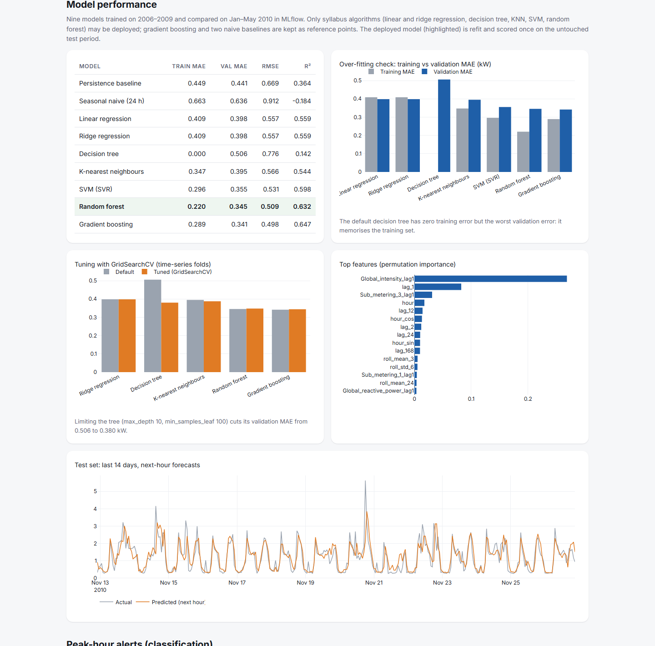
Figure M.2: Web application – model performance, over-fitting and tuning
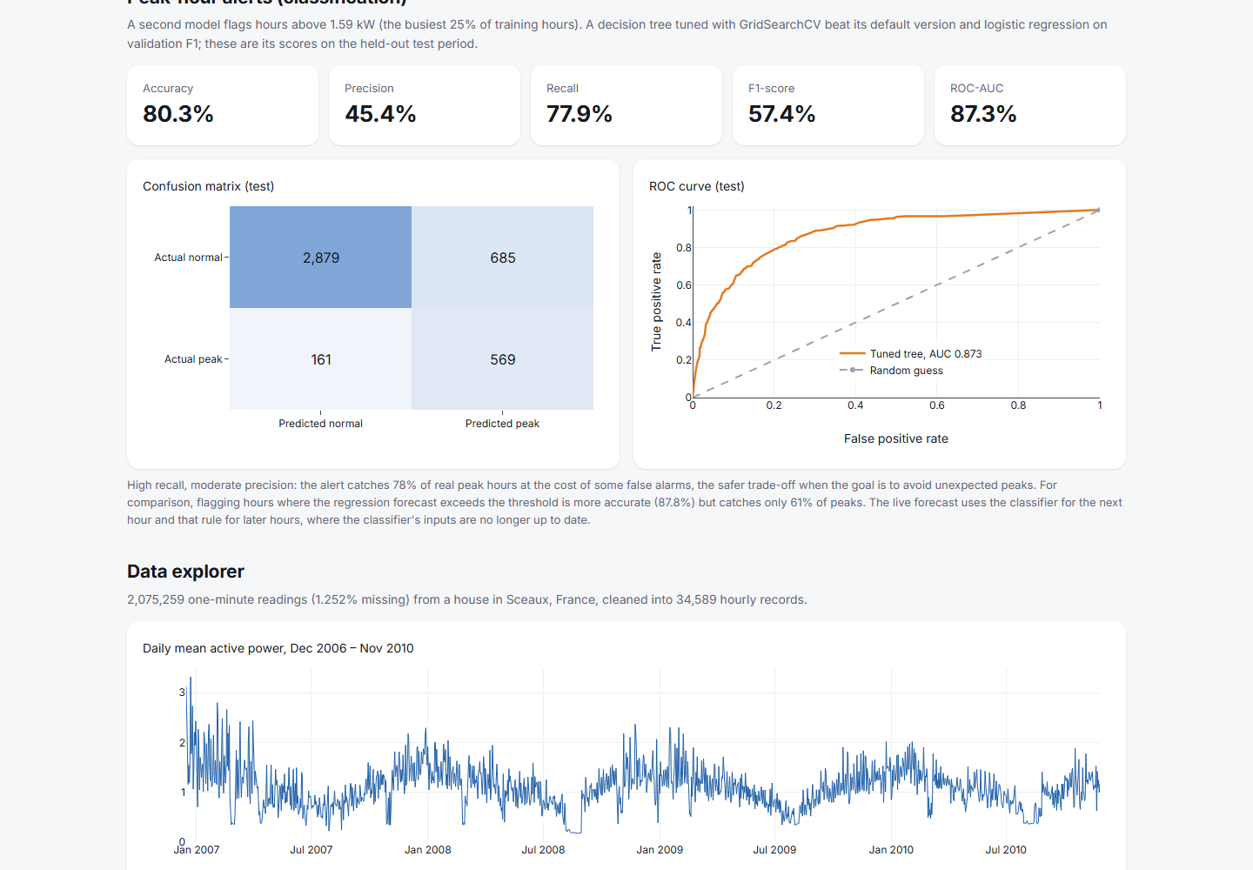
Figure M.3: Web application – peak-hour classifier metrics
Figure M.4: Grafana monitoring dashboard
Figure M.5: Prometheus targets page
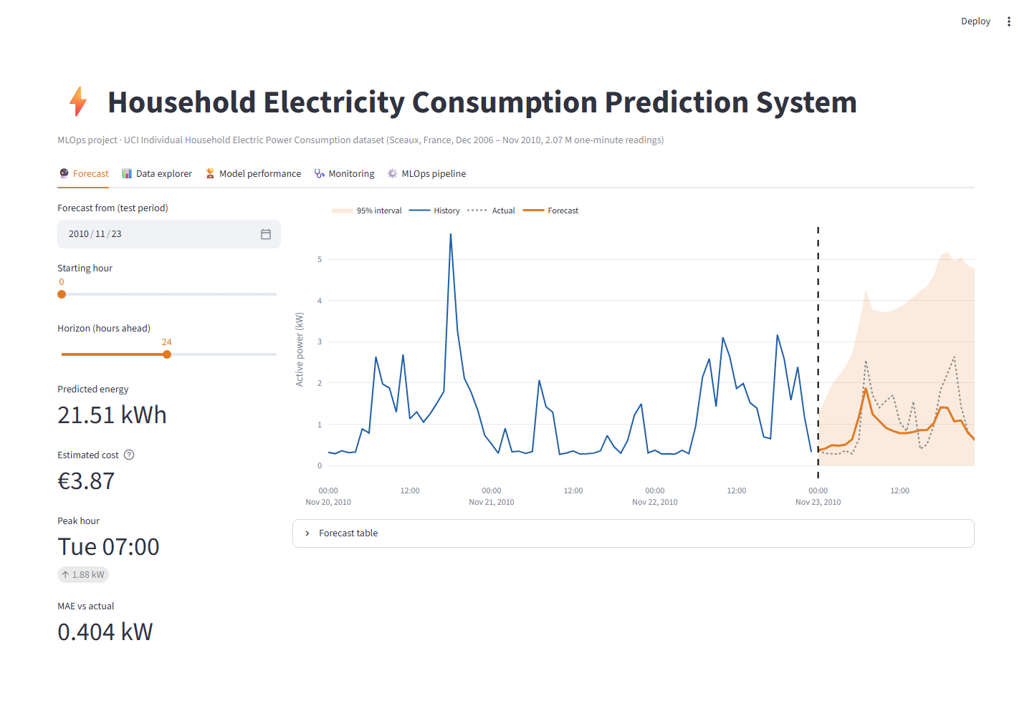
Figure M.6: Streamlit dashboard (Docker / local) – forecast tab

