Predicting Term-Deposit Subscription in Retail Banking
An End-to-End Data Science Project: Cleaning, EDA, Statistical Modelling, Machine Learning and Business Impact
Dataset: UCI Bank Marketing (BFSI) | Final Project — Week 6
Prepared by: Kunal
October 2026

Contents
Executive Summary
1. Problem Definition
2. Data Collection and Description
3. Data Preprocessing
4. Exploratory Data Analysis
5. Hypothesis Testing
6. Statistical Modelling (Logistic Regression)
7. Machine Learning: Selection, Tuning and Evaluation
8. Business Impact
9. Implications and Recommendations
10. Limitations
11. Further Work
12. Conclusion
Appendix A: Project Structure and Reproducibility
Appendix B: References

Executive Summary
A retail bank's telemarketing team converts only 11.3% of calls into term-deposit subscriptions, so most call effort is spent on clients who say no. This project uses the public UCI Bank Marketing dataset (41,188 calls, 21 columns) to answer two questions: which factors are associated with a successful call, and can a model rank clients well enough to focus calls on the most promising ones?
The full pipeline was followed: data cleaning, exploratory analysis, hypothesis tests, logistic regression for inference, four machine-learning algorithms compared with 5-fold cross-validation, randomised hyper-parameter tuning, held-out test evaluation, and a business-impact (gain/lift) analysis.
Key findings:
- Prior campaign success is the strongest behavioural signal: conversion is 65.11% for previously successful clients versus 8.83% for never-contacted clients, and the adjusted odds ratio is 6.10 (95% CI 5.24-7.09).
- Cellular contact converts at 14.74% versus 5.23% for landline; adjusted for other factors, landline contact has 0.55x the odds of cellular (about 45% lower).
- Three of the macro-economic indicators are severely collinear (VIF up to 64.5); keeping only nr_employed stabilises the coefficients but costs model fit (AIC +181), a trade-off documented in Section 6.
- Age is not significant as a linear term in the full model (OR 1.002, p = 0.29), but the age-subscription relationship is strongly U-shaped (20.96% for under-25s, 8.51% for 35-45, 46.93% for over-65s), so the non-significant linear term should not be read as "age does not matter".
- The final model, a tuned Random Forest, reaches a test ROC-AUC of 0.816 and average precision of 0.490 (random split). Scoring clients and calling the top 20% would reach 66% of all subscribers (lift 3.3x).
- Important caveat: when the model is trained on the earliest 75% of calls and tested on the latest 25%, ROC-AUC falls to 0.631 (Random Forest) and 0.430 (logistic regression). The headline figures therefore describe performance within the 2008-2010 campaign period and should not be read as a forecast for future campaigns.

1. Problem Definition
Business problem: outbound telemarketing is expensive and most calls fail. If the bank can estimate each client's probability of subscribing before calling, it can prioritise high-probability clients and reduce wasted calls.
Analytical formulation: supervised binary classification, target y = 1 if the client subscribed to a term deposit, else 0. The project has a descriptive goal (which factors matter, with statistical evidence) and a predictive goal (rank clients accurately on unseen data).
Success criteria: (a) statistically supported findings with effect sizes and confidence intervals; (b) a model evaluated on data it never saw during training or tuning, using metrics suited to a 11% positive class (ROC-AUC, average precision, recall, precision); (c) a business-facing translation of model quality into calls saved.

2. Data Collection and Description
Source: UCI Machine Learning Repository, Bank Marketing dataset (Moro, Cortez and Rita, 2014), obtained as a public CSV mirror on GitHub. Each row is one phone contact with a client of a Portuguese retail bank between May 2008 and November 2010.
Attribute | Detail
Raw size | 41,188 rows x 21 columns (semicolon-delimited)
Target | y: subscribed to a term deposit (yes / no)
Client features | age, job, marital, education, default, housing, loan
Campaign features | contact channel, month, day_of_week, duration, campaign (contacts this campaign)
History features | pdays, previous, poutcome (outcome of previous campaign)
Macro-economic features | emp_var_rate, cons_price_idx, cons_conf_idx, euribor3m, nr_employed

Numeric summary (after cleaning):
Variable | Mean | Std | Min | Median | Max | Skew
age | 40.02 | 10.42 | 17.00 | 38.00 | 98.00 | 0.78
duration | 258.33 | 259.31 | 0.00 | 180.00 | 4918.00 | 3.26
campaign | 2.57 | 2.77 | 1.00 | 2.00 | 56.00 | 4.76
previous | 0.17 | 0.49 | 0.00 | 0.00 | 7.00 | 3.83
emp_var_rate | 0.08 | 1.57 | -3.40 | 1.10 | 1.40 | -0.72
cons_price_idx | 93.58 | 0.58 | 92.20 | 93.75 | 94.77 | -0.23
cons_conf_idx | -40.50 | 4.63 | -50.80 | -41.80 | -26.90 | 0.30
euribor3m | 3.62 | 1.73 | 0.63 | 4.86 | 5.04 | -0.71
nr_employed | 5167.03 | 72.25 | 4963.60 | 5191.00 | 5228.10 | -1.04

Age, duration, campaign and previous are all right-skewed (skew 0.78, 3.26, 4.76, 3.83): most calls are short, most clients are contacted a few times, and a small number of extreme values pull the mean above the median (for example duration: mean 258s versus median 180s).

3. Data Preprocessing
Issue found | Evidence | Action and rationale
Duplicate rows | 12 exact duplicates | Removed.
Missing values | 0 NaN; but 'unknown' category in job (330), marital (80), education (1731), default (8597), housing (990), loan (990) | Kept 'unknown' as its own level; not imputed, because non-disclosure can itself be informative and the largest case (default) is 21% of rows.
Sentinel value | pdays = 999 means 'never previously contacted' | Replaced by binary flag was_previously_contacted; raw pdays dropped to avoid a meaningless numeric scale.
Quasi-complete separation | default = 'yes' has 3 rows, all non-subscribers | Rows removed: otherwise the logistic-regression coefficient diverges and the optimiser fails to converge.
Data leakage | duration is known only after the call ends | Excluded from all predictive and explanatory models. It correlates strongly with the target (r = 0.405) but cannot be used to decide whom to call.
Skewed count | campaign skew 4.76 | log(1 + campaign) used in models.
Categorical encoding | 8 categorical features | One-hot encoding with first level dropped; numeric features standardised only for the scale-sensitive logistic regression.

After cleaning, 41,173 rows remain with a positive rate of 11.27%. The cleaned dataset is saved as data/bank_clean_final.csv.

4. Exploratory Data Analysis
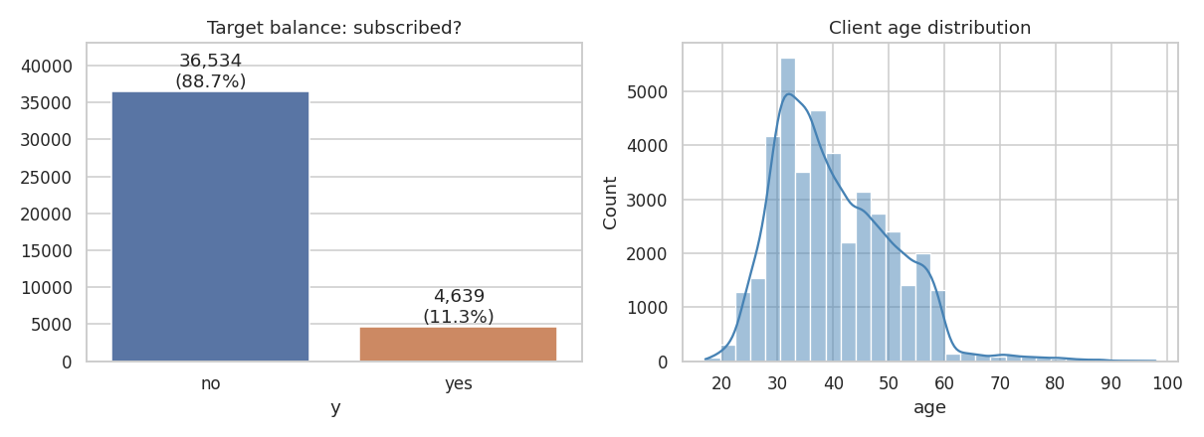
Figure 1. Target balance (left) and client age distribution (right).
The target is imbalanced: 11.3% of contacts subscribed. Plain accuracy would therefore be misleading (always predicting 'no' scores about 89%), so ROC-AUC, average precision, recall and precision are used throughout. Ages concentrate between 30 and 50 with a long right tail up to 98.
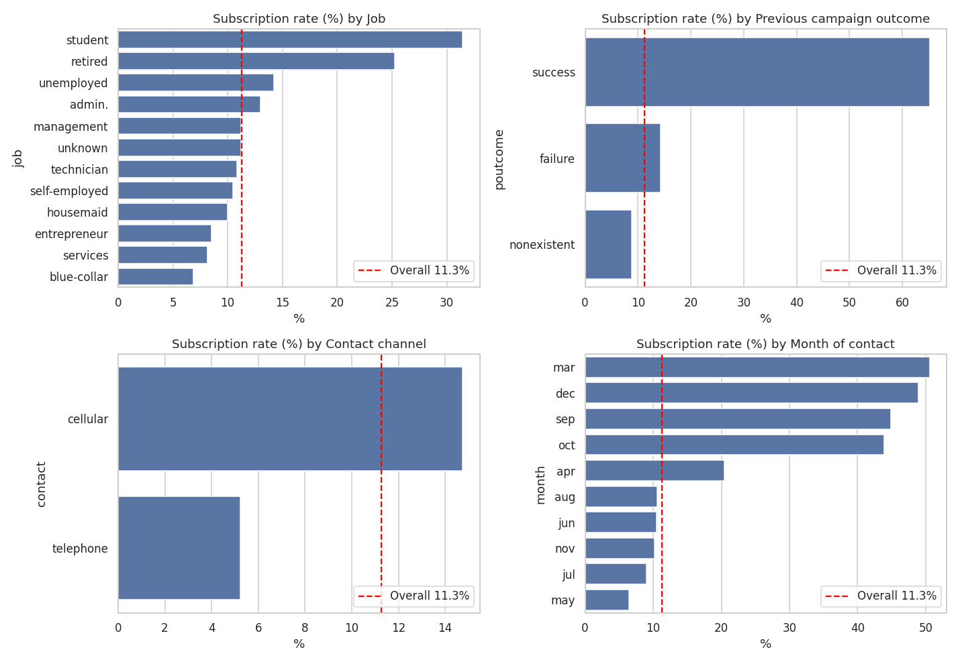
Figure 2. Subscription rate by job, previous outcome, contact channel and month; dashed line is the overall rate.
- Previous outcome: success 65.11%, failure 14.23%, nonexistent 8.83%.
- Job: students 31.43% and retirees 25.26% are highest; blue-collar 6.9% and services 8.14% are lowest.
- Channel: cellular 14.74% versus telephone 5.23%.
- Month: March (50.55%), December (48.9%) and September (44.91%) are highest, May is lowest (6.44%). These high-rate months are also the smallest: March, September and December have 546, 570 and 182 contacts versus 13,767 in May, so their rates are less precise.
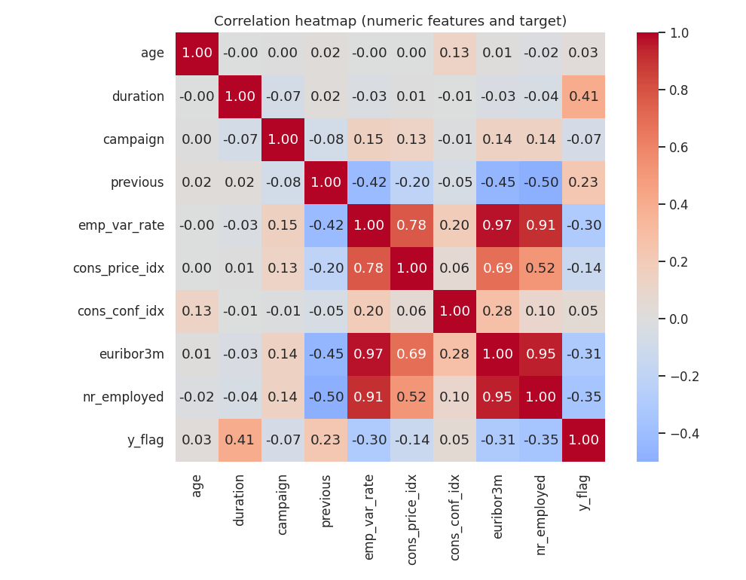
Figure 3. Correlation heatmap of numeric features and the target.
Three macro-economic variables are almost interchangeable: emp_var_rate with euribor3m r = 0.972, euribor3m with nr_employed r = 0.945, emp_var_rate with nr_employed r = 0.907. Each is negatively correlated with subscription (nr_employed r = -0.355, euribor3m r = -0.308); duration has the highest positive correlation (r = 0.405) but is excluded as leakage. Section 6 examines the consequences of this collinearity.

5. Hypothesis Testing
Univariate tests (alpha = 0.05, two-sided) were run before modelling to decide which variables merit inclusion.
Test | Result | Decision
Welch t-test: duration, yes vs no | Mean 553.3s vs 220.9s; t = 55.5; p < 0.001 | Reject H0 (but leakage variable)
Welch t-test: age, yes vs no | Mean 40.91 vs 39.91 years; t = 4.78; p = 1.8e-6 | Reject H0 (small difference of about 1 year)
Chi-square: poutcome vs y | chi2 = 4229.9, df = 2, p < 0.001 | Reject H0 (associated)
Chi-square: job vs y | chi2 = 961.7, df = 11, p < 0.001 | Reject H0 (associated)
Chi-square: contact vs y | chi2 = 862.3, df = 1, p < 0.001 | Reject H0 (associated)
Chi-square: default vs y | chi2 = 405.4, df = 1, p < 0.001 | Reject H0 (associated)
Chi-square: education vs y | chi2 = 192.8, df = 7, p < 0.001 | Reject H0 (associated)
Chi-square: marital vs y | chi2 = 122.9, df = 3, p < 0.001 | Reject H0 (associated)
Chi-square: housing vs y | chi2 = 5.7, df = 2, p = 0.057 | Fail to reject H0
Chi-square: loan vs y | chi2 = 1.1, df = 2, p = 0.576 | Fail to reject H0

poutcome, job, contact, default, education and marital status are significantly associated with the outcome. housing and loan are not (p = 0.057 and 0.576) and were excluded from the logistic model. Note that with 41,000 rows even very small differences become statistically significant, which is why effect sizes (odds ratios, differences in rates) are reported alongside p-values.

6. Statistical Modelling (Logistic Regression)

6.1 Multicollinearity: diagnosis, consequences and treatment
VIF alone says a variable is redundant; it does not show what the redundancy does to the model. Four complementary diagnostics were therefore used.
Diagnostic | All 4 macro variables | Only nr_employed kept
VIF: emp_var_rate / euribor3m / nr_employed / cons_price_idx | 33.2 / 64.5 / 31.6 / 6.3 | nr_employed 1.37
Largest VIF among all predictors | 64.5 | 1.37
Condition number (standardised predictors) | 18.8 | 1.79
Log-likelihood / AIC | -11595.9 / 23259.7 | -11689.3 / 23440.5

1) VIF. emp_var_rate, euribor3m and nr_employed have VIF 33, 64 and 32, far above the usual threshold of 5-10.
2) Condition number. 18.8 for the full set. By the common rule of thumb (above 30 is severe) this is only moderate, so VIF and the condition number disagree on severity; the VIFs are the more alarming and, as the next check shows, the better guide here.
3) Coefficient behaviour. In the model with all four macro variables, euribor3m has coefficient 0.006 (SE 0.075) and nr_employed -0.0004 (SE 0.0013): both are indistinguishable from zero even though each has a marginal correlation near -0.3 with the target. cons_price_idx takes a coefficient of 1.18 (positive) although its marginal correlation is -0.136 (negative), a sign reversal typical of collinearity. With only nr_employed retained, its coefficient becomes -0.0103 with SE 0.00025, a stable and interpretable estimate.
4) Cost of the fix. Dropping three variables is not free: AIC rises from 23259.7 to 23440.5 (+181), so the full model fits the data better. The reduced model was chosen for interpretability, not fit. Its nr_employed coefficient should be read as a proxy for the overall economic regime, not as the isolated effect of the number of employees, because the three dropped variables moved together with it.
Prediction is a different matter: tree ensembles and regularised models are not harmed in accuracy by correlated inputs, so all macro variables were kept in the machine-learning stage. The cost appears instead in interpretation: permutation importance is split across the correlated variables (nr_employed 0.020, euribor3m 0.016, emp_var_rate 0.010), so no single one looks as important as the group as a whole.

6.2 Final logistic model
Specification: logit P(subscribe) = intercept + age + log(campaign) + previous + cons_conf_idx + nr_employed + job + marital + education + contact + poutcome + default (30 estimated parameters besides the intercept), fitted on all 41,173 cleaned rows (converged: true). Likelihood-ratio test against the intercept-only model: chi2 = 5612.5, df = 30, p < 0.001. McFadden pseudo-R2 = 0.194.
Predictor | Odds ratio | 95% CI | p-value | Reading
poutcome = success (vs nonexistent) | 6.10 | 5.24 - 7.09 | < 0.001 | Previous success multiplies the odds about 6-fold
contact = telephone (vs cellular) | 0.549 | 0.502 - 0.600 | < 0.001 | Landline: about 45% lower odds
nr_employed (per unit) | 0.9898 | 0.9893 - 0.9903 | < 0.001 | Stronger economy, lower odds (regime proxy)
log(campaign) | 0.834 | 0.770 - 0.903 | < 0.001 | More contacts in this campaign, lower odds
cons_conf_idx (per unit) | 1.022 | 1.015 - 1.028 | < 0.001 | Higher confidence, slightly higher odds
job = retired (vs admin.) | 1.363 | 1.137 - 1.635 | 0.0008 | About 36% higher odds
job = student (vs admin.) | 1.355 | 1.117 - 1.644 | 0.0021 | About 35% higher odds
job = blue-collar (vs admin.) | 0.797 | 0.698 - 0.910 | 0.0008 | About 20% lower odds
default = unknown (vs no) | 0.735 | 0.658 - 0.822 | < 0.001 | Non-disclosure: about 26% lower odds
previous | 1.072 | 0.970 - 1.186 | 0.174 | Not significant once poutcome is included
age (per year) | 1.0022 | 0.9981 - 1.0063 | 0.290 | Not significant as a linear term; see 6.3

6.3 The age effect: significant alone, not significant in the full model
Age is a good test of how much a single coefficient can be trusted. The table shows the age odds ratio as blocks of covariates are added.
Model | Age OR per year | 95% CI | p-value
Age only | 1.0090 | 1.0061 - 1.0119 | < 0.001
+ job | 1.0040 | 1.0006 - 1.0074 | 0.022
+ marital & education | 1.0106 | 1.0068 - 1.0144 | < 0.001
+ contact, poutcome, default | 1.0088 | 1.0048 - 1.0128 | < 0.001
+ campaign, previous, confidence, nr_employed | 1.0022 | 0.9981 - 1.0063 | 0.290

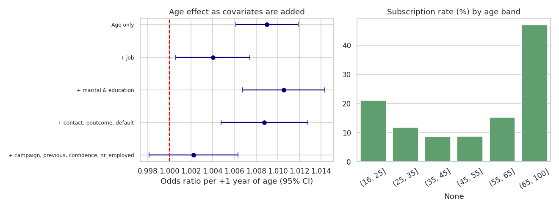
Figure 4. Age odds ratio as covariates are added (left) and subscription rate by age band (right).
Observation 1: the path is not monotonic. Adding job reduces the age OR from 1.0090 to 1.0040, which fits the idea that age partly stands in for life stage (retirees average 62 years, students 25.9). But adding marital status and education raises it again to 1.0106, so job does not simply 'explain away' age. Only the final block (campaign, previous, consumer confidence and nr_employed together with the categorical set) pushes it to p = 0.29.
Observation 2: the relationship is U-shaped, so a straight line is the wrong summary. Subscription rates are 20.96% (under 25), 11.72% (25-35), 8.51% (35-45), 8.7% (45-55), 15.22% (55-65) and 46.93% (over 65). Adding a squared age term to an age-only model gives p < 0.001 for both terms (squared-term coefficient 0.25 per squared standard deviation). A single linear coefficient averages a falling and a rising segment and can land near zero.
Observation 3: macro context alone does not remove it. Age with nr_employed only keeps a significant age effect (OR 1.0040, p = 0.004), and age is almost uncorrelated with nr_employed (r = -0.018). The loss of significance therefore comes from the combination of covariates, not from a single confounder. Months with high conversion also have older clients (December mean age 47.3, October 44.1, against 39 in May); month is not in the logistic model, which may be one route, but this was not tested directly.
Conclusion. The honest reading is that the linear age coefficient is small (about 0.2% change in odds per year, CI 0.998 to 1.006) and unreliable, because the true shape is non-linear. Age matters, but at the extremes (young and, above all, elderly clients), and the appropriate model term is a non-linear one; the machine-learning models in Section 7 can capture this automatically. The univariate t-test result (p = 1.8e-6, difference of about one year) is statistically significant but practically small.

7. Machine Learning: Selection, Tuning and Evaluation

7.1 Setup
Features: 47 columns after encoding (duration excluded). Split: stratified 75/25 into 30,879 training and 10,294 test rows, preserving the 11.3% positive rate. The test set was used once, after all selection and tuning. Random seed 42 throughout.

7.2 Algorithm choice
Four algorithms were compared with identical stratified 5-fold cross-validation on the training set, scored on ROC-AUC (threshold-independent, suited to imbalance):
- Logistic regression: interpretable baseline and the Section 6 model; linear in its inputs.
- Decision tree: captures non-linearity and interactions; expected to overfit when unconstrained.
- Random forest: averaging many de-correlated trees lowers variance; handles mixed feature types and the U-shaped age pattern without manual terms.
- Histogram gradient boosting: sequentially corrects errors; typically strongest on tabular data, fast enough for a single CPU.
Model (default settings) | CV ROC-AUC | CV avg. precision | CV recall | CV precision
Logistic Regression | 0.789 +/- 0.008 | 0.448 | 0.619 | 0.353
Decision Tree | 0.626 +/- 0.005 | 0.188 | 0.346 | 0.313
Random Forest | 0.764 +/- 0.009 | 0.389 | 0.288 | 0.495
Hist. Gradient Boosting | 0.797 +/- 0.011 | 0.466 | 0.253 | 0.653

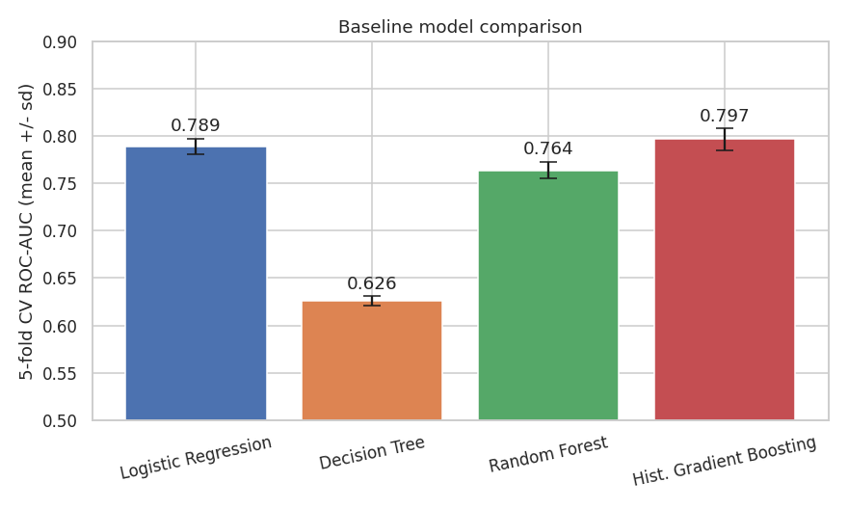
Figure 5. Cross-validated ROC-AUC of the four candidate models (error bars: one standard deviation across folds).
The single decision tree is clearly worst (AUC 0.626), the textbook overfitting result. Gradient boosting (0.797) and logistic regression (0.789) lead, and the untuned random forest trails (0.764). Fold-to-fold standard deviations are 0.005-0.011, so gaps of about 0.01 between the top models are within noise. Recall and precision differ by model mainly because only logistic regression and the forest/tree used class weighting at a 0.5 cut-off, so these two columns are not directly comparable; ROC-AUC and average precision are.

7.3 Hyper-parameter tuning
Random Forest and Gradient Boosting were tuned with RandomizedSearchCV (10 sampled configurations each, 3-fold stratified CV, ROC-AUC). Random search was preferred to a full grid because the spaces have 6 dimensions and the effort must stay reproducible on a single CPU.
Model | Best CV ROC-AUC | Selected hyper-parameters
Random Forest | 0.7988 | n_estimators 101, max_depth 9, min_samples_leaf 9, min_samples_split 4, max_features 0.3, class_weight balanced_subsample
Gradient Boosting | 0.7973 | learning_rate 0.05, max_depth 6, max_leaf_nodes 15, min_samples_leaf 20, l2_regularization 5, max_iter 300

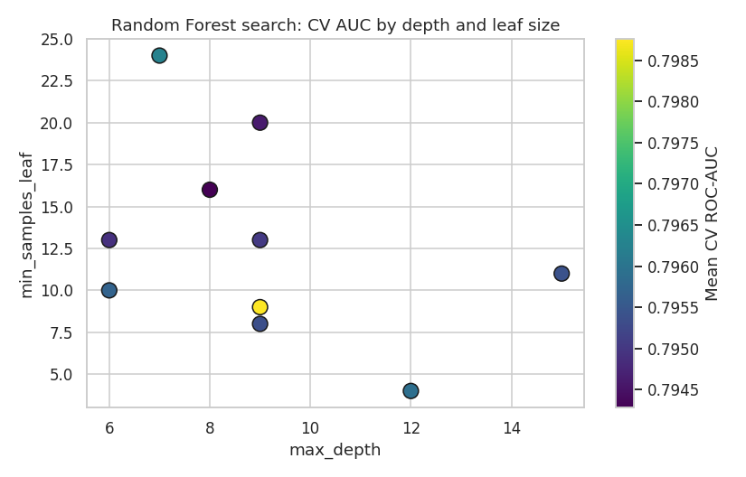
Figure 6. Random Forest search: cross-validated AUC by tree depth and minimum leaf size (10 configurations).
Tuning improved the forest from 0.764 (default, 5-fold) to 0.799 (tuned, 3-fold); the two CV schemes differ, so the comparison is indicative. Within the 10 tuned configurations the CV AUC ranged only from 0.7943 to 0.7988, so cross-validated AUC is insensitive to these settings across the sampled range. The tuned forest (CV 0.7988) and tuned boosting (CV 0.7973) are effectively tied; the forest was selected as final on the higher CV score, a margin of 0.0014 that is well inside fold noise.

7.4 Test-set results
Metric (threshold 0.5) | Logistic Reg. | Random Forest (tuned) | Grad. Boosting (tuned)
ROC-AUC | 0.802 | 0.816 | 0.812
Average precision | 0.443 | 0.490 | 0.484
Accuracy | 0.835 | 0.858 | 0.901
Precision (yes) | 0.366 | 0.414 | 0.674
Recall (yes) | 0.641 | 0.639 | 0.237
F1 (yes) | 0.466 | 0.503 | 0.351
Specificity | 0.859 | 0.885 | 0.985
TN / FP / FN / TP | 7849 / 1285 / 417 / 743 | 8087 / 1047 / 419 / 741 | 9001 / 133 / 885 / 275

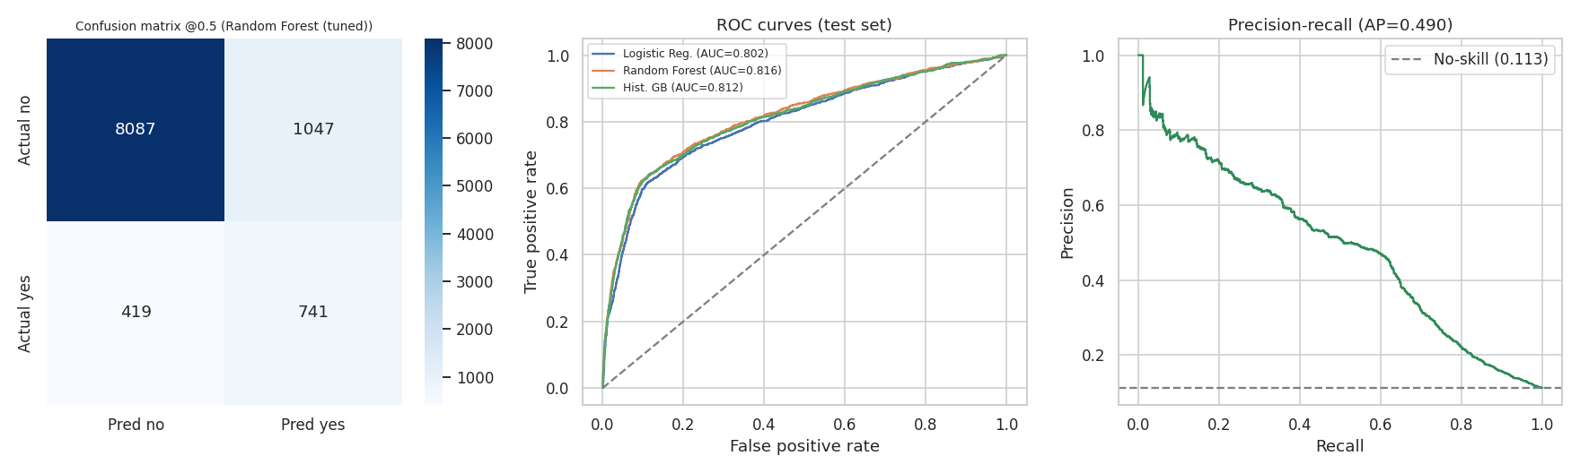
Figure 7. Final model on the test set: confusion matrix (left), ROC curves of the three models (centre), precision-recall curve (right).
Final model: tuned Random Forest. ROC-AUC 0.816, average precision 0.490 (no-skill baseline 0.113), recall 0.639, precision 0.414. It finds 741 of the 1160 test subscribers (64%) at the price of 1047 false alarms. Roughly 4 in 10 flagged clients subscribe, against 1 in 9 overall.
Comparison with logistic regression. The forest improves ROC-AUC by only 0.014 and average precision by 0.047; both are modest, and given a CV standard deviation near 0.01 the improvement should be called small rather than decisive. The simpler model remains a serious option when interpretability matters.
Boosting at the default threshold. Its recall of 0.237 and precision of 0.674 reflect an unweighted model at a 0.5 cut-off, not weaker ranking: its AUC (0.812) is within 0.004 of the forest. Choosing a threshold is a business decision, not a modelling default.
Overfitting check. Train AUC 0.842 versus test AUC 0.816, a gap of 0.026: mild, consistent with the depth and leaf constraints chosen in tuning.
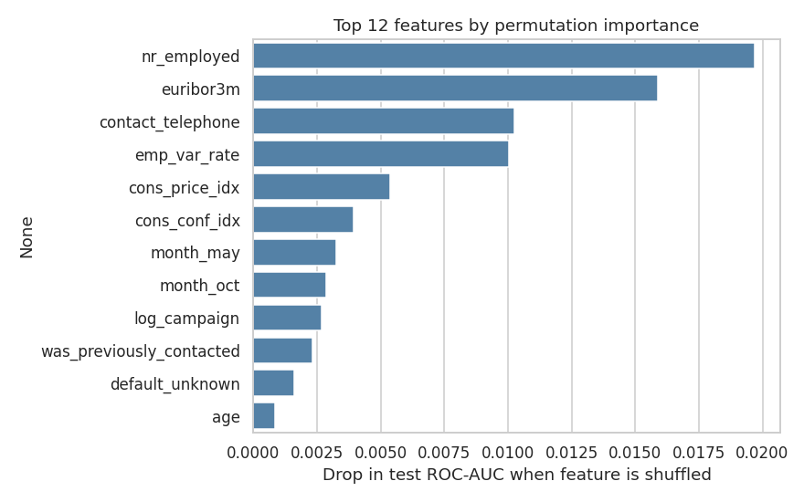
Figure 8. Permutation importance on the test set (drop in ROC-AUC when a feature is shuffled).
The most important features are the macro-economic variables (nr_employed 0.020, euribor3m 0.016, emp_var_rate 0.010) followed by landline contact (0.010). Because these macro variables are collinear, their importance is shared among them. Note that nearly all the top-ranked features describe the campaign context (economic timing and contact channel) rather than client characteristics, which links directly to the robustness result below.

7.5 Robustness check: out-of-time evaluation
The data are chronological and the macro variables nearly identify the calendar period, so a random split lets the model see the same economic regime in training and test. To test this, the first 30,879 rows (75%) were used for training and the last 10,294 rows (25%) for testing, with the tuned forest settings and the logistic baseline.
Evaluation | Logistic Regression ROC-AUC | Random Forest ROC-AUC
Random stratified split (Section 7.4) | 0.802 | 0.816
Out-of-time split (train early, test late) | 0.430 | 0.631

Performance drops sharply. The positive rate shifts from 6.4% in the early training period to 25.8% in the late test period, so the later campaign period behaves very differently. The forest keeps some ranking ability (AUC 0.631, average precision 0.341), but logistic regression scores 0.430, below the 0.5 expected from random ranking. A likely explanation, not tested here, is that the linear macro-economic relationships learned in 2008-2009 do not extend to the later economic conditions. Whatever the exact cause, this is the single most important limitation of the project: the model ranks clients well within the period it was built on and cannot be assumed to do so for a future campaign without retraining and monitoring.

8. Business Impact
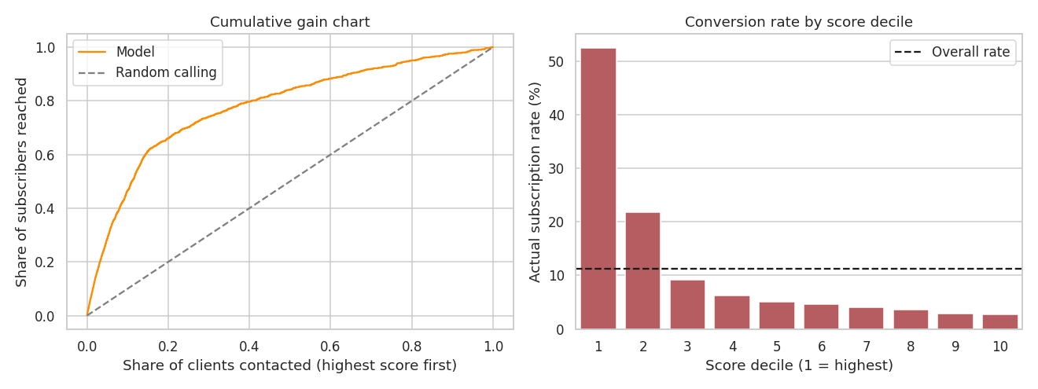
Figure 9. Cumulative gain chart (left) and actual subscription rate by score decile (right), test set, random split.
Share of clients called (highest score first) | Share of subscribers reached | Lift vs random calling
10% | 46.6% | 4.66x
20% | 66.0% | 3.30x
30% | 74.1% | 2.47x
40% | 79.7% | 1.99x
50% | 84.1% | 1.68x

Within the test set, the top-scoring decile converts at 52.52% and the second at 21.87%, against 2.72% in the lowest decile and 11.3% overall. Calling only the top 20% of clients would reach 66% of subscribers with 80% fewer calls; the top 30% would reach 74%. These are in-period figures from a random split; the out-of-time result in Section 7.5 shows they would likely be lower for a future campaign. The cost per call and the value of a deposit are not in the dataset, so the optimal cut-off cannot be computed here; it is a simple calculation once the bank supplies those two numbers.

9. Implications and Recommendations
- Build a priority list of previously successful clients: they convert at 65% and have about six times the adjusted odds.
- Shift outreach to cellular numbers; landline contact has about 45% lower adjusted odds and converts at 5%.
- Design segment-specific offers for students and retirees (conversion 31% and 25%) rather than a single script.
- Use the model as a ranking tool within an ongoing campaign, with a decile or score threshold chosen from the bank's own cost per call and value per deposit.
- Treat macro-economic features cautiously: they carry the largest predictive weight but also the largest risk of not transferring to a new period. Retrain per campaign wave and track the live positive rate and AUC.
- Do not interpret the logistic age coefficient as 'age does not matter'; the effect is U-shaped and concentrated at the youngest and oldest ages.

10. Limitations
- Time shift: out-of-time AUC is 0.631 (forest) and 0.430 (logistic) versus 0.816 and 0.802 on a random split. Headline results are in-period only.
- Single bank, single country, 2008-2010 financial-crisis period; coefficients on macro variables may not generalise.
- Observational data: associations, not causal effects. For instance, contact channel may reflect which clients the bank chose to reach by mobile.
- Collinear macro variables: the reduced logistic model sacrifices fit (AIC +181) for interpretability, and the nr_employed coefficient is a regime proxy.
- Linear age term mis-specified; the logistic model was not re-fitted with a non-linear age term, which would be the natural next step.
- 'unknown' categories kept as levels rather than modelled as missing data; sensitivity to this choice was not tested.
- Modest tuning budget (10 configurations per model, 3-fold) and differing CV schemes between the baseline (5-fold) and tuning (3-fold) stages; differences among the top models are within fold noise.
- Probabilities are not calibrated; use scores for ranking, not as literal probabilities.
- Costs and revenues are unknown, so the financial value of the campaign model is not quantified.

11. Further Work
- Re-fit the logistic model with a spline or squared age term and compare via likelihood-ratio test.
- Replace the random split by rolling-origin (time-series) validation and tune against it.
- Drop or compress the macro variables (for example, first principal component) and measure the effect on out-of-time AUC.
- Calibrate probabilities (Platt scaling or isotonic regression) and choose the threshold by expected profit.
- Add SHAP explanations and test interaction effects such as job x previous outcome.
- Validate on a more recent BFSI marketing dataset.

12. Conclusion
This project took a real banking question through the full data science workflow. Cleaning removed duplicates, a separation-causing category and a leakage variable; EDA and hypothesis tests identified prior outcome, contact channel, job segment and economic context as the main drivers; logistic regression quantified them with confidence intervals, and a close look at collinearity and the age effect showed where simple summaries mislead. Four machine-learning algorithms were compared with cross-validation, the leading two were tuned, and a tuned Random Forest reached a test ROC-AUC of 0.816, enough to reach 66% of subscribers by calling the top fifth of clients on a random split. An out-of-time check showed that this performance does not carry over cleanly to later periods (AUC 0.631), which defines the key next step: time-aware validation and regular retraining before any deployment.

Appendix A: Project Structure and Reproducibility
Path | Content
README.md | Overview and how to reproduce
requirements.txt | Python package list
data/bank_raw.csv | Original public dataset (semicolon-delimited)
data/bank_clean_final.csv | Final cleaned dataset used for analysis
notebooks/Term_Deposit_End_to_End_Project.ipynb | Complete executed notebook (cleaning, EDA, tests, logistic model, ML, lift, robustness)
notebooks/term_deposit_project.py | Same code as a script (jupytext percent format)
figures/01 ... 09 *.png | All nine report figures
metrics.json | Every number reported here, exported by the notebook
reports/ (this document) | Final report in Word format

To reproduce: install the requirements, place bank_raw.csv in data/, and run the notebook from top to bottom (about 4 minutes on one CPU core). A fixed random seed (42) is used for splits, cross-validation and model training, so results are repeatable.

Appendix B: References
- Moro, S., Cortez, P., Rita, P. (2014). A data-driven approach to predict the success of bank telemarketing. Decision Support Systems, 62, 22-31.
- UCI Machine Learning Repository: Bank Marketing dataset.
- Pedregosa et al. (2011). Scikit-learn: Machine learning in Python. JMLR 12, 2825-2830.
- Seabold, S., Perktold, J. (2010). Statsmodels: Econometric and statistical modeling with Python.

