Week 4 Task
Machine Learning Model Development and Evaluation
Breast Cancer Wisconsin (Diagnostic) Classification

Prepared by: Kunal
Tools: Python, pandas, scikit-learn, matplotlib, seaborn
Companion file: Week4_ML_Model_Development.ipynb

1. Executive Summary
This report documents an end-to-end machine learning workflow for classifying breast tumours as malignant or benign using the Breast Cancer Wisconsin (Diagnostic) dataset (569 samples, 30 numeric features). Four algorithms (Logistic Regression, SVM, Decision Tree and Random Forest) were compared using 5-fold stratified cross-validation. The two strongest families, Random Forest and SVM, were then tuned with GridSearchCV and evaluated once on an untouched 20% test set.
Key results: the tuned SVM achieved the best cross-validated F1 (0.9674), followed by the tuned Random Forest (0.9553). On the test set both models reached 97.37% accuracy, 100% precision, 92.86% recall and a ROC-AUC of about 0.9950. The Random Forest missed 3 of 42 malignant cases and raised no false alarms. Repeating the split with 10 different random seeds gave a mean F1 of 0.9255 (std 0.0267), so the single test split is somewhat optimistic and a slightly lower real-world score should be expected.

2. Problem Definition and Dataset
The task is a binary classification problem: given measurements of cell nuclei from a fine-needle-aspirate (FNA) image of a breast mass, predict whether the mass is malignant (positive class, 1) or benign (0). The dataset comes from the UCI Machine Learning Repository and is publicly available; it is also bundled with scikit-learn, which makes the work fully reproducible.
Property | Value
Samples | 569
Features | 30 numeric (mean, standard error and "worst" of 10 nucleus measurements)
Target | Malignant (1) vs Benign (0)
Class balance | 357 benign (62.7%) / 212 malignant (37.3%)
Missing values / duplicates | None / None

The ten base measurements are radius, texture, perimeter, area, smoothness, compactness, concavity, concave points, symmetry and fractal dimension. Each is summarised as a mean, a standard error and a "worst" (largest) value, giving 30 features. The label was flipped from the scikit-learn default so that malignant = 1. This makes recall and precision refer to the clinically important class.

3. Exploratory Data Analysis
The data is clean and moderately imbalanced (37.3% malignant), so stratified splitting and F1/recall metrics are appropriate rather than accuracy alone. Features linked to nucleus size and shape show the strongest correlation with the target. The top five by absolute Pearson correlation are worst concave points (0.794), worst perimeter (0.783), mean concave points (0.777), worst radius (0.776) and mean perimeter (0.743).
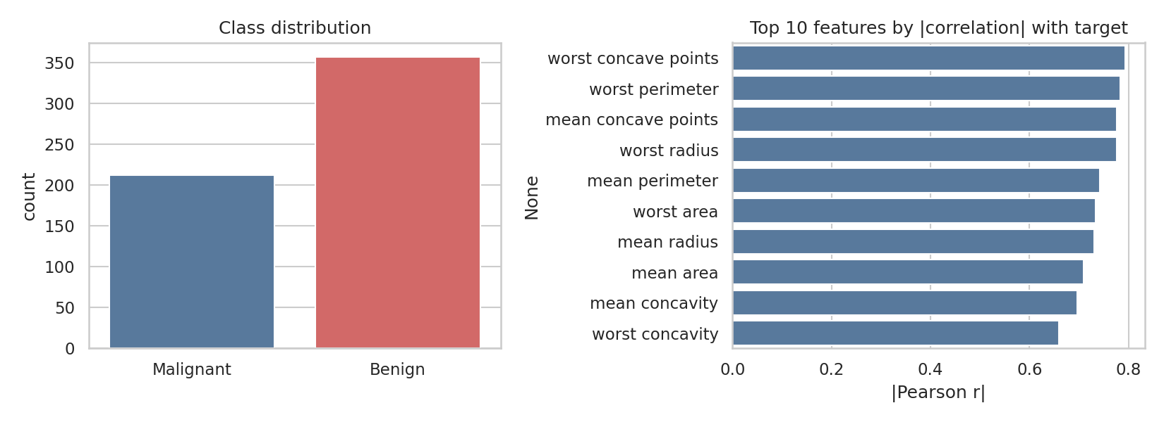
Figure 1: Class distribution and the features most correlated with the target
The correlation heatmap shows strong multicollinearity: 21 feature pairs have |r| > 0.9 (for example radius, perimeter and area measure closely related quantities). This does not hurt tree-based models but can make linear-model coefficients unstable, which is one reason regularised or kernel-based models are also worth testing.
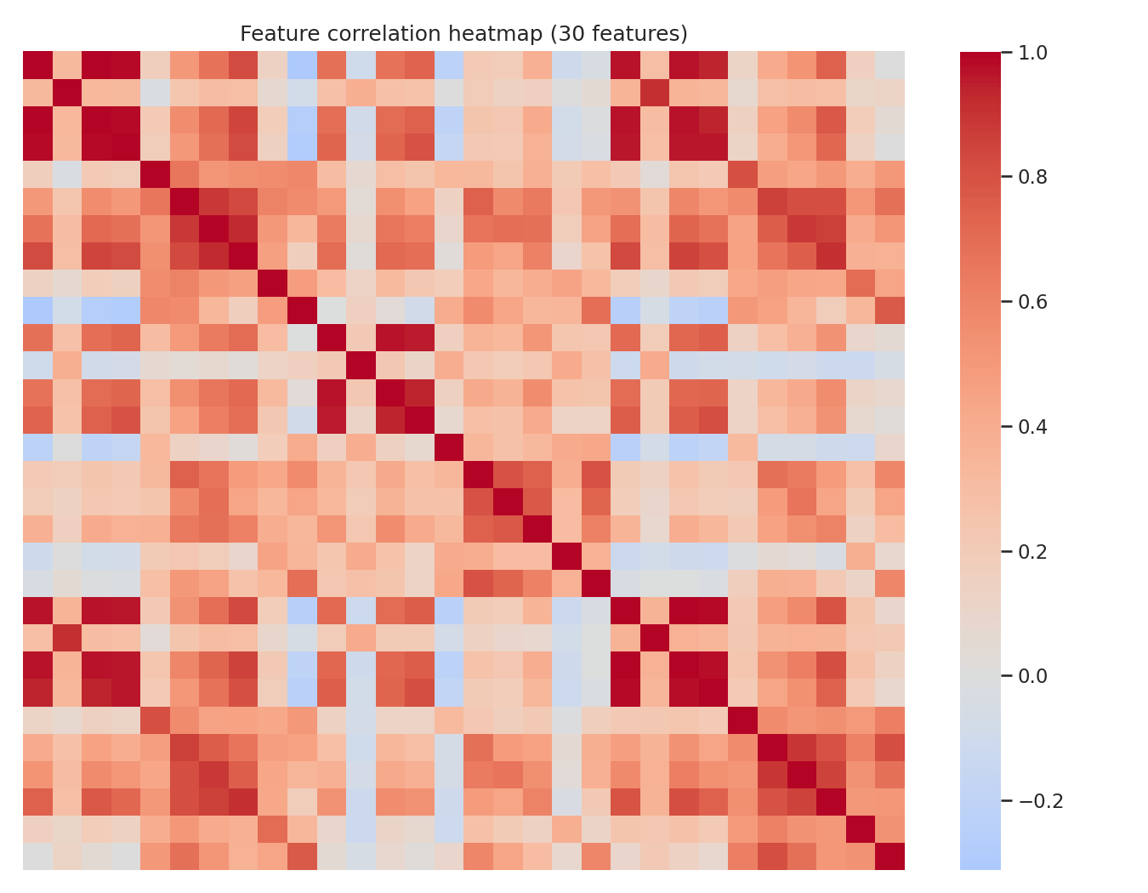
Figure 2: Correlation heatmap of the 30 features

4. Data Preprocessing and Train/Test Split
- Cleaning: no missing values or duplicate rows were found, so no imputation or removal was needed.
- Split: 80/20 stratified hold-out split with random_state=42, giving 455 training and 114 test samples. The malignant share is 37.4% in training and 36.8% in test, so class balance is preserved.
- Scaling: StandardScaler is applied inside a scikit-learn Pipeline. It is therefore fitted only on the training portion of each cross-validation fold, which prevents data leakage. Scaling is essential for SVM and Logistic Regression and harmless for tree models.
- Test set discipline: the test set was not used for any modelling decision. All selection and tuning used cross-validation on the training data only.

5. Algorithm Selection and Justification
Four algorithms with different inductive biases were compared as baselines using 5-fold stratified cross-validation on the training set:
- Logistic Regression: simple, interpretable linear baseline.
- Support Vector Machine (RBF): effective on small, high-dimensional, scaled data with non-linear boundaries.
- Decision Tree: fully interpretable rules, but prone to overfitting.
- Random Forest: an ensemble of trees that reduces variance, handles correlated features and gives feature importances.

Model | Accuracy | Precision | Recall | F1 | ROC-AUC | F1 std
Logistic Regression | 0.9736 | 0.9771 | 0.9529 | 0.9640 | 0.9958 | 0.0207
SVM (RBF) | 0.9714 | 0.9769 | 0.9471 | 0.9610 | 0.9949 | 0.0082
Decision Tree | 0.9231 | 0.8996 | 0.8941 | 0.8962 | 0.9172 | 0.0447
Random Forest | 0.9648 | 0.9641 | 0.9412 | 0.9519 | 0.9889 | 0.0207
Table 1: Baseline 5-fold CV results on the training data (best F1 highlighted).
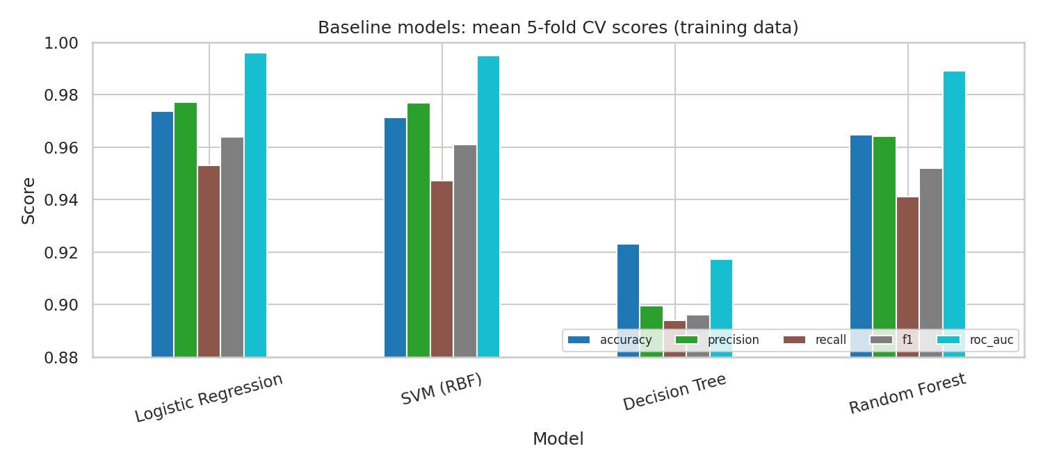
Figure 3: Baseline model comparison
Interpretation. Logistic Regression (F1 0.9640) and SVM (0.9610) were the strongest baselines, which shows that the classes are close to linearly separable once features are scaled. The single Decision Tree was clearly weakest (F1 0.8962) and least stable (std 0.0447), confirming its tendency to overfit. Random Forest (F1 0.9519) improves substantially on a single tree.
Choice. Random Forest and SVM were carried forward to tuning. Random Forest was chosen because it is the standard robust ensemble method and provides feature importances, which matters for interpretation. SVM was chosen because it was the best non-linear baseline. Logistic Regression was not tuned because it is already a strong, near-optimal baseline with little to tune; it is a reasonable alternative if simplicity is preferred.

6. Cross-Validation and Hyperparameter Tuning
Both models were tuned with GridSearchCV using 5-fold stratified cross-validation (shuffle=True, random_state=42). Five metrics were tracked in every fold (accuracy, precision, recall, F1, ROC-AUC) and the best configuration was refitted on the metric F1. F1 was chosen because it balances precision and recall, and in cancer screening missed cases (false negatives) are the costliest error.

6.1 Search spaces
Model | Hyperparameter | Values searched
Random Forest | n_estimators | 100, 300
 | max_depth | None, 5, 10
 | min_samples_split | 2, 5
 | min_samples_leaf | 1, 2, 4
 | max_features | sqrt, log2
SVM | C | 0.1, 1, 10, 100
 | gamma | scale, 0.001, 0.01, 0.1
 | kernel | rbf, linear
The Random Forest grid had 72 combinations (360 model fits) and the SVM grid 32 combinations (160 fits).

6.2 Best parameters and tuned CV scores
- Random Forest: n_estimators=100, max_depth=5, min_samples_split=2, min_samples_leaf=1, max_features='sqrt'.
- SVM: C=10, kernel='rbf', gamma='scale'.

Model | Accuracy | Precision | Recall | F1 | ROC-AUC | F1 std
Random Forest (default) | 0.9648 | 0.9641 | 0.9412 | 0.9519 | 0.9889 | 0.0207
Random Forest (tuned) | 0.9670 | 0.9645 | 0.9471 | 0.9553 | 0.9882 | 0.0284
SVM (tuned) | 0.9758 | 0.9711 | 0.9647 | 0.9674 | 0.9935 | 0.0114
SVM (default) | 0.9714 | 0.9769 | 0.9471 | 0.9610 | 0.9949 | 0.0082
Table 2: Default vs tuned models, mean 5-fold CV scores (best CV F1 highlighted).
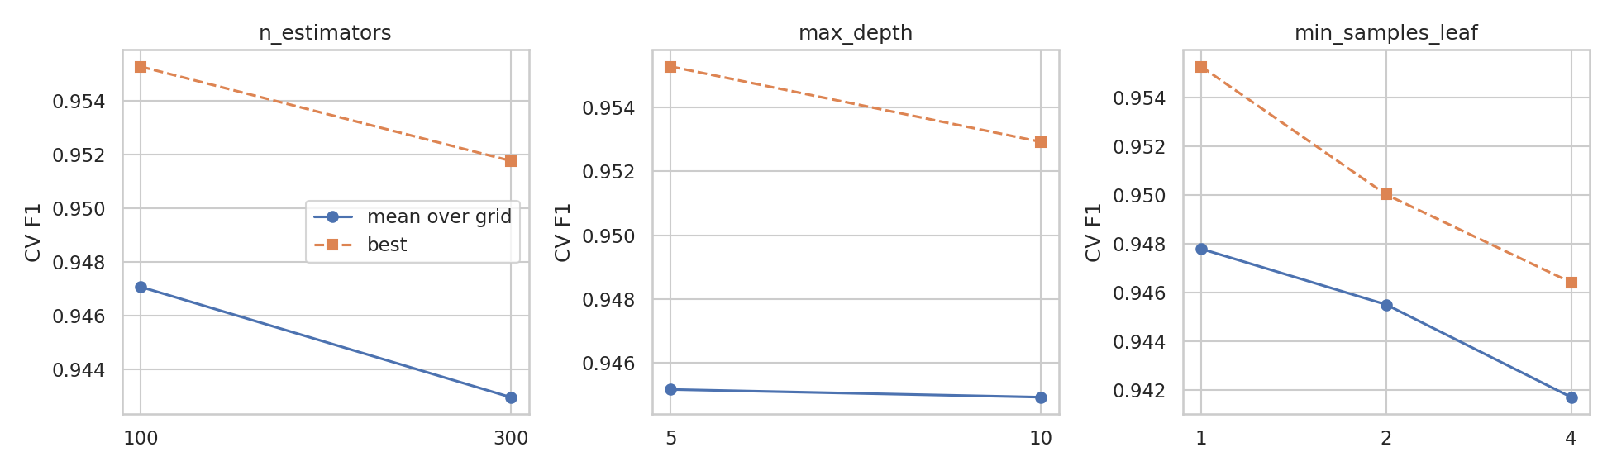
Figure 4: Sensitivity of Random Forest CV F1 to key hyperparameters
Findings. Tuning produced only a small gain: the Random Forest CV F1 rose from 0.9519 to 0.9553 and the SVM from 0.9610 to 0.9674. Shallow trees (max_depth=5) worked as well as deeper ones, which suggests that regularisation matters slightly more than model capacity on this small dataset. The tuned SVM had the highest CV F1, but the gap to the Random Forest (about 0.012) is smaller than the fold-to-fold standard deviation, so the two models are statistically hard to separate.

7. Final Model Evaluation on the Test Set
Both tuned models, plus the default Random Forest, were evaluated once on the 114 held-out samples. The Random Forest is examined in detail below because it supports feature-importance analysis; the SVM is reported for comparison.
Model | Accuracy | Precision | Recall | F1 | ROC-AUC
Random Forest (default) | 0.9737 | 1.0000 | 0.9286 | 0.9630 | 0.9929
Random Forest (tuned) | 0.9737 | 1.0000 | 0.9286 | 0.9630 | 0.9950
SVM (tuned) | 0.9737 | 1.0000 | 0.9286 | 0.9630 | 0.9927
Table 3: Test-set performance (malignant = positive class).

7.1 Confusion matrix and ROC curve (tuned Random Forest)
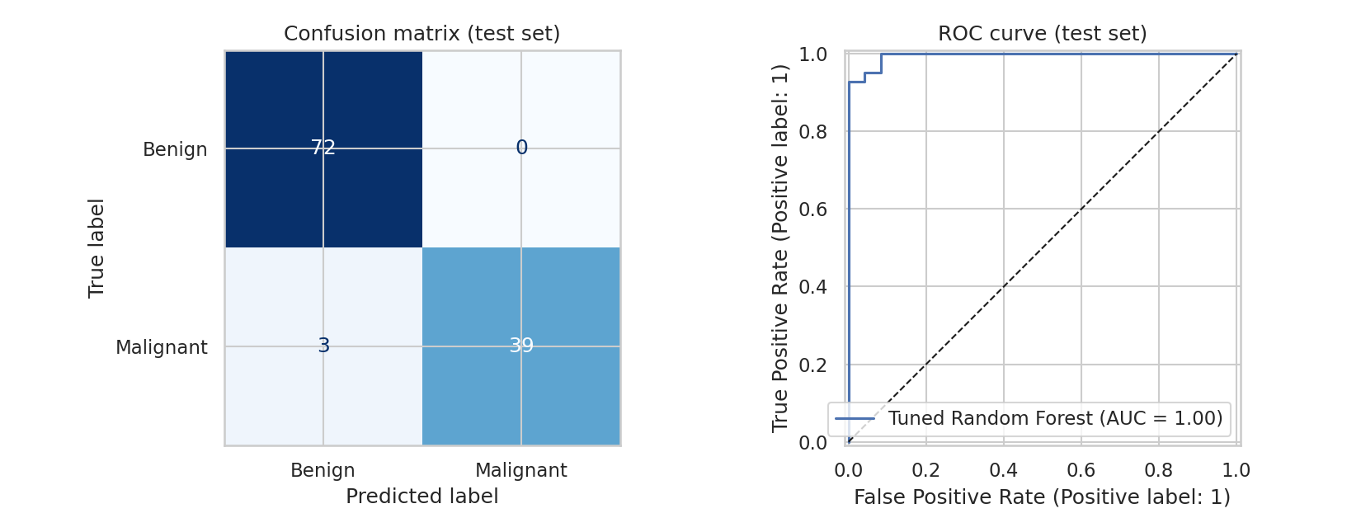
Figure 5: Confusion matrix and ROC curve on the test set
 | Predicted Benign | Predicted Malignant
Actual Benign | 72 (TN) | 0 (FP)
Actual Malignant | 3 (FN) | 39 (TP)

Class | Precision | Recall | F1-score | Support
Benign | 0.9600 | 1.0000 | 0.9796 | 72
Malignant | 1.0000 | 0.9286 | 0.9630 | 42
Macro average | 0.9800 | 0.9643 | 0.9713 | 114
Table 4: Confusion matrix and classification report for the tuned Random Forest.
Interpretation. Of 114 test cases, 111 were classified correctly (97.37%). Precision for the malignant class is 100%: every case the model flagged as malignant truly was. Recall is 92.86% (39 of 42), meaning 3 malignant tumours were missed. In a screening context these false negatives are the most serious error. The ROC-AUC of 0.9950 shows the model ranks malignant cases above benign ones almost perfectly, so the missed cases are mainly a threshold issue rather than a lack of signal.

7.2 Error analysis and decision threshold
The three missed cases (test indices 73, 86, 385) received malignant probabilities of 0.15, 0.263, 0.161, i.e. the model was fairly confident they were benign. Lowering the decision threshold trades precision for recall:
Threshold | Precision | Recall | False negatives | False positives
0.5 | 1.0000 | 0.9286 | 3 | 0
0.4 | 0.9750 | 0.9286 | 3 | 1
0.3 | 0.9750 | 0.9286 | 3 | 1
0.2 | 0.8696 | 0.9524 | 2 | 6
Table 5: Effect of the decision threshold on the test set.
Lowering the threshold to 0.2 recovers one additional malignant case but adds six false positives, a poor trade on this small sample. The final recommendation is to keep 0.5 unless the clinical cost of a missed cancer is explicitly weighted higher, in which case the threshold should be chosen with cross-validated probabilities rather than on the test set.

7.3 Robustness of the estimate
The tuned Random Forest achieves a training F1 of 0.9911 versus a test F1 of 0.9630, a modest generalisation gap. To check that the single split was not lucky, the model was retrained and tested on 10 different stratified splits: F1 averaged 0.9255 (std 0.0267, range 0.8718 to 0.9639). The realistic expected F1 is therefore closer to 0.93 than 0.96, and with only 114 test samples a single split has wide uncertainty. Note that these 10 splits reuse hyperparameters tuned on one training set, so this is a stability check and not a fully unbiased estimate.

8. Model Interpretation
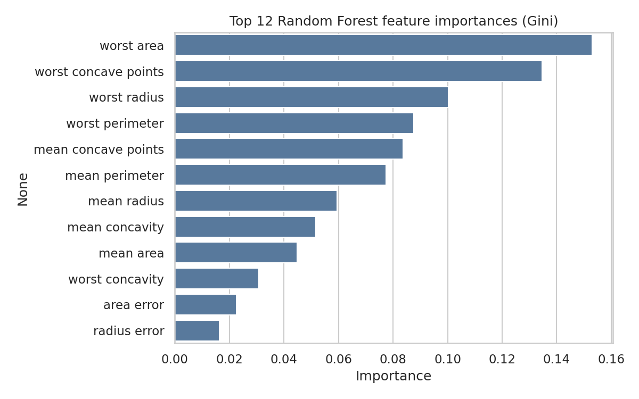
Figure 6: Top 12 Random Forest feature importances
The Gini importances are led by worst area (0.1529), worst concave points (0.1345), worst radius (0.1004) and worst perimeter (0.0876). Permutation importance on the test set, which is less biased toward correlated features, ranks worst concave points (0.0276), worst area (0.0246) and worst radius (0.021) at the top. Both methods agree that the size and irregularity of the largest nuclei are the key signals, which is consistent with medical knowledge that malignant nuclei are larger and have more irregular contours. Because area, radius and perimeter are highly correlated, their importance is shared between them and should be read as a group.

9. Strengths and Weaknesses

Strengths
- High and stable discrimination: ROC-AUC of about 0.99 in both cross-validation and testing.
- Perfect precision on the test set: no benign patient was wrongly flagged as malignant.
- Leakage-safe pipeline (scaling inside cross-validation) and a test set used exactly once.
- Interpretable outputs: feature importances match clinical intuition about nucleus size and shape.
- Robust to multicollinearity and needs little preprocessing.

Weaknesses
- Missed cancers: recall of 92.86% means 3 of 42 malignant cases were predicted benign, which is unacceptable if used alone for screening.
- Small data: 569 samples and a 114-sample test set give wide confidence intervals; one misclassified case changes recall by about 2.4 points.
- Optimistic single split: 10-split mean F1 (0.9255) is lower than the reported test F1 (0.9630).
- Limited tuning gain: grids were kept small, and the differences between tuned models are within cross-validation noise.
- Single-source data: no external validation on images from other hospitals or scanners, so real-world performance is unknown.

10. Limitations and Future Work
- Use nested cross-validation or repeated stratified CV to obtain an unbiased performance estimate together with confidence intervals.
- Try gradient boosting (XGBoost, LightGBM) and probability calibration, and choose the threshold using cross-validated predictions with an explicit cost for false negatives.
- Reduce redundancy with PCA or feature selection and compare with the full feature set.
- Add SHAP values for per-patient explanations and validate the model on an external dataset before any practical use.

11. Conclusion
This project followed a complete machine learning workflow: data inspection, leakage-safe preprocessing, a stratified split, a four-model comparison with cross-validation, grid-search tuning, and a single final test evaluation. The tuned SVM (CV F1 0.9674) and the tuned Random Forest (CV F1 0.9553) performed almost identically, both reaching 97.37% test accuracy with 100% precision and 92.86% recall. The Random Forest was used for interpretation and points to worst area, worst concave points and worst radius as the main drivers. The results show that the features are highly informative for this problem, but the small sample, the three missed malignant cases and the lower multi-split F1 mean that the model should be treated as a decision-support prototype and not a diagnostic tool.

Appendix: Reproducibility
- Environment: Python 3, scikit-learn 1.8.0, pandas, numpy, matplotlib, seaborn.
- Random seed: random_state=42 for the split, cross-validation folds and all models.
- Run the notebook Week4_ML_Model_Development.ipynb from top to bottom. Every table and figure in this report is produced by it. Total runtime is a few minutes on a single CPU.
- Dataset: sklearn.datasets.load_breast_cancer (UCI Breast Cancer Wisconsin Diagnostic).

