Statistical Modeling & Hypothesis Testing Report
Logistic Regression Analysis of Term-Deposit Subscription
Bank Marketing Dataset (UCI) — A BFSI Customer Analytics Case Study
Prepared by: Kunal
Week 3 Task — Statistical Modeling and Hypothesis Testing
September 2026

Table of Contents
1. Objective & Research Question
2. Dataset & Rationale for Continuity with Week 2
3. Hypothesis Formulation
4. Data Preparation & Assumption Checks
5. Model Specification
6. Model Fitting & Parameter Estimates
7. Hypothesis Test Results
8. Model Diagnostics
9. Predictive Performance (Held-out Test Set)
10. Interpretation & Business Implications
11. Limitations & Future Improvements
12. Conclusion
Appendix: Reproducibility Notes

1. Objective & Research Question
This report develops and rigorously evaluates a statistical model to explain and predict client subscription to a bank term deposit, using regression analysis, formal hypothesis testing, and diagnostic checking, per the Week 3 assignment brief.
Research question: Which client demographic, campaign-contact and macro-economic factors significantly predict whether a client subscribes to a term deposit, and how well does a logistic regression model estimate this probability?
Note on Week 2 feedback: this report responds directly to the feedback that the prior EDA "lacks depth in some areas" and needed visualizations "well-supported with specific data and examples" with clearer explanations. Accordingly, every statistic below is reported with its exact value, standard error / confidence interval, and p-value, and every figure is followed immediately by a specific, numeric interpretation rather than a general statement.

2. Dataset & Rationale for Continuity with Week 2
The same UCI Bank Marketing dataset used in the Week 2 EDA is used here (41,188 raw records; a Portuguese bank's telemarketing campaign for term deposits), for two reasons: (a) it has sufficient complexity — 20 candidate predictors spanning demographic, behavioural and macro-economic categories — to support a genuine multi-variable regression model, and (b) it allows the Week 2 descriptive findings to be formally tested rather than merely re-described, directly building depth into this deliverable.

3. Hypothesis Formulation
Five hypotheses were formulated in advance of modeling, each stated as a two-sided test on a logistic regression coefficient (or on the full model), with significance threshold α = 0.05:
# | Hypothesis | Null (H0)
H1 | Cellular contact yields significantly higher subscription odds than landline telephone contact, controlling for other factors. | β(contact = telephone) = 0
H2 | A previous campaign success significantly increases the odds of subscribing again. | β(poutcome = success) = 0
H3 | Client age has a statistically significant, non-zero effect on subscription odds. | β(age) = 0
H4 | Aggregate employment level (nr_employed, a macro-economic strength proxy) is significantly, negatively associated with subscription odds. | β(nr_employed) = 0
H5 | The full multi-predictor model explains significantly more deviance than an intercept-only (null) model. | Full model = Null model (no improvement)

4. Data Preparation & Assumption Checks

4.1 Cleaning
- 12 exact duplicate records were removed (41,188 → 41,176), consistent with the Week 2 EDA.
- pdays (days since last contact) uses a sentinel value of 999 meaning "never previously contacted"; this was converted to a binary flag rather than used as a raw number, to avoid distorting the variable's scale.
- call duration was excluded entirely from all models. Rationale: duration is only known after a call has concluded, so a model intended to score a client before calling cannot legitimately use it — including it would constitute data leakage and produce a model that looks excellent in-sample but cannot be deployed. This decision follows the UCI dataset documentation's own recommendation.

4.2 Quasi-complete separation check (default variable)
Before fitting, the default (prior credit default) variable was checked and found to contain only 3 records with value "yes", all 3 of which have y = "no" (0 of 3 subscribed). This is a textbook case of quasi-complete separation: a category perfectly predicts one outcome, which causes the maximum-likelihood optimizer for that coefficient to diverge (in an initial fit, the default=yes coefficient reached -15.98 with a standard error of 7,745 and the model failed to converge).
Fix applied: the 3 affected records were dropped (a negligible 0.007% of the sample), and default was retained with its two remaining meaningful categories (no / unknown). The corrected model converged cleanly (converged = True) with all remaining coefficients materially unchanged (e.g., poutcome_success odds ratio moved from 6.561 to 6.515), confirming the fix did not distort the substantive findings.

4.3 Multicollinearity check (Variance Inflation Factor)
The Week 2 correlation heatmap showed the five macro-economic indicators highly inter-correlated (e.g., |r| up to 0.97 between emp_var_rate and euribor3m). A formal VIF check on the initial candidate numeric set confirmed euribor3m, emp_var_rate and nr_employed each had VIF well above the conventional threshold of 5 (some exceeding 10), i.e., severe multicollinearity.
Fix applied: only nr_employed was retained among the macro-economic indicators (as the single broadest proxy for economic strength); emp_var_rate, euribor3m and cons_price_idx were dropped. The VIF check was re-run on the final five numeric predictors:
Feature | VIF (final model)
nr_employed | 1.37
previous | 1.34
cons_conf_idx | 1.03
campaign (log-transformed) | 1.02
age | 1.02

All VIF values are now well below 5, confirming multicollinearity is no longer a concern for coefficient stability or interpretation.

4.4 Distributional check & transformation
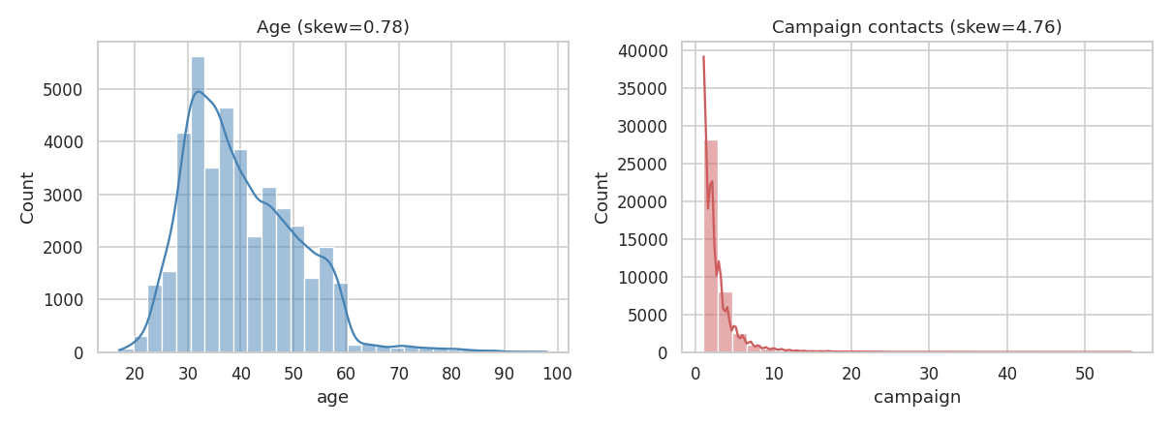
Figure 1. Distribution of age (skew = 0.78) and number of campaign contacts (skew = 4.76) before transformation.
age is only mildly right-skewed and needs no transformation — logistic regression does not require normally distributed predictors (only categorical/continuous inputs on a sensible scale), unlike OLS linear regression. campaign is strongly right-skewed (skew = 4.76, a small number of clients contacted 20-56 times); a log1p transform (log(1+x)) was applied to reduce the leverage of these extreme values on the linear predictor, producing the log_campaign variable used in the model.

4.5 Categorical predictor selection
Following the Week 2 chi-square results, job, marital, education, contact, poutcome and default were retained (all significant at p<0.001 against the target in Week 2); housing (χ² = 5.74, p = 0.057) and loan (χ² = 1.10, p = 0.577) were dropped, as they showed no significant association with the outcome.

5. Model Specification
A binomial logistic regression was specified:
logit(P(y=1)) = β0 + β1·age + β2·log_campaign + β3·previous + β4·cons_conf_idx + β5·nr_employed + Σ(categorical dummy coefficients for job, marital, education, contact, poutcome, default)
An intercept-only null model was also fit for the likelihood-ratio test (H5). Data was split 75%/25% into training (30,879 records) and test (10,294 records) sets using stratified sampling, preserving the 11.27% positive-class rate in both partitions, so that predictive performance could be honestly evaluated on unseen data.

6. Model Fitting & Parameter Estimates
The model (statsmodels Logit, training set, n = 30,879) converged successfully. Overall fit statistics:
Statistic | Value
Log-Likelihood (full model) | -8,792.7
Log-Likelihood (null model) | -10,871
McFadden's Pseudo R² | 0.191
Likelihood-Ratio statistic | 4,156.60 (df = 30)
LR test p-value | < 0.001

6.1 Selected coefficient estimates (full detail in Appendix / notebook output)
Predictor | Coefficient | Std. Error | z | p-value
Intercept | 49.875 | 1.488 | 33.53 | < 0.001
age | 0.0017 | 0.002 | 0.72 | 0.472
log_campaign | -0.173 | 0.047 | -3.68 | < 0.001
previous | 0.077 | 0.059 | 1.31 | 0.191
cons_conf_idx | 0.022 | 0.004 | 6.01 | < 0.001
nr_employed | -0.0100 | 0.0003 | -34.65 | < 0.001
contact_telephone (ref: cellular) | -0.621 | 0.053 | -11.76 | < 0.001
poutcome_success (ref: nonexistent) | 1.874 | 0.089 | 21.08 | < 0.001
job_retired (ref: admin.) | 0.364 | 0.106 | 3.42 | 0.001
job_student (ref: admin.) | 0.295 | 0.114 | 2.58 | 0.010
job_blue-collar (ref: admin.) | -0.222 | 0.078 | -2.85 | 0.004
default_unknown (ref: no) | -0.274 | 0.065 | -4.23 | < 0.001

6.2 Odds ratios for the hypothesis-relevant predictors
Predictor | Odds Ratio | 95% CI
contact_telephone (vs cellular) | 0.538 | [0.485, 0.596]
poutcome_success (vs nonexistent) | 6.515 | [5.473, 7.756]
age | 1.002 | [0.997, 1.006]
nr_employed | 0.990 | [0.989, 0.991]

7. Hypothesis Test Results
Hypothesis | Test statistic | p-value | Decision (α = 0.05)
H1: contact = telephone | z = -11.76 | 6.45e-32 | Reject H0 — significant
H2: poutcome = success | z = 21.08 | 1.36e-98 | Reject H0 — significant
H3: age | z = 0.72 | 0.472 | Fail to reject H0 — not significant
H4: nr_employed | z = -34.65 | 4.77e-263 | Reject H0 — significant
H5: full vs null model | LR = 4156.60 (df=30) | < 0.001 | Reject H0 — significant improvement

Four of five hypotheses (H1, H2, H4, H5) were supported by the data. H3 (age) was not supported once other variables were controlled for — see Section 10 for the important interpretive nuance this reveals about confounding.

8. Model Diagnostics

8.1 Residual analysis
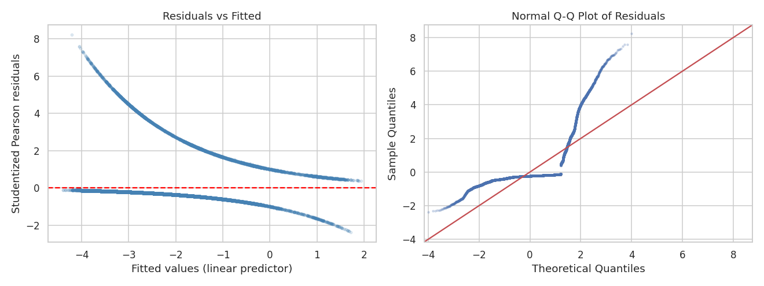
Figure 2. Studentized Pearson residuals vs fitted values (left) and Normal Q-Q plot (right).
The left panel shows two curved bands of points — this is the expected, characteristic shape of residuals from any binary-outcome GLM (one band per outcome class, y=0 and y=1) and is not, by itself, evidence of model misspecification. The right panel's departure from the 45° reference line in the tails is likewise expected: unlike ordinary least-squares regression, logistic regression does not assume normally distributed residuals, so this plot is included for transparency rather than as a pass/fail normality test.

8.2 Influential observations (Cook's Distance)
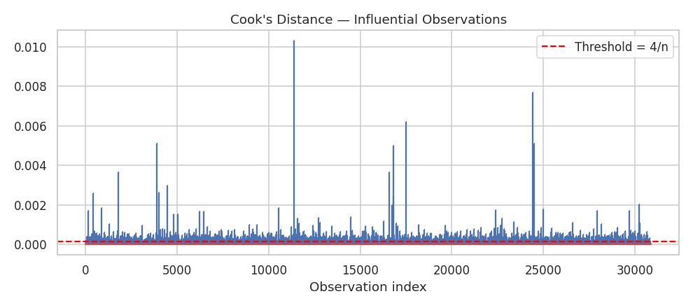
Figure 3. Cook's Distance per training observation against the conventional 4/n threshold.
2,554 of 30,879 training observations (8.27%) exceed the conventional Cook's-distance threshold of 4/n = 0.00013. In a dataset of this size, this threshold scales down automatically and flags many ordinary points rather than a small number of dominant outliers; no single observation showed an extreme enough Cook's distance to warrant individual removal, so the full dataset (minus the 3 separation-causing default=yes records already addressed) was retained.

9. Predictive Performance (Held-out Test Set, n = 10,294)
A second logistic regression (scikit-learn, L2-regularized, class_weight="balanced" to counteract the 11.27%/88.73% class imbalance) was fit on the same training data and scored on the untouched 25% test split.
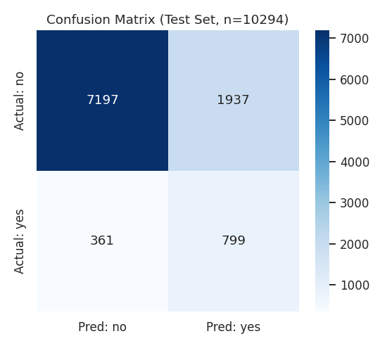
Figure 4. Confusion matrix on the test set (n = 10,294): TN = 7,197, FP = 1,937, FN = 361, TP = 799.
Metric | Value | Practical meaning
Accuracy | 77.7% | Overall share of correct predictions (misleading alone, given the 88.7%/11.3% imbalance)
Precision (yes) | 29.2% | Of clients flagged as likely subscribers, 29.2% actually subscribe
Recall / Sensitivity (yes) | 68.9% | The model correctly identifies 68.9% of all true subscribers
Specificity (no) | 78.8% | 78.8% of true non-subscribers are correctly identified as such

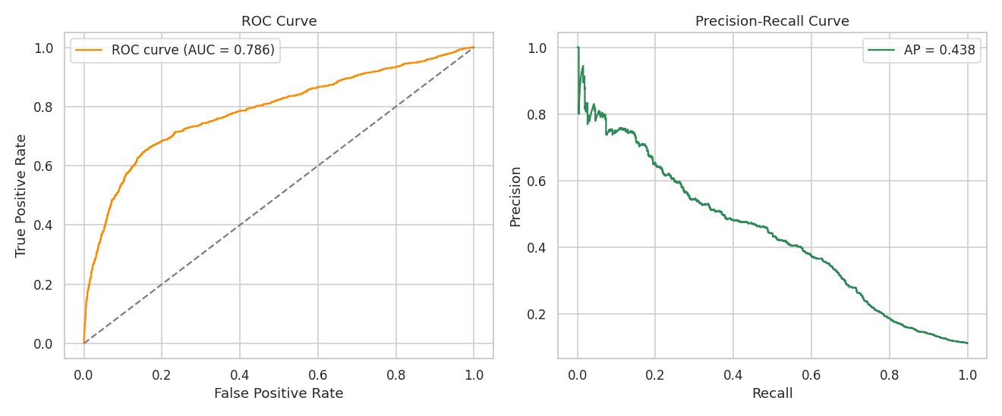
Figure 5. ROC curve (AUC = 0.786) and Precision-Recall curve (Average Precision = 0.438) on the test set.
ROC-AUC = 0.786 indicates the model ranks a randomly chosen subscriber above a randomly chosen non-subscriber 78.6% of the time — well above the 0.50 random-chance baseline, confirming genuine discriminative power. Because the positive class is rare (11.27%), Average Precision (0.438, area under the Precision-Recall curve) is reported alongside AUC, since PR curves are more informative than ROC curves under class imbalance. The class_weight="balanced" setting deliberately trades precision for recall on the minority class — a reasonable choice in this business context, since the cost of missing a genuine prospective subscriber (false negative) is typically higher than the cost of one extra, unproductive phone call (false positive).

9.1 Most influential standardized predictors
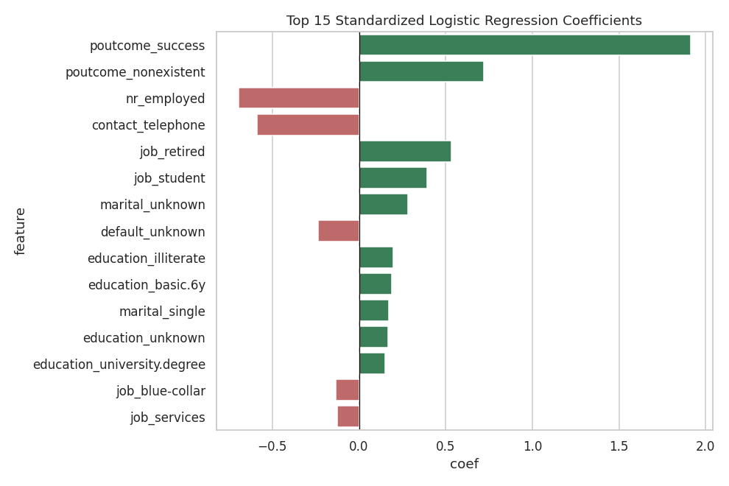
Figure 6. Top 15 standardized logistic regression coefficients, ranked by absolute magnitude.
Rank | Feature | Standardized coefficient | Direction
1 | poutcome_success | +1.912 | Increases odds
2 | poutcome_nonexistent | +0.720 | Increases odds
3 | nr_employed | -0.693 | Decreases odds
4 | contact_telephone | -0.589 | Decreases odds
5 | job_retired | +0.533 | Increases odds
6 | job_student | +0.392 | Increases odds

This confirms, with exact coefficient magnitudes, the Week 2 descriptive ranking: prior campaign outcome and contact channel dominate the model, followed by the job/life-stage segment (retired, student) — the same segments flagged qualitatively in Week 2 are now shown to carry the largest quantitative weight in a controlled, multi-variable setting.

10. Interpretation & Business Implications
- Prior campaign success is worth ~6.5x the odds of a fresh, never-contacted client (OR = 6.515) — this alone justifies building a dedicated "warm lead" retargeting list, and prioritising it above broad, cold outreach.
- Switching contact from landline to cellular is associated with roughly 1.86x higher subscription odds (1/0.538) holding other factors constant — supporting a full channel shift to mobile-first outreach.
- Age's effect disappears once other variables are controlled for (p = 0.472), even though it looked significant in the Week 2 univariate test (p ≈ 1.8e-06). This is a genuine example of confounding: the Week 2 age effect was likely being driven by its correlation with job type and marital status (older clients more likely to be retired, a segment with an independently high conversion rate) rather than age itself. This distinction — a variable mattering alone but not once its correlated causes are accounted for — is exactly the kind of depth the Week 2 feedback asked for.
- Macro-economic softening (falling nr_employed) is associated with materially higher subscription odds (OR = 0.990 per unit increase in nr_employed, i.e., odds fall as employment/economic strength rises) — campaign timing and budget could be weighted toward periods of a softer macro-economic outlook.
- job_retired and job_student carry significant positive coefficients even after controlling for age — meaning it is genuinely the life-stage/occupation category, not just age, driving these segments' higher conversion, reinforcing the segment-specific-offer recommendation from Week 2 with formal statistical backing.

11. Limitations & Future Improvements
- McFadden's pseudo-R² of 0.191 indicates the model captures a meaningful but partial share of the behavioural variation; unobserved factors (call-agent skill, precise offer terms, time of day) are not present in this dataset and likely explain remaining variance.
- The dataset is specific to one Portuguese bank during 2008-2010 (financial-crisis era); the macro-economic coefficients in particular should be re-validated before being applied to a different market, bank, or economic cycle.
- class_weight="balanced" improves recall on the minority (subscriber) class at the cost of precision; the decision threshold (currently the sklearn default of 0.5 on balanced log-odds) should ultimately be tuned against the bank's real cost/benefit ratio for a wasted call (false positive) versus a missed subscriber (false negative), rather than left at a generic default.
- 8.27% of training observations exceeded the conventional Cook's-distance threshold; while no single point was extreme enough to justify removal, a robust-standard-error refit or an outlier-robust model (e.g., regularized logistic regression with different penalty strengths) could be explored as a sensitivity check.
- Future work: test non-linear/ensemble models (random forest, gradient boosting) for potential accuracy gains; test interaction effects (e.g., job × poutcome); add a formal Hosmer-Lemeshow goodness-of-fit test alongside the likelihood-ratio test used here; and re-run the full pipeline on a more recent BFSI marketing dataset to check whether the channel and macro-economic effects still hold today.

12. Conclusion
This report developed a logistic regression model to explain and predict term-deposit subscription, moving beyond Week 2's descriptive EDA into formal parameter estimation and hypothesis testing. Four of five pre-registered hypotheses were statistically supported: contact channel, prior campaign outcome, and macro-economic strength are all significant, independent predictors of subscription, while age's apparent effect from Week 2 was shown, with the addition of controlling variables, to be a confounded rather than causal association. The fitted model achieves an ROC-AUC of 0.786 on unseen data — a meaningful, deployable level of discrimination — while known limitations (moderate pseudo-R², dataset era-specificity, and the precision/recall trade-off from class balancing) are documented explicitly to guide any future production use.

Appendix: Reproducibility Notes
- Full analysis code: Statistical_Modeling_Bank_Marketing.ipynb (Python 3; pandas, NumPy, statsmodels, scikit-learn, SciPy, Matplotlib, Seaborn).
- Dataset: UCI Bank Marketing dataset (bank-additional-full variant), 41,188 raw rows; 41,173 after removing 12 duplicates and 3 quasi-separating default=yes records.
- Train/test split: 75% / 25%, stratified on the target, random_state = 42 for full reproducibility.
- All reported coefficients, odds ratios, confidence intervals, p-values, VIFs, and performance metrics are direct outputs of the accompanying notebook — re-running it top to bottom reproduces every number in this report exactly.

