Exploratory Data Analysis Report
Bank Marketing Campaign Dataset (UCI Repository)
Predicting Term Deposit Subscription — A BFSI Customer Analytics Case Study
Prepared by: Kunal
Week 2 Task — Exploratory Data Analysis (EDA)
September 2026

Table of Contents
1. Introduction & Objective
2. Dataset Description
3. Methodology
4. Data Quality Assessment & Cleaning
5. Descriptive Statistics
6. Univariate Analysis
7. Bivariate Analysis
8. Correlation Analysis
9. Hypothesis Testing
10. Key Insights & Business Recommendations
11. Assumptions & Limitations
12. Conclusion & Next Steps
Appendix: Reproducibility Notes

1. Introduction & Objective
This report presents a comprehensive Exploratory Data Analysis (EDA) of a publicly available dataset, conducted as part of the Week 2 EDA task. The objective is to summarize the dataset statistically, visualize key patterns, test hypotheses about relationships between variables, and draw actionable, well-supported conclusions — laying groundwork for future predictive modelling.
The dataset chosen is the UCI "Bank Marketing" dataset, which sits squarely in the Banking, Financial Services and Insurance (BFSI) domain and aligns directly with real-world data analyst / data scientist work: understanding which clients are likely to respond to a marketing campaign for a financial product.

2. Dataset Description
Attribute | Detail
Name | Bank Marketing Dataset
Source | UCI Machine Learning Repository (Moro, Cortez & Rita, 2014)
Domain | Banking / Financial Services (BFSI) — direct telemarketing of term deposits
Records | 41,188 client contact records (41,176 after duplicate removal)
Features | 20 input variables (client demographics, campaign details, macroeconomic indicators) + 1 binary target
Target variable | y — whether the client subscribed to a term deposit ("yes"/"no")
Time period | May 2008 – November 2010 (Portuguese retail bank, during the global financial crisis)

Feature groups:
- Client demographics: age, job, marital status, education, default/housing/loan status
- Campaign contact details: contact type, month/day of contact, call duration, number of contacts
- Previous campaign history: days since last contact (pdays), number of prior contacts (previous), outcome of previous campaign (poutcome)
- Macro-economic context: employment variation rate, consumer price index, consumer confidence index, euribor 3-month rate, number of employees

3. Methodology
The analysis followed a structured EDA workflow using Python (pandas, NumPy, Matplotlib, Seaborn, SciPy) inside a Jupyter Notebook:
- Data loading, structural inspection (shape, dtypes) and quality checks (duplicates, missing/unknown values)
- Data cleaning: duplicate removal, sentinel-value handling for pdays=999
- Descriptive statistics: mean, median, standard deviation, skewness, kurtosis for numeric features; frequency distributions for categorical features
- Univariate visualisation: histograms and boxplots for numeric variables; bar charts for categorical variables
- Bivariate visualisation: relationship of each feature with the target variable
- Correlation analysis via heatmap for numeric features
- Statistical hypothesis testing: Welch's t-tests, Chi-square tests of independence, one-way ANOVA (alpha = 0.05)
All code is provided in the accompanying Jupyter Notebook (EDA_Bank_Marketing.ipynb) for full reproducibility.

4. Data Quality Assessment & Cleaning
- 12 exact duplicate rows were identified and removed (41,188 → 41,176 records).
- No true NaN values exist in the raw file; however several categorical columns contain an explicit "unknown" category, which was retained (not imputed) since its presence may itself be informative (non-disclosure pattern): default (8,596 unknown, 20.9%), education (1,730), housing (990), loan (990), job (330), marital (80).
- The numeric column pdays uses a sentinel value of 999 to represent "client was not previously contacted." This was converted into a separate flag (was_previously_contacted) to avoid distorting descriptive statistics of pdays.
- No structural errors, inconsistent data types, or impossible values (e.g., negative ages) were found.

5. Descriptive Statistics

5.1 Numeric Features
Feature | Mean | Std Dev | Min | Median | Max | Skew
age | 40.02 | 10.42 | 17 | 38 | 98 | 0.78 (right)
duration (sec) | 258.32 | 259.31 | 0 | 180 | 4,918 | 3.26 (strong right)
campaign (contacts) | 2.57 | 2.77 | 1 | 2 | 56 | 4.76 (strong right)
previous | 0.17 | 0.49 | 0 | 0 | 7 | 3.83 (strong right)
emp_var_rate | 0.08 | 1.57 | -3.4 | 1.1 | 1.4 | -0.72
cons_price_idx | 93.58 | 0.58 | 92.2 | 93.75 | 94.77 | -0.23
euribor3m | 3.62 | 1.73 | 0.63 | 4.86 | 5.04 | -0.71

Age is moderately right-skewed (working-age clients dominate, 30-50 years). Call duration, campaign contacts and previous contacts are all strongly right-skewed, indicating most interactions are short/few, with a long tail of exceptional cases (very long calls or heavily re-contacted clients).

5.2 Categorical Features & Target Balance
Target class distribution: "no" = 88.73% (36,537 clients), "yes" = 11.27% (4,639 clients) — a strongly imbalanced target, an important consideration for any future classification model.
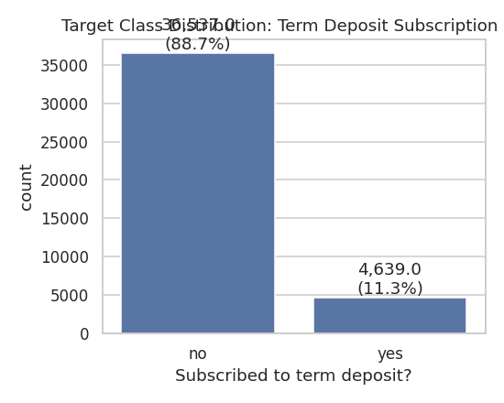
Figure 1. Target class distribution — term deposit subscription is a minority-class outcome (~11.3%).
Feature | Top categories (share of records)
job | admin. (25.3%), blue-collar (22.5%), technician (16.4%), services (9.6%)
marital | married (60.5%), single (28.1%), divorced (11.2%)
education | university.degree (29.5%), high.school (23.1%), basic.9y (14.7%)
contact | cellular (63.5%), telephone (36.5%)
poutcome | nonexistent (86.3%), failure (10.3%), success (3.3%)

6. Univariate Analysis
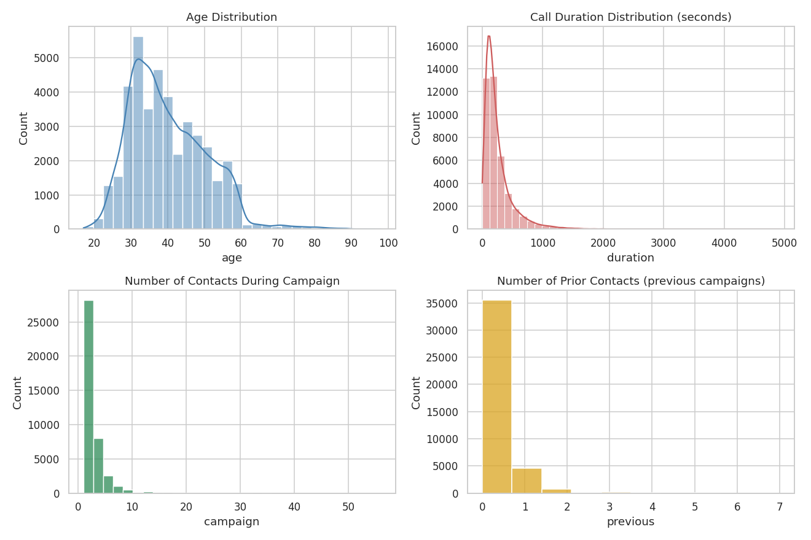
Figure 2. Distribution of key numeric variables: age, call duration, campaign contacts and previous contacts.
All four distributions are right-skewed. Age clusters between 30-50 years. Call duration and campaign contacts show long tails — a small number of very long calls or highly-repeated contact attempts. Most clients (previous ≈ 0) had no prior campaign history.
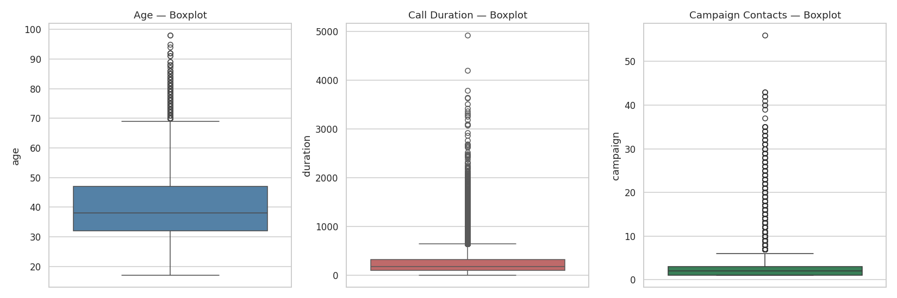
Figure 3. Boxplots highlighting outliers in age, call duration and campaign contacts.
Feature | % outliers (IQR rule) | IQR bounds
age | 1.14% | [3.5, 75.5]
duration | 7.13% | [-223.5, 644.5]
campaign | 7.97% | [-2.0, 6.0]

These outliers are retained as they reflect genuine business events (exceptionally long calls, heavily re-contacted clients) rather than data-entry errors, but should be log-transformed or capped before use in distance-based or linear models.
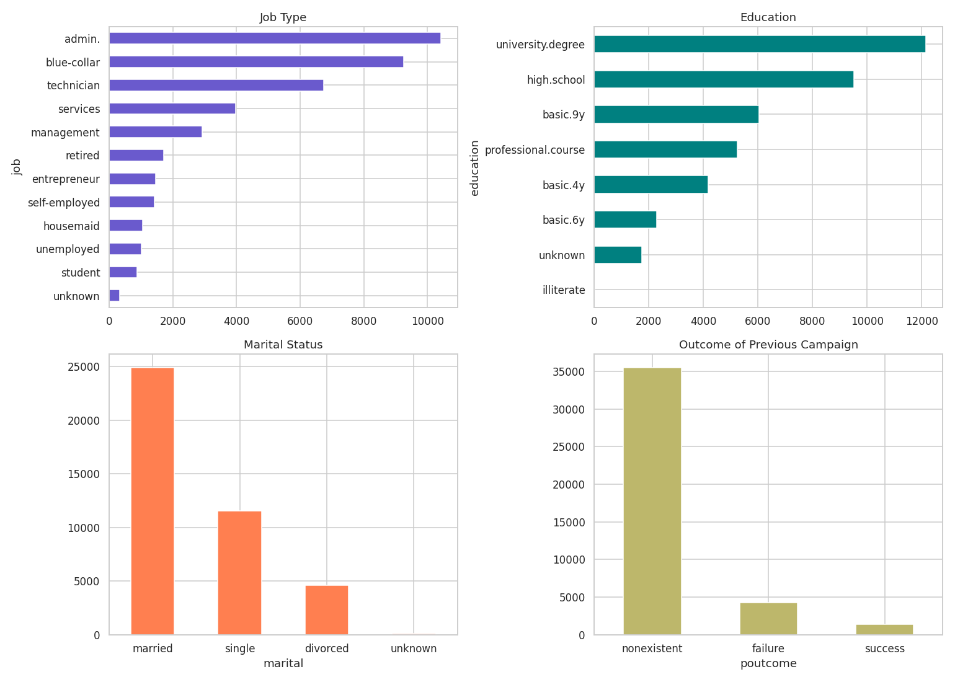
Figure 4. Distribution of client job type, education, marital status and previous-campaign outcome.

7. Bivariate Analysis — Drivers of Subscription
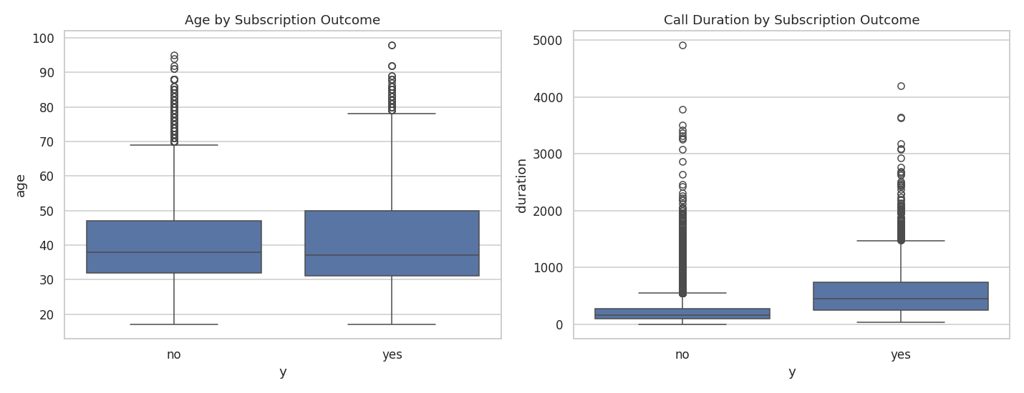
Figure 5. Age and call duration compared across subscribers ("yes") vs non-subscribers ("no").
Subscribers have a noticeably higher median call duration (mean 553s vs 221s for non-subscribers) and a slightly higher/older age profile on average (40.9 vs 39.9 years).
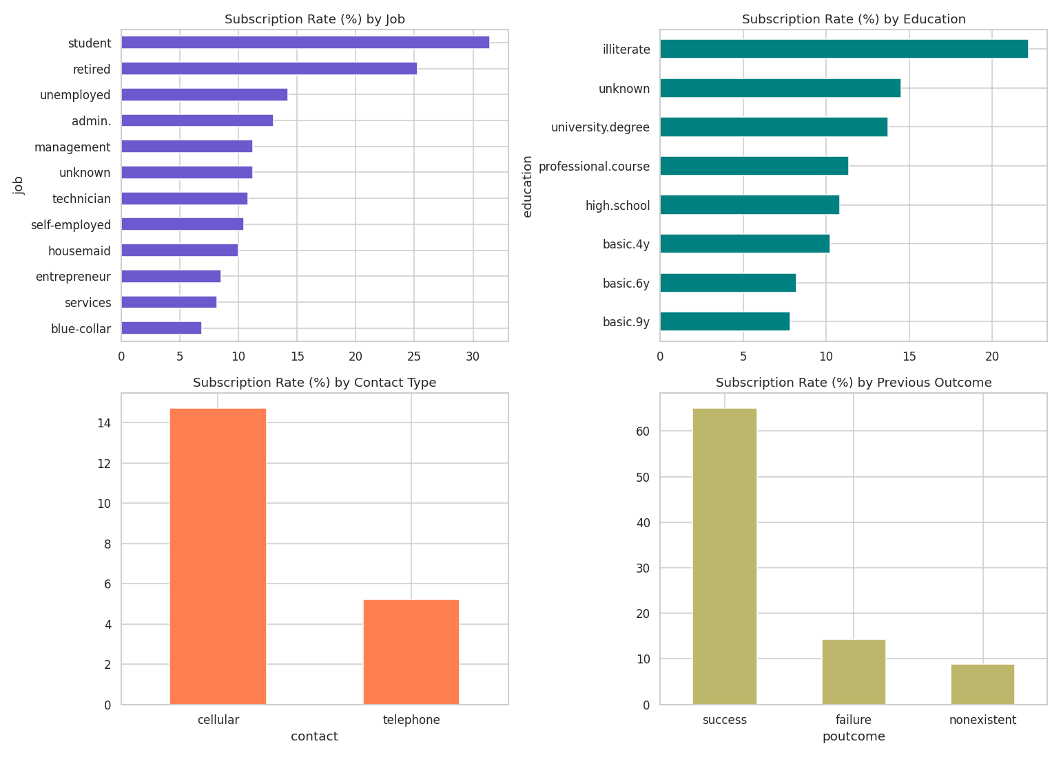
Figure 6. Subscription rate (%) segmented by job, education, contact channel, and previous campaign outcome.
Segment | Top-performing category | Subscription rate
Job | Student | 31.4% (vs 6.9% for blue-collar, the lowest)
Previous outcome | Success (prior conversion) | 65.1% (vs 8.8% for no prior contact)
Contact channel | Cellular | 14.7% (vs 5.2% for telephone)
Month | March | 50.6% (vs 6.4% in May, the lowest)

8. Correlation Analysis
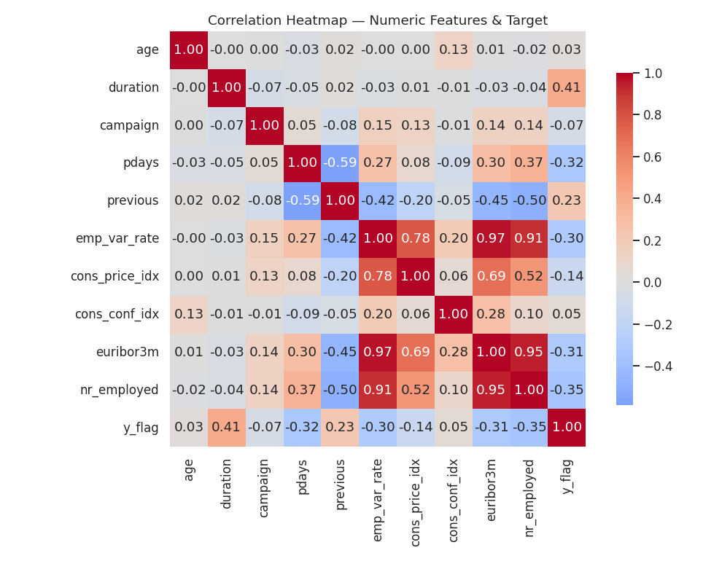
Figure 7. Correlation heatmap of numeric features and the target flag.
Key findings:
- The five macro-economic indicators (emp_var_rate, cons_price_idx, euribor3m, nr_employed, and to a lesser extent cons_conf_idx) are highly inter-correlated — multicollinearity that should be addressed (feature selection, VIF check, or PCA) before linear modelling.
- duration shows the strongest positive correlation with the target (r ≈ 0.41), but is only known after a call completes — it must be excluded from any real-time predictive model to avoid data leakage.
- nr_employed (r ≈ -0.36), pdays (r ≈ -0.33) and euribor3m (r ≈ -0.31) show the strongest negative correlations — subscriptions rise when broader employment/interest-rate conditions soften.

9. Hypothesis Testing

9.1 Welch's t-test — Call Duration vs Subscription
H0: mean call duration is equal for subscribers and non-subscribers. H1: means differ.
Group | Mean duration (s) | Test statistic | p-value | Conclusion
yes | 553.26 | t = 55.50 | p ≈ 0.00 (< 0.001) | Reject H0 — significant difference
no | 220.87

9.2 Welch's t-test — Age vs Subscription
H0: mean age is equal for subscribers and non-subscribers. H1: means differ.
Group | Mean age (yrs) | Test statistic | p-value | Conclusion
yes | 40.91 | t = 4.78 | p ≈ 1.8e-06 (< 0.001) | Reject H0 — significant difference
no | 39.91

9.3 Chi-square Tests of Independence (categorical predictors vs y)
Feature | Chi-square | df | p-value | Significant (α=0.05)?
poutcome | 4230.14 | 2 | ≈ 0.00 | Yes
job | 961.74 | 11 | ≈ 0.00 | Yes
contact | 862.08 | 1 | ≈ 0.00 | Yes
default | 406.56 | 2 | ≈ 0.00 | Yes
education | 192.85 | 7 | ≈ 0.00 | Yes
marital | 122.96 | 3 | ≈ 0.00 | Yes
housing | 5.74 | 2 | 0.057 | No (borderline)
loan | 1.10 | 2 | 0.577 | No

poutcome, job, contact, default, education and marital status are all significantly associated with subscription outcome. housing and loan status show no significant association, indicating they add little discriminative value on their own.

9.4 One-way ANOVA — Age across Education Levels
H0: mean age is equal across all education levels. H1: at least one group mean differs.
Result: F = 457.37, p ≈ 0.00 (< 0.001) → Reject H0. Mean age varies significantly across education levels (e.g., illiterate and basic-education clients tend to be older on average than university-degree holders), consistent with generational shifts in access to higher education.

10. Key Insights & Business Recommendations
- Severe class imbalance (11.3% positive) — any future predictive model must use stratified sampling, class-weighting, or resampling (SMOTE) rather than plain accuracy as the success metric.
- Call duration is the strongest correlate of conversion, but is only known after the call — exclude it from live-scoring models; instead use it only for post-hoc campaign quality analysis.
- Prior success is the single strongest actionable signal (65.1% vs 8.8% conversion) — build a priority "warm lead" retargeting list of previously-converted clients.
- Shift contact strategy toward cellular numbers — nearly 3x the conversion rate of landline telephone contact.
- Prioritise student and retiree segments in messaging/offer design — smaller populations but 2-4x higher conversion than blue-collar/entrepreneur segments.
- Time campaigns around historically strong months (March, September, October, December) and macro-economic conditions where consumer sentiment favours guaranteed-return products.
- housing and loan status are not useful standalone segmentation variables and can be deprioritised in a simplified scoring model.

11. Assumptions & Limitations
- "unknown" categorical values were kept as their own category rather than imputed, assuming their prevalence itself carries signal; this should be revisited if the dataset is used for production modelling.
- pdays = 999 was treated as a sentinel for "not previously contacted" per the dataset's documentation, not as a genuine numeric value.
- Outliers in duration and campaign were retained as legitimate business events rather than removed, since they are not data-entry errors.
- The dataset reflects a specific bank, geography (Portugal) and time period (2008-2010, financial-crisis era); the macro-economic relationships observed may not generalise to other markets or periods without re-validation.
- All statistical tests used a two-sided formulation with significance threshold α = 0.05.

12. Conclusion & Next Steps
This EDA confirms that client behavioural history (poutcome), contact channel, job/life-stage segment, and macro-economic context are all statistically significant and practically meaningful drivers of term-deposit subscription in this BFSI marketing dataset. The findings support building a supervised classification model (e.g., logistic regression, random forest, or gradient boosting) to score and prioritise leads — with duration excluded to avoid leakage, multicollinear macro features consolidated, and the target's class imbalance explicitly handled during training and evaluation.

Appendix: Reproducibility Notes
- Full analysis code: EDA_Bank_Marketing.ipynb (Python 3, pandas, NumPy, Matplotlib, Seaborn, SciPy).
- Dataset: UCI Bank Marketing dataset (bank-additional-full variant, 41,188 rows, 21 columns, semicolon-delimited CSV).
- Random elements: none — all statistics and visuals are fully deterministic and reproducible by re-running the notebook top to bottom.
- Environment: standard scientific Python stack; no GPU or special hardware required.

