PROJECT REPORT
ON
“BOOKOURSHOTELS”

Bachelor of Computer Applications (BCA)

To

UTTARANCHAL SCHOOL OF COMPUTING SCIENCES



SESSION: (2025-2026)

Submitted To Submitted By
Mr. Anup Shekhar Chamoli Kunal Khatri
Assistant Professor BCA-IV-F
USCS UU2409000173

ACKNOWLEDGEMENT

There are many people who helped directly or indirectly on the successful completion of my major project.
I am very thankful to our project guide “Mr. Anup Shekhar Chamoli” who has been inspiring guide and committed caretaker for her unflinching devotion. The encouragement and support by her, especially in carrying out this project motivated me to complete this project.
I would like to thank Director of USCS “Prof Dr. Sonal Sharma” for providing us with all the necessary resources required to complete the project. We profusely are thankful to the program head of the department “Dr. Sameer Dev Sharma” for their valuable guidance.
I would like to express deep sense of gratitude to our staff members of Dept. of Computer Applications for their co-operation, which has given in the congruency to build up this project. I would like to thank all our friends for their help and constructive criticism during my project period.
Finally, I am very much indebted to my parents for moral support and encouragement to achieve goals. I have no words to express my gratitude and still I am very thankful to my parents who have shown me this world and for every support they gave me.

Name: Kunal Khatri
BCA IV SEM

DECLARATION

I hereby declare that the project report entitled HOTEL BOOKING WEBSITE “BookOursHotels” submitted by Kunal Khatri Enrollment No. UU2409000173 to Uttaranchal School of Computing Science. The project was done under the Guidance of Mr. Anup Shekhar Chamoli . I further declare that the work reported in this project has not been submitted and will not be submitted, either in part or in full, for the award of any other degree or diploma in this university or any other university or institute.

Name:Kunal Khatri
BCA IV SEM

CERTIFICATE

This is to certify that the project entitled HOTEL BOOKING WEBSITE “BookOursHotels” by Kunal Khatri Enrollment No. UU2409000173 and Ankit Kumar Enrollment No. UU2409000044 and has been submitted in the partial fulfillment of the requirements for the award of the degree of BCA from Uttaranchal University, Dehradun. The results embodied in this project have not been submitted to any other University or Institution for the record of any degree.

Under the guidance of:
Mr. Anup Shekhar Chamoli
Assistant Professor
Uttaranchal School of Computing Sciences,
Uttaranchal University,
Dehradun

Table of Contents

ACKNOWLEDGEMENT ...............................................................................................2

DECLARATION .............................................................................................................3

CERTIFICATE OF ORIGINALITY................................................................................4

LIST OF FIGURE………………………………….…………………………………..7

LIST OF TABLES……………………………………………………………………...8

1.INTRODUCTION ........................................................................................................9

2.OBJECTIVE .................................................................................................................10
3.SYSTEM ANALYSIS ..................................................................................................11

3.1.EXISTING SYSTEM ................................................................................................11

3.2.PROPOSED SYSTEM ..............................................................................................11

3.3.FEASIBILTY STUDY ..............................................................................................12

3.3.1.TECHNICAL FEASIBILITY.................................................................................12

3.3.2.ECONOMIC FEASIBILITY ..................................................................................12

3.3.3.OPERATIONAL FEASIBILITY ...........................................................................12

3.4.PROJECT PLANNING .............................................................................................13

3.5.PROJECT SCHEDULING ........................................................................................14
3.5.1.GANTT CHART ....................................................................................................15

3.5.2.PERT CHART ........................................................................................................16

3.6.SOFTWARE REQUIREMENT SPECIFICATION..................................................17

3.6.1.FUNCTIONAL REQUIREMENT .........................................................................17

3.6.2.NON- FUNCTIONAL REQUIREMENT ..............................................................19

3.7.SYSTEM SPECIFICATION .....................................................................................20

3.8.DATA MODELS .......................................................................................................21

3.8.1.USE CASE DIAGRAM..........................................................................................21

3.8.2.ACTIVITY DIAGRAM..........................................................................................21

3.8.3.STATE DIAGRAM .................................................................................................22

4.SYSTEM DESIGN .......................................................................................................23

4.1.MODULARIZATION DETAILS ..............................................................................23

4.2.DATABASE DESIGN...............................................................................................25
5.TESTING......................................................................................................................26

6.SYSTEM SECURITY MEASURES............................................................................28

7.REPORT.......................................................................................................................29

8.FUTURE SCOPE ………………………… ................................................................30

9. SOURCE CODE…………………………………………………………………….31

10. BIBLIOGRAPHY......................................................................................................41

LIST OF FIGURES

Fig | FIGURE NAME | PAGE NO
1. | Gantt Chart | 11
2. | Pert Chart | 12
3. | Use Case Diagram | 15-16
4. | Activity Diagram | 17-18
5. | State Machine Diagram | 19-20

LIST OF TABLES

Sr. No. | Table Numbers | Table Name | Page No.
1. | Table No.1 | Pert Chart | 7
2. | Table No.2 | Gant Chart | 8
3. | Table No.3 | Functional Requirement | 13
4. | Table No.4 | Non-Functional Requirement | 14

1. INTRODUCTION
The BookOurHotels system is a web-based hotel booking platform designed to help users easily search, explore, and book hotels online. In today’s digital world, people prefer quick and convenient ways to plan their travel and accommodation. Traditional hotel booking methods often require visiting travel agencies or making phone calls, which can be time-consuming and inefficient. The BookOurHotels platform provides a modern solution to these problems by offering an online interface where users can view hotel details, compare prices, and make bookings instantly.
This system is developed using modern web technologies such as HTML, CSS, JavaScript, TailwindCSS, and APIs like Leaflet Maps and Chart.js. The platform provides several features including hotel search, filtering options, interactive maps, user authentication, booking management, payment simulation, and an admin dashboard. These features allow users to easily manage their travel plans while administrators can monitor bookings and system activities.
The main purpose of this project is to create a user-friendly and efficient travel booking system that simplifies the process of finding and reserving hotels. The system also focuses on providing a responsive design, secure user interaction, and a smooth booking experience.
Additionally, an Admin Panel is provided to monitor revenue, user base, and booking statistics through an analytics dashboard and data management tools. This dual interface design allows the platform to act as a realistic hotel booking system suitable for academic study or a real-world commercial prototype.
Another important aspect of this system is the integration of interactive maps that allow users to view hotel locations visually. This feature helps users understand the exact location of hotels and nearby attractions, making travel planning more convenient. The system also supports multiple currencies and provides notifications and alerts for important actions such as successful bookings.
The design of the BookOurHotels platform focuses on simplicity, accessibility, and efficiency. The interface is responsive, meaning it can adapt to different screen sizes and devices, including desktops, tablets, and smartphones. This ensures that users can access the system anytime and anywhere. Security features such as user authentication, session management, and input validation are also included to protect user data and maintain system reliability.
2. OBJECTIVE
The objective of the BookOurHotel – Hotel Booking System is to design and develop a comprehensive online booking platform that enhances the experience of hotel reservation through advanced search capabilities, interactive features, secure transactions, and administrative control.
Key objective
1. To digitalize the hotel booking process
Transforming traditional manual reservation into an automated online system for faster and more accurate service.
2. To simplify hotel search and comparison
Allow users to easily filter hotels based on price, location, and rating so they can choose the best option.
3. To improve accessibility and convenience
Provide a platform that is available 24/7 from any device (mobile, tablet, laptop, desktop).
4. To show complete hotel details in a single interface
Including images, pricing, address, ratings, and descriptions to assist users in informed decision-making.

3. SYSTEM ANALYSIS
In the case of the BookOurHotels platform, system analysis focuses on understanding the traditional hotel booking methods and designing a modern web-based solution that provides better efficiency, convenience, and accessibility.

3.1 EXISTING SYSTEM
Some of the major problems in the existing system include:
- Customers have limited access to hotel information.
- Booking a room requires contacting multiple hotels or travel agents.
- The process is time-consuming and sometimes inconvenient.
- It is difficult to compare hotel prices, services, and availability.
- Manual record keeping can lead to errors and data loss.

3.2 PROPOSED SYSTEM.
The proposed system provides several advantages, such as:
- Easy online hotel searching and booking.
- Access to complete hotel details including price, location, rating, and amenities.
- Interactive maps to view hotel locations.
- Secure login and user account management.
- Booking confirmation and downloadable receipts.
- Ability to cancel bookings if needed.
- Admin dashboard for monitoring users and bookings.
3.3 FEASIBILITY STUDY
The feasibility study of the BookOurHotels system includes the following aspects:
- Technical Feasibility
- Economic Feasibility
- Operational Feasibility
3.3.1 TECHNICAL FEASIBILITY
The BookOurHotels system is technically feasible because it is developed using commonly available and widely used web technologies such as HTML, CSS, JavaScript, and TailwindCSS. These technologies are easy to implement and supported by all modern web browsers. Additional tools such as Leaflet Maps for displaying hotel locations and Chart.js for visualizing booking statistics enhance the functionality of the system.

3.3.2 ECONOMIC FEASIBILITY
The BookOurHotels project is economically feasible because it is developed using open-source technologies and free development tools. Technologies such as HTML, CSS, JavaScript, TailwindCSS, and other libraries used in the system do not require any licensing cost. This significantly reduces the overall development cost.
3.3.3 OPERATIONAL FEASIBILITY
The BookOurHotels system is designed with a simple and user-friendly interface that allows users to easily navigate through the platform. Users can search for hotels, view hotel details, book rooms, and manage their bookings without requiring technical knowledge.
The system also provides features such as notifications, booking history, cancellation options, and downloadable receipts, which improve the overall user experience. The admin panel allows administrators to monitor bookings, manage users, and analyze system data efficiently.
3.4 PROJECT PLANNING
The BookOurHotels project, project planning was done to structure the development process in a systematic manner. The development was divided into several phases so that each stage could be completed efficiently.
The main steps involved in project planning are:
- Requirement Analysis
In this phase, the requirements of the system were identified. The features needed for the project such as hotel search, booking system, user login, payment simulation, and admin dashboard were analyzed.
- System Design
During this stage, the overall structure of the system was designed. This includes designing the user interface, system architecture, and data models required for the platform.
- Development Implementation
In this phase, the actual coding of the system was performed using technologies such as HTML, CSS, JavaScript, and TailwindCSS. Various features like hotel search, booking functionality, map integration, and user authentication were implemented.
- Integration of Additional Features
Additional tools and libraries such as Leaflet Maps for location display, Chart.js for data visualization, and JavaScript-based storage for managing booking data were integrated into the system.
- Testing Phase
The system was tested to ensure that all functionalities such as login, booking, payment simulation, and admin features were working correctly without errors.
- Documentation
In this final stage, all details related to the project including system analysis, design diagrams, implementation details, and testing results were documented in the project report.

3.5 PROJECT SCHEDULING
In the BookOurHotels project, scheduling was done to divide the development process into different phases. Each phase of the project was assigned a specific time duration to ensure systematic development and timely completion. The scheduling process helped in tracking progress and managing different activities involved in the project.
The main activities involved in project scheduling are:
- RequirementAnalysis
Understanding the project requirements and identifying the main features needed for the system such as hotel search, booking system, user authentication, and admin panel.
- System Design
Designing the structure of the system including interface layout, system architecture, and data models.
- System Development
Writing the program code using technologies such as HTML, CSS, JavaScript, and TailwindCSS to implement the required functionalities.
- Integration of Features
Adding advanced features such as interactive maps, hotel filters, booking management, and admin dashboard.
- Testing and Debugging
Checking the system for errors and ensuring that all modules work correctly and efficiently.
- Documentation and Final Submission
Preparing the project report and organizing all project files for final submission.

3.5.1 GANTT CHART
Task / Activity | Week 1 | Week 2 | Week 3 | Week 4 | Week 5 | Week 6
Requirement Analysis | █████
System Design |  | █████
UI Design |  | █████ | █
Coding / Development |  |  | █████ | █████
Feature Integration |  |  |  | █████
Testing & Debugging |  |  |  |  | █████
Documentation |  |  |  |  | ███ | ███
Final Submission |  |  |  |  |  | █

- Week 1 → Requirement analysis
- Week 2 → System and interface design
- Week 3–4 → Coding and development
- Week 5 → Testing and debugging
- Week 6 → Documentation and submission

3.5.2 PERT CHART
PERT Chart Table
SDLC Phase | Project Activity | Duration | Start | Finish
1 | Requirement Analysis | 6 days | 26-01-2026 | 31-01-2026
2 | Feasibility Study | 5 days | 01-02-2026 | 05-02-2026
3 | System Design | 8 days | 06-02-2026 | 13-02-2026
4 | Documentation | 7 days | 14-02-2026 | 20-02-2026
5 | Coding / Implementation | 10 days | 21-02-2026 | 02-03-2026
6 | Testing | 6 days | 03-03-2026 | 08-03-2026

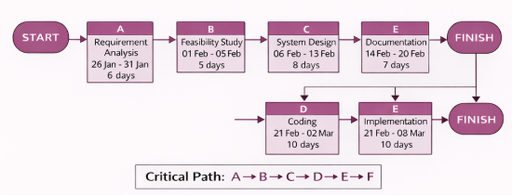

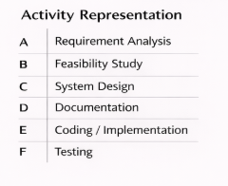

3.6 SOFTWARE REQUIREMENT SPECIFICATION
The Software Requirement Specification for the BookOurHotels system describes the functional and non-functional requirements needed for the development and operation of the online hotel booking platform. It provides a clear understanding of how the system will work and what services it will provide to users and administrators.
The main components of the SRS for the BookOurHotels system include functional requirements and non-functional requirements.

3.6.1 FUNCTIONAL REQUIREMENTS
Functional requirements describe the specific functions and operations that the system must perform.
S.No | Module | Functional Requirement | Description
1 | User Registration | Create Account | Users can sign up using email, phone, or social login
2 | User Login | Authentication | Users can securely log in and log out
3 | Profile Management | Edit Profile | Users can update personal details, password, preferences
4 | Hotel Search | Search Hotels | Users can search hotels by location, date, price, rating
5 | Filters & Sorting | Advanced Filters | Filter by price, amenities, ratings, room type
6 | Hotel Details | View Hotel Info | Display images, description, facilities, reviews
7 | Room Availability | Check Rooms | Show available rooms based on selected dates
8 | Booking System | Book Room | Users can select rooms and confirm booking
9 | Payment Gateway | Online Payment | Support multiple payment methods (UPI, cards, wallets)
10 | Booking History | View Bookings | Users can see past and upcoming bookings
11 | Cancellation | Cancel Booking | Users can cancel bookings based on policy
12 | Notifications | Alerts | Email/SMS confirmation for booking, cancellation
13 | Reviews & Ratings | Feedback System | Users can rate and review hotels
14 | Admin Panel | Manage Hotels | Admin can add/update/delete hotel listings
15 | Admin Dashboard | Reports | View booking reports, user data, revenue stats
16 | Customer Support | Help System | Chat/email support for user queries
17 | Multi-language | Language Support | Users can change website language
18 | Currency Converter | Currency Selection | Display prices in different currencies
19 | Wishlist | Save Hotels | Users can save favorite hotels
20 | Map Integration | Location View | Show hotel location on map

3.6.2 NON-FUNCTIONAL REQUIREMENTS
S.No | Category | Non-Functional Requirement | Description
1 | Performance | Fast Response Time | Pages should load within 2–3 seconds
2 | Performance | Scalability | System should handle increasing users and bookings
3 | Availability | Uptime | System should be available 24/7 with minimal downtime
4 | Security | Data Protection | User data must be encrypted (HTTPS, secure login)
5 | Security | Authentication | Secure login with password protection and validation
6 | Usability | User-Friendly UI | Easy navigation and simple interface
7 | Usability | Accessibility | Accessible on mobile, tablet, and desktop devices
8 | Compatibility | Cross-Browser Support | Works on Chrome, Firefox, Edge, Safari
9 | Reliability | Error Handling | Proper error messages and system recovery

3.7 SYSTEM SPECIFICATION

SOFTWARE USE

Category | Requirement | Description
Operating System | Windows / macOS / Linux | Compatible with major platforms
Frontend Technologies | HTML5, CSS3 (Tailwind CSS),  JavaScript (ES6+) | Used for UI design and client- side functionality
Browser | Google Chrome, Mozilla Firefox, Safari, Microsoft Edge | Needed to run the web-based system
Storage | LocalStorage (Browser-based DB) | Stores users, bookings, and session data
External Libraries | Leaflet.js, Chart.js, FontAwesome | For maps, charts & icons
Code Editor | VS Code / Sublime / Atom | For development and modification of code
Package/CDN Resources | Tailwind CDN, Confetti CDN, Google Fonts | Integrated for enhanced UI design
Version Control (Optional) | Git / GitHub | For project tracking and collaboration

HARDWARE USE

Component | Minimum Requirement | Recommended
Processor | Intel Dual Core or Equivalent | Intel i5 / Apple M1 or above
RAM | 4 GB | 8 GB or higher for smooth development

3.8 DATA MODEL
3.8.1. USE CASE DIAGRAM
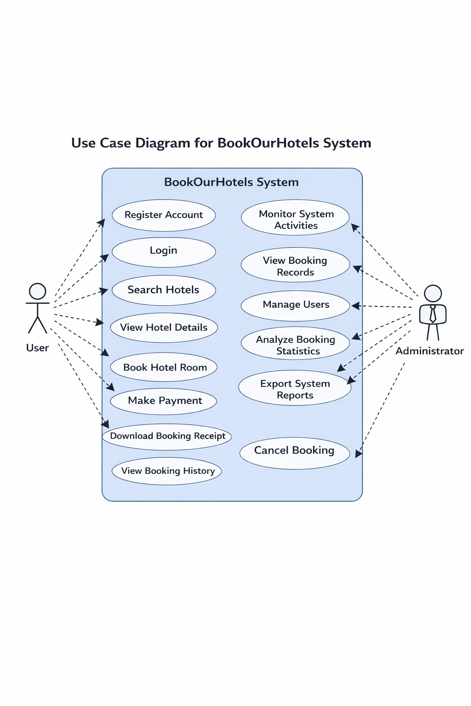

3.8.2. ACTIVITY DIAGRAM
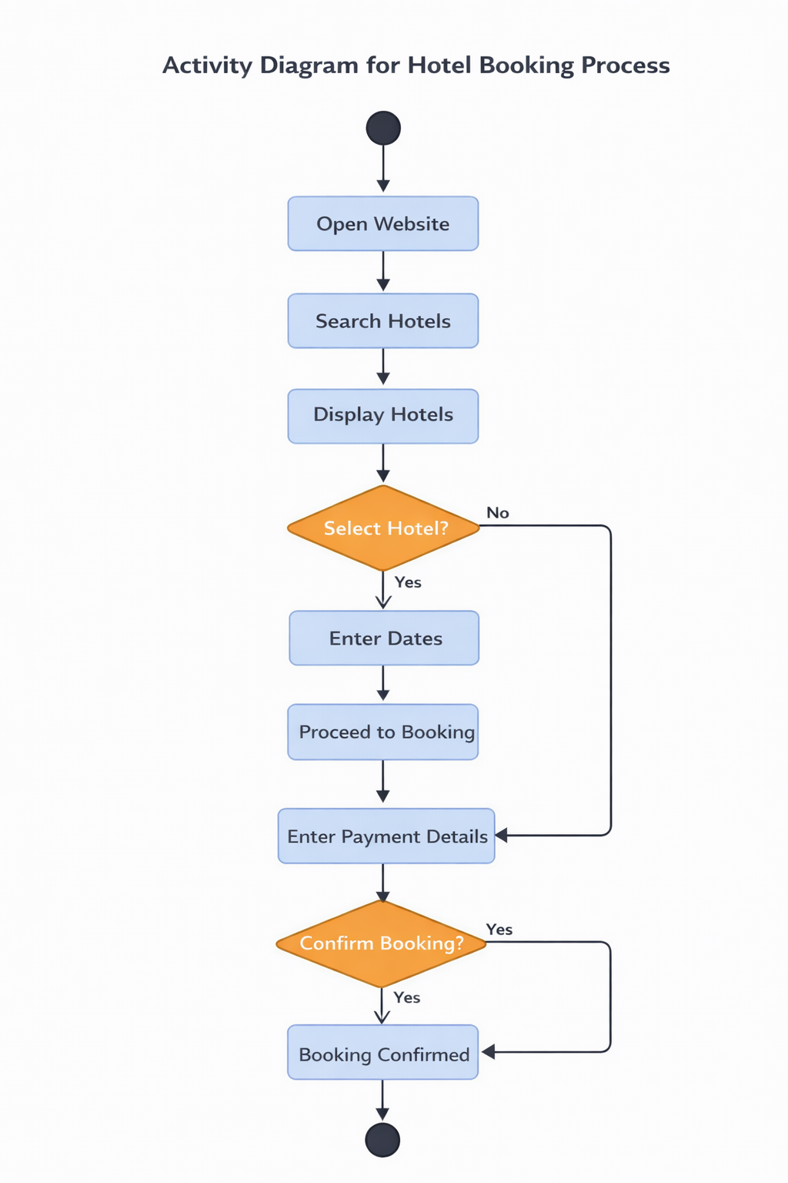

3.8.3. STATE DIAGRAM
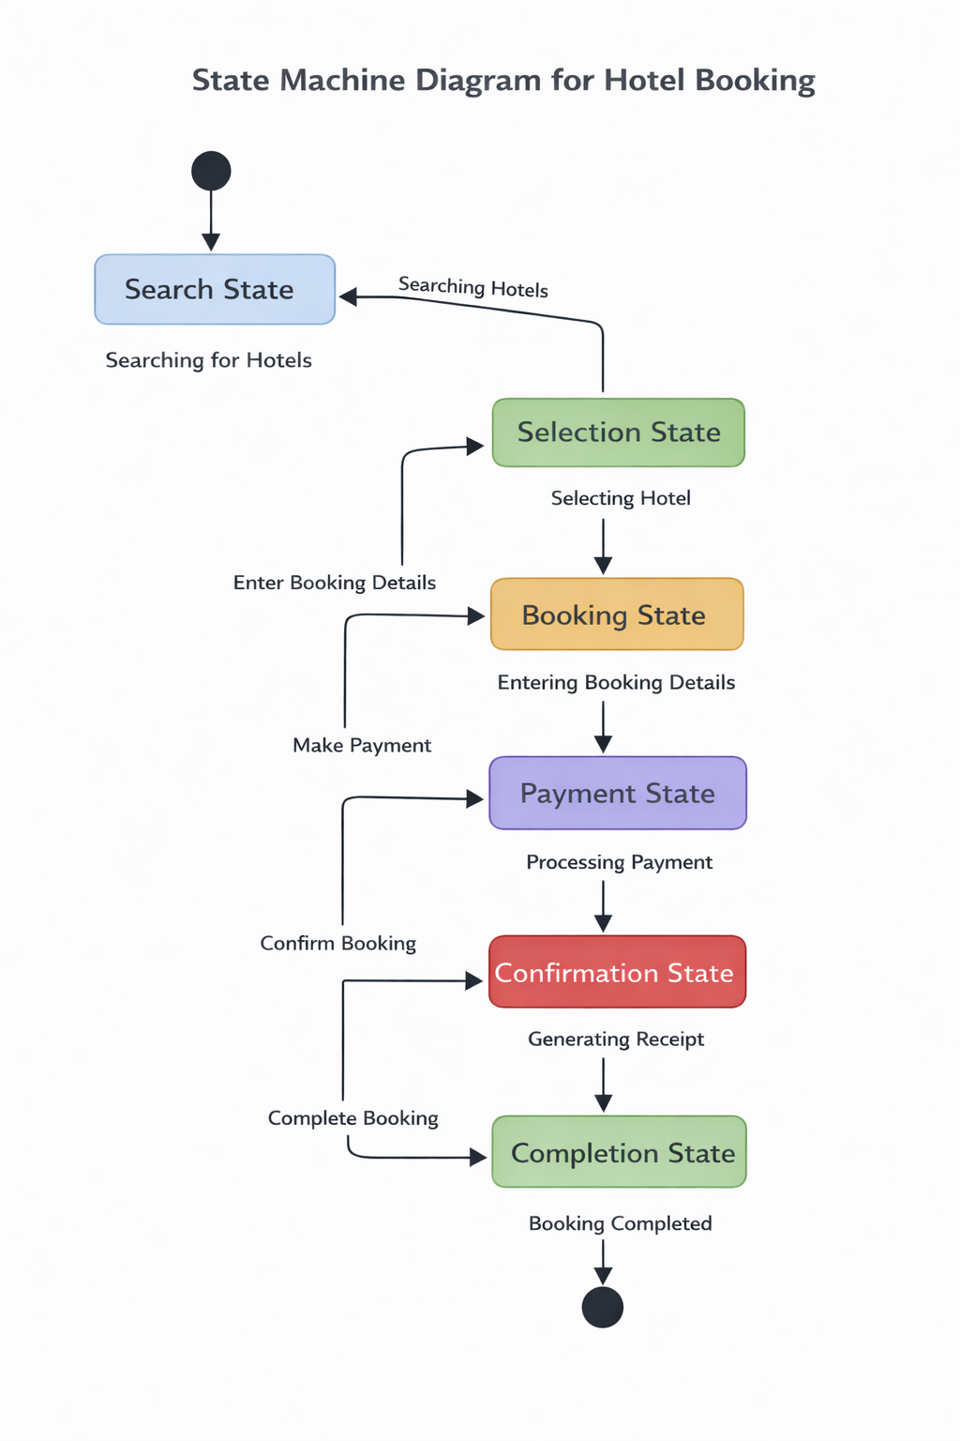

4. SYSTEM DESIGN
The BookOurHotels system is designed as a web-based hotel booking platform that allows users to search for hotels, view hotel information, make bookings, and manage their travel plans easily.
4.1 MODULARIZATION DETAILS
Each module performs a specific task and helps in simplifying the development and maintenance of the system.
The BookOurHotels system is divided into the following modules:
1. User Authentication Module
- Allows users to register and log in to the system.
- Maintains user profiles and login credentials.
2. Hotel Search Module
- Enables users to search hotels by location or hotel name.
- Displays hotel listings with price, rating, and amenities.
3. Hotel Details Module
- Shows complete information about the selected hotel.
- Displays hotel images, location, price, and available facilities.
4. Booking Module
- Allows users to select check-in and check-out dates.
- Calculates booking cost and confirms reservations.

5. Payment Module
- Simulates payment processing for hotel booking.
- Generates booking confirmation after successful payment.

6. Booking History Module
- Allows users to view their previous bookings.
- Provides option to cancel bookings if required.
7. Admin Management Module
- Allows administrators to monitor users and bookings.
- Displays booking statistics and system reports.
8. Notification Module
- Sends alerts and notifications for booking confirmations and updates.
These modules work together to provide complete functionality of the BookOurHotels platform.

4.2 DATABASE DESIGN
In the BookOurHotels system, the database stores information related to users, hotels, and bookings.
Main Tables in the Database
1. Users Table
Field Name | Description
User_ID | Unique ID for each user
Name | Name of the user
Email | User email address
Password | Login password
Role | User role (User/Admin)

2. Hotels Table
Field Name | Description
Hotel_ID | Unique ID of the hotel
Hotel_Name | Name of the hotel
Location | Hotel location
Price | Cost per night
Rating | Hotel rating

3. Bookings Table
Field Name | Description
Booking_ID | Unique booking ID
User_ID | ID of the user
Hotel_ID | ID of the hotel
Check_In | Check-in date

5. TESTING
Testing is performed to ensure that the system works correctly and all functionalities operate as expected. The BookOurHotels system was tested with different test cases to verify the accuracy and reliability of the application.
Types of Testing Performed
1. Unit Testing
Unit testing is performed to test individual components or modules of the system separately. Each module such as login, hotel search, booking system, and payment module is tested individually to ensure that it functions correctly.
2. Integration Testing
Integration testing checks how different modules of the system work together. In the BookOurHotels system, modules such as hotel search, booking system, and payment module were integrated and tested to ensure smooth communication between them.
3. System Testing
System testing evaluates the entire system to verify that all features and functionalities are working properly. The complete workflow of searching hotels, booking rooms, and generating receipts was tested during this phase.
4. User Acceptance Testing
User acceptance testing ensures that the system meets the requirements of the users. In this stage, the system was tested from the user’s perspective to confirm that the interface is user-friendly and easy to operate.

Testing Table
Test Case ID | Module | Test Description | Input | Expected Output | Result
TC01 | Login System | Check user login with valid credentials | Valid Email & Password | User successfully logs in | Pass
TC02 | Login System | Check login with invalid credentials | Invalid Email/Password | Error message displayed | Pass
TC03 | Registration | Register new user | Name, Email, Password | User account created successfully | Pass
TC04 | Hotel Search | Search hotels by location | Location name | List of hotels displayed | Pass
TC05 | Hotel Details | View hotel details | Select hotel | Hotel information displayed | Pass
TC06 | Booking Module | Book hotel room | Check-in & Check-out date | Booking confirmation shown | Pass
TC07 | Payment Module | Enter payment details | Card number, expiry, CVC | Payment processed successfully | Pass
TC08 | Booking History | View user bookings | User login | Booking history displayed | Pass
TC09 | Cancel Booking | Cancel a confirmed booking | Booking ID | Booking status updated to cancelled | Pass
TC10 | Admin Panel | View booking records | Admin login | Booking data displayed | Pass

6. SYSTEM SECURITY MEASURES
In the BookOurHotels system, several security measures have been implemented to maintain data privacy, protect user accounts, and ensure safe system operation.
The following security measures are used in the system:
1. User Authentication
The system requires users to register and log in using their email and password. This ensures that only authorized users can access their accounts and booking information.
2. Secure Login Validation
The system verifies the user’s login credentials before granting access. Invalid login attempts are rejected and an error message is displayed to prevent unauthorized access.
3. Session Management
The system includes session control mechanisms that automatically log out users after a period of inactivity. This helps prevent unauthorized access if the user leaves the system unattended.
4. Input Validation
All user inputs such as login details, booking information, and payment details are validated to prevent incorrect or harmful data from being entered into the system.
5. Role-Based Access Control
The system provides different access levels for users and administrators. Normal users can search and book hotels, while administrators have special privileges to manage users, bookings, and system reports.

7. REPORTS
These reports help administrators monitor the system performance and maintain records efficiently.
Reports generated in the system include:
• Booking Report
Displays detailed information about hotel bookings such as booking ID, user name, hotel name, check-in date, check-out date, and payment status.
• User Registration Report
Shows information about registered users including user name, email, and account details.
• Hotel Availability Report
Displays the list of available hotels along with their location, price, rating, and amenities.
• Revenue Report
Shows the total revenue generated from hotel bookings. This helps administrators analyze the performance of the system.
• Booking History Report
Allows users to view their previous bookings and transaction details.
• System Activity Report
Records system activities such as login attempts, bookings, cancellations, and admin operations.

8. FUTURE SCOPE
The BookOurHotels system provides many useful features, additional functionalities can be implemented to improve the system further.
Future improvements of the system include:
- Online Payment Integration
- Integration with real payment gateways such as Optimism pay, Razorpay, PayPal, or Stripe.
- Mobile Application Development
- Developing an Android or iOS mobile application for easier access.
- Real-Time Hotel Availability
- Connecting the system with real hotel databases to display live room availability.
- AI-Based Hotel Recommendations
- Using artificial intelligence to recommend hotels based on user preferences.
- Multi-Language Support
- Allowing users to use the system in different languages.

SOURCE CODE
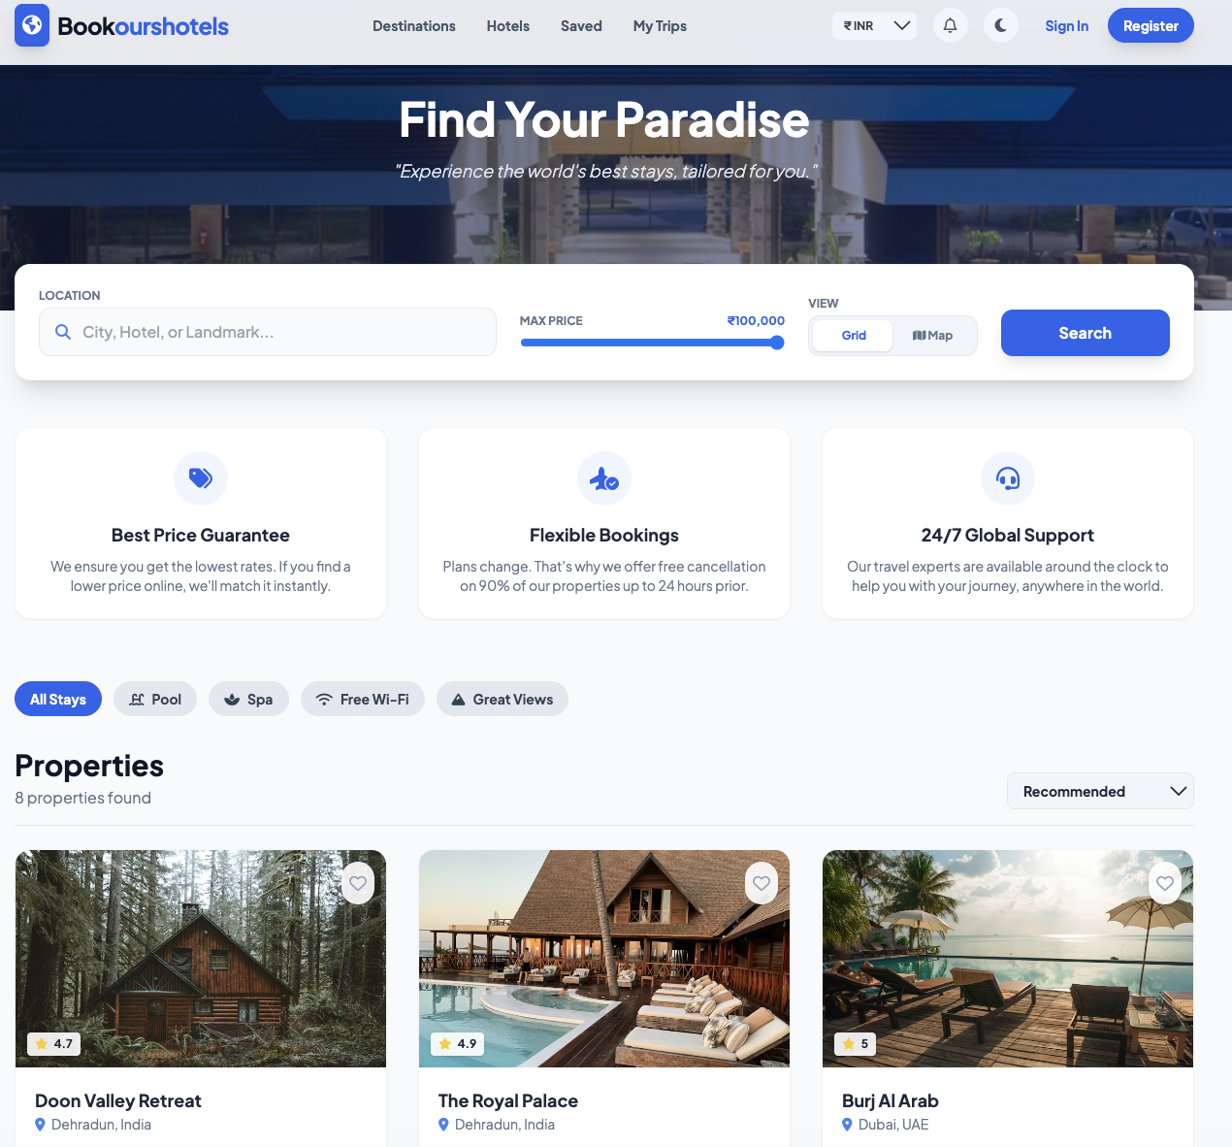
Front End

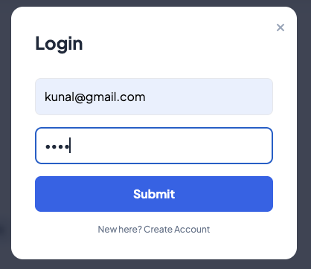
Login Page

<!DOCTYPE html>
<html lang="en" class="scroll-smooth">
<head>
<meta charset="UTF-8">
<meta name="viewport" content="width=device-width, initial-scale=1.0">
<title>BookOurHotel | Ultimate Travel Platform</title>

<script src="https://cdn.tailwindcss.com"></script>
<link href="https://cdnjs.cloudflare.com/ajax/libs/font-awesome/6.4.0/css/all.min.css" rel="stylesheet">
<link href="https://fonts.googleapis.com/css2?family=Plus+Jakarta+Sans:wght@300;400;500;600;700&display=swap" rel="stylesheet">
<link rel="stylesheet" href="https://unpkg.com/leaflet@1.9.4/dist/leaflet.css" />
<script src="https://cdn.jsdelivr.net/npm/canvas-confetti@1.6.0/dist/confetti.browser.min.js"></script>
<script src="https://cdn.jsdelivr.net/npm/chart.js"></script>
<script src="https://cdnjs.cloudflare.com/ajax/libs/jspdf/2.5.1/jspdf.umd.min.js"></script>

<link rel="stylesheet" href="https://cdn.jsdelivr.net/npm/flatpickr/dist/flatpickr.min.css">
<script src="https://cdn.jsdelivr.net/npm/flatpickr"></script>

<script>
tailwind.config = {
darkMode: 'class',
theme: {
extend: {
colors: {
brand: { 50: '#eff6ff', 100: '#dbeafe', 500: '#3b82f6', 600: '#2563eb', 700: '#1d4ed8', 900: '#1e3a8a' },
dark: { bg: '#0f172a', card: '#1e293b', text: '#f8fafc', muted: '#94a3b8' },
-style: none; scrollbar-width: none; }

.skeleton { background: #f6f7f8; background-image: linear-gradient(to right, #f6f7f8 0%, #edeef1 20%, #f6f7f8 40%, #f6f7f8 100%); background-repeat: no-repeat; background-size: 1000px 100%; animation: shimmer 1.5s infinite linear; }
.dark .skeleton { background: #1e293b; background-image: linear-gradient(to right, #1e293b 0%, #334155 20%, #1e293b 40%, #1e293b 100%); }

.admin-table th { @apply px-6 py-3 text-left text-xs font-medium text-slate-500 uppercase tracking-wider; }
.admin-table td { @apply px-6 py-4 whitespace-nowrap text-sm text-slate-500 dark:text-slate-300; }
.admin-table tr:hover { @apply bg-slate-50 dark:bg-slate-700/50; }

#modalMap { height: 100%; width: 100%; z-index: 1; }
#globalMap { height: 500px; width: 100%; z-index: 0; border-radius: 1rem; }
.pay-input { @apply w-full p-3.5 border border-slate-200 rounded-lg text-sm text-slate-700 outline-none focus:border-indigo-500 focus:ring-1 focus:ring-indigo-500 transition-all dark:bg-slate-900 dark:border-slate-700 dark:text-white; }
.pay-input:valid { border-color: #22c55e; }
.pay-input.error { border-color: #ef4444; animation: shake 0.4s cubic-bezier(.36,.07,.19,.97) both; }
@keyframes shake { 10%, 90% { transform: translate3d(-1px, 0, 0); } 20%, 80% { transform: translate3d(2px, 0, 0); } 30%, 50%, 70% { transform: translate3d(-4px, 0, 0); } 40%, 60% { transform: translate3d(4px, 0, 0); } }

.chat-message { @apply p-3 rounded-lg text-sm max-w-[85%] mb-2 animate-fade-in; }
enchange="app.sortHotels()" class="bg-slate-100 dark:bg-slate-800 px-3 py-2 rounded-lg text-sm font-bold outline-none cursor-pointer dark:text-white">
<option value="rec">Recommended</option>
<option value="price_asc">Price: Low to High</option>
<option value="price_desc">Price: High to Low</option>
<option value="rating_desc">Rating: High to Low</option>
</select>
</div>

<div id="hotelGrid" class="grid grid-cols-1 md:grid-cols-2 lg:grid-cols-3 gap-8"></div>
<div id="globalMapContainer" class="hidden animate-fade-in relative"><div id="globalMap"></div></div>
</div>
</main>

<footer class="bg-white dark:bg-[#1a1a1a] text-slate-800 dark:text-slate-200 py-12 border-t border-slate-200 dark:border-slate-800 transition-colors duration-300">
<div class="max-w-7xl mx-auto px-4 sm:px-6 lg:px-8">
<div class="grid grid-cols-1 md:grid-cols-4 lg:grid-cols-5 gap-8">
<div class="space-y-4">
<div>
<h5 class="font-bold mb-3">Company</h5>
<ul class="space-y-2 text-sm text-slate-500 dark:text-slate-400">
<li><a href="#" target="_blank" class="hover:text-brand-600 dark:hover:text-brand-400">About</a></li>
<li><a href="#" target="_blank" class="hover:text-brand-600 dark:hover:text-brand-400">Careers</a></li>
<li><a href="#" target="_blank" class="hover:text-brand-600 dark:hover:text-brand-400">Jobs</a></li>
</ul>
</div>
</div>
<div>
<h5 class="font-bold mb-3">Legal & Help</h5>
<ul class="space-y-2 text-sm text-slate-500 dark:text-slate-400">
<li><a href="#" target="_blank" class="hover:text-brand-600 dark:hover:text-brand-400">Terms and conditions</a></li>
<li><a href="#" target="_blank" class="hover:text-brand-600 dark:hover:text-brand-400">Privacy notice</a></li>
</ul>
</div>
<div class="lg:col-span-3">
<h5 class="font-bold text-lg mb-3">Get exclusive inspiration for your next stay – subscribe to our newsletter.</h5>
<form onsubmit="app.subscribe(event)" class="flex flex-col sm:flex-row gap-3">
<input type="email" id="newsEmail" required placeholder="Email address" class="flex-grow bg-transparent border-b-2 border-slate-300 dark:border-slate-600 py-2 px-1 text-sm outline-none focus:border-brand-500 transition">
<button class="bg-brand-600 text-white px-6 py-2 rounded font-bold hover:bg-brand-700 transition">Subscribe</button>
</form>
</div>
</div>
<div class="mt-12 pt-8 border-t border-slate-200 dark:border-slate-800 text-sm text-slate-500 dark:text-slate-400 flex flex-col md:flex-row justify-between items-center">
<p>Copyright 2026 bookourshotels | All rights reserved.</p>
</div>
</div>
</footer>

<button onclick="ui.toggleChat()" class="fixed bottom-6 right-6 bg-brand-600 text-white w-14 h-14 rounded-full shadow-lg hover:bg-brand-700 transition z-40 animate-bounce-in flex items-center justify-center">
<i class="fa-solid fa-comments text-2xl"></i>
</button>
<div id="chatWindow" class="fixed bottom-24 right-6 w-80 sm:w-96 bg-white dark:bg-slate-800 rounded-2xl shadow-2xl z-50 hidden flex-col border border-slate-200 dark:border-slate-700 overflow-hidden animate-slide-up origin-bottom-right">
<div class="bg-brand-600 text-white p-4 flex justify-between items-center">
<div class="font-bold flex items-center gap-2"><i class="fa-solid fa-robot"></i> Travel Assistant</div>
<button onclick="ui.toggleChat()" class="text-white/80 hover:text-white"><i class="fa-solid fa-xmark text-lg"></i></button>
</div>
<div id="chatBody" class="h-80 p-4 overflow-y-auto bg-slate-50 dark:bg-slate-900/50 flex flex-col gap-2"></div>
<div class="p-3 border-t border-slate-200 dark:border-slate-700 bg-white dark:bg-slate-800 flex gap-2">
<input type="text" id="chatInput" placeholder="Type a message..." class="flex-grow bg-slate-100 dark:bg-slate-900 text-sm p-2 rounded-lg outline-none dark:text-white border border-transparent focus:border-brand-500 transition-colors" onkeyup="if(event.key==='Enter') chatbot.handleText()">
<div id="modalAmenities" class="flex flex-wrap gap-2"></div>
</div>

<p id="modalDesc" class="text-sm text-slate-600 dark:text-slate-300 leading-relaxed mb-6"></p>

<div class="border-t border-slate-200 dark:border-slate-700 pt-6">
<div class="grid grid-cols-2 gap-4 mb-4">
<div>
<label class="text-[10px] font-bold uppercase text-slate-500">Check In</label>
<input type="text" id="dateIn" class="w-full bg-slate-100 dark:bg-slate-900 text-sm p-2 rounded-lg outline-none dark:text-white cursor-pointer" placeholder="Select Date">
</div>
<div>
<label class="text-[10px] font-bold uppercase text-slate-500">Check Out</label>
<input type="text" id="dateOut" class="w-full bg-slate-100 dark:bg-slate-900 text-sm p-2 rounded-lg outline-none dark:text-white cursor-pointer" placeholder="Select Date">
</div>
</div>
<button onclick="app.openPaymentModal()" class="w-full bg-brand-600 text-white py-3 rounded-xl font-bold hover:bg-brand-700 transition shadow-lg flex justify-between px-6 items-center"><span>Proceed to Pay</span><span id="totalPriceDisplay"></span></button>
</div>
</div>

<div class="hidden flex-grow relative min-h-[400px] w-full" id="viewMap">
<div id="modalMap" class="absolute inset-0"></div>
</div>
</div>
</div>

<div id="paymentModal" class="fixed inset-0 z-[100] hidden bg-black/60 backdrop-blur-sm flex items-center justify-center p-4">
<div class="flex flex-col md:flex-row bg-white dark:bg-slate-800 rounded-2xl shadow-2xl overflow-hidden max-w-4xl w-full animate-bounce-in">
<div class="md:w-5/12 bg-[#0B1120] text-white p-8 relative">
<h2 class="text-2xl font-bold mb-6">Trip Summary</h2>
<div class="bg-slate-800/50 p-4 rounded-xl border border-slate-700 flex gap-4 mb-6"><img id="payImg" src="" class="w-16 h-16 rounded-lg object-cover bg-slate-700"><div><h3 id="payHotel" class="font-bold text-sm">Hotel Name</h3><p id="payLoc" class="text-xs text-slate-400 mt-1">Location</p></div></div>
<div class="grid grid-cols-2 gap-4 mb-6">
<div class="bg-slate-800/50 p-3 rounded-lg border border-slate-700"><label class="text-[10px] font-bold text-slate-400 uppercase">Check In</label><p id="payIn" class="font-bold text-sm">--</p></div>
<div class="bg-slate-800/50 p-3 rounded-lg border border-slate-700"><label class="text-[10px] font-bold text-slate-400 uppercase">Check Out</label><p id="payOut" class="font-bold text-sm">--</p></div>
</div>
<div class="mb-8"><label class="text-[10px] font-bold text-slate-400 uppercase mb-2 block">Promo Code</label><div class="flex"><input type="text" id="promoInput" placeholder="LUX10" class="flex-grow bg-slate-800 border-none text-sm p-3 rounded-l-lg outline-none uppercase tracking-widest text-white placeholder-slate-600"><button type="button" onclick="app.applyPromo()" class="bg-indigo-600 text-white px-4 text-xs font-bold rounded-r-lg hover:bg-indigo-500 transition">APPLY</button></div><p id="promoMsg" class="text-[10px] text-green-400 mt-2 hidden">Discount applied!</p></div>
<div class="mt-auto space-y-3 pt-6 border-t border-slate-800"><div class="flex justify-between items-center pt-2"><span class="font-bold text-lg">Total</span><span id="payTotal" class="font-bold text-2xl text-white">0</span></div></div>
</div>

<div class="md:w-7/12 bg-white dark:bg-slate-900 p-8 relative">
<button onclick="ui.closeModal('paymentModal')" class="absolute top-6 right-6 text-slate-400 hover:text-slate-600"><i class="fa-solid fa-xmark text-xl"></i></button>
<div class="flex justify-between items-center mb-8"><h2 class="text-2xl font-bold text-slate-900 dark:text-white">Payment Details</h2><div class="flex items-center gap-2 bg-red-50 text-red-600 px-3 py-1 rounded-full text-xs font-bold border border-red-100"><i class="fa-regular fa-clock"></i> <span id="payTimer">05:00</span></div></div>

<form id="paymentForm" onsubmit="app.processPayment(event)" class="space-y-4" autocomplete="off">
<div class="grid grid-cols-2 gap-4">
<div>
<label class="block text-xs font-bold text-slate-500 uppercase mb-2">Cardholder Name</label>
<input type="text" required class="pay-input" placeholder="John Doe" autocomplete="off">
</div>
<div>
<label class="block text-xs font-bold text-slate-500 uppercase mb-2">Phone Number</label>
<input type="tel" id="payPhone" required pattern="[0-9]{10}" maxlength="10" placeholder="9876543210" class="pay-input" oninput="this.value = this.value.replace(/[^0-9]/g, '').substring(0,10)" title="Please enter valid 10 digit number" autocomplete="off">
</div>
</div>
<div>
<label class="block text-xs font-bold text-slate-500 uppercase mb-2">Card Number</label>
<div class="relative">
<input type="text" id="cardNum" required maxlength="19" placeholder="0000 0000 0000 0000" class="pay-input pr-10 font-mono" oninput="app.formatCard(this)" autocomplete="off">
<i class="fa-regular fa-credit-card absolute right-4 top-4 text-slate-400 text-lg"></i>
</div>
</div>

<div class="grid grid-cols-2 gap-6">
<div>
<label class="block text-xs font-bold text-slate-500 uppercase mb-2">Expiry (MM/YY)</label>
<input type="text" id="cardExp" required placeholder="MM/YY" maxlength="5" class="pay-input text-center" oninput="app.formatExpiry(this)" autocomplete="off">
</div>
<div>
<label class="block text-xs font-bold text-slate-500 uppercase mb-2">CVC</label>
<input type="password" id="cardCvc" required placeholder="123" maxlength="3" pattern="[0-9]{3}" class="pay-input text-center tracking-widest" title="3 digits only" autocomplete="new-password">
</div>
</div>
<button type="submit" id="payBtn" class="w-full bg-indigo-600 hover:bg-indigo-700 text-white font-bold py-4 rounded-xl text-lg shadow-xl shadow-indigo-200 transition transform hover:-translate-y-1">Pay Total</button>
</form>
</div>
</div>
</div>

<div id="profileModal" class="fixed inset-0 z-[90] hidden bg-slate-900/90 backdrop-blur-sm flex items-center justify-center p-4">
<div class="bg-white dark:bg-slate-800 w-full max-w-md rounded-2xl shadow-2xl p-8 relative animate-bounce-in">
<button onclick="ui.closeModal('profileModal')" class="absolute top-4 right-4 text-slate-400 hover:text-slate-600"><i class="fa-solid fa-xmark text-xl"></i></button>
<h2 class="text-2xl font-bold mb-6 dark:text-white">Edit Profile</h2>
<form onsubmit="app.updateProfile(event)" class="space-y-5">
<div>
<label class="block text-xs font-bold text-slate-500 dark:text-slate-400 uppercase mb-1">Full Name</label>
<input type="text" id="editProfName" required class="w-full p-3 rounded-lg bg-slate-50 dark:bg-slate-900 border border-slate-200 dark:border-slate-700 outline-none focus:border-brand-500 dark:text-white">
</div>
<div>
<label class="block text-xs font-bold text-slate-500 dark:text-slate-400 uppercase mb-1">Email Address</label>
<input type="email" id="editProfEmail" required class="w-full p-3 rounded-lg bg-slate-50 dark:bg-slate-900 border border-slate-200 dark:border-slate-700 outline-none focus:border-brand-500 dark:text-white" readonly>

const lower = msg.toLowerCase();
if(lower.includes('hello') || lower.includes('hi')) {
chatbot.addMessage("Hello! Ready to plan your next getaway?", false);
} else if(lower.includes('cancel') || lower.includes('refund')) {
chatbot.addMessage("To cancel a trip, click on 'My Trips' in the top menu.
</script>
</body>
</html>

BIBLIOGRAPHY
Book
1. Sommerville, Ian. Software Engineering. Pearson Education, 10th Edition, 2016.
2. Pressman, Roger S. Software Engineering: A Practitioner’s Approach. McGraw-Hill Education, 8th Edition, 2014
3. Connolly, Thomas M., and Carolyn E. Begg. Database Systems: A Practical Approach to Design, Implementation, and Management. Pearson, 6th Edition, 2015
4. Laudon, Kenneth C., and Jane P. Laudon. Management Information Systems: Managing the Digital Firm. Pearson, 15th Edition, 2018
5. Duckett, Jon. HTML and CSS: Design and Build Websites. John Wiley & Sons, 2011
Websites
6. BookOurHotels. Project Website and Documentation. Accessed in 2026
7. W3Schools. HTML, CSS, JavaScript, and PHP Tutorials. Accessed in 2026.
8. MDN Web Docs. Web Development Documentation. Accessed in 2026.
9. Stack Overflow. Community Discussions and Problem-Solving Support. Accessed in 2026.
10. Bootstrap. Official Documentation for Responsive Design and UI Components. Accessed in 2026.
11. JavaScript.com. JavaScript Fundamentals and Examples. Accessed in 2026.
Software Tool
12. Visual Studio Code. Used for coding and development.
13. XAMPP. Used for local server and database management.
14. MySQL. Used for database design and management.

