Spring-DATA-JPA(Quick example outputs)

Mendatory feature-getAllCountries

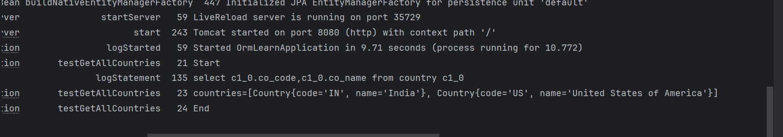

Additional features-

FindCountryByCode-



addCountry-

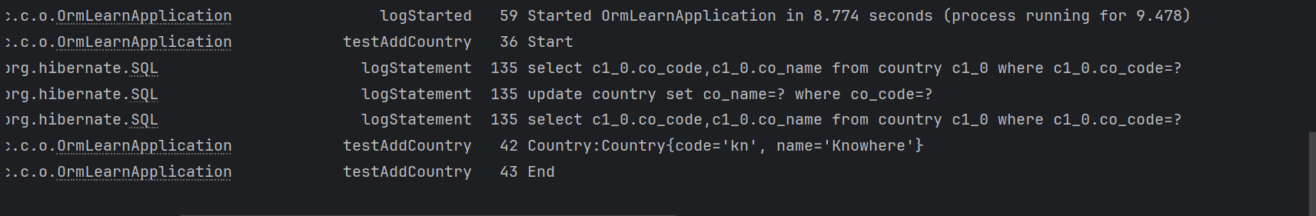

updateCountry-

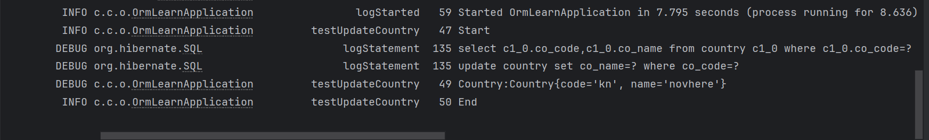

deleteCountry-

