Week-2

(JUnit)

**Exercise 1 -Setting up Junit**

**Pom.xml-**

<project xmlns="http://maven.apache.org/POM/4.0.0" xmlns:xsi="http://www.w3.org/2001/XMLSchema-instance"

xsi:schemaLocation="http://maven.apache.org/POM/4.0.0 http://maven.apache.org/xsd/maven-4.0.0.xsd">

<modelVersion>4.0.0</modelVersion>

<groupId>org.example</groupId>

<artifactId>Exercise-1-Setting_Up_JUnit</artifactId>

<version>1.0-SNAPSHOT</version>

<packaging>jar</packaging>

<name>Exercise-1-Setting_Up_JUnit</name>

<url>http://maven.apache.org</url>

<properties>

<project.build.sourceEncoding>UTF-8</project.build.sourceEncoding>

</properties>

<dependencies>

<dependency>

<groupId>junit</groupId>

<artifactId>junit</artifactId>

<version>4.13.2</version>

</dependency>

<dependency>

<groupId>org.junit.jupiter</groupId>

<artifactId>junit-jupiter</artifactId>

<version>RELEASE</version>

<scope>test</scope>

</dependency>

</dependencies>

</project>

src/main/java/org/example

App.java

package org.example;

/**

* Hello world!

*

*/

public class App

{

public static void main( String[] args )

{

System.out.println( "Hello World!" );

}

}

Calculator.java

package org.example;

public class Calculator {

public int add(int a, int b) {

return a + b;

}

}

src/test/java/org/example

AppTest.Java

package org.example;

import junit.framework.Test;

import junit.framework.TestCase;

import junit.framework.TestSuite;

/**

* Unit test for simple App.

*/

public class AppTest

extends TestCase

{

/**

* Create the test case

*

* @param testName name of the test case

*/

public AppTest( String testName )

{

super( testName );

}

/**

* @return the suite of tests being tested

*/

public static Test suite()

{

return new TestSuite( AppTest.class );

}

/**

* Rigourous Test :-)

*/

public void testApp()

{

assertTrue( true );

}

}

CalculatorTest.Java

package org.example;

import org.junit.jupiter.api.Test;

import static org.junit.jupiter.api.Assertions.assertEquals;

public class CalculatorTest {

// This is a test method

@Test

public void testAdd() {

Calculator calc = new Calculator();

int result = calc.add(2, 3);

// Assert that result is 5

assertEquals(5, result);

}

}

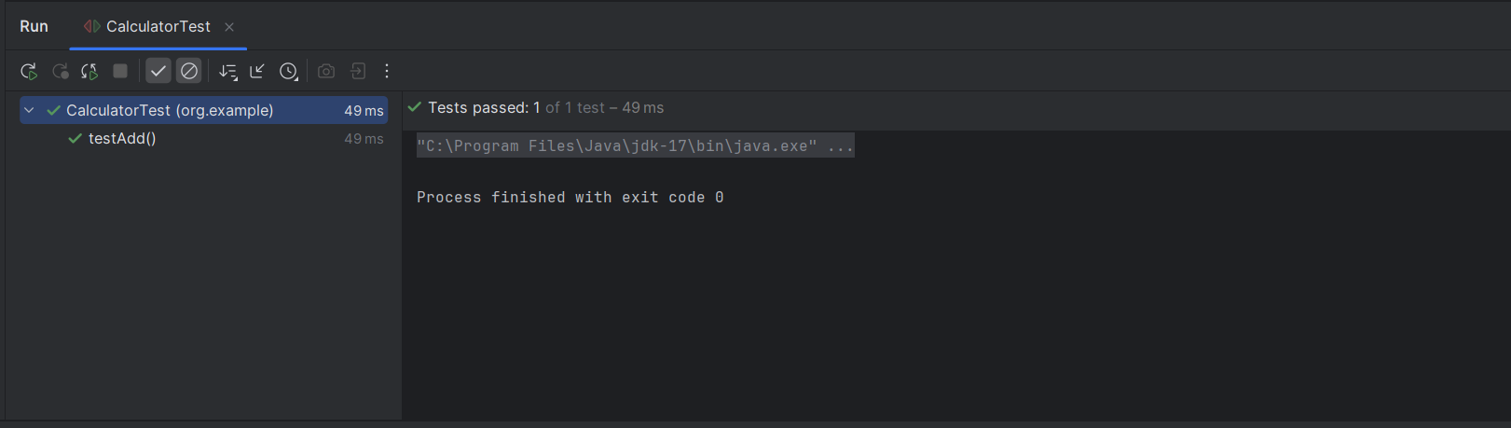

**Exercise 3 -Assertion in JUnit**

**Pom.xml**

<project xmlns="http://maven.apache.org/POM/4.0.0" xmlns:xsi="http://www.w3.org/2001/XMLSchema-instance"

xsi:schemaLocation="http://maven.apache.org/POM/4.0.0 http://maven.apache.org/xsd/maven-4.0.0.xsd">

<modelVersion>4.0.0</modelVersion>

<groupId>org.example</groupId>

<artifactId>Exercise-3-Assertions-in-jUnit</artifactId>

<version>1.0-SNAPSHOT</version>

<packaging>jar</packaging>

<name>Exercise-3-Assertions-in-jUnit</name>

<url>http://maven.apache.org</url>

<properties>

<project.build.sourceEncoding>UTF-8</project.build.sourceEncoding>

</properties>

<dependencies>

<dependency>

<groupId>junit</groupId>

<artifactId>junit</artifactId>

<version>3.8.1</version>

<scope>test</scope>

</dependency>

<dependency>

<groupId>org.junit.jupiter</groupId>

<artifactId>junit-jupiter</artifactId>

<version>RELEASE</version>

<scope>test</scope>

</dependency>

</dependencies>

</project>

src/main/java/org/example

App.Java

package org.example;

/**

* Hello world!

*

*/

public class App

{

public static void main( String[] args )

{

System.out.println( "Hello World!" );

}

}

src/test/java/org/example

AppTest.java

package org.example;

import junit.framework.Test;

import junit.framework.TestCase;

import junit.framework.TestSuite;

/**

* Unit test for simple App.

*/

public class AppTest

extends TestCase

{

/**

* Create the test case

*

* @param testName name of the test case

*/

public AppTest( String testName )

{

super( testName );

}

/**

* @return the suite of tests being tested

*/

public static Test suite()

{

return new TestSuite( AppTest.class );

}

/**

* Rigourous Test :-)

*/

public void testApp()

{

assertTrue( true );

}

}

AssertionsTest.java

package org.example;

import org.junit.jupiter.api.Test;

import static junit.framework.Assert.*;

public class AssertionsTest {

@Test

public void testAssertions() {

// Checks if the two values are equal

assertEquals(5, 2 + 3);

// Checks if the condition is true

assertTrue(5 > 3);

// Checks if the condition is false

assertFalse(5 < 3);

// Checks if the object is null

assertNull(null);

// Checks if the object is NOT null

assertNotNull(new Object());

}

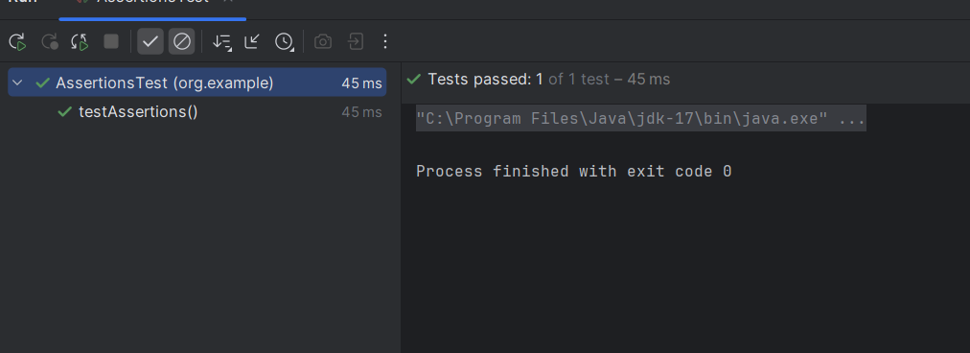}

**Exercise 4 -AAA Pattern**

**Pom.xml**

<project xmlns="http://maven.apache.org/POM/4.0.0" xmlns:xsi="http://www.w3.org/2001/XMLSchema-instance"

xsi:schemaLocation="http://maven.apache.org/POM/4.0.0 http://maven.apache.org/xsd/maven-4.0.0.xsd">

<modelVersion>4.0.0</modelVersion>

<groupId>org.example</groupId>

<artifactId>Exercise-4</artifactId>

<version>1.0-SNAPSHOT</version>

<packaging>jar</packaging>

<name>Exercise-4</name>

<url>http://maven.apache.org</url>

<properties>

<project.build.sourceEncoding>UTF-8</project.build.sourceEncoding>

</properties>

<dependencies>

<dependency>

<groupId>junit</groupId>

<artifactId>junit</artifactId>

<version>3.8.1</version>

<scope>test</scope>

</dependency>

<dependency>

<groupId>junit</groupId>

<artifactId>junit</artifactId>

<version>4.13.1</version>

<scope>test</scope>

</dependency>

</dependencies>

</project>

src/main/java/org/example

App.java

package org.example;

/**

* Hello world!

*

*/

public class App

{

public static void main( String[] args )

{

System.out.println( "Hello World!" );

}

}

Calculator.java

package org.example;

public class Calculator {

public int add(int a, int b) {

return a + b;

}

public int multiply(int a, int b) {

return a * b;

}

}

src/test/java/org/example

AppTest.java

package org.example;

import junit.framework.Test;

import junit.framework.TestCase;

import junit.framework.TestSuite;

/**

* Unit test for simple App.

*/

public class AppTest

extends TestCase

{

/**

* Create the test case

*

* @param testName name of the test case

*/

public AppTest( String testName )

{

super( testName );

}

/**

* @return the suite of tests being tested

*/

public static Test suite()

{

return new TestSuite( AppTest.class );

}

/**

* Rigourous Test :-)

*/

public void testApp()

{

assertTrue( true );

}

}

CalculatorTest.java

package org.example;

import org.junit.After;

import org.junit.Before;

import org.junit.Test;

import static junit.framework.Assert.assertEquals;

public class CalculatorTest {

private Calculator calculator; // Shared test object

// This runs before EACH test

@Before

public void setUp() {

calculator = new Calculator(); // Arrange: setup Calculator

System.out.println("Setup: Calculator instance created");

}

// This runs after EACH test

@After

public void tearDown() {

calculator = null; // Cleanup

System.out.println("Teardown: Calculator instance cleared");

}

// Test using AAA pattern

@Test

public void testAddition() {

// Arrange

int a = 10, b = 5;

// Act

int result = calculator.add(a, b);

// Assert

assertEquals(15, result);

}

// Another test

@Test

public void testMultiplication() {

// Arrange

int a = 4, b = 3;

// Act

int result = calculator.multiply(a, b);

// Assert

assertEquals(12, result);

}

}

