Week-2

(Mockito)

**Exercise 1 -Mocking and Stubbing**

**Pom.xml-**

<project xmlns="http://maven.apache.org/POM/4.0.0"

xmlns:xsi="http://www.w3.org/2001/XMLSchema-instance"

xsi:schemaLocation="http://maven.apache.org/POM/4.0.0 http://maven.apache.org/xsd/maven-4.0.0.xsd">

<modelVersion>4.0.0</modelVersion>

<groupId>org.example</groupId>

<artifactId>Exercise-1-Mocking-and-Stubbing</artifactId>

<version>1.0-SNAPSHOT</version>

<properties>

<maven.compiler.source>1.8</maven.compiler.source>

<maven.compiler.target>1.8</maven.compiler.target>

</properties>

<dependencies>

<!-- JUnit 5 -->

<dependency>

<groupId>org.junit.jupiter</groupId>

<artifactId>junit-jupiter</artifactId>

<version>5.10.0</version>

<scope>test</scope>

</dependency>

<!-- Mockito -->

<dependency>

<groupId>org.mockito</groupId>

<artifactId>mockito-core</artifactId>

<version>5.7.0</version>

<scope>test</scope>

</dependency>

</dependencies>

<build>

<plugins>

<!-- Required for JUnit 5 -->

<plugin>

<groupId>org.apache.maven.plugins</groupId>

<artifactId>maven-surefire-plugin</artifactId>

<version>3.0.0-M9</version>

</plugin>

</plugins>

</build>

</project>

src/main/java/com/example

ExternalApi.java

package com.example;

public interface ExternalApi {

String getData();

}

MyService.java

package com.example;

public class MyService {

private final ExternalApi api;

public MyService(ExternalApi api) {

this.api = api;

}

public String fetchData() {

return api.getData();

}

}

src/test/java/com/example

MyServiceTest.Java

package com.example;

public class MyService {

private final ExternalApi api;

public MyService(ExternalApi api) {

this.api = api;

}

public String fetchData() {

return api.getData();

}

}

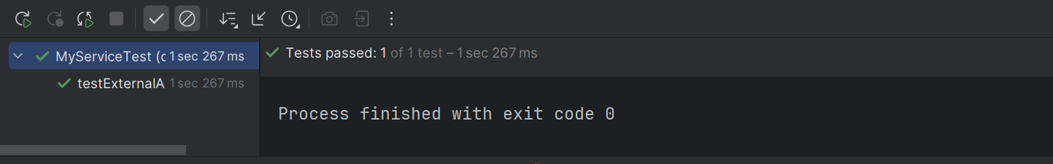

**Exercise 2 -Verifying Interactions**

**Pom.xml-**

<project xmlns="http://maven.apache.org/POM/4.0.0"

xmlns:xsi="http://www.w3.org/2001/XMLSchema-instance"

xsi:schemaLocation="http://maven.apache.org/POM/4.0.0 http://maven.apache.org/xsd/maven-4.0.0.xsd">

<modelVersion>4.0.0</modelVersion>

<groupId>org.example</groupId>

<artifactId>Exercise-2-Verifying-Interactions</artifactId>

<version>1.0-SNAPSHOT</version>

<properties>

<maven.compiler.source>1.8</maven.compiler.source>

<maven.compiler.target>1.8</maven.compiler.target>

</properties>

<dependencies>

<!-- JUnit 5 -->

<dependency>

<groupId>org.junit.jupiter</groupId>

<artifactId>junit-jupiter</artifactId>

<version>5.10.0</version>

<scope>test</scope>

</dependency>

<!-- Mockito -->

<dependency>

<groupId>org.mockito</groupId>

<artifactId>mockito-core</artifactId>

<version>5.7.0</version>

<scope>test</scope>

</dependency>

</dependencies>

<build>

<plugins>

<!-- Required for JUnit 5 -->

<plugin>

<groupId>org.apache.maven.plugins</groupId>

<artifactId>maven-surefire-plugin</artifactId>

<version>3.0.0-M9</version>

</plugin>

</plugins>

</build>

</project>

src/main/java/com/example

ExternalApi.java

package com.example;

public interface ExternalApi {

String getData();

}

MyService.java

package com.example;

public class MyService {

private final ExternalApi api;

public MyService(ExternalApi api) {

this.api = api;

}

public String fetchData() {

return api.getData();

}

}

src/test/java/com/example

MyServiceTest.Java

package com.example;

import static org.mockito.Mockito.*;

import org.junit.jupiter.api.Test;

import org.mockito.Mockito;

public class MyServiceTest {

@Test

public void testVerifyInteraction() {

// Arrange: create mock

ExternalApi mockApi = Mockito.mock(ExternalApi.class);

// Act: call method

MyService service = new MyService(mockApi);

service.fetchData();

// Assert: verify interaction

verify(mockApi).getData();

}

}

