

**INTERACTIVE SIMULATION ( PHASER )**

## **NUMBER LINE**

## ABOUT THE GAME

This is a Interactive Simulation template with application across grades 6-8, Learner will be able to perform operations and compare multiple types of numbers, including rational numbers. This simulation will act as a guided simulation to represent the numbers on a number line and understand the difference among different types of numbers.

**Game Play Rules –**

* Select the operation: Addition/ subtraction/ multiplication/ division.
* Select the number set (Fractions/ integers/ rational numbers/ whole numbers)
* Select the number to perform the operation.
* Add/subtract/multiply/divide a number suggested by the game. ​
* The learner must select the output number on the number line and if correct, the entire process is repeated for multiple operations.

### HOME PAGE

This page describes the name of the activity/game.

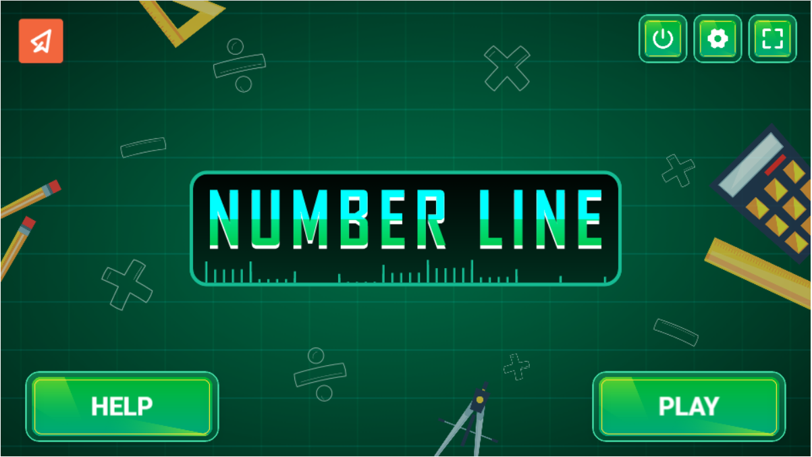

## **Buttons**

* Press here to Play: - 
* Press here for Help: - 
* Press here for full screen: - 
* Press here Quit: - 
* Press here for settings: - 

#### GAME PLAY SECTION

This page is main game play section of the activity/game.

* The learner will click on the operation to be performed.
* Select the number to be added and the Simulation suggests the second number.
* Learner is asked to perform the operation and provide the input.
* On correct answer, the process is repeated.

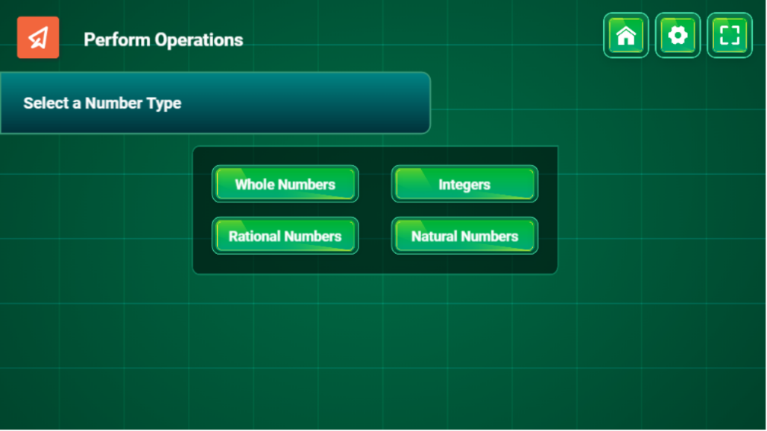

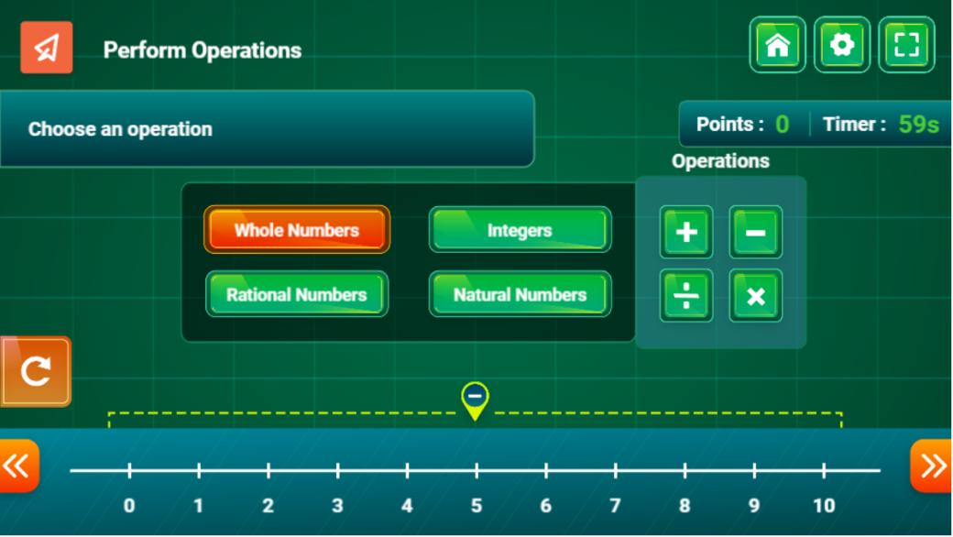

### Buttons in Game Play

* Press here for Whole Number: - A green and white sign

  Description automatically generated with low confidence
* Press here for Integer Number: - A green rectangle with white text

  Description automatically generated with medium confidence
* Press here for Rational Number: - A green and white sign

  Description automatically generated with low confidence
* Press here for Natural Number: - A picture containing text, green, player, container

  Description automatically generated
* Press here for Addition: - A picture containing text, first-aid kit

  Description automatically generated
* Press here for Subtraction: - Icon

  Description automatically generated
* Press here for Division: - Graphical user interface

  Description automatically generated
* Press here for Multiplication: - Icon

  Description automatically generated
* Press here to Reset Number Line: - Icon

  Description automatically generated
* Press here to see previous numbers: - Icon

  Description automatically generated
* Press here to see next Numbers: - Icon

  Description automatically generated
* Game Play Time: - A picture containing text, hitting

  Description automatically generated
* Game Play Score: - A picture containing text, ball, hitting, player

  Description automatically generated

### Result Section

This page shows the score and star rewards which was earned by the user.

### Buttons in Result

* Press here to Replay: - A picture containing text, sign

  Description automatically generated
* Press here to Quit :- Graphical user interface

  Description automatically generated

#### HELP PAGE

This page describes how to play the activity/game.

