ATOMA Pay Marketplace Platform

Architecture Overview for Stakeholders
Prepared for: ATOMA (ATOMA Pay)
Document version: 1.0
Status: Backend foundation implementation and client surfaces in phased delivery
____________________________________________________________

1. Executive Summary
This document describes the technical architecture of the platform, how it aligns with the six-month delivery roadmap, and how stakeholders should understand system boundaries, integrations, and deployment.
Attribute | Detail
Architecture style | Spring Boot monolith (single deployable backend)
Deployment target | ATOMA on-premise infrastructure
Client surfaces | 5 (Merchant Mobile, Merchant Web, Admin, Customer Web, Customer Mobile)
Shared backend | Single API, PostgreSQL database, unified JWT authentication
Compliance scope | DAB, EMI, AML/CFT hooks built into merchant onboarding and audit workflows
Current backend version | 0.1.0-SNAPSHOT

____________________________________________________________

2. Solution Context

2.1 Purpose
The marketplace enables:
- Merchants to onboard via mobile-first KYC/KYB, list products, manage orders, and receive automated settlements.
- Customers to browse, search, purchase via ATOMA Pay Wallet, track delivery, and request refunds.
- ATOMA operations teams to verify merchants, manage policies, resolve disputes, and monitor platform health.
- Agents (future surface integration) to support field onboarding and local operations.

2.2 Five Client Surfaces
All surfaces consume the same REST API. No surface maintains its own business data store.
# | Surface | Technology | Primary users | Backend API prefix
1a | Merchant Mobile App | React Native (Android & iOS) | Field merchants | /api/v1/merchant
1b | Merchant Web Portal | React.js | Merchant back-office staff | /api/v1/merchant
2 | Admin Portal | React.js | Operations, compliance, finance | /api/v1/admin
3 | Customer Marketplace Website | React.js | End customers (web) | /api/v1/catalog, /api/v1/customer
4 | Customer Mobile App | React Native (Android & iOS) | End customers (mobile) | /api/v1/customer

Shared authentication: All authenticated surfaces use JWT tokens issued by /api/v1/auth. A merchant who lists a product on mobile sees the same catalog on the customer website once admin approval completes.
____________________________________________________________

3. High-Level Architecture

3.1 Architecture Diagram
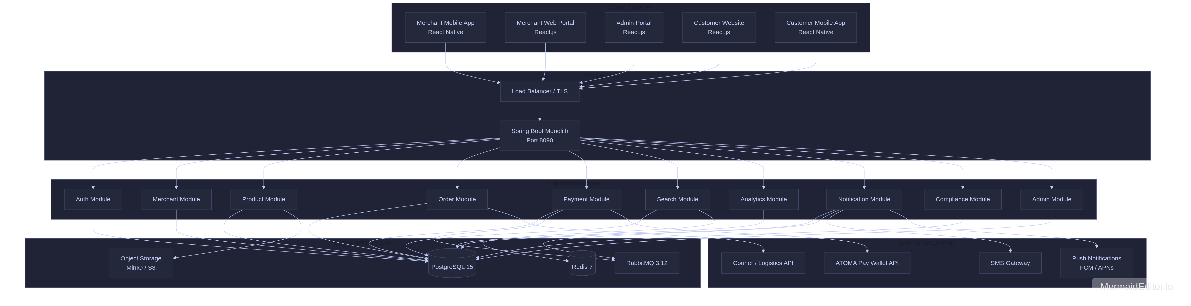

3.2 Design Principles
- Single source of truth — One PostgreSQL database; all surfaces read and write through the same API.
- Merchant-first sequencing — Backend and merchant APIs are built first to support field onboarding before customer go-live.
- Modular monolith — Business domains are separated into Java packages (not separate microservices), simplifying deployment and debugging while preserving clear boundaries.
- Compliance by design — KYC/KYB workflows, audit logs, and dispute handling are first-class modules, not afterthoughts.
- Integration-ready — External systems (wallet, courier, SMS) are accessed through dedicated client adapters with stub implementations for development.
____________________________________________________________

4. Technology Stack
Layer | Technology | Role
Backend runtime | Java 17, Spring Boot 3.4 | Core application server
Web framework | Spring Web, Spring Security | REST APIs, JWT auth, RBAC
Persistence | Spring Data JPA, Flyway | ORM and schema migrations
Primary database | PostgreSQL 15 | Transactional data (users, products, orders, payments)
Cache | Redis 7 | Search result caching, session/rate-limit support
Message queue | RabbitMQ 3.12 | Async notifications and event processing
Object storage | MinIO / S3-compatible | Product images, KYC documents
API documentation | OpenAPI 3 / Swagger UI | Interactive API docs at /swagger-ui.html
Health monitoring | Spring Actuator | /actuator/health, metrics
Mobile clients | React Native 0.73+ | Merchant and Customer mobile apps
Web clients | React.js 18+ | Merchant Web, Admin, Customer Website
Containerization | Docker Compose (dev) | Local PostgreSQL, Redis, RabbitMQ

____________________________________________________________

5. Application Module Breakdown
The backend will be organized into domain modules under Each module owns its entities, repositories, services, and (where applicable) REST controllers.
Module | Package | Responsibilities | Key endpoints
Auth | auth/ | Registration, login, JWT issuance, RBAC | POST /api/v1/auth/register, POST /api/v1/auth/login
Merchant | merchant/ | Onboarding, KYC/KYB, geo-tagging, merchant profile | POST /api/v1/merchant/onboard, POST /api/v1/merchant/kyc/documents
Product | product/ | Catalog CRUD, categories, reviews, admin approval | POST /api/v1/merchant/products, PUT /api/v1/admin/products/{id}/approve
Order | order/ | Cart, checkout, wishlist, fulfillment, refunds | POST /api/v1/customer/checkout, PUT /api/v1/merchant/orders/{id}/status
Payment | payment/ | Wallet checkout, escrow, settlement splits, retry | POST /api/v1/customer/orders/{id}/pay, POST .../pay/retry
Search | search/ | Product discovery, category filter, text search | GET /api/v1/catalog/products/search
Analytics | analytics/ | GMV dashboards, merchant KPIs | GET /api/v1/admin/analytics/dashboard
Notification | notification/ | In-app notifications for order/payment events | GET /api/v1/customer/notifications
Compliance | compliance/ | Disputes, audit logs | Dispute queue via Admin APIs
Admin | admin/ | Policies, category management, verification | GET /api/v1/admin/merchants, POST /api/v1/admin/policies
Catalog | catalog/ | Public, unauthenticated browse/search | GET /api/v1/catalog/products

5.1 Module Dependency Flow

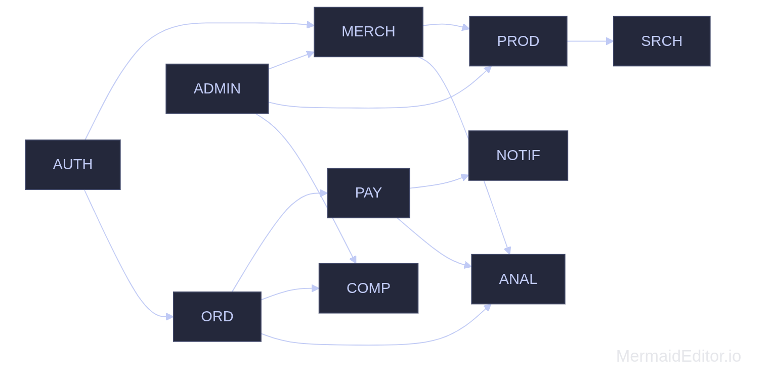

____________________________________________________________

6. API Surface Map
All APIs will be versioned under /api/v1. Swagger UI provides full request/response schemas for development and integration teams.

6.1 Public (no authentication required)
Method | Endpoint | Purpose
POST | /api/v1/auth/register | Register customer, merchant, or admin user
POST | /api/v1/auth/login | Obtain JWT access token
GET | /api/v1/catalog/** | Browse and search active products
GET | /api/v1/health | Platform health and metadata

6.2 Customer (role: CUSTOMER)
Method | Endpoint | Purpose
GET | /api/v1/customer/catalog/search | Authenticated product search
GET/POST/DELETE | /api/v1/customer/cart/** | Shopping cart management
POST | /api/v1/customer/checkout | Create order from cart
POST | /api/v1/customer/orders/{id}/pay | ATOMA Pay Wallet payment
POST | /api/v1/customer/orders/{id}/pay/retry | Retry failed payment (max 3 attempts)
POST | /api/v1/customer/orders/{id}/refund | Customer-initiated refund request
POST/DELETE | /api/v1/customer/wishlist/{productId} | Favorites / wishlist
GET | /api/v1/customer/orders | Order history
GET | /api/v1/customer/notifications | In-app notifications

6.3 Merchant (role: MERCHANT)
Method | Endpoint | Purpose
POST | /api/v1/merchant/onboard | Business profile and geo-location
POST | /api/v1/merchant/kyc/documents | Upload KYC/KYB documents
GET/POST/PUT | /api/v1/merchant/products/** | Product listing management
GET | /api/v1/merchant/orders | Incoming orders
PUT | /api/v1/merchant/orders/{id}/status | Accept, ship, deliver
GET | /api/v1/merchant/settlements | Payout and settlement history
GET | /api/v1/merchant/analytics/dashboard | Sales and inventory KPIs

6.4 Admin (role: ADMIN, SUPPORT)
Method | Endpoint | Purpose
GET | /api/v1/admin/merchants | Merchant verification queue
PUT | /api/v1/admin/merchants/{id}/verify | Approve/reject KYC
PUT | /api/v1/admin/products/{id}/approve | Approve product listings
POST/GET | /api/v1/admin/categories | Category taxonomy management
POST/GET | /api/v1/admin/policies | Platform policy configuration
GET/PUT | /api/v1/admin/disputes/** | Dispute resolution queue
GET | /api/v1/admin/audit-logs | Compliance audit trail
GET | /api/v1/admin/analytics/dashboard | Platform GMV and health metrics

____________________________________________________________

7. Security & Access Control

7.1 Authentication
- Mechanism: Stateless JWT (JSON Web Token) via Spring Security
- Token lifetime: 24 hours (configurable via atoma.security.jwt-expiration-ms)
- Password storage: BCrypt hashing
- Session model: Stateless — no server-side sessions; token validated on every request

7.2 Role-Based Access Control (RBAC)
Role | Access
CUSTOMER | Customer APIs, own cart/orders/wishlist
MERCHANT | Merchant APIs, own products/orders/settlements
ADMIN | Full admin APIs + merchant endpoints
SUPPORT | Admin APIs (operations/support staff)
AGENT | Reserved for field agent workflows (future)

7.3 Security Controls (Implemented / Planned)
Control | Status
JWT authentication on all protected routes | Implemented
Role-based endpoint authorization | Implemented
Public catalog without auth | Implemented
TLS 1.3 in transit | Planned (production load balancer)
AES-256 encryption at rest | Planned (PostgreSQL / storage)
Rate limiting at API gateway | Planned
Audit logging for admin actions | Implemented
MFA support (user flag) | Schema ready; UI integration planned

____________________________________________________________

8. Data Model Overview
The PostgreSQL schema (Flyway migration V1__init_schema.sql) defines the core entities. JPA entities in the codebase extend this model for orders, payments, disputes, and notifications.

8.1 Core Entities
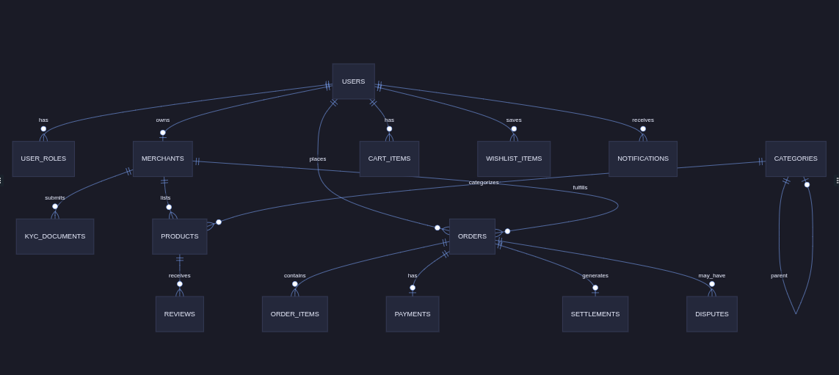

8.2 Key Entity Summary
Entity | Purpose
users | Unified accounts across all surfaces; email, phone, MFA flag
merchants | Business profile, KYC status, geo-location, commission rate
kyc_documents | Uploaded license, TIN, NIC, utility bills
categories | Multi-level taxonomy with per-category commission rates
products | Listings with SKU, pricing, stock, approval status
orders | Full lifecycle from placement through delivery/refund
payments | Wallet transactions, escrow hold, retry tracking
settlements | Platform commission vs. merchant net amount
disputes | Customer refund requests and admin resolution
audit_logs | Compliance trail for critical admin actions
platform_policies | Version-controlled operational rules
notifications | In-app alerts for order and payment events

8.3 Order Lifecycle
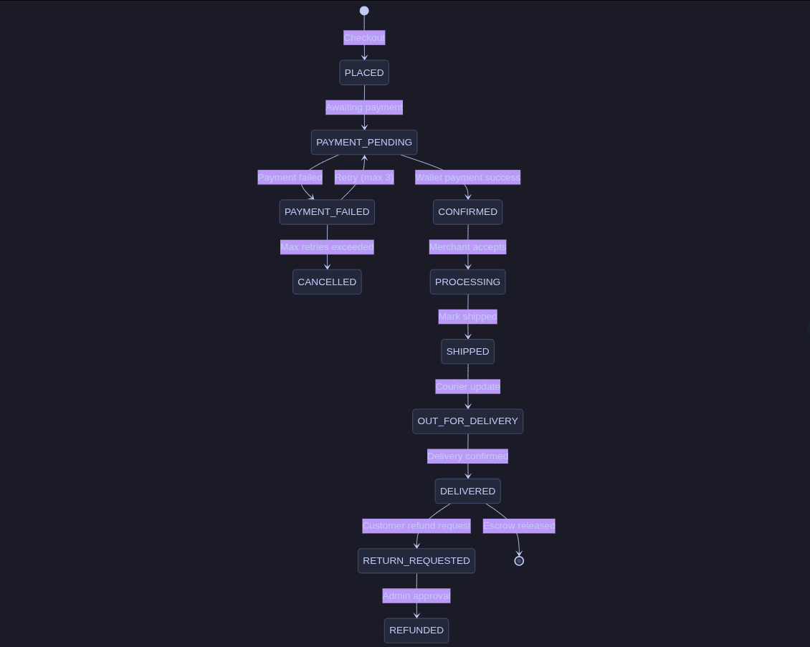

____________________________________________________________

9. Key Business Flows

9.1 Merchant Onboarding Flow
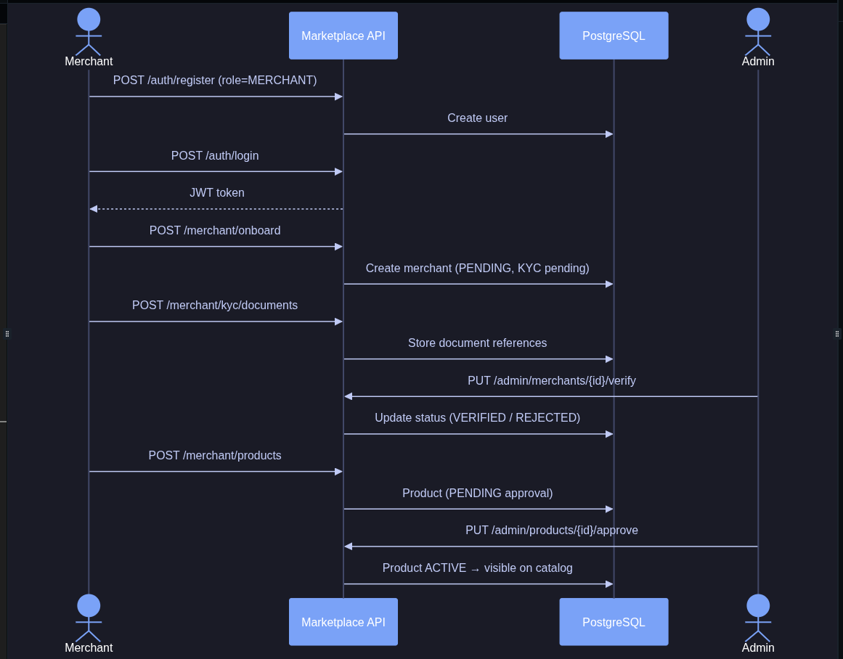

9.2 Customer Purchase Flow

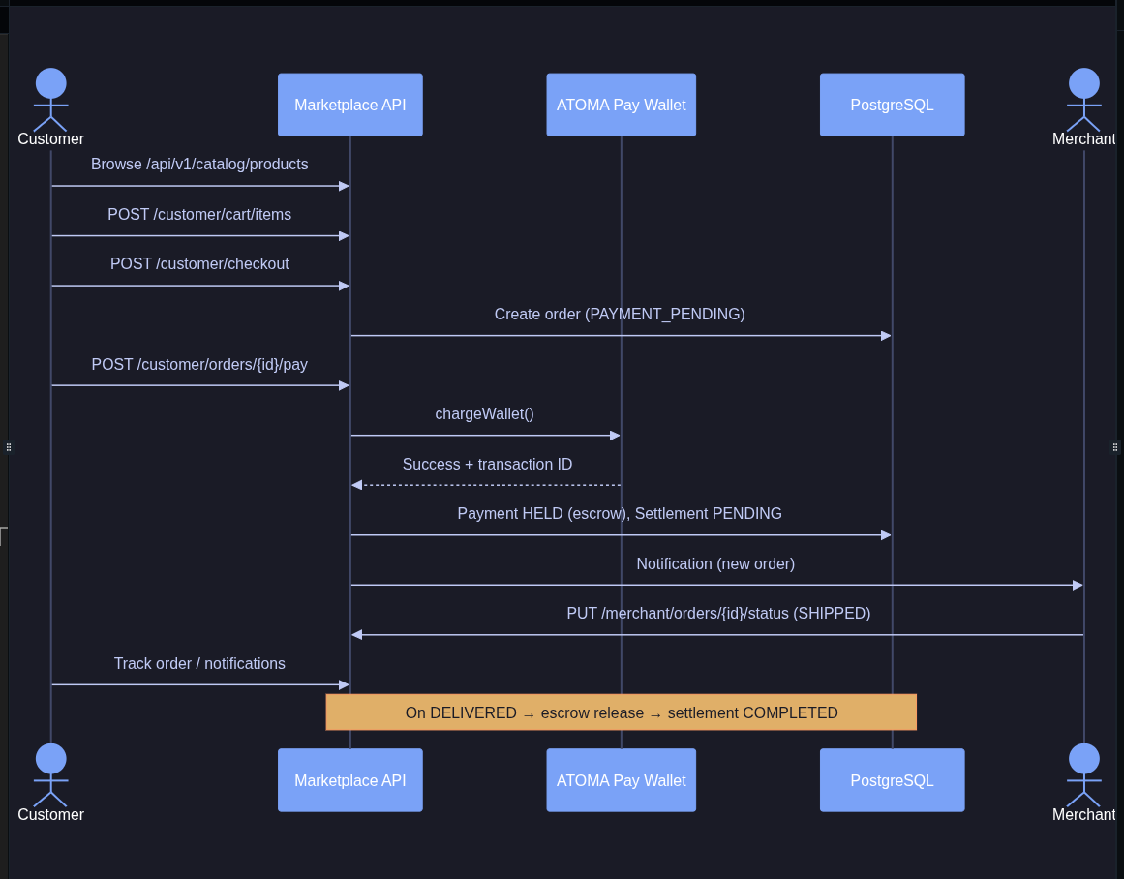

9.3 Payment & Settlement Logic
When a customer pays via ATOMA Pay Wallet:
- Charge — Funds are debited from the customer wallet and held in escrow.
- Split calculation — Platform commission (merchant-specific or category rate) is computed; merchant net amount is derived.
- Settlement record — A settlement entry is created with status PENDING until delivery confirmation.
- Escrow release — After delivery, escrow is released and settlement moves to COMPLETED.
- Retry logic — Failed payments allow up to 3 retry attempts before the order is cancelled and inventory is released.
____________________________________________________________

10. External Integrations
Integration | Purpose | Implementation status
ATOMA Pay Wallet | Checkout, escrow, refunds, auto-reversal | Stub client (AtomaWalletClient); real API wiring in Month 4–5
SMS Gateway | OTP and order alerts | Planned
Email (SMTP) | Receipts, KYC notifications | Planned
Push (FCM/APNs) | Mobile order alerts | Planned
Courier API | Tracking numbers, delivery status | Schema ready (trackingNumber, courierName on orders)
Object Storage | Product images, KYC documents | Planned (MinIO on-premise)

The wallet integration stub allows full end-to-end testing of order and settlement logic without live wallet credentials. Production go-live requires ATOMA to provide sandbox and production API access per the project dependency register.
____________________________________________________________

11. Deployment Architecture

11.1 Environments
Environment | Purpose | Database | Configuration profile
Development | Local developer machines | H2 in-memory (default) | dev
Staging / UAT | QA, integration testing, UAT | PostgreSQL + Redis + RabbitMQ | prod
Production | Live marketplace | PostgreSQL HA cluster + Redis + RabbitMQ | prod

11.2 Local Development Stack
# Start infrastructure
docker compose up -d # PostgreSQL, Redis, RabbitMQ
# Run application
./gradlew bootRun # dev profile (H2, port 8090)
./gradlew bootRun --args='--spring.profiles.active=prod' # with Docker services
[bash diagram / code block]

11.3 Production Topology (Target)
Per the infrastructure requirements document, production deployment on ATOMA on-premise infrastructure includes:
- 2× Application servers — Spring Boot monolith behind load balancer
- 3× PostgreSQL nodes — Primary + 2 read replicas
- 1× Redis server — Cache layer
- 2× RabbitMQ nodes — HA message queue
- 1× Object storage — MinIO (10 TB)
- 1× Load balancer — SSL termination, WAF
- Monitoring — Prometheus + Grafana + log aggregation
Web surfaces (Merchant Web, Admin, Customer Website) are deployed as static React builds served by Nginx on ATOMA's web server. Mobile apps are published to Google Play and Apple App Store under ATOMA developer accounts.

11.4 Configuration Reference
Property | Description | Default
JWT_SECRET | JWT signing key (required in production) | Dev default
DB_HOST, DB_PORT, DB_NAME | PostgreSQL connection | localhost:5432/atoma_marketplace
REDIS_HOST | Redis cache host | localhost
RABBITMQ_HOST | Message queue host | localhost
server.port | Application port | 8090

____________________________________________________________

12. Observability & Operations
Capability | Endpoint / Tool
Health check | GET /actuator/health
Platform metadata | GET /api/v1/health
API documentation | GET /swagger-ui.html
Metrics | GET /actuator/metrics (authorized)
Database migrations | Flyway (db/migration/V1__init_schema.sql)
Build & test | ./gradlew build / ./gradlew test

Operational runbooks for backup, disaster recovery, and incident response will be delivered during Month 6 handover per the project plan.
____________________________________________________________

13. Implementation Status

13.1 Backend Foundation

Area
Spring Boot monolith project structure
Auth module (register, login, JWT, RBAC)
Merchant onboarding and KYC document upload
Product catalog CRUD and admin approval
Category management
Shopping cart, checkout, wishlist
Order lifecycle and merchant fulfillment updates
Payment processing with escrow and settlement split
Payment retry logic (max 3 attempts)
Customer refund / dispute initiation
Admin merchant verification, disputes, policies, audit logs
Search and catalog browse
Admin and merchant analytics dashboards
In-app notification service
OpenAPI / Swagger documentation
Flyway database migration (core schema)
Docker Compose for PostgreSQL, Redis, RabbitMQ
Global exception handling and standardized API errors

____________________________________________________________

14. Alignment with Marketplace Requirements
This architecture directly supports the functional requirements defined in the ATOMA Pay Marketplace Requirements document:
Requirement area | Architecture support
Five-surface delivery model | Single API with role-scoped endpoints per surface
Merchant-first sequencing | Merchant and admin modules built before customer-facing integration
ATOMA Pay Wallet checkout | Payment module with escrow, retry, and settlement engine
KYC/KYB and DAB compliance | Merchant module + compliance audit logs + admin verification
Automated settlement splits | Payment module calculates commission and merchant net per order
Customer refund flow | Dispute module with admin resolution queue
Search and discovery | Search module with category and text query support
Platform policies | Admin module with version-controlled policy entities
Analytics and reporting | Analytics module with admin GMV and merchant KPI dashboards
99.9% uptime target | HA deployment topology (load-balanced app servers, DB replicas)

____________________________________________________________

15. Risks & Dependencies
Dependency | Owner | Impact if delayed
ATOMA Pay Wallet API access (sandbox + prod) | ATOMA | Blocks live payment testing and go-live
On-premise server provisioning | ATOMA | Blocks staging/UAT and production deployment
Google Play / App Store developer accounts | ATOMA | Blocks mobile app publication
Domain, DNS, TLS certificates | ATOMA | Blocks public website and API access
Courier API commercial agreement | ATOMA | Blocks live delivery tracking
Stakeholder availability for UAT sign-off | ATOMA | Blocks Month 6 go-live

____________________________________________________________

16. Appendix

A. Project Structure
atoma/
├── src/main/java/com/atoma/marketplace/
│ ├── auth/ # Authentication & JWT
│ ├── merchant/ # Merchant onboarding & operations
│ ├── product/ # Catalog & categories
│ ├── order/ # Cart, checkout, fulfillment
│ ├── payment/ # Wallet, escrow, settlement
│ ├── search/ # Product discovery
│ ├── analytics/ # Dashboards & KPIs
│ ├── notification/ # Alerts & messaging
│ ├── compliance/ # Disputes & audit logs
│ ├── admin/ # Platform administration
│ ├── catalog/ # Public catalog API
│ ├── customer/ # Customer-facing API controller
│ ├── common/ # Shared DTOs, enums, exceptions
│ └── config/ # Security, OpenAPI, JPA
├── src/main/resources/
│ ├── application.yaml
│ ├── application-dev.yaml
│ ├── application-prod.yaml
│ └── db/migration/ # Flyway SQL migrations
├── docker-compose.yml # PostgreSQL, Redis, RabbitMQ
├── build.gradle
└── README.md

B. User Roles
Role | Description
CUSTOMER | Marketplace buyer
MERCHANT | Seller / business owner
ADMIN | ATOMA platform administrator
SUPPORT | Customer support / operations staff
AGENT | Field agent (reserved)

C. Document References
- Marketplace Requirements Document (Ismat Tarin IT Services Company)
- Figma Design Preview: https://lever-framer-16237874.figma.site/
- API Documentation (runtime): /swagger-ui.html
____________________________________________________________
*This document reflects the architecture as implemented in the ATOMA Pay Marketplace backend codebase (v0.1.0-SNAPSHOT) and its alignment with the agreed six-month delivery plan. For technical integration details, refer to the OpenAPI specification served by the running application.*

