**CHICKEN 65 WINGS (INDIAN MASALA FRIED WINGS)**

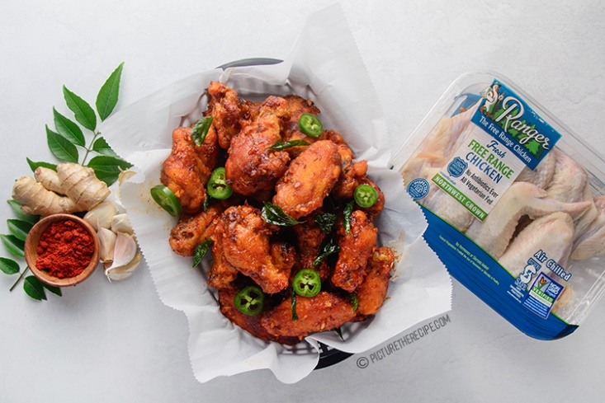

INGREDIENTS

1.• 2-3lbs Chicken Wings ( 24-30 wings)

2.• Oil for frying

YOGURT MARINADE FOR CHICKEN

1. • 1/4 cup Yogurt
2. • 2 tsp red chili powder (Kashmiri preferably)
3. • 1 tsp coriander powder
4. • ½ tsp garam masala
5. • 1 tsp grated fresh ginger
6. • 2 tsp grated fresh garlic
7. • 1/4 tsp black pepper
8. • Juice of 1/2 Lime

BREADING

1. • 1/2 cup rice flour (you can use A.P Flour instead)
2. • 1 cup cornstarch

FOR THE SAUCE

• 2 tbsp oil (use oil from the frying pot)

• 1/2 tsp cumin seeds

• 1 sprig of curry leaves

• 1 tbsp fresh garlic (finely minced)

• 1 tsp fresh ginger (finely mined)

• 1/2-1 tsp Kashmiri chilli powder

• 1-2 tbsp chilli paste/ (Sambal oelek/sriracha) {add more or less depending on your heat tolerance}

• 1 tbsp ketchup (optional)

• 2 tbsp water

• 1 jalapeno pepper (sliced for garnish)

INSTRUCTIONS

1.In a large mixing bowl add all the ingredients for the marinade mix it well.

2.Toss the chicken wings in the marinade and stir them around so that all the wings are coated well.

3.Cover, refrigerate and let the chicken marinate for at least a couple hours or even overnight.

4.About1.5 hrs before you want the serve the chicken, mix together the breading rice flour & cornstarch.

5.Dredge each one of the chicken wings individually in the breading without shaking off the marinade (it will help the breading stick to the chicken). And lay the dredged chicken wings on a sheet pan, not touching each other.

6.Then (optional step for extra crispy chicken!) place the sheet pan in the fridge, uncovered for about 45mins or so to dry out the breading.

7.Then take out the chicken about 15-20 minutes before frying while you prep the frying stage.

8. Heat frying oil about 2 inches deep in a heavy bottom pot or cast iron pan until it reaches 370F

9. Fry the chicken wings in small batches for about 8-10 minutes on medium- medium-high heat until crispy and golden and cooked all the way through. Drain on paper towels and set aside.

10.Once all the chicken wings are cooked, heat a skillet on high.

11. Add a couple tablespoons of the frying oil to the pan.

12. When the oil is hot, add the cumin seeds, and sauté for a minute. Then throw in the curry leaves and they will splutter and turn crisp in a minute or two.

13.Quickly add the minced garlic, ginger, chilli powder, chilli paste & ketchup and sauté for 1-2 minutes .

14. Finally, add 2 tsp of water. Remove from the heat and stir to combine. Add the sauce to the chicken and toss well to combine in a large bowl.

15. Garnish with sliced jalapeno peppers & serve hot.