🔹 Abstract
This project presents an analytical study of air pollution patterns in Delhi using hourly pollutant data. The objective is to understand temporal variation, identify major pollution contributors, and detect extreme pollution events. Using Python libraries such as Pandas, Matplotlib, and Seaborn, the dataset was cleaned, transformed, and visualized. PM2.5 was used as a proxy for AQI to evaluate air quality trends. The analysis reveals significant hourly variation and strong correlation among particulate pollutants. The findings provide useful insights for environmental monitoring and pollution control strategies.

🔹 Introduction
Air pollution in Delhi has become a major environmental and public health concern. The Air Quality Index (AQI) is widely used to communicate pollution levels and associated risks. Data visualization techniques enable effective understanding of pollutant behavior over time.
This study performs exploratory and statistical analysis on hourly air quality data of Delhi to uncover meaningful pollution patterns.

🔹 Objectives
- To preprocess and analyze Delhi air quality data
- To study temporal variation in pollution levels
- To identify dominant pollutants
- To detect extreme pollution events
- To examine statistical relationships among pollutants

The dataset contains 561 hourly observations of air pollutants in Delhi.
Features
- date (timestamp)
- co
- no
- no2
- o3
- so2
- pm2_5
- pm10
- nh3
Data Characteristics
- Frequency: Hourly
- Type: Numerical pollutant concentrations
- Missing values: None observed

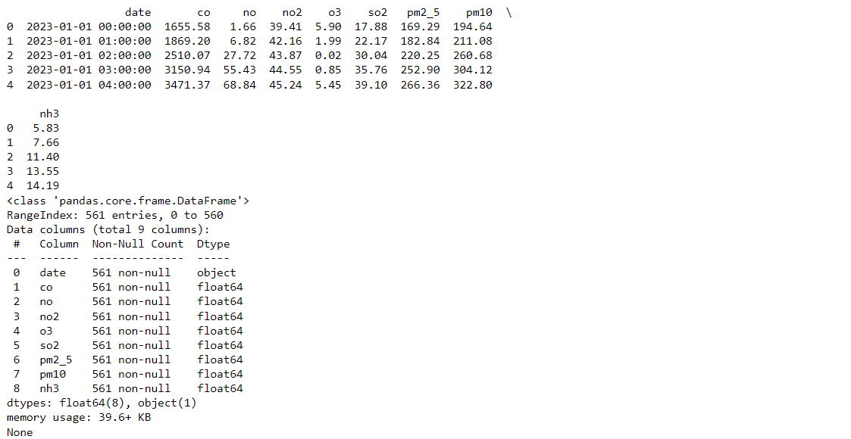

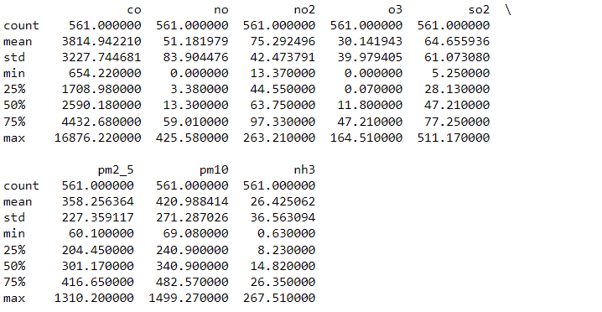
🔹 Exploratory Data Analysis
- AQI Trend Over Time

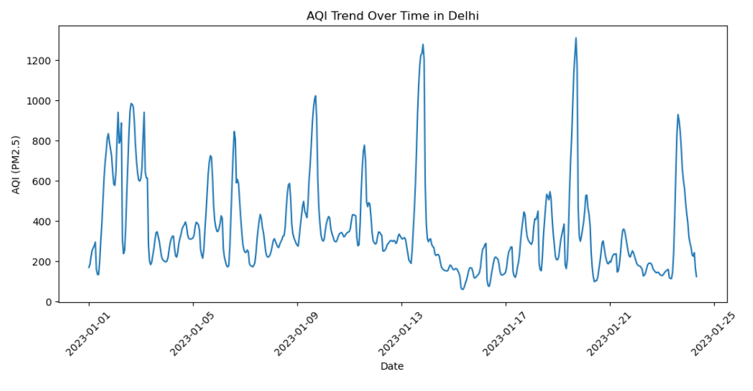
The time-series visualization indicates fluctuating air quality levels throughout the observed period. Several high pollution episodes are visible, suggesting intermittent pollution accumulation events.

- Hourly AQI Pattern
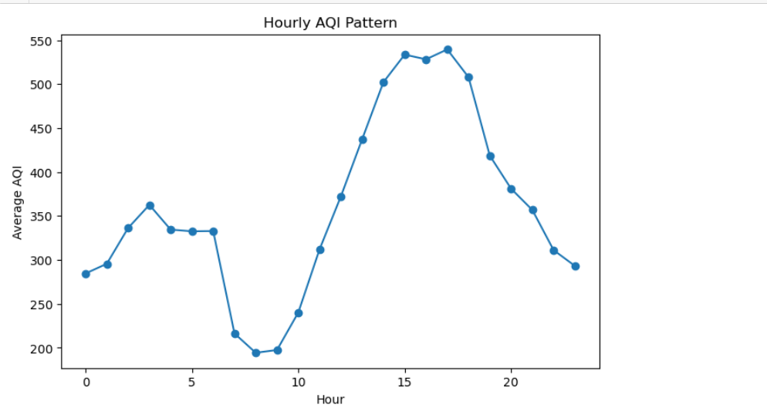

- Monthly Average AQI
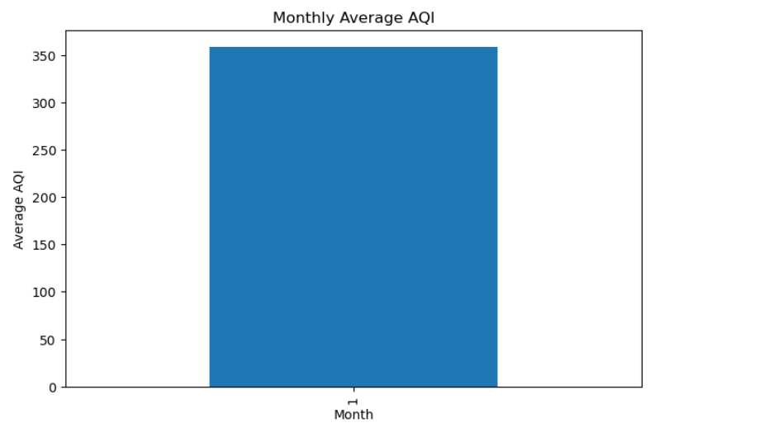
Monthly aggregation shows variation within the available time window. However, the dataset covers a limited temporal span, so full seasonal conclusions cannot be drawn.

- Pollutant Correlation Heatmap
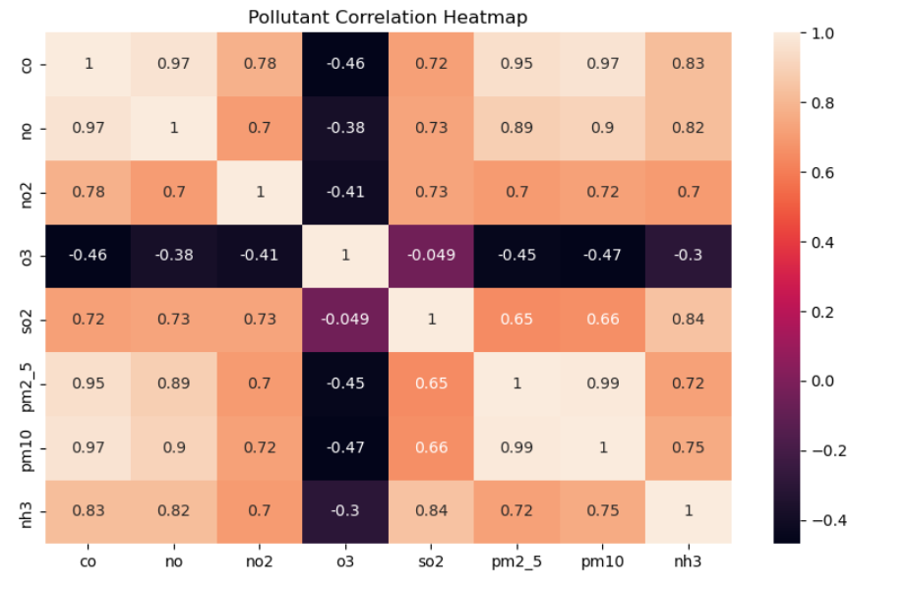
Strong positive correlation is observed between PM2.5 and PM10, indicating common emission sources such as vehicular pollution and road dust. Other gaseous pollutants show moderate relationships.

- Average Pollutant Levels
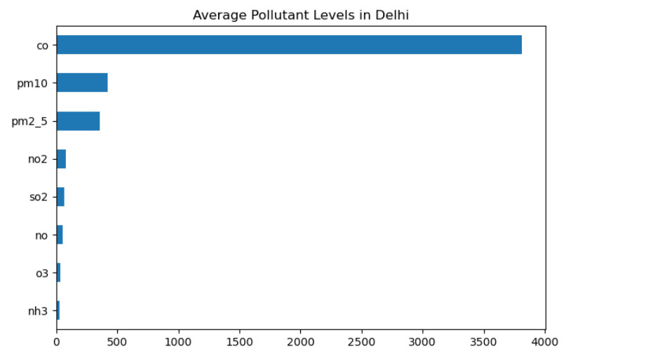
Particulate matter (PM2.5 and PM10) exhibits significantly higher average concentrations compared to other pollutants, suggesting that particulate pollution is the dominant contributor to poor air quality in Delhi.

- Seasonal Analysis
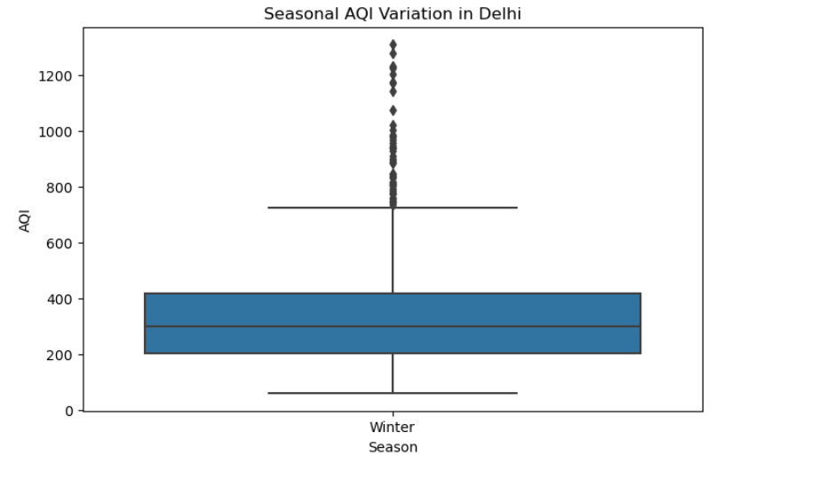
Seasonal boxplot visualization was generated; however, the dataset primarily contains winter-period data. Therefore, full seasonal comparison is limited.

- Extreme Pollution Events
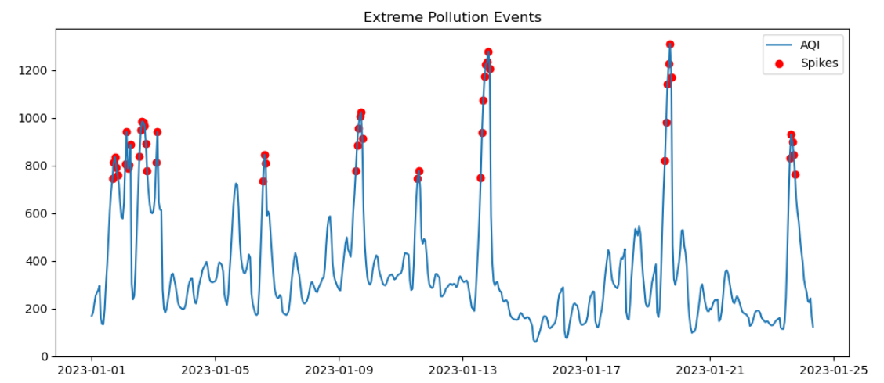
Using the Interquartile Range (IQR) method, several extreme pollution spikes were identified. These events represent periods of unusually high particulate concentration and may correspond to localized emission surges or unfavorable meteorological conditions.
AQI Distribution
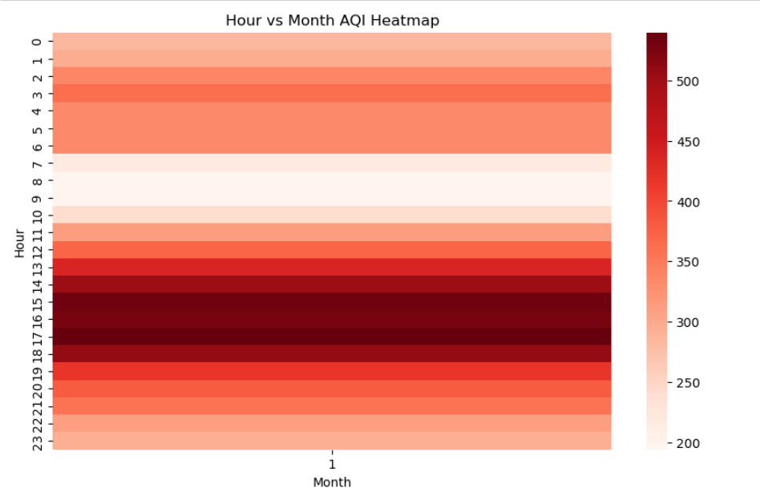
The AQI distribution appears right-skewed, indicating frequent occurrences of high pollution levels rather than a normal distribution.

🔹 Statistical Analysis
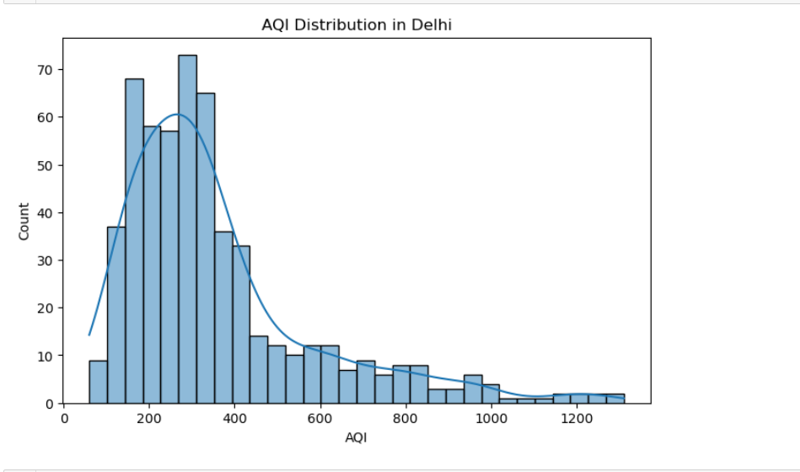
Correlation analysis confirms that PM2.5 has the strongest association with AQI, validating its use as a proxy indicator in this study.

- Seasonal ANOVA
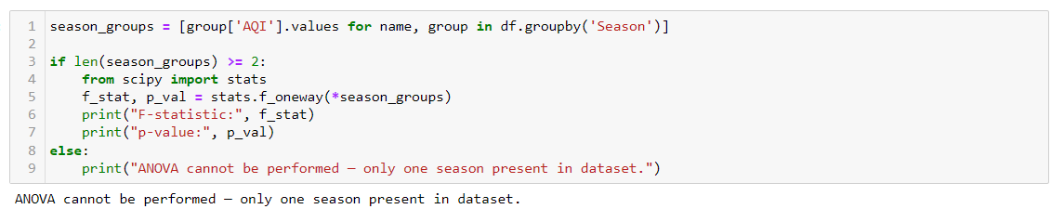
Seasonal ANOVA could not be meaningfully interpreted because the dataset predominantly contains observations from a single season. A full-year dataset would be required for statistically valid seasonal comparison.

- Hourly ANOVA
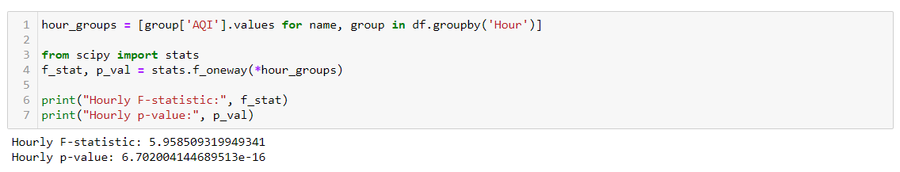
One-way ANOVA performed across hourly groups produced a statistically significant result (p < 0.05), indicating that AQI varies meaningfully across different hours of the day.

