|  |  |
| --- | --- |
| Program- B.Tech-3rd Semester | Type- Core |
| Course Code- CSET213 | Course Name-Linux and Shell Programming |
| Year- 2024 | Semester- Odd |
| Date- 29/07/2024 | Batch- NA |

**Lab Assignment 1.1**

**Objective**: Installation of Linux and its various distributions

**Problem1:** Install the Kali Linux on your machine as dual boot. Moreover, install Kali Linux on Virtual Machine.

**Outcomes:**

1. Understand different Linux distros.
2. Able to install any Linux flavor in dual boot with Windows.
3. Able to install Linux on Virtual Machine.

**About Linux:** Linuxis an open-source operating system used almost in all businesses. We have more three hundred versions of Linux, called distributions or distros. Each distro is developed for a specific need like for operating a web server, network switches etc. Let us know few of the distros:

The following Linux distributions have usually been around for a while and are well-established. They generally support several architectures and are translated into multiple languages. Some come from companies that supply service and support contracts for their products, others are community projects.

**Beginner-Friendly Distributions:**

1. **Ubuntu:** Known for its user-friendly interface and extensive community support, making it ideal for beginners.
2. **Linux Mint**: Based on Ubuntu, it offers a more traditional desktop experience and is also beginner-friendly.
3. **Fedora:** Known for its cutting-edge features and stability, making it a good choice for those wanting to explore new technologies.

**Intermediate to Advanced Distributions:**

1. Debian: The foundation for many other distributions, known for its stability and large repository of software packages.
2. Arch Linux: Ideal for those who want to learn more about the inner workings of Linux, as it requires manual setup and configuration.
3. openSUSE: Offers both rolling release (Tumbleweed) and regular release (Leap) versions, suitable for intermediate users.

**Specialized Distributions:**

1. Kali Linux: Designed for penetration testing and cybersecurity, a great choice for students interested in these fields.
2. CentOS/RHEL (Red Hat Enterprise Linux): Widely used in enterprise environments, making it a good choice for those looking to work in industry.
3. Manjaro: Based on Arch Linux but more user-friendly, offering a balance between usability and advanced features.
4. Gentoo: Known for its flexibility and performance optimization, suitable for those who want to customize their system extensively.

**Educational Distributions:**

1. Edubuntu: An official Ubuntu derivative designed for educational purposes, though it’s not actively developed anymore, it still provides educational software.
2. Ubuntu Studio: Aimed at creative professionals, it includes a suite of multimedia content creation applications.

**Lightweight Distributions:**

1. Lubuntu: A lightweight version of Ubuntu, suitable for older hardware or those who prefer a minimalistic desktop environment.
2. Xubuntu: Another lightweight Ubuntu variant, using the Xfce desktop environment, known for its speed and efficiency.

**Research and Development Focused Distributions:**

1. Scientific Linux: Based on RHEL, designed for scientific computing and research environments.
2. Debian Science: A blend of Debian tailored with scientific and engineering software packages.

These distributions offer a range of experiences from user-friendly to highly customizable, catering to various levels of expertise and specific interests within the field of technology and engineering.

* **Prerequisites to install Linux in dual boot system**

1. **Need the following things to easily and safely installing Linux along with Windows:**
2. A computer that comes preinstalled with Windows 10.
3. A USB key (pen drive or USB drive) of at least 4 GB in size and no data on it.
4. Internet connection (for downloading Kali ISO image and live USB creating tool). You can do this on any system, not necessarily on the system you are dual booting.

Optional: External USB disk for making back up of your existing data.

Optional: Windows recovery or bootable disk (if you encounter any major boot issues, it could be fixed).

* **Steps to install the Kali Linux:**

1. First, download Kali Linux latest version ISO file from the above-provided link. Download either 32 bit or 64 bit, that’s your choice.

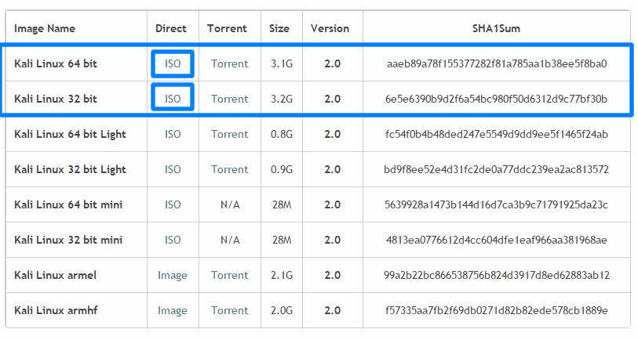

1. After downloading Kali Linux the next step is the creation of a bootable USB. For that, we need Rufus – a utility that helps to create bootable USB flash drives. So download it from the above link and install it.
2. Let’s start making a bootable USB. First, connect your USB drive. As already said we need a minimum 4GB memory pen drive. Now run Rufus and follow steps to create a bootable USB.
3. Now you get a screen like the below image.

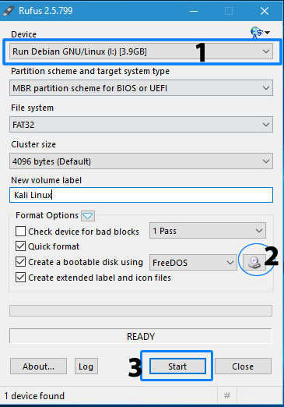

1. First, check your USB drive is selected. Then click the small CD drive icon below (2) and locate the Kali Linux iso file that you downloaded from Kali official website. And finally, click “Start” and wait for the process to complete.
2. After process completion, c­­­lick the close button to exit from the Rufus window and yes, here is your Kali Linux bootable USB drive. Other than dual booting Kali Linux with Windows, you can also use this bootable USB to live boot Kali — means run Kali without installing it but with some limited features and functions.
3. Next, we are going to create a separate partition for the Kali Linux installation. So open your Disk Management settings or Run “diskmgmt.msc” command in Windows. Create a new partition of size about 15-20GB minimum by shrinking an existing volume. Here we created a new partition of size 17GB.

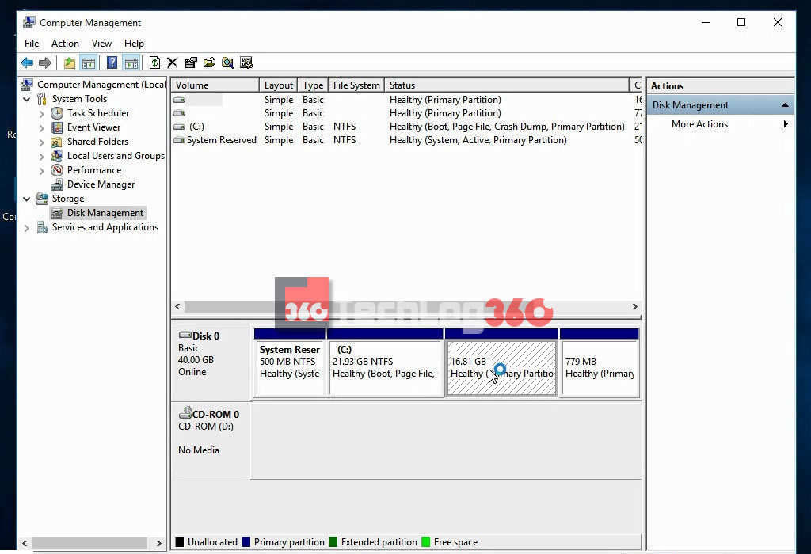

1. Initial processes are all done. Downloaded Kali Linux ISO, created a bootable USB drive and created a separate partition for Kali Linux installation. Before going on keep in mind always Disable Secure Boot and Fast Boot option in BIOS. Now restart your PC/Laptop and go to boot manager and select the option boot as USB [Options will be different for different brands]. Now you will see the installation window of Kali Linux. There are different options to install Kali Linux. Here you have to choose “Graphical Install” to start with ease.

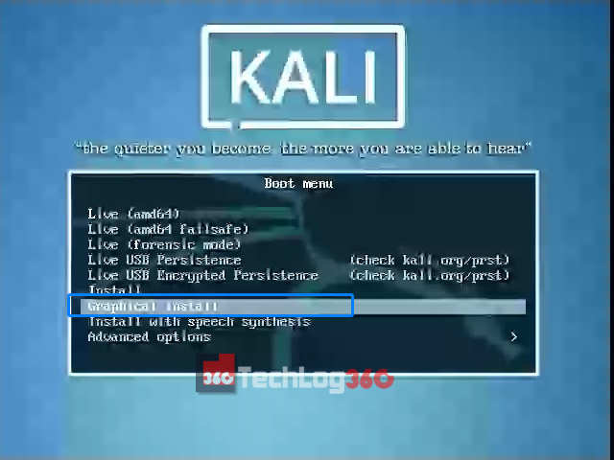

1. Choose the language to be used for the installation process. And press “Continue”.

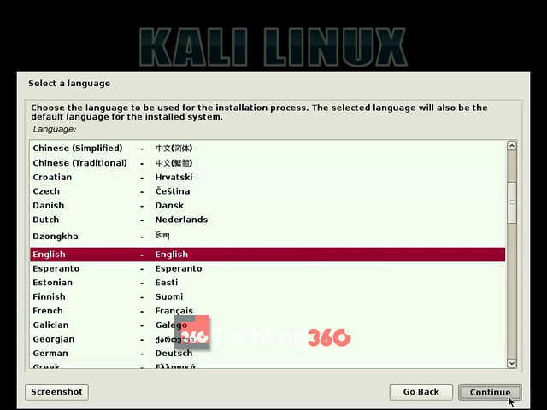

1. Choose your country and continue the installation process.

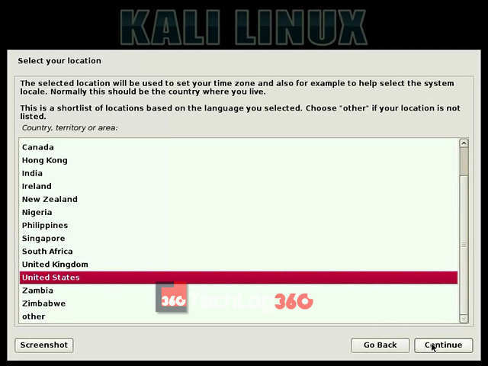

1. Next set type of keyboard layout. Here I choose “American English”.

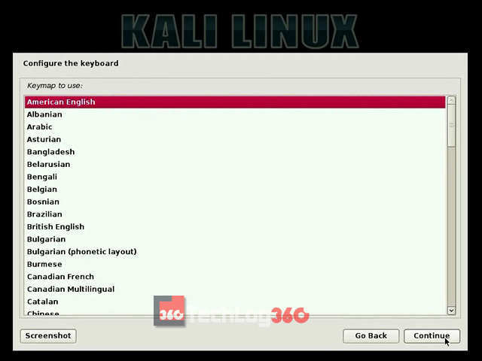

1. Next step set IP configurations. You can configure your network automatically or manually.

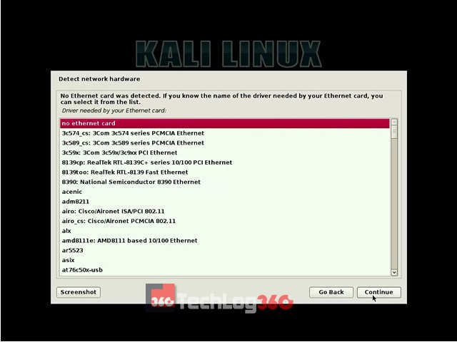

1. Now the installation will ask for a Hostname. Set any name you want. It’s kinda like a username.

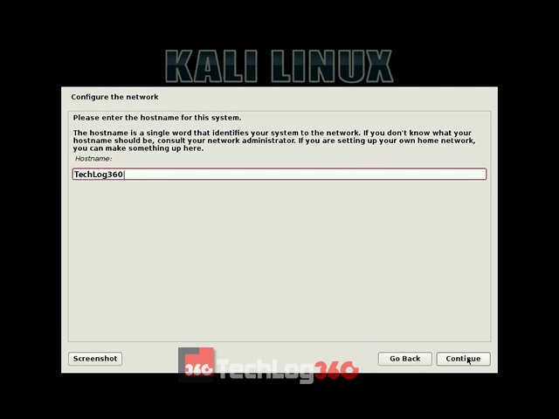

1. In this step, you have to enter a password for “root user “. After entering the administrative account password click “Continue”.

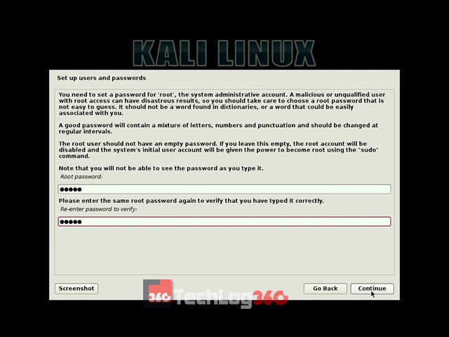

1. Next, choose the partitioning method as “Manual“.

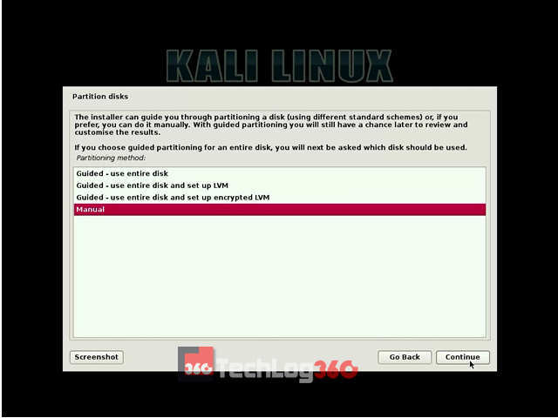

1. Carefully do this step. Only choose the partition that we created earlier for Kali installation and press “Continue”.

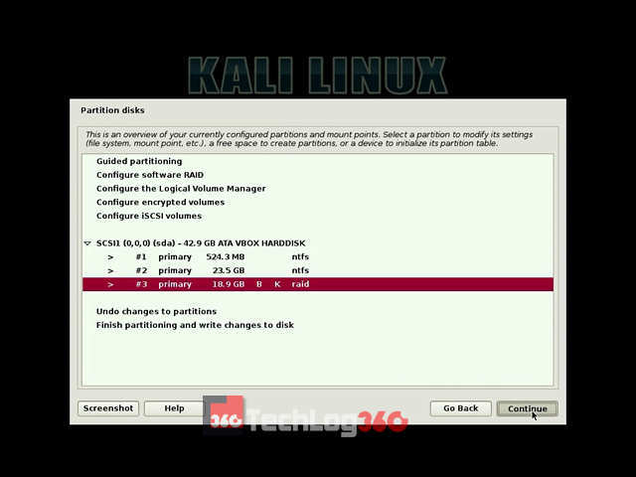

1. Then select the option “Delete the partition” and hit “Continue”.

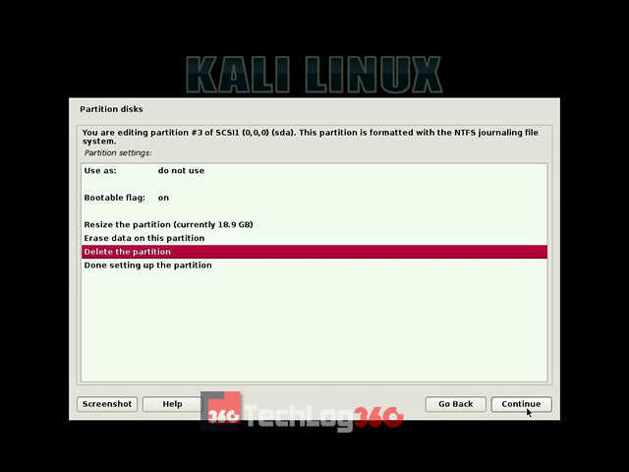

1. After the above step, now you can see that your Kali installation partition is now shown as “FREE SPACE“. Choose that free space partition and “Continue”.

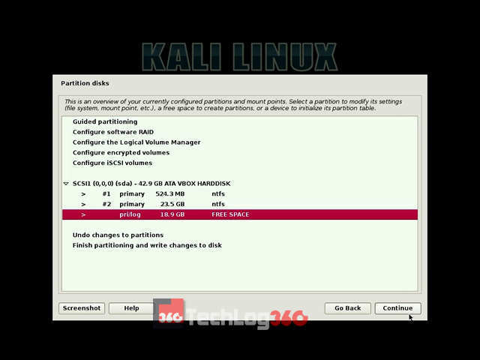

1. Now, it will ask us how to use those free space. Select the option “Automatically partition the free space” and “Continue” the process.

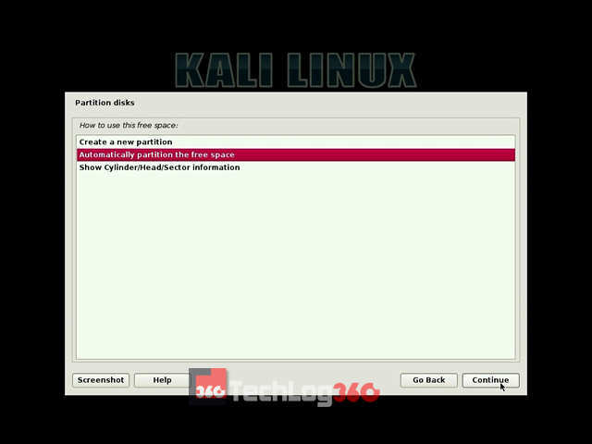

1. Next, choose the option “All files in one partition” that is recommended for new users and press “Continue”.

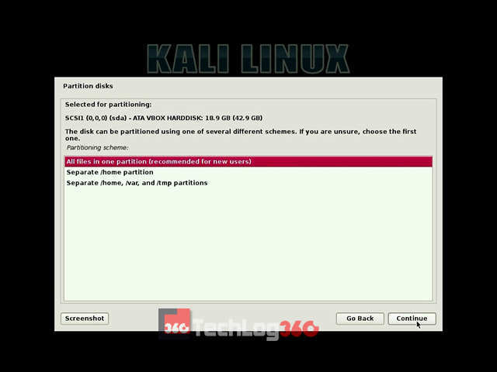

1. Finally, select the option “Finish partitioning and write changes to disk’’.

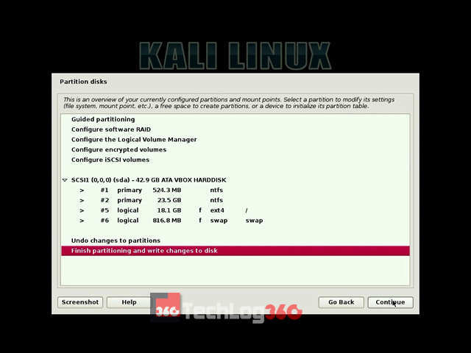

1. Here, it will ask permission to write changes in the disk. Choose “Yes” and “Continue”.

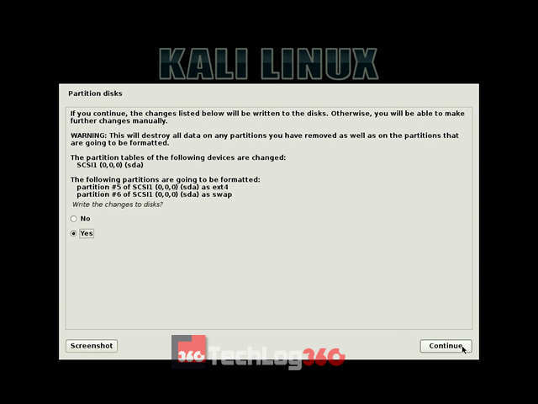

Now the Kali will start the installation process. Wait 10-15 minutes to complete the installation.

1. In the middle of the installation, it will ask for the network mirror, choose “Yes” or “No”. This setting is about an update option. So we recommended you to choose “No” now. You can later enable it.

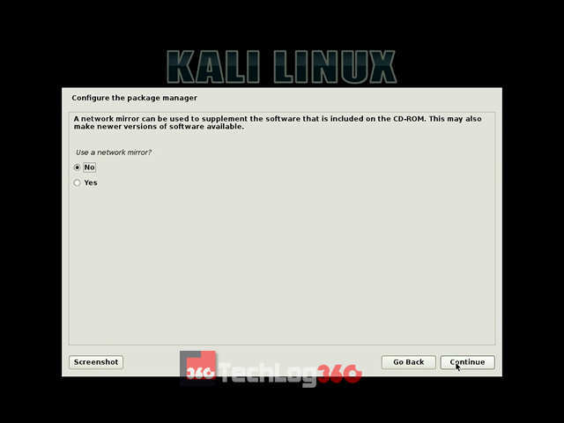

1. Next, it will ask for installing GRUB boot loader, choose “Yes” and “Continue”.

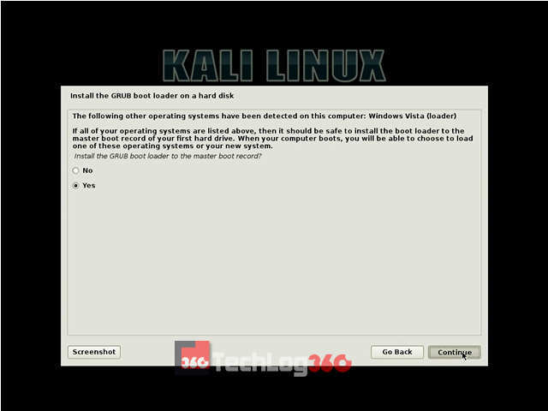

1. Next, it will ask where to install Kali GRUB boot loader. Choose your hard disk, second option. Remember only choose your hard disk to install GRUB. Otherwise, after the installation of Kali Linux, your system will not display the option to choose the operating systems on startup.

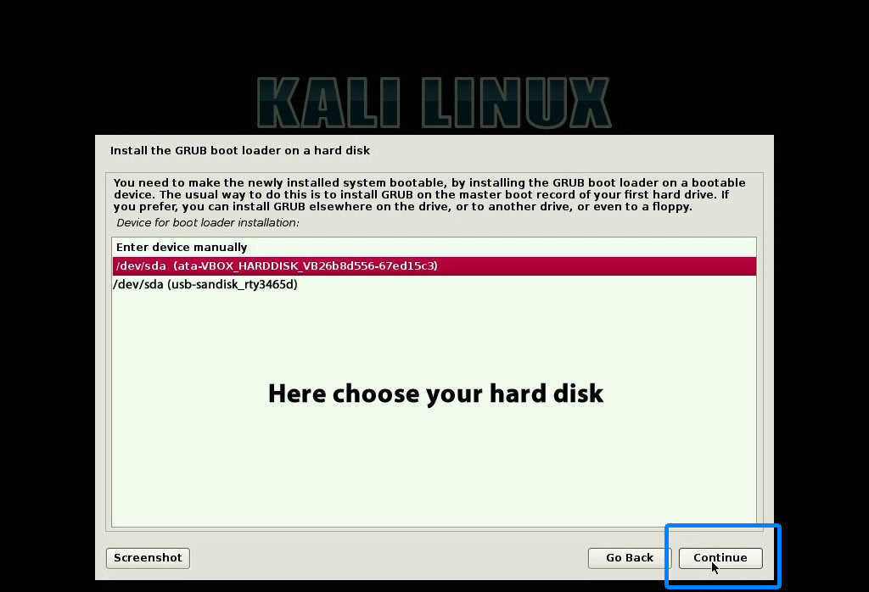

1. After the successful completion of the installation process, now you can see a screen similar to the below screenshot. Choose “Continue”.

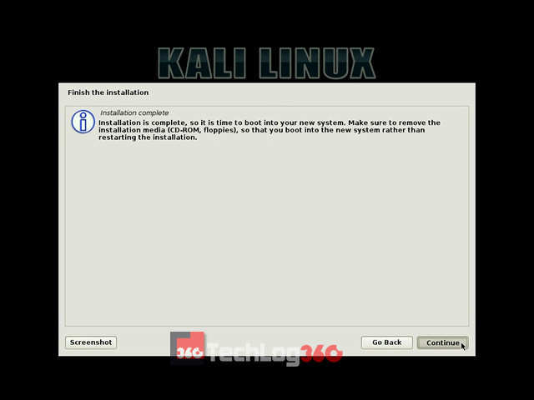

1. Now eject USB drive and restart your system. During startup you can see the GRUB Loader of Kali Linux. Here you can choose “Kali GNU/Linux” to boot your PC/Laptop with the new Kali Linux or else choose “Windows Recovery Environment” to boot into Windows

* **Steps to install the Kali Linux on VirtualBox:**

1. Download and install VirtualBox: The first thing you need to do is to download and install VirtualBox from Oracle’s official website. Once you download the installer, just double click on it to install VirtualBox. It’s the same for installing VirtualBox on Ubuntu/Fedora Linux as well.
2. Download ready-to-use virtual image of Kali Linux: After installing it successfully, head to Offensive Security’s download page to download the VM image for VirtualBox.

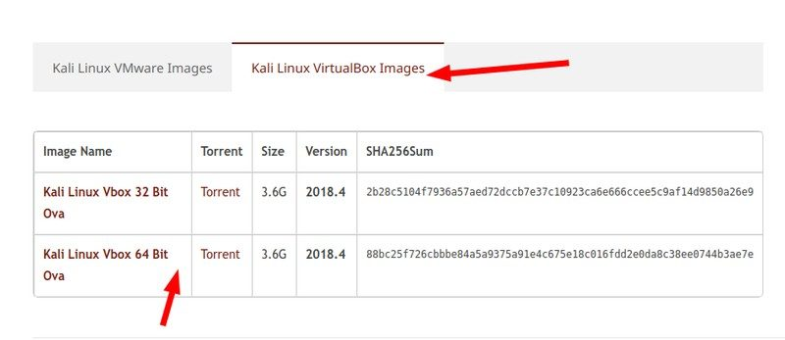

1. Install Kali Linux on Virtual Box: Once you have installed VirtualBox and downloaded the Kali Linux image, you just need to import it to VirtualBox in order to make it work.
2. Step 1: Launch VirtualBox. You will notice an Import button – click on it

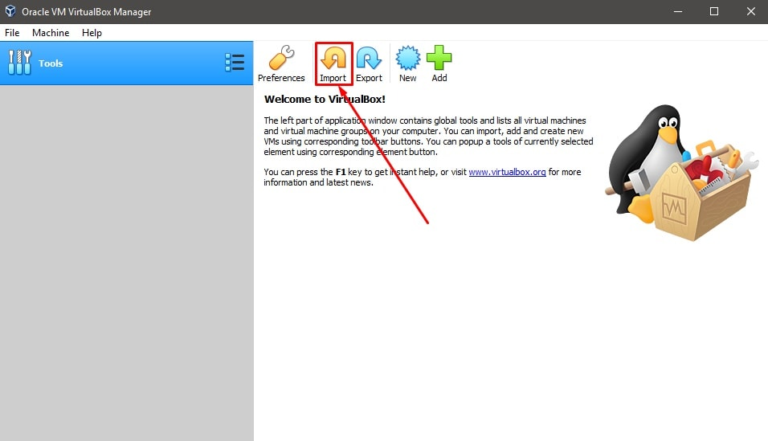

1. Step 2: Next, browse the file you just downloaded and choose it to be imported (as you can see in the image below). The file name should start with ‘kali linux‘ and end with .ova extension. So once selected, proceed by clicking on Next.

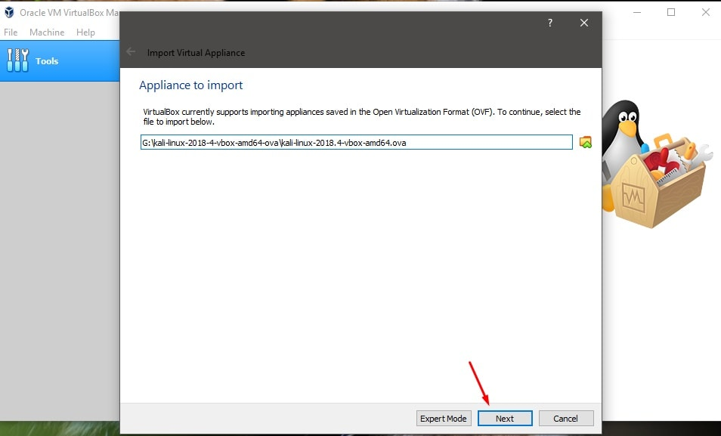

1. Step 3: Now, you will be shown the settings for the virtual machine you are about to import. So, you can customize them or not – that is your choice. It is okay if you go with the default settings. You need to select a path where you have sufficient storage available. It is recommended not to install on C: drive on Windows.

Here, the hard drives as VDI refer to virtually mount the hard drives by allocating the storage space set. After you are done with the settings, hit Import and wait for a while.

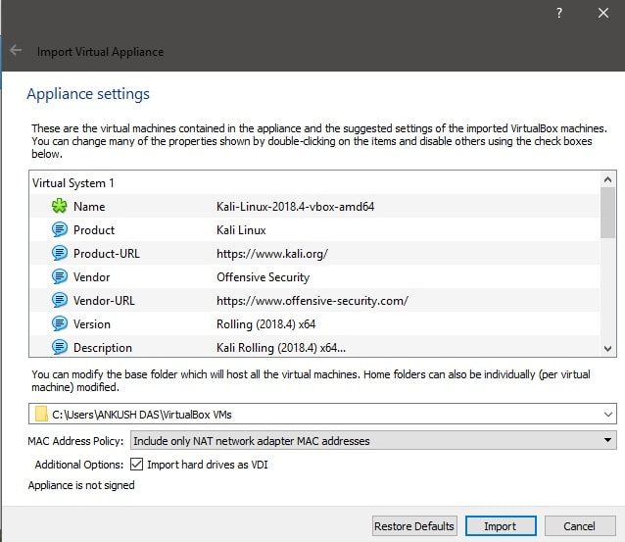

Step 4: You will now see it listed. So, just hit Start to launch it. The default account and password both are kali.

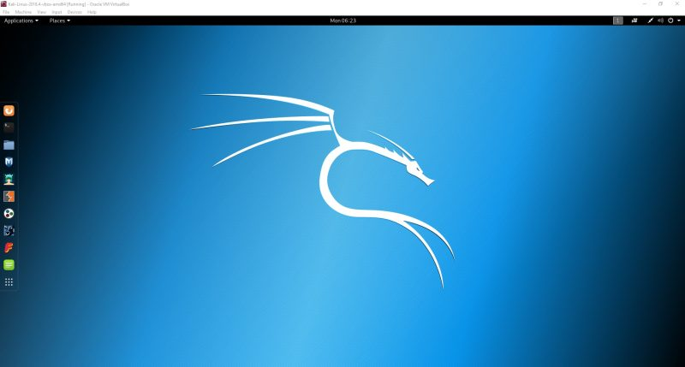

**References:**

1. [www.myhsts.org/tutorial-list-of-all-linux-operating-system-distributions.php](http://www.myhsts.org/tutorial-list-of-all-linux-operating-system-distributions.php)
2. https://techlog360.com/how-to-dual-boot-kali-linux-v2-0-with-windows-10/

**Submission Instructions:**

1. Submission requires the screen shots of all the incurred steps.
2. All these files are in single zip folder.
3. Use the naming convention: Prog_CourseCode_RollNo_LabNo.docx (Example: BTech3rdSem_CSET213_ E20CSE002_Lab1.1)
4. Submission is through LMS only