|  |  |
| --- | --- |
| Program- BTech-3rd Semester | Type- Sp. Core-I |
| Course Code- CSET213 | Course Name-Linux and Shell Programming |
| Year- 2024 | Semester- Odd |
| Date- 06/09/2024 | Batch- BXX-BXX (Cyber Security)   |  | | --- | |  | |

**Lab Assignment 5**

|  |  |  |  |  |
| --- | --- | --- | --- | --- |
| **Exp No** | **Name** | **CO1** | **CO2** | **CO3** |
| 5 | Introduction to Shell, Shell basic commands, variables | 100+ Free Tick Mark & Tick Images - Pixabay | 100+ Free Tick Mark & Tick Images - Pixabay | - |

**Objective**: To understand file permissions, external & bult-in Linux commands, and environment variables using shell commands

**Outcomes:** After hands-on youwill be able to write basic shell scripts.

**Hands-on Learning (60 minutes)**

**Understanding Linux File Permissions (30 minutes)**

|  |  |  |
| --- | --- | --- |
| **Command** | **Syntax** | **Work** |
| chmod | $ chmod g+w filename  $ chmod g-wx filename  $ chmod o+w filename  $ chmod o-rwx foldername | Changing the permissions on files and directories  The 4 directory permissions in Linux |
| **$** chmod ugo+rwx foldername | to give read, write, and execute to everyone. |
| **$** chmod a=r foldername | to give only read permission for everyone. |
| $ chmod 777 foldername | Change Permissions in Numeric Code instead of “r”, “w”, or “x”.  0= No Permission,  1 = Execute  2 = Write  4 = Read  Permission numbers are:  0 = ---  1 = --x  2 = -w-  3 = -wx  4 = r-  5 = r-x  6 = rw-  7 = rwx |
| chgrp | $ chgrp groupname filename  $ chgrp groupname foldername | Change Groups of Files and Directories |
| chown | $ chown name filename  $ chown name foldername | changing ownerships of files and directories |

**Parent & Child Shell Relationship (10 minutes)**

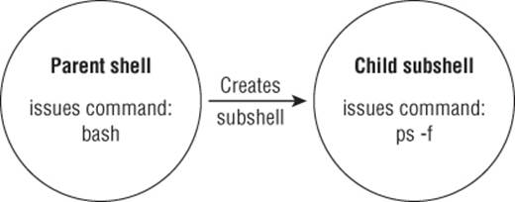 

******External commands Vs Built-in commands (10 minutes)**

For external commands a child process is forked, while built-in commands are part of the shell’s toolkit.

**Exploring Environment Variables (10 minutes)**

Global & Local Env Variables:

$ **printenv,** $ **printenv HOME,** $ **echo $HOME,** $ **ls $HOME, $ ls /home/vimal,** $ **set**

User Defined Variables:

$ **echo $my_variable,** $ **my_variable=Hello,** $ **echo $my_variable**

**Problems to be solved (40 minutes)**

1. Write a shell script to put the effect of commands **sleep 2; echo $BASH_SUBSHELL; sleep 2** into background.
2. Write a shell script to change permissions of a file state.txt.
3. Write a script to identify that the given command is an external command or built-in command
4. Write shell script to display the local and global environment variables.
5. Write a shell script to print multiplication table of a given number.

**Submission Instructions:**

1. Submission requires the screen shots of all the incurred steps to execute a shell script or a video showing the whole process.
2. All these files are in single zip folder.
3. Use the naming convention: Prog_CourseCode_RollNo_LabNo.docx
4. Submission is through LMS only