**Instructions to build and run java code for Decision tree**

* Change directory on the terminal where the Java file (main.java) is present on the computer, for example, if java file is on desktop then,

cd /Users/[Username]/Desktop

* Compile the java file using the following command which will create 4 .class files named, [main.class], [Node.class], [DecisionTree.class], [ID3_algo.class]

javac main.java

* Run the main.class file using the following command which will give you the desired result. E.g, java main /Users/[Username]/Desktop/car.csv 6

java main [filepathname] [classAttributeIndex]

**Output/Result:**

* The result will look like following screenshot:

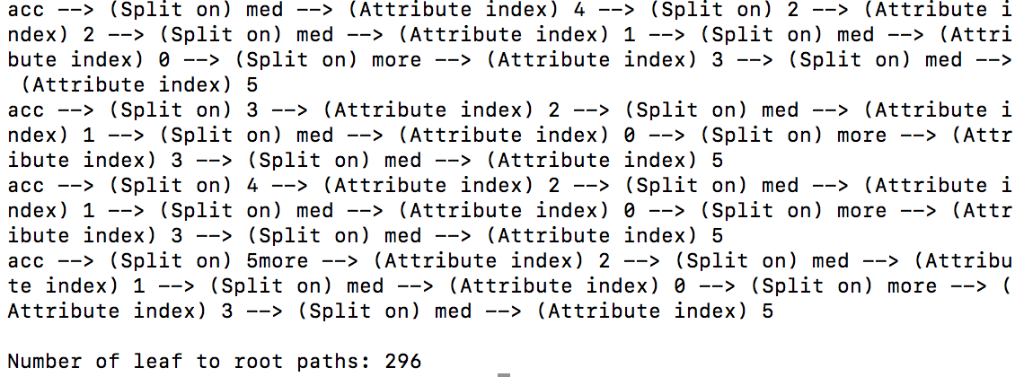

* In the result, all the possible combinations from leaf to root path is printed with a total count in the end.
* **Split on** is the different values of an attribute or the branch value on which the node is split and **Attribute index** is the index of attribute which is either the root, parent or grand parent in the tree.
* In the end, the **Number of leaf to root paths** indicates the count of leaf to root paths for the decision tree build.