**Name: Kunal Baghele**

**Database Assignment- 2**

use world;

select * from city;

select * from country;

select * from countrylanguage;

* **TASK-1**

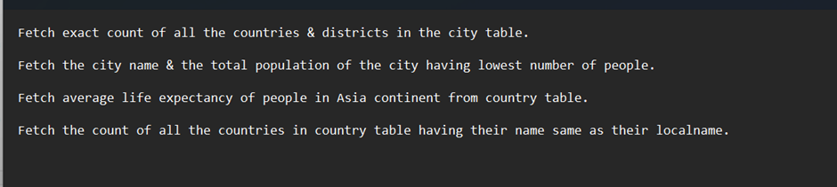

1. select count(distinct name) as CITIES , count(distinct district)as DISTRICTS from city;

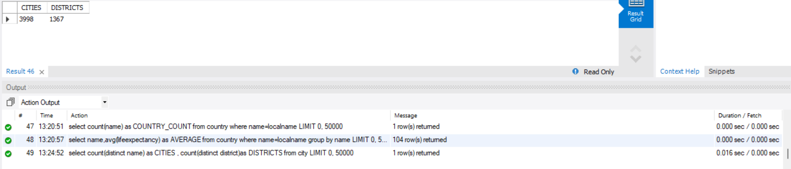

1. select name,population from city order by population asc limit 1;

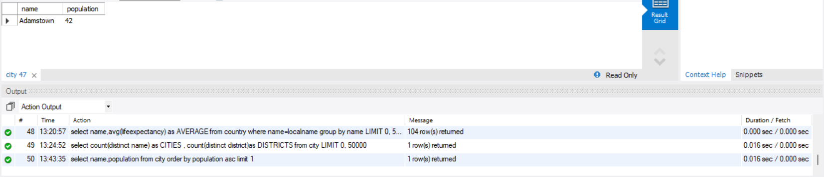

1. select avg(lifeexpectancy) as AVERAGE from country where continent='asia';

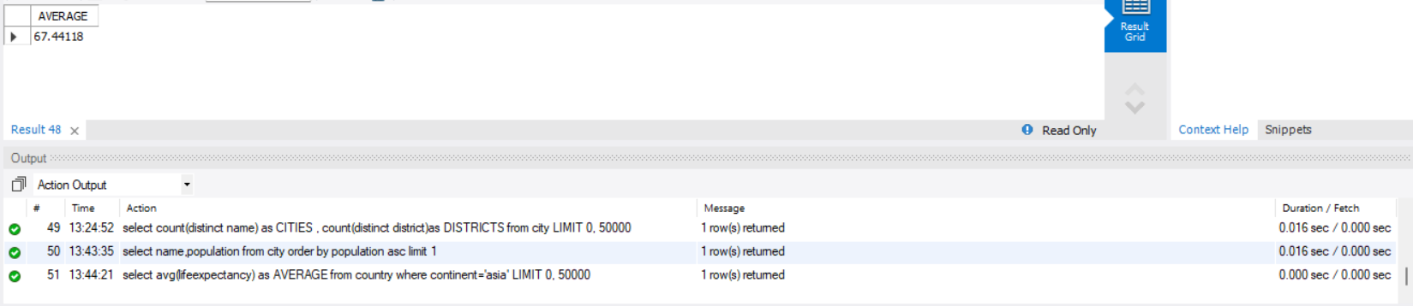

1. select count(name) as COUNTRY_COUNT from country where name=localname;

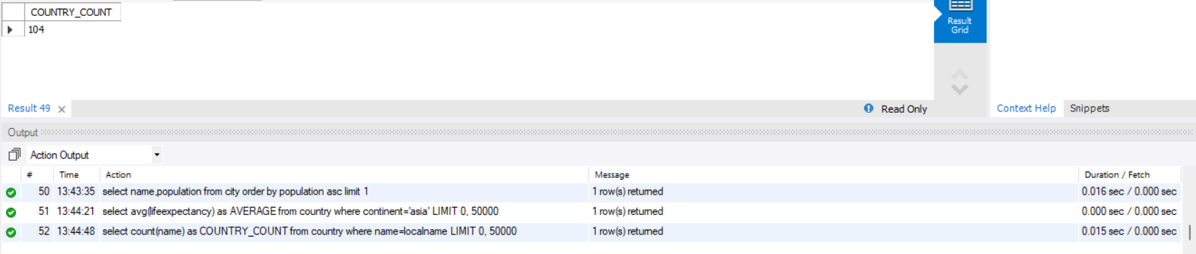

* **TASK-2**

1. select name,avg(lifeexpectancy) as AVERAGE from country where name=localname group by name;

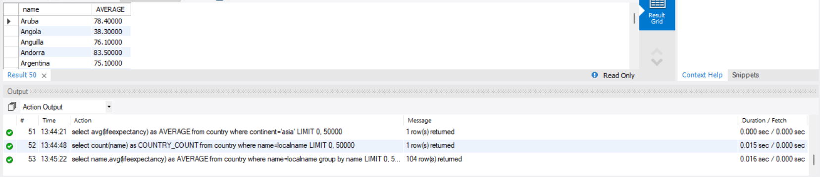

1. select c.name,countrycode,count(language) cnt from countrylanguage cl inner join country c on c.code=cl.countrycode group by countrycode

having cnt = (select max(languagecount) from (select count(language) as languagecount from countrylanguage group by countrycode) as languagecounts)

order by cnt desc;

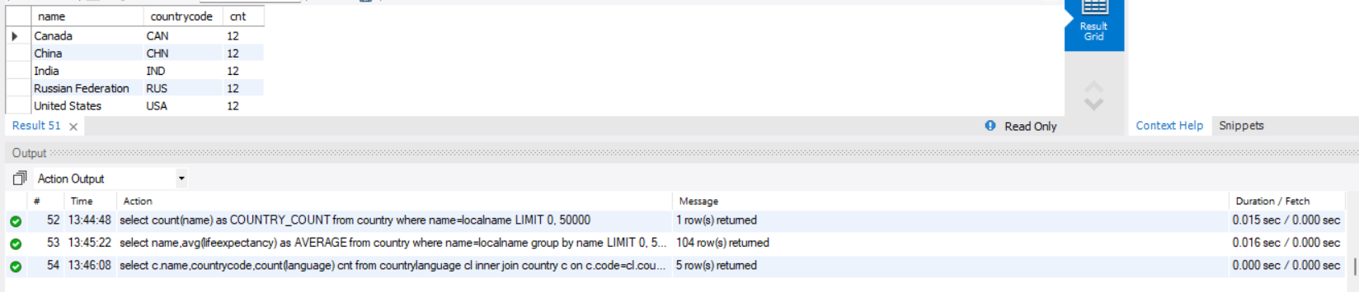

1. select c.name, count(cl.language) as nonofl from countrylanguage cl inner join country c on cl.countrycode = c.code

where cl.isofficial = 'F' group by c.name

having nonofl = (select max(cnt) from (select count(language) as cnt from countrylanguage where isofficial = 'F' group by countrycode) as counts)

order by nonofl desc;

