* **ER-Diagram**

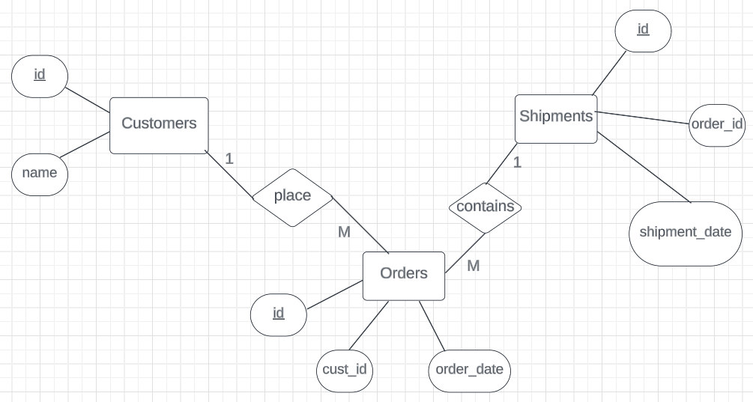

use info;

create table department (

id int primary key,

department_name varchar(255)

);

create table faculty (

id int primary key,

faculty_name varchar(255),

department_id int,

foreign key (department_id) references department(id)

);

create table subject (

id int primary key,

subject_name varchar(255),

faculty_id int,

student_id int,

foreign key (student_id) references student(id),

foreign key (faculty_id) references faculty(id)

);

create table student (

id int primary key,

student_name varchar(255),

department_id int,

foreign key (department_id) references department(id)

);

-- data for department table

insert into department (id, department_name) values

(1, 'computer science'),

(2, 'physics'),

(3, 'mathematics'),

(4, 'chemistry'),

(5, 'biology');

-- data for faculty table

insert into faculty (id, faculty_name, department_id) values

(101, 'dr. gupta', 1),

(102, 'prof. verma', 2),

(103, 'dr. sharma', 3),

(104, 'prof. patel', 4),

(105, 'dr. singh', 5);

-- data for student table

insert into student (id, student_name, department_id) values

(201, 'amit kumar', 1),

(202, 'priya sharma', 2),

(203, 'rahul singh', 3),

(204, 'neha verma', 4),

(205, 'suresh patel', 5);

-- data for subject table

insert into subject (id, subject_name, faculty_id, student_id) values

(301, 'database management', 101, 201),

(302, 'quantum mechanics', 102, 202),

(303, 'linear algebra', 103, 203),

(304, 'organic chemistry', 104, 204),

(305, 'genetics', 105, 205);

1. **Detail of Student including personal info and department.**

select

student.id,

student.student_name,

department.department_name

from student

join department on student.department_id = department.id;

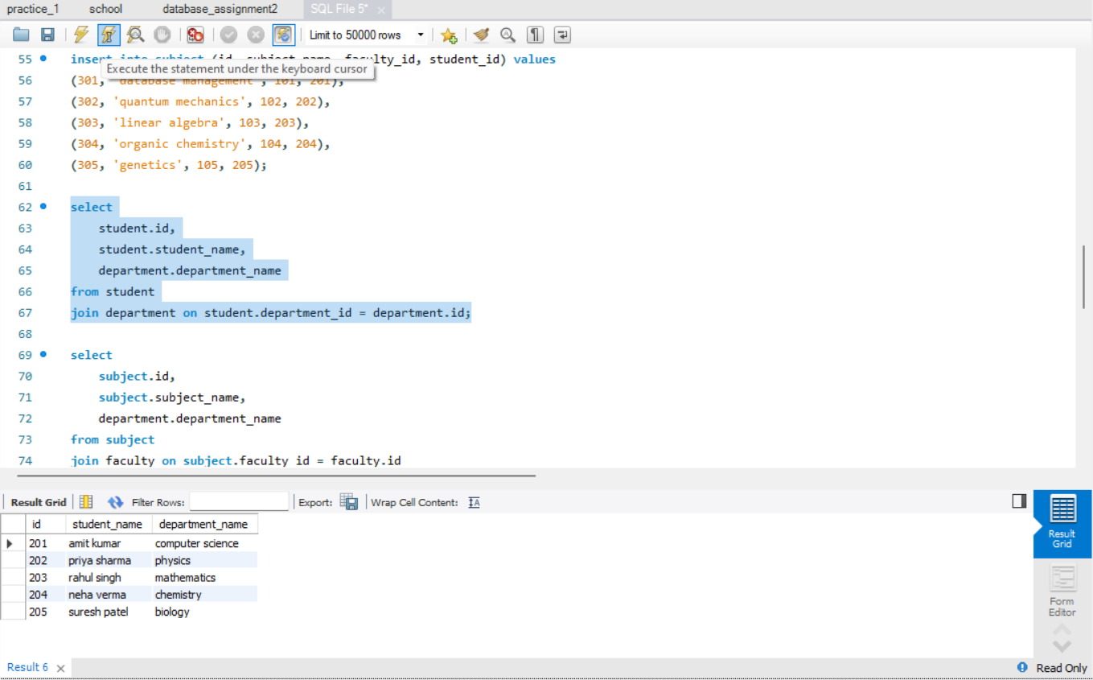

1. **List of Subject teach by particular faculty along with the department details.**

select

subject.id,

subject.subject_name,

department.department_name

from subject

join faculty on subject.faculty_id = faculty.id

join department on faculty.department_id = department.id

where faculty.id = 103;

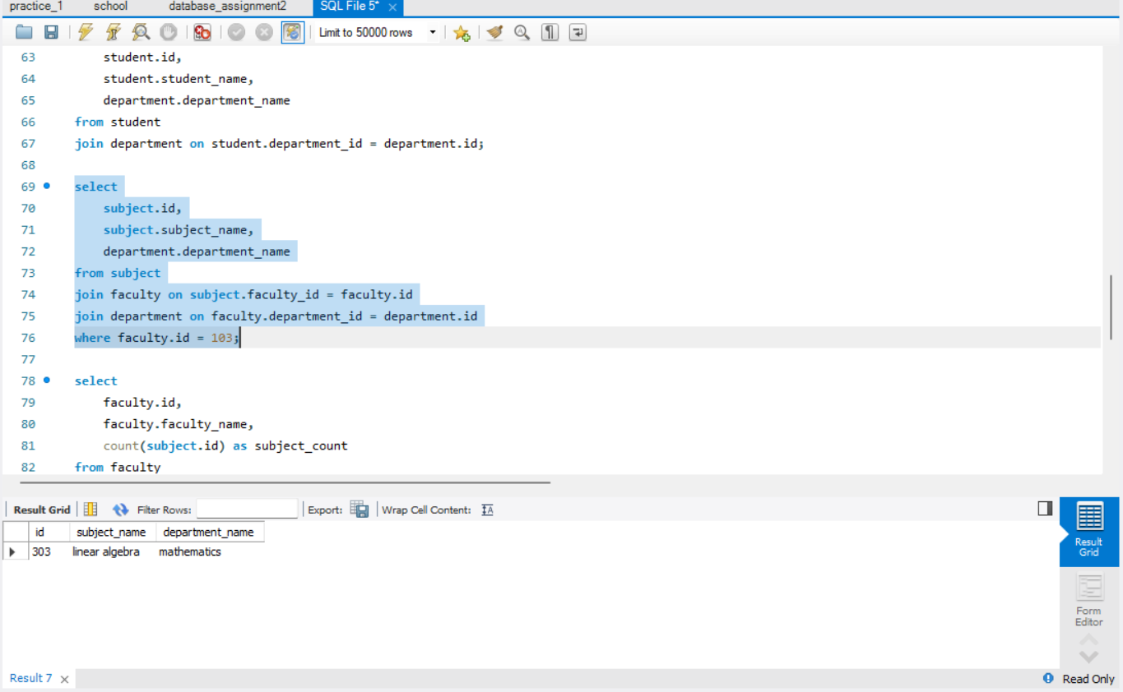

1. **No. of Subject teach by each faculty.**

select

faculty.id,

faculty.faculty_name,

count(subject.id) as subject_count

from faculty

left join subject on faculty.id = subject.faculty_id

group by faculty.id, faculty.faculty_name;

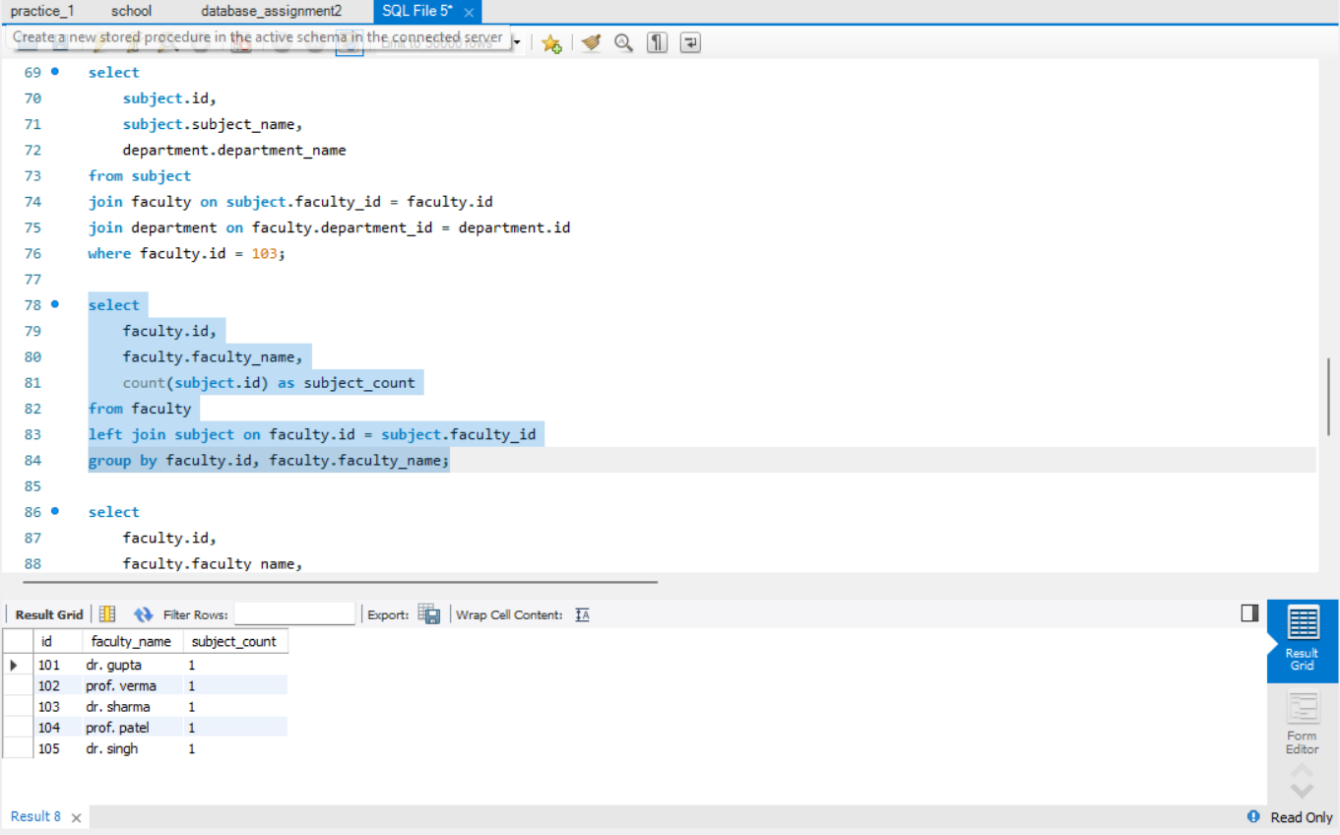

1. **List of Subject teach by each faculty in each department**

select

faculty.id,

faculty.faculty_name,

department.id as department_id,

department.department_name,

group_concat(subject.subject_name) as subjects_taught

from faculty

join department on faculty.department_id = department.id

left join subject on faculty.id = subject.faculty_id

group by faculty.id, faculty.faculty_name, department.id, department.department_name;

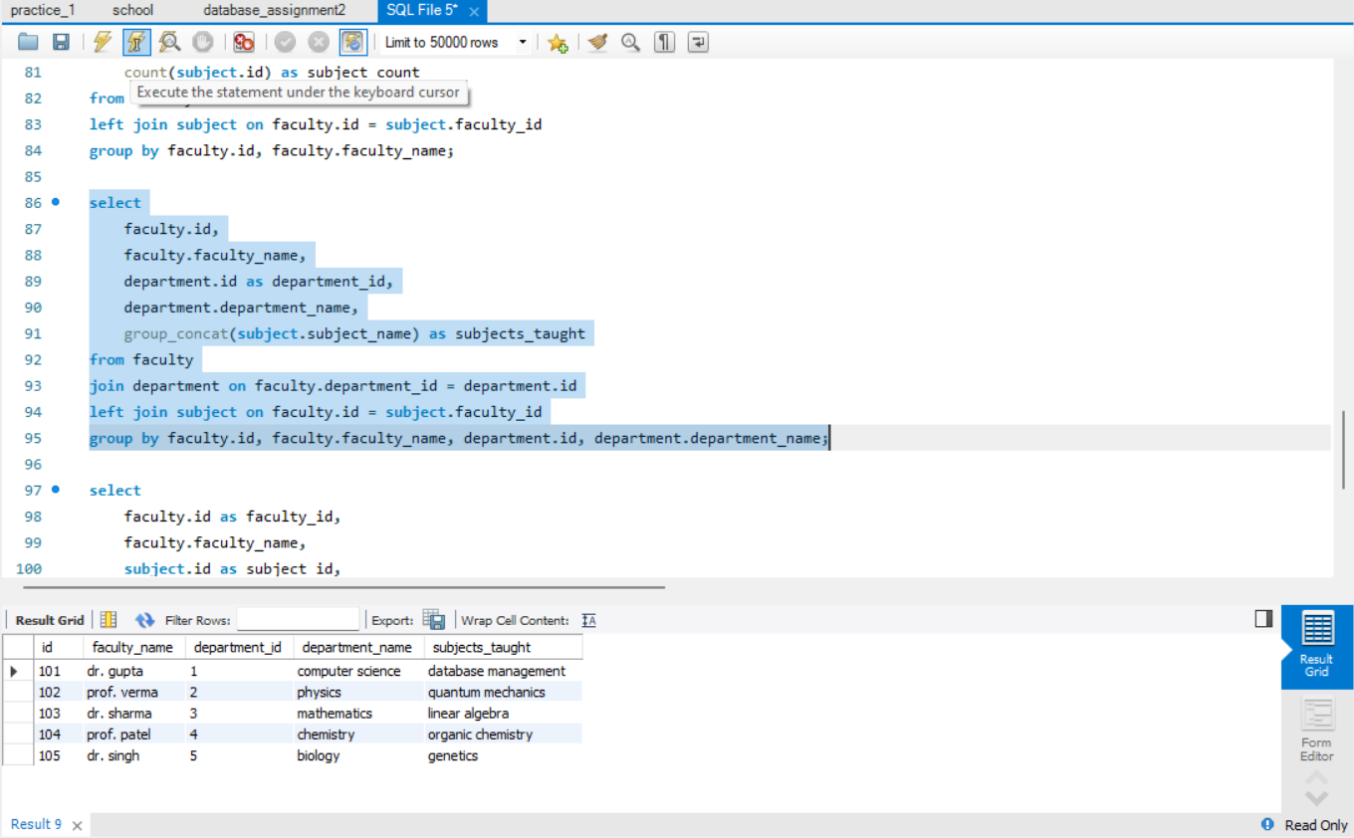

1. **No. of Student who is learning a particular subject by particular faculty in particular department.**

select

faculty.id as faculty_id,

faculty.faculty_name,

subject.id as subject_id,

subject.subject_name,

department.id as department_id,

department.department_name,

count(student.id) as student_count

from subject

join faculty on subject.faculty_id = faculty.id

join department on faculty.department_id = department.id

left join student on subject.student_id = student.id

group by faculty.id, faculty.faculty_name, subject.id, subject.subject_name, department.id, department.department_name;

