**Name: Kunal Baghele**

**Java Assignment-1**

1. **Print Even and Odd elements of array as string.**

package assignment1;

import java.util.Scanner;

public class EvenOdd {

public static void main(String[] args) {

int n, i;

Scanner s = new Scanner(System.***in***);

System.***out***.print("Enter the length of array : ");

n = s.nextInt();

int arr[] = new int[n];

String even = "";

String odd = "";

for (i = 0; i < n; i++) {

System.***out***.print("Enter " + i + " element of array : ");

arr[i] = s.nextInt();

}

for (i = 0; i < n; i++) {

if (arr[i] % 2 == 0) {

even=even.concat(Integer.*toString*(arr[i])).concat(",");

} else {

odd=odd.concat(Integer.*toString*(arr[i])).concat(",");

}

}

System.***out***.println("Even numbers:- " + even);

System.***out***.println("Odd numbers:- " + odd);

}

}

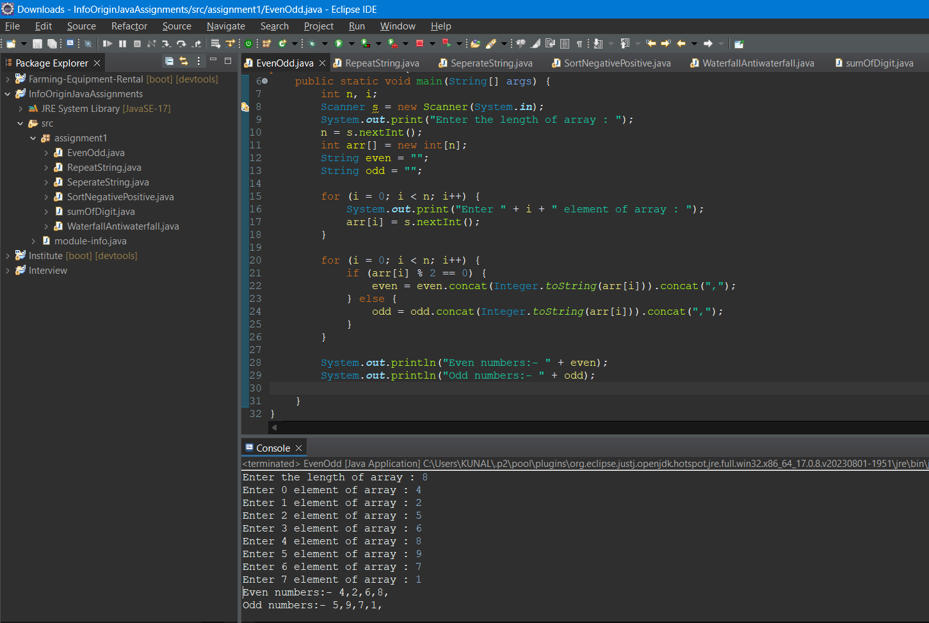

1. **Repeat the string for length number of times of a input string.**

package assignment1;

import java.util.Scanner;

public class RepeatString {

public static void main(String[] args) {

String str;

Scanner s = new Scanner(System.***in***);

System.***out***.print("Enter string :- ");

str = s.nextLine();

int len = str.length();

str = str.concat(",").repeat(len);

System.***out***.println(str);

}

}

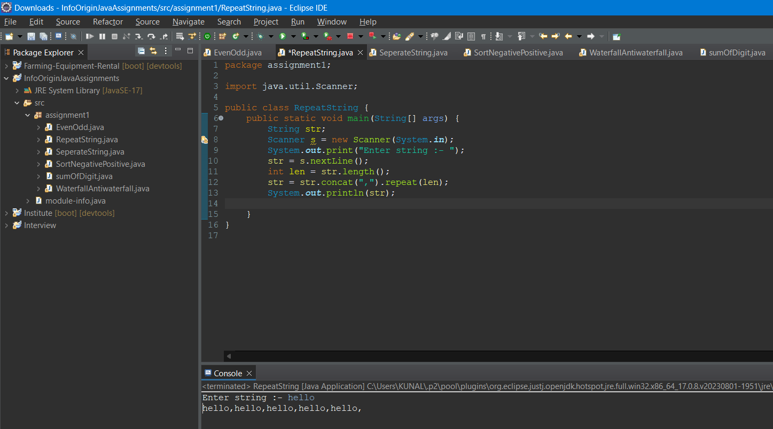

1. **I**nput a string and prints every second element and separates them using comma.

package assignment1;

import java.util.Scanner;

public class SeperateString {

public static void main(String[] args) {

String str;

Scanner s = new Scanner(System.***in***);

System.***out***.println("Enter the string :- ");

str = s.nextLine();

String words[] = str.split("\\s");

for (int i = 0; i < words.length; i = i + 2) {

System.***out***.print(words[i]+",");

}

}

}

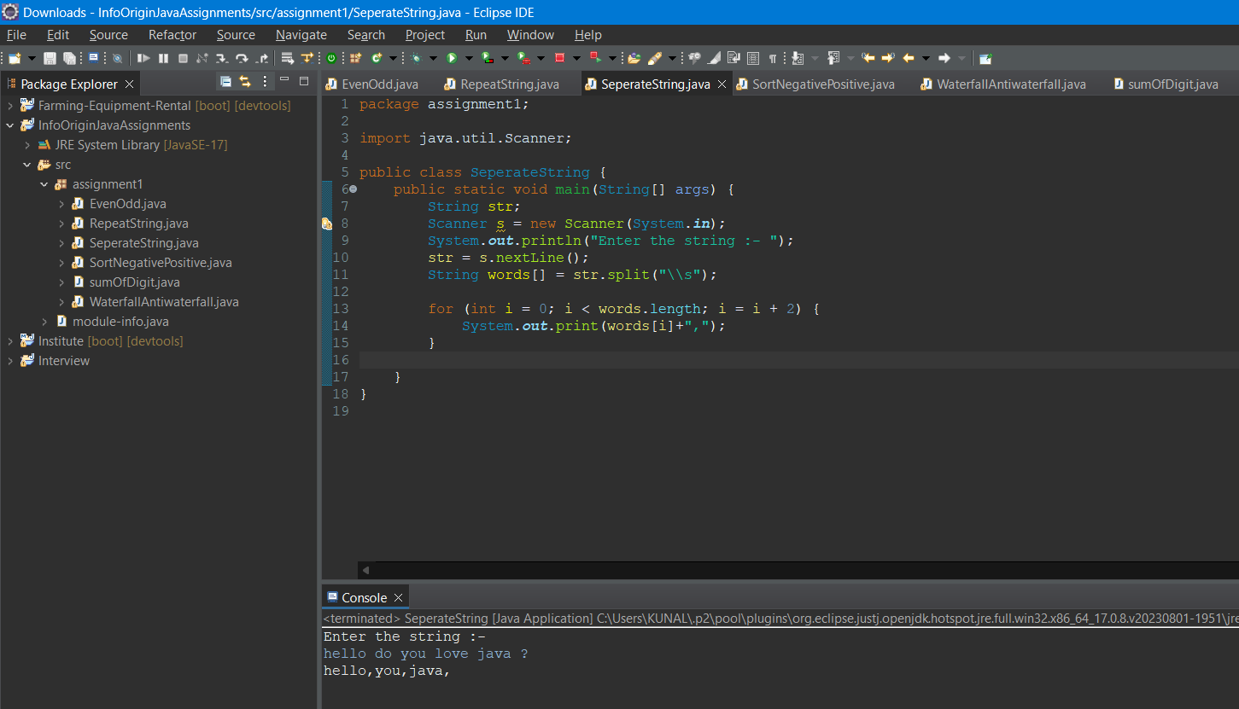

1. **Sorting positive and negative elements of array in descending and ascending manner respectively**.

package assignment1;

import java.util.Arrays;

import java.util.Scanner;

public class SortNegativePositive {

public static void main(String[] args) {

int n, i;

Scanner s = new Scanner(System.***in***);

System.***out***.print("Enter the length of array : ");

n = s.nextInt();

int arr[] = new int[n];

int pos[]=new int[n/2];

int neg[]=new int[n/2];

for(i=0;i<n;i++) {

System.***out***.print("Enter "+i+" element : ");

arr[i]=s.nextInt();

}

int pcnt=0;

int ncnt=0;

for(i=0;i<n;i++) {

if(arr[i]>0) {

pos[pcnt]=arr[i];

pcnt++;

}

else {

neg[ncnt]=arr[i];

ncnt++;

}

}

Arrays.*sort*(neg); //sorting negative array

//sorting positive array in descending order

int temp=0;

for (i = 0; i < pos.length; i++) {

for (int j = i+1; j < pos.length; j++) {

if(pos[i] < pos[j]) {

temp = pos[i];

pos[i] = pos[j];

pos[j] = temp;

}

}

}

//printing alternately

for (i = 0; i < pos.length; i++) {

System.***out***.print(pos[i] + " ");

System.***out***.print(neg[i] + " ");

}

}

}

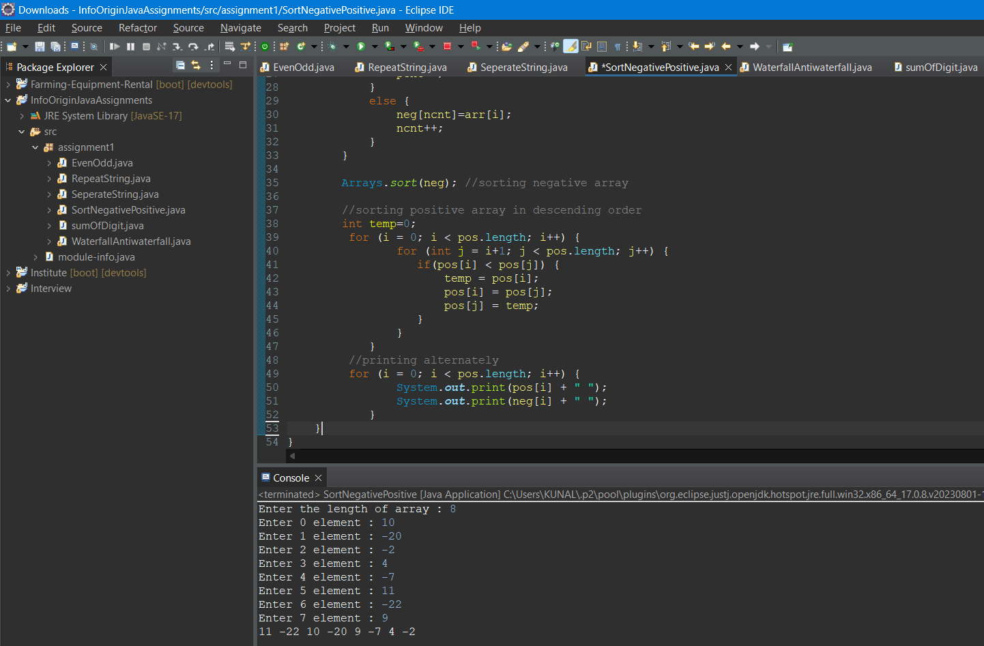

1. Take Array input from user and make X elements flow in waterfall and antiwaterfall direction.

package assignment1;

import java.util.Scanner;

public class WaterfallAntiwaterfall {

public static void main(String[] args) {

Scanner s = new Scanner(System.***in***);

// Input from user

System.***out***.print("Enter the size of the array: ");

int n = s.nextInt();

int[] arr = new int[n];

for (int i = 0; i < n; i++) {

System.***out***.print("Enter "+i+ " element : ");

arr[i] = s.nextInt();

}

System.***out***.print("Enter the value of X: ");

int x = s.nextInt();

// Waterfall

System.***out***.println("Waterfall : ");

for (int i = n - x; i < n; i++) {

System.***out***.print(arr[i] + " ");

}

for (int i = 0; i < n - x; i++) {

System.***out***.print(arr[i] + " ");

}

System.***out***.println();

// Antiwaterfall

System.***out***.println("AntiWaterfall : ");

for (int i = x; i < n; i++) {

System.***out***.print(arr[i] + " ");

}

for (int i = 0; i < x; i++) {

System.***out***.print(arr[i] + " ");

}

}

}

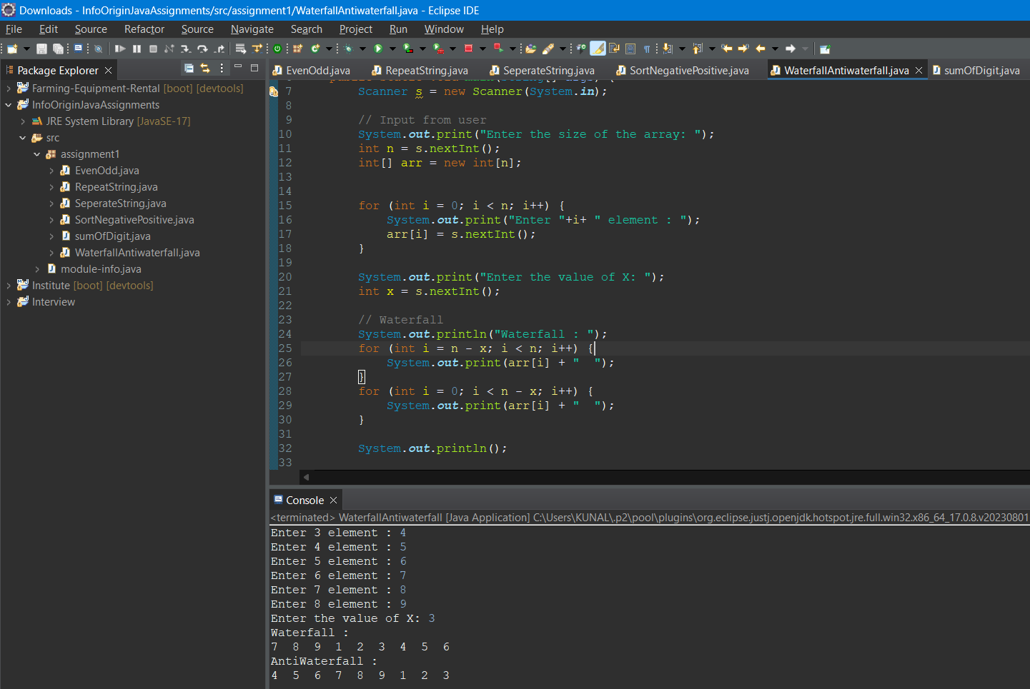

1. Input a array input with three digit number and calculate sum of digits till single digits and at the end calculate sum of array.

package assignment1;

public class sumOfDigit {

public static int getSum(int n) {

int sum = 0;

while (n != 0) {

sum += n % 10;

n /= 10;

}

return sum;

}

public static void main(String[] args) {

int arr[] = { 123, -311, 236, -624, 441 };

// int arr[] = { 123, 311, 236, 624, 441 };

for (int i = 0; i < arr.length; i++) {

int ele = arr[i];

while (ele > 9 || ele < -9) {

int sumdigit = *getSum*(Math.*abs*(ele));

if (ele < 0) {

ele = -sumdigit;

} else {

ele = sumdigit;

}

}

arr[i] = ele;

}

System.***out***.print("{ ");

for (int i = 0; i < arr.length; i++) {

System.***out***.print(arr[i]);

if (i < arr.length) {

System.***out***.print(",");

}

}

System.***out***.println(" }");

int sum = 0;

for (int s : arr) {

sum += s;

}

System.***out***.println("Sum of array: " + sum);

}

}

