**Name: Kunal Baghele**

**Java Assignment-2**

1. **Generate a pattern for a string.**

package assignment2;

import java.util.Scanner;

public class Pattern {

public static void main(String[] args) {

Scanner s=new Scanner(System.***in***);

String str;

System.***out***.print("Enter the string :");

str=s.nextLine();

for(int i=0;i<str.length();i++) {

for(int j=0;j<=i;j++) {

System.***out***.print(str.charAt(j));

}

System.***out***.println();

}

}

}

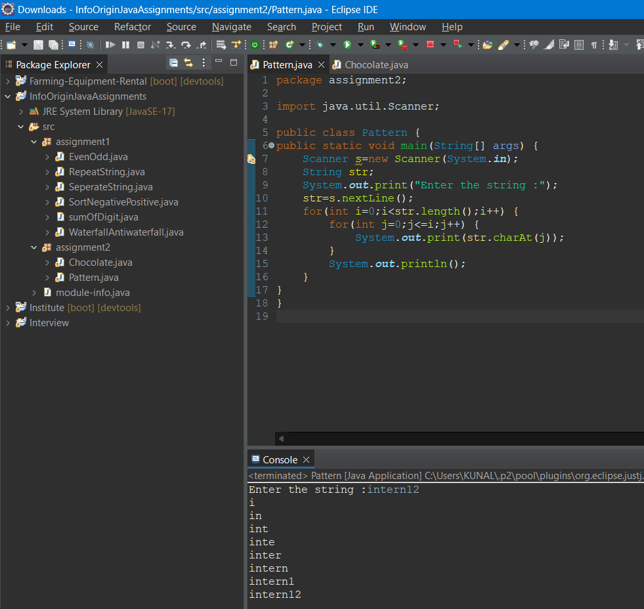

1. **Chocolate Distribution.**

package assignment2;

import java.util.Scanner;

public class Chocolate {

public static void forward(int[] arr, int choclate) {

for (int i = 0; i < arr.length && choclate != 0; i++) {

arr[i]++;

choclate--;

}

if (choclate != 0) {

*backward*(arr, choclate);

}

}

public static void backward(int[] arr, int choclate) {

for (int i = arr.length - 1; i >= 0 && choclate != 0; i--) {

arr[i]++;

choclate--;

}

if (choclate != 0) {

*forward*(arr, choclate);

}

}

public static void main(String[] args) {

Scanner s=new Scanner(System.***in***);

System.***out***.print("Enter number of chocolates :");

int choclate=s.nextInt();

System.***out***.print("Enter number of people :");

int people=s.nextInt();

int arr[] = new int[people];

*forward*(arr, choclate);

for (int a : arr) {

System.***out***.print(a + " ");

}

}

}

