**Thomas-Kilmann Conflict Style Questionnaire**

**Instruction:** On the following pages are 30 pairs of statements describing possible behavioural responses to a conflict situation. For each pair, circle the "A" or "B" statement which is most characteristic of your own behaviour.

You may find that neither of the "A" or "B" statements is typical of your behaviour; and if this is so, please select the response which you would be more likely to use.

|  |  |  |
| --- | --- | --- |
| 1 | A. There are times when I let others take responsibility for solving the problem.  B. Rather than negotiate the things on which we disagree, I try to stress those things upon which we both agree. | B |
| 2 | A. I try to find a compromise solution.  B. I attempt to deal with all of his/her and my concerns. | A |
| 3 | A. I am usually firm in pursuing my goals.  B. I might try to soothe the other's feelings and preserve our relationship. | A |
| 4 | A. I try to find a compromise solution.  B. I sometimes sacrifice my own wishes for the wishes of the other person. | A |
| 5 | A. I consistently seek the other's help in working out a solution.  B. I try to do what is necessary to avoid useless tensions. | B |
| 6 | A. I try to avoid creating unpleasantness for myself.  B. I try to win my position. | A |
| 7 | A. I try to postpone the issue until I have had some time to think it over.  B. I give up some points in exchange for others. | B |
| 8 | A. I am usually firm in pursuing my goals.  B. I attempt to get all concerns and issues immediately out in the open. | B |
| 9 | A. I feel that differences are not always worth worrying about.  B. I make some effort to get my way. | B |
| 10 | A. I am firm in pursuing my goals.  B. I try to find a compromise solution. | B |
| 11 | A. I attempt to get all concerns and issues immediately out in the open.  B. I might try to soothe the other's feelings and preserve our relationship. | A |
| 12 | A. I sometimes avoid taking positions which would create controversy.  B. I will let the other person have some of his/her positions if he/she lets me have some of mine. | B |
| 13 | A. I propose a middle ground.  B. I press to get my points made. | A |
| 14 | A. I tell the other person my ideas and ask for his/hers.  B. I try to show the other person the logic and benefits of my position. | B |
| 15 | A. I might try to soothe the other's feelings and preserve our relationship.  B. I try to do what is necessary to avoid tensions. | B |
| 16 | A. I try not to hurt the other's feelings.  B. I try to convince the other person of the merits of my position. | B |
| 17 | A. I am usually firm in pursuing my goals.  B. I try to do what is necessary to avoid useless tensions. | B |
| 18 | A. If it makes other people happy, I might let them maintain their views.  B. I will let other people have some of their positions if they let me have some of mine. | B |
| 19 | A. I attempt to get all concerns and issues immediately out in the open.  B. I try to postpone the issue until I have had some time to think it over. | A |
| 20 | A. I attempt to immediately work through our differences.  B. I try to find a fair combination of gains and losses for both of us. | B |
| 21 | A. In negotiations, I try to be considerate of the other person's wishes.  B. I always lean toward a direct discussion of the problem. | B |
| 22 | A. I try to find a position that is intermediate between his/hers and mine.  B. I assert my wishes. | A |
| 23 | A. I am very often concerned with satisfying all our wishes.  B. There are times when I let others take responsibility for solving the problem. | A |
| 24 | A. I try meet to meet the wishes of others when it’s important to them.  B. I try to get the other person to settle for a compromise. | B |
| 25 | A. I try to show the other person the logic and benefits of my position.  B. In negotiations, I try to be considerate of the other person's wishes. | A |
| 26 | A. I propose a middle ground.  B. I am nearly always concerned with satisfying all our wishes. | A |
| 27 | A. I sometimes avoid taking positions that would create controversy.  B. If it makes other people happy, I might let them maintain their views. | A |
| 28 | A. I am usually firm in pursuing my goals.  B. I usually seek the other's help in working out a solution. | B |
| 29 | A. I propose a middle ground.  B. I feel that differences are not always worth worrying about. | A |
| 30 | A. I try not to hurt the other's feelings.  B. I always share a problem with the other person so that we can work it out. | B |

**Scoring Your Thomas -Kilmann Response**

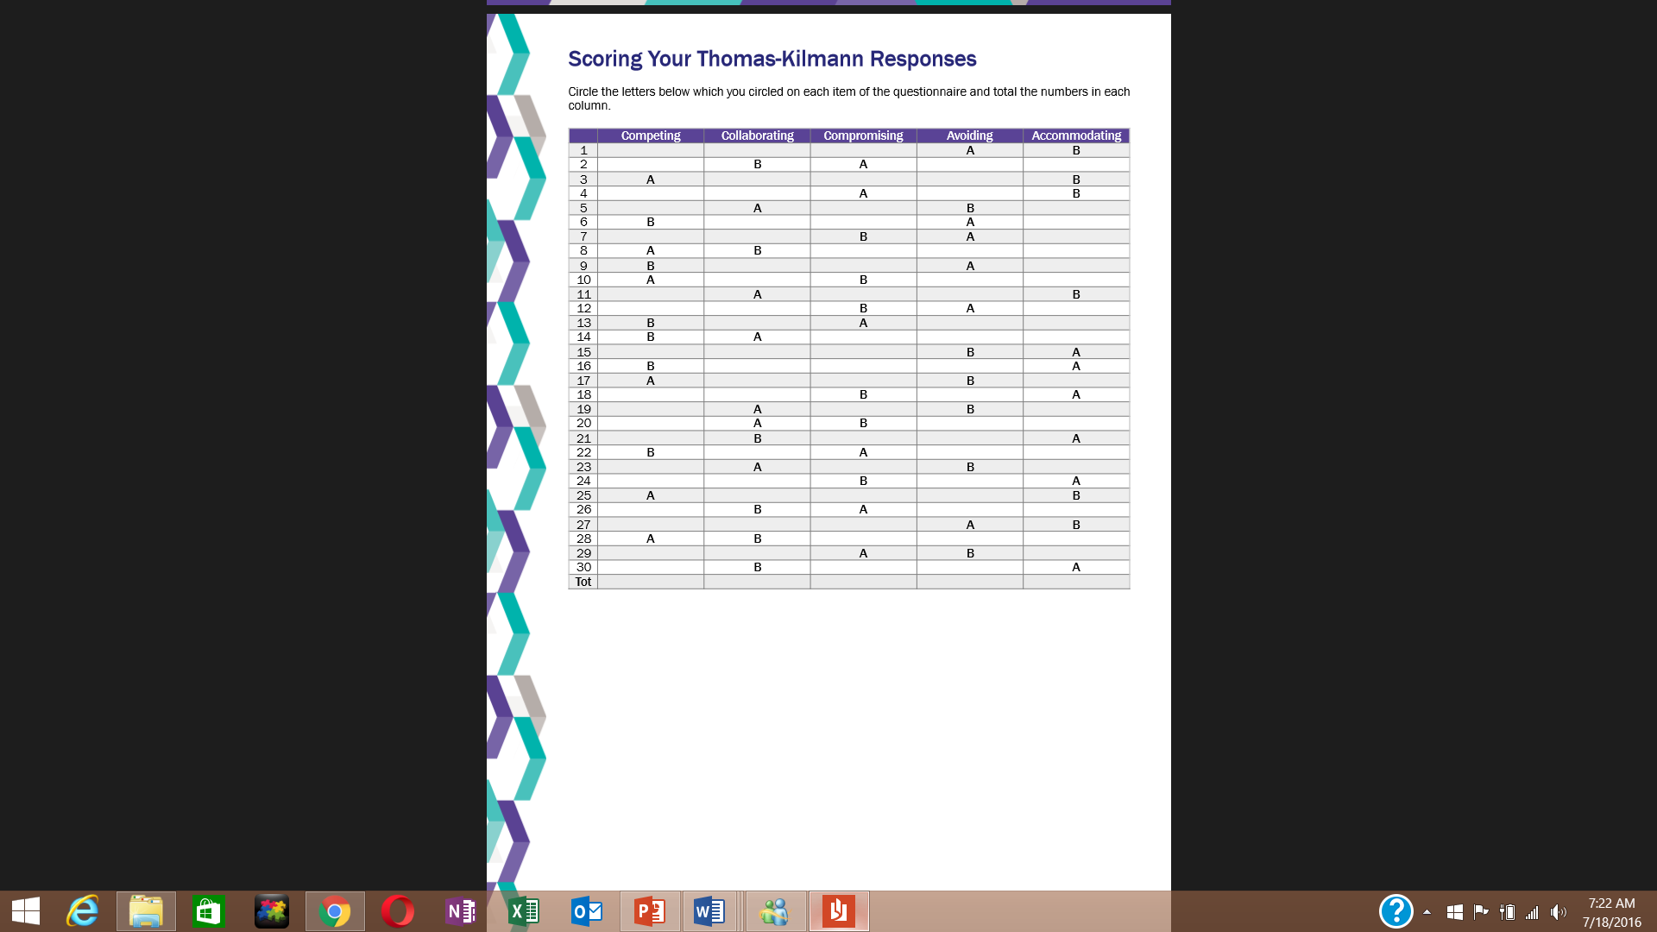Circle the letters below which you circled on each item of the questionnaire and total the numbers in each column.

You will have a numerical score for each of the five conflict mode styles, competing, avoiding, accommodating, collaborating and compromising. Each of the five columns has a range of possible scores from 0 (for very low use) to 12 (for very high use).

These have been averaged out on a distribution curve against other manager responses. Check your range of scores against the following key to identify how they compare in relation to other managers in your business sector.

Your highest scoring column represents the conflict style mode that is your ‘default or natural’ mode.

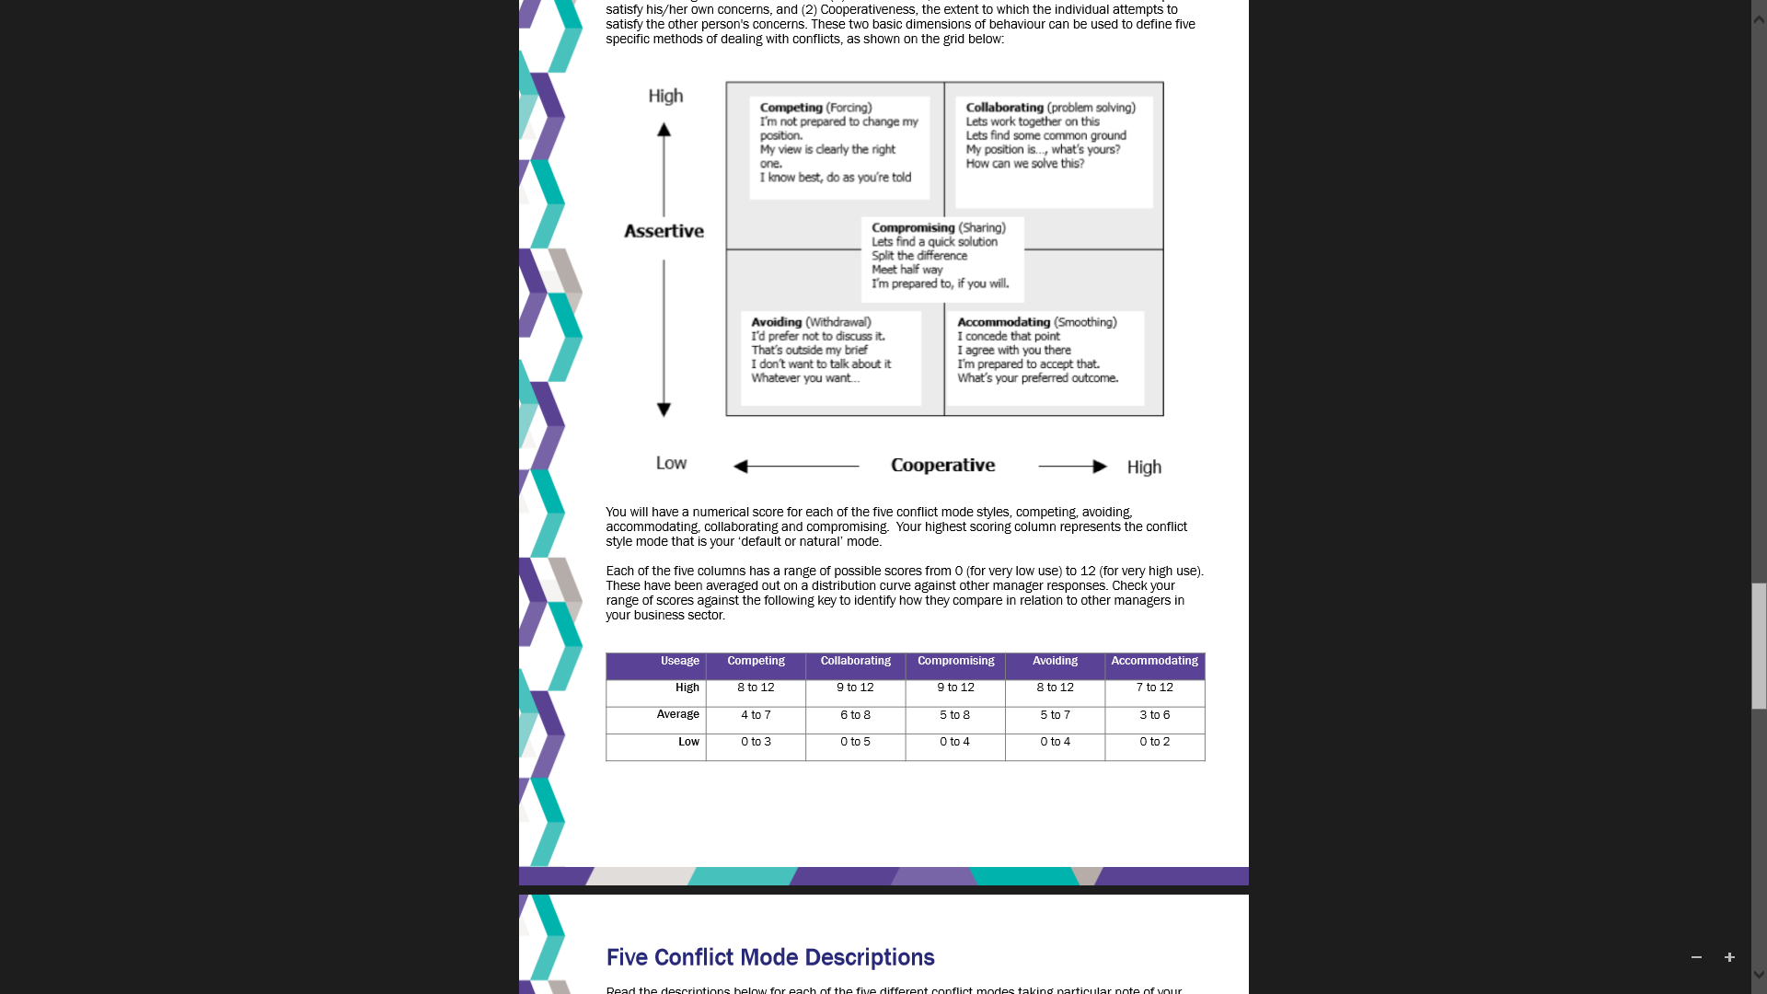

**My default Conflict Style is __________________.**