NAME: JOSHI KUNAL DEEPAK (Lastname, Firstname) Section ISTE230._______

Homework #7: Transposing - Supertypes, Subtypes

Due Date: Sunday night 6pm 11/24/2019 Must covert this word document to PDF

Note: submissions must be made to the appropriate dropbox in PDF format. This homework is required to be typed, not handwritten.

PART 1: Transposing an E-R Diagram (55 pts)

Transpose the E-R Diagram for RITPO into relations. Use the relational notation: RELNAME( KeyAttr, Attr1, Attr2, FK ). Italicize or dash underline your foreign keys. Be sure to include a reference statement for each foreign key that follows the format :
CURRENT_TABLE(fkattribute(s)) must exist in ORIGINAL_TABLE(pkattribute(s))
Create & submit a PDF file called yourname_HW7.pdf to include all of the resulting relations.

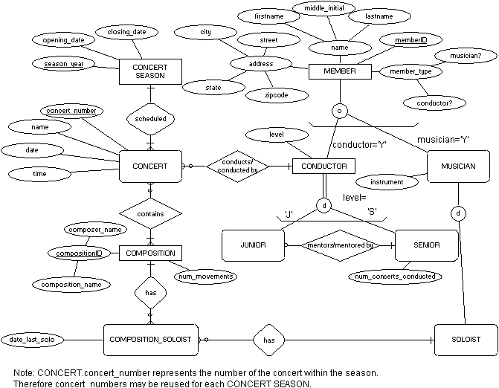
ANSWER:-

MEMBER(memberID, firstname, middle_name, lastname, zipcode, street, state, city, musician?, conductor?)

CONDUCTOR(memberID, level)
CONDUCTOR(memberID) must exist in MEMBER(memberID)

MUSICIAN(memberID, instrument)
MUSICIAN(memberID) must exist in MEMBER(memberID)

SENIOR(memberID, num_concerts_conducted)
SENIOR(memberID) must exist in CONDUCTOR(memberID)

JUNIOR(memberID, mentor_memberID)
JUNIOR(memberID) must exist in CONDUCTOR(memberID)
JUNIOR(mentor_memberID) must exist in SENIOR(memberID)

SOLOIST(memberID)
SOLOIST(memberID) must exist in MUSICIAN(memberID)

CONCERT SEASON(season_year, opening_date, closing_date)

CONCERT(concert_number, season_year, name, date, time, memberID)
CONCERT(season_year) must exist in CONCERT SEASON(season_year)
CONCERT(memberID) must exist in CONDUCT(memberID)

COMPOSITION(composer_name, composition_name, num_movements)

CONCERT_COMPOSITION(concert_number, season_year, composer_name, composition_name)
CONCERT_COMPOSITION(concert_number, season_year) must exist in CONCERT(concert_number, season_year)
CONCERT_COMPOSITION(composer_name, composition_name) must exist in COMPOSITION(composer_name, composition_name)

COMPOSITION_SOLOIST(composer_name, composition_name, memberID, date_last_solo)
COMPOSITION_SOLOIST(composer_name, composition_name) must exist in COMPOSITION(composer_name, composition_name)
COMPOSITION_SOLOIST(memberID) must exist in SOLOIST(memberID)

