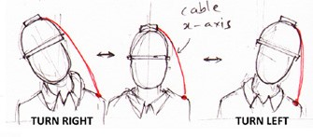**Abstract** – Over the years Technology has improved health care and has given life to several differently abled people across the globe. Now one such technology which has remained crucial to disabled people has been wheelchair and now we aim to make it a smart one to incorporate latest technology to expand utility of wheelchair to more range of disabilities. One crucial implementation is in control the wheelchair movement by body gesture independent of limb disability.

Smart Wheel Chair

Suyash Pati Tripathi , Kunal Dhawan , Sasank Gurajapu

I. Introduction

Wheelchair has been the fundamental means of commute for differently abled people across the globe for decades now. This has seen its own improvements in terms of implementation and motorization .This has indeed made life better for these abled people who can now commute easily across places. The major drawback of this model of wheelchair has been that it required personal efforts from person to move the wheel or person assists in their movement. This has been resolved by the implementation of motors in present day wheel chair. But how do we account it for the 27.3% of disabled people who also have limitations in their hand movements. This makes the person dependent on another person for commute making the whole purpose of wheel chair unfulfilled.

We aimed at tackling this issue by entirely removing the requirement of hands in navigation or movement of wheel chair. The idea we turned our head towards was “Turning our heads” to navigate around and Lean back to move forward. That is to control the turn of wheel chair by head direction and resting back on chair ensures you move forward.

Gyroscopes were attached to the head cap whose data was translated into the turn by differential drive motor driven by Arduino. The movement of head to left about in z-axis ensures wheel chair turns to left and vice-versa. Force sensors were attached to the back rest of wheelchair and sensed the force on them. Beyond a certain value, Arduino ensures the powering up of DC Motors for lateral movement of wheelchair

This was basic working which replaced the human efforts for movement and direction. The Force sensor threshold can be calibrated according to user’s wish and value beyond threshold will be made digital and motor permanently switched on.

Force Sensor

Force Sensor

Gyroscope

Motion

Microcontroller

II: Outline

1. **Gyroscope Cap**

The Gyroscope Cap has a gyroscope fit on a cap which the wearer will be wearing once he settles on chair. The gyroscope will give the estimate the movement of head WRT Z-axis. The value from the Gyroscope is then fed into Arduino which evaluates the value and triggers the turning of wheelchair using a differential drive. The amount of turn is decided by the amount of turn on gyroscope.

1. **Back Rest**

The backrest is equipped with Force Sensors. The force sensors detect the amount of force exerted on them and is fed into Arduino. Arduino (using a threshold value ) converts all analog input into Binary Output affecting in movement or no movement

1. **Power Source**

Since motion is generated entirely given by DC motors, the main power source are Batteries.

1. **Motors**

DC motors were used. Motor driver controls speed of motors and accordingly moves wheels. Mechanical Gears were used to reduce RPM to required level.

III. Parts

1. **Gyroscope**

Gyroscope–ITG/MPU-6050-It’s a motion processor with in-built Gyroscope module which returns value to Arduino in degrees measured along all axis. Specifically we will be using the angle WRT Z-Axis.

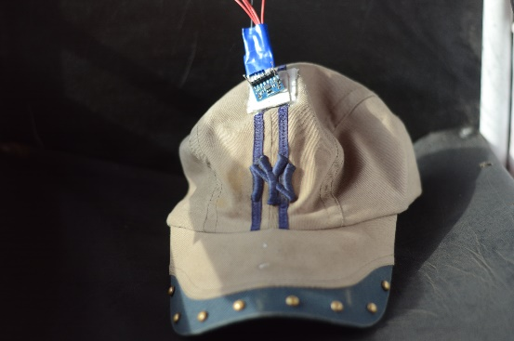

1. **Arduino Uno**

Arduino Uno will be the standard microcontroller which will be performing all the computational tasks for all kinds in the wheel chair. It will be Handling Inputs from Force Sensor and Gyroscope and processes them .The output reflects in the Motor Driver and Differential Drive

1. **Force Sensor**

Force sensor is a Pressure varying Resistor whose resistance is starts from infinity (mega ohms) and decreases with increasing pressure. It is a basic piezoelectric quartz sensor .This is added in series with another resistor and corresponding current values at fixed voltage is translated into Arduino as input from Force Sensor.

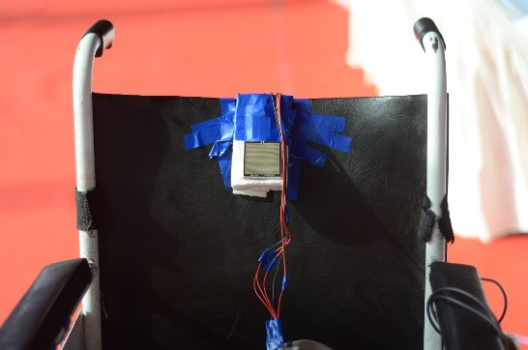

1. **Battery**

2 Lead Acid Batteries of 12V 24Ah in Series. Each were used to power up the DC motors.

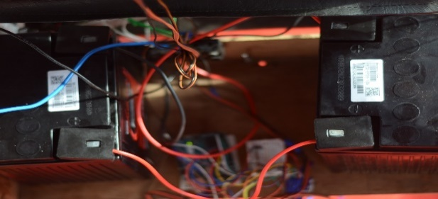

**5) Motor Driver**

RKI-1340 model of motor driver was used to drive up motors. It has a max current output of 20A and input varies from 6-24V. It directly connected to Arduino from which it receives instructions to perform necessary actions. Differential Drive is entirely achieved via motor driver. Pulse Width Modulation used in this helps in implementation of Speed control with minimal energy loss.

**5) Motors**

Two 24V-60W 3000RPM Motors were used to move the wheel chair. To reduce the rpm of wheelchair to our requirement we used Mechanical gear reduction.

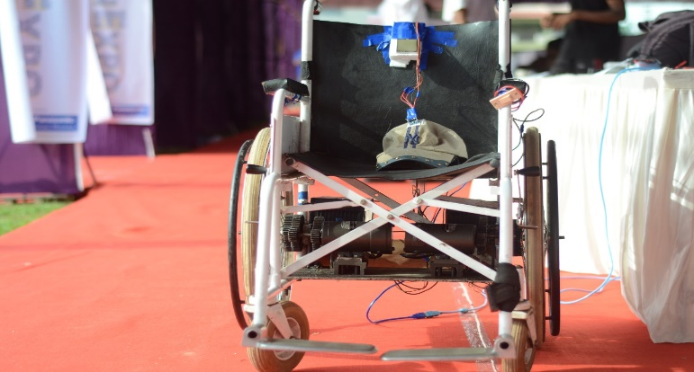

IV) Detailed Explanation

Getting into the complete working of Wheel chair, as a natural reaction of a person the resting of his/her back onto the backrest is sign of settling on chair and this is also the start of motion. On further press by the person activates the force sensor to turn on the DC motors. The force value beyond a certain threshold value, Arduino instructs to power up DC motors ensuring the linear motion of the Wheelchair. One can get the threshold value to be changed depending on his personal preference and calibrate the sensor accordingly.

Once the value of Force Sensor falls below the threshold value, brakes are applied to softly stop the motion of wheelchair and ensuring there are no jerks or mechanical vibrations in a given reaction time. The force sensor is suitable placed in the cushion of the backrest and underneath the spine. This ensures Sensor is ergonomically placed for person and underneath spine ensures the maximum contact area of person’s body upon sensor. Placing sensor in cushion might reduce its accuracy and also diluted values, but this can be compensated in the Sensitivity of sensor and lowering the threshold value

Now coming to the navigation part of the motion, Motion Processing Unit (MPU) which includes a 3-axis gyroscope is fit in on the cap worn by the person. It is suitably placed to orient the Z-axis of Gyroscope along the body axis of person to ensure realistic values from Gyroscope. In accordance to natural gestures to turn our heads while turning around, Gyroscope values with respect to Z-Axis are taken into consideration for calculation in Arduino. A Variable Tolerance of +-50 along this direction is taken to account for general head gestures of person. This value of angle can be varied accordingly depending on person’s requirement and can be calibrated. So to initiate the turning motion person can slowly turn his head in direction required, once he/she turns more than the required value of threshold the wheelchair turns to move.

The Arduino gives the required instructions to motor to ensure turning via differential drive. The more angular displacement more the turn by bot .One can as well turn with/without linear motion. As the person resets himself into the normal head position ie:Below the threshold value, Motor driver sets the wheel onto normal position with equal movement on both the motors.All this is powered up by the DC batteries present on the wheel chair providing constant voltage supply of 12V each.

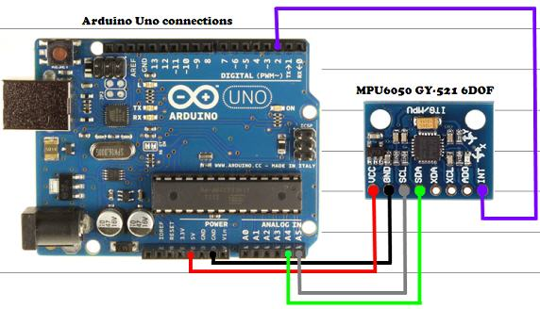

Circuit connections from MPU to Arduino

V) Troubleshooting

Debugging and refining any prototype is the most significant part of its development. There have been several problems we faced in the course of the project.

1. **Coding and Calibration**

The Gyroscope and force sensor readings had to be calibrated so as to by in sync with natural response and expectation of person. This required lot of testing for pre-decided values to confirm with one, which can be calibrated later.

VI) Economic Feasibility

* Circuitry-INR 2000
* Basic Wheelchair – INR 6000
* High Power Motors –INR 12000
* Battery-Lead Gel Battery- INR 5000
* MPU and Microcontroller-INR 2000
* Additional Production and transportation cost- INR 3000
* Total approx. cost-INR 30000

Further Incorporation of shock absorbers and Better wheels for comfort the cost spikes to INR 40000.

But ultimately it’s cost effective and is at just 75% price of the present day motorized wheelchair. This is makes wheelchair a feasible option for the customer

VII) Future Incorporation

The Significant Future incorporation would be the implementation of Solar Panel on the Wheelchair. A flexible efficient Solar panel which would be incorporated like a roof on the wheelchair. On sufficient sunlight, it directly powers up the Motors. The produced excess energy by solar panel is conveniently used to charge the batteries. This mechanism is achieved by Schmitt trigger. When the production falls below the requirement at any point (mostly indoors) the batteries power up .Microcontroller can sense the voltage levels and can decide whether battery or panel will be providing with energy.

Comparator circuit can be implemented as well for above reasons to sort the higher voltage and select it. This implementation also compensates for time varying factors like cloud cover, sun position etc. This implementation also has advantage of acting as roof for the person but most importantly it makes the wheelchair self-sustainable and eco-friendly with its constant energy regeneration. It also eliminates the requirement of additional charges on the replacing battery or any other.

We can also implement a sun tracker system for better power generation but it contradicts our initial advantage as a roof.

We can also further work on the increasing efficiency of sensors so as to give even quicker and natural response especially while turning.

VIII) Conclusion

It was an ambitious project to improve the life of millions across the globe in a simple way. This is an easily implemented Project with ease of commercialization given the availability of materials and ease of use. We expect a bright prospects of turning into commercially available wheelchair in upcoming years.

IX) References

* Arduino- https://www.arduino.cc/en/Reference/HomePage
* Force Sensor-

<https://cdn-learn.adafruit.com/downloads/pdf/force-sensitive-resistor-fsr.pdf>

* MPU-6050-

<https://www.cdiweb.com/datasheets/invensense/PS-MPU-6000A.pdf>

* Motor Driver-

<http://robokits.co.in/motor-drives/dc-motor-driver-20a>