Date:24.11.2021

**Third Year B. Tech., Sem V 2021-22**

**Programming Lab 3**

**Lab Assessment ESE**

**PRN/ Roll No: 2019BTECS00064**

**Full name: Kunal Santosh Kadam**

**Batch: T2**

**Problem Statement:**

Design a website for Online Library Management with following objectives:\r\n Home Page showing library details and images\r\n User Registration – Full Name, Mobile Number, ID Proof, Address, user id, password\r\n Every page should be responsive\r\n Provide all validations\r\n Use styles to make it attractive\r\nLink all pages using navigation bar\r\n Use appropriate HTML elements and CSS properties\r\n Host website on any free web hosting service and upload the source code GitHub public repository

**Code:**

**Homepage:**

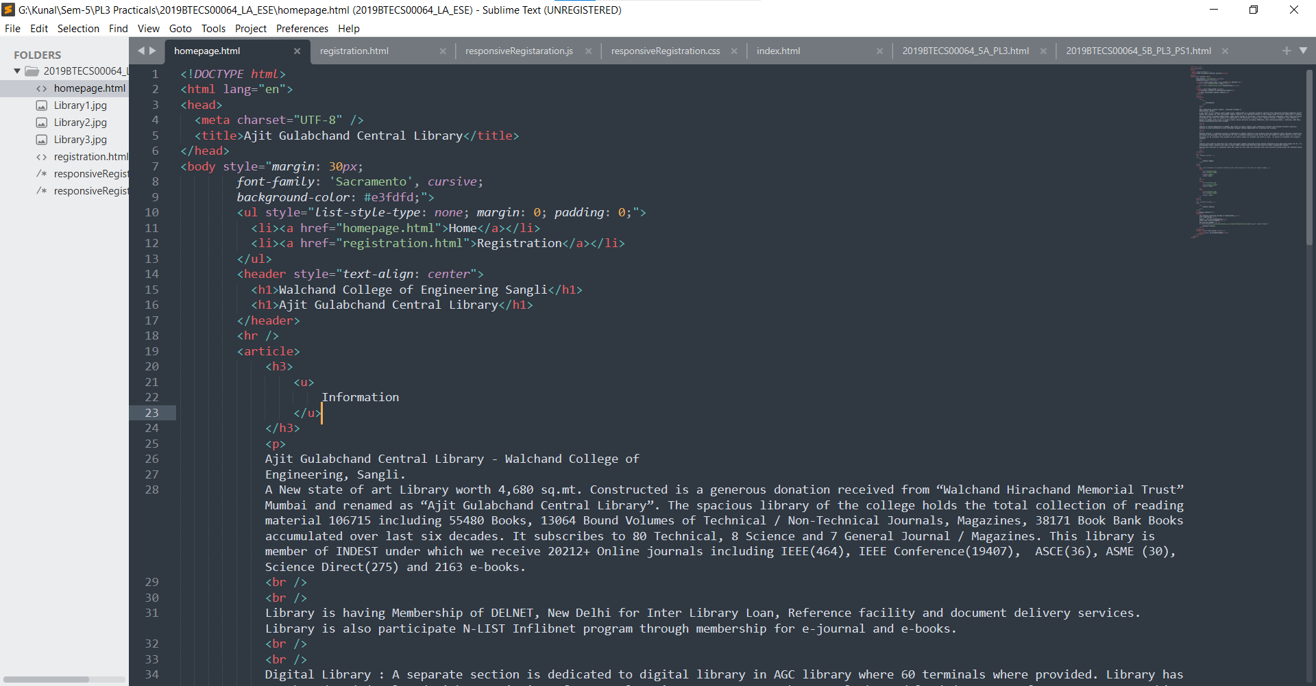

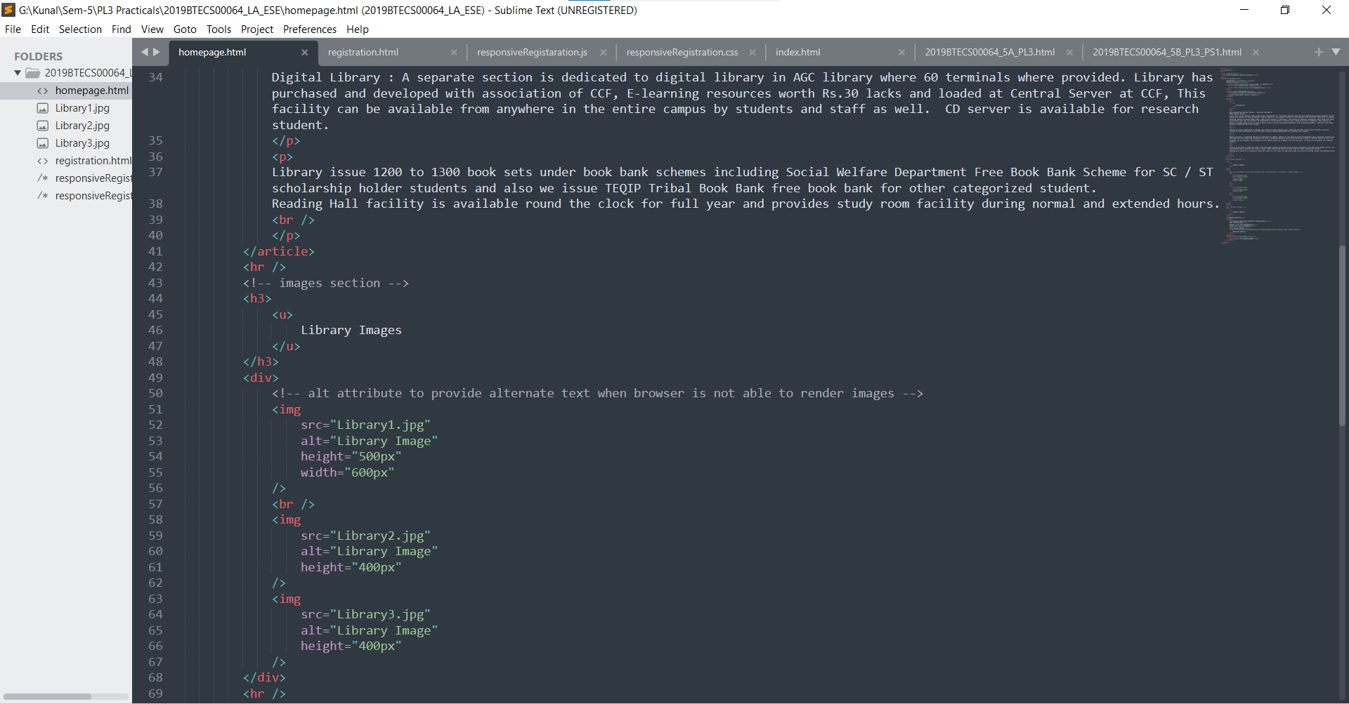

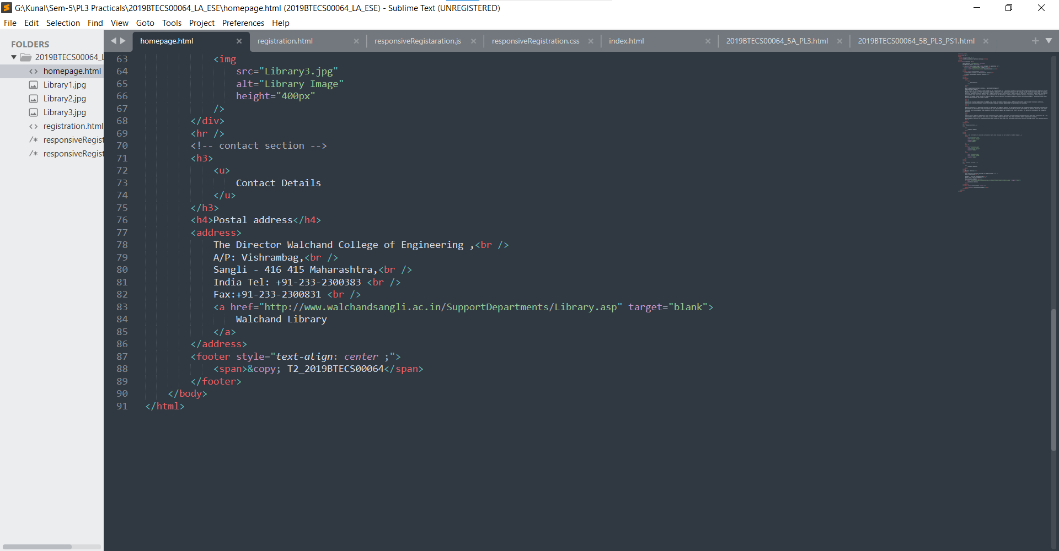

**Registration:**

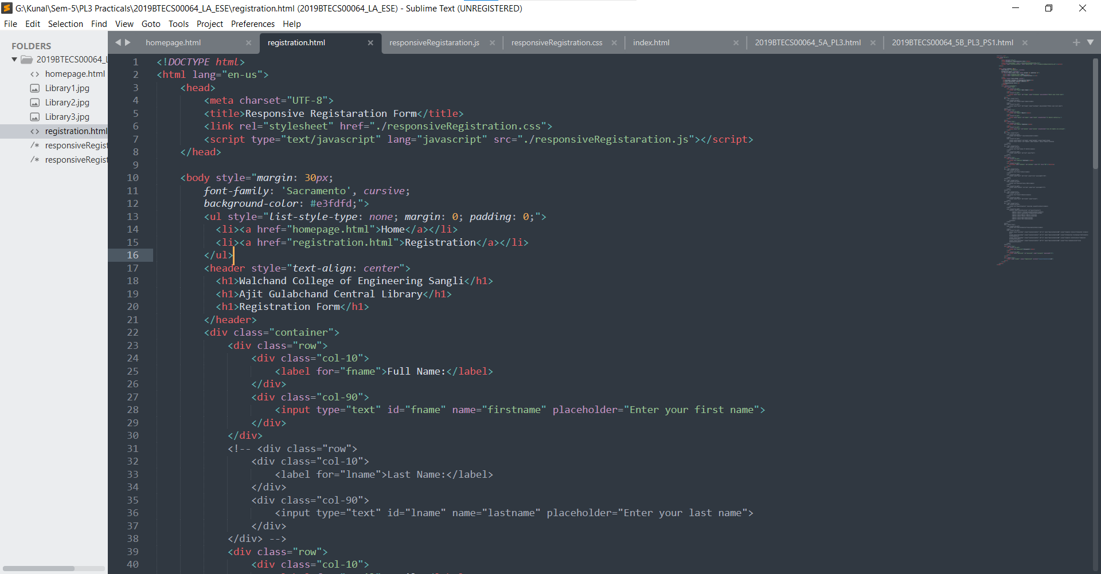

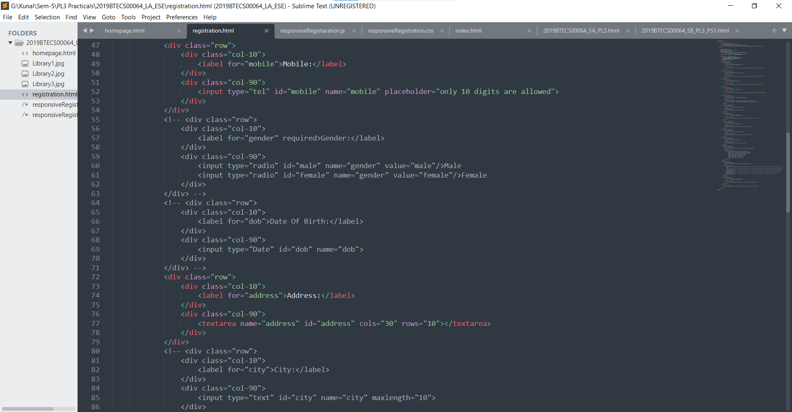

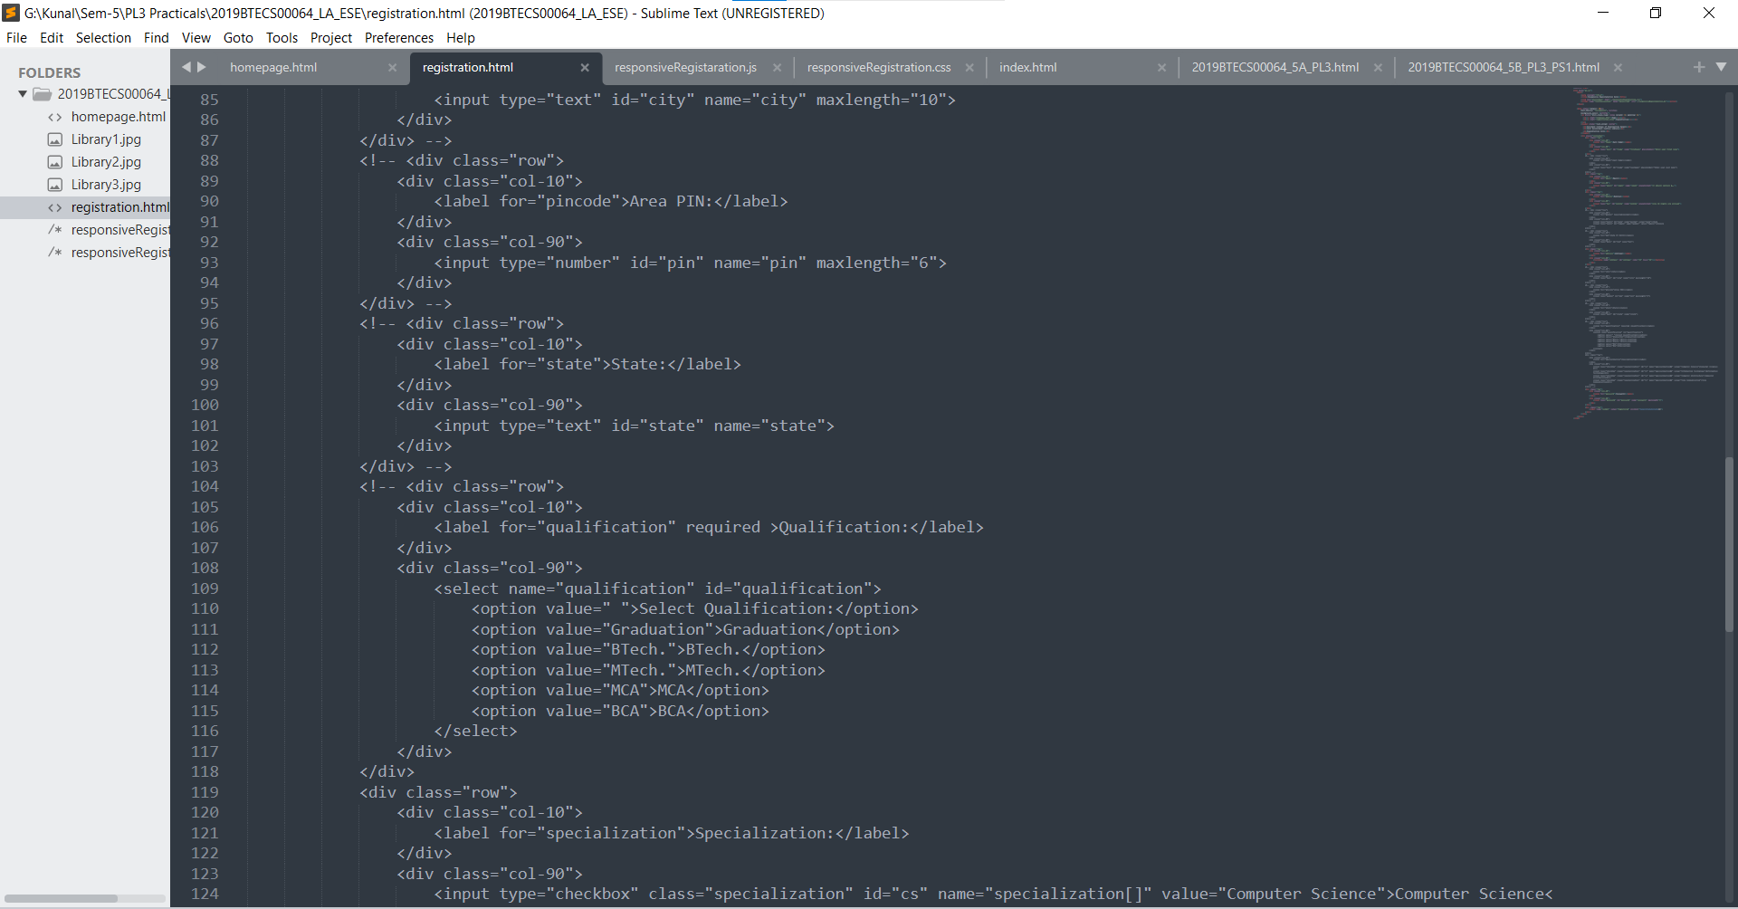

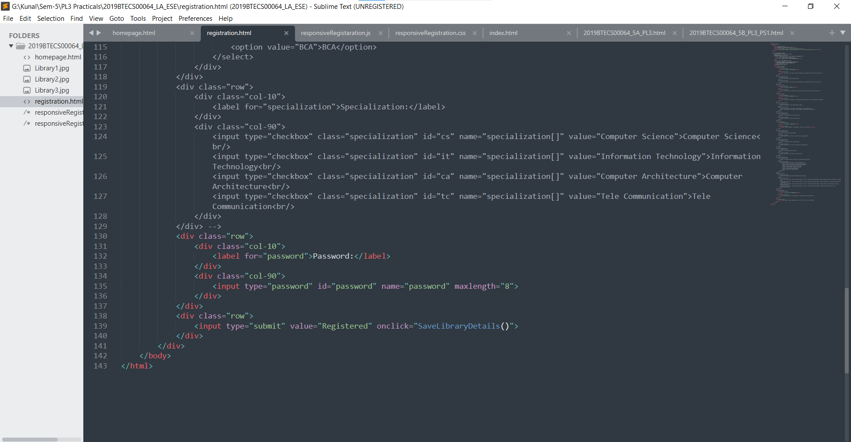

**Registration css:**

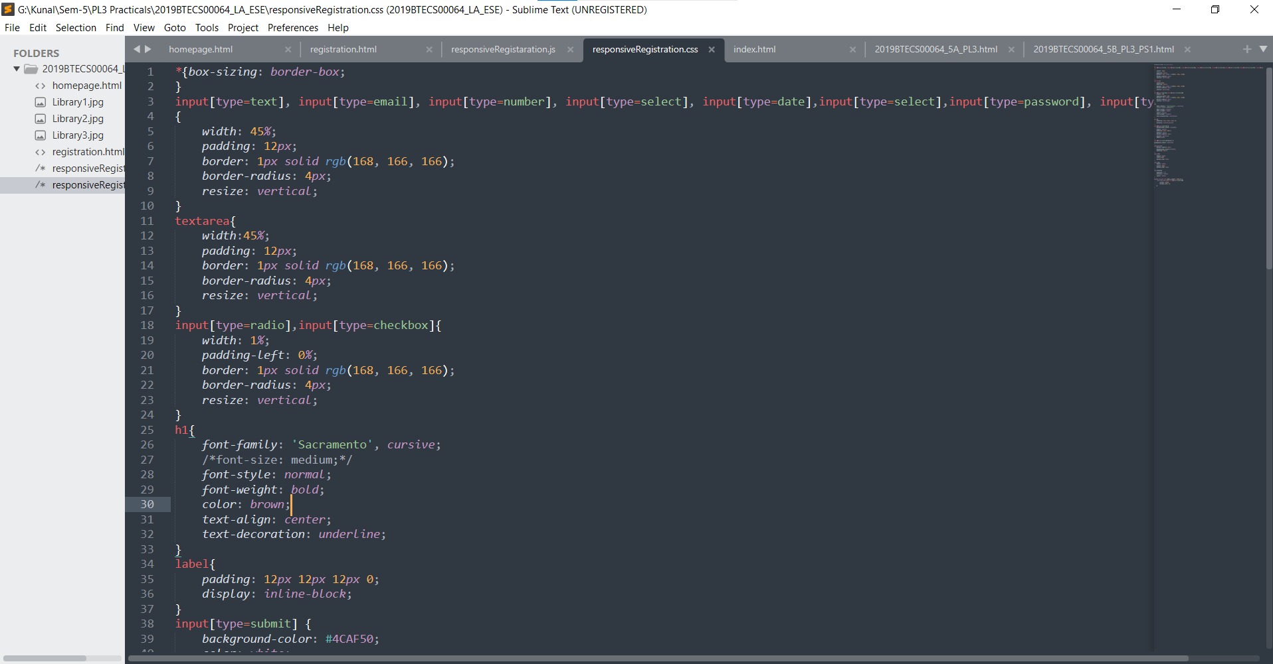

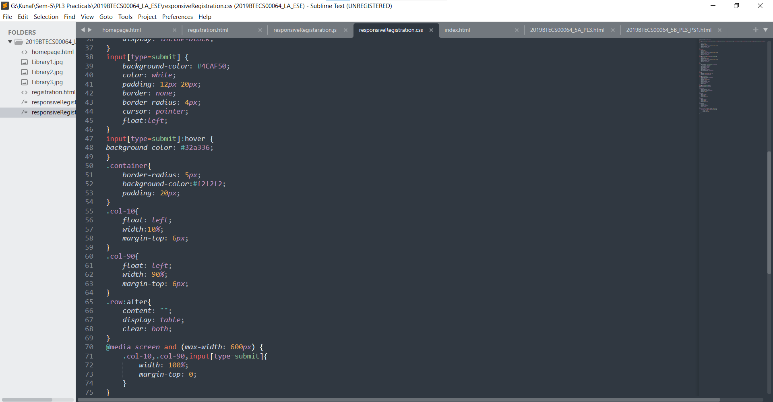

**Registration js:**

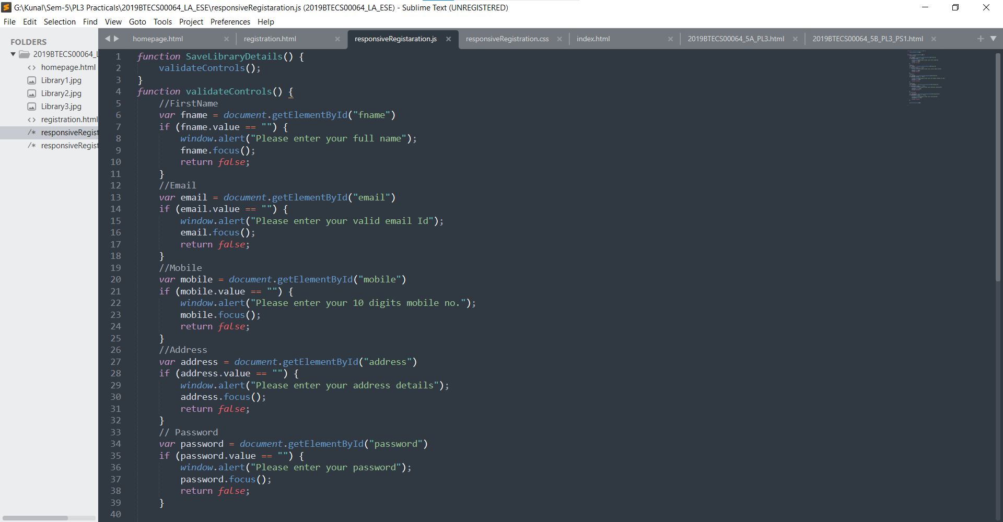

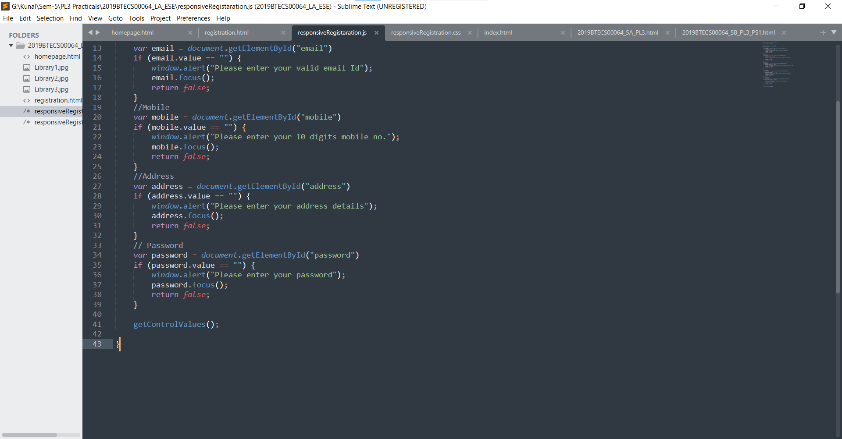

**Hosted Link:**

https://kunalkadam64.github.io/PL3-Practicals/