Date:06.09.2021

**Third Year B. Tech., Sem V 2021-22**

**Programming Lab 3**

**Practical No- 4**

**PRN/ Roll No: 2019BTECS00064**

**Full name: Kunal Santosh Kadam**

**Batch: T2**

**Title of Practical: To install and configure web server**

Problem Statement 1:

1. Install a web server on your machine. Run the server locally.

Ans:

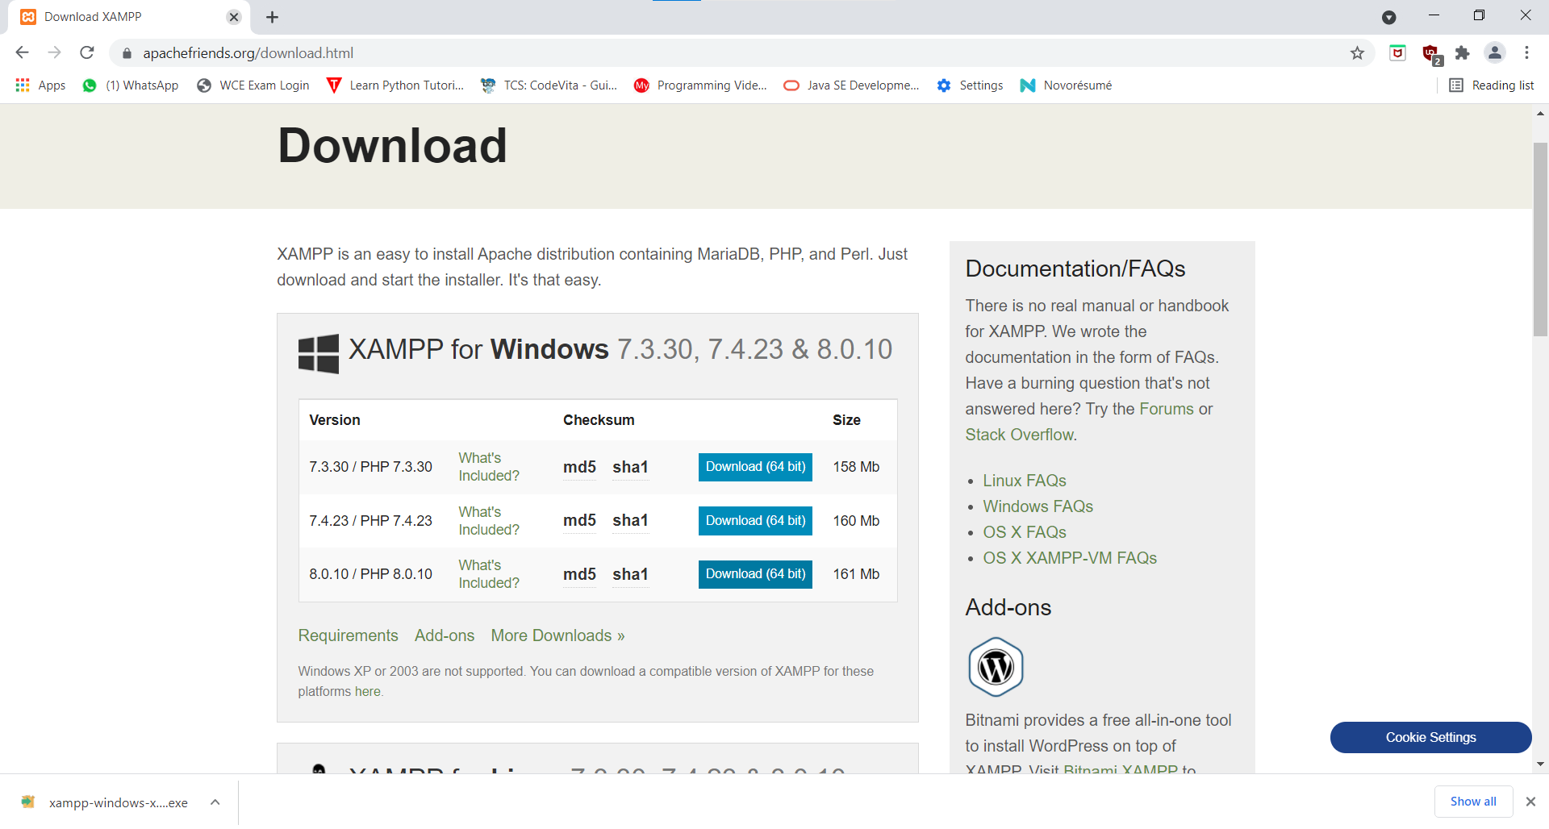

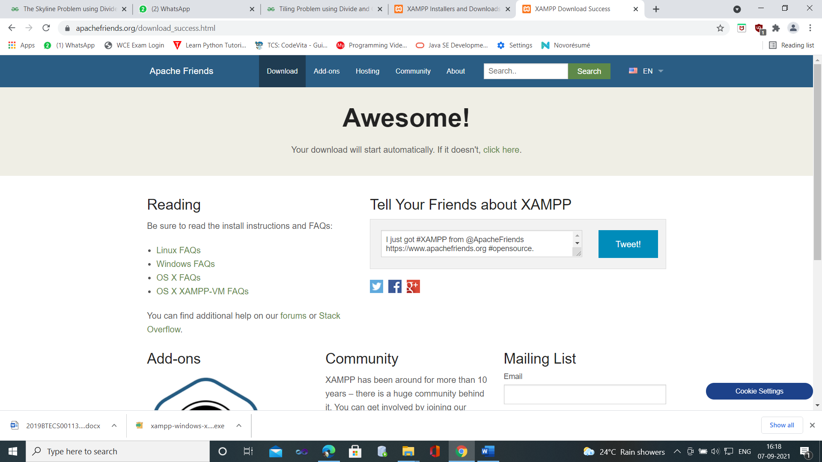

Install

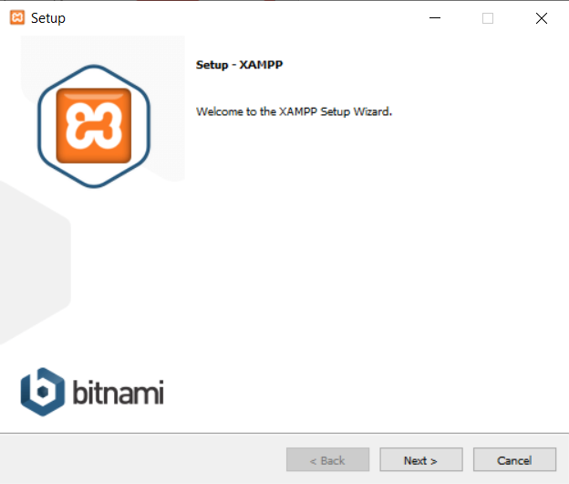

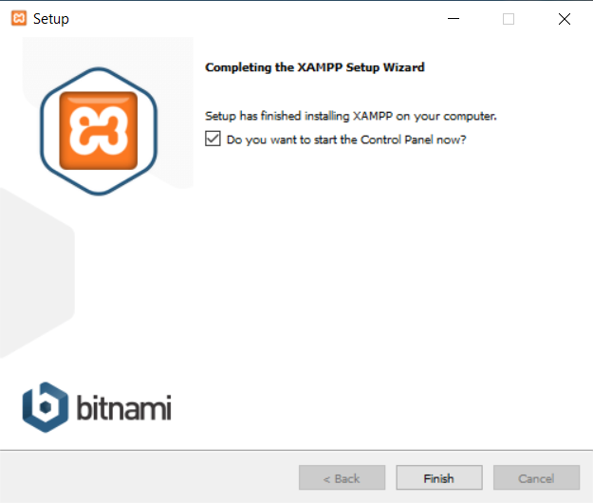

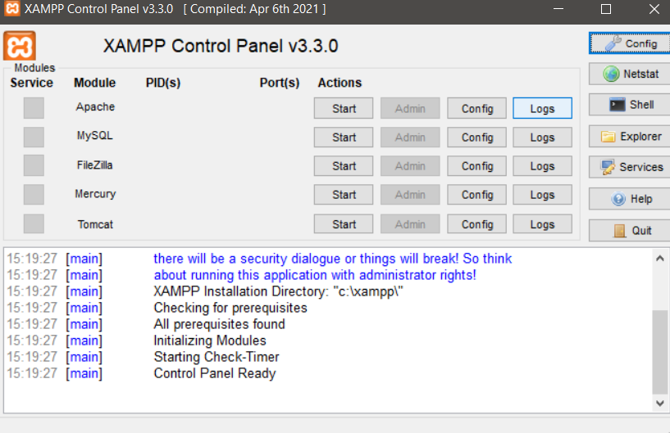

Running server:

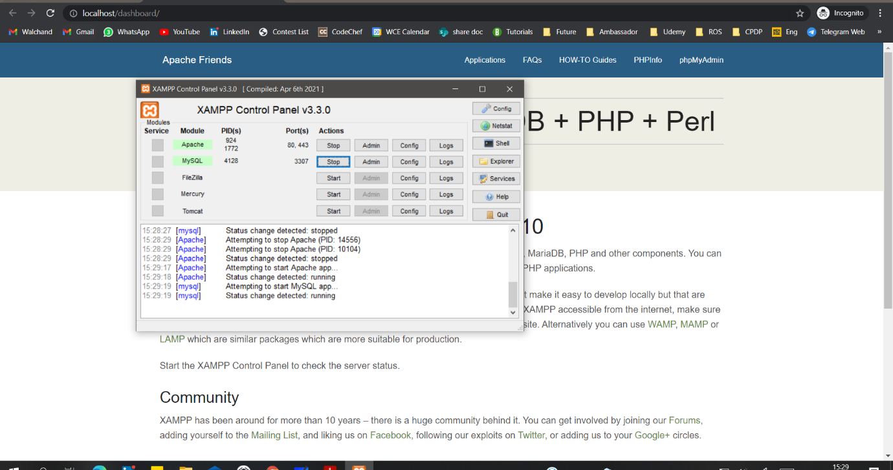

1. Locate and study its configuration file.

Ans:

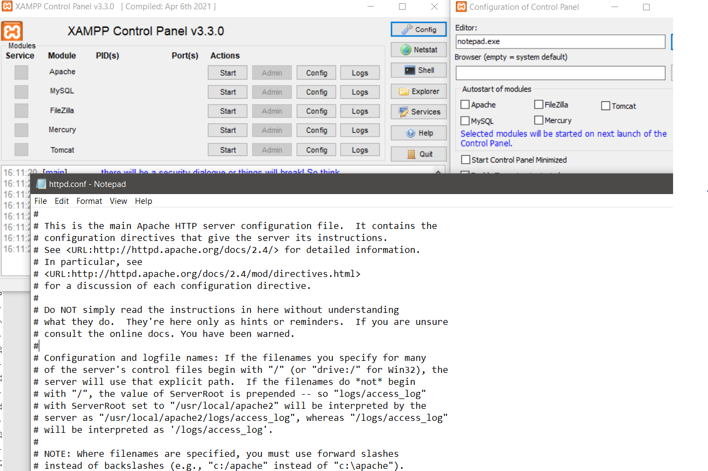

1. Change the port number in the configuration file to any other valid port number. Re-run the server locally using newly assigned port number.

Ans:

Old Port Number:

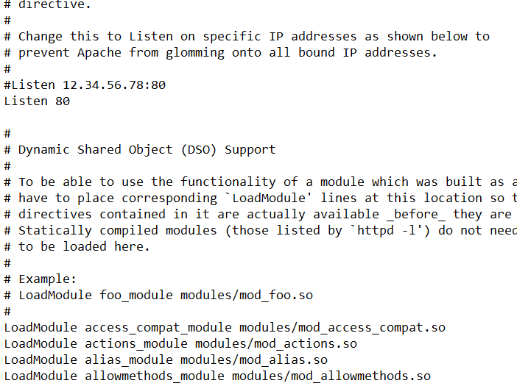

New Port Number

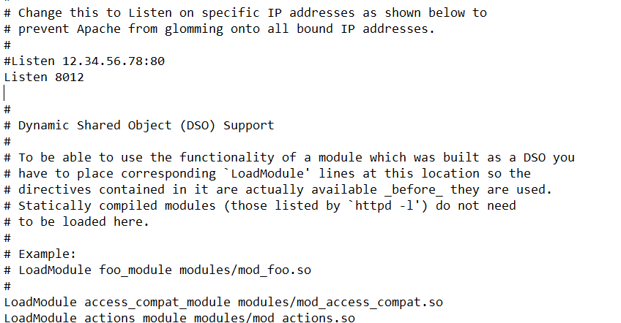

Old SSL port

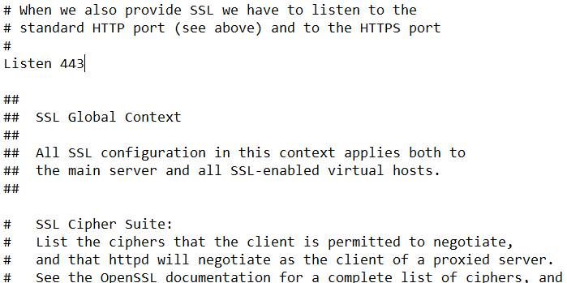

New SSL port

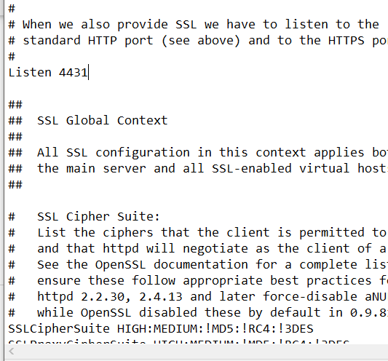

Running server with new port number

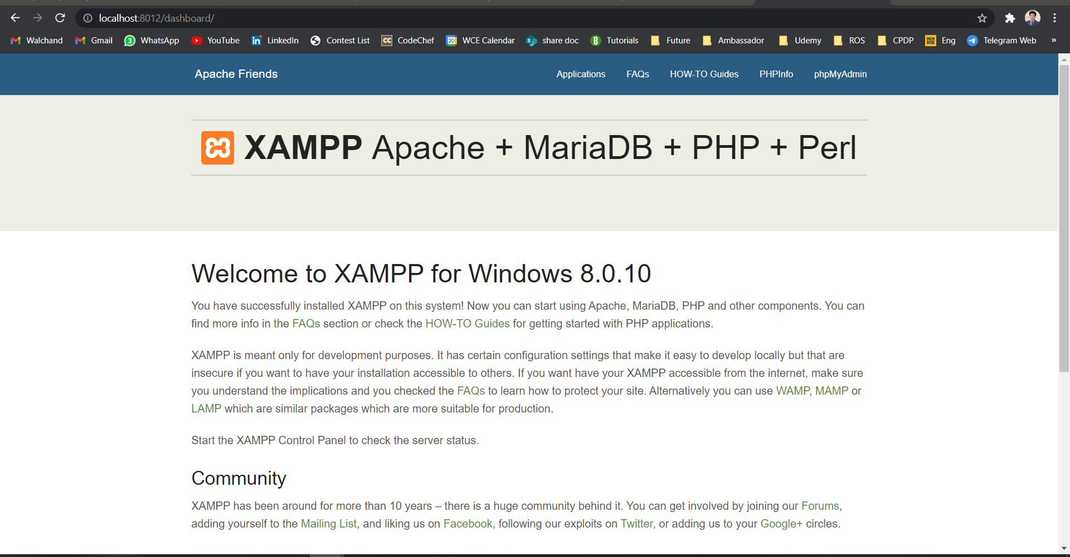

1. Change the default IP address (127.0.0.1 or localhost) and port number of the server in the configuration file to any other valid IP address and port number. Re-run the server and access it in a network from another machine.

Ans:

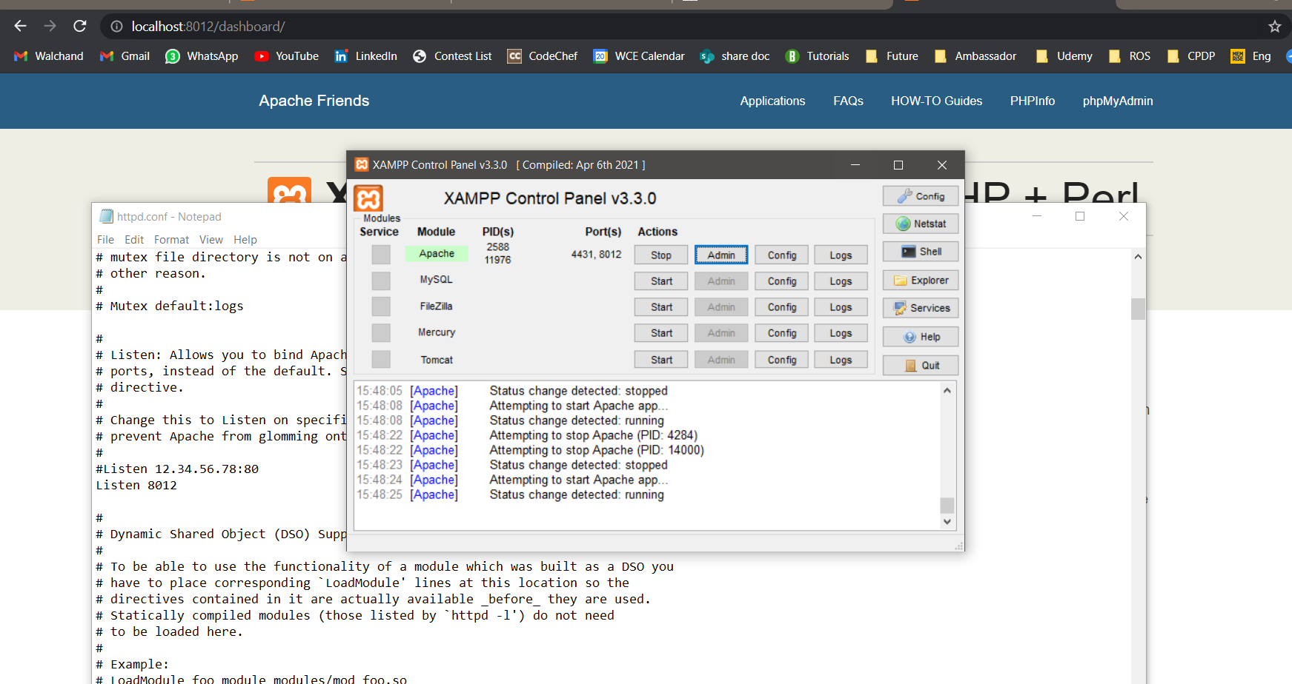

Running Server with old IP address(localhost)

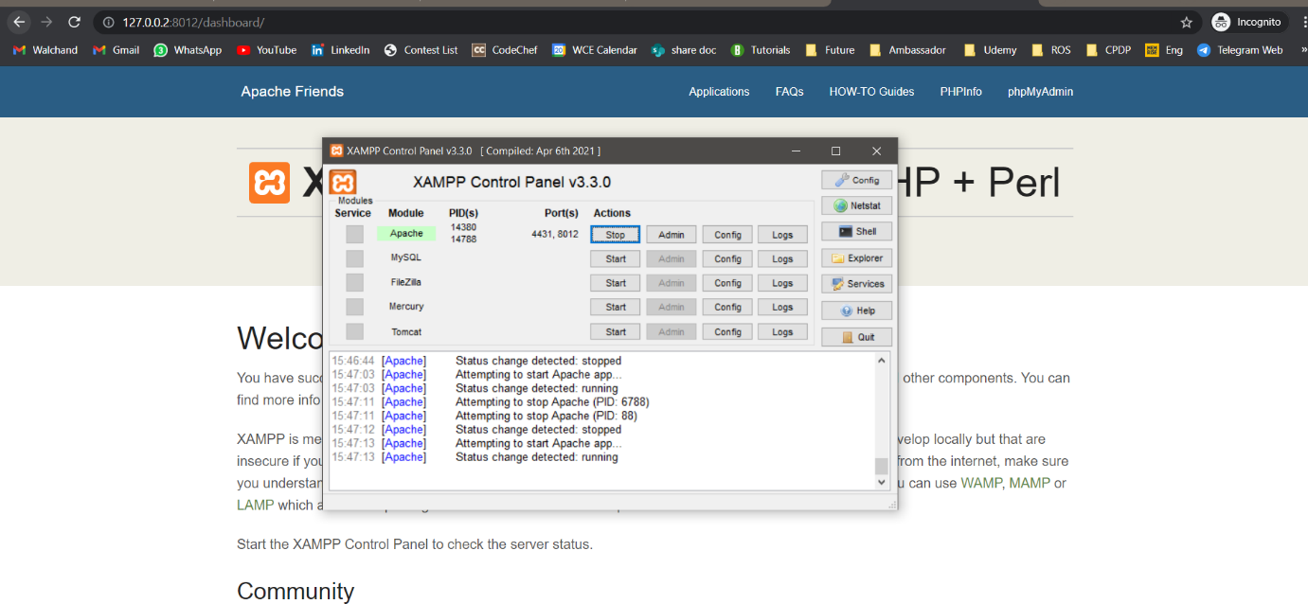

Running Server with New IP address (127.0.0.2 with port 8012)