Date:16.10.2021

**Third Year B. Tech., Sem V 2021-22**

**Programming Lab 3**

**Practical No- 5A**

**PRN/ Roll No: 2019BTECS00064**

**Full name: Kunal Santosh Kadam**

**Batch: T2**

**Title of Practical: To design and develop web pages using HTML fundamental and formatting elements**

**Problem Statement 1:**

Design a static web page using HTML for **Physics Department** information. Access it locally and in LAN using web server.

It should have following sections:

1. Department Information
2. Department Images
3. Contact Details

It should have following tags:

1. Only one **<h1> tag**
2. At least one **<h2> to <h6> tag**
3. At least one **<p> tag**
4. HTML5 **semantic tags**
5. At least one **anchor tag**
6. At least one **<br> tag**
7. At least one **<img> tag**
8. At least one **comment tag**

**Ans:**

**Code:**

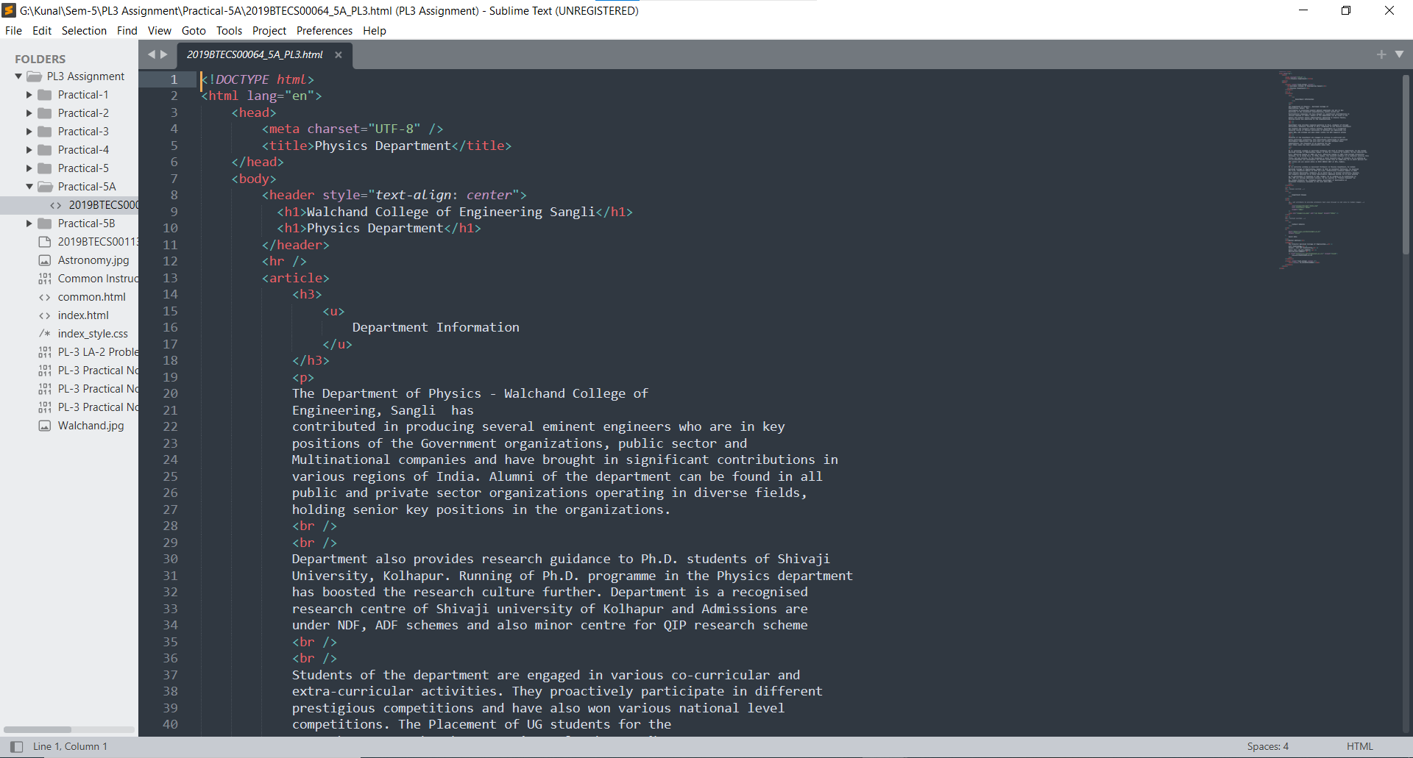

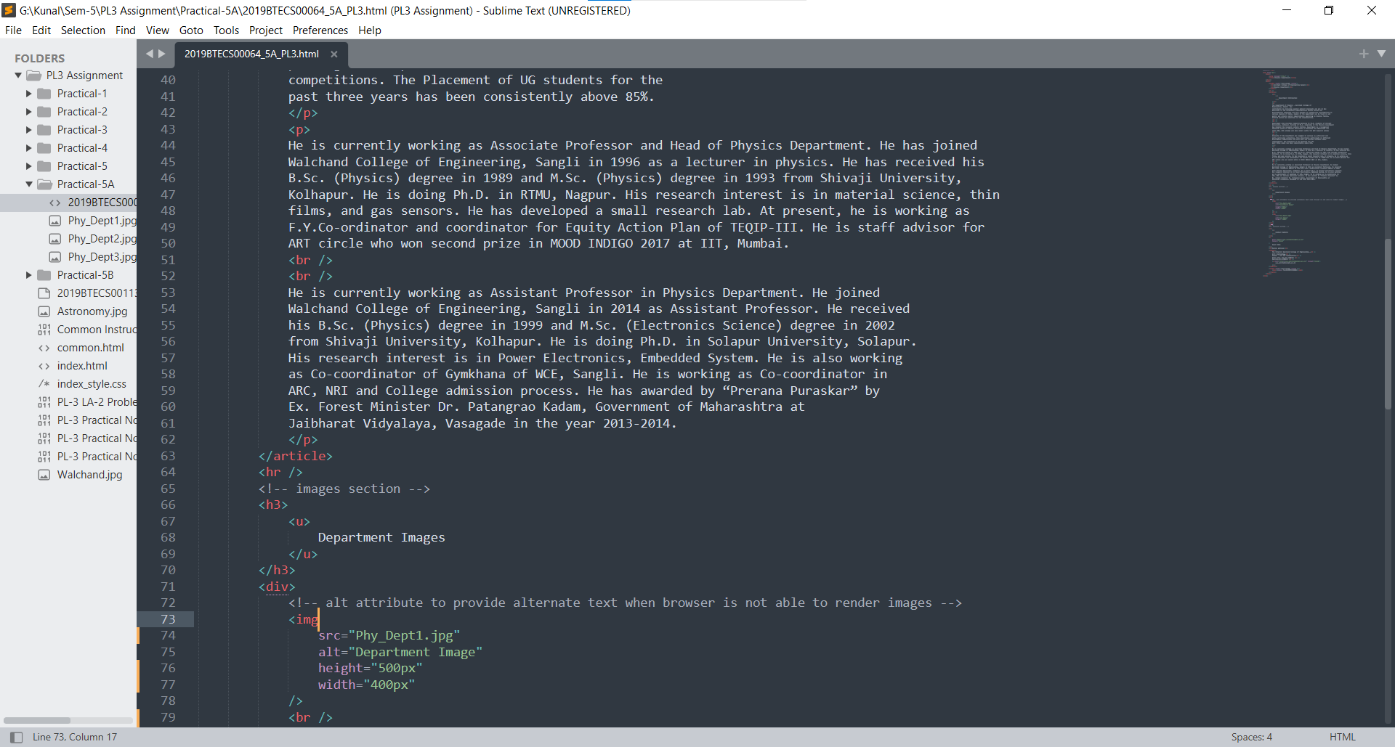

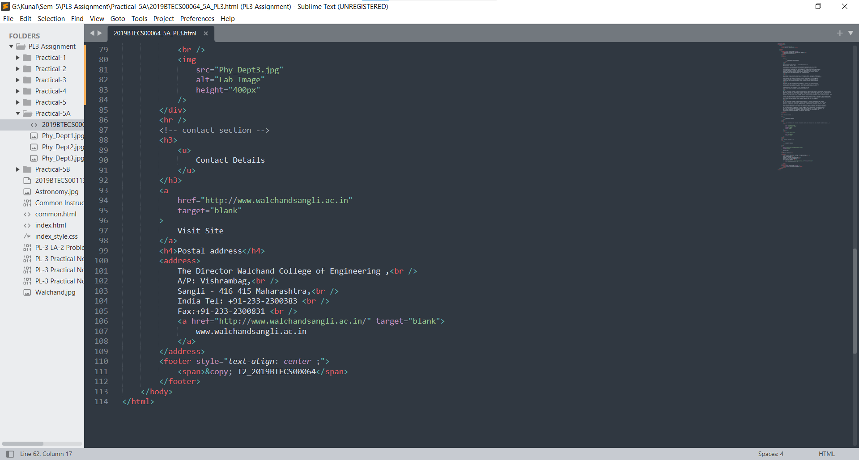

**Output:**

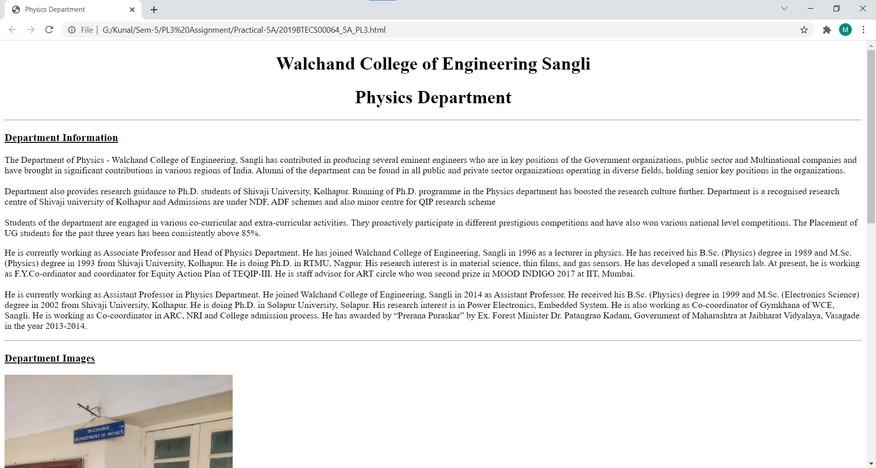

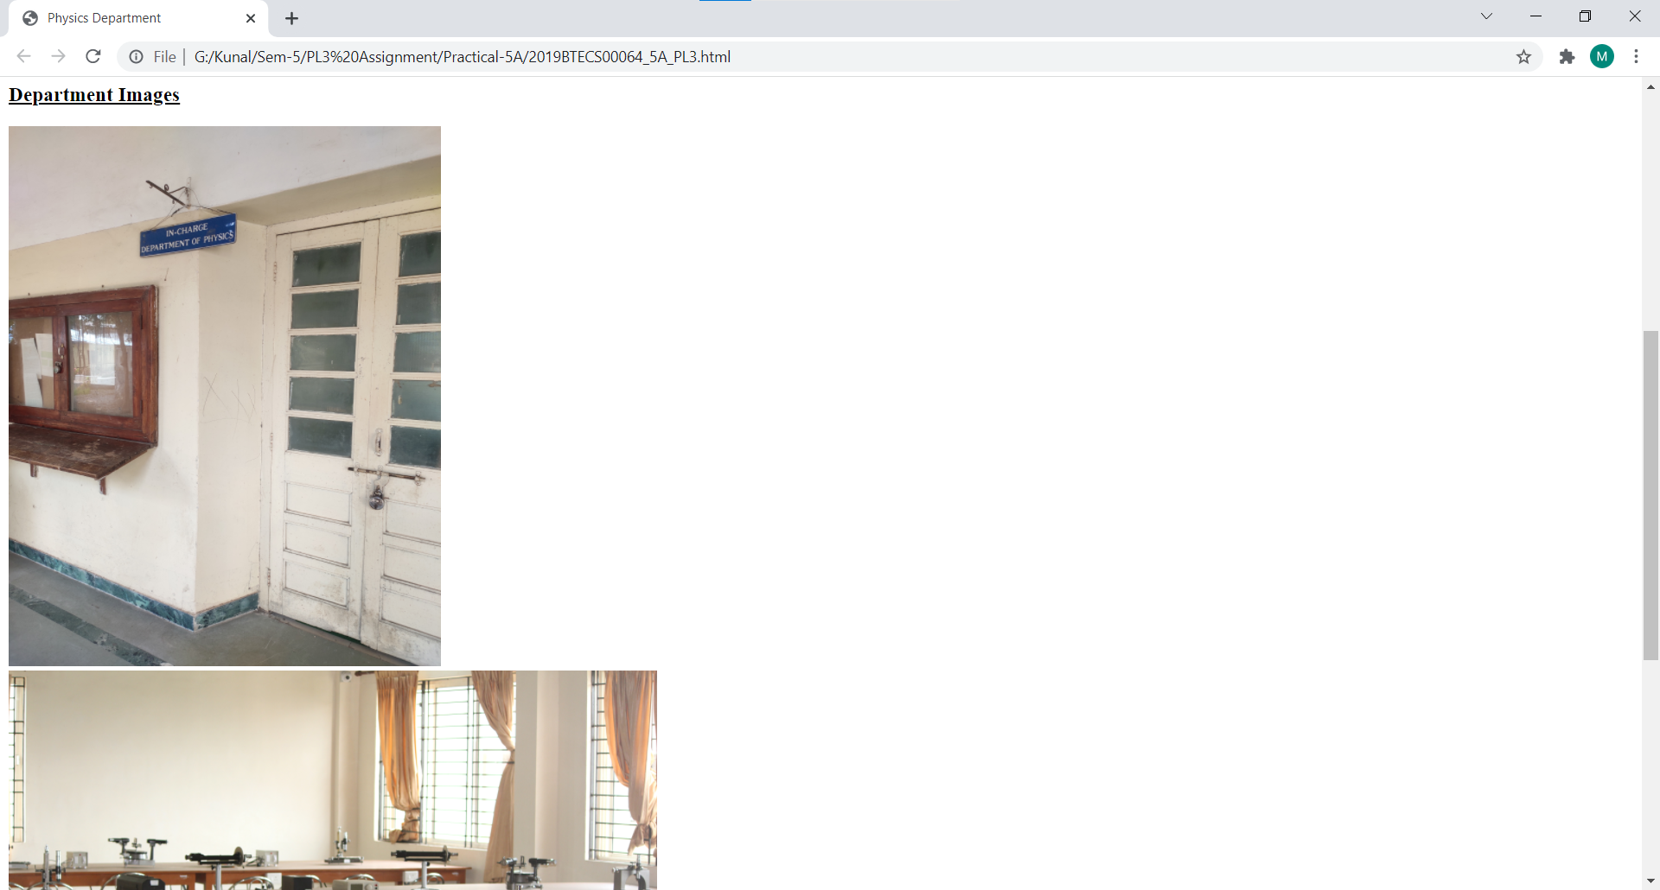

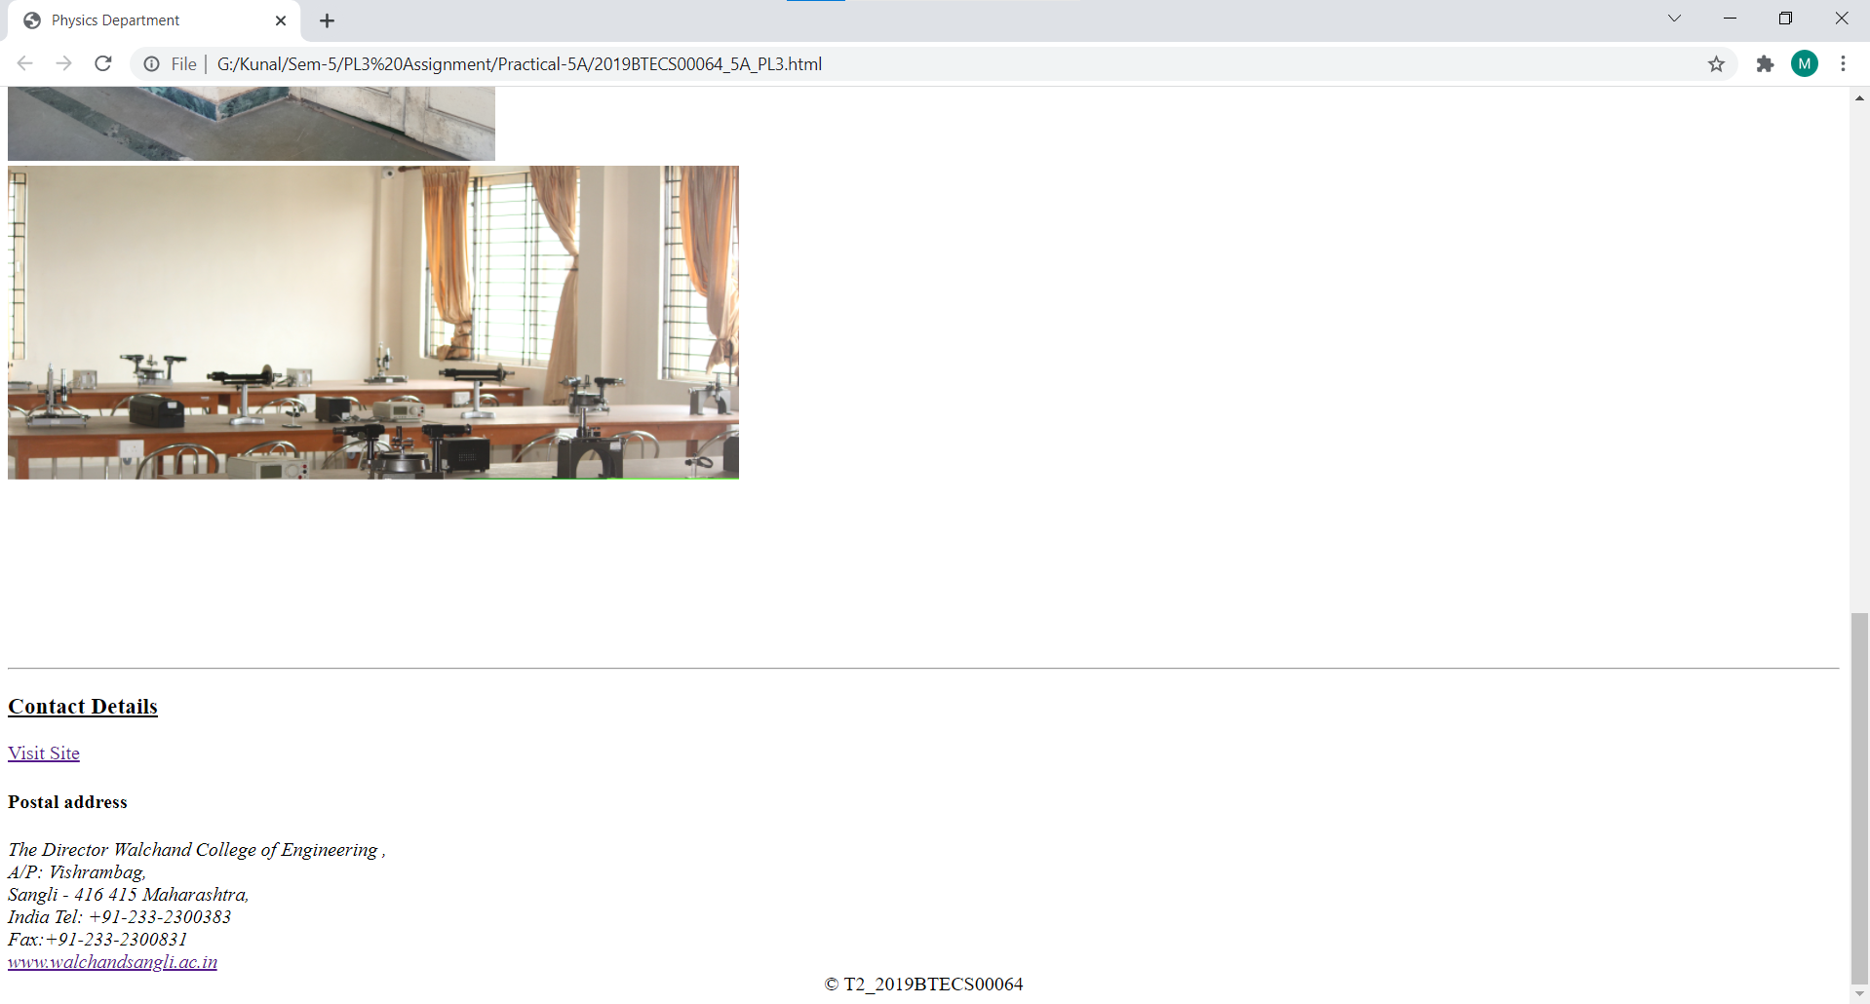

**Github Link:**

https://github.com/KunalKadam64/PL3-Practicals/tree/main/Practical-5A