Date:16.10.2021

**Third Year B. Tech., Sem V 2021-22**

**Programming Lab 3**

**Practical No- 5B**

**PRN/ Roll No: 2019BTECS00064**

**Full name: Kunal Santosh Kadam**

**Batch: T2**

**Title of Practical: To design and develop web pages using HTML fundamental and formatting elements**

**Problem Statement 1:**

Design and develop a static web page using HTML for Astronomy blog. Access it locally and in LAN using web server.

It should have following sections:

1. Header – Title and authorship information of a blog
2. Three links to other astronomy blogs
3. Article – At least two articles should be there
4. Contact Information of author

It should have following tags:

1. Use semantic tags appropriately (<section>, <header>, <footer>, <article>,
2. <aside> and <nav>)
3. Use <h1> to <h6> tags at least once.
4. Use single line break tag.
5. Use <a> tags in the articles with the absolute and relative URLs.
6. Use thematic grouping for different sections and articles using <hr> tag.
7. Use <strong> and <em> instead of <b> and <i> resp.
8. Use <address> tag for displaying author’s information.

**Ans:**

**Code:**

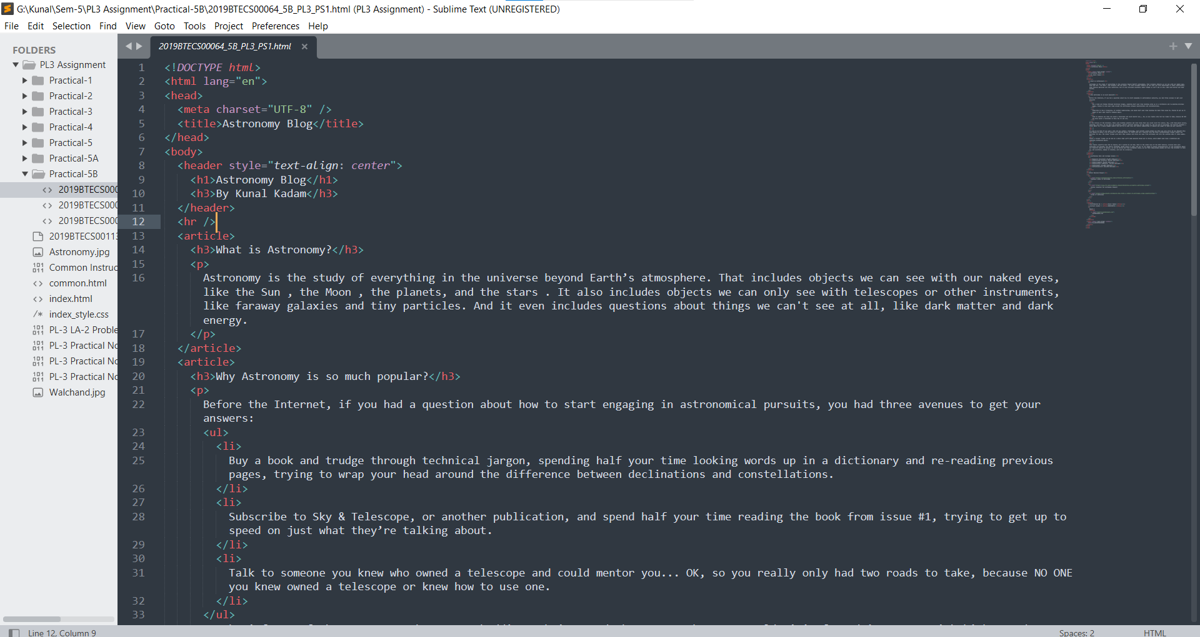

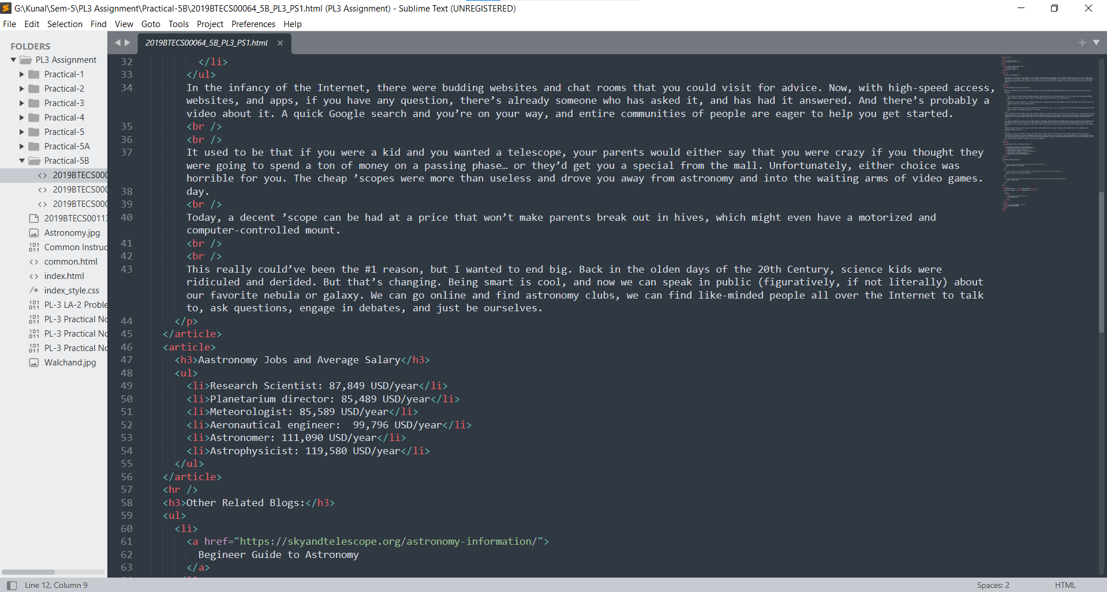

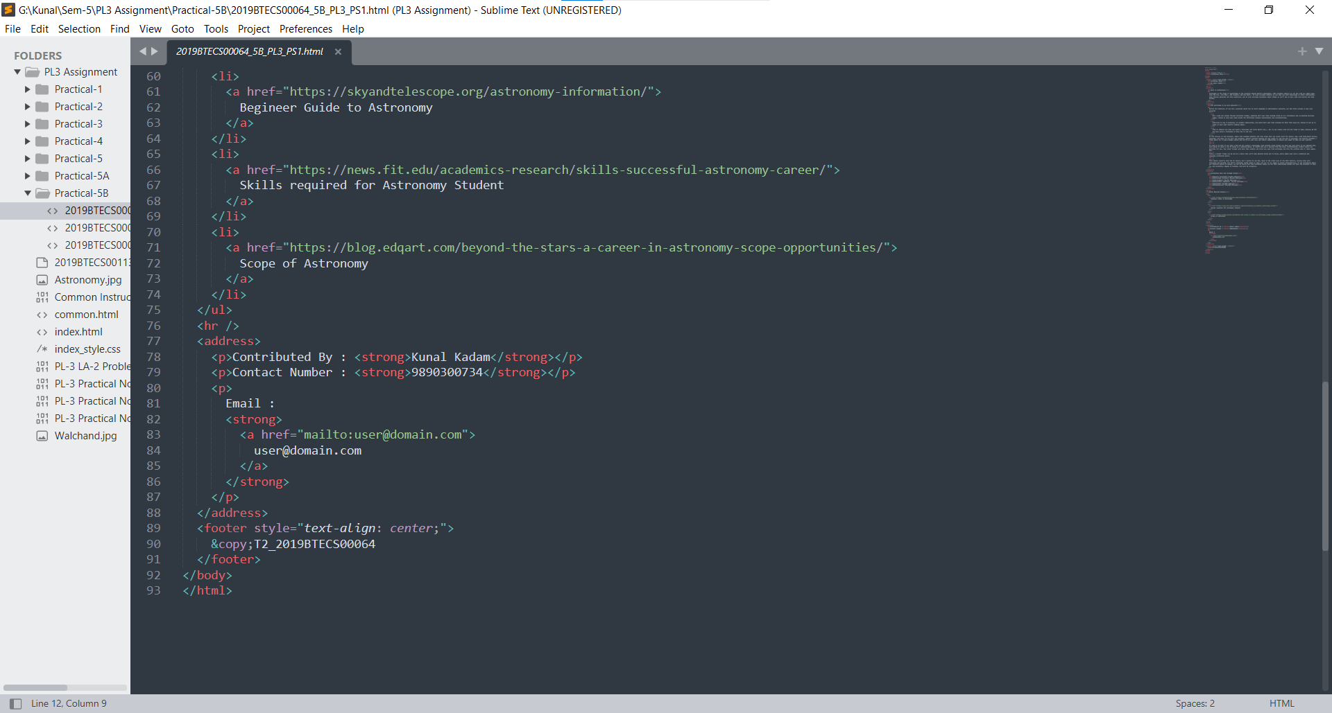

**Output:**

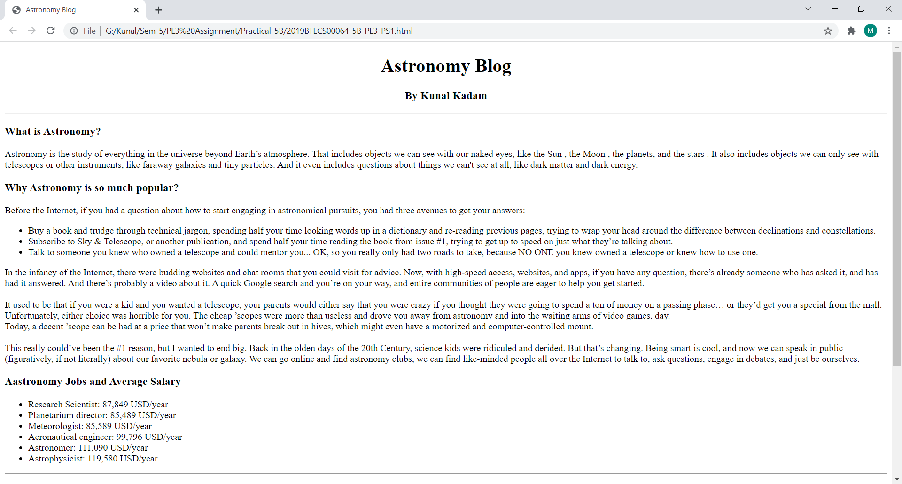

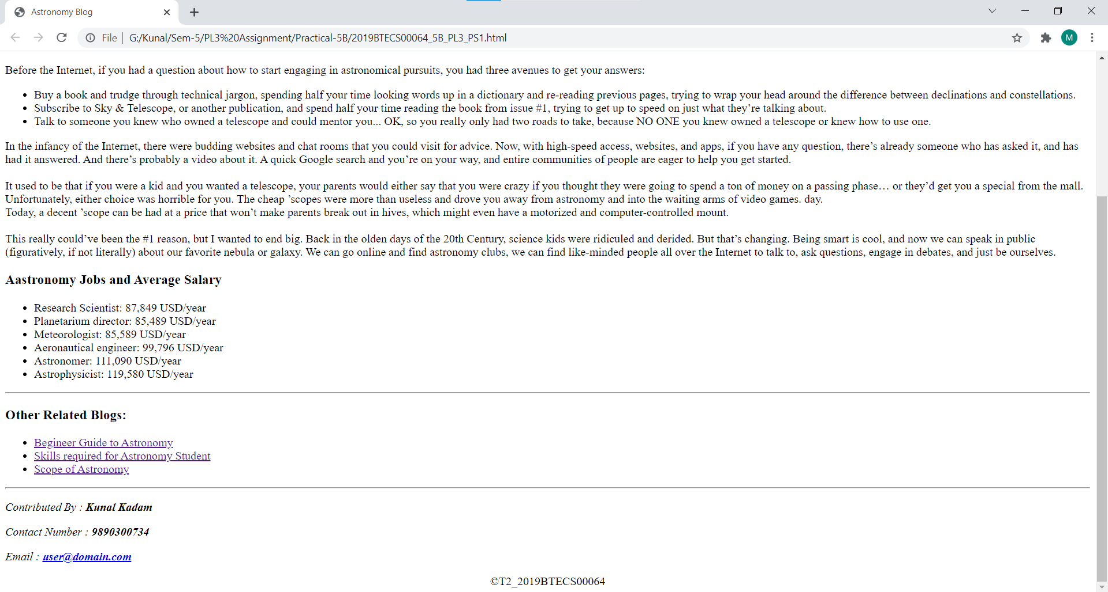

**Problem Statement 2:**

Design and develop a static web page using HTML for following requirement. Access it locally and in LAN using web server.

It should have following sections:

1. Problem Statement: Write a program in any language to read 10 numbers from keyboard and find their sum and average.
2. Code
3. Sample Input
4. Sample Output
5. Variables used in the program
6. Complexity

It should have following tags:

1. Use semantic tags appropriately (<section>, <header>, <footer>, <article>, <aside> and <nav>)
2. Use <code>, <samp>, <kbd>, and <var> at least once.
3. Use <s>, <small>, <sub> and <sup> at least once.
4. Use <h1> to <h6> tags at least once.
5. Use single line break tag.
6. Use thematic grouping for different sections using <hr> tag.
7. Add the reference link for the algorithm using <a> tag.

**Ans:**

**Code:**

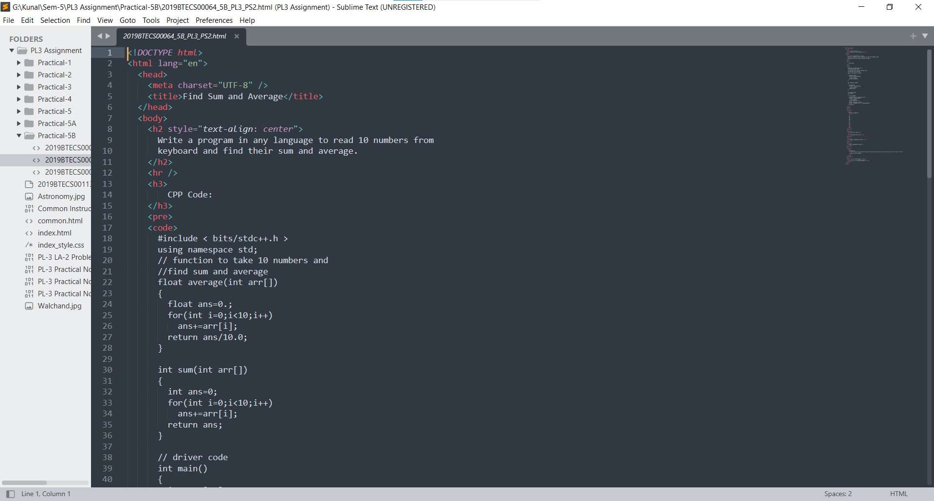

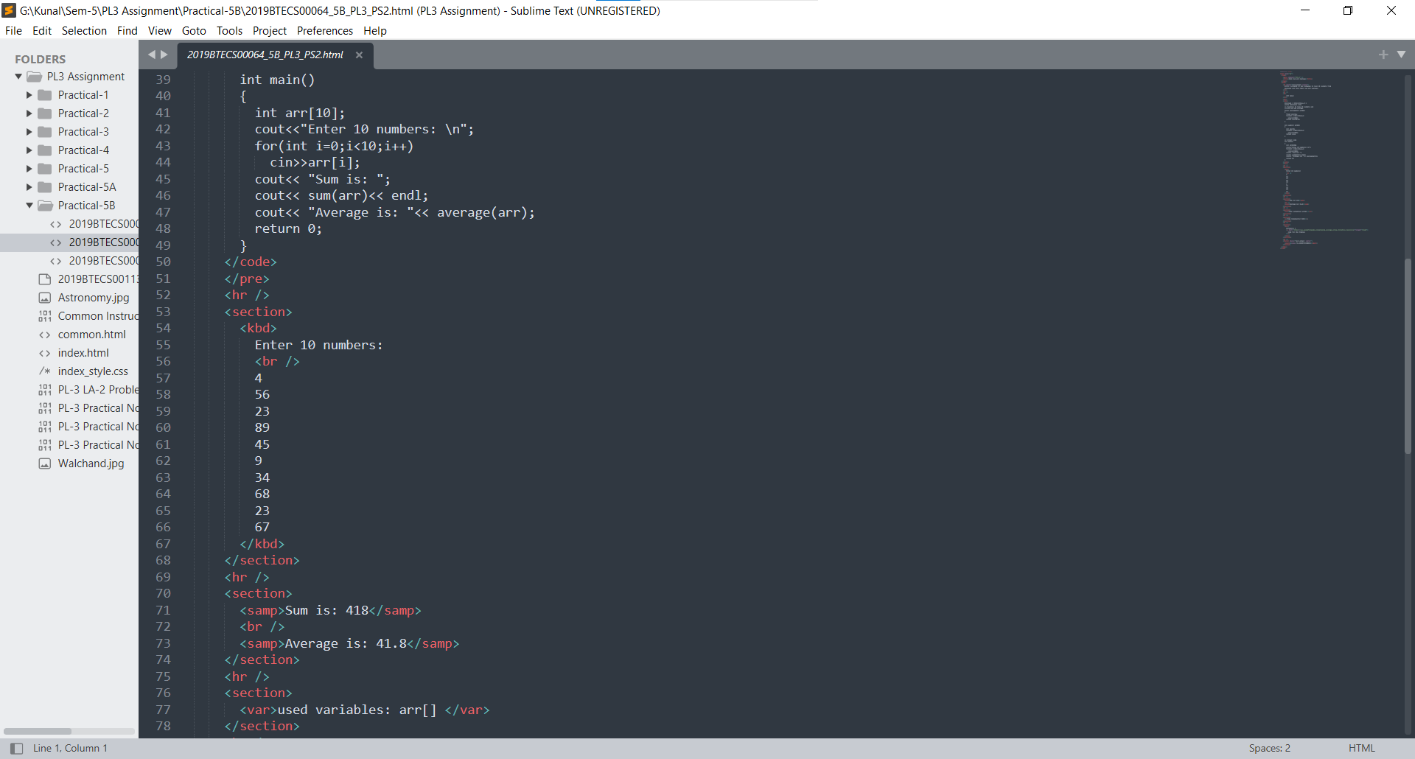

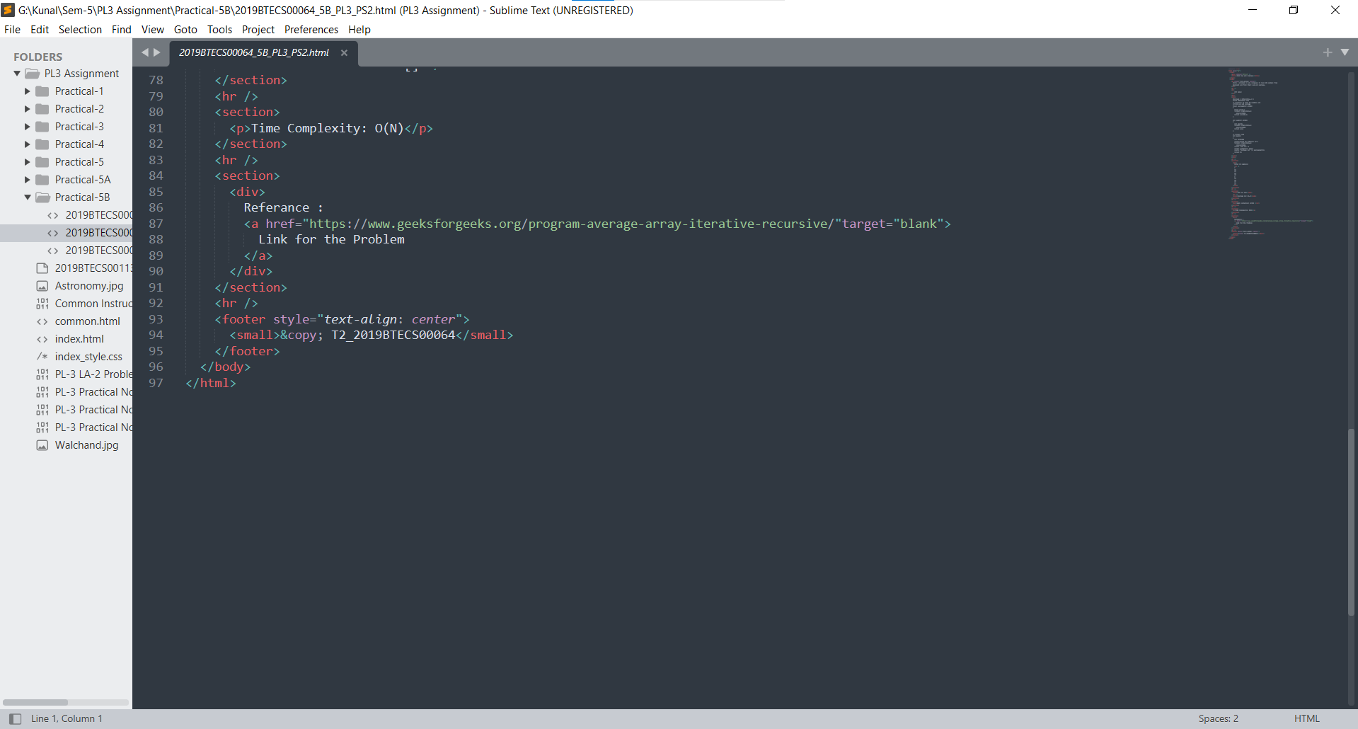

**Output:**

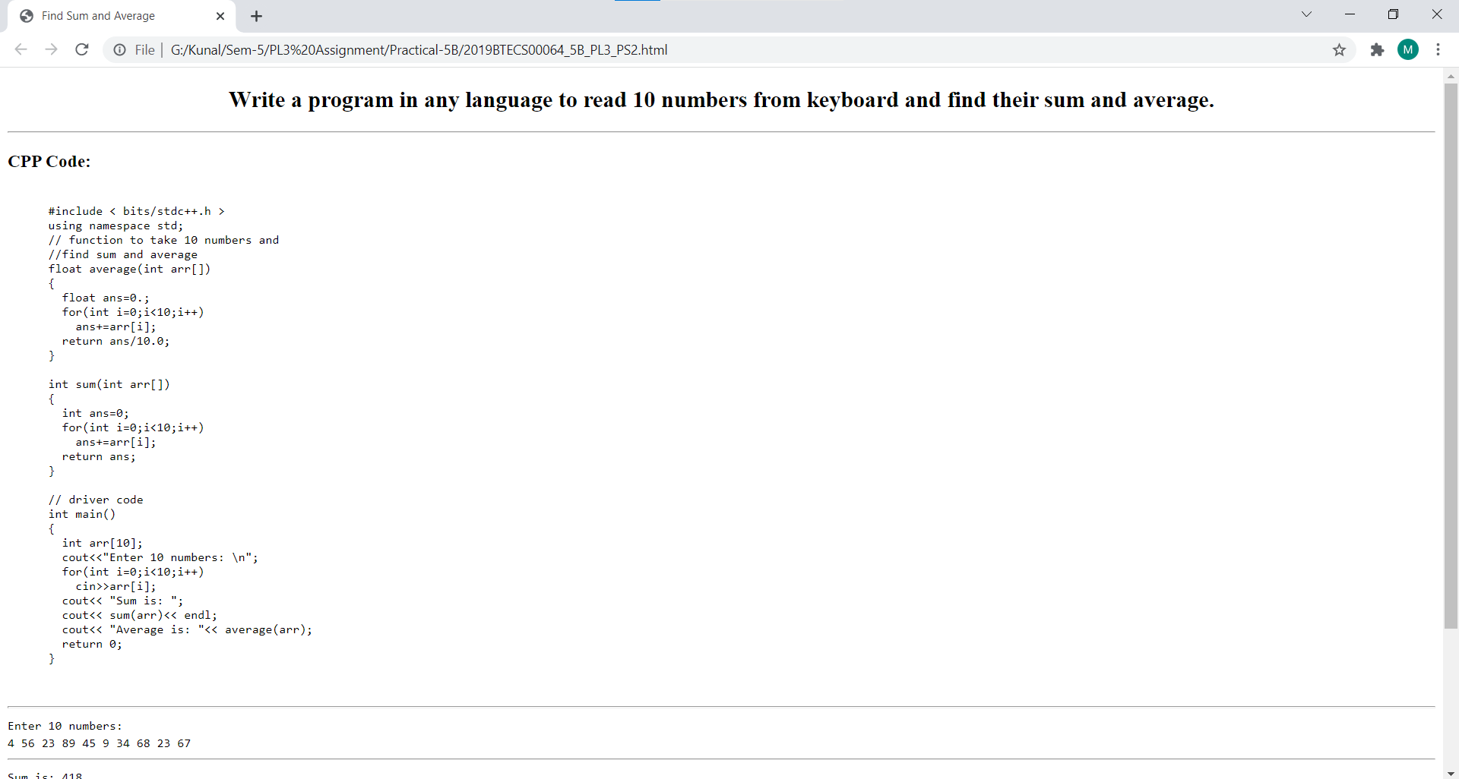

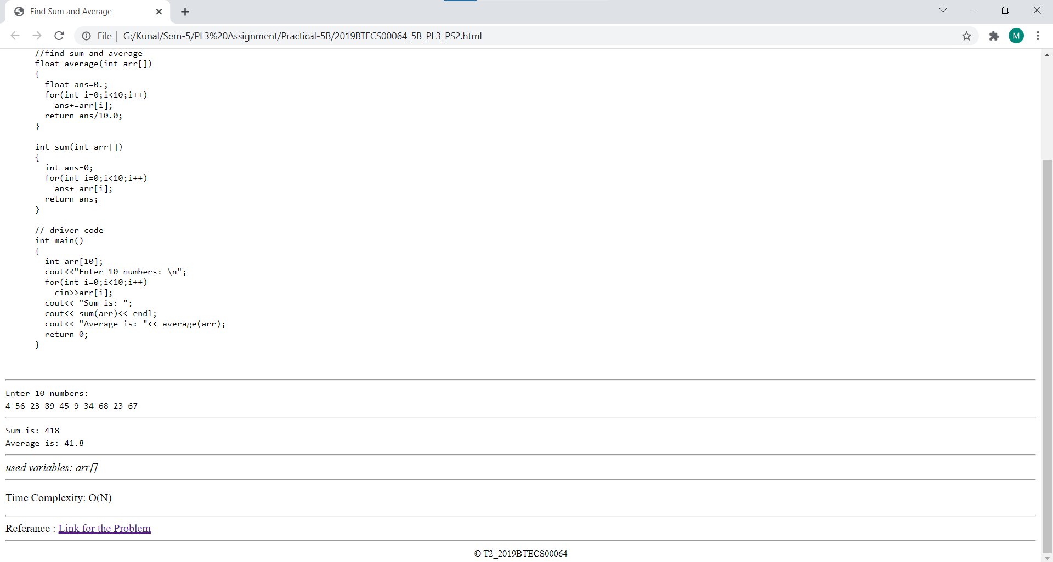

**Problem Statement 3:**

Design and develop a static web page using HTML for following requirement. Access it locally and in LAN using web server.

It should have following sections:

1. Any three quotes from https://www.brainyquote.com/ with the name of person who quoted it.

It should have following tags:

1. Use semantic tags appropriately (<section>, <header>, <footer>, <article>, <aside> and <nav>)
2. Use <blockquote> and <quote> tags.
3. Use <h1> to <h6> tags at least once.
4. Use single line break tag.
5. Use thematic grouping for different sections using <hr> tag.
6. Add the reference link using <a> tag.

**Ans:**

**Code:**

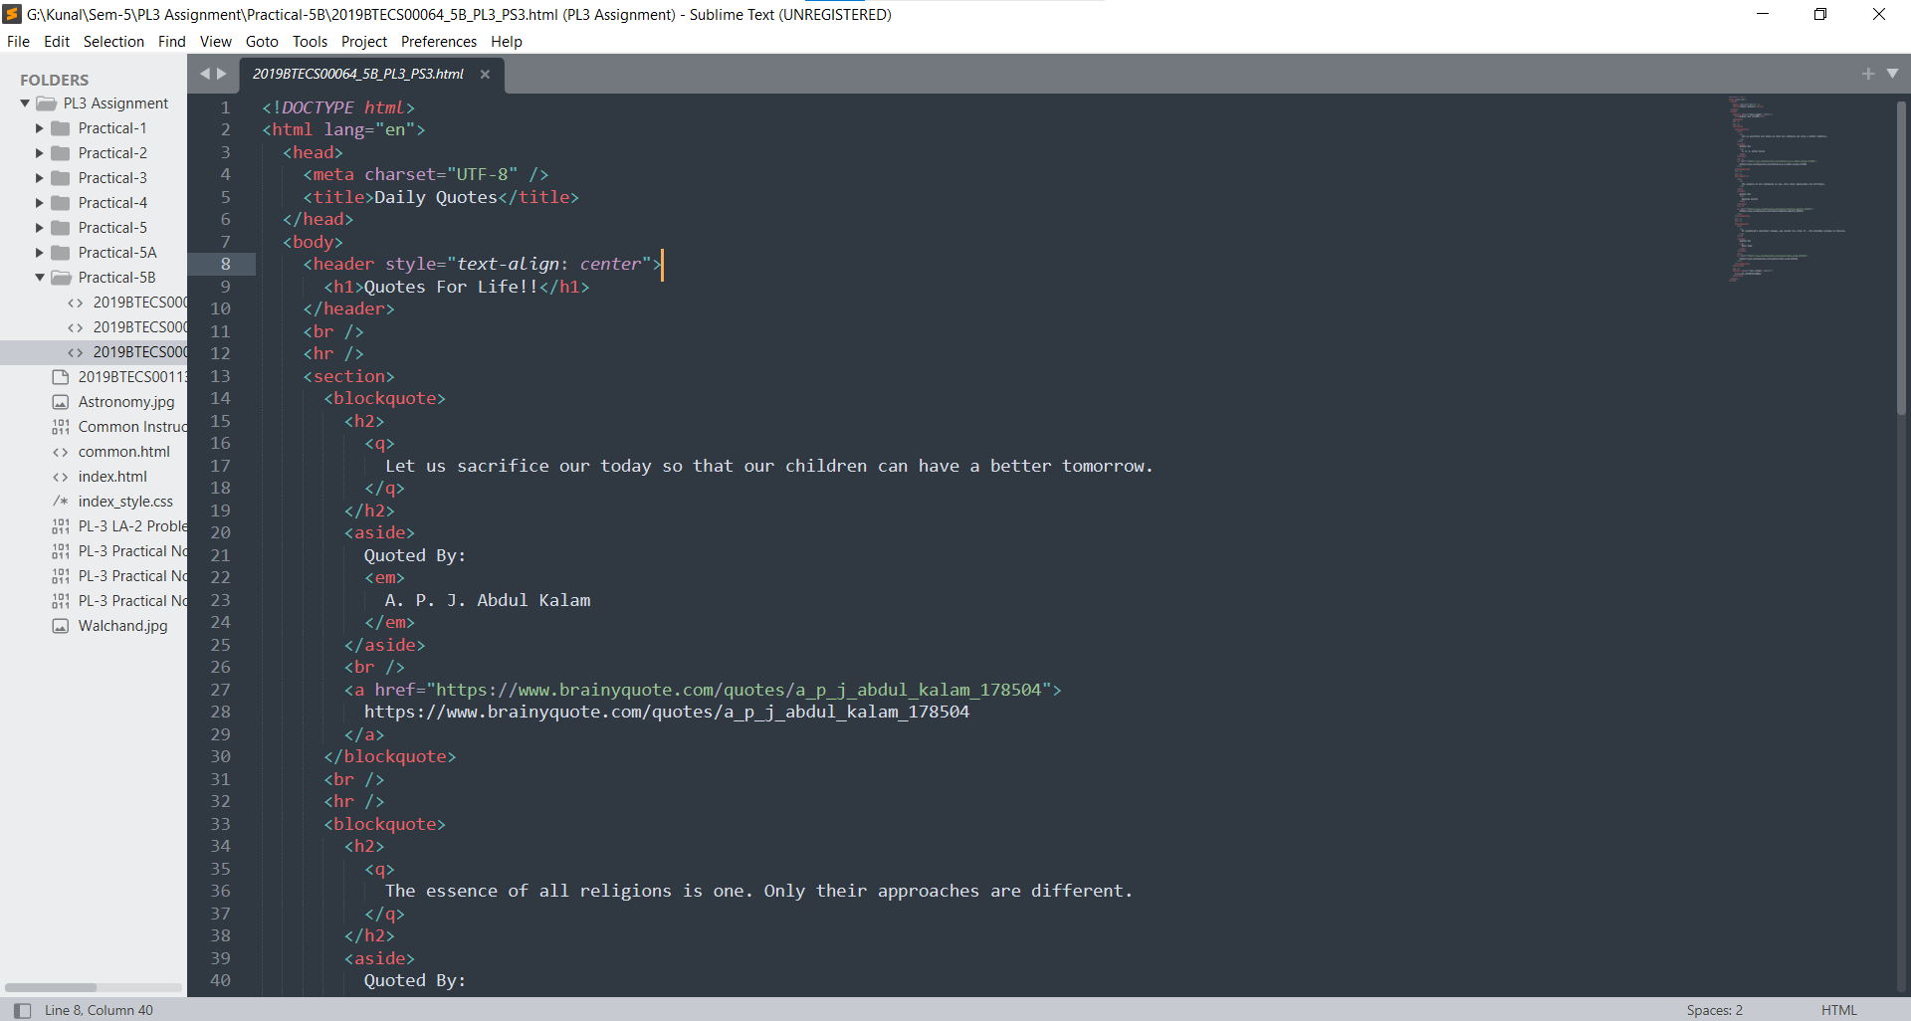

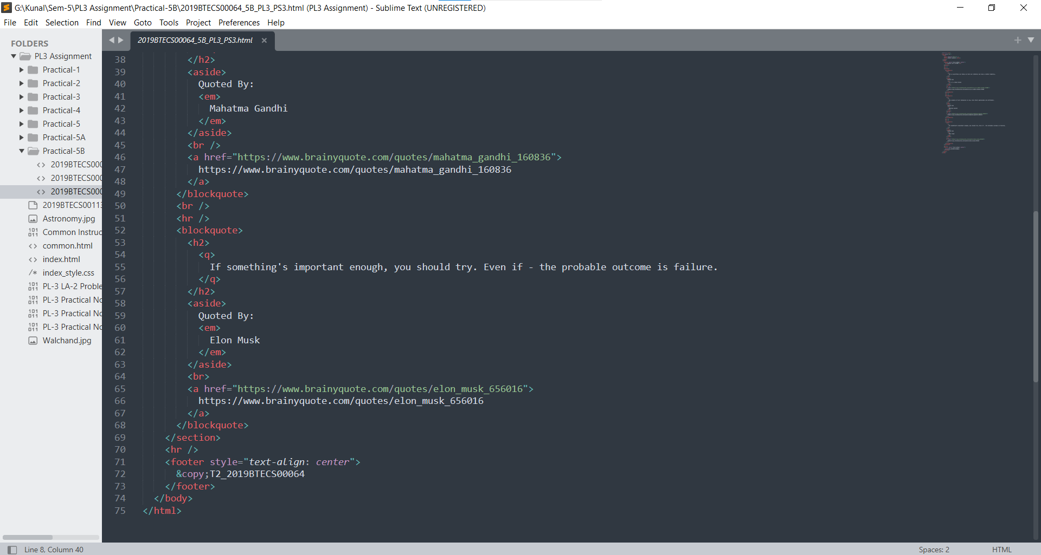

**Output:**

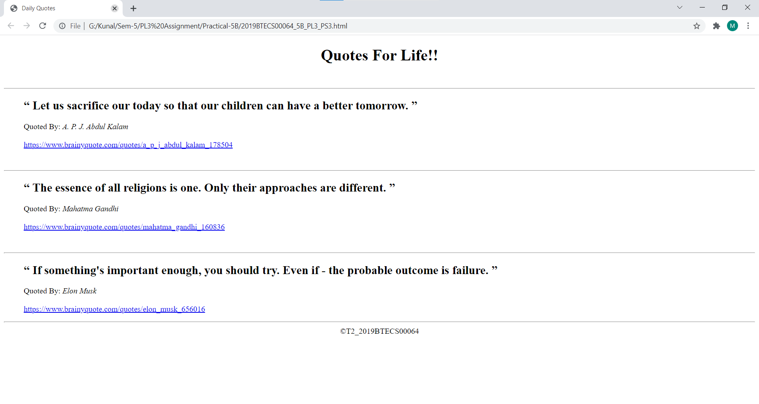

**Github Link:**

https://github.com/KunalKadam64/PL3-Practicals/tree/main/Practical-5B