Date:20.11.2021

**Third Year B. Tech., Sem V 2021-22**

**Programming Lab 3**

**Practical No- 6**

**PRN/ Roll No: 2019BTECS00064**

**Full name: Kunal Santosh Kadam**

**Batch: T2**

**Title of Practical: To install and configure Node.js server and IDE.**

**Problem Statement 1:**

1. Download Node.js pre-built installer for your platform (Window, macOX, Linux).
2. Verify and install necessary dependencies, make sure you have ports available for use.
3. While installing select the checkbox “Automatically install the necessary tools”.
4. Verify the installation from command prompt. (Type node -v on command prompt to check the version of node.js)
5. Download and install the IDE (Integrated Development Environment) that supports JavaScript syntax.
6. Recommended IDEs are Visual Studio Code, Sublime Text and Eclipse.

**Ans:**

1. Download the Windows installer from Nodejs.org.

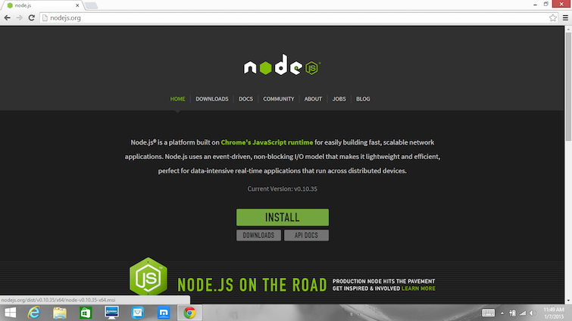

1. Run the installer (the .msi file you download in the previous step.)
2. Follow the prompts in the installer (Accept the licence agreement, click the NEXT button a bunch of times and accept the default installation settings).

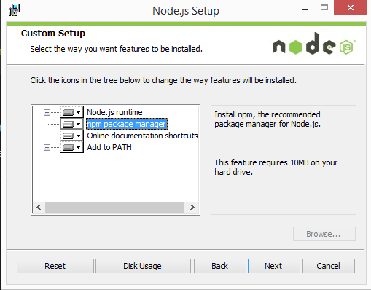

1. **Testing of installation:**

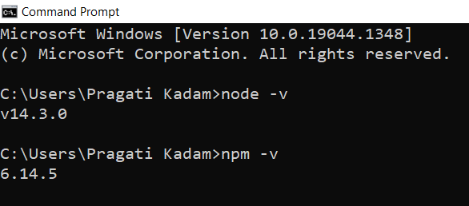

1. **Editor Installation (Sublime Text):**
2. Download the .exe packages from the official website as shown below – <https://www/sublimetext.com/3>

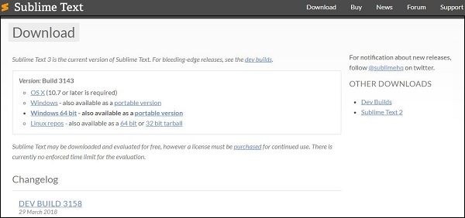

1. Now, run the executable file. This defines the environment variables. Just click next on the prompt.
2. Now, choose a destination location to install Sublime Text 3 and click Next.

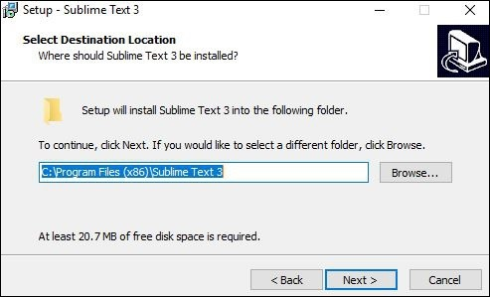

1. Now, click Finish to complete the installation.

